
Applied Leadership and Management in the Workplace
Module Assignment Submission
Student Name: | Rebecca Forshaw
Student Number: | 2238205
Module No: | BMSK5012
Module Title: | Understanding and Engaging in the Customer Experience.

Statement of Confirmation of Authenticity
By the act of making this submission, the student declares that this is the work of the student named above. The work has not, in whole or in part, been knowingly presented elsewhere for assessment, or where assessment has been built on a previous assessment, this has been identified. Where materials have been used from other sources it has been properly acknowledged. If this statement is untrue, the student acknowledges that an assessment offence has been committed.
Attention is drawn to the plagiarism and unfair practice policies of both the University and of ILM.

Table of Contents

Introduction 3
Customer Value. 4
CRM, Value & Purpose. 6
Customer Centrality. 7
Customer Loyalty 9
Experience, Emotions & Rationality. 11
Buyer/Seller Relationships. 12
Quality Frameworks. 15
Loyalty, Segmentation & Targeting. 17
Conclusion 20
References 22
Appendices 23

Introduction

Understanding and engaging in the customer experience is a critical aspect of modern business practices, especially within the dynamic and competitive field of children's entertainment. This paper delves into the customer experience within a specific niche of this sector: a children's entertainment business that specialises in hosting discos for children aged 5 to 10 years old. The objective is to explore how such a business can effectively engage its young audience and their guardians, ensuring a memorable and enjoyable experience that fosters customer satisfaction and loyalty.

Through a combination of theoretical frameworks and practical case studies, this paper seeks to shed light on the importance of creating an engaging and inclusive environment that appeals to both children and their parents. The ultimate goal is to offer insights that can help enhance the overall customer experience, thereby contributing to the long-term success and sustainability of children's entertainment businesses within the UK.

Customer Value.

In a children's party business, "customer value" means how much the customers think the services are worth to them. Customers in this case include both the children who are the main audiences and their parents or guardians.

Kotler and Keller (2016) say that customer value is the difference between what a customer thinks a product or service will do for them and how much it will cost them to get those benefits. When it comes to children's entertainment, this means how much the children enjoy and are excited about the event, weighed against how much the parents paid, how good the service was, and how satisfied they were with the entire experience.

A children's entertainment business can create a lot of customer value by providing high-quality fun that keeps children and parents happy. This can lead to more satisfied customers, repeat business, and good word-of-mouth recommendations.

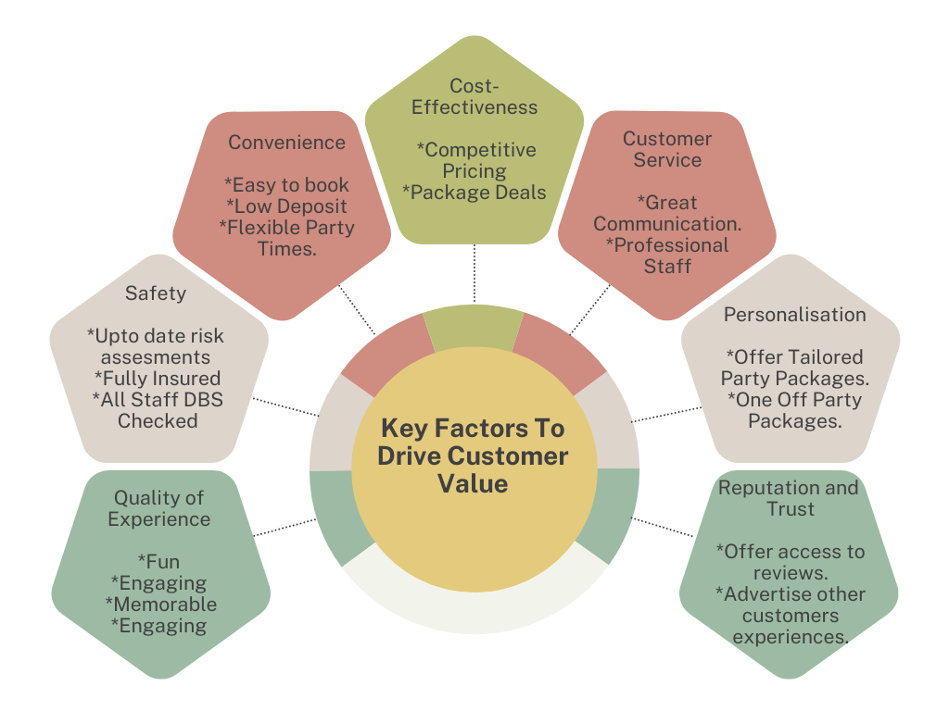

Categories of Customer Value and Their Impact on Perceived Value
Functional Value: This is the value that comes from how well and how useful a service is. When talking about children's discos, practical value includes the music, games, and how well the whole event is put together. When a service has a high useful value, it meets or goes beyond what the customer expects, which makes them happier. Sheth, Newman, and Gross (1991) believe that practical value is an important part of consumer choice and happiness.
Emotional worth: This is the worth of how the service makes you feel and what it does for you. Children's discos have emotional value because they make children happy and excited, and they make parents happy when they see their children having fun. Positive emotional events make people see things as more valuable and make them more loyal. Holbrook and Hirschman (1982) say that emotional reactions have a big effect on how people act and what they think something is worth.
Value that changes a person's life: Value that changes a person's life means having big effects and benefits on them. In a children's party, this could mean helping children build their confidence and social skills.
Social Impact Value: This is the value of the service's services and benefits to the community as a whole. Children's discos that support local communities, encourage inclusion, or give to good causes can increase their worth because they are in line with parents' ethics. Making a positive effect on the community can set a company apart and keep customers coming back. According to Kotler, Hessekiel, and Lee (2012), social effect projects can make people feel much better about a brand and make them more loyal to it.
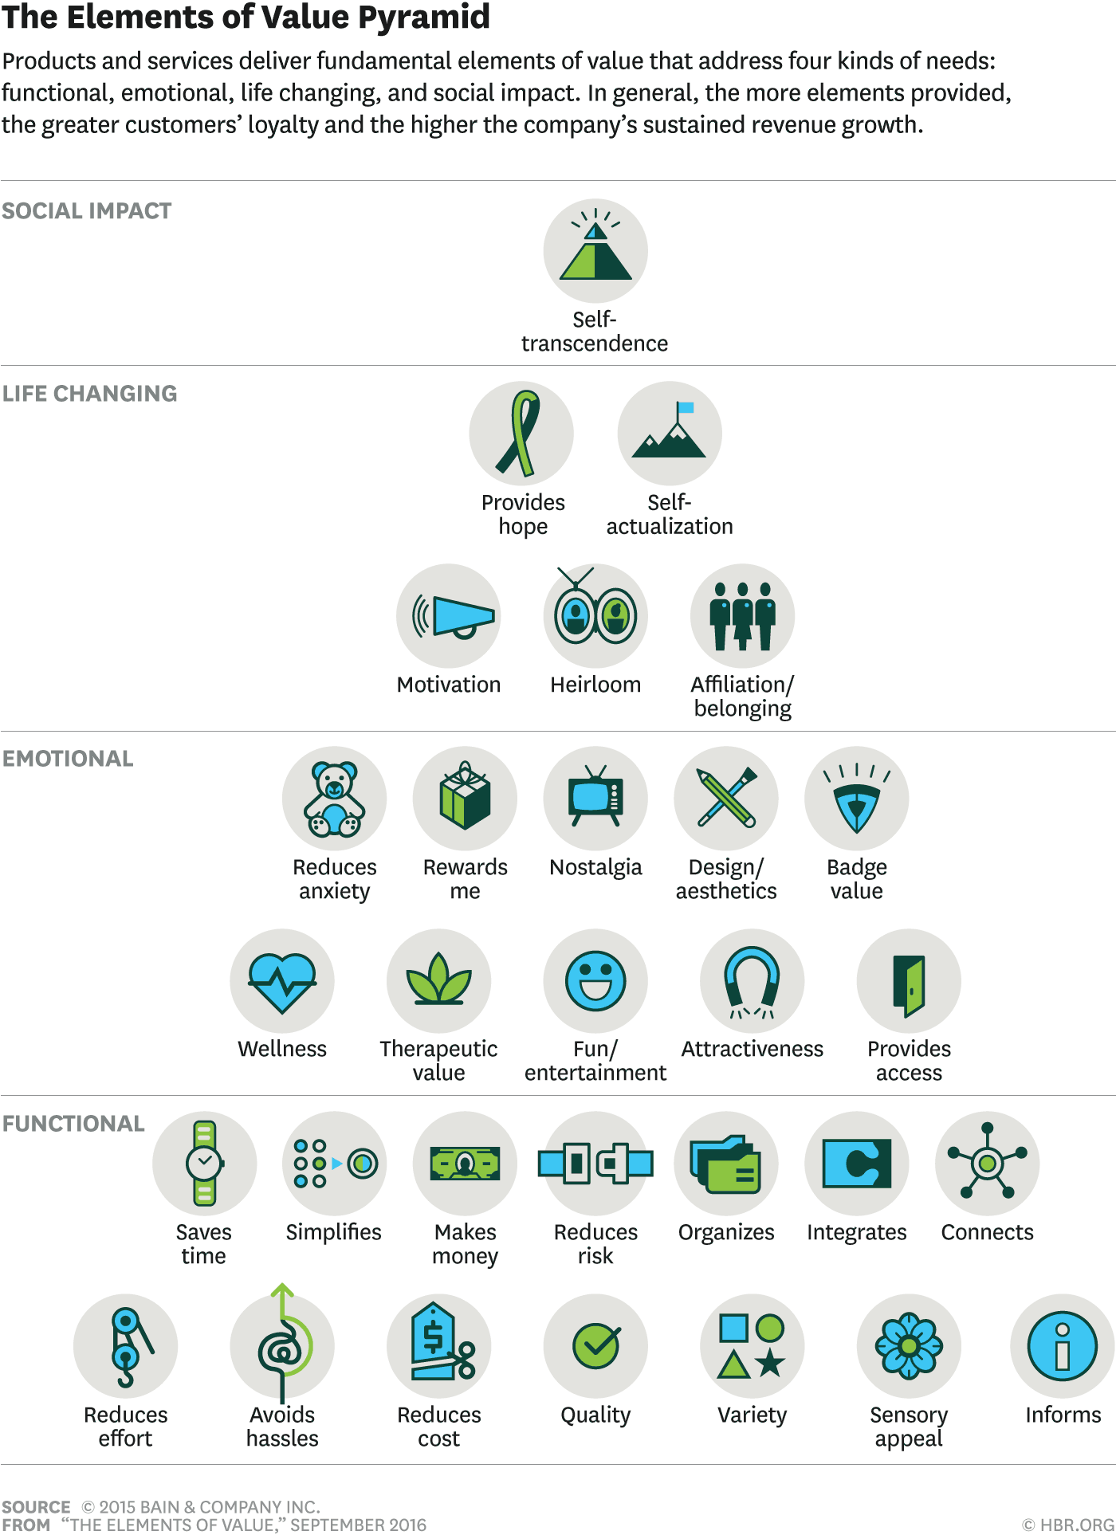

CRM, Value & Purpose.
A CRM system offers numerous benefits for enhancing value and purpose in a business. It provides enhanced customer understanding by offering insights into customer preferences, enabling businesses to tailor their offerings and interactions, thereby increasing customer satisfaction and perceived value. Leveraging CRM data allows for personalized interactions, leading to higher engagement and stronger customer relationships, aligning with the business's purpose of creating meaningful connections. CRM systems improve customer retention by tracking interactions and identifying potential issues, allowing businesses to proactively address problems and build long-term loyalty, which supports the business's goal of sustained customer care. Additionally, CRM systems streamline sales processes and manage leads, boosting sales productivity and enabling businesses to focus on delivering exceptional service. By storing previous interactions, CRM systems enhance customer service, leading to higher satisfaction and loyalty, aligning with the business's purpose of exceptional service provision. CRM systems also facilitate targeted marketing by segmenting customers and addressing their specific needs, ensuring marketing efforts are relevant and effective, in line with the company's objective to meet customer needs. Lastly, strong reporting and analytics within CRM systems support informed decision-making and strategic planning, ensuring that businesses act in accordance with their core goals and values.

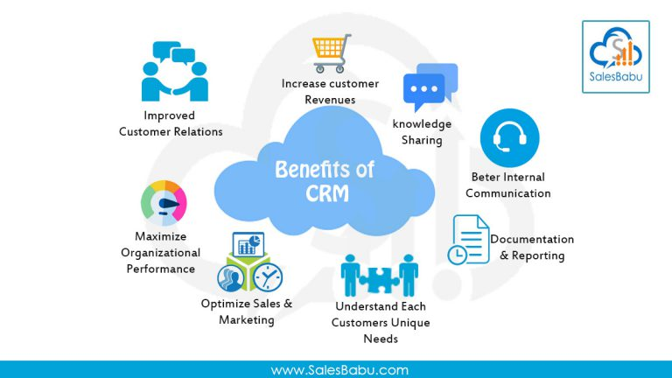

Customer Centrality.

Customer Centrality: The 5 Stages of a Customer Relationship
Pre-relationship Stage: At this stage, you use marketing and your website to bring in possible buyers. The goal is to get people to know about and be interested in the business (Kotler & Keller, 2016).
Early Stage: The goal of this stage is to turn people who are interested into buyers by giving them great customer service and clear information. It's important to build trust and make a good first impression (Grönroos, 2004).
During the development stage, putting the customer first is very important. Customers are happier and more faithful when you understand and meet their specific wants through personalised services and active engagement (Payne & Frow, 2005).
Long-term Stage: The relationship is safe and good at this point. Through loyalty programmes and special deals, you can keep the excitement up and strengthen the bond (Reichheld & Sasser, 1990).
The Final Stage: This is where the connection ends, and it's done with thanks and great memories. Dwyer, Schurr, and Oh (1987) say that good customer service can lead to recommendations and a lasting image.

Here is an example of the 5 Stages of a Customer Relationship.

1. Pre-relationship Stage - Sarah, a mother of two young children, aged 6 and 8, is looking for a fun and engaging birthday party idea. She comes across a local child’s entertainer through a friend's recommendation and a targeted social media ad. The vibrant photos and positive reviews got her interest.

2. Early Stage - Sarah visits the business's website and fills out a contact form to inquire about available packages and pricing. She receives a prompt and friendly response from the business, providing detailed information and answering her questions. Impressed by the customer service, she decides to book a party for her daughter’s upcoming birthday.

3. Development Stage - In preparation for the party, the business reaches out to Sarah to discuss her daughter’s favourite music and any specific dances she might want. They customise the playlist and games to fit her daughter's interests, ensuring a personalised experience. The party is a huge success, with the children enjoying the games and music. The business follows up with a thank-you email and a request for feedback, showing their commitment to customer satisfaction.

4. Long-term Stage - Sarah is delighted with the party and shares her positive experience on social media and with other parents. She receives a special discount offer for future bookings, encouraging her to choose the same business for her son’s birthday party later in the year. The business also sends occasional newsletters with updates and exclusive offers, maintaining engagement and loyalty.

5. Final Stage - After a few years, Sarah’s children have outgrown the age range the business caters for. The business sends a personalized thank-you note expressing gratitude for her loyalty over the years. They also provide a referral discount for any friends or family she might recommend. Sarah leaves a glowing review and refers her friends, contributing to the business's positive reputation and customer base growth.

Customer Loyalty

Examining the Difference Between Customer Loyalty and Customer Satisfaction in a Children-Focused Business Using The KANO Theory
Customer Satisfaction: Customer happiness measures how well a business meets the needs of its customers, and for a child-focused business, this means providing a great experience at the child’s party. The KANO Theory suggests customer happiness consists of three parts: Basic Needs, which include safety and cleanliness and must be met to keep people happy; Performance Needs, which encompass the level of excitement and fun the staff brings to the party, enhancing overall satisfaction; and Delight Needs, which are unexpected extras like personalizing the party or offering more than what was paid for, significantly boosting happiness. High satisfaction leads to good reviews and initial endorsement, but it doesn't always guarantee repeat customers.
Customer Loyalty: A loyal customer is someone who consistently returns to a business and enthusiastically recommends it to friends, indicating a strong connection with the company. According to the KANO Theory, consistently meeting and exceeding customer expectations fosters loyalty. This includes fulfilling Basic Needs by providing reliable service to prevent dissatisfaction, addressing Performance Needs by regularly delivering enjoyable experiences to strengthen the connection, and meeting Delight Needs by continually introducing new ideas and going above and beyond to build emotional ties and long-term loyalty. As a result, loyal customers make repeat purchases, join reward programs, and advocate for the business, contributing to steady growth and revenue.
Satisfaction is immediate and short-lived, occurring right after a positive experience, whereas loyalty develops over time as customers accumulate positive interactions with the business. Satisfaction involves meeting standards, while loyalty signifies an emotional connection and trust. The impact on the business is that satisfied customers provide good feedback, whereas loyal customers make repeat purchases and recommend the business to others.

Experience, Emotions & Rationality.
The Hierarchy of Emotional Value helps businesses understand and connect with customers by meeting their emotional needs. For a children's entertainment business offering discos and character visits, using this framework can improve the experience for both children and their parents.
The Hierarchy of Emotional Value Clusters
The Hierarchy of Emotional Value includes four clusters: Functional, Emotional, Life-Changing, and Social Impact values.
Functional Value Cluster: Basic needs include ensuring service quality provides high-quality entertainment that children love, with good music, fun activities, and friendly staff.
Emotional Value Cluster: Joy and fun are created by establishing a fun and exciting atmosphere with games and energetic hosts. Positive memories are made with personal touches like themed character visits or favourite songs.
Life-Changing Value Cluster: Personal growth can be fostered by offering activities that help children develop social skills and creativity. Confidence building is encouraged by involving children in activities like dancing that boost their self-esteem.
Social Impact Value Cluster: Community engagement is achieved by hosting events that bring families together and promote inclusivity.
Engaging the Customer Experience
Before the Event: Marketing should use happy pictures in ads to highlight fun and memorable experiences, sharing reviews and photos from past events. Personalisation allows parents to customise the party with their child’s favourite character mascot, music, and games.
During the Event: Creating joy involves ensuring the event is lively and fun with engaging hosts.
After the Event: Feedback collection involves asking parents and children for their input to understand their experience and identify areas for improvement. Building relationships can be done by sending thank-you messages and sharing event photos, creating lasting positive memories and encouraging repeat business.
Using the Hierarchy of Emotional Value clusters helps a children's entertainment business connect deeply with both the children and the parents. By focusing on functional needs, joy, personal growth, and social impact, businesses can boost customer satisfaction and loyalty for long-term success.

Buyer/Seller Relationships.
When parents decide on the entertainment for their children’s party, they go through a series of steps in the decision-making process. Using the 5-step process by Lamb, Hair, and McDaniel (2009), we can understand the buyer/seller relationships in this context.
First, there is Need Recognition. From the buyer's perspective, parents recognize the need to entertain their children, especially for a birthday party or a special occasion. For sellers, entertainment businesses can stimulate need recognition through marketing efforts, showcasing the benefits and fun experiences they offer for children's parties.
The next step is the Information Search. Buyers gather information about available options, often searching online, asking for recommendations from friends, or looking at reviews. Sellers play a crucial role here by providing detailed and accessible information. Entertainment companies should maintain an informative website, an active social media presence, and positive online reviews to make information easily available.
Following the information search is the Evaluation of Alternatives. Buyers compare different entertainment options based on factors such as price, quality, and customer reviews. Sellers can differentiate themselves by highlighting unique selling points, offering testimonials, and providing clear, comparative information that positions their services favourably against competitors.
The fourth step is the Purchase Decision. After evaluating the options, parents decide on the entertainment service that best meets their needs and preferences. For sellers, making the purchasing process straightforward is key. Clear pricing, easy booking systems, and responsive customer service are essential components.
Finally, there is Post-Purchase Behaviour. Buyers assess their satisfaction with the party they paid for. Positive experiences can lead to repeat business and recommendations, while negative experiences can result in complaints or negative reviews. Sellers should focus on maintaining a positive relationship after the purchase. Follow-up communications, thank-you messages, and requests for feedback show that the business values the customer's experience and is committed to continuous improvement.
Enhancing Buyer/Seller Relationships involves several key strategies. Trust and Communication are critical factors, especially for parents choosing services for their children. Businesses can build trust by being transparent, reliable, and responsive. Clear and honest communication throughout the entire process helps reassure parents and ensures a positive relationship.
Adopting a Customer-Centric Approach ensures that the business focuses on meeting the specific needs and preferences of each child. Personalized services, flexibility in planning, and attentive customer service demonstrate a commitment to delivering a high-quality experience.
Feedback and Improvement are also important. Actively seeking feedback from parents and using it to make improvements shows that the business values its customers' opinions. This continuous request for feedback and improvement can lead to higher customer satisfaction and loyalty.
Understanding the buyer/seller relationship when choosing a children's entertainment company involves recognizing the steps parents take in their decision-making process. By effectively addressing each step, from need recognition to post-purchase behaviour, entertainment businesses can build strong, trust-based relationships with their customers. This approach not only enhances customer satisfaction but also encourages loyalty and positive word-of-mouth referrals, which are crucial for long-term success.

Common Market Beliefs, Aids, and Barriers

Common Market Beliefs:
Parents prioritise safety when choosing entertainment options for their children. They would expect the host to be DBS checked and understand the possible risks there could be in a party environment and would trust that the host could deal with such problems should the occur. The cost of children's entertainment should reflect the quality and variety of activities provided. Parents expect a good balance between price and the entertainment value delivered. Parents seek unique and memorable experiences for their children. They believe that a successful event should be fun, engaging, and leave a lasting positive impression. Parents often rely on the reputation of the entertainment provider. They believe that positive reviews, word-of-mouth recommendations, and established trust are indicators of a reliable service.

Aids in the Market: Positive online reviews and testimonials from previous customers significantly attract new clients by providing credibility and building trust. Word-of-mouth referrals from friends, family, and other parents act as powerful advertisements, instilling confidence in potential customers. An active social media presence allows businesses to reach a wider audience, showcasing their offerings, and allowing them to interact with potential clients. Promotions, discounts, loyalty programs, and special offers appeal to cost-conscious parents and encourage repeat business. Additionally, awards, and affiliations with reputable organisations serve as quality assurances, making parents feel more comfortable with their decision.

Barriers in the Market
High Competition: The children's entertainment market is saturated with numerous options, making it challenging for businesses to stand out.
Cost Sensitivity: Some parents may find high-quality entertainment options too expensive, limiting their ability to book your services.
Safety Concerns: Any past incidents or negative news regarding safety can create significant barriers. Parents may be hesitant to choose a service if there are any doubts about the safety of their children.
Lack of Awareness: New or lesser-known businesses may struggle to attract customers who are unfamiliar with their business and offerings.
Inconsistent Quality: Variability in service quality can deter repeat business. Parents expect consistent high standards, and any deviation can lead to negative reviews and loss of trust.
Understanding the common market beliefs, aids, and barriers is crucial for a children's party business. By addressing safety concerns, providing value for money, creating memorable experiences, and building a strong reputation, the business can align with market beliefs. Utilising aids like online reviews, social media, and word-of-mouth referrals can help attract and retain customers. Overcoming barriers such as high competition, cost sensitivity, and safety concerns requires strategic planning and consistent party quality. Addressing these factors can enhance customer satisfaction and ensure long-term success.

Quality Frameworks.

Understanding Total Quality Management (TQM)
Total Quality Management (TQM) focuses on improving every aspect of a business through continuous improvement, customer satisfaction, and effective problem-solving. Key principles include customer focus, continuous improvement, employee involvement, and process management.

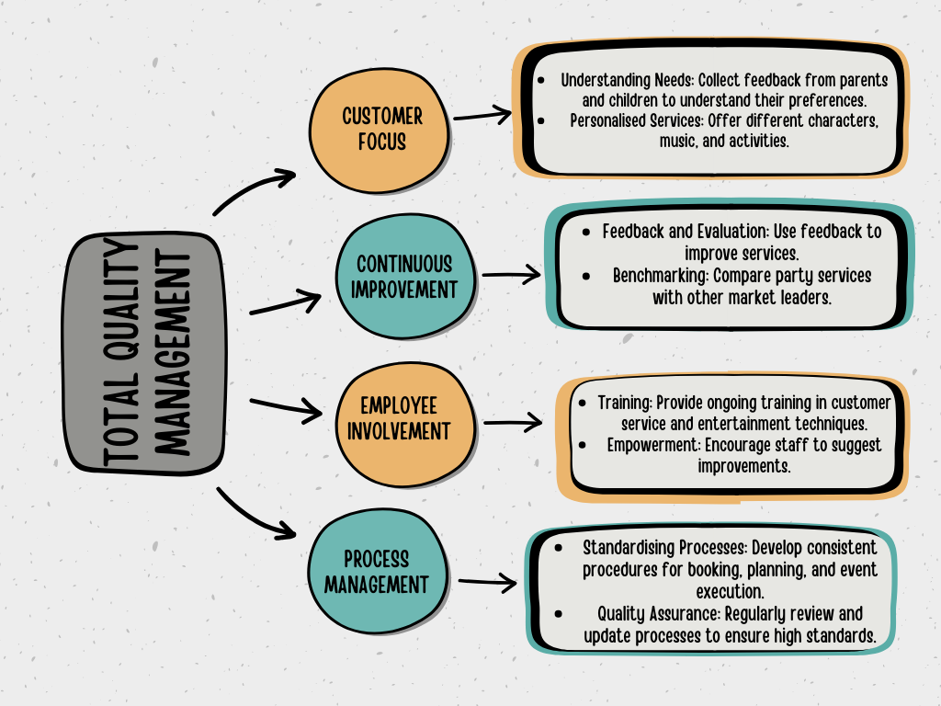

Implementing Total Quality Management (TQM) in a children's entertainment business can significantly improve customer satisfaction by meeting specific needs, ensuring customers are likely to return and recommend the business. Continuous improvements enhance service quality and build a strong reputation, while standardised processes increase efficiency and reduce costs. Employee engagement is boosted by involving staff in decision-making, which increases their commitment and productivity. High-quality, customer-focused services provide a competitive advantage, helping the business stand out from competitors. Successful implementation of TQM requires leadership commitment, with entertainers supporting TQM principles and leading by example. Training employees at all levels on TQM principles and their roles is essential, along with developing systems to collect and analyse customer feedback for continuous improvement. Forming quality circles to address quality issues and using key performance indicators (KPIs) to monitor effectiveness and adjust strategies as needed are also critical. Although implementing TQM is time-consuming and requires significant effort, the long-term benefits, including improved customer satisfaction, service quality, efficiency, and employee engagement, make it a worthwhile investment for a business willing to commit the necessary resources (Deming, 1986).

Loyalty, Segmentation & Targeting.
Porter's Generic Strategies (1980) outline four approaches to achieving competitive advantage: Cost Leadership, Differentiation, Cost Focus, and Differentiation Focus. Applying these strategies to a children's party business involves focusing on various key aspects. For Cost Leadership, the objective is to achieve the lowest operational cost in the industry by optimising processes and automating bookings. Increasing event hours to reduce costs and using low-cost marketing strategies like social media and referrals are essential. Differentiation aims to offer unique and superior services by providing a range of customisable party types and characters, ensuring premium service quality, and continuously introducing new activities and new mascots. Cost Focus targets specific market segments like budget-conscious families, offering mid-week discounts, simplified packages. Differentiation Focus involves targeting a specific segment with unique services, such as developing offerings age specific groups or parties at school, creating niche marketing campaigns, and building strong customer relationships through personalised communication and loyalty programs. By effectively leveraging these strategies, a children's entertainment business can achieve a competitive advantage and ensure long-term success.

Conclusion

Ultimately, understanding and enhancing client value is essential for a children's entertainment company to be successful. Customer value, as per the definition provided by Kotler and Keller (2016), is a balance between the perceived benefits and the costs incurred by customers. Children's entertainment involves making sure that both children and their parents are totally happy with the experience offered, which incorporates aspects such as quality of service and lasting memories.
A comprehensive approach for customer value involves acknowledging and tackling various categories of value. Functional value guarantees that the services are practical and fulfil basic needs. Emotional value is centred around the creation of enjoyable and engaging experiences, while life-changing value promotes growth for individuals, including the development of confidence and social skills. Businesses that prioritise social impact value are more likely to be trustworthy and to support causes close to their customers' hearts.
A Customer Relationship Management (CRM) system can make this worth even higher by giving you deep insights into what your customers want, letting you connect with them in a more personalised way, and helping you keep your customers. This is in line with the company's objective of establishing important connections and providing outstanding service.
Adopting a customer-centric strategy that includes all stages of client interactions, from initial contact to the last stage, facilitates the development of lasting customer loyalty. According to the KANO Theory, companies may transform content consumers into devoted advocates by constantly exceeding their expectations.
Additionally, knowing common market beliefs, like how important value for money and unique experiences are, and using tools like online reviews, social media, and word-of-mouth recommendations can help bring in and keep customers. To overcome market hurdles, such as strong competition and price sensitivity, it is necessary to employ strategic planning and maintain a constant commitment to maintaining high quality standards.
Integrating Total Quality Management (TQM) concepts into the company model may greatly enhance customer happiness, service quality, operational efficiency, and staff involvement. The primary emphasis of Total Quality Management (TQM) is on the ongoing enhancement of processes, the fulfilment of customer needs and desires, and the efficient resolution of issues. These objectives are reinforced by the unwavering dedication by management and the offering of training to employees. As a result, TQM guarantees lasting advantages over competitors.
A children's entertainment business can gain a competitive edge and long-term growth by using strategies like Porter's Generic Strategies to achieve cost leadership, uniqueness, and focused market targeting. A value-driven, customer-cantered approach, along with strong management guidelines, can help a business achieve long-term success and build a strong, loyal customer base.

References

Berry, L. L., Seiders, K., & Grewal, D. (2002). Understanding service convenience. Journal of Marketing, 66(3), 1-17.
Delgado-Ballester, E., & Munuera-Alemán, J. L. (2001). Brand trust in the context of consumer loyalty. European Journal of Marketing, 35(11/12), 1238-1258.
Deming, W. E. (1986). Out of the Crisis. MIT Press.
Dick, A. S., & Basu, K. (1994). Customer Loyalty: Toward an Integrated Conceptual Framework. Journal of the Academy of Marketing Science, 22(2), 99-113.
Dwyer, F. R., Schurr, P. H., & Oh, S. (1987). Developing Buyer-Seller Relationships. Journal of Marketing, 51(2), 11-27.
Grönroos, C. (2004). The relationship marketing process: Communication, interaction, dialogue, value. Journal of Business & Industrial Marketing, 19(2), 99-113.
Holbrook, M. B., & Hirschman, E. C. (1982). The experiential aspects of consumption: Consumer fantasies, feelings, and fun. Journal of Consumer Research, 9(2), 132-140.
Kotler, P., & Keller, K. L. (2016). Marketing Management (15th ed.). Pearson.
Kotler, P., Hessekiel, D., & Lee, N. R. (2012). Good Works! Marketing and Corporate Initiatives that Build a Better World...and the Bottom Line. Wiley.
Lamb, C. W., Hair, J. F., & McDaniel, C. (2009). Marketing. Cengage Learning
Maslow, A. H. (1943). A theory of human motivation. Psychological Review, 50(4), 370-396.
Oliver, R. L. (1999). Whence Consumer Loyalty? Journal of Marketing, 63, 33-44.
Parasuraman, A., Zeithaml, V. A., & Berry, L. L. (1988). SERVQUAL: A multiple-item scale for measuring consumer perceptions of service quality. Journal of Retailing, 64(1), 12-40.
Payne, A., & Frow, P. (2005). A Strategic Framework for Customer Relationship Management. Journal of Marketing, 69(4), 167-176.
Piaget, J. (1964). Development and learning. Journal of Research in Science Teaching, 2(3), 176-186.
Pine, B. J., & Gilmore, J. H. (1998). Welcome to the experience economy. Harvard Business Review, 76, 97-105.
Prahalad, C. K., & Ramaswamy, V. (2004). Co-creating unique value with customers. Strategy & Leadership, 32(3), 4-9.
Reichheld, F. F. (2003). The One Number You Need to Grow. Harvard Business Review, 81(12), 46-54.
Schmitt, B. (1999). Experiential Marketing. Journal of Marketing Management, 15(1-3), 53-67.
Sheth, J. N., Newman, B. I., & Gross, B. L. (1991). Why we buy what we buy: A theory of consumption values. Journal of Business Research, 22(2), 159-170.
Vygotsky, L. S. (1978). Mind in Society: The Development of Higher Psychological Processes. Harvard University Press.
Zeithaml, V. A. (1988). Consumer perceptions of price, quality, and value: A means-end model and synthesis of evidence. Journal of Marketing, 52(3), 2-22.

Appendices

