

Developing Emotional Intelligence Skills for the workplace

Student : Md. Abdul Q Chowdhury
ID :--------- 2119999
Module code – BMSW6106
Lecturer – Mr . Amare Desta

Table of Contents
Introduction 4
Investigating the Role of EI in the Workplace and at FAYE Inc. 5
Understanding Emotional Intelligence in Workplace Dynamics 5
Impacts of Low EI on Leadership 5
Benefits of High EI in Leadership 6
Challenges of Implementing EI in the Workplace 7
The Role of EI in Multicultural Settings 7
Discussing Two EI Models to Enhance Clarke's Workplace Abilities 8
Introduction to EI Models 8
1. Daniel Goleman’s EI Model 8
Strengths and Limitations of Goleman’s Model 9
2. Bar-On Emotional Quotient Inventory (EQ-i) 10
Strengths and Limitations of Bar-On EQ-i 11
Comparative Analysis 11
The Role of Culture in Understanding EI and Mindfulness of Employees 11
The Interplay of Culture and EI 12
Cultural Barriers to Practicing EI 12
Mindfulness in a Cultural Context 13
Strategies for Integrating Culture, EI, and Mindfulness 13
Benefits of Cultural Awareness in EI and Mindfulness 14
How FAYE Inc. Can Harness the Benefits of EI and Mindfulness among Employees 14
Establishing an EI-Centric Leadership Approach 14
Embedding Mindfulness in Organizational Practices 15
Promoting Diversity and Discrimination 16
Addressing Technology and EI and Mindfulness Development 16
Establishing Feedback and Recognition Mechanisms. 17
Evaluating EI and Mindfulness 17
Conclusion 19
References 20
Appendix -------------------------------------------------------------------------------------------------

Introduction
Emotional Intelligence (EI) has become crucial for facilitating and encouraging teamwork, leadership and productivity in the modern workplace (Gainer, 2018). EI is the capacity to accurately perceive, understand, and appraise emotions in oneself and others and to regulate these emotions for personal, and to foster interpersonal effectiveness, EI is critical for constructing healthy and effective teams. In FAYE Inc. where multiculturalism is the core of its employees’ structure, EI integration is beneficial and mandatory (Callahan, 2016). This paper is a case study of Clarke, a newly promoted supervisor who struggles to manage cultural and workplace relations with his team. Cases like referring to someone as ‘my love’, or proposing alterations to certain cultural values are a good indication that leaders need to embrace more emotional and cultural intelligence. Moreover, the Chinese team also brings up the issues of the priority of family and cultural background, which also should be handled delicately. From the above challenge, FAYE Inc. can solve by analyzing EI status, analysing the use of EI in multicultural environments, and incorporating mindfulness practice at the workplace. This paper presents different steps and models for improving EI and creating a more inclusive culture to increase team morale and guarantee the future development of a business.

Investigating the Role of EI in the Workplace and at FAYE Inc.

Understanding Emotional Intelligence in Workplace Dynamics
Emotional Intelligence (EI) refers to the ability to identify, understand, and manage one’s emotions and influence others positively (Sarkar & Oberoi, 2020). This is a valuable asset for the management of diverse employees or for organisations with branches in different countries such as FAYE Inc. EI encompasses five key competencies: These are; self-awareness, self-regulation, motivation, empathy, and social skills. These skills play a crucial role in cooperation, conflict-solving, and creating a good organizational climate (Udod, Hammond-Collins & Jenkins, 2020).
Namely, failures and issues of Clarke at FAYE Inc. can justify the need for the EI in working on the interpersonal and cultural issues. The female employee was embarrassed when Clarke used the word “my love” Among rightful social cues and the role of the language that can be applied to the norms of the firm, appropriateness of language to the greatest extent. Also, Clarke’s desire to ask Chinese workers to use their English names is insensitive and this will demotivate the workers and repel them.

Impacts of Low EI on Leadership
Low EI among the leaders can create an uninviting work environment for other people to work together with them. In the case of FAYE Inc., Clarke has already caused employees to become uncomfortable and escalate the possibility of cultural misunderstandings. It has implications on personal morale and also implies other organizational problems such as low production, high Attrition rates and harm to the organization’s image (Yasmeen, Khan & Imran, 2024). Low EI can result in:
- Decreased Morale: Employees who feel disrespected or misunderstood are less likely to engage with their work or colleagues.
- Conflict Escalation: Poor emotional regulation can lead to unresolved disputes, fostering a tense workplace atmosphere.
- Limited Collaboration: A lack of social skills and empathy can hinder teamwork and innovation (Raza, 2023).
For Clarke, the failure to perceive how he responds to others with his communication patterns shows that he lacks emotional intelligence. Even his reaction to the feedback shows a lack of realization of what goes on outside the sphere of his culture. Such deficits can escalate tensions and decrease staff engagement especially where there is multiculturalism such as in FAYE Inc.

Benefits of High EI in Leadership
On the other hand, leaders with high EI can help change organizational culture with positivity, and support and encourage high performance (Dennett & Dedonno, 2024). With the enhancement of EI in FAYE Inc., Clarke and other leaders can:

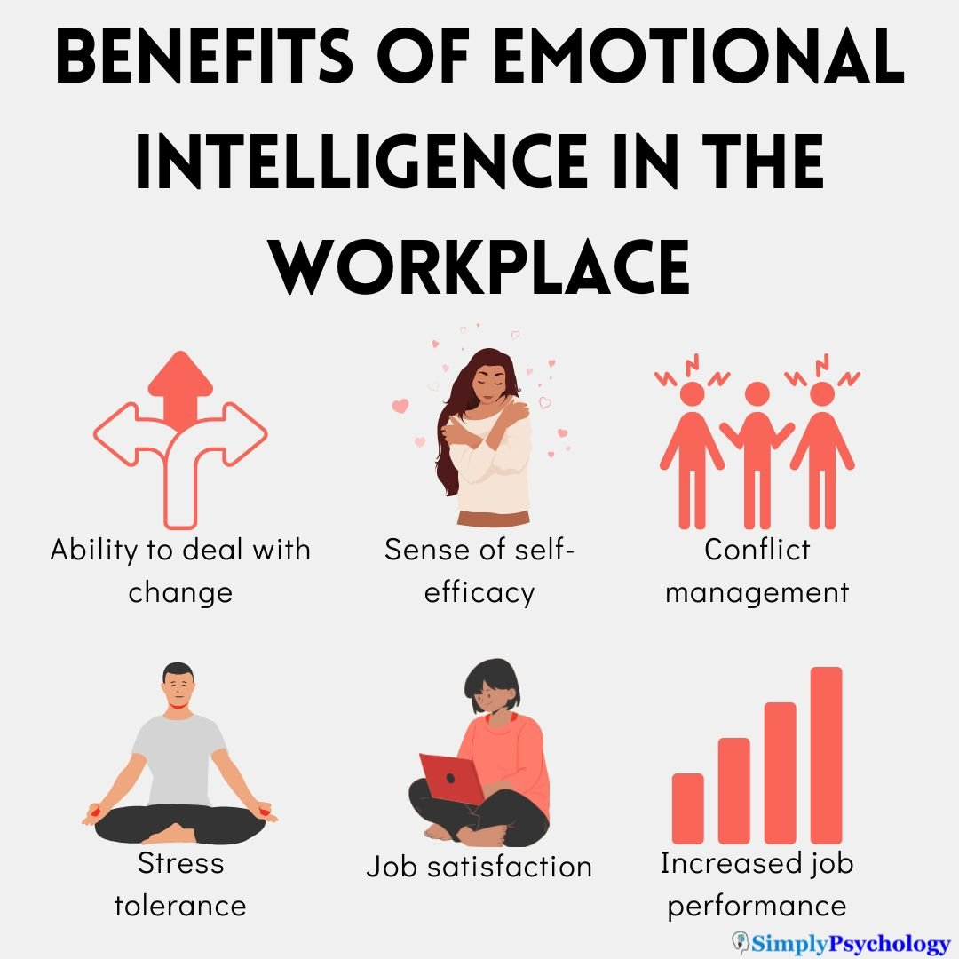
Figure 1: Benefits of EI in the workplace (Iguodala-Cole, 2021)
- Enhance Communication: Empathetic leaders can adapt their communication styles to resonate with diverse teams, reducing misunderstandings (Fedorova et al., 2023).
- Build Trust: Employees are more likely to trust leaders who demonstrate emotional awareness and genuine concern for their well-being.
- Improve Collaboration: High EI leaders can navigate cultural differences effectively, promoting teamwork and cohesion (MacCann et al., 2020).
- Resolve Conflicts: Leaders who can manage their emotions and mediate disputes are better equipped to maintain harmony.
To work on these challenges from employees and be an emotionally intelligent manager, Clarke can restore trust in relationships. High EI will let him value the opinions of others, which will help him become more flexible and productive at work.

Challenges of Implementing EI in the Workplace
Although many advantages of employing EI are visible, organizing the practical use of EI in various organizations has its difficulties. At FAYE Inc., these challenges may include:
- Resistance to Change: Leaders like Clarke, who are accustomed to traditional management styles, may find it difficult to embrace EI concepts initially (Dabke, 2016).
- Cultural Variations: People’s culture defines how they show and interpret emotions. For instance, Clarke is used to direct communication, which is tolerable in Texas, but might not go down well in the UK or China.
- Time and Resource Constraints: Developing EI requires training and consistent practice, which may be perceived as an additional burden in a fast-paced work environment (Görgens-Ekermans & Roux, 2021).
To solve these problems, several methods need to be implemented, such as EI training for leaders, and integration of the company’s culture into perceiving emotions inclusively.

The Role of EI in Multicultural Settings
Multicultural organizations such as FAYE Inc. are relatively complex and diverse for the practical application of EI. Managers face differences in managerial cultures, business communication, and their expectations. For example, the Chinese team chose to refer to their Chinese name as a sign of regard for their culture. Such as Clarke’s plan, in the beginning, to name the Chinese team to carry English names which can negatively impact team cohesion or productivity (Lopes, 2016).
Ideally, empathic understanding and social cognition are pivotal in any such environment. In this case, learning cultural differences helps leaders to appreciate cultural diversity and gives them pride in working for the company (Kotsou et al., 2019). This not only increases motivation but also increases creativity and productivity, because every team has different visions and approaches to work.

Discussing Two EI Models to Enhance Clarke's Workplace Abilities

Introduction to EI Models
Two significant Emotional Intelligence models, Daniel Goleman’s EI model and the Bar-On Emotional Quotient Inventory (EQ-i), can improve Clark’s workplace behaviour (Varvatsoulias, 2023). Both offer a systematical framework for comprehending and using EI skills in organisations to different extents.

1. Daniel Goleman’s EI Model
Daniel Goleman’s model identifies five key components such as self-awareness, self-regulation, motivation, empathy, and social skills (Singh, Prabhakar & Kiran, 2022). These elements are related and all help determine a leader's relationship and emotional intelligence.
For instance, there is a lack of self-regulation, which would enable Clarke to understand why ladies at the workplace may be uncomfortable with being called “my love” by their male colleagues. Self-regulation would also help Clarke become more aware to change his behaviour to fit the appropriate working culture (Chung, Cichocki & Chung, 2023). Self-regulation would, in addition, help Clarke regulate his impulses, including his desire for order to meet the needs of his team.
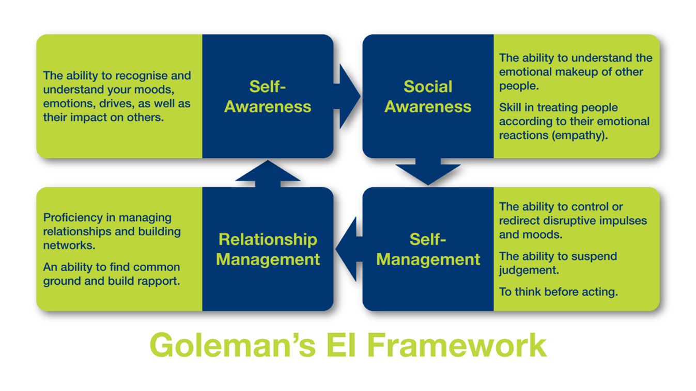
Figure 2: Daniel Goleman’s EI Model (Williams, 2021)
Empathy, one of the elements of Goleman’s model, is especially important during the work with people of different cultures. By recognising the clashing viewpoints and tendencies of the Chinese team, Clarke will be able to adapt to the environment to be more culturally sensitive to the Chinese employees. It might range from calling people by their first names and presenting an actual interest in their worldview and culture (Fianko, Jnr & Dzogbewu, 2020).
Other important interpersonal skills include active listening and communication. For example, Clarke learnt that taking time to make pleasantries and small talk with subordinates goes a long way in relation-building endeavours. The other component would be motivation, which would make Clarke encourage and direct his subordinates towards realizing organizational objectives in a positive environment.

Strengths and Limitations of Goleman’s Model
Goleman’s model provides quite a detailed approach to leadership competency models focusing on the aspects of emotional intelligence (Aamir, 2023). Because of its emphasis on understanding others and interpersonal skills, the model is especially relevant to multicultural organizations such as FAYE Inc. However, the scope of the model can be practically quite diffused, which may lack clear, concrete recommendations.

2. Bar-On Emotional Quotient Inventory (EQ-i)
Bar-On EQ-i model focuses on social and emotional aspects of human functioning. It includes five composite scales: self-awareness, inter- and intrapersonal skills, stress coping, flexibility, and affect (Allahyari, 2020). This model makes it possible to accurately evaluate an individual’s emotional competencies and, thus, prioritize training needs.
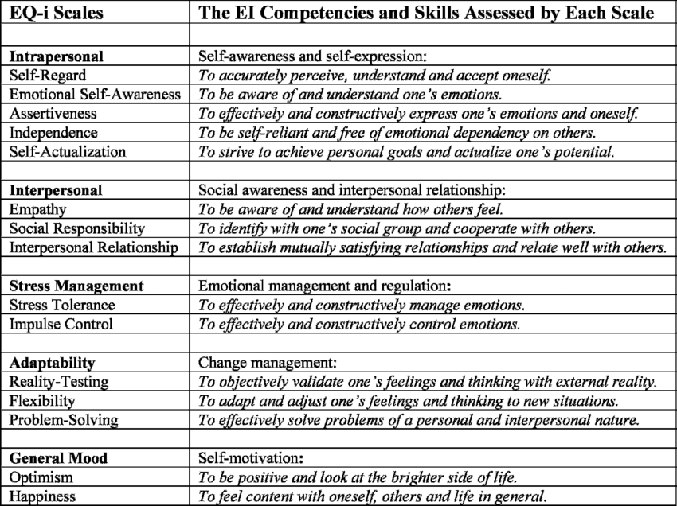
Figure 3: The Bar-On EQ-i scales and what they assess (Seok et al., 2020).
For Clarke, the intrapersonal scale may open up the world for him, and help him think about how to express himself better. Self-awareness can help him avoid misinterpretation of his feelings by others and consequently improve communication with co-workers (Agarwalla et al., 2020). The interpersonal scale may also be more effective because it focuses on the building of relationships to address the issues of female employees in diverse teams.
Stress management is another focal issue involved with Clarke. If Clarke gains better ways of handling stress, then he will work towards developing a much friendlier leadership demeanour.
The particular scale reflects the ability to solve problems and manage changes. This is especially important for Clarke, given his difficulties in managing a multicultural team (Esnaola et al., 2016). By increasing his level of flexibility, it will be easier for him to deal with cultural differences and other unforeseen occurrences. Lastly, the general mood scale reveals that positive thinking is a key to success in inspiring employees.

Strengths and Limitations of Bar-On EQ-i
The Bar-On EQ-i model provides the framework and system for evaluating and enhancing EI systematically. Nonetheless, owing to its focus on stress and its ability to address these issues in dynamic and multicultural contexts, LMX is even more appropriate for use in leadership positions (Sánchez-Teruel, Robles-Bello & Camacho-Conde, 2020). Nonetheless, the measurement of variables within the model depends on personal assessments by the individuals involved, which may reduce the validity of the model. Furthermore, its emphasis on developing competencies suggests that the social aspect of the organization, the group dynamics and organizational culture are not important for emotional intelligence.

Comparative Analysis
By comparing Goleman’s model with the Bar-On model EQ-i, it is possible to find out what facets of Clarke’s work performance can be improved. Whereas Goleman’s model focuses on interpersonal skills as well as empathy, Bar-On’s, Bar-On EQ-i is a model that comprises several indices and provides a wider range of measures of emotions (Kazmi, Hafeez & Hassan, 2020). The hybrid of the models can be used to achieve a good middle ground in the development of Clarke’s EI. For instance, Goleman’s concern with empathy and interpersonal skills may well dovetail with the Bar-On EQ-i interest in stress and flexibility.

The Role of Culture in Understanding EI and Mindfulness of Employees
Emotional Intelligence (EI) and mindfulness are two aspects that differ from one culture to another and can only be understood in the broadest terms concerning the culture in which they are being practised (Irlbeck & Dunn, 2020). When working in multicultural organizations such as Faye Inc. it is very important to respect cultural differences. EI and mindfulness, if incorporated with cultural sensitivity, will assist in the improvement of organizational relationships, decrease misunderstandings and improve the psychological health of the employees.

The Interplay of Culture and EI
Emotions as a concept are influenced by culture and as such determine how people employ EI (Gip et al., 2022). For example, in the American culture, people often use the first-name basis to address colleagues who are the same or even older, or speak louder than others, whereas the Chinese prefer to subordinate themselves to maintain peaceful relations among colleagues. This divergence is practised in the field of developing empathy, social skills and emotional regulation.
The Chinese team at FAYE Inc. expected to be called by their Chinese names while in the US; this shows that cultural identity is valued. The idea by Clarke for the use of English names though noble could be demeaning to them and disrespectful to their culture (Amina et al., 2021). This shows how important it is that when practising EI, more attention should be paid to cultural sensitivity.
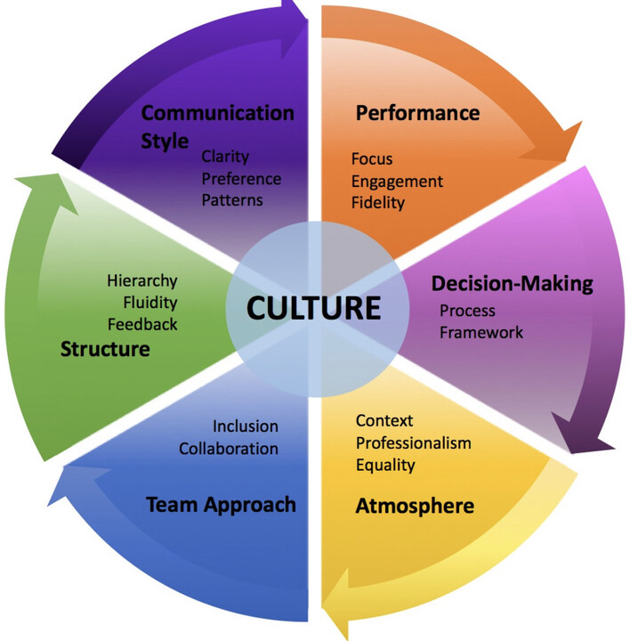
Figure 4: CULTURAL INTELLIGENCE AND ITS ROLE IN ORGANISATIONAL DECISION MAKING (Amina et al., 2021)

Cultural Barriers to Practicing EI
Several cultural barriers can hinder the effective practice of EI in multicultural workplaces:
- Diverse Emotional Norms: The relation between people also has differences based on the culture they come from as to how they depict emotions. For example, while affection and free display of emotion may be permitted in some cultures of the West, they may be seen as improper in some cultures of Asia (Jena & Pradhan, 2018).
- Misinterpretation of Behaviours: When it comes to gestural or facial language, misunderstandings are likely to occur because of different cultures. A behaviour which may be perceived as courteous in one culture may well be perceived as unfriendly or even impolite in another (Azevedo & Shane, 2019).
- Language and Communication Styles: Language barriers and differing communication styles can complicate the practice of empathy and active listening, which are crucial EI components.

Mindfulness in a Cultural Context
Mindfulness is getting a lot of attention as a useful tool in EI enhancement because of its meaning, which is the presence of mind and being fully attentive to the present task. Nevertheless, cultural perceptions of such practices as meditation or reflection exercises are quite diverse (Shakir et al., 2017). Despite adopting its origins from Eastern practices, contemporary adaptations of mindfulness may not be perceived similarly by different cultural groups.
For instance, most employees from cultures that embrace and appreciate the acts of doing and moving may feel that practising mindfulness will only be a waste of precious time. On the other hand, some cultures encourage one to look inward and seek the middle ground, mindfulness will not be difficult to sell (Klockner, 2017). As with any change, for mindfulness to be effective in organizations such as FAYE Inc., it will be important to consider the above cultures and try to fit them into the employees’ cultural beliefs.

Strategies for Integrating Culture, EI, and Mindfulness
- Cultural Sensitivity Training: Provide the organizational leaders and the employees with efficient ethno-cultural sensitivity (Oeij, Hulsegge & Preenen, 2022). This includes perception of cultures and beliefs, perception of communication and feeling.
- Inclusive Mindfulness Programs: Develop cultural sensitivity programmes for mindfulness at the workplace. Provide a variety of practices, including mindfulness, breathing, or writing, to appeal to clients’ individual needs.
- Encouraging Open Dialogue: Encourage self-organization around issues of culture and its relation to organizational work. This helps to avoid getting into disputes with any party because everyone feels that the other party understand them.
- Adapting Leadership Styles: Promote boundless leadership virtues in Clarke and other managers to be responsive to cultural inclinations while at the same time considerate of their subordinates’ requirements (Dietz et al., 2017). These are engaging in active listening, expressing concern for others and acknowledging differing opinions.

Benefits of Cultural Awareness in EI and Mindfulness
Integrating cultural awareness with EI and mindfulness offers several benefits:
- Enhanced Collaboration: Understanding and respecting cultural differences fosters stronger relationships and teamwork.
- Reduced Misunderstandings: Cultural competence minimizes the risk of misinterpreting behaviours or intentions (Oeij, Hulsegge & Preenen, 2022).
- Improved Employee Well-Being: Mindfulness practices tailored to diverse cultural contexts support mental health and resilience.
- Greater Organizational Success: A culturally aware and emotionally intelligent workforce drives innovation, productivity, and employee satisfaction.

How FAYE Inc. Can Harness the Benefits of EI and Mindfulness among Employees
Emotional Intelligence and mindfulness become invaluable for enhancing organisational success in the competitive environment (Dietz et al., 2017). The following are some of the strategies that may be embraced by FAYE Inc., a multicultural organization to improve multicultural workforce for productivity and workforce strength.

Establishing an EI-Centric Leadership Approach
FAYE Inc. needs to focus on the application of EI in the development of emotionally intelligent leaders to get maximum efficiency:
- Targeted Leadership Training: Lectures in base talents including attitudes, self-awareness and social skills training should be arranged. These sessions should be devoted to cultural appropriateness so that managers, directors, supervisors, etc – such as Clarke – develop the skills necessary to meet the various expectations of the subordinates (Norris, 2019).
- Mentorship Programs: Find out developmental mentoring relationships between the emergent leaders and the existent ones with high levels of EI to enhances the organisational culture of emotional intelligence.
- Leadership Assessments: Utilize tools like 360-degree feedback to identify gaps in leaders’ emotional intelligence and tailor developmental programs to address them.
Outcome: Arming the leaders with the EI tools helps to equip them appropriately to manage relationships at personal and intergroup levels, creating trust, and cooperation throughout the company (Lilley, Whitehead & Midgley, 2022).

Embedding Mindfulness in Organizational Practices
As a strategy of integrating mindfulness in the business FAYE Inc. aims to promote the organisation’s health and employees’ performance:
- Mindfulness Breaks: This article suggests that possible mindfulness exercises at the workplace are short breathing exercises and writing (Azevedo & Shane, 2019). These activities assist the employees to relax and focus on their tasks.
- Corporate Wellness Programs: Add programs such as Yoga, Meditation, and stress management programs into wellness programs. All these activities help a person to maintain a balance as well as build mental strength.
- Mindful Meetings: Suggest leaders begin meetings with five or ten minutes of silence or exercises aimed at increasing concentration and decreasing stress levels at work (Klockner, 2017).
Outcome: Merging mindfulness leads to the decrease of stress, improvement of the decision-making process, and focus on paying attention.

Promoting Diversity and Discrimination
By aligning EI and mindfulness with inclusivity initiatives, the company can create a supportive environment:
- Cultural Sensitivity Training: Make sure that people have enough knowledge regarding different cultural peculiarities of behaviour and attitudes (Irlbeck & Dunn, 2020). This training should preferably focus on the aspect of the globalization of workplaces, which would require a much more empathetic approach.
- Celebrating Diversity: Host diversity awareness that recognizes and appreciates the employee’s culture as a way of making them feel valued. For instance, to foster unity a concept like International Food Day or cultural storytelling session.
- Clear Communication Guidelines: Develop and implement organisational communication policies that curb any form of prejudice through such terms as those used by Clarke (Fianko, Jnr & Dzogbewu, 2020).
Outcome: Employees are more motivated, there are few clashes, and different groups work well together when the organization promotes equality and courtesy.

Addressing Technology and EI and Mindfulness Development
Technology can amplify the effectiveness of EI and mindfulness initiatives by providing scalable solutions:
- Digital Platforms: Provide the opportunity to use the Headspace or Calm apps for practising mindfulness or other EI development, as well as cognitive EI assessment and training apps.
- Virtual Training Sessions: Employ multimedia to provide engaged EI and mindfulness sessions for learning while offering inclusive classes for employees working from home (Kotsou et al., 2019).
- AI-Driven Analytics: Use AI to supervise many of the employees’ interactions and detect signs that they may be under pressure, unhappy, or have interpersonal problems. This can be used for prevention.
Outcome: Technological applications make it possible to have standardized approaches to EI and mindfulness and provide measurable results in their implementation (MacCann et al., 2020).

Establishing Feedback and Recognition Mechanisms.
FAYE Inc. can reinforce the importance of EI and mindfulness by incorporating these elements into their practices:
- Regular Feedback Channels: Use an online feedback form or mail anonymous feedback for the employees to give their opinions about various EI and mindfulness programs.
- Employee Recognition Programs: Incorporate and celebrate examples of positive employee behaviours reflective of high levels of EI or Mindfulness at the workplace (Aamir, 2023). For instance, it is positive when one member of a team is commended for performing the role of a mediator in a conflict instance.
- Iterative Improvement: Collected feedback can then be used to review initiatives in order to keep them relevant for the shifting needs of the workforce (Chung, Cichocki & Chung, 2023).
Outcome: Paying attention to, and responding to, feedback increases trust and involvement; publicizing the success of EI and mindfulness emphasizes its importance.

Evaluating EI and Mindfulness
To demonstrate the tangible benefits of these strategies, FAYE Inc. should establish metrics for evaluating success:
- Employee Satisfaction Surveys: To assess the effectiveness of EI and mindfulness interventions, incorporate important indices of morale, engagement and well-being into routine assessment (Allahyari, 2020).
- Productivity Metrics: Regarding EI and mindfulness practices, it is also advisable to monitor the relationship between KPIs, and the efficiency of the team; the output, and the completion rates of projects.
- Retention Rates: Track the number of employees leaving in order to determine if these interventions are effecting a decline in turnover and increasing overall satisfaction with their jobs (Gainer, 2018).
Outcome: All these backed EI and mindfulness programs suggest that there is more value in investing in such programs.

Conclusion
FAYE Inc. is at a crucial stage for culture modification in the workplace with the integration of EI and Mindfulness. In the case of the organisation, current difficulties can be resolved and a positive change in the work environment can be made by providing leaders and employees with the necessary tools to be fully aware of themselves, accept others and be ready to change. Mindfulness programs are also integrated to increase employee protection, stress, and concentration to balance production and employees. Similarly, promoting a culture of civility and respect will not only address individual disputes but will also enhance organizational results by bringing in and keeping the best employees. Technology and feedback systems can be effective means of achieving the intended objectives and monitoring progress toward achieving organizational objectives. Though the journey does take time and dedication, the rewards range from higher employee satisfaction levels to higher organizational performance to well make it a valuable journey. FAYE Inc. has the potential to be a model of practice for emotional intelligence and mindfulness in the business environment.
References
Aamir, A. (2023). Emotional Intelligence and Organizational Commitment-Application of the Goleman’s Model of Emotional Intelligence. International Journal of Intellectual Human Resource Management (IJIHRM), 4(01), pp.01-06.
Agarwalla, S., Chandra, B., Kundu, G.K. and Poddar, S. (2020). Psychometric properties of BarOn emotional quotient inventory youth version among Bengali children. IAHRW International Journal of Social Sciences Review, 8(4-6), pp.143-147.
Allahyari, E. (2020). Differential item functioning analysis of the Bar-On Emotional Quotient Inventory (EQ-i) across gender and age groups: an iterative hybrid ordinal logistic regression. Psychologia. Avances de la Disciplina, 14(2), pp.95-105.
Amina, A., Hadi, N.U., Waheed, A. and Fayyaz, H. (2021). The effect of leader mindfulness on employee job performance: Investigating the mediating and moderating role of leader-member exchange and organization culture. Journal of Behavioral Sciences, 31(2), pp.138-165.
Azevedo, A. and Shane, M.J. (2019). A new training program in developing cultural intelligence can also improve innovative work behaviour and resilience: A longitudinal pilot study of graduate students and professional employees. The International Journal of Management Education, 17(3), p.100303.
Callahan, H. (2016). Emotional intelligence: A leader's impact on productivity in a distribution environment (Doctoral dissertation, Brandman University).
Chung, S.R., Cichocki, M.N. and Chung, K.C. (2023). Building emotional intelligence. Plastic and Reconstructive Surgery, 151(1), pp.1-5.
Dabke, D. (2016). Impact of leader’s emotional intelligence and transformational behaviour on perceived leadership effectiveness: A multiple source view. Business Perspectives and Research, 4(1), pp.27-40.
DENNETT, S.K. and DEDONNO, M.A. (2024). Resilience and Emotional Intelligence: A Dynamic Partnership for Human Resources Professionals in Today's Workplace. Journal of HRM, 27(1).
Dietz, J., Fitzsimmons, S.R., Aycan, Z., Francesco, A.M., Jonsen, K., Osland, J., Sackmann, S.A., Lee, H.J. and Boyacigiller, N.A. (2017). Cross-cultural management education rebooted: Creating positive value through scientific mindfulness. Cross Cultural & Strategic Management, 24(1), pp.125-151.
Esnaola, I., Freeman, J., Sarasa, M., Fernández-Zabala, A. and Axpe, I. (2016). Validity evidence based on the internal structure of scores of the Emotional Quotient-Inventory: Youth Version Short (EQ-i: YV-S) in a Spanish sample. The Spanish Journal of Psychology, 19, p.E12.
Fedorova, Y., Pilková, A., Mikuš, J., Holienka, M. and Brytan, Y. (2023), September. Fostering Emotional Intelligence on Challenge-Based Learning Principles. In International Conference on Interactive Collaborative Learning (pp. 291-299). Cham: Springer Nature Switzerland.
Fianko, S.K., Jnr, S.A.J.S.A. and Dzogbewu, T.C. (2020). Does the interpersonal dimension of Goleman's emotional intelligence model predict effective leadership? African Journal of Business and Economic Research, 15(4), p.221.
Gainer, P.S. (2018). The effects of emotional intelligence on productivity (Doctoral dissertation, Walden University).
Gip, H., The Khoa, D., Guchait, P., Fernando Garcia, R.L. and Pasamehmetoglu, A. (2022). Employee mindfulness and creativity: When emotions and national culture matter. The Service Industries Journal, 42(5-6), pp.383-411.
Görgens-Ekermans, G. and Roux, C. (2021). Revisiting the emotional intelligence and transformational leadership debate:(How) does emotional intelligence matter to effective leadership? SA Journal of Human Resource Management, 19, p.1279.
Iguodala-Cole, H.I. (2021). The importance of emotional intelligence skills in the workplace: A sociological perspective. Humanus Discourse, 1(3.2021).
Irlbeck, S.A. and Dunn, S. (2020). Emotional intelligence: A missing link in preparing instructional design students for workplace success. Performance Improvement, 59(9), pp.15-23.
Jena, L.K. and Pradhan, S. (2018). Workplace spirituality and employee commitment: The role of emotional intelligence and organisational citizenship behaviour in Indian organisations. Journal of Enterprise Information Management, 31(3), pp.380-404.
Kazmi, G., Hafeez, G. and Hassan, M. (2020). Emotional intelligence: Relationship between emotional quotient and stress management. Available at SSRN 3709504.
Klockner, K. (2017). Developing organisational resilience: Organisational mindfulness and mindful organising. Australian Journal of Emergency Management, The, 32(4), pp.47-51.
Kotsou, I., Mikolajczak, M., Heeren, A., Grégoire, J. and Leys, C. (2019). Improving emotional intelligence: A systematic review of existing work and future challenges. Emotion Review, 11(2), pp.151-165.
Lilley, R., Whitehead, M. and Midgley, G. (2022). Mindfulness and behavioural insights: Reflections on the meditative brain, systems theory and organisational change. Journal of Awareness-Based Systems Change, 2(2), pp.29-57.
Lopes, P.N. (2016). Emotional intelligence in organizations: Bridging research and practice. Emotion Review, 8(4), pp.316-321.
MacCann, C., Erbas, Y., Dejonckheere, E., Minbashian, A., Kuppens, P. and Fayn, K. (2020). Emotional intelligence relates to emotions, emotion dynamics, and emotion complexity: A meta-analysis and experience sampling study. European Journal of Psychological Assessment, 36(3), p.460.
Norris, G. (2019). Adaptability and mindfulness of Chinese knowledge workers in multinational companies (Doctoral dissertation, Edinburgh Business School).
Oeij, P.R., Hulsegge, G. and Preenen, P.T. (2022). Organisational mindfulness as a sustainable driver of employee innovation adoption: individual and organisational factors. Safety Science, 154, p.105841.
Raza, N. (2023). The Role of Emotional Intelligence in Effective Leadership and Team Dynamics. Liberal Journal of Management & Social Science, 1(2), pp.61-68.
Sánchez-Teruel, D., Robles-Bello, M.A. and Camacho-Conde, J.A. (2020). Assessment of emotional intelligence in adults with Down syndrome: Psychometric properties of the Emotional Quotient Inventory. PLoS One, 15(7), p.e0236087.
Sarkar, M.P. and Oberoi, S. (2020). Emotional intelligence and its impact on team building through the mediation of leadership effectiveness. International Journal of Management (IJM), 11(12).
Seok, C.B., Hashmi, S.I., Madlan, L. and Mutang, J.A. (2020). Psychometric Study of Bar-On Emotional Quotient Inventory: Youth Version in Malaysian Sample. Pertanika Journal of Social Sciences & Humanities, 28(2).
Shakir, H.J., Recor, C.L., Sheehan, D.W. and Reynolds, R.M. (2017). The need for incorporating emotional intelligence and mindfulness training in modern medical education. Postgraduate medical journal, 93(1103), pp.509-511.
Singh, A., Prabhakar, R. and Kiran, J.S. (2022). Emotional intelligence: A literature review of its Concept, models, and measures. Journal of Positive School Psychology, 6(10), pp.2254-2275.
Udod, S.A., Hammond-Collins, K. and Jenkins, M. (2020). Dynamics of emotional intelligence and empowerment: the perspectives of middle managers. Sage Open, 10(2), p.2158244020919508.
Varvatsoulias, G. (2023). Investing cognitions in emotions? Is that what really matters? A methodological review on Daniel Goleman’s emotional intelligence book (1996) in line with cognitive-behavioural psychotherapeutic postulates. Education Sciences & Psychology, 68(3).
Williams, Z. (2021). Daniel Goleman’s emotionally intelligent contribution to organisational theory. Journal of Management and Innovation, 7(1).
Yasmeen, K., Khan, M.L. and Imran, H. (2024). Exploring Emotional Intelligence, Remote Work Dynamics, Team Collaboration, and Adaptive Leadership for Enhanced Success in the Digital Workplace.Social Sciences Review, 8(2), pp.969-979
Appendix



 

