Living with care : The older person

Student: Karon Mcqueen
Student number:1809080
Module: BMHP6009
Lecturer : Joanne Davies
26 march 2021
The Impact of Loneliness and Social Isolation on the Elderly Population of the UK.

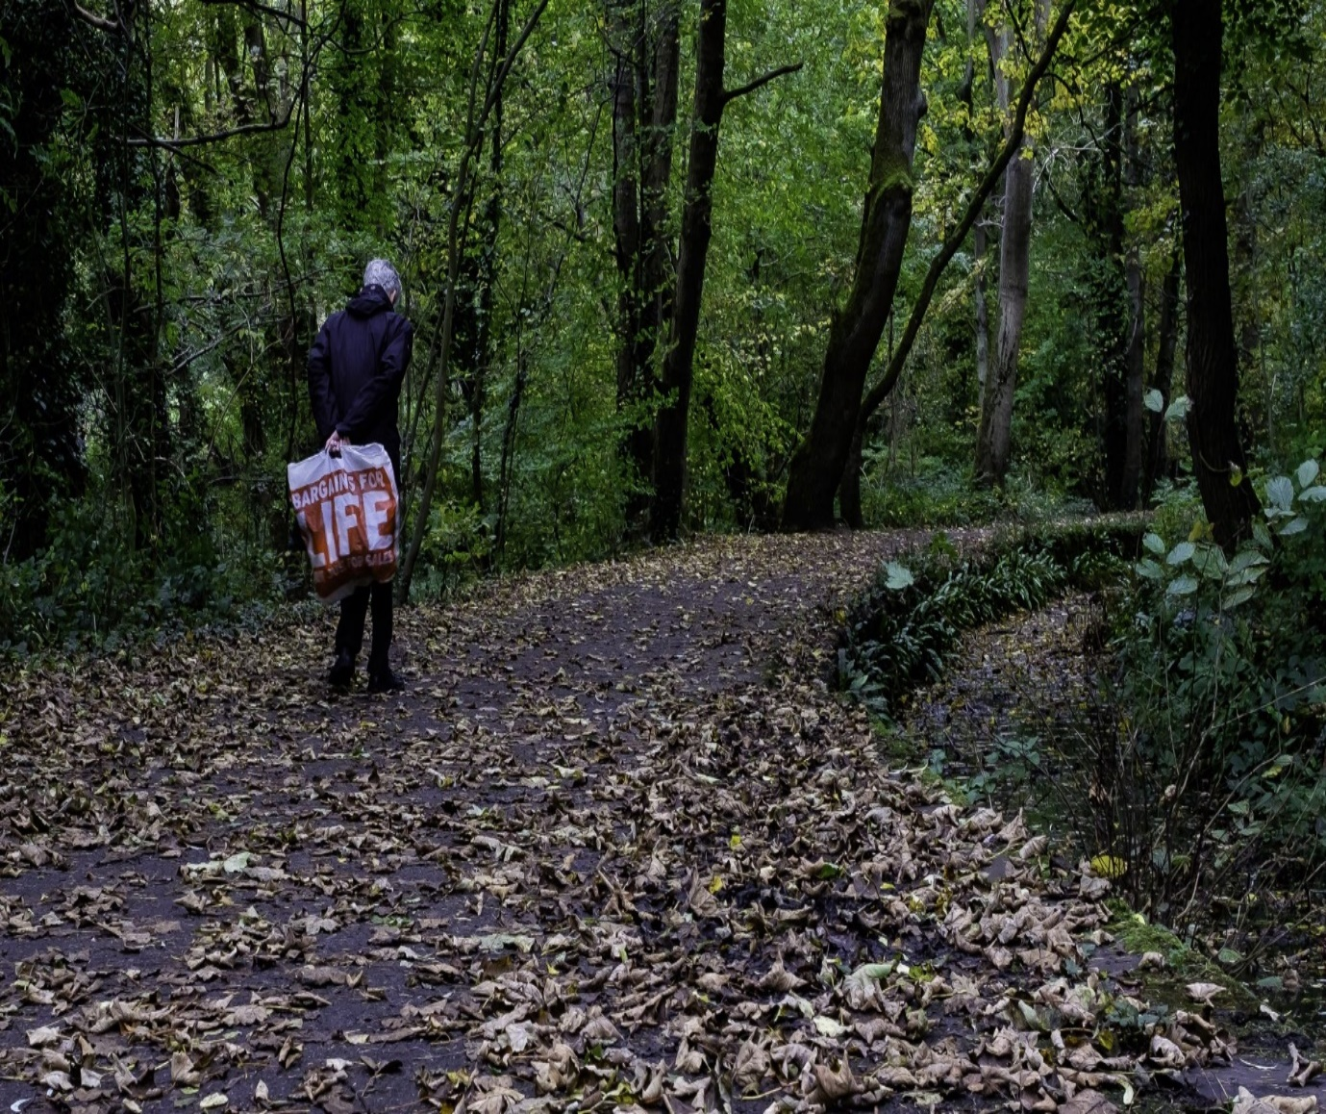

Loneliness and Social Isolation on the Elderly Population of the UK. - Google Search

Introduction
The reason for this report is base on more older individuals with huge complex issues, how things change during ongoing long periods of a more established individual, what they feel how thing as meant for them like work ,retirement, lodging, day to day environments inside care settings ,legislation and strategy likewise speculations of maturing which experimental endeavours includes the depiction of various kinds of way to deal with the maturing cycle

Main body
Being an elderly person in the UK began at the age of 65 traditionally because it was officially the retirement age for men and also the age they could collect the state pension, but now the increasing number of people are working past the age of 65 and state pension age is rising due to people living longer lives. According to ONS a man age 65 could expect to live another 18.6 years while a woman could expect to ;live 21 years more. for the most part, somebody over the period of 65 might be viewed as a more established person, however, it is difficult to apply a severe definition since individuals can naturally age at various rates, (NHS, 2021) Old age in numerous nations apparently begins exactly when dynamic commitment is no longer possible. The population over the age of 65 increment by 37% in rustic zones somewhere in the range of 2001 and 2015,and increment by 17% in uraban areas(, Age UK. 2021 ) .In 2018, 18% of UK population at 65 years old and over compared in 1950 it was 10.8% and it is anticipated that by 2050 it will be 24.8%. Ngaire coombs from ONS expressed that individuals are carrying on with longer and better lives,(THE GUARDING.COM/SCIENCE/2019) ,
The existences of more seasoned individuals have been impacted by the choices, behaviours and encounters of their previous lives, more established individuals will have an expanded requirement for casual consideration, lodging cost( and so forth) at this stage uneasiness levels are most noteworthy in midlife and begin to decrease in individuals' right on time to mid-60s, dropping to their least levels in the mid-to late-60s after which they stay moderately steady . It appears to be plausible that the announced more significant levels of prosperity from the mid-to late-60s mirror the existence stage change from working life to retirement and the abatements in prosperity at the most seasoned ages reflect decreases in wellbeing and expanded danger of widowhood. (Home - Office for National Statistics, 2021).older people will have expanded requirement for casual consideration and will likewise have lodging issues. there are1 additionally strategy drive to build business, more established adults help support the increment cost of giving wellbeing and social consideration and state benefits (NOS,) lives, older individuals have been affected by the choices, behaviours and encounters of their prior life's (Deaths-Office for statistics,2021). they resign from their positions, youngsters move away, companions and mates die and in the long run they become housebound on the off chance that they lose their capacity to function. Elderly mishandle represents a genuine, medical conditions for those influenced and it might even build their odds of dying. Some seniors are casualties of misuse submitted by laborers or their own family members, for example, physical or sexual violence, psychological or psychological mistreatment, disregard and surprisingly monetary abuse.
Upon retirement most seniors lived on a fix pay alongside continually expanding average cost for basic items can present numerous monetary restrictions, they may at this point don't have the option to manage the cost of a similar way of life they had been ensemble to ,pensioner destitution has ascended in the previous few years ,amazingly there were 2,000,000 UK beneficiary age 65 or more were in neediness in 2017, and a further million simply over the destitution line ,as we age, muscles and bones starts to weaken, we lose vision and hearing and furthermore versatility frequently becomes limited. Older people experience the ill effects of dementia including Alzheimer's illness, which influence individuals beyond 65 years old , Health is a significant issue for more established individuals more than 4,000,000 more older individuals live with more genuine long haul conditions like diabetes and coronary illness by 65,there are about three out of 10 individuals that are not, at this point healthy. there are about1.5 million older individuals in England that are not getting the assistance and backing they need to live well, there will be a more prominent requirement for medical care, especially geriatric wards and for costly expert wellbeing administrations, there will likewise be lodging issues as there will be an expanding interest for retirement homes, there are about 1.1 million more established individuals in England live in unfit, dealing with damp, rot pervasions electrical and pluming issues.
Population will require an increment in administrations like dinners on haggles care, moreover there are 3.4 million people age 65 that have never used the web, there is a genuine danger that pattern to digital as a matter of course will deny numerous more older individuals administrations they need. ( State of Ageing in 2020, 2021)
more seasoned individuals are suffering degrees of dread and nervousness and feel that their lives and wishes don't make any difference( Ageuk.2021) they likewise experience with depression ,loss of hope, low mood, lack of help for supper planning falling apart phsycial wellbeing and expanding torment because of untreated conditions. Ageuk.og.uk.2012
there is mounting proof that more older people comprise a disgrace that a considerable lot of society's negatives generalizations about more older individuals being sick, poor and slow (Home - Books - NCBI, 2021)) The world value an overview down by WHO revealed that more older individuals are not regarded this affirms that ageism is very common, yet the vast majority are uninformed of the psyche generalizations they hold about more older individuals said John Beard, WHO Director of Ageing and life course, Ageism can take numerous structures, for example, portraying more older individuals as frail, dependent, and distant in the media( who.int. 2021) It additionally produces pointless fear, waste,,illness and wretchedness.
As the UK's population quickly ages, the issues of intense loneliness and isolation is perhaps the greatest test confronting our society, older individuals specific helpless against social confinement and dejection inferable from loss of companions and family, mobility or income. (Home, 2021)
Isolation is a detachment from social contact to local area association or admittance to administrations (Age Uk 2015) it target proportions of the number or contacts that individuals have, it is about the amount and not the nature of relationships, this can happen over a short or extensive stretch of time.
Loneliness is the abstract horrendous and troubling marvel coming from an inconsistency between people wanted and accomplished degrees of social relations(scie,2018),.loneliness isn't equivalent to disengagement individuals can be isolated(alone) however yet not feel lonely moreover it is an abstract inclination about the hole between an individual's ideal degrees of social contacts and their real degree of social contact ,it alludes to the apparent nature of the individual's relationship. . (.ageuk.org 2021)8% of older individuals in England battle with loneliness and 6% are isolated .loneliness and isolation in more older people are a genuine general medical problems, research has connected social detachment and depression to higher dangers for assortment of physical and psychological circumstances, for example, Dementia, high blood pressure, heart disease , obesity a debilitated insusceptible framework, anxiety , depression, intellectual decay, Alzheimer's illness and even death. These issues are considerably to a greater degree a worry since the pandemic of Covid 19, which has in wrinkle more seasoned grown-ups to be desolate and secluded ,it started as physical distancing , shielding and lock down measures, this was presented in walk 2020 in the UK. Besides because of the limitations and social separating just as the decrease in eye to eye freedoms to mingle and associate with loved ones and furthermore to participate in physcial action has made these issues most noticeably terrible in more seasoned grown-ups.(Age uk 2021)
loneliness influences over 1,000,000 individuals over the age of 65 in the ordinary course of occasion yet it is progressively evident that the pandemic has made numerous more established individuals become desolate, this is for various reasons, regular routines, opportunities to mingle and escape the house have been ended by lock down. sometimes typically influencing adapting systems and informal community have been absolutely disrupted, leaving them high and dry. It was recommended that psychological and actual wellbeing in more established individuals are generally influenced during the social separating for Covid-19 the results expressed that there were anxiety, depression, poor rest and actual latency during the confinement time frame. during the Coronavirus elderly folks individuals are compelled from visiting their family or companions hence the social cooperation have been confined, thus, the diminishing of social communication delivered by friendly removing could adversely affect mental and actual wellbeing in more seasoned individuals since it has restricted the social support in local area associations and family exercises. (Home - PMC - NCBI, 2021)
Older adults are at increase risk for social isolation and loneliness because they are more likely to face predisposing factors such as living alone, the lose of family friends, chronic illness and sensory impairment.
old individuals generally live in helped care, adult care, long haul care, in home consideration and palliative consideration these age care is the satisfaction of exceptional prerequisite that are extraordinary to senior citizen. (Home - PMC - NCBI, 2021)
According to Christine R Victor’s , more than 80% of more established consideration home inhabitants with emotional wellness issues said they felt desolate in their consideration home and that this could be facilitated if staff had the option to invest more energy with them, many appreciate the organization of care home staff, but consider their to be as deterrent to additional social interaction. In A more extensive population more than 2m over 75s live alone in the UK with half routinely going for over one month without talking with a companion or relative, over 1m more older individuals report feeling forlorn all the time, or regularly, 49% of over 65s refer to TV or pets as their primary wellspring of company49% of over 75s live alone 12% of more seasoned individuals state they never invest energy with family46% of throughout 65s affirm they invested time with their family on most days contrasted with 65-76% for other age groups.9% of more established individuals feel caught in their own home 600.000 take off from the house once each week or less 41% of more older individuals feel withdrawn from the speed of present day life.(www.thegoodcaregroup.com)The experience of forlornness in nursing homes occupants is related with critical higher impediments in exercises of everyday living, helpless self-detailed health ,disability ,mobility problems ,reduced intellectual function ,depression ,poor mental prosperity and eventually a huge higher ethical quality.(www.journal.lipnetwork.org) All care homes was influenced by Coronavirus, most offices have asked that nobody enter the offices except if they work there, on account of the great danger that Coronavirus would spread rapidly ,group exercises have been dropped mutual eating has been stopped, residents are eating in their rooms ,groups strict administrations have been disconnected.no one from outside can visit including relatives inhabitant can just banter by utilizing PC, iPad and telephone and occupant with dementia are ameliorated with sensible toys. Feeling of dejection has numerous pernicious outcomes these including hazard of depression, alcoholism ,suicidal, contemplations forceful behaviours, anxiety and impassivity. a few investigations found that depression is additionally hazard factor for decrease and movement of Alzheimer infection, repetitive stroke, stoutness, raised circulatory strain, and mortality. desolate more older individuals might be trouble by more manifestations before death and might be presented to more extreme finish of life care contrasted with others that are not forlorn this expansion the disengagement and coming about forlornness of inhabitants. (www.jamda.com/articles)

A maturing population and lower resource return(as security yields sanctuary fallen, pushing down pension rates) could double total cost of keeping up retirement standards. To day's 35 years of age need a benefits pot of in any event £666.000 by age 65 to get the very way of life the present beneficiaries in the UK, that implies long term old need to save 40% of their pay rates for at any rate 40 years to have the option to manage the cost of retirement .And as the sector profile moves, the conventional direct life pattern of education, work and business will turn out to be progressively upset.(www.pwc.co.uk>issues)
youth lumps can expand the test to public funds struggling to offer types of assistance to the youngsters today as well as the test for the general public in coming a very long time as it battles to manage its maturing population(www.un.org>shifting)
It was stated that more older individuals keep on experiencing pessimistic generalizations that prompts discrimination isolation and exclusion. Committee of social affairs, Health and Sustainable Development meaning to give basic liberties of more older people, additionally Age UK is strong of extra peaceful accords which will improve security of privileges of more older individuals, which will empower them to keep adding to society across their lifetime ,It would furnish them more with a significant instrument for considering their administration responsible when they experience the unsafe impact of age. Equality Act 2010 and Human Rights Act 1998, furnishes a far reaching scope of devices with which to address penetrates of more seasoned individuals' principal rights to freedom ,respect .equality ,dignity and autonomy .Human rights norms give crucial assurance to more older adults by assisting with changing practice and system, culture and attitudes ,and offering review when breaks of common liberty have occurred, for example, abuse, neglect, and undignified treatment Accounts of misuse and disregard inside both private and nursing homes are extremely basic with stunning proof of remorselessness, inadequacy and crime besides these causes genuine mischief not simply victims ,but likewise to our general public, influencing families and companions and over all trust in care area Care Quality Commission Regulation 18 expresses that staff ought to get suitable on-going management in their part to ensure capability is maintained , safe guarding conversations ought to be a standard component of oversight with the chance to ponder the consideration and backing that they convey to forestall the advancement of helpless practice and energize positive methods of working.:Ageuk.org.uk. 2021
Organisations pointed toward diminishing loneliness and isolation can be sorted comprehensively into coordinated interventions, group administration and more extensive local area commitment, ,for example Befriend schemes which offer dejection and confined individuals essential friendship and enthusiastic support, group services research proof is specific strong of gatherings of people exercises with an innovative restorative or conversation based core interest. there are different gatherings which mean to assist more established individuals with extending their groups of friends, for example, day centres lunch clubs and gathering of people schemes. Community Navigators are volunteers who give individuals enthusiastic support, (Scie.org.uk. 2021). Birmingham LGBT gives sexual prosperity support guiding and psychotherapy. ( Age UK. 2021)
The accentuation on friendly withdrawal is in consistence with what has all the earmarks of being a critical component of life satisfaction. as individuals ages they lose connections to everyone around them since they anticipate that death and their abilities should draw in with others fall apart after some time, it is regular and adequate for more established grown-ups to pull out from society. (Crossman, 2021)
It battles that more established grown-ups should keep physical dynamic and sound because of their huge social commitment ,the more dynamic and included they are the more probable their life would be fulfil, remaining involved is important to having a wonderful life being dynamic draws out middle age and along these lines defer the unfriendly impacts of mature age which thusly may advance their prosperity , older adults who take part in less exercises are bound to report undeniable degree of gloom and less inclined to influence the personal satisfaction in the future (Bengtson et al 2021). This may happen when an individual is too old and maybe experiencing issues in participating in exercises in light of actual changes and possibly requirements or absence of social monetary assets .(Mauk,2010)The thought of having an old fashioned age holds incredible appeal for people examining their own future just as the future for their loved ones, Old individuals should join idea like sense of self, honesty exceptionally good faith, getting joy from exercises that make up one's life ,holding a positive perspective on oneself tolerating duty regarding one's life, and consistency between objectives that were wanted and that have been accomplished. (Bengtson, et al 2021) .It as stated that middle-age and more older adults endeavour to save and keep up internal and external structures ,and they like to achieve this target by utilizing methodologies attached to their past encounters of themselves and their social world, ( ScienceDirect Topics, 2021) internal continuity comes from those part of an individual's character, for example, temperament ,emotions and encounters extraordinary to the individual and it additionally associate them to their past,. external comes from climate, physical and social and incorporates the jobs every one of us is engaged with and the positions we proceed as we arrives at mature age. (Atchley, 2021)

conclusion
numerous intrusion have been create to battle depression and seclusion among more seasoned individuals, the distinction of the experience of dejection and segregation may cause trouble in the conveyance of normalized mediations. hence they need to tailor interventions to suit the necessities of people, explicit requirements or the level of dejection experienced. Furthermore, future examination ought to be pointed toward knowing what intercession works for whom in what specific setting and how, so while a mediation in one setting works for one individual in another it may not work completely additionally people regularly react contrastingly relying upon their circumstances. Health care suppliers ought to talk about the unfriendly wellbeing results related with isolation and loneliness with older adults and their legitimately selected representatives, also this arrangement should be sufficiently adaptable to react to singular inclinations, assumptions and goals.

References :

Age UK. 2021. [online] Available at: <https://www.ageuk.org.uk/information-advice/health-wellbeing/loneliness/> [Accessed 8 April 2021]
Age UK. 2021. [online] Available at: <https://www.ageuk.org.uk/latest-press/articles/2020/10/age-uk--research-into-the-effects-of-the-pandemic-on-the-older-populations-health/> [Accessed 8 April 2021].
Ageuk.org.uk. 2021. [online] Available at: <https://www.ageuk.org.uk/globalassets/age-uk/documents/reports-and-publications/reports-and-briefings/equality-and-human-rights/age-uk---human-rights-of-older-persons-and-their-comprehensive-care---july-2017.pdf> [Accessed 7 April 2021].
Age UK. 2021. [online] Available at: <https://www.ageuk.org.uk/our-impact/policy-research/loneliness-research-and-resources/> [Accessed 8 April 2021].
Age UK. 2021. [online] Available at: <https://www.ageuk.org.uk/services/information-advice/guides-and-factsheets/> [Accessed 23 March 2021
Ageuk.org.uk. 2021. [online] Available at: <https://www.ageuk.org.uk/globalassets/age-uk/documents/reports-and-publications/reports-and-briefings/equality-and-human-rights/age-uk---human-rights-of-older-persons-and-their-comprehensive-care---july-2017.pdf> [Accessed 7 April 2021].
Atchley, R., 2021. PubMed. [online] PubMed. Available at: <https://pubmed.ncbi.nlm.nih.gov/> [Accessed 7 April 2021].
Bengtson, et al., 2021. Handbook of Theories of Aging, Second Edition. [online] Google Books. Available at: <https://books.google.co.uk/books [Accessed 27 March 2021]. Centre for Ageing Better. 2021. Summary | State of Ageing in 2020. [online] Available at: <https://www.ageing-better.org.uk/summary-state-
Centre for Ageing Better. 2021. Summary | State of Ageing in 2020. [online] Available at: <https://www.ageing-better.org.uk/summary-state-[Accessed 30 March]
Crossman, A., 2021. Understanding Disengagement Theory and Why It Is Controversial. [online] ThoughtCo. Available at: <https://www.thoughtco.com/disengagement-theory-3026258> [Accessed 27 March 2021]
England, N., 2021. NHS England » Improving care for older people. [online] England.nhs.uk. Available at: <https://www.england.nhs.uk/ourwork/clinical-policy/older-people/improving-care-for-older-people/> [Accessed 7 April 2021].
Mauk, K., 2021. Gerontological Nursing. [online] Google Books. Available at: <https://books.google.co.uk/books[Accessed 28 March 2021]
Ncbi.nlm.nih.gov. 2021. Home - PMC - NCBI. [online] Available at: <https://www.ncbi.nlm.nih.gov/pmc/> [Accessed 8 April 2021].

Ncbi.nlm.nih.gov. 2021. Home - Books - NCBI. [online] Available at: <https://www.ncbi.nlm.nih.gov/books> [Accessed 25 March 2021].
Ons.gov.uk. 2021. Home - Office for National Statistics. [online] Available at: <https://www.ons.gov.uk/> [Accessed 23 March 2021].
Ons.gov.uk. 2021. Deaths - Office for National Statistics. [online] Available at: <https://www.ons.gov.uk/peoplepopulationandcommunity/birthsdeathsandmarriages/deaths> [Accessed 7 April 2021].
Scie.org.uk. 2021. SCIE: At a glance 60: Preventing loneliness and social isolation among older people. [online] Available at: <https://www.scie.org.uk/publications/ataglance/ataglance60.asp> [Accessed 8 April 2021].

Sciencedirect.com. 2021. Continuity Theory - an overview | ScienceDirect Topics. [online] Available at: <https://www.sciencedirect.com/topics/medicine-and-dentistry/continuity-theory> [Accessed 7 April 2021].
Social Care Institute for Excellence (SCIE). 2021. Home. [online] Available at: <https://www.scie.org.uk/> [Accessed 8 April 2021].

who.int. 2021. Newsroom. [online] Available at: <https://www.who.int/news-room> [Accessed 2 April 2021]
2021. [online] Available at: <https://www.jamda.com/articles> [Accessed 8 April 2021].

