The Shrine and Relics of St Thomas Cantilupe of Hereford

The shrine (built 1287) that once contained the excarnated bones of Thomas de Cantilupe, Bishop of Hereford and Saint of the Marches, is located in the north transept of Hereford Cathedral. His bones, which were reported to perform healing miracles, were moved to a more richly decorated shrine in the lady chapel in the 14th century, however for this reason, the original shrine escaped the 16th century iconoclasm that befell its successor.

Thomas de Cantilupe, also known as: Thomas of Hereford, was born around 1218, Buckinghamshire, England, and died near Orvieto, Italy, 25th August 1282. He was born to an established Anglo-Norman family. His grandfather was named one of king John’s closest advisors by Roger of Wendover. His father held office in the royal court, and his uncle, Walter de Cantilupe was the esteemed bishop of Worcester. Thomas decided to follow his uncle’s path into the clerical vocation, he became highly educated in Oxford, Paris, and Orleans, and was elected Chancellor of Oxford University in 1261. Like his Uncle, he was fiercely involved in the politics of the second barons war on the De Montfortian side, and although he was restored to favour in the years following the barons defeat, he soon left England to resume his academic career in Paris. During his time in Paris, he would become close friends with future archbishop, Robert Kilwardby who took his confessions and proclaimed he believed Thomas to be ‘free of mortal sin.’ Thomas returned to England in the early 1270s’, In 1275 he was consecrated by Kilwardby as Bishop of Hereford after a unanimous election. It is while he is bishop that he performs his first miracle. Richard Swinfield, who would succeed Thomas as bishop of Hereford and who began the canonisation process after his death, gives the second hand account of Cantlupes Pentecost miracle in the 1307 papal dossier. While celebrating Pentecost in 1278 in Wallingford castle at the invitation of Edmund earl of Cornwall, a flock of at least 30 birds assembled outside the window of the chapel, they dispersed at the sound of the choir but returned only when Thomas began the next verse. Robert Deynte even recalls the birds singing alongside Thomas before they eventually flew away. According to Swinfield, Edmund, who had brought him the news, proclaimed he had as much trust in the blessings and prayers of Thomas as he did in those of Augustine of Cantebury.

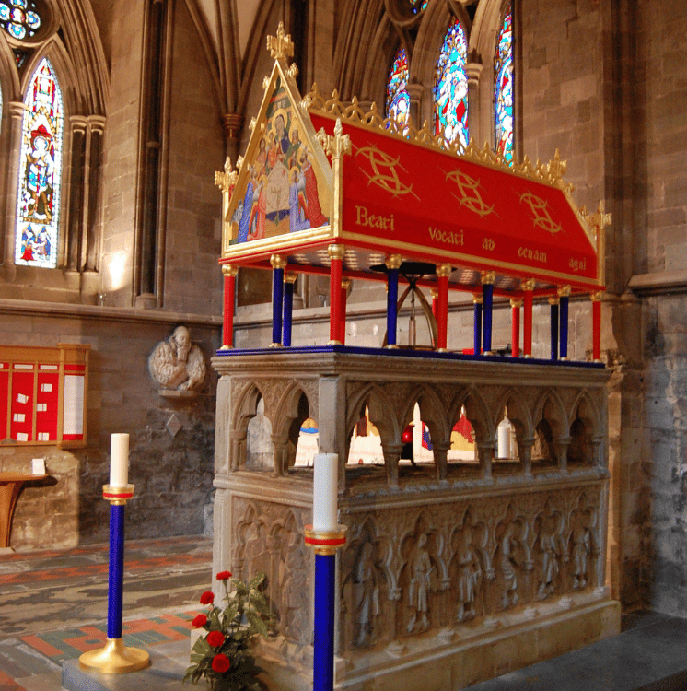
Despite these proclamations however, Thomas would end his life an excommunicate after a fierce quarrel with the Archbishop Pecham over the autonomy of his episcopal see. Thomas travelled to Rome to plead his case but, in 1282, died before a decision was taken. His heart was removed, and his body was excarnated (boiled so the flesh separated from the bones) and taken back, against Pechams wishes, by Richard Swinfield to Hereford. It is on the journey back where the next miracle is recorded to have taken place, it is part of the miracle of Edith Oldecriste (also known as Edith Kok in some sources), who was also the first person to experience a miracle in Hereford Cathedral, where in 1287 she was cured of being “furiosa” after spending the night in the lady chapel where Thomas’s relics were at that time. What is more interesting though about this early case is that the reason Ediths parents and husband brought her to Hereford was a story of how on the return from Italy, the bones of Thomas had flowed with blood as they passed through the lands of Archbishop Pecham. This shows the beginning of Thomas’s cult was likely community led, the Oldecristes found opposition within the church to the miracle on account of the bishop’s excommunication. But it shows the political life of Thomas was known to people already, and it was understood that it had claimed his life in Italy.
Figure 1. Tomb of Thomas Cantilupe (1287), Diocese of Hereford, Medieval Celebrity <https://www.hereford.anglican.org/about-us/our-structure/bishops-palace-garden/medieval-celebrity-.php> [accessed 2nd November 2024].

Within the same year, Swinfield who was the recently elected Bishop of Hereford, devoted himself to the veneration of Thomas as a saint. This began with moving the bones to a new and grander tomb in the north transept of the cathedral (fig. 1.). The modern tomb is made in 3 sections. The base is unfortunately the only part that dates to the 13th century and although it was evidently not originally intended as a shrine, it is far more decorated than the tombs of other previous bishops at the cathedral (fig. 2.). The arched upper part of the shrine was likely created after the canonisation process in the 14th century.

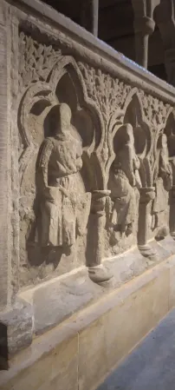
Between 1287 when the bones were translated to their new tomb, and 1289, when Swinfield formally requested canonisation for Thomas, there was an influx of miracles connected to Thomas. It is important however to remember that the earliest any of these miracles were recorded was for the canonisation inquiry which was held between the years 1307 and 1320. The miracles spanned a large geographical area, across Wales and England, and spanned multiple social levels and factions. Swinfield was already set on recording Cantaloupes’ miracles, having sent men to Orvieto to find miracles associated with the rest of Cantaloupes’ remains there in 1286. Even at this early date, Cantilupe was already a known saint in both the popular eye and that of the nobility. A subsidiary shrine containing a knife Thomas had used was set up in a chapel owned by Edmund of Cornwall, who had witnessed Thomas performing a miracle at the Pentecost in 1278. This was all much the distaste of Archbishop Pecham who had attempted to delay the entry of the bones into England with indirect excommunication, he reportedly remarked, “Blessed God! That the Lord performs miracles for excommunicates these days.” Such was Pechams distaste towards Cantilupe, he appears to have ignored letters from Galfridus de Sheppy that recorded his absolving of Thomas with the approval of Pope Martin IV. He was however ineffectual at stopping the cult from forming.
Figure 2. North face of Thomas' tomb. Caradoc Ewing (2024).

Between 1287 and 1320 (when Thomas was officially canonised), between 400 and 500 miracles were recorded. Almost all these miracles involved healing, with no other common themes and thus Hereford became an important place of pilgrimage. In 1293, William de Lonsdale and his 5-year-old daughter Alice made the long trip to London from the North, on this trip down Alice had tripped and broken her foot, When they got to London she became incredibly ill and the ankle became swollen. William prayed to St. Thomas and vowed to dedicate Alice to St. Mary if she healed, he then made the gruelling journey to Hereford, carrying Alice in a wheel barrow. They arrived at the tomb on the Pentecost in 1303, Alice had a vision of Thomas physically healing her and on the third night and was miraculously recovered. This is probably one of the most extraordinary journeys recorded in terms of distance, from Lonsdale, to London to Hereford, carrying his crippled daughter much of the way, would have taken incredible will power and faith in the legitimacy of the saint to whom they were travelling.

The vision of Thomas appears in quite a few of the miracles although not all, in some miracles it is simply a prayer that is needed rather than physical proximity to his remains. Perhaps the most famous miracle of St Thomas is that of the ‘twice hung man,’ William Cragh (also known as William ap Rees) recorded in the 1307 papal commission. William, from Swansea, was sentenced to hang for the deaths of 13 men, a charge he denied. It seems likely, although not conclusive, that he was a Welsh rebel who took part in Rhys ap Maredudd’s rebellion in 1287. William was hung and presumed dead, however the next man who was hung broke the beam that supported them both. Although both were believed to be dead at the time, according to custom, they had to be hung at the gallows until the lord gave permission for them to be cut down. So they were hung again and left there till sunrise. When the body was returned to the family he was measured for St Thomas. This was a practice where a body of someone in need was measured with thread, and an appropriate sized candle would be offered to a saint. The measuring was reportedly done by a maid of Marie de Braose, who testified that her and her servants had also prayed to St Thomas on behalf of William. Miraculously, over the next days, he recovered. It was only a partial miracle as he was not fully recovered, but he was certainly alive. After this miracle, Marie and the lord of Braose took him on a pilgrimage to Hereford to give thanks to St Thomas. William made the pilgrimage barefoot with his noose around his neck. He gifted the noose to St Thomas at the shrine with a wax image of a hanged man. This incredible journey from Swansea to Hereford is a testament to the genuine belief that it was Thomas who had saved his life. This miracle is also interesting as it shows how the cult transcended borders and factions. From an English saint of the marches to a failed Welsh Rebel. Thomas also of course performed miracles for the enemies of Rhys ap Maredudd. At the siege of Dryslwyn in 1287, Thomas is reported not only to have saved Herefordshire knight Ralph le Buteler from an arrow in the head, but also miraculously saved more nobles from a fallen castle wall.

Although Thomas’ cult was certainly spread faster thanks to the aid of Richard Swinfield, who also was instrumental in Thomas’s canonisation as a Saint. His cult quickly took on a life of his own. Cantilupes cult saw his death as a bloodless martyr and even as a second Becket. Although his cult did quite conjure the same longevity in the British psyche as Beckets, Iconography shows that this comparison was somewhat successful. For example, both Becket and Cantilupe stand above the tomb of Peter, Lord Grandison, along with St Ethelbert (another saint within the grounds of Hereford Cathedral, Christ, and St John the Baptist. Although the bones were unfortunately lost in the reformation, his memory remains important to the diocese of Hereford and the
Cathedral.

Bibliography
- A. Fleming, The Cult of St Thomas Cantilupe and the Politics of Remembrance (PhD thesis, University of Oxford, 2023) https://ora.ox.ac.uk/objects/uuid:10250a2b-2823-48d2-9e7f-9b33e79bdc38 [accessed 2nd November 2024].
- Catherine A.M. Clarke, ed., The St. Thomas Way and the Medieval March of Wales: Exploring Place, Heritage, Pilgrimage (Amsterdam University Press, 2020).
- G. Marchall, 'The Shrine of St Thomas de Cantilupe in Hereford Cathedral', in: Transactions of the Woolhope Naturalists' Field Club (1935), 34-50.
- Harriett Webster, ‘Mediating Memory: Recalling and Recording the Miracles of St Thomas Cantilupe’, Journal of Medieval History, 41.3 (2015), 292–308 https://doi.org/10.1080/03044181.2015.1048977
- Ian L. Bass, ‘Bishop Cantilupe Is Dead! Long Live St Thomas of Hereford! The Effects of St Thomas of Hereford’s Miraculous Cult’, History, 105.367 (2020), 691–715 https://doi.org/10.1111/1468-229X.13032
- Ian L. Bass, ‘COMMEMORATING CANTILUPE: THE ICONOGRAPHY OF ENGLAND’S SECOND ST THOMAS’, Antiquaries Journal, 103 (2023), 292–314 https://doi.org/10.1017/S0003581523000331
- Ian L. Bass, ‘St Thomas de Cantilupe’s Welsh miracles’ Studia Celtica, 53.1 (2019), 83–102 https://doi.org/10.16922/SC.53.6
- J. H. Ross, Meryl Jancey, ‘The Miracles of St Thomas of Hereford’, British Medical Journal, 295:1590 (1987) 1590-1594.
- Jussi Hanska, ‘The hanging of William Cragh: anatomy of a miracle’, Journal of Medieval History, 27:2 (2001) 121-138 https://doi-org.ezproxy.uwtsd.ac.uk/10.1016/S0304-4181(01)00006-9
- Lisbeth Corens, ‘Saints beyond borders: relics and the expatriate English Catholic community’, in: Jesse Spohnholz and Gary Waite, eds., Exile and the Formation of Religious Identities in the Early Modern World (London: Pickering and Chatto, 2014) 25-38.
- Philippa Hoskin, ‘Cantilupe’s Crusade? Walter de Cantilupe Bishop of Worcester and the Baronial Rebellion.’, Transactions of the Worcestershire Historical Society, 10:32 (2012).
- Stefan Dragulinescu, ‘Thomas of Hereford’s Miracles - between Aquinas and Augustine’, Journal of Medieval History, 44.5 (2018), 543–68 https://doi.org/10.1080/03044181.2018.1524332
- Valerie I. J. Flint, ‘The Hereford Map: Its Author(s), Two Scenes and a Border’, Transactions of the Royal Historical Society, 8:19 (1998) 19-44 http://dx.doi.org/10.2307/3679287

Catherine A.M. Clarke, ed., The St. Thomas Way and the Medieval March of Wales: Exploring Place, Heritage, Pilgrimage (Amsterdam University Press, 2020), p. 89.
A. Fleming, The Cult of St Thomas Cantilupe and the Politics of Remembrance (PhD thesis, University of Oxford, 2023) p. 11, https://ora.ox.ac.uk/objects/uuid:10250a2b-2823-48d2-9e7f-9b33e79bdc38 [accessed 2nd November 2024].
J. H. Ross, Meryl Jancey, ‘The Miracles of St Thomas of Hereford’, British Medical Journal, 295:1590 (1987) 1590-1594 (p. 1590).
Ibid.
Philippa Hoskin, ‘Cantilupe’s Crusade? Walter de Cantilupe Bishop of Worcester and the Baronial Rebellion.’, Transactions of the Worcestershire Historical Society, 10:32 (2012) 91-102.
A. Fleming, The Cult of St Thomas Cantilupe and the Politics of Remembrance. p. 72.
Ibid. p. 73-74.
Ibid. p. 75.
Valerie I. J. Flint, ‘The Hereford Map: Its Author(s), Two Scenes and a Border’, Transactions of the Royal Historical Society, 8:19 (1998) 19-44 (p. 35) http://dx.doi.org/10.2307/3679287
A. Fleming, The Cult of St Thomas Cantilupe and the Politics of Remembrance, p. 248-249.
Lisbeth Corens, ‘Saints beyond borders: relics and the expatriate English Catholic community’, in: Jesse Spohnholz and Gary Waite, eds., Exile and the Formation of Religious Identities in the Early Modern World (London: Pickering and Chatto, 2014) 25-38, p. 34.
J. H. Ross, Meryl Jancey, ‘The Miracles of St Thomas of Hereford’, British Medical Journal, p. 1592-1593.
A. Fleming, The Cult of St Thomas Cantilupe and the Politics of Remembrance. p. 206.
Ibid., p. 207.
Valerie I. J. Flint, ‘The Hereford Map: Its Author(s), Two Scenes and a Border’, p. 34.
For more on the tomb, see G. Marchall, 'The Shrine of St Thomas de Cantilupe in Hereford Cathedral', in: Transactions of the Woolhope Naturalists' Field Club (1935), 34-50.
Ian L. Bass, ‘Bishop Cantilupe Is Dead! Long Live St Thomas of Hereford! The Effects of St Thomas of Hereford’s Miraculous Cult’, History, 105.367 (2020), 691–715 https://doi.org/10.1111/1468-229X.13032 p. 701.
Ibid.
Ibid. p. 697.
J. H. Ross, Meryl Jancey, ‘The Miracles of St Thomas of Hereford’, British Medical Journal, p. 1593.
Ian L. Bass, ‘Bishop Cantilupe Is Dead! Long Live St Thomas of Hereford! The Effects of St Thomas of Hereford’s Miraculous Cult’, p. 697.
J. H. Ross, Meryl Jancey, ‘The Miracles of St Thomas of Hereford’, British Medical Journal, p. 1592.
For more information on this miracle, see. Jussi Hanska, ‘The hanging of William Cragh: anatomy of a miracle’, Journal of Medieval History, 27:2 (2001) 121-138 https://doi-org.ezproxy.uwtsd.ac.uk/10.1016/S0304-4181(01)00006-9
Ibid. p. 124-125.
Ibid. 128.
Ian L. Bass, ‘St Thomas de Cantilupe’s Welsh miracles’ Studia Celtica, 53.1 (2019), 83–102 https://doi.org/10.16922/SC.53.6 p. 89-91.
Ian L. Bass, ‘COMMEMORATING CANTILUPE: THE ICONOGRAPHY OF ENGLAND’S SECOND ST THOMAS’, Antiquaries Journal, 103 (2023), 292–314 https://doi.org/10.1017/S0003581523000331 p. 293.
Ibid. 297.

