Title Page

EXECUTIVE SUMMARY
British American Tobacco (BAT) is a multinational tobacco company headquartered in London, UK. It is one of the world's biggest tobacco companies and does business in more than 180 countries. The company was founded in 1902 as a joint venture between the UK's Imperial Tobacco Company and the American Tobacco Company. BAT and other tobacco corporations are increasingly under government pressure. Higher tobacco pricing, plain packaging, and advertising restrictions are being implemented worldwide to discourage smoking.
British American Tobacco (BAT) is the largest tobacco multinational. It operates in more than 180 nations. BAT's annual reports detail its financial performance, strategic aims, and environmental actions as a public company. We'll utilize BAT's annual and special reports to demonstrate how vital cultural transformation is to BAT. BAT's success hinges on its culture. Its purpose-driven culture motivates and engages people, enhances stakeholder connections, and delivers long-term shareholder value. BAT can also cope with shifting legislation and stay competitive by adjusting its culture and development. BAT should prioritize its purpose-driven culture and invest in innovation and flexibility to succeed. BAT recognizes the need for organizational culture growth and transformation, but it has to disclose more openly how well and how long its initiatives work. Because of its stagnant corporate culture, BAT has suffered. The company has struggled to adapt to changing market conditions, and its reputation has suffered because people think it doesn't care about sustainability, social responsibility, or doing the right thing. But there are hints that the corporation is taking these issues more seriously, so it will be vital to monitor its progress over the next few years.
Through this report, the author addressed all the criteria pertaining to the above points in depth.

TABLE OF CONTENT

1. EXECUTIVE SUMMARY 2
2. TABLE OF CONTENT 3
3. LIST OF TABLES AND FIGURES 4
4. COMPANY INTRODUCTION 5
5. ORGANISATIONAL CULTURE CHANGE AND DEVELOPMENT 7
6. WEAKNESSES IN THE ORGANISATION 11
7. IMPACT ON THE ORGANISATION 12
8. RECOMMENDATIONS 13
9. REFERENCE LIST 14
10. Appendices 17

LIST OF TABLES AND FIGURES
Figure 1: BAT Logo 5
Figure 2: BAT Products 5
Figure 3: BAT Human Rights Performance 2019 8
Figure 4: Product Portfolio 9

COMPANY INTRODUCTION
British American Tobacco (BAT) is a multinational tobacco company headquartered in London, UK. It is one of the world's biggest tobacco companies and does business in more than 180 countries. The company was founded in 1902 as a joint venture between the UK's Imperial Tobacco Company and the American Tobacco Company.

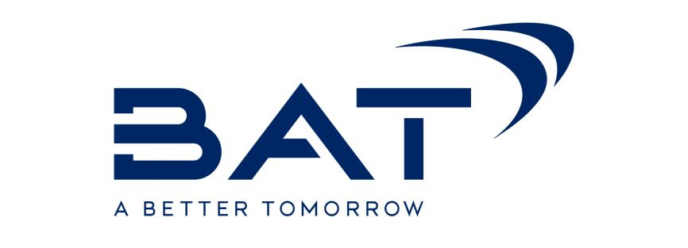
Figure 1: BAT Logo
BAT makes, sells, and distributes cigarettes, cigars, and other tobacco products as part of its business. Dunhill, Lucky Strike, Kent, Pall Mall, and Rothmans are some of the cigarette brands made by the company. It also produces a range of tobacco products, including cigars, pipe tobacco, and smokeless tobacco.
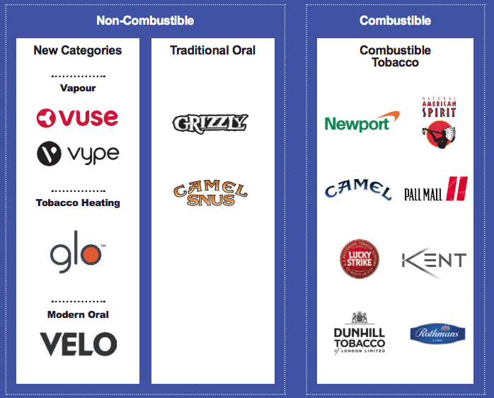
Figure 2: BAT Products
In the past few years, BAT has expanded its business beyond traditional tobacco products and put a lot of money into new products like vaping and heated tobacco. The company's Vype brand of e-cigarettes is one of the most popular in the UK, and its Glo and Velo heated tobacco products are becoming more popular in other markets.
Even though there are more rules to follow, and less people smoke in many countries, BAT is still a major player in the global tobacco industry. The company has a significant presence in both developed and emerging markets, with a strong market share in countries such as Brazil, Russia, and Indonesia.
BAT has invested in industries like agriculture and technology, in addition to its main business, which is selling tobacco. The company has set ambitious sustainability targets, with a focus on reducing its environmental impact and promoting sustainable farming practises. It is also committed to promoting responsible marketing practises and working with governments and other stakeholders to reduce the harm that tobacco products cause.
One of the biggest problems for BAT and other tobacco companies is that their products are coming under more and more pressure from the government. Governments around the world are introducing measures to discourage smoking, such as higher taxes on tobacco products, plain packaging requirements, and restrictions on advertising and promotion. BAT has responded to these problems by making its business more diverse and investing in new products that are thought to be less harmful than traditional cigarettes.
Public health advocates and other interested parties have also said that BAT's products cause serious health problems and add to the number of sick people around the world. In response to these complaints, the company has put money into scientific research to find out more about how its products affect health and has worked to promote responsible marketing practises.
Overall, British American Tobacco is a major player in the global tobacco industry. It has a strong presence in both developed and emerging markets. The company doesn't just sell traditional tobacco products anymore. Instead, it is investing in new products like vaping and heated tobacco. Even though there is more pressure from regulators and more criticism from people who care about public health, BAT is still committed to promoting responsible marketing practises and making its products less harmful (BAT, 2023), (BAT, 2021/2022), (BAT, 2019/2020).

ORGANISATIONAL CULTURE CHANGE AND DEVELOPMENT
British American Tobacco (BAT) is the world's largest multinational tobacco company. It does business in more than 180 countries. As a public company, BAT puts out annual reports that explain the company's financial performance, strategic priorities, and efforts to be more environmentally friendly. In this essay, we will use examples from BAT's annual reports and special reports to show how important it is for the BAT organisation for its culture to change and grow.
The 2020 Annual Report is one example of a BAT annual report. It shows how the company did during a difficult year because of the COVID-19 pandemic. The report shows that even though the pandemic hurt the global economy, BAT was still able to show strong financial results, keep paying dividends to its shareholders, and speed up its efforts to be more sustainable. The report also lists BAT's strategic goals, such as focusing on its core business, changing its portfolio, and speeding up its business in new categories (BAT, 2020/2021).
The 2019 Annual Report is another example of a BAT annual report. It shows how the company has changed its product line and grown its business in new categories. The report shows that BAT's new categories business, which includes vaping, heated tobacco products, and oral tobacco products, grew by 32% in 2019, making up 6% of the company's revenue. The report also talks about BAT's sustainability efforts, such as reducing its impact on the environment, promoting human rights and labour standards, and improving its customers' health and well-being (BAT, 2019/2020).
BAT also puts out special reports that go into more detail about certain topics than its annual reports. One example is the 2020 Human Rights Report, which shows that BAT is committed to promoting human rights and labour standards all along its value chain. The report shows that BAT has set up a human rights due diligence programme that covers all of its operations and suppliers. It has also made partnerships with other groups to deal with human rights problems in the tobacco industry (BAT, 2020).

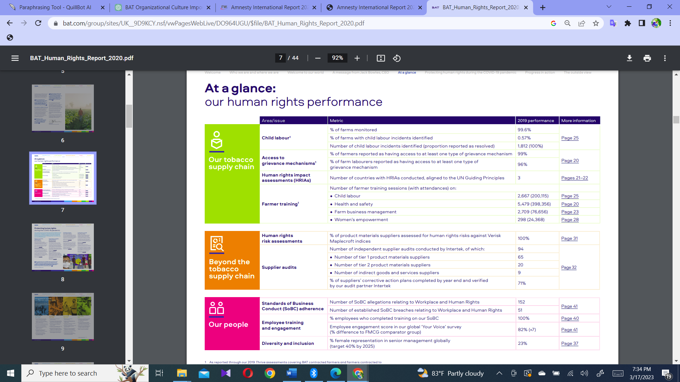
Figure 3: BAT Human Rights Performance 2019
The 2022 one of the Sustainability Report is another example. It shows how far BAT has come in meeting its sustainability goals and dealing with its social and environmental effects. The report shows that BAT has come a long way in reducing the amount of greenhouse gases it puts into the air (BAT, 2022).

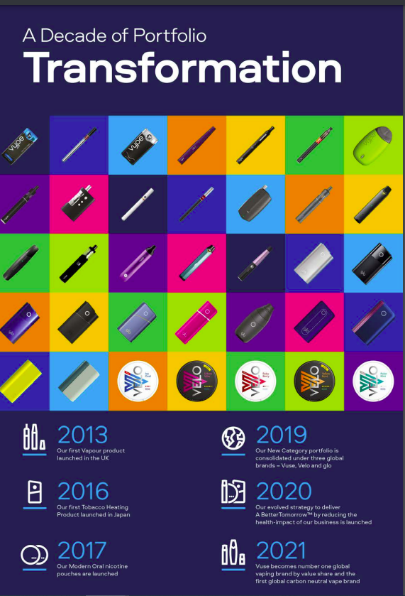
Figure 4: Product Portfolio
BAT can't say enough about how important it is for the organization's culture to change and grow. As a global tobacco company, BAT does business in a world that is becoming more and more regulated and difficult. BAT needs to have a culture that encourages innovation, flexibility, and doing the right thing if it wants to stay competitive and keep growing.
BAT's success depends on its culture of being driven by a purpose. By aligning its business strategies with its purpose, BAT can motivate and engage its employees, strengthen its relationships with its stakeholders, and create long-term value for its shareholders. BAT's purpose-driven culture is also important for its reputation and brand value, as consumers and investors are increasingly looking for businesses to act in an ethical and sustainable way.
Also, organisational culture change and development can help BAT deal with the problems caused by the changing rules and regulations. As governments all over the world make rules about tobacco products stricter, BAT needs to be more flexible and creative in how it develops, markets, and distributes its products. By encouraging a culture of innovation, BAT can use new technologies and business models to meet the changing needs of its customers and stay competitive in the market.
In the end, BAT's success depends on its ability to change and improve its organisational culture. The company's purpose-driven culture gives it a competitive edge because it inspires and engages its employees, strengthens its relationships with its stakeholders, and creates long-term value for its shareholders. Changes to organisational culture and development can also help BAT deal with the problems caused by changing regulations and stay competitive in the market. BAT should keep putting its purpose-driven culture first and investing in innovation and flexibility if it wants to keep doing well.

WEAKNESSES IN THE ORGANISATION
The company British American Tobacco (BAT) makes and sells tobacco products all over the world. The company has been putting out annual reports for several years, including 2021, 2020, and 2019.
In its 2021 Annual Report, BAT says that it needs to change and improve its organisational culture to keep up with changes in the market, consumer tastes, and societal expectations. The company talks about its efforts to create a culture that is more diverse and open to everyone, to adopt a purpose-driven approach, and to improve its environmental practises (BAT, 2021/2022).
BAT talks about the need to build a culture that encourages innovation, flexibility, and working together in its 2020 Annual Report. The company knows how important it is to adapt to a market that is changing quickly, especially considering the COVID-19 pandemic. BAT also stresses how important it is to build a strong culture of ethics and keep high standards of corporate governance (BAT, 2020/2021).
In its 2019 Annual Report, BAT talks about how it is trying to change its culture to be more customer-focused, flexible, and tech-savvy. The company talks about what it is doing to give its employees more power, improve its leadership development programmes, and encourage a culture of always getting better (BAT, 2019/2020).
By looking closely at these reports, it's clear that BAT knows it needs to change and improve its organisational culture to stay competitive and meet the changing needs of the market and society. But the reports mostly talk about the company's initiatives and efforts without showing how well they work or how they change the organisational culture. Also, the reports don't go into detail about the problems that came up during the process of changing the culture or how the company plans to keep the new culture going and make it a permanent part of the business.
In conclusion, BAT recognises the need for organisational culture development and change, but it is important for the company to give more open and detailed reports on how well and how long its efforts to improve its culture work.

IMPACT ON THE ORGANISATION
BAT is a company that has been known for its aggressive marketing strategies and efforts to keep a strong market share in the tobacco industry. But the industry has been criticized by different groups for not caring enough about sustainability, social responsibility, and doing business in an honest way.
Different groups have put pressure on BAT to deal with issues related to sustainability, social responsibility, and doing business in an honest way. In response, the company has started several projects to deal with these issues. For example, BAT has promised to reduce its impact on the environment, support sustainable agriculture, and promote responsible marketing. Even so, the company has been criticized for not making enough progress in these areas, despite its efforts (BAT, 2022).
One of the main reasons for how slowly these problems are being fixed is that BAT doesn't do enough to change and improve its organisational culture. The company has been in a very competitive and aggressive field for a long time, and this way of doing business has become deeply ingrained in the organisation. Because of this, the company has been slow to adopt new ways of doing business that put an emphasis on sustainability, social responsibility, and ethics (BAT, 2022).
According to the background investigation author identified, one of the main effects of this lack of organisational culture change and development is that BAT has had trouble adapting to changing market conditions. There are a lot of problems facing the tobacco industry, such as fewer people smoking, more rules, and changing consumer tastes. Companies like BAT need to be able to change quickly and well to stay competitive in this market. But the traditional culture of the company has made it hard to do so.
Moreover, because of the lack of organisational culture change and development, BAT has had a lot of damage done to its reputation. Several groups have said that the company doesn't care enough about sustainability, social responsibility, and ethical business practises. This has led to bad news in the media and a loss of trust among consumers, investors, and other important people. Because of this, the company has had to spend a lot of money on PR and managing its reputation.
Even with these problems, there are signs that BAT is starting to take organisational development and culture change more seriously. The company has started several programmes to encourage sustainability, social responsibility, and moral behaviour. For example, BAT has promised to get all its agricultural raw materials in a sustainable way by 2025, and it has started several programmes to encourage responsible marketing (BAT, 2022).
In the end, BAT has suffered a lot because its organisational culture hasn't changed or grown. The company has had trouble adapting to changing market conditions, and its reputation has taken a hit because people think it doesn't care about sustainability, social responsibility, and doing the right thing. But there are signs that the company is starting to take these problems more seriously, and it will be important to keep an eye on its progress in this area over the next few years.

RECOMMENDATIONS
Aa per the report the several organizational changes were identified by the author. However, the following key areas were recommended by author to make much focus in future endeavors.
BAT would be well to continue investing in new goods like e-cigarettes and heated tobacco products, which are seen as less dangerous than regular cigarettes, given the current worldwide trend towards reduced tobacco consumption. As the health and wellness industry continues to flourish, BAT may want to consider expanding into related markets by developing and marketing products like nicotine-free alternatives.
BAT has high sustainability ambitions, one of which is to lessen its influence on the environment, and it needs to speed up its efforts to achieve these goals. BAT needs to continue to speed up its efforts to decrease the environmental impact of its operations, notably in the areas of greenhouse gas emissions and waste reduction, if it wants to keep its reputation as a socially responsible firm.
Encourage ethical advertising techniques Despite BAT's best efforts, the corporation still needs to keep an eye on the marketing it does. Especially in developing nations where rules may be slack, BAT should keep working with governments and other stakeholders to lessen the damage that tobacco causes.
Keep pouring money into scientific studies BAT has invested in studies to determine the health impacts of its products. This work needs to continue, especially as new items are introduced to the market.
With the complexity of the legal landscape increasing for tobacco products, it is crucial that BAT cultivate a culture of innovation and flexibility inside the company. In addition to providing opportunities for employees to think outside the box and take calculated risks, this strategy also entails providing resources for learning and growth so that workers can adjust to shifts in the market. Also, author recommend different cultural change model for the BAT.

REFERENCE LIST

- Abbas, W. & Asghar, I., 2010. The Role of leadership in organizational change. Master’s Thesis in Industrial Engineering and Management, p. 57.
- BAT, 2019/2020. Annual Report, London: BAT.
- BAT, 2020/2021. Annual Report, London: BAT.
- BAT, 2020. BAT Human Rights Report, London: BAT.
- BAT, 2021/2022. Annual Report , London: BAT .
- BAT, 2022. British American Tobacco - Climate Change, London: BAT.
- BAT, 2022. British American Tobacco - Forests 2022, London: BAT.
- BAT, 2022. Combined Annual and ESG Report, London: BAT.
- BAT, 2023. Building A Better Tomorrow. [Online]
Available at: https://www.bat.com/#
[Accessed 16 March 2023].
- BAT, 2023. Embracing diversity and inclusion. [Online]
Available at: https://www.bat.com/yourvoice
[Accessed 15 March 2023].
- BAT, 2023. People and culture. [Online]
Available at: https://www.bat.com/peopleandculture
[Accessed 15 March 2023].
- Ferner, A. & Quintanilla, J., 1998. Multinationals, national business systems and HRM: the enduring influence of national identity or a process of ‘Anglo- Saxonization’. The International Journal of Human Resource Management, 9(4), pp. 710-731.
- Gorton, G. B., Grennan, J. & Zentefis, A. K., 2022. Corporate Culture. Annual Review of Financial Economics, Volume 14, pp. 535-561.
- Hall, R. & Wailes, N., 2022. International and Comparative Human Resource Management. The SAGE Handbook of Human Resource Management.
- Isensee, C., Teuteberg, F., Griese, K.-M. & Topi, C., 2020. The relationship between organizational culture, sustainability, and digitalization in SMEs: A systematic review. Journal of Cleaner Production, Volume 275, p. https://doi.org/10.1016/j.jclepro.2020.122944.
- James, C., 2023. Report ON BAT - strategic analysis of British American Tobacco. [Online]
Available at: https://www.studocu.com/en-gb/document/university-of-kent/introduction-to-strategic-management/report-on-bat-strategic-analysis-of-british-american-tobacco/42891018
[Accessed 15 March 2023].
- Mackness, J., 2008. Evaluation of two approaches to organizational change for small and medium sized businesses. Sunway Academic Journal, Volume 5, pp. 31-47..
- Martins, E. & Martins, N., 2002. An organisational culture model to promote creativity and innovation. SA Journal of Industrial Psychology, 28(4), p. https://hdl.handle.net/10520/EJC88924.
- Maull, R., Brown, P. & Cliffe, R., 2001. Organisational culture and quality improvement. International Journal of Operations & Production Management, 21(3), pp. ISSN: 0144-3577.
- Mingaleva , Z. et al., 2022. Organizational Culture Management as an Element of Innovative and Sustainable Development of Enterprises. Sustainability, 14(10).
- MsKinsey, 2018. Why data culture matters. [Online]
Available at: https://www.mckinsey.com/~/media/McKinsey/Business%20Functions/McKinsey%20Analytics/Our%20Insights/Why%20data%20culture%20matters/Why-data-culture-matters.ashx
[Accessed 15 March 2023].
- Newton , C. & Knight, R., 2022. Chapter 3: Leadership and organizational culture. In: Handbook of Research Methods for Organisational Culture. s.l.:https://doi.org/10.4337/9781788976268.00009, p. 23–38.
- Nwagbara, U., 2011. Managing Organizational Change: Leadership, Tesco, and Leahy's Resignation. e-Journal of Organizational Learning and Leadership , 9(1).
- Saheem, W. H.-. & Festing, M., 2018. Human resource management – a national business system perspective. The International Journal of Human Resource Management, 31(14), pp. 1863-1890.
- Tandfonline, 2022. The International Journal of Human Resource Management. [Online]
Available at: https://www.tandfonline.com/action/journalInformation?show=journalMetrics&journalCode=rijh20
[Accessed 5 December 2022].

10. Appendices
- Change theories.
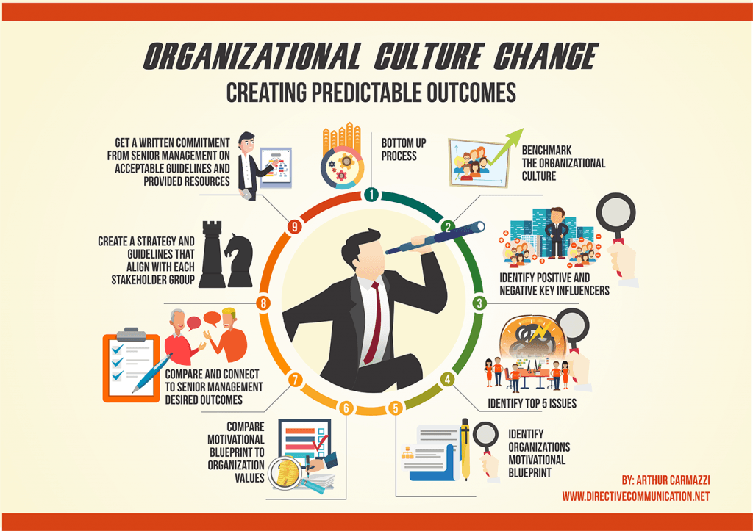

2. BAT Report Extractions



