Kimberley Robinson 1707907 assignment 1, Doing history: The past in Practice.

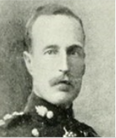
Major John Southern Maidlow.
“Truth and Honour were always before him”
In this Reflective Journal there have been several primary sources used to build a life profile of a person that was discovered on the Maidlow family tree, from his birth to memories and commemorations of him after his death.
John Southern Major was born in Forest Hill London on 27th June 1875. His parents were John Mott Maidlow who was 36 years old and Hannah Shirley Southern was 26 years old when John was born. John Southern Maidlow had an elder brother who was three years older than him who was born in 1871 (Ancestry 2018). His name was Lord Hugh Lansdown Stephenson G.C.I.E. K.C.S.I, who was the British Governor of Bihar and Orissa in India from April 1927 to 1932, and acting Governor of Bengal in 1926 and 1937 (Michael Macnamara 2015).
In 1874, when John Southern Maidlow was two years old, his brother James Francis was born. His younger sister was born when John was seven years old, his sister was called Dorothy Ellen Maidlow and was born in 1883 in Kensington London (Ancestry).
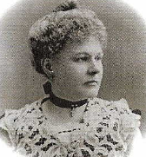


Parents of John Southern Maidlow (Ancestry)

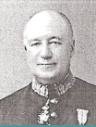
John Southern Maidlow’s older brother Lord Hugh Lansdown Stephenson G.C.I.E. K.C.S.I, and sister Dorothy Ellen Maidlow (Ancestry).

By the time John Southern Maidlow was fifteen years old he had left home, as shown in the census report from 1891 below, Figure 1. This Census 1891 entry shows his age and that he was in a boarding house with sixteen other people, the report shows he was living in Hastings and was not employed at this time.
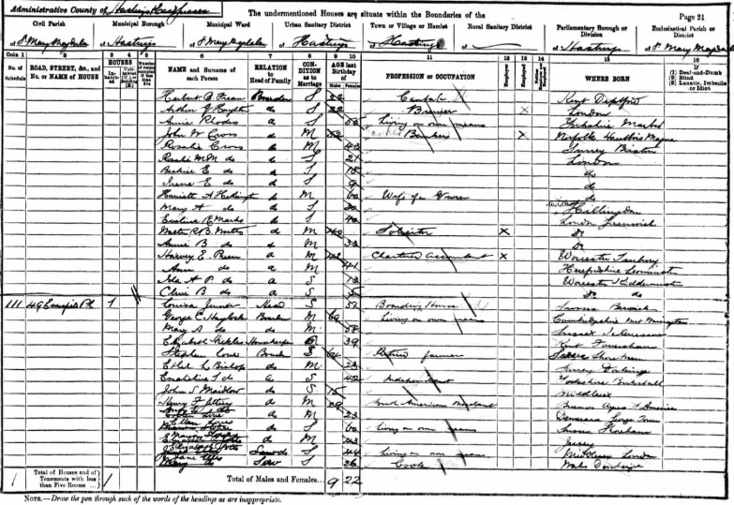
Figure 1 census report (Ancestry).
On further investigation, John Southern Maidlow is recorded in the National Archives as joining and in July 1892 leaving St Pauls School (St Pauls School register, Nat Archives). This archive material also describes his father as being a barrister with the family home then being in Hyde Park. With luck it also confirms his army ranking and the dates in which he was promoted. The address on the register could have been his parents address at the time:
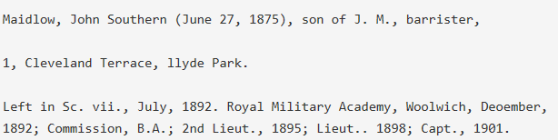
St Pauls School register 1876-1905 (National Archives)

From the dates provided above, it shows John Southern Maidlow leaving school at 17 years of age. A year after leaving school, when John was 18 years old, his father John Mott Maidlow passed away on 26 September 1893 at the age of 54.
It was two years later that John Southern Maidlow started his army career. The year was 1895 and John was 20 years old. His army career began with a commission as a 2nd Lieutenant Royal Artillery on 15 Jun 1895. Promoted to Lieutenant on 15 Jun 1898 (National Archives).
On 16th November 1899 Lieutenant John Southern Maidlow married Amy Caroline Aynes Lugard in Nagpor, Bengal, India (Ancestry). It is possible that he married in India to be with his elder brother, Lord Lansdown Stephenson. However, there is no evidence of him being positioned in India until November 1903 and he was then serving there until October 1906.
A possible reason for John Southern Maidlow and Amy Lugard wanting to get married in India was because Amy was born in India (Census report 1911). It is possible Amy’s family was still living in India at the time of their marriage.
John Southern Maidlow was promoted to Captain on 7th May 1901. This was prior to being positioned in India where he was Aide-de-Camp to the Lieutenant Governor of Bengal. At some point before 1912 he served in New Zealand as the Assistant Director in the NZ Army Department of the Director of Ordnance, up to January 1911. He was then promoted to Major on 15 Feb 1912. He was also later the Commander of the Company of Cadets at the Royal Military Academy Sandhurst until Jan 1914. On the outbreak of war, he was posted to 40 Brigade of the Royal Field Artillery, a part of the 3rd Division of the British Army (Ancestry).
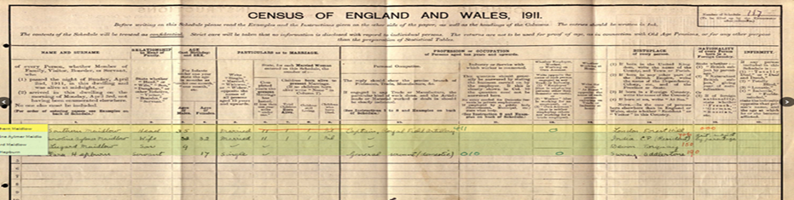
On 21st January 1901, John and Amy Maidlow had a son, who they named John Lugard Maidlow, He was born in Newton Abbot in Devon. he grew up to be a bricklayer and lived until he was 80 years old (Ancestry) John Southern Maidlow and his wife Amy had moved to Headley in Hampshire in England by 1911, according to the Census reports. Their son John was 9 years old at the time and was attending the same school as his father, St Rohan’s School (National Archives). There was another member of the household in 1904, the servant, and her name was Clara Hepburn.

Census report 1911 (Ancestry)
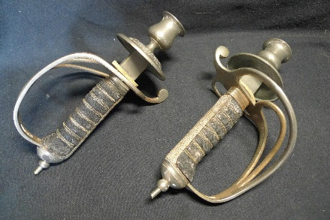
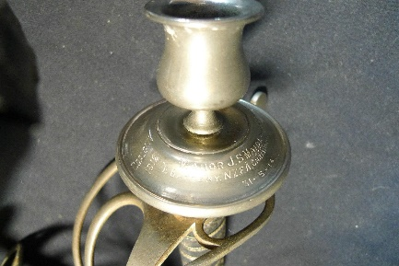
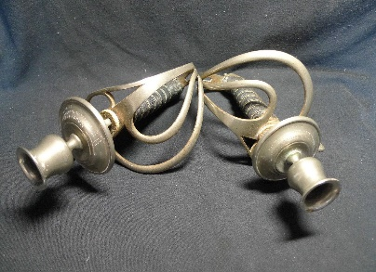
After searching Major John Southern Maidlow on the internet, it appears that there was a presentation to him of two sword hilts that had been made into candle sticks. The inscription on them mentions two training camps at Canterbury, New Zealand and it is possible that the candlesticks were presented to Major Maidlow by the soldiers and staff of the camps on his transfer back to the UK in preparation for the war. The items are engraved with the date 31-5-14, from E Battery N.Z.F.A., Christchurch, NZ. See photographs below, that were found on the
Sword hilts (saleroom.com)
selling site (Saleroom.com). On July 17th, 1914 John, Amy and their 13yr old son were travelling from Wellington, New Zealand to Plymouth, on the passenger ship, The Ruahine (National Archives). The document below shows the family in order of Name’s, ages, and occupation. This would be the Maidlow family’s last journey together (National Archives).
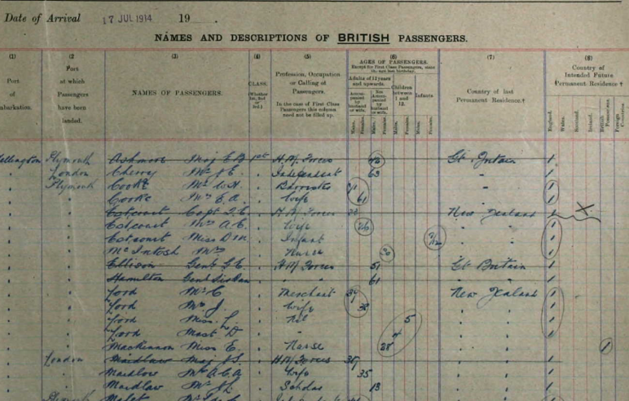

National Archives.
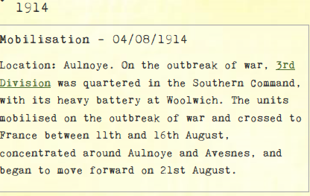
The paragraph above shows the exact date in which Major John Southern Maidlow and his division went to war (National Archives).
Britain declared war on Germany on 4th August 1914. By mid-August the 3rd Division troops had made their way through France and onto a town in Belgium called Mons. Mons was a coal mining town, which had a 16-mile canal that had 18 bridges (David Lomas 2012). John Southern Maidlow and 49th Battery were positioned on a hill opposite Oberg Bridge in the 40th Brigade Royal Field Artillery. The map below shows where the British Army was positioned on 23rd August 1914 (Farndale 1986).

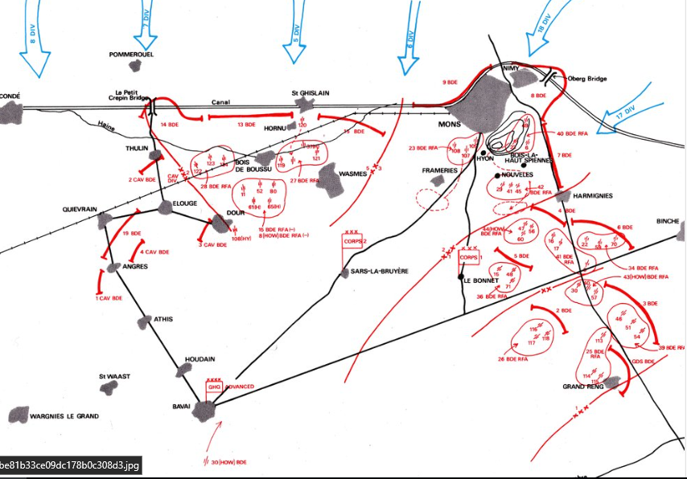
The History of the Royal Regiment of Artillery Western Front 1914-18. By General Sir Martin Farndale, KCB

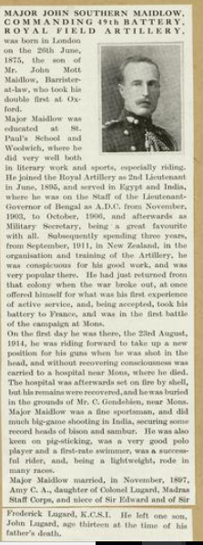
It was here that John Southern Maidlow lost his life on the first day of the Battle of the Mons. His obituary (War Graves Commission) describes his death, with him riding up to position his troops when he was shot in the head. He did not die immediately but never recovered from his wounds (see Figure 2). There is another account of his death in J Horsfall’s book Mons 1914 based on war diaries of the Mons. It was early in the afternoon when a building being used as a hospital was bombed while Major John Southern Maidlow was inside recovering from his wound.
The Gendebien Chateau building was being used by a Major Long as a first aid post, Red Cross flags hung from the windows and the roof, but this didn’t stop the bombs from bombarding it that afternoon and setting it on fire. Although the majority of the injured were dragged to safety into the woods, the commanding officer of 49th Royal Field Artillery, John Southern Maidlow, along with a Private C H Jackson, died in the ruins (J Horsfall 2000). Maidlow’s obituary does say the hospital was set on fire, and John’s remains were recovered from the building. He was buried in the grounds of the Chateau building that John was in when it was destroyed.

Figure 2, Obituary (common wealth graves commission).

John received medals for his service in the army. He was awarded the 1914 Star, also known as the Mons Star. He would have also received the Victory medal given to those who had received the 1914 Star. John was entitled to the British War Medal for service in World War One. This British Empire campaign medal was issued for services between 5th August 1914 and 11th November 1918. Amy, John’s wife would have been sent his death plaque after the war to commemorate all the war dead. Over 1 million were issued in total (Forces War records). Below is a Medal card for the medals he had received three days before his death on the 20th August 1914. It states he had received the Star and the Victory Medal.

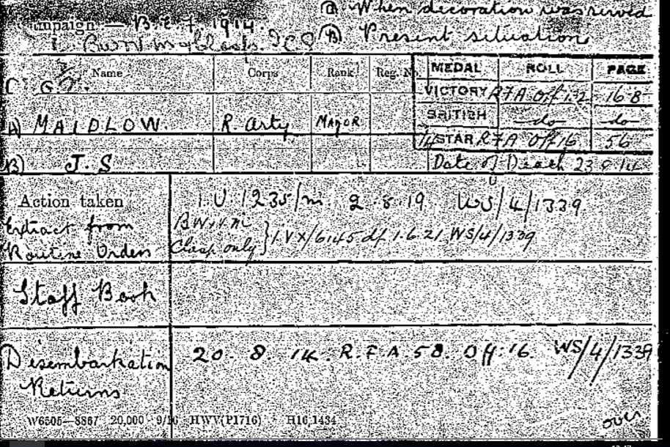
John Southern medal card (Forces war records).

There is a grave for John in the communal Cemetery of Mons. Below are the relevant documents connected to his grave. The registration of the grave shows Amy as his next of kin, living in Pinner Middlesex. the registration shows the exact place where John’s headstone is giving a Map reference, plot 6, Row A, Grave 1A.
To the left is a map of the cemetery at Mons. Standing with your back to the great cross, John’s grave is at the front on the end of row eight on the right. The commonwealth graves commission online states that, “Details of individuals who were originally buried in smaller or isolated cemeteries, but who, later, were exhumed and reburied in war cemeteries” (2018). Both documents at the bottom of the next page is evidence to confirm John Southern Maidlow’s Body was moved from his original grave at the Gendebien Chateau where he Died, to The communal cemetery in Mons.
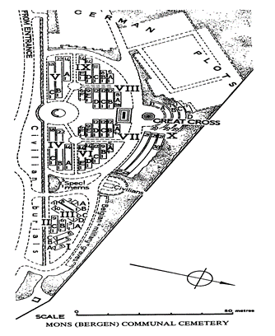
In order of display: left map of communal Cemetery at Mons (Common Wealth Grave Commission)
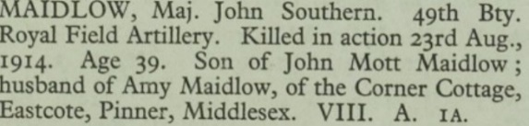
Above is a cutting of the Grave report, (common wealth graves commission)

Below are the documents, showing the relocation of Major John Southern Maidlows Grave. (commonwealth grave commission)

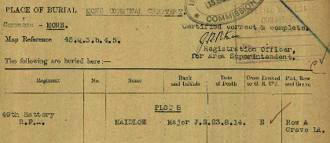
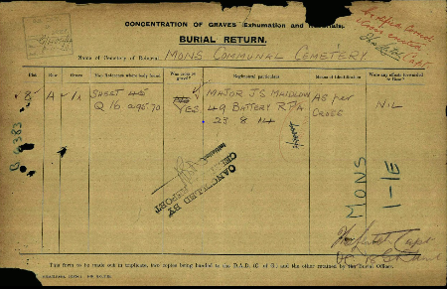
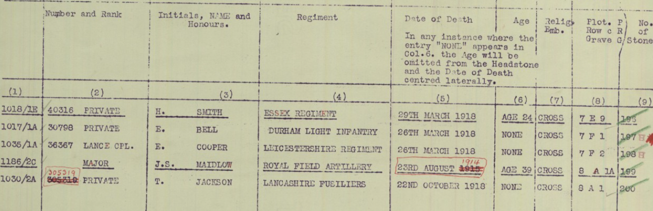
Along with the above evidence are further documents showing the religious emblem, and inscription on the grave that his wife Amy would have chosen for him.
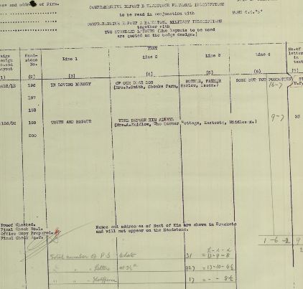
commonwealth war graves commission
commonwealth war graves commission
The words she had chosen were “Truth and Honour were always before him” (Commonwealth War Graves Commission), John’s name can also be found on other memorials.
St Ronan’s School is a boarding school, that has a roll of honour for its previous scholars who fought in World War I. John Southern Maidlow is mentioned in this Roll. The names of the boys who grew up to fight for their country are also commemorated on the Wall in the Chapel, and some are on a memorial stone in the school grounds. One hundred and thirty Boys who were educated at St Ronan’s School, saw active service, 30 of those were killed. 25 of these were awarded military distinctions (St Ronan’s School 2018).

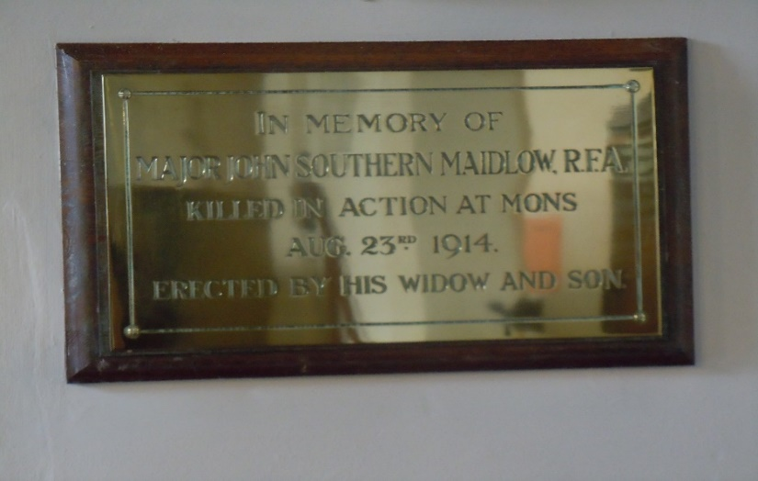
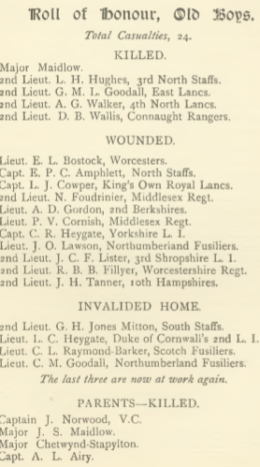
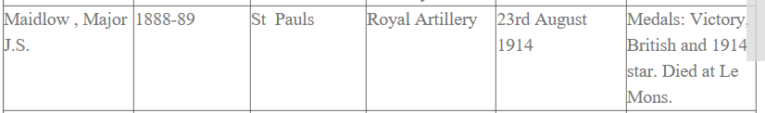
The section of the Roll of honour above shows John Maidlow’s Senior school which was St Pauls, it also lists his medals. (St Ronan’s School). To the left is the roll of honour by St Ronan’s school.

Above is a plaque that was erected by his wife and son.
In Bramley church Surrey.
In conclusion, it has been possible to follow J S Maidlow from birth to the commemoration of his death, and there were other documents that are available. Archives charge a fee for the privilege of reading these documents, so it has been necessary to select a few to conduct research into this man. One important item of evidence that could not be found was Major Maidlow’s Army Number, which made this exercise more difficult. Below is Major John Southern Maidlows Grave at Mons, Provided by the common Wealth graves commission.
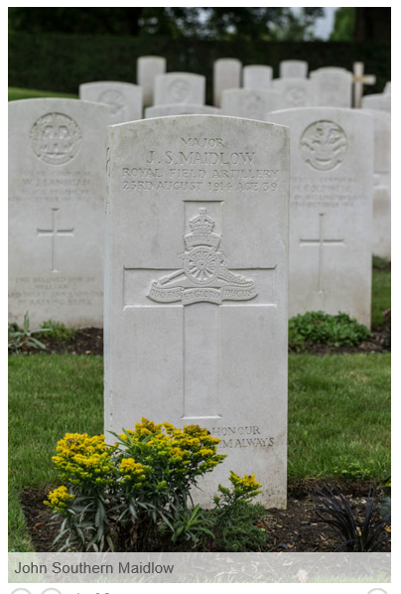
Major John Southern Maidlow (War graves Commision)

Horsfall, J. 2000. Mons 1914. 1st ed. Barnsley: Pen and Sword.
Lomas, D. 2012. Mons 1914: The BEF's Tactical Triumph. 1st ed. Oxford: Osprey.
Macnamara, F M. 2015. A Governors’ Raj: British Administration during Lord Irwin’s Viceroyalty, London: Sage publications ltd.
Terraine, J. 2002. Mons: The retreat to victory. 2nd ed. Ware: Wordsworth Additions Ltd.
Martin, F., 1986. The History of the Royal Regiment of Artillery Western Front 1914-18. 1st ed. Woolich: The Royal Artillery Instituton.

Ansestry. 2018. Maidlow Family Tree. [ONLINE] Available at: https://www.ancestry.co.uk/family-tree/tree/74433129/family?cfpid=48338758475&selnode=1&usePUBJs=true. [Accessed 16 March 2018].
Find War Dead. 2018. GWGC. [ONLINE] Available at: https://www.cwgc.org/history-and-archives. [Accessed 14 March 2018].
FORCES WAR RECORDS. 2018. Record Details for John Southern Maidlow (Royal Field Artillery). [ONLINE] Available at: https://www.forces-war-records.co.uk/records.asp?SE=go&adID=248536195566&KW=war%20death&SC=16&NO=674&gclid=CjwKCAjw-bLVBRBMEiwAmKSB8-bnnINEsVsPoDyRwH8N4xcpZsauCSTvmpqVCa4ydiChV16mmFmKHxoCxrsQAvD_BwE. [Accessed 21 March 2018].
LSE. 2014. Lest we forget 1914-1918 – LSE’s First World War roll of honour. [ONLINE] Available at: http://blogs.lse.ac.uk/lsehistory/2014/11/11/lest-we-forget-the-first-world-war-roll-of-honour/. [Accessed 17 March 2018].
Papers Past. 1914. Major Maidlow Killed. [ONLINE] Available at: https://paperspast.natlib.govt.nz/newspapers/CHP19141109.2.31.63. [Accessed 17 March 2018].
St Ronan's School. 2018. Roll of honour. [ONLINE] Available at: https://www.saintronans.co.uk/old-ronians/roll-of-honour/. [Accessed 17 March 2018].
The Great War Forum. 2002. The Great War Forum. [ONLINE] Available at: http://1914-1918.invisionzone.com/forums/topic/200928-information-about-soldiers-who-died-in-mons-in-august-1914/?page=2&tab=comments#comment-2255232. [Accessed 17 March 2018].
The long trail. 2018. The British army in the great war 1914-1918. [ONLINE] Available at: http://www.longlongtrail.co.uk/?s=40+brigade+of+the+royal+artillery. [Accessed 15 March 2018].
The National Archives. 2018. British Army War diaries. [ONLINE] Available at: http://www.nationalarchives.gov.uk/help-with-your-research/research-guides/british-army-war-diaries-1914-1922/. [Accessed 8 March 2018].
The lives of the first world War. 2018. John Southern Maidlow. [ONLINE] Available at: https://livesofthefirstworldwar.org/dashboard. [Accessed 13 March 2018].
Youtube. (2016). WW1: The shock defeat at Mons | History - Britain's Great War. [Online Video]. 17 March 2016. Available from: https://www.youtube.com/watch?v=eTZap6ouiyk. [Accessed: 18 March 2018].
A pair of candlesticks fashioned from infantry sword handles. 2015. Sale room. [ONLINE] Available at: https://www.the-saleroom.com/en-gb/auction-catalogues/wotton-auction-rooms/catalogue-id-srwot10054/lot-880d5257-e7ab-455e-b809-a47c00fd8366. [Accessed 20 March 2018].

