

Module name: Effective Team Work and Communication
Module code: BMSW4002
Lecturer: Diya Ganguly

Student name: Bozica Katic
Student ID: 2008115

Table of content

- Introduction 1

- Models of communication 1
  - Shannon – Weaver model of communication 1
  - Berlo’s model of communication 2
  - Schramm’s model of communication 3

- Communication skills 6

- Refer to Case studies 8

- Examples of poor communication in the workplace 9

- Suggestions for improvements by using theory 10

- Conclusion 11

- References 12

- Appendix 14

- Introduction

Good communication is important for efficiency in the workplace and in life. Therefore, it is important to be aware of the sources of barriers that affect messages sent and to avoid the consequences of poor communication.

2. Models of communication
2.1. Shannon – Weaver model of communication
Mathematician Claude Shannon and social scientist Professor Warren Weaver (1949) developed the first communication model, the Shannon – Weaver model of communication (Weaver.dvi., 1949). It was the mathematical theory of communication
and is known as the “mother of all models” (businesstopia,2018).
This model is simple, linear, and includes sending encode signal (message) from an information source (sender), through the channel, to the receiver who needs to decode the message. When the receiver decodes the message it means that the sent message arrived at its destination. The barrier to good communication in this model is a source of noise in the channel. Noise in the channel can be caused by different reasons, such as loud background sounds, talking too fast, wandering thoughts, jargon. (Norris, J. E., 2016)
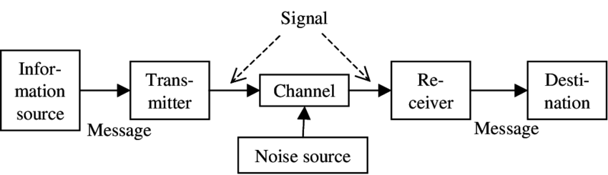

This model highlights the importance of noise reduction (dtu, 2019). Noice in the channel is the biggest barrier to efficient communication. If the initial message is transmitted between multiple receivers, each receiver may decode the message differently. So the final message may have a completely different meaning than the initial message. (Preeti, 2017)

2.2. Berlo’s model of communication

David Berlo’s SMCR (sender, message, channel, receiver) model of communication (1960) describes the different components in detail, that form the basic process of communication (Management study guide, n.y.).
Berlo’s model goes a step further and highlights the importance of four different components, the mathematical Shannon-Weaver model, and various factors that influence them. (Toolshero, n.y.)
Efficient communication depends upon encoding and decoding the message, so the sender and receiver must share a similar background. Factors such as communication skills, attitude, knowledge, social system, and culture play a vital role in this. For example, what may be offensive in one culture, maybe perfectly fine in others. A message can be sent through the channel in different ways (table under) and could contain clear main information (content); extra elements such as emotions, which help explain the communication; treatment (professionally make content); good structure (introduction, main body, conclusion) and code (being clear).
This model explains that barriers in communication can be caused by many other reasons, not just noise in the channel as the Shannon – Weaver model explains.

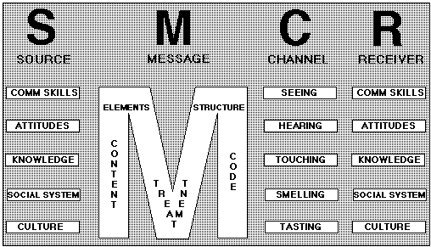
(Management study guide, n.y.)

2.3. Schramm’s model of communication
Schramm’s model (1954.) has its roots from the Shannon-Weaver and Berlo’s model.
The model includes all factors from previous models but emphasizes that effective communication includes feedback from the receiver to the sender(Management study guide, 2021).
This model highlights the phases of encoding the message (because here starts the process of communication) and decoding the message (the receiver needs to understand the message that the sender wants to communicate). He also emphasizes that communication is complete at the moment when the receiver sends feedback to the sender on the received message. If the sender does not receive feedback or respond, communication is not complete. According to Schramm communication is a two-way process.

Schramm’s model of communication

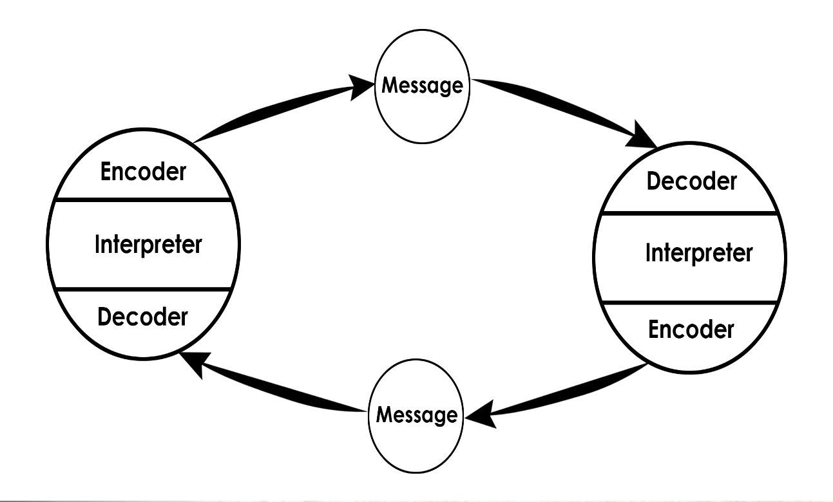

(communicationtheory, 2021)

Advantages and disadvantages of communication models:
Model of communication | Shannon – Weaver model | Berlo’s model | Schramm’s model
Advantages | - the first model which tried to explain communication  - highlights “noise in the channel”  - understandable  - simple | - analyzes 4 different components in more detail  - account emotional aspect of the message | - insist on feedback  - explains communication as a two-way process(circular)  - highlight the importance of encoding and decoding the message  - include the source of noise
Disadvantages | - does not insist on feedback  - explains communication as a one-way process (linear)  - “Toothpaste” effect | - Does not insist on feedback  - explains communication as a one-way process (linear)  - does not highlight the source of noise  - receiver and sender need to have a similar background | - neglects the importance of noise in the channel

3. Communication skills
Verbal communication is communication by words that are spoken (includes face to face, presentations, telephone, television, Youtube, and other media) and written (includes email, letters, magazines, books, the internet, Facebook, and Whatsapp.
(Expert program management, 2019)
For effective verbal communication what's important is clarity, empathy, sincerity, relaxation, eye contact, appearance, posture, volume, speed, pitch, and tone.
And for written communication what's important is the use of words, sentences, paragraphs, tone. Silence is also a part of communication. The strength of the message of silence depends on the situation. (Bureau, 2013)
Non-verbal communication includes all things we do not say by words, but we say it through our body language, facial expressions, eye contact, touch, personal appearance, smell, signs, and signals. (Help Guide, 2020)
For effective non-verbal communication it's good to have an open posture (arms and legs uncrossed), smiling, eye contact, active listening, and be professional.
Both types of communication are important and linked. Although the listener is more focused on understanding the message, during verbal communication, it is good to be aware of both because the receiver gets a complete message when including both communications together. When verbal and nonverbal communication is different one should trust nonverbal because people cannot constantly control their nonverbal communication. (Bajracharya, S., 2018)
For example, we meet a person with a worried, absent look, an unpleasant odour sitting on a bench with arms and legs crossed. We ask her how she feels today and she verbally answers that she feels great.
As complete communication involves verbal and non-verbal communication it is clear that we will conclude that the person is not feeling well. We will believe non-verbal communication

Different types of non-verbal communication:

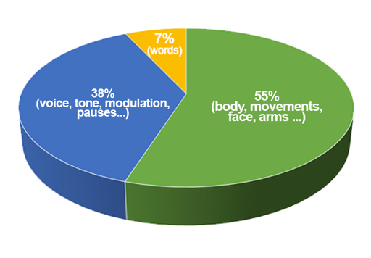
(OpenLearn, n.y.)

Receivers take about 93 % from non-verbal communication and only 7 % from verbal communication. (Bajracharya, S., 2018)
Active listening, as opposed to passive hearing, is a communication skill in which the listener gives full attention to the speaker trying to understand the message. The full attention of the receiver can be shown verbally by saying “Yes”, “I agree” or “I understand” or by non-verbal signs. (Skills you need,2021)
For example, we talk to a friend and tell him that we were on a day trip to the sea in Bournemouth. After a while, he asks us how were we on the trip to Brighton? He didn’t listen actively. If he had listened actively he would not have replaced the names of the cities.
Empathic listening is an extension of active listening. The listener fully concentrates on the message, even if he doesn't agree with it, and tries to feel how the speaker is feeling. The listener needs to keep his own emotions under control while listening empathetically. (Mindtools, 2021)
It is important to know the difference between sympathy and empathy which is often equated. Sympathy is a feeling of concern for someone and doesn’t involve shared emotions. Sympathy may become empathy. (Mindtools,2021)
We can feel sympathy for a person even if we know nothing about that person but empathy requires recognizing that person’s emotions and understanding their view of the situation.
For example, we find ourselves on a children’s playground and see one girl pushing a stroller borrowed from another child present on the playground. We liked the girl - we feel sympathy for her. The mother of another child comes and takes away her stroller because they have to go home for lunch. The girl, therefore, starts crying and says that she is unhappy. If we identify with her feelings and understand why she feels that way we feel empathy for the girl.

4. Refer to Case studies

An example of communication between Maria and Pedro is an example of how noise in a channel negatively affects effective communication. Maria knew that Pedro was at a job where there was mostly noise, but she chooses the usual and easiest way of communication, forgetting that there could be a misunderstanding due to an incorrectly decoded message because of the noise in the surroundings. Physical distractions are big barriers in communication, as Shannon – Weaver's model of communication explains. Pedro was on the construction site, so due to the noise in the background, he did not hear Maria properly on the phone. He heard her passively but did not listen to her actively, so he replaced the word "chicken" with the word "kitchen".
This confusion could have been avoided if Maria had chosen some additional channel of communication (e.g. sent Pedro a text message) or insisted on his feedback as Schramm’s model requests.
An example of communication between a professor and a village shows that the sender and receiver must share a similar background. That noise in the channel is not the only barrier to ineffective communication, but that barriers in communication can also occur due to various other influences such as Berlo’s model of communication explains. The professor, as an academically educated person, had too much knowledge that he unconsciously expressed through his verbal communication. Such knowledge, culture, and that level of communication were not had by ordinary village people who lived near him. These facts were one of the reasons why the village people failed to decode the professor's message. This case study shows us that status effect, semantic problems and cultural differences are barriers to effective communication. Likewise, the professor’s behaviour contributed to this because he did not socialize with the environment in which he lived.
These barriers could have been avoided had the professor used simpler words while seeking help; words that villagers could understand, like “Help me” or “Fire in my house”. The professor had to establish any kind of communication with the people among whom he lived and that would bring him closer to the community. They would not perceive him as a foreigner, but as a member of the community and they would show more interest. So perhaps non-verbal communication, such as holding their palms to their heads with panicked facial grimaces and pointing to the house, would give better results.
5. Examples of poor communication in the workplace
Example 1.
Good communication in a fast-food kitchen is very important. The person who serves the food (sender) should constantly monitor the amount of available food and be in contact with the grill chef (receiver). If she runs out of food for a further serving of food, which must be fresh and served quickly, she should contact the grill chef to prepare more food. Due to noise in the kitchen, it often happens that the grill chef hears incorrectly, so instead of "fries" he cooks "rice" and vice versa. Sometimes it happens that he does not prepare food, at all, even though it is ordered. Such moments result in great stress for the overall staff because customers do not want to wait long for their order. This causes customer dissatisfaction. Negative customer feedback is not desirable.
Example 2.

A few days ago I received an unexpected email from the head office of the company I work for. The attitude of the company in the email was unusual, just like the reason for sending it. Furthermore, it is unusual compared to the culture of the country I come from, which further confused me. As a receiver of the message, I was decoding it incorrectly. I thought it was some mistake or April Fool's joke. Instructed by the newly acquired knowledge of communication, I decided to check its validity by sending feedback to the received message. Feedback from the company on my feedback removed the error in our communication. (Appendix)
6. Suggestions for improvements by using theory
The verbal communication in a fast-food kitchen between a person who serves food and a grill chef presents the Shannon-Weaver model of communication. The barrier in that communication is easily avoided by the person who serves the food (sender) insisting on grill chef feedback, according to Schramm's model of communication, when communicating with the grill chef (receiver) and knowing that he has heard and understood what she ordered.

If I did not send a message to the head office, written communication between the head office and myself would have remained a one-way communication, as the Shannon-Weaver model of communication explain. The communication error was caused by incorrect message decoding, caused by the company's attitude in the message and the culture of the environment I come from. The sender and receiver shared different backgrounds and it caused an error in communication, as Berlo’s model of communication describes. Also, messages contained extra elements and had all components of the message that Berlo’s model describes. Finally, because of feedbacks, that communication was a two-way process, as Schramm’s model explains. Feedback has removed the barrier to communication.
7. Conclusion
Communication in the workplace, as well as in life, is very important for efficiency and success. Poor communication can cause a variety of undesirable consequences. Therefore, it is very important to know why, how, and when bad communication occurs and how to improve existing communication. These theoretical models of communication, as well as their application to examples from everyday life, are a great way to become aware of this.

- References

Bajracharya, S., (2018) Verbal versus Non-verbal Communication, Available at: https://www.businesstopia.net/category/communication (Accesses: 15. April 2021)
Bureau, (2013) The Power of Silence in Effective Communication, Available at: https://www.freepressjournal.in/education/the-power-of-silence-in-effective-communication
(Accessed: 15.04.2021.)

Businesstopia, (2018) Shannon and Weaver Model Of Communication, Available at: https://www.businesstopia.net/communication/shannon-and-weaver-model-communication, (Accessed: 28 April 2021)

Communicationtheory, (2021) Osgood- Schramm model of communication, Available at: https://www.communicationtheory.org/osgood-schramm-model-of-communication, (Accessed: 28 April 2021)

Dtu, (2019) Shannon and Weaver Model for Communication, Available at: http://apppm.man.dtu.dk/index.php/Shannon_%26_Weaver_Model_for_Communication, (Accessed: 28 April 2021)
Expert program management, (2019) Types of Communication, Available at: https://expertprogrammanagement.com/2019/04/the-communication-process/ https://onthego.fm/4-types-noise-disrupt-communication-non-technical-problem-podcasters-face/ (Accessed: 15. April 2021)

Help Guide, (2020) Nonverbal Communication and Body Language, Available at: https://www.helpguide.org/articles/relationships-communication/nonverbal-communication.htm
(Accessed:15. April 2021)
Management study guide, (2021) Schramms Model of Communication, Available at: https://managementstudyguide/schramm-model-of-communication.htm (Accessed:11. March 2021)
Management study guide, (2021) Berlo’s Model of Communication, Available at: https://www.managementstudyguide.com/shannon-and-weaver-model-of-communication.htm (Accessed:28. April 2021)

Mind tools (2021), Empathic Listening, Available at: https://www.mindtools.com/CommSkll/EmpathicListening.htm (Accessed: 20.March 2021)
Norris, J. E., (2016), 4 types of noise that disrupt communication (the non-technical problem all podcasters face), Available at: https://onthego.fm/4-types-noise-disrupt-communication-non-technical-problem-podcasters-face/ (Accessed: 10. March 2021)
OpenLearn,(n.y.) What is non-verbal communication? Available at: https://www.open.edu/openlearn/ocw/mod/oucontent/view.php?id=98509&section=_unit4.1 (Accessed: 15.April 2021)
Preeti, (2017) Communication models – Types, Advantages and Disadvantages, Available at: http://www.simplynotes.in/mbabba/communication-models/ (Accessed: 01. April 2021)
Skills you need, (2021) Active listening, Available at: https://www.skillsyouneed.com/ips/active-listening.html (Accessed: 20. March 2021)
Toolshero, (n.y.) Berlo’s SMCR Model of Communication, Available at: https://www.toolshero.com/communication-skills/berlos-smcr-model-of-communication/ (Accessed: 10. March 2021)
Weaver. Dvi., (1949) Recent Contributions to The Mathematical Theory of Communication, Available at: http://www.sietmanagement.fr/wp-content/uploads/2016/04/Weaver1949.pdf (Accessed: 28 April 2021)

.

- Appendix:



