Student No- 1703993
Student Name: Chibueze Utah

Module Name- RESEARCHING AND ANALYSING DATA

Research Title:
To study the effect of online shopping on the retail stores business

Executive Summary:
The research aims to analyse the impact of online shopping or e-commerce on the traditional retail business. With increased penetration of mobile devices and easy access to internet, online shopping behaviour has seen a major surge in recent years. Online businesses are also known to have multiple added advantages in the form of lesser operational costs, low taxes, and economies of scale, more number of choices to offer etc. which is an area of struggle for in-store retail businesses. This research adopts a secondary methodology to analyse background literature on changing buying patterns, varying social factors and evolving decision making in buyers. Based on the analysis, the research helps to arrive at key insights and conclusions on online shopping and its impact on traditional retail. The research also gives recommendations which traditional retail business can follow to sustain within the changing consumer buying patterns.

Table of Contents
Executive Summary: 2
1.0 Introduction: 4
1.1 Research aim and objectives 4
1.2 Research Questions 4
1.3 Research Background and rationale 4
2.0 Critical Literature Review: 5
2.1 Internet and online shopping 5
2.2 Online players also extending physical channels 6
2.3 Advantages to online players 7
2.4 Digital expansion would drive future sales 7
3.0 Methodology: 7
3.1 Research Approach & philosophy 7
3.2 Data sampling and collection 7
3.3 Data Analysis 8
3.4 Ethical considerations 8
4.0 Findings and Analysis 8
5.0 Conclusion and Limitations 9
References 10
References 12

Introduction:
e-commerce is the buying and selling of goods using internet based communication channels, and draws the usage of several technologies like, electronic funds transfer, mobile based communication devices, electronic data interchange, and online transaction processing etc. On the other hand, the traditional retail business comprises of brick and mortar retail stores with wide network of distribution channels, a physical presence, and traditional modes of buying and selling (Daniel & Myers, 2010). In the recent times, with the penetration of internet and mobile devices, the large-scale expansion of online shopping and the subsequent impact on traditional retail business, has been much of a topic of debate. Taking the case of UK, the e-commerce sales figures for UK were £60 billion in 2016 alone, and witnessed a 16% growth from 2015 (Lindner, 2017). 80% of the internet users in the UK have been known to shop online, at least once in a year. Digital business has emerged to be become the third largest contributor the economy and contributes 8% of the UK GDP. This research is an attempt to understand the impact of online shopping on the traditional retail business.

1.1 Research aim and objectives
The research aims to study the impact of online shopping on the retail business. Below are the research objectives:
- To analyse the penetration of online shopping and the changing consumer behaviour
- To study the impact of online business on traditional retail business
- To make recommendations for retail businesses to revise their sale strategy for business advantage

1.2 Research Questions
Below are the questions framed to meet the research objectives:
- How has online shopping and consumer buying pattern changed over time?
- How has online shopping and e-commerce impacted the traditional retail business?
- What can retail stores do to enhance their business strategy and promote better sales?

1.3 Research Background and rationale
Penetration of e-commerce and the changing buying patterns have been a topic of interest and debate in the recent times. Taking the case of UK alone, a survey by the pwc.com, (2017), across around 5000 online shoppers in UK alone revealed that, 38% of consumers start their product search at Amazon, 38% of the consumers make monthly purchases, 35% say that their mobile handset is their main shopping tool. Similarly, within Europe, the online sales witnessed a growth rate of 32% from 2012 to 2015, while the traditional retail sales growth was hardly 3.4% in sales, during the same period. This indicates that the immediate and long-term impacts are quite apparent.
This research makes an attempt to study the impact in detail and understand the change in shopping behaviour. The research report will help readers to specifically understand the impact, and also help traditional retail sellers get an idea on what could be the recommended approach to sustain long term growth and profitability.

2.0 Critical Literature Review:
A number of sources of literature are available on how online shopping and penetration of internet has changed the very dynamics of consumers and markets. This literature review is an attempt to understand the same.

2.1 Internet and online shopping
Internet and penetration of mobile devices offered the convenience of buying things on the go, viewing large number of options, and making assured and easy payments through online channels. This facilitated a convenience based online purchasing. The figure below shows a comparative account of how purchasing across various channels has evolved across the last five years:
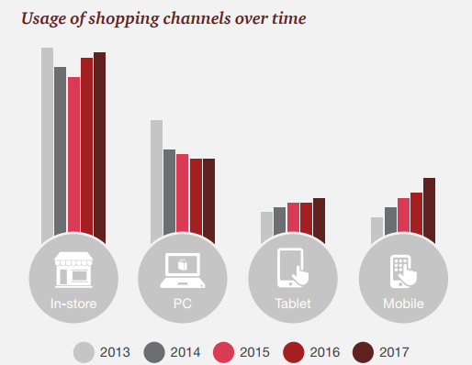
Source: (pwc.com, 2017)
As see in the figure, while the in-store purchases have remained stagnant, and PC based purchases have declined, both tablet and mobile based purchases have seen a steep rise in the recent years. This explains the changing consumer buying behaviour associated with mobility and all-the-time availability of internet device. Looking at the online buying pattern in the UK for 2016 are as shown in the figure below:
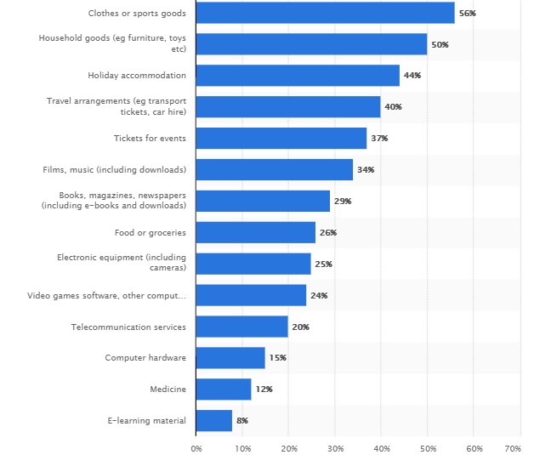
Figure: Share of different product types in online shopping in UK (statista.com, 2016)
As seen in the figure above, clothes, household goods, holidays and travel are most common online purchases. In terms of physical goods like, food and groceries, books, electronics equipment etc. as well, significant purchase happens through online channels

2.2 Online players also extending physical channels
Another factor leading to stagnancy in in-store based purchase has been the dual strategy of some online players. Increasingly, online players can also be seen to make use of physical communication medium to manage clients better. For instance: Players like Lewis are making use of physical shops to extend their reach of online network. Under such strategy, Lewis is making use of a Click + Collect scheme, where buyers can purchase goods online, and then collect them from a network of 5000+ independent stores (Butler, 2013). Such a strategy makes use of the fact that customers, though purchase online, would still like to visit a pleasant store premise, and pick up their goods. According to Butler, (2013), more than 35% of the sales for Lewis in UK, happens through this medium, and is thus again giving a tough competition to traditional physical retailers. Similarly, Amazon also offers a wide network of pickup and drop options for purchasing and returning goods, which further motivates online based buying.

2.3 Advantages to online players
There are numerous advantages which e-commerce channels have over physical retailers. According to Harvey, (2013), online retailers save on the usual costs of setting up attractive outlets, spending on front office staff members, and paying for electricity and other utility bills etc. Additionally, UK based retail chains face significantly higher taxes than their online counterparts. Kingfisher, which is Europe’s largest home improvement retailer with 1100 stores across Europe, faces as much as £120m in taxes each year, which is much higher than similar sized online players in UK. All this decreases the competitive strength of the traditional retail players, and increases profit margins for online companies.

2.4 Digital expansion would drive future sales
Multiple literature indicate that digital expansion and online presence is going to drive future sales and consumers. According to O'Carroll, (2013), companies need to appreciate and realise that internet based commerce would become the next biggest contributor to the GDP of any country. Similarly, companies like Amazon and Google have already taken a dominant share of the media, retail, food, and travel industry, and are not going to stop there (Clarke & Birkin, 2015). Multiple case studies indicate how Kodak could not foresee the digital move, and how HMV stores in UK have faced business downfalls owing to the changing buying behaviour and online shift of consumers.

3.0 Methodology:
The research follows a secondary research methodology in which authentic and reliable secondary sources are referred. These sources are studied to analyse the impact of online shopping, with specific focus on the UK market. The advantage of adopting a secondary methodology is that it helps cover a large volume of data within a short span of time.

3.1 Research Approach & philosophy
The research adopts a positivism based philosophy in which evidence is gathered through effective analysis, instead of arriving at subjective interpretation (Saunders, et al., 2014). Given the context of this research, real word facts on changing consumer buying statistics, and online shift patterns are to be studied for which a positivist approach is more favourable.

3.2 Data sampling and collection
Reliable secondary sources are chosen based on a judgmental sampling, where only recent and highly relevant data has been chosen. Industry reports, news sources, journal articles and other published sources have been considered for data collection.

3.3 Data Analysis
The research adopts a qualitative data analysis approach in which underlying data is studied to arrive at some specific key themes relevant to the research objective. According to Bryman & Bell, (2006), thematic analysis helps identify patterns and logically understand the research context. Based on this, qualitative analysis would be conducted to arrive at conclusions and recommendations.

3.4 Ethical considerations
The research would adopt all ethical considerations by choosing all authentic and reliable sources, and not manipulating data in any form. Also, due credits have been given by following adequate referencing at all places. All this gives credibility to research findings.

4.0 Findings and Analysis
The secondary study and findings helps to arrive at various insights on how online shopping and increasing digital strategy has come to impact traditional in-store businesses. The figure below helps understand the key themes:

Figure: Themes for findings and analysis
As seen above, it is clearly evident from the study that online penetration can no longer be denied. With 82% of the population in UK having access to the internet, this trend is going to gain more momentum and social acceptance (Doherty & Chadwick, 2015). Increasingly, various factors will favour the online movement. High discounting due to high volume of orders, and subsequent economies of scale, is one such factor which will always work in favour of these online giants. Additionally, the savings from low manpower costs, low energy expenses, and other operational savings are going to get translated into increased competitiveness as compared to in-store traditional players. To add to this, the social habit of people, of spending more time with their mobile devices, spending more time on social media platforms like Twitter and Facebook, and increased tendency to rely on online reviews, are some social forces which will favour online migrations. According to Frederick, (2016), 81% consumers in UK has a voucher code for food and grocery purchases made online, 68% women, and 56% men consult product reviews before making an online purchase, which are significantly high numbers within the UK consumer market.
Increasingly, more and more business sectors are going to be impacted with this change. The analysis of online purchase behaviour shows that the purchases which were earlier only limited to travel, clothes, holidays, movie tickets and online music downloads, has increased to the extent of buying medicines, and even doctor consultation online. Online travel service providers like Uber, have already penetrated into online food delivery space through UberEats app. Likewise, Amazon has also launched its own digital wallet which can be used or payment across its partner network of restaurants, online stores and other platforms etc. (Moth, 2017). All this indicates that traditional business units need to gear up to manage the online revolution and shift pattern by leveraging a mix of online and offline selling, or devising approaches to complement their offerings with the convenience or cost-benefits which online platforms offer.

5.0 Conclusion and Limitations
Thus, the research indicates various key conclusions with regard to online shopping and consumer buying patterns. Consumers would increasingly move towards online shopping, and the trend would be supported by increased penetration of internet and mobile devices. Added advantages, more discounts, home delivery and easy payment conveniences would boost this growth. Tax benefits, economies of scale, and low cost of operations would act as competitive advantage for online businesses in the present and future. From the perspective of in-store traditional businesses, there is a need to devise right strategy to sustain within this trend. A large section of consumers relies on actual look and feel, trying out themselves, and enjoying in-store experiences while purchasing. These are some recommended areas which these companies would need to focus and promote as well. Additionally, allowing for online booking, followed by convenient in-store pickups, investing in the correct digital strategy, having own mobile apps, social media marketing, etc. are some recommended approaches to retaining customers.
The research helps understand the changing market dynamics and buying patterns in online versus traditional markets. A key limitation within the research is that it is more focused on UK market alone, for which the conclusions may not be generalisable to overall global business environment.

References
Bryman, A. & Bell, E., 2006. Business Research Methods. London: Oxford University Press.
Butler, S., 2013. John Lewis to extend online shopping empire via thousands of corner stores. [Online]
Available at: https://www.theguardian.com/business/2013/feb/21/john-lewis-online-shopping-collect?INTCMP=ILCNETTXT3487
[Accessed 11 January 2017].
Clarke, G. & Birkin, M., 2015. The emerging geography of e-commerce in British retailing. Regional Studies, 2(1), pp. 21-28.
Daniel, E. & Myers, A., 2010. Adoption of E-Commerce by SMEs in the UK. International Small Business Journal, 15(2), pp. 18-28.
Doherty, N. & Chadwick, E., 2015. Internet retailing: the past, the present and the future. International Journal of Retail & Distribution Management, 38(2), pp. 943-957.
Frederick, J., 2016. 2016 U.K. ECOMMERCE MARKET. [Online]
Available at: http://www.pfsweb.com/blog/2016-uk-ecommerce-market/
[Accessed 11 January 2017].
Harvey, F., 2013. Kingfisher chief warns of store closure over online firms' tax advantage. [Online]
Available at: https://www.theguardian.com/business/2013/mar/04/kingfisher-warns-of-store-closures
[Accessed 11 January 2018].
Lindner, M., 2017. UK e-commerce sales grow nearly 16% in 2016. [Online]
Available at: https://www.digitalcommerce360.com/2017/01/17/uk-e-commerce-sales-grow-nearly-16-2016/
[Accessed 11 January 2018].
Moth, D., 2017. UK online retail sales hit £133bn in 2016, up 16% year-on-year: stats. [Online]
Available at: https://econsultancy.com/blog/68709-uk-online-retail-sales-hit-133bn-in-2016-up-16-year-on-year-stats
[Accessed 11 January 2018].
O'Carroll, C., 2013. City must wake up to digital growth, says tech investor. [Online]
Available at: https://www.theguardian.com/business/2013/mar/01/city-wake-up-digital-investor
[Accessed 11 January 2018].
pwc.com, 2017. Around the world with Total Retail 2017. [Online]
Available at: https://www.pwc.com/gx/en/industries/retail-consumer/total-retail.html
[Accessed 11 January 2018].
Saunders, N., Thornhill, A. & Lewis, P., 2014. Research methods for business students. London: Pearson education.
statista.com, 2016. Goods and services ranked by share of individuals who purchased online in Great Britain. [Online]
Available at: https://www.statista.com/statistics/275973/types-of-goods-purchased-online-in-great-britain/
[Accessed 11 January 2018].

