Corina Berco

Module: Understanding and Engaging in the Customer Experience Module code: BMSW5101 Student name: Corina Berco Student ID: 1918420 Lecturer name: Obinna Nkwocha
Customer Relationship Management and Ethical Practices

Table of Contents

Introduction 2
1. Ethics and its components 3
2. Ethical policies of ASDA supermarket and how it impacts customers 3
3. Sustainability is and its components 5
3.1. Sustainability policies of ASDA supermarket and how it impacts customers 6
4. Quality is and its components 8
4.1. Deming’s theories of quality 9
4.2. Juran’s theories of quality 10
Recommendation 11
Conclusion 12
References 13

Introduction.
Quality management can be stated as an approach to oversee all organisational activities to maintain a certain level of excellence. This report will shed light on the influence of factors such as ethics and sustainability on quality management and customer experience. Additionally, the report will evaluate quality models and theories, which may support customer relationship management. The assessments will be done in context to the current strategies of ASDA. Headquartered in Leeds, the company consists of almost 145000 employees and is one of the leading supermarkets in the United Kingdom (Asda, 2021). In 2019, the company generated revenue of almost £22,899.2 million (Asda, 2021).

1. Ethics and its components.

In business, ethics can be referred to as the set of moral principles, which act as guidelines for all operations, decision-making, and transactions. This can be regarded as one of the key aspects of business and ensures accountability, transparency, and integrity in all organisational activities (Sroka and Lőrinczy, 2015).
Source: fe42b2_81788c3d909e46ecb73e20ec942b9b78~mv2.jpeg (5811×3875) (wixstatic.com)
Moreover, it leads to the setting of a code of conduct, which influences other rules and policies of a business. The key elements of business ethics are integrity, respect, customer focus, results-oriented, persistence, and risk-taking. Organisations such as ASDA must focus highly on these elements to maintain their ethical standards in the market. The implication of ethics in business can be understood through the theory of utilitarianism. According to this theory, the quality of ethics in business can be determined by assessing the consequences of its associate decisions (Kahane et al., 2015). The inclusion of ethical policies requires decision-makers of businesses to assess the benefits and costs to stakeholders and implement activities, which contributes highly to the same.

2. Ethical policies of ASDA supermarket and how it impacts customers.
In ASDA, ethical policies are always drafted to satisfy the concerns and needs of the maximum stakeholders of the business. In a market environment of growing competition and customer concerns, business ethics and associated policies have emerged as highly necessary and significant for organisations. It is similar for organisations such as ASDA operating in the retail supermarket of the United Kingdom. The company incorporates an efficient and transparent “Ethical and Compliance Programme” (Asda, 2021). This approach complies with risk with some factors associated with retail business, as anti-corruption, antitrust, consumer protection, environmental, food safety, health and safety, labour and employment, and product safety.
ASDA aims at generalising and prioritising these standards across the different levels of the supply chain and ensure that all associated stakeholders are contributing effectively to the moral and ethical principles. These principles have a major influence over the experiences that customers gain in these organisations. Tormo-Carbó et al. (2018) stated that ethical principles are hugely responsible for shaping the overall culture of an organisation. Similarly, to maintain higher standards of ethics, ASDA complies with different regulations and laws. Through this, the company shares its value with all stakeholders and encourages a culture, where always the “right thing” is done in all situations. Organisations through this can flourish a more inclusive and responsible culture, where employees can efficiently recognise and restrict wrongdoings. The absence of the same will result in ineffective employee management and poor customer service.
Therefore, it is more likely that all the customers are treated fairly with respect and integrity. This helps in meeting their needs as well as providing them with a profound experience. Further, ASDA also adheres with the “Groceries Supply Code of Practice” for Anti-Trust issues and conducts training programmes for maintaining Anti-corruption, Anti-money laundering, and Environmental Compliance standards (Asda, 2021). These approaches contribute highly to the organisational reputation in the industry, improving its brand image. Customers tend to associate with such companies more as they can trust them. With higher trust, customer satisfaction tends to increase, which proves to be highly beneficial for the company. Under Anti-Trust policies, ASDA also ensures that there is transparency in all information shared in the market among customers. However, the absence of appropriate ethical policies will more likely result in customer disengagement in the market. Jung and Seock (2016) argued that the absence of ethical parameters causes a downfall in the reputation of the organisation and its brand value reduces. In such circumstances, customers are more likely to be hesitant in having an association with companies such as ASDA.
This reliability in the source of information plays a huge role in the trust factor among customers. Reliable information makes it easier for the customers to make decisions for their buying process and this indirectly improves their experience and satisfaction levels (Shaw, 2016). The labour laws and environmental policies of ASDA help it being a good corporate citizen. This supports elevating the experience of the customers through their evaluations of the corporate image of the company, who might not have even engaged in purchase transactions with any of the company’s deliverables. For example, customers with higher environmental awareness are more likely to have an efficient perspective and experience towards companies such as ASDA. Health and well-being practices are also prioritised under the ethical codes of the company. According to asda.com (2021), the company has been able to reduce the customer accident scales by almost 30% in 2020 compared to previous years.
Different safety measures are included in the stores of the company under the company’s “Zero Ham Strategy” (Asda, 2021). These safety measures build confidence among customers for visiting the stores and availing of different services. Amidst current COVID19 circumstances, this standard has been hugely influential for maintaining the customer experience and enhancing their satisfaction levels. To reduce the vulnerability of customers, the company followed the safety policies to incorporate social distancing measures, hygiene procedures, and online staff training processes. McMurrian and Matulich (2016) stated that without these policies and practices, the customers will lose confidence in the organisation. This will lower the ability of the company to attract and retain customers and reduce the sales ratio.
However, the company has been facing issues in maintaining ethical compliance with its supplier management strategies. According to The Guardian (2021), 12% of the ASDA suppliers have allegedly complained that the company rarely complies with the policies of “Grocery Supply Code of Practice”. The complaints have been raised considering inappropriate invoice billing without appropriate notice. This has created a major void in the company’s relationships with the suppliers and delayed supply chain processes.

3. Sustainability is and its components.
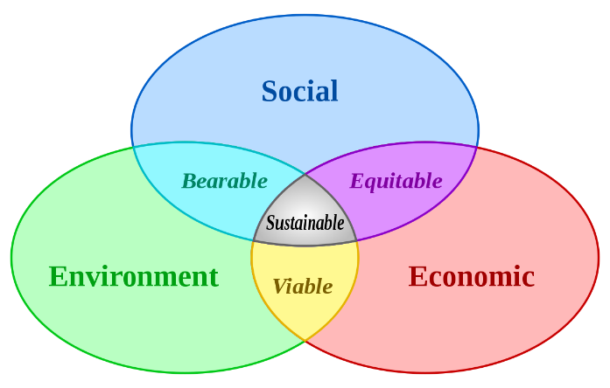
Sustainability emphasises fulfilling the present needs without compromising the future. This mentions the marketing activities along with meeting customer needs and preserving the ability and needs of the future generation. Moreover, it can also be stated that sustainable marketing has long-term business and consumer welfare, which needs to be achieved through ethical market conduction.
Source: 1200px-Sustainable_development.svg.png (1200×765) (wikimedia.org)
Therefore, ethical marketing is linked with sustainable marketing. According to Martínez-Martínez et al. (2019), sustainable customer service depicts identifying the core elements and the prices in the competitive market. The company has major economic benefits as it reduces sickness in employees and thus reduces the cost of leaves. This also helps in improved productivity and increases job satisfaction along with talent retention within the organisation. Furthermore, sustainability within a company helps in more socialisation and thus helps in using retail accessories in the supermarket. Therefore, sustainability in the contemporary days has become a value proposition that increases the consciousness of consumers and attracts many customers equivalently. Sustainability in the corporate sector denotes generating long-term value while considering the operations of an organisation.
The 3P of sustainability is the business concept, which refers to the planet, people, and profit and is referred to in triple bottom line. This includes the ecological, economic, and social environment. People are part of businesses, which seek economic growth and work towards implementing practices of sustainability (Coşkun et al. 2017).

3.1. Sustainability policies of ASDA supermarket and how it impacts customers.
ASDA protects the environment and the environmental impact of operations goods and services. This aims in preserving the social capital while creating and investing in a different sustainable framework. CSR helps in clarifying the direction in which the organisation needs to move. In contemporary days, customers are increasingly embracing various social issues, are seeking the value of the environment, and preserve the same for future aspects. It takes initiatives to be more eco-friendly and is changing the plastic bags into paper or cloth bags and are promoting sustainable foods in the market. The impacts of sustainability are as follows:
High Prices
Sustainability is becoming more costly because of advertisement and promotion, distribution, and other reasons. ASDA is one of the largest supermarkets within the UK. Therefore, its huge sales help it to keep prices lower and make people take products at a greater value.
High-Pressure Selling
As consumers are unable to understand the pricing strategy and the salesperson puts pressure on personnel that makes them buy goods that are of no use. In most cases, it includes long-term business relationships along with valued consumers (Trucillo et al. 2020). Much pressure on sales can also decline the relationship and the business.
Deceptive Practices
The company to ensure greater value than they can make uses these practices. These are categorised as deceptive pricing, promotion, and packaging. These products are harmful and provide less value to the consumers. As per Rodionova (2016), ASDA muddled its consumers by showing misleading advertisements as per the Advertising Standards Authority. Moreover, the supermarket has strict orders to ensure proper future promotions.
Planned Obsolescence
Products are changing in the recent days and producers are obsoleting many products which are then marketed by individuals by changing the styles for earlier buying (Brondoni, 2018). These are done due to the market pressure that is forcing for an improved number of products and services. Moreover, the expectation of consumers within the organisation is also changing. Therefore, keeping up with the trend is a real struggle for all retail companies. To avoid such circumstances, ASDA has been inclined towards the introduction of online shopping measures transforming from traditional processes. Under this, the company introduced the “Express Delivery” service providing the customers with ordered products within an hour (Standard, 2021).
Poor Service to Disadvantaged Consumers
Business needs better customer services and behaviour for long-term business within an area. In some areas, the business owners put red lines and avoid having any business in that place. These consumers are targeted sometimes, and marketers try to provide false values, services, and charges to those people. Therefore, the way of treating the consumers helps in understanding the values of its business and the professionalism too. ASDA introduced a “volunteers shopping card” for disadvantaged and vulnerable customers in the UK to ensure that all are provided with equal opportunities (Asda, 2021). The company aims to initiate and maintain the efficient betterment of communities. According to Asda (2021), the company has also been involved in almost £28.5 million contributions for the improvement of community lifestyle.
Shoddy, Harmful, or Unsafe Products
These types of products possess very low to zero benefits and are harmful. Good Sellers understand the impact of harmful and unsafe products. The Office for Product Safety and Standards (OPSS), in the UK is responsible for regulating and ensuring the safety and standard of the products while are being sold to the consumers. ASDA has provided safe foods and services and its supply chain managed to provide proper supply and maintain the stores accordingly.

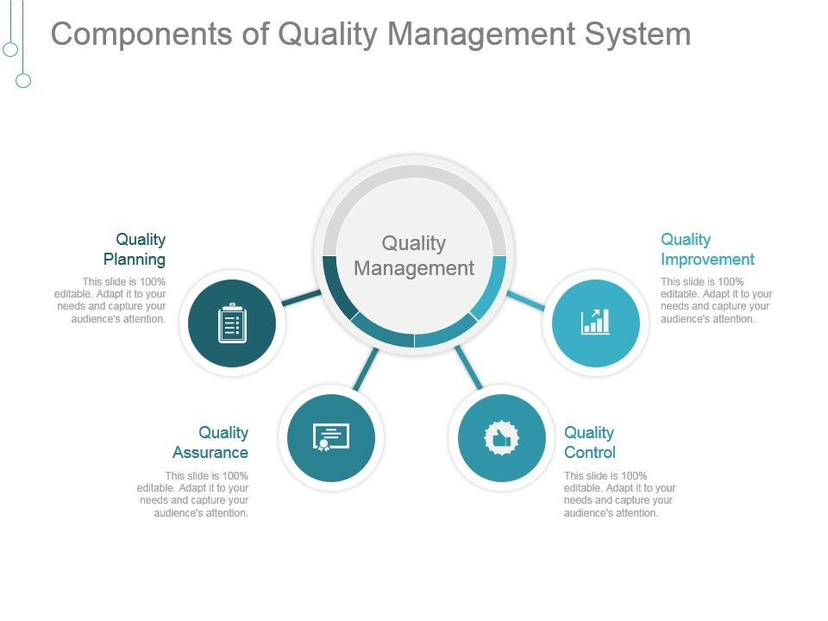
4. Quality is and its components.
Quality management denotes the standard of products and their quality. This helps in determining the quality of products along with ensuring the fulfilment of the needs of consumers (Stanciu et al., 2016). Therefore, quality management aims in providing standards to all the products within a company.
Source: components_of_quality_management_system_good_ppt_example_Slide01.jpg (960×720) (slideteam.net)
Quality can be regarded as one of the most important factors for business growth. Organisations such as ASDA are required to manage their quality consistently to meet the expectations of the customers in the market. The importance of managing quality can be understood through its influence on the level of customer loyalty. Some of the dimensions of service quality are – assurance, time, responsiveness, reliability, and convenience.
ASDA needs to ensure higher efficiency in these dimensions to ensure that there is proper quality management. These dimensions interlink the quality of services within an organisation to the level of customer relationship management. For example, courtesy determines the behaviours of the employees in delivering the services to the customers. High quality of courtesy will make it easier for the company to maintain the CRM in the market (Siva et al., 2016). Quality management has become a major concern as it has the potential to shape the customer satisfaction levels for an organisation. Given the cutthroat competition in the retail industry, the same has also been prioritised heavily in the frameworks of ASDA.
The organisation is inclined towards incorporating a Total Quality Management framework for the same, which supports continuous improvement for the various processes (Lemmon, 2016). With the help of this, the organisation has been able to ensure the safety of external customers. This safe and responsible approach has supported the organisation to enhance its relationship with the customers and strengthen the level of loyalty. Further, the company incorporates major components of Information and Communication Technology within its quality framework.
This allows an organisation to make appropriate arrangements for maintaining superior quality of various processes. Through this continuous improvement strategy, ASDA can align its strategies and quality metrics with its vision, mission, and overall strategy. With the help of these strategies, the company can ensure that the customers are provided with deliverables of the highest order and quality (Oakland et al., 2020). This supports in catering the customer expectations efficiently and henceforth, increases their loyalty towards the company.

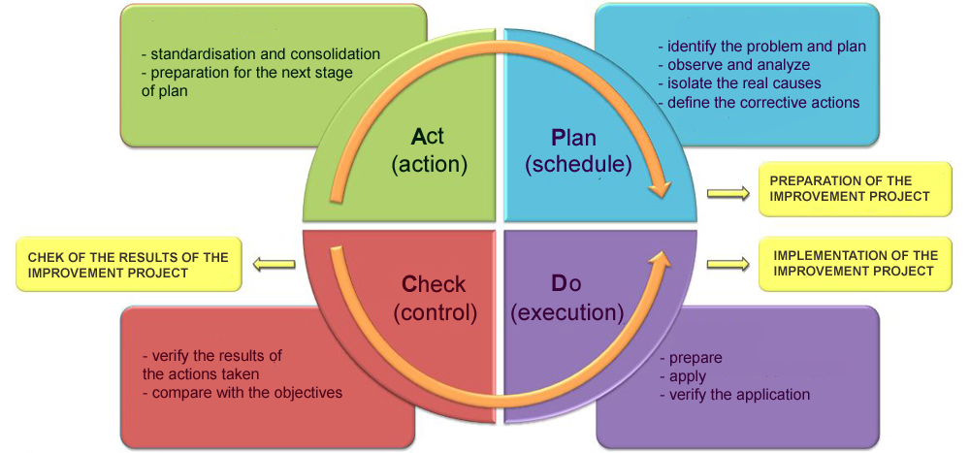
4.1. Deming’s theories of quality.
Deming’s theory of quality is the systematic approach of tallying defects in products while analysing their causes to prevent the defects.
Source: PDCA_en.jpg (1000×467) (iwolm.com)
According to Agrawal (2019), this helps in better quality while lower the cost and higher productivity resulting in fewer mistakes, few reworks, and better usage of materials and time. The theory helps in achieving greater market share and stay in business, which helps in providing more jobs.
This approach mainly focuses on the efforts of the management towards attaining the betterment of the overall quality. In this, it is the responsibility of ASDA management to make necessary modifications in the internal systems, which would enhance the capability of the employees to perform efficiently for different operations (Krehbiel and Miller 2018). Moreover, through improvements in systems, ASDA can attain elevation in the quality of production with fewer delays and errors, which directly contribute to its overall competitive ability. Adhering to this model will require the management to have an appropriate understanding of the various product defects and their sources and making changes to mitigate the same.
Through this systematic approach, will allow the company to make smaller changes and modifications in its system framework and attain benefits in the future. Corbacioglu (2016) stated that the improvement process is also referred to as the “PDCA Cycle”, which involves the steps, “Plan”, “Do it”, “Chack it”, and “Act on”. One of the major benefits of this approach is its ability to initiate an efficient long-term improvement. ASDA through this can avail improved sustainability in its operations and quality management of the same. As discussed, one of the key principles of this sustainable approach is improvement in the employee performances and systems available for the same.
Training is an integral principle of this model, which inclines towards developing the credibility and competencies of the workforce. In such situations, the employees will be better prepared and be equipped to detect errors and mitigate the same. Additionally, they can have an efficient understanding of the organisational value and culture, which brings major developments in their attitudes and behaviours. The result of this is improvement in customer services and assistance (Ladewski and Al-Bayati, 2019). ASDA’s values focus on enhancing the experience and safety of the customers and sharing this value profoundly among all employees will support elevating the quality of the services provided. The customers will be more satisfied with such approaches and it would become easier for ASDA to build and maintain stronger relationships with them.

4.2. Juran’s theories of quality.
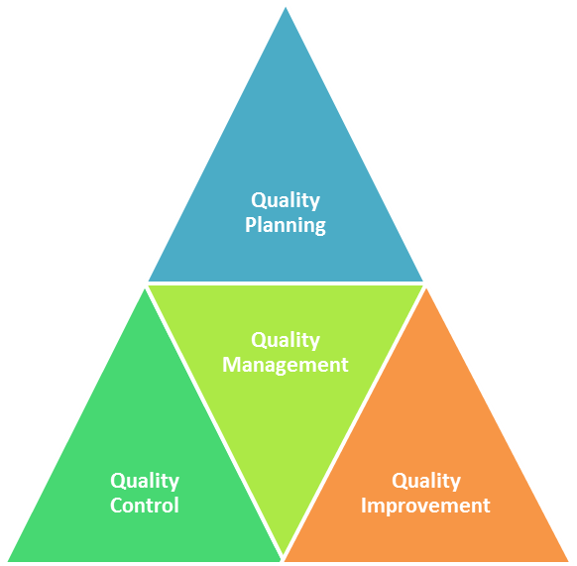
In contrast, according to Neyestani (2017), the Juran’s trilogy helps in extending the quality of customer’s expectations while accomplishing improvement in quality, quality control, and quality planning of the products. Thus, this can be defined as the conformance of design while fulfils both customer and the owner’s expectations. ASDA can use this theory for preventing defects in the long run and getting things done while fixing them faster. As it is a cyclic process of planning, testing, and improving activities, hence formalises the improvement in an organized manner.
Source: Juran’s-Quality-Trilogy-Components.png (582×571) (whatissixsigma.net)
The different components are:
Quality planning
This determines the standard of products, which guides the stakeholders on the quality management of the project. This includes the expectations of stakeholders and the quality of the project (Abramov, 2019). Thus, prioritises the affected areas that are needed to be of better quality.
Quality improvement
Improving the management processes in ASDA assists the future improvement and systematic approaches of the company in accordance with total quality management (TQM).
Quality control
Ngambi and Nkemkiafu (2015) stated that this part consists of testing, quality measurement, and inspection, which verify the desirable conform which fit the expectations of consumers. These exact inspection methods have been developed by the concerned company.
Quality assurance
This is one of the key tools, which provides quality assurance and is used in controlling the quality of products. This covers the full lifecycle of the project and the services and possesses other services such as control and planning (Lucena et al. 2018). Therefore, this involves independent audits, regular, pre-planned reviews that consistently verify and provides confidence to the stakeholders who satisfy the relevant requirement standards and quality. This can provide an efficient checklist for customer requirements along with measurements based on their needs. Therefore, for ASDA it can be easier to track the quality of the products and services and ensure that they are in line with the customer expectations. Mukhopadhyay (2020) opined that it becomes easier to satisfy the customers and strengthen their loyalty over time.
Recommendation.
The importance of sustainability and ethical practice for customer relationships in ASDA can be understood through the above evaluations. However, some recommendations, which can support the company to improve the same in its global operations:
- One of the key processes that can be helpful is employee training and development courses. For ethical viability and integrity, the workers must have appropriate knowledge and understanding about the corporate values and embedded systems. To create this awareness, training can benefit ASDA largely. Additionally, the employees can develop their competencies in this and manage to provide the customers with better services (Neyestani, 2017). At the same time, the company can ensure the maintenance of ethical practices and improvement in productivity through this.
- For sustainable practices, ASDA needs to ensure adherence to the standards of the Office for Product Safety and Standards. Through this, it can deliver its customers safe and hygienic products, which will be beneficial in elevating their satisfaction levels. The reputation and sales of the company will increase at the same time along with the retention rates of the customers.
Conclusion.
With the help of the above discussions, the importance of ethics and sustainability on the customer relationships for ASDA can be understood. It can be stated that the ethical approaches of an organisation directly influence the level of trust shared with the customers. For example, ASDA can maintain profound trust by prioritising the health and safety standards of the customers in its stores along with strong confidentiality and security procedures. This affects the image of the company as perceived by the customers. Moreover, ASDA through an ethical code of conduct maintains a strong reputation in the market, which supports in retaining and attracting customers. Moreover, sustainability supports an organisation to cater to the wider needs of business and helps in improving socialisation. It provides companies such as ASDA with better exposure in the market and ensures that it can deliver higher value to its customers. Establishing customer relationships becomes easy and with higher retention abilities.

Reference.
1. Abramov, I.L. (2019) Systemic integrated method as the basis for high-quality planning of construction production. In IOP Conference Series: Materials Science and Engineering (Vol. 603, No. 5, p. 052077). IOP Publishing.
2. Agrawal, N.M. (2019) ‘Modelling Deming’s quality principles to improve performance using interpretive structural modelling and MICMAC analysis’, International Journal of Quality & Reliability Management.
3. Asda (2021) Asda increases its support for vulnerable customers with the launch of a ‘volunteers shopping card’. Available: Asda increases its support for vulnerable customers with the launch of a ‘volunteers shopping card’ (Accessed: 23 July 2021).
4. Asda (2021) Better communities. Available at: Better Communities | Asda (Accessed: 23 July 2021).
5. Asda (2021) Ethics and compliance programme. Available at: Ethics & Compliance | Better Business | Asda (Accessed: 13 July 2021).
6. Brondoni, S.M. (2018) ‘Planned obsolescence, total quality, zero defects and global competition’, Symphonya. Emerging Issues in Management, (2), pp.8-20.
7. Corbacioglu, S. (2016) ‘Influence of Taylorism on Deming’s quality management’, Inquiry-Sarajevo Journal of Social Science, 2(2), pp.77-87.
8. Corporate.asda.com (2021) Available at: Asda Group Limited publishes annual Statutory Accounts (Accessed: 13 July 2021).
9. Coşkun Arslan, M. and Kısacık, H. (2017) The corporate sustainability solution: Triple bottom line.
10. Deming Cycle [illus.] (ND) Available at: PDCA_en.jpg (1000×467) (iwolm.com) (Accessed: 16 July 2021).
11. Ethics [illus.] (ND) Available at: fe42b2_81788c3d909e46ecb73e20ec942b9b78~mv2.jpeg (5811×3875) (wixstatic.com) (Accessed: 25 July 2021).
12. Evening standard (2021) Asda launches full range one-hour delivery service. Available at: Asda launches full range one-hour delivery service | Evening Standard (Accessed: 23 July 2021).
13. Ferrell, O.C., Harrison, D.E., Ferrell, L. and Hair, J.F. (2019) ‘Business ethics, corporate social responsibility, and brand attitudes: An exploratory study’, Journal of Business Research, 95, pp.491-501.
14. Jung, N.Y. and Seock, Y.K. (2016) ‘The impact of corporate reputation on brand attitude and purchase intention’, Fashion and Textiles, 3(1), pp.1-15.
15. Juran quality trilogy [illus.] (ND) Available at: Juran’s-Quality-Trilogy-Components.png (582×571) (whatissixsigma.net) (Accessed: 16 July 2021).
16. Kahane, G., Everett, J.A., Earp, B.D., Farias, M. and Savulescu, J. (2015) ‘Utilitarian judgments in sacrificial moral dilemmas do not reflect impartial concern for the greater good’ Cognition, 134, pp.193-209.
17. Krehbiel, T.C. and Miller, D.P. (2018) ‘Should agile be part of your quality management system?’ Journal of International Technology and Information Management, 27(1), pp.2-28.
18. Ladewski, B.J. and Al-Bayati, A.J. (2019) ‘Quality and safety management practices: The theory of quality management approach’ Journal of Safety Research, 69, pp.193-200.
19. Lemmon, C. (2016) Asda rolls out quality management system, Retail Systems. Available at: Asda rolls out quality management system - Retail Systems (retail-systems.com) (Accessed: 13 July 2021).
20. Lucena, P., Binotto, A.P., Momo, F.D.S. and Kim, H. (2018) A case study for grain quality assurance tracking based on a Blockchain business network. Available at:
arXiv:1803.07877 (Accessed: 15 July 2021).
21. Martínez-Martínez, A., Cegarra-Navarro, J.G., Garcia-Perez, A. and Wensley, A. (2019) Knowledge agents as drivers of environmental sustainability and business performance in the hospitality sector. Tourism Management, 70, pp.381-389.
22. McMurrian, R.C. and Matulich, E. (2016) ‘Building customer value and profitability with business ethics’, Journal of Business & Economics Research (JBER), 14(3), pp.83-90.
23. Mukhopadhyay, M. (2020) Total quality management in education. SAGE Publications Pvt. Limited.
24. Neyestani, B. (2017) Principles and Contributions of Total Quality Management (TQM) Gurus on Business Quality Improvement. Available at SSRN 2950981.
25. Ngambi, M.T. and Nkemkiafu, A.G. (2015) The impact of total quality management on firm's organizational performance. American Journal of Management, 15(4), p.69.
26. Oakland, J.S., Oakland, R.J. and Turner, M.A. (2020) Total quality management and operational excellence: text with cases. Routledge.
27. Quality management [illus.] (ND) Available at: components_of_quality_management_system_good_ppt_example_Slide01.jpg (960×720) (slideteam.net) (Accessed: 23 July 2021).
28. Rodionova, Z. (2016) Asda confused customers with misleading promotion on Choco Squares cereal, ASA finds. Available at: Asda confused customers with misleading promotion on Choco Squares cereal, ASA finds | The Independent | The Independent (Accessed: 12 July 2021).
29. Shaw, W.H. (2016) Business ethics: A textbook with cases. Cengage Learning.
30. Siva, V., Gremyr, I., Bergquist, B., Garvare, R., Zobel, T. and Isaksson, R. (2016) The support of Quality Management to sustainable development: A literature review. Journal of cleaner production, 138, pp.148-157.
31. Sroka, W. and Lőrinczy, M. (2015) The perception of ethics in business: Analysis of research results. Procedia Economics and Finance, 34, pp.156-163.
32. Stanciu, A.C., Condrea, E. and Zamfir, C. (2016) The importance of communication in quality management. Ovidius University Annals, Economic Sciences Series, 16(2), pp.393-396.
33. Sustainable [illus.] (ND) Available at: 1200px-Sustainable_development.svg.png (1200×765) (wikimedia.org) (Accessed: 23 July 2021).
34. The Guardian (2021) Asda is named worst supermarket in treatment of suppliers. Available at: Asda is named worst supermarket in treatment of suppliers | Asda | The Guardian (Accessed 23 July 2021).
35. Tormo-Carbó, G., Seguí-Mas, E. and Oltra, V. (2018) Business ethics as a sustainability challenge: Higher education implications. Sustainability, 10(8), p.2717.
36. Trucillo, P., Campardelli, R., Iuorio, S., De Stefanis, P. and Reverchon, E. (2020) Economic Analysis of a New Business for Liposome Manufacturing Using a High-Pressure System. Processes, 8(12), p.1604.

