Lorena Maria Mihalcea (2019847)
20198847@student.uwtsd.ac.uk
Team Working and Communication Within The Workplace
Effective Team Working C2

Executive Summary
Teamwork establishes a method for ensuring that deadlines are fulfilled, and that work is of a high standard. When one member of the team lags, another step in to fill the gap. When tasks are delegated to team members, they are completed more quickly, which improves the firm’s overall efficiency. In this report, we have worked on ABC technology, a well-known company of the UK operating its two offices in two different places. They have faced difficulties completing their targeted task due to the lack of proper communication among the team members and the right communication channel. As an expert, I have identified the members about the importance of team collaboration and how the theories of Tuckman and Belbin can help determine their roles and divide their responsibilities to achieve their goals. Also, we have identified some ways to effective communication, but Schramm’s Model of communication seems perfect because of its two-way method. We have also recommended for the organisation which can help them to perform better in future.

Introduction
Communication is vital to leading a formed team to its desired goals by engaging them in day-to-day talks directed through the right channel (McConnell, 2017). Effective communication within a group will encourage them to set a common purpose to work on their desired outcome. For completing this report, a case study has been assigned, which shows that ABC technology, one of the prominent groups of the Uk, is facing difficulties managing two teams operating from different countries working on a single project. AS a business consultant, a workshop has been arranged to them aware of teamwork and team communication. Also, the leader will identify the roles of the team members to make the project successful. The report is going to illustrate ways of communication and critical methods which are applicable in this work-frame. To achieve the outcome of this case study, two-way communication is essential to enabling feedback from the members through verbal or non-verbal communication.

Findings

Area 1

Explanation of how theories of Tuckman & Belbin can work better in the case study
From the above case, we have found that the team initiated by the team is six months behind due to a pandemic. And neither of the team members could work on that due to the lack of desired goals, interests, and defined roles. The productivity is decreasing, and on the other hand, the conflict is increasing. According to Burns (2012), Competition is unavoidable in any organisation, but it causes incredible positivity and understanding among the team members. He also explained that there might not raise the actual lackings and difficulties of the project without conflict, and the members will not find a solution for that. For providing a solution to ABC technology, the teamwork theory of Tuckman and Belbin is described below:
Theory of Tuckman
The effectiveness of a team is increased by their power of reflection and evaluation within themselves. Groups scattered go through some phase, and among many of them, Tuckman’s five stages model has a significant impact from the beginning of the nineties. The stages of this framework will identify the behavioural pattern of ABS’s team members and work on changes to maximise productivity.
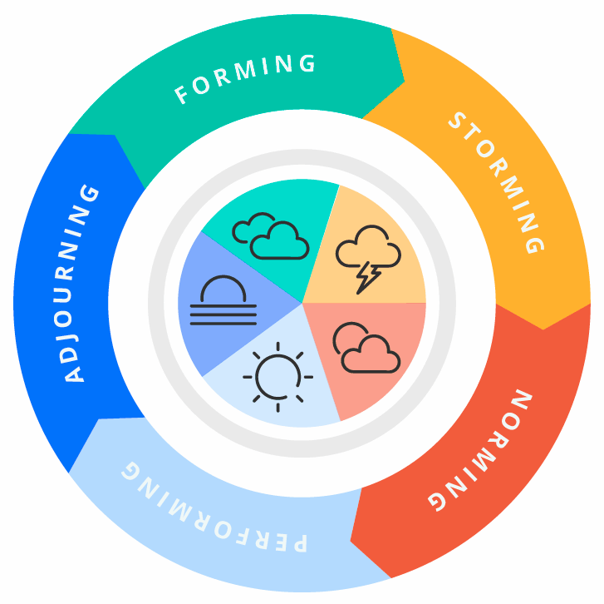
The five stages of the theory can impact differently on the members, which is described below:
Forming: During the workshop, the leader will work on the team mainly. In this stage, the members are generally overwhelmed by joining a group, while others may be excited to work on further, and others might raise questions on their minds for being in that situation. The leader will find out the behavioural patterns of the members and note them down for further forming. As this is the forming period, the leader will divide the teams according to their traits and abilities by defining their roles, goals & objectives within a specific timeframe. If the forming stage is not precise, the leader cannot proceed to the next steps due to unidentified roles and confusions.
Storming: This is where conflicts raise the most, but this is not mandatory; it may rise in different levels. As the roles are already assigned, the team might start working towards their goals but gets easily frustrated by the team’s progress. It is normal when a group begins working, and there might raise questions about reaching the goals and providing their ideas and opinions (McConnell, 2017). They are much straight forward in this phase and do not want to agree with others. Team leaders must change the roles if needed and solve the disputes among members to bring them into a win-win situation where both parties and the firm can benefit. Emotional imbalance is seen in this phase.
Norming: Norming is the stage where mutual norms are shared within the members of ABC technology. Both of the team will learn about their roles and identify their goals to help each other. As the opinions and views are shared among them, the issues and conflicts are being resolved. This is a plus point of raising dispute in the second stage. As they have grown mutual understanding, they the ground rules are also be formed. According to Mburu (2021), Norming is the period where ate group harmony is much stable, and teams start moving towards their goals as quickly as possible, Though some problems can be raised too if any elements are missing among the members, which is a criticism of the theory of theory Tuckman’s.
Performing: In the performance phase, the team progresses significantly towards its goals. The goal of the group is excellent, and the skills of team members are likewise high. Team members of ABC technology should plan to increase their knowledge and abilities, particularly striving to improve organisational innovation continually. The cooperation among the members is seen as they are well aware of their strength and weakness. If the before stages are not met, the performance can be decreased.
Adjourning: The last stage is formed later because it has been seen that there might be some teamwork effects. You may experience grief or a feeling of loss because of the changes in your team interactions. And, at the same time, teammates might feel deeply satisfied with the team’s achievements. Emotional understanding is noticed in this situation.

Team role theory by Belbin
According to Salam (2014), a team of individuals with comparable behavioural patterns or team responsibilities can become unequalled. For instance, if teammates have similar talents, they might compete for projects, role and activities that add to their skills. A team of people with comparable limitations can demonstrate this shortcoming in its entirety. The Belbin framework will assist ABC technology in developing a more solid combination and identifying growth possibilities depending on the job description.
Belbin Team Roles is an evaluation technique that will assist ABC in determining why specific individuals do well in certain teams but not others. It will uncover an individual’s perceived advantages and acceptable flaws, allowing the leader to choose the roles that teammates usually fill in a team or spots for growth that would help the team advance. Belbin is more than nine team responsibilities and a system for identifying individuals. It is a common language that enables leaders and followers to share information more efficiently and effectively.
Belbin’s team building session, led by a specialist, will help respondents know which positions they probably lean toward and why. Additionally, how the opportunity to collaborate to complete an unfinished assignment by maximising the effectiveness of each team member’s abilities (Salam et al., 2014). They will learn about the nine roles identified by him and which is suitable for them. This can be established only by providing them with a specific questionnaire. So, when they meet the traits of an individual role, the leader can place them in their position. For example, If any of a team member of ABC is interested in idea generation and looking towards new ways to solve a specific problem will be suitable of PL (Plant) role. A leader must be conscious while handling him because he can act weird if his idea is not taken. Self-perception inventory, Self-observer assessment and team report will be suitable in the case of ABC. The self-observer evaluation relies on the information gathered in the personality survey by examining both individuals’ personal and their impression of how they operate in a unit (Mburu, 2021). When administered properly, this evaluation may be quite beneficial in increasing an individual’s self-awareness and personality. This Belbin Team Functions Report helps team leaders know the ins and outs of their group and how they operate collaboratively.

Area 2

3.2.0 Importance of two-way communication
Two-way communication is done when the recipient provides the message with a reaction or opinion. The transmitter initially sends the signal during two-way interaction. After a message comes, the recipient compiles it and sends its reply back to the person. Two-way information helps the recipient to respond to the message he has received directly. As a consequence, information flows freely in both ways. Two-way interaction happens when the sender provides data to the control, and the recipient responds or responds to the sender (Frazer & Oswald, 2016). Thus, two-way communication confirms the receiver’s receipt of the information. For example, if Team Glasgow sends any message to team Cardiff and reply, it is considered a two-way communication. ABC technology can be influenced by some of the proven methods of communication which are given below:
The Shannon-Weaver Mathematical Model: We saw the video on YouTube about how Shannon weaver works during the lectures. This model has four components which are sender message channel and receiver. Pierce (2012) argued that this is a complicated method because it is an unfinished method. After all, no feedback is found after the message is being sent to the receiver. The imagination of the sender and receiver can create misunderstanding among the parties. So, it is not a well-defined model for ABC technology.
David Berlo’s SMCR model: For our lecturer’s suggested video tutorial, we have found that the SMCR model has five components in total: sender message channel receiver and coding system (Trahair & Biddle, 2019). Firstly, it has the only one-way transfer of information, but following the scholars aided the model with a bandaid that said that the receiver might want to send something back to the sender. But it is also not present in the actual model. It might be helpful for ABC technology.
Schramm’s Model of communication: The components of this model are sender encoder-decoder interpreter message feedback medium and noise (Bhasin, 2021). As it is a two-way method, ABC must apply this one in their team communication. The advantage they can gain is it will show them how the model works in a different situation. It will also point out the importance of redundancy to the members. As the communication occurs in a circular motion, the decision can be central oriented.

3.2.1 Importance of effective teamwork
Teamwork provides a sense of connection and is the foundation for all successful enterprises. This simplifies things and enables a group of people to face challenges that would be insurmountable for an individual. Effective teamwork is essential because more people contribute to a single project by brainstorming and generating ideas to solve the problem. ABC technology can get different new ideas to complete their unfinished tasks within the timeframe. Effective collaboration enables employees to break down complex jobs into smaller, more doable ones. When cooperation is prioritised, individuals will feel appreciated for their efforts and that their actions were critical to the business’s success. This will raise their confidence and motivate them to excel in future tasks. This assists in avoiding future blunders and provides information from several angles, basically allowing them to discover more.

3.2.2 Importance of effective teamwork for the continued success of the organisation
Building a firm on a foundation of ineffective cooperation may rapidly become an issue for the entire organisation - impacting all levels of ABC technologies to various degrees (Pierce, 2012). As the Covid-19 has attacked the whole company and the employees were not so adaptable to the new technologies created the actual blunder. As the workshop will proceed, the members will learn about their roles and define their place in the organisation, The conflicts will vanish, and mutual understanding will grow as a result. This will help the organisation not only to complete their task but also to work better in future. Once the team collaboration can be identified, it becomes straightforward for the members to work on their strengths and weaknesses. They do not have to work repeatedly to find out who should be responsible for which function. So, there might be a strong possibility of the future success of the corporation.

Recommendations
ABC technology is an emerging organisation facing difficulties having a project to be completed, but their team cannot cooperate. In this case, a well-defined team leader should be appointed and trained on team works and collaboration. The leader can work on them using different team-building theories and confirm two-way communication among the members (Weaver et al., 2016). From lecture six, we have learned that communication barriers can create aggressiveness and misunderstanding among the members, so the leader and teammates of ABC must pay concern. Thus, they must work on building the relationship for future success.

Concussion
Teamwork is an essential part of any business to achieve its targeted goals. It helps in emerging different ideas in a single table so that the team members can pick the best among many according to the choice of everyone. Here ABC technology was in a massive dilemma as there we no defined roles of the individual conducting a single project. The report identified the way of communication for the team and how they can locate their desired positions and work collaboratively to bring success to the organisation.

References
Bhasin, H., 2021. Schramm model of communication | Elements, Advantages & Limitations. [online] Marketing91. Available at: <https://www.marketing91.com/schramms-model-of-communication/> [Accessed 23 June 2021].
Burns, J., 2012. Leadership. New York, NY: Open Road Integrated Media.
Frazer, R. and Oswald, P., 2016. Teamwork!. New York: Simon Spotlight.
Mburu, S., 2021. How Tuckman’s stages of group development played out in my PSYCH 281 class.. [online] Sites.psu.edu. Available at: <https://sites.psu.edu/leadership/2014/04/14/how-tuckmans-stages-of-group-development-played-out-in-my-psych-281-class-2/> [Accessed 23 June 2021].
McConnell, C., 2017. Effective communication. Gaithersburg, Md.: Aspen Publishers.
Pierce, J., 2012. Team collaboration. Redmond, Washington: Microsoft Press.
Saud, S., Jufri, A., Rahman, M. and Salam, S., 2014. Learning Devices Development on Descriptive Writing for Foreign Language Based on Berlo’s SMCR Communication Model of Secondary School Student. Journal of Language Teaching and Research, 5(5).
Trahair, R. and Biddle, B., 2019. Role theory classification for the worker’s judgment. Columbia: Center for Research in Social Behavior, University of Missouri.
Vajda, S., Shannon, C. and Weaver, W., 2016. The Mathematical Theory of Communication. The Mathematical Gazette, 34(310), p.312.

