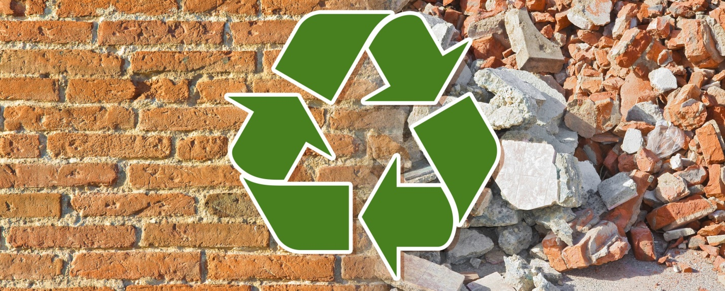

Student name: Antonio Joseph
Student ID number: 2113837
Module: Work Based Project
Module code: ACBA5009
Assignment Title: Learning contract
Lecturer: Dr Deborah Hughes

Table of content
Aim…………………………………………………………………………………………………………..……………………………………………1
About………………………………………………………………………………………………………..……………………………………………1
Objective…………………………………………………………………………………………………….………………………………………….2
Benefit of research………………………………………………………………………………………………………….………………………2
Methodology…………………………………………………………………………………………………………………….…………………….3
References………………………………………………………………………………………………………………………………………………4

Topic : The utilization of recycled materials in concrete
Aim
Examining the utilisation of recycled resources in concrete mix designs is the goal of this study. This study will provide a thorough analysis of the mix design and pouring procedure for a typical concrete mix and adapt this technique to be used with recycled aggregate mixtures. Research will be done to discover if it is feasible to minimise the quantity of natural virgin aggregate used in the building industry. Various forms of aggregate substitutes will be examined as potential replacements for virgin aggregate. The corresponding financial and environmental benefits and drawbacks will also be examined.
About
Despite significant research investigations, construction demolition waste (CDW) and worn-out motor vehicle tyres are still not entirely repurposed and are so disposed of in environmentally hazardous ways. A number of studies have been conducted into the production of concrete utilising recycled aggregates from CDW and crumb rubber. However, without investing additional expenditures, it has not been possible to produce recycled aggregate concrete with the same performance as normal natural aggregate concrete. Natural coarse aggregate production is both ecologically destructive and expensive. With rising global demand for concrete and a commitment to sustainable development, it is critical that massive amounts of CDW and tyres with high embodied carbon content are utilised in structural applications without compromising cost or performance.
One of the seven principles of sustainable construction is the use of recycled materials. The International Council of Buildings created these standards based on resource efficiency in 1994. Recycled resources such as recycled concrete aggregate or recycled brick aggregate from building and demolition waste, waste glass from municipal garbage, or recycled waste gypsum from gypsum boards can be used in cement and concrete production as a replacement for main raw materials. Production of cement and concrete is entirely dependent on natural resources. Over the past six decades, the global output of concrete has expanded by a factor of twelve. Today, on average, one tonne of concrete is produced annually every person on the planet. On the one hand, using recycled materials in the manufacturing of cement and concrete helps to lower the amount of raw resources and urban land use. On the other hand, the qualities of the finished product are influenced by the recycled materials utilised in part replacement of raw materials.

Objective
Recycled materials should be used more frequently in construction products than ever before. Recycled materials are used in concrete mixes to prevent waste from going to landfills and to conserve virgin raw materials.
The goals of this study are to analyse existing research and development studies on recycled concrete aggregate, examine its present use in construction, and offer appropriate tactics for wider applications while investigating the structural needs of concrete in compliance with Eurocodes, as well as the properties of a variety of potential replacements. The primary kind of recycled aggregate being researched in this study are recycled concrete rubble and waste glass. The uniformity of the recycled concrete aggregate will be assessed, and a sieve analysis will be calculated based on the results. Building Research Establishment Environmental Assessment Method (BREEAM) criteria will be used to analyse project sustainability and how the use of recycled materials inside a construction enhances its BREEAM grade. An examination of potential incentives for the use of recycled aggregate, such as a tax on virgin aggregate and the effect this might have on the material's use will be undertaken.
Benefit of this research
In line with the concept of sustainable development, industry, particularly the construction sector, has recently concentrated on efficiently lowering the use of natural resources. The World Commission on Environment and Development defined "sustainable development" as "development that fulfils the demands of the present without compromising the ability of future generations to satisfy their own needs" in its research "Our Common Future," which was released in April 1987. As a result, the design and manufacture of materials, particularly construction materials, should be done with environmental conservation in mind and future generations in mind. It is also crucial to use cutting-edge technology to limit the use of natural resources in the manufacture of products like these, which may be replaced by waste materials and recycled building materials from the construction industry or waste materials from other sectors.

Methodology
Based on a study of the literature on international experimental campaigns on this form of environmentally friendly concrete, this research presents a methodology for predicting long-term qualities of recycled aggregate concrete. The approach described is based on previously determined aggregate parameters (density and water absorption), primary and recycled, coarse and fine, as well as the 7-day compressive strength of concrete formed with those aggregates. Based on a visual study of the most crucial characteristics of hardened concrete, the approach is confirmed (compressive strength, modulus of elasticity, splitting and flexural tensile strength, shrinkage, creep, water absorption, and carbonation and chloride penetration depth). The approach can, inferred from comparisons with an equivalent conventional concrete, estimate the long-term performance of recycled aggregate concrete, and this prediction may be utilised to modify structural designs for this material.
Nine cubes will be created and crushed at 7, 14, and 28 days to ascertain which variety of recycled aggregate would have the maximum compressive strength. This study will be used to assess the properties of C20 concrete mixtures. The usage of ground granulated blast furnace slag in mixtures will also be studied. Measures will be made to examine the carbon footprint of this project and how the use of recycled materials may be used to reduce carbon footprint.

References
Abdelfatah, A.S. and Tabsh, S.W. (2011). Review of Research on and Implementation of Recycled Concrete Aggregate in the GCC. Advances in Civil Engineering, 2011, pp.1–6. doi:10.1155/2011/567924.
Gardner, A. (n.d.). How recycling concrete could accelerate sustainable construction - Arup. [online] www.arup.com. Available at: https://www.arup.com/perspectives/how-recycling-concrete-could-accelerate-sustainable-construction [Accessed 5 Dec. 2022].
Ulewicz, M. (2021). Recycled Materials for Concrete and Other Composites. Materials, [online] 14(9), p.2279. doi:10.3390/ma14092279.

