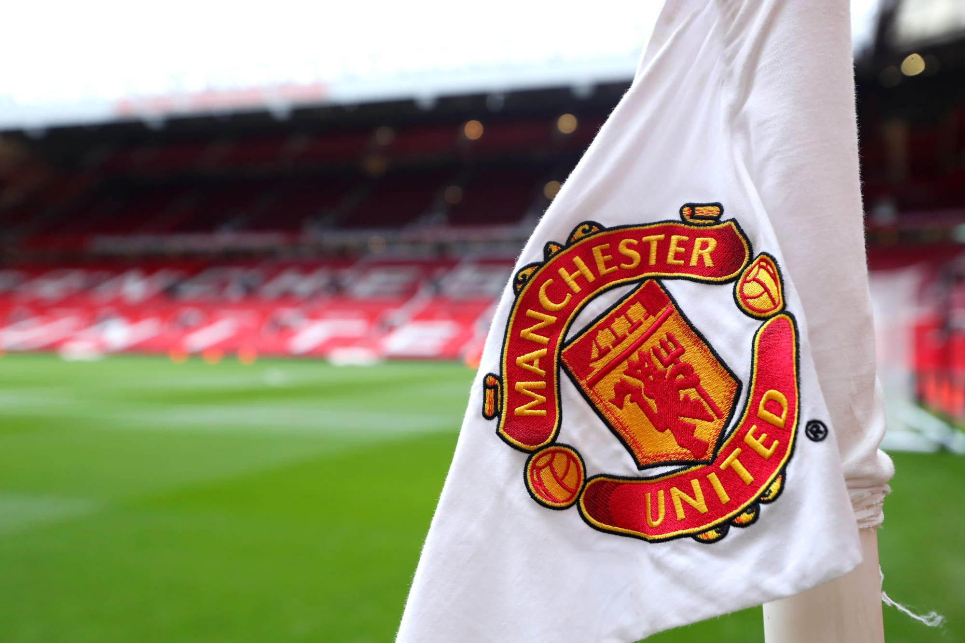
Kyle Williams
2005148
Strategic management evaluation

Report represents an analysis and evaluation of competitive and development strategies. Analysis suggests there is still heavy deliberation over the best term of strategy. Recommendations suggest continuing with current strategy, whilst adding in a newer environment.
Table of Contents
2.0 Introduction 2
2.1 Strategic Management 2
2.2 Manchester United PLC 2
2.2.1 2005 Purchase 2
2.2.2 Revolt against Ownership 3
3.0 Strategy 4
3.1 Michael Porter 4
3.1.1 Five forces 4
3.2 Johnson et al 5
3.2.1 Three Levels 6
3.3 Ansoff Matrix 7
4.0 Manchester United Strategies 10
4.1 The Model 10
4.2 Manchester United Strategy 10
5.0 Manchester United’s Possible Future 12
5.1 Three Possibilities 12
6.0 Conclusion 13
6.1 Recommendations 13
7.0 References 15

2.0 Introduction

2.1 Strategic Management
Strategic management consists of pinpointing what the main objective/s behind an organisation and the resources they have in place in which to achieve said objective/s. (Lynch, 2012)

2.2 Manchester United PLC
Manchester United PLC are the company side to the football club of Manchester United Football Club. Manchester United, established in 1878 as Newtown Heath LYR, are one of the most successful football clubs in history, and are one of the top sports brands on the planet today who have amassed over 1 billion worldwide fans. (Manchester United, 2023)
Manchester United today are owned by The Glazer Family, the family were headed by Malcolm Glazer up until his death in 2014, and Malcolm built his fortune via a real estate business in the 1950’s and 60’s (Czarnecka, 2021) The family started their venture into sports with their purchase of the Tampa Bay Buccaneers in 1995, (Associated Press, 1995) and was followed by their purchase of Manchester United ten years later in 2005. Since his death in 2014, the club has been in the hands of his six children (Bulbul & Hassan, 2013)

2.2.1 2005 Purchase
The Glazer family first invested in Manchester United as minority shareholders in 2003, purchasing a less than 3% share before continuously attaining more of the shares up to, when they purchased 28.7% from the previous owners JP McManus & John Magnier bringing their control to more than 70%. (BBC, 2005)

2.2.2 Revolt against Ownership
In bidding for Manchester United, Malcolm glazer had the intention of buying the club via a loan (Hamil 2007) This led to large outrage from supporters as it would’ve left Manchester United riddled with hundreds of millions of debt as Malcolm Glazer would be able to transfer his loan over to the balance sheets once gaining control, which is exactly what he did, as of 2022, the debt of Manchester United PLC stands at £636.1 Million. (Manchester United, 2022)
There was mass turmoil and fight back from supporters over years, first in 2005, club supporters who were so against the ownership of the glazer family, defected and formed their own football club, FC United of Manchester, (Brown, 2008) there were also supporters who called for the attack of sponsors, boycotting products or services offered by the Clubs sponsors. (Marketing Week, 2005) This was followed in 2010 by Manchester United fanzine group RedIssue, fronted the ‘Green and Gold until the club is sold’ campaign. (Luckhurst, 2020)

3.0 Strategy

3.1 Michael Porter
Professor Michael Porter (1996) defined strategy as being about deciding on ways to act differently from that of your competition, and choosing what you shouldn’t do, Porter believed that in doing the same as your competition, there is no strategy there, there is only copying and there is no intention of superseding rivals, just living up to their success. In his 1996 Harvard Business Review post, he details his opinion on competitive strategy, which he defines as just about being different, providing a unique value to the chosen target audience.
In his Keynote at the Institute for Competitiveness in India (2017) Michael Porter goes on to further define his view of strategy as long term decisions that are made in order to distance themselves and stand out from their own competitors, where he makes a large emphasis on long term. Porter makes note that strategy isn’t something which is put in place to have an impact on the first day or week, and is something that needs. When it comes to strategy, there is one vital piece of information to know, that being that there is no best thing to do, there is no best company, there is no one specific way to compete, it is all about being diverse and unique, and being the best is all dependant on what the customer needs that the company is trying to meet are. Porter is an adamant believer that no one can serve everyone, it is impossible. Porter believes that fundamentally, an inability to make choices in strategy, is what leads to a lack of success.

3.1.1 Five forces
Michael Porter introduced the Five Forces in 2008, which was labelled as an extension to his piece previously published in the Harvard Business Bureau ‘How Competitive forces shape strategy’ (1979) The five forces are competition amongst rivals, the threat of new entrants to the market, the threat of alternatives for products or services on offer, as well as bargaining power of both buyers, and suppliers. (HBR, 2008)
The five forces represent threats coming from all angles, from the companies rivals making it difficult, the threat of the alternatives leads to not being able to charge more, as does the threat of newer entrants into the sector, as well as with buyers and suppliers bargaining power having the ability to affect prices.
Applying this context to a real world environment is relatively simple, when applying the model to an industry such as the car / motor vehicle industry, as the priority threat, of substitutions is high as there are always cheaper which carry similar performance, then customer bargaining power of the buyers, is also high in this industry as automobiles are in most cases a necessity that people would prefer to have them than to not. Bargaining power for the supplier in this case is lower as vehicles are mass produced by numerous companies, the threat of new entrants is also a low threat, due to it being a difficult and very expensive market to enter as well as being very difficult to make a large impact. The final force being the rivalry of the current competitors, where there is a high risk because there are many differing companies already in the industry, all developing their vehicles to maintain or increase their position in the sector.

3.2 Johnson et al
Gerry Johnson alongside Kevan Scholes and Richard Whittington have published numerous titles on strategy, from business strategy to corporate strategy. In their publication Exploring Strategy: text and cases (2017) strategy is defined as where an organisation plans to go in the long term future, and compares the different views of other world leading strategy theorists, including the likes of Porter. They mention how Alfred Chandler, another graduate from Harvard Business School alongside Porter, focuses on logic flows from goals and objectives which derive the choices made, compared to Porters outlook on deliberate choices. There is also mention of Professor Henry Mintzberg who believes strategy is not a certain thing, and prefers to look at pattern in decision making instead of Porters chosen phrase of ‘deliberate’ choices.
Johnson describes his definition of strategy as having two main focal advantages, those being that his definition can include both factors of Mintzbergs view and Porters, as he believes the long-term direction of an organization is able to include both deliberate and logical choices, as well as those decisions made based on patterns that are discovered.
The second advantage to Johnson and Co’s definition of strategy is that as well as being able to combine the views of Porter and Mintzberg, the ‘long-term’ phrasing allows also for a combination of strategies which include both a strategy in which being different and competitive is indicative, with a strategy that acknowledges being co-operative as well as doing the same or similar.

3.2.1 Three Levels
There are three levels to Johnson et al’s strategies, those being business strategy, corporate strategy, and operational strategy. Business strategy finds itself being about the success of competing to be the best in the service or product that is on offer, comparing to corporate strategy, this is something which involves including more decisions based around the whole of the company, instead of just around the business product, such as in office decisions to be made based on putting the right people in the right roles.
Operational strategy, or functional strategy, is different to both of these, as operational strategy is how all of the parts of the organization comes together to bring the best level of output possible for both of the previous levels with the resources available.

3.3 Ansoff Matrix
The Ansoff Matrix is a very popular model in business strategy. First brought forward by Russian mathematician Igor Ansoff (HBR, 1957) The model is simply about helping businesses determine the best possible strategy for growth in terms of for the product, and the area within the market they chose to sell in.
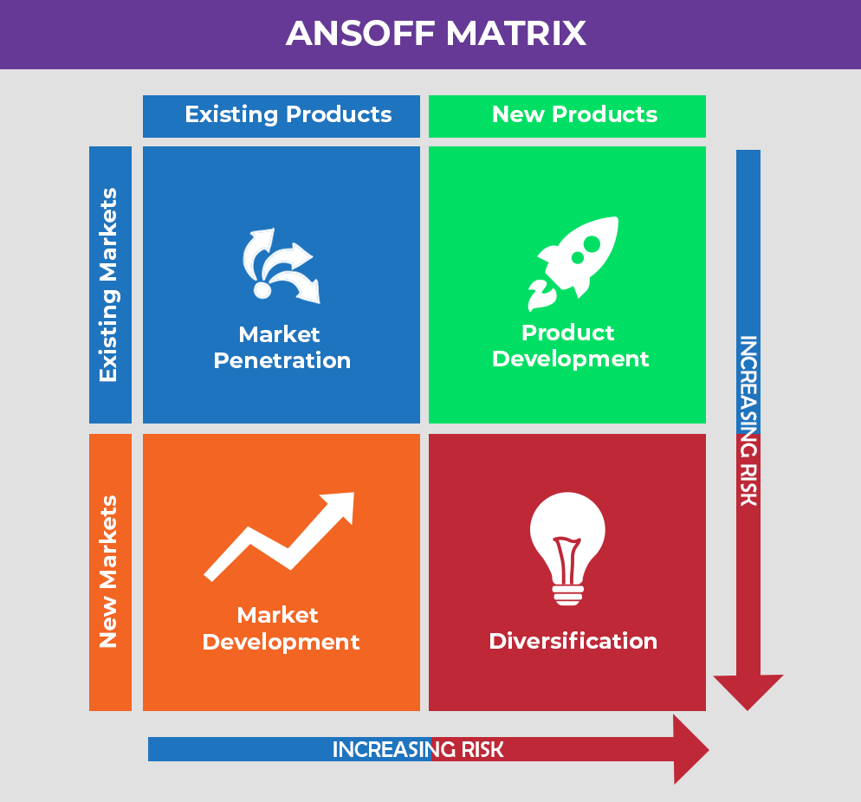
There are four elements to the Ansoff Matrix, which are laid out on a grid. (Figure 1)
Figure 1 – Ansoff Matrix grid
As can be seen, the four elements to Ansoff’s matrix form the grid, their placements on the grid represent the risk involved relative to the age of the product and the market it is in. For example, a newer product will always be on the right hand side of the grid, and if the product is entering a new market, it will always be along the bottom of the grid, those products towards the bottom right of the matrix, are seen as those with the greatest risk, whilst those toward the top left are seen as carrying minimal risk.
Of the four elements, the first is Market Penetration, which is the about already existing products in the same markets, examples of this includes companies opening more branches of the same store amongst the same environments, the second being Product Development, where a company puts a new product in a market they are already established in with their customer base, an example being a company adding to their own portfolio, such as AU Vodka, releasing new flavours to their customer base. The third of the elements is Market Development, where a company takes an already existing product and attempts to sell it to newer audiences. An example here would be a company opening more branches of the same store, but under a different environment, such as a fast food company opening their first chain overseas. Finally, Diversification, seen as the riskiest is where a new product is placed in a new market for the organization Diversification is seen as the riskiest as it involves a company moving into an environment where they have no direct experience to what they are selling, or the market they are selling to. Singer Rhianna is an example with Diversification, as she once moved from selling her music, to selling her own brand of Perfume, in Fenty, to then also releasing a clothing line of Fenty Clothing.

4.0 Manchester United Strategies

4.1 The Model
Manchester United monetize themselves and their brand via three main systems, sponsorship, and retail & licensing (Manchester United, 2023) Manchester United split their sponsorship through global, regional and product segmentation sponsorship, in the year end June 30, 2019, Manchester United have twenty-five global partners, the main ones being Adidas, their kit supplier, TeamViewer, the front of shirt sponsor, Tezos, training wear provider, and DXC Technology, additional shirt sponsor.
As well as commercial, Manchester United business model also includes the revenue of Matchdays and broadcasting. Manchester United play their football in Old Trafford, the second largest stadium in England, and one of the most famous around the world, averaging over 99% attendance every year from 1998 to 2019, with a maximum capacity of 74,140 people.
Broadcasting rights are earned from Manchester United games being televised, as well as their own TV channel MUTV. MUTV broadcast themselves in 56 countries. Manchester United earn broadcasting rights from the Premier League, UEFA competitions such as the UEFA Champions League or UEFA Europa League. Manchester United announced that at June 30th, 2019 a total revenue income from all three segments of £627.1 million

4.2 Manchester United Strategy
Manchester United label their business strategy as aiming to ‘Increase our revenue and profitability by expanding our brand, global community and marketing infrastructure’ Manchester United announced they plan to expand their own broadcasting revenue through an increase in the overall packages agreed with existing TV partners, when looking back to the Ansoff Matrix, this would be seen as Market Penetration, with the product and market remains the same.
Manchester United also announced plans to expand their own broadcasting package, with social media a focus, as well as plans to ‘roll out carefully targeted new products and services’ Manchester United would be following Porters interpretation of strategy here, by deliberately choosing differently from rivals, specifically main city rivals Manchester City, as through their business, they plan to expand their business, via the purchasing of other football clubs (CityFootballGroup, 2023)
Where Manchester United faulter, is with investment, from 2014 through to 2020, Manchester United did not invest a single penny into the club, instead they withdrew £169 Million, ranking them 20th out of 20 for total financing, and also the club who paid the most dividends, at £89 million, where 18 out of 20 didn’t pay dividends to owners at all. (O’Connell, 2020), at a time where Manchester United created the highest revenue of all English football clubs (Statista, 2022) Providing their own investment can significantly improve revenue as investment into the team, would lead to greater chance at success.

5.0 Manchester United’s Possible Future

5.1 Three Possibilities
As of March 10th, 2023, Manchester United and the Glazer Family itself, have three possible outlooks for the future. On November 22nd, 2022, The Glazer family announced they were starting the process to look at ‘strategic alternatives’. (Jackson. Araons, 2022) Since then, there have been two public attempts at a full takeover from the Glazer Family ownership, those being from British chemical company Ineos, fronted by Sir Jim Ratcliffe, as well as Sheikh Jassim bin Hamad Al Thani, the son of a former Qatari Prime Minister.
As well as offers of full takeover, the Glazer Family have also had an approach from an American hedge fund, Elliot Investment Management, who instead of offering a takeover, are offering financial investment on their own (Hall, 2023)
Looking towards both takeover attempts, they are attempts at different takeovers. The Qatar takeover looks at purchasing full 100% ownership, whilst the Ineos takeover attempt is only looking to take over the shares held by the Glazer family, thus becoming majority owner. (Luckhurst 2023)
The third option is to stay the course long haul for the Glazer family, recent indication from outside suggests that is not ideal, as when news broke of the possibility of the Glazer family remaining as owners of the club, the share price dropped by 17% in one week, dropping the valuation of the club by just under 1 billion USD. (Solhekol, 2023)

6.0 Conclusion
Concluding this report, it is clear to see there are still heavy deliberations over strategic management and what the best method of strategy is, although what is clear to see where there is no deliberation, is that it is the consensus that strategy in business revolves around decisions to be made, throughout the definitions of Porter, Chandler and Johnson et al, all mention strategy being about decisions made for a company, the deliberation is still there to show how those decisions should be made.
From looking at the business strategy and model provided in this case, it is clear to see that Manchester United take an approach similar to that of Porter, making their own deliberate choices on their strategy based on what they derive to be the best way to improve the output and revenue streams.

6.1 Recommendations
Manchester United should stay the course with the way they currently deliver their strategy and carry out their management process,. As a whole the way that Manchester United have run their corporate side of operations since they became majority owners in 2005, revenue has increased year on year without any area of business declining, but as well as continuing what they are doing, they can look to other areas as extra.
Manchester United do need to look into more areas where they can generate more revenue. Manchester United are in the sports industry, but they do not generate the revenue through sport in the way they can, Manchester United have taken out money since being taken over, rather than invest into the team to earn the best prizes on field, which in itself would generate the most revenue, and best grow their brand.
Continuous investment into the club to prevent them being overtaken by rivals could be a key factor in determining the success of Manchester United in the future, as Manchester United have an advantage as the team who generated the most revenue in England as of 2020, continuous development of the clubs primary focus, on field activities will drive forward the success of Manchester United.

7.0 References
Ansoff, I. (1965) ‘Corporate strategy’. John Wiley & Sons. First accessed March 9th, 2023.
Ansoff, I. (1957) ‘Strategies for Diversification’. Harvard Business Review. Available at: https://archive.org/details/strategiesfordiversificationansoff1957hbr/mode/2up. First accessed March 9th, 2023.
BBC. (2005) ‘Glazer wins control of Man United’. Available at: http://news.bbc.co.uk/1/hi/business/4540939.stm. First accessed March 7th, 2023.
Brown, A. (2008) ‘Our Club, our rules: fan communities at FC United of Manchester’ Soccer & Society, 346-358. First accessed March 8th, 2023.
Bulby, N. Hassan, B, N. (2023) ‘Who are the Glazer family, owners of Manchester United, and what is their net worth?’. Available at: https://uk.finance.yahoo.com/news/glazer-family-net-worth-180306543.html?guccounter=1&guce_referrer=aHR0cHM6Ly93d3cuYmluZy5jb20v&guce_referrer_sig=AQAAAMzQniohJ0_q6nWzVqOjdjUovnybHZhMJuVv2zv7zidgTXEw7kr22I0MIjScY3P8-U9QpqH3I4X0TuZGR1pOaciTbLTvkSJwcAKYMO1VJkHQxTAct_o-TWfci0lP0yS_9jl02z8vmtX-cmmJOQ-T7FlD8_-fAX0gi-kf_Azuq8Qf. First accessed March 8th, 2023.
Czarnecka, E. (2021) ‘Malcolm Glazer: The Most Diverse Portfolio Ever’. Available at: https://thefinancefriday.com/2021/06/11/malcolm-glazer-diverse-portfolio/. First accessed March 7th, 2023.
D.C, W. (2022) ‘Manchester United plc’. Available at: https://ir.manutd.com/~/media/Files/M/Manutd-IR/documents/manu-20f-2022-09-24.pdf. First accessed March 7th, 2023.
Forbes. (2017) ‘Glazer family’. Available at: https://www.forbes.com/profile/glazer-1/?sh=53a4b65e615e. First accessed March 7th, 2023.
Group, C, F. (2023) ‘Our Business’. Available at: https://www.cityfootballgroup.com/Our-Business. First accessed March 9th, 2023.
Hall, P. (2023) ‘U.S. Hedge Fund Elliott to offer financing for Manchester United takeover bid’. Available at: https://www.reuters.com/lifestyle/sports/us-hedge-fund-elliott-enters-5-billion-stg-bidding-battle-manchester-united-2023-02-18/. First accessed March 9th, 2023.
Hamil, S. (2008) ‘Manchester United: the commercial development of a global football brand. ResearchGate. First accessed March 8th, 2023.
Indeed. (2022) ‘What is Porter’s five forces model? (With examples)’. Available at: https://uk.indeed.com/career-advice/career-development/what-is-porter-five-forces-model#:~:text=The%20five%20forces%20model%20is%20a%20tool%20that,and%20how%20to%20compete%20in%20an%20existing%20industry.. First accessed March 9th, 2023.
Jackson, J. Aarons, E. (2022) ‘Manchester United up for sale as Glazers announce plans to leave Old Trafford’. Available at: https://www.theguardian.com/football/2022/nov/22/manchester-united-up-for-sale-as-glazers-announce-plans-to-leave-old-trafford. First accessed March 8th, 2023.
Johnson, G. Whittington, R. Scholes, K. Angwin, D. Regner, P. (2017) ‘Exploring Strategy’. Pearson Education. First accessed March 7th, 2023.
Josh. (2022) ‘Ansoff Matrix Explained: Practical Examples, Theory, & Strategy’. Available at: https://businessyield.com/business-strategies/ansoff-matrix/. First accessed March 9th, 2023.
Luckhurst, S. (2020) How the Manchester United green and gold movement started and could begin again’. Available at: https://www.manchestereveningnews.co.uk/sport/football/man-united-glazers-green-gold-17595955. First accessed March 8th, 2023.
Luckhurst, S. (2023) ‘Official statement on behalf of Sir Jim Ratcliffe #mufc’. Available at: https://twitter.com/samuelluckhurst/status/1626928636963037184. First accessed March 9th, 2023.
Luckhurst, S. (2023) ‘Official statement confirming Sheikh Jassin Bin Hamad Al Thani’s submission of a bid for to buy Manchester United #mufc’ Available at: https://twitter.com/samuelluckhurst/status/1626678231620366336. First accessed March 9th, 2023.
Porter, M. (2017) ‘Keynote on Strategy By Michael Porter, Professor, Harvard Business School’. Arthsastra. Available at: https://www.youtube.com/watch?v=EvvnoNAUPS0. First accessed March 7th, 2023.
Porter, M. (2008) ‘The five Competitive Forces That Shape strategy’. Harvard Business Review. Available at: https://www.youtube.com/watch?v=mYF2_FBCvXw. First accessed March 9th, 2023.
Porter, M. (1996) ‘What Is Strategy?’ Harvard Business Review. First accessed March 7th, 2023
Press, A. (1995) ‘Buccaneers Sold to Glazer’. Available at: https://www.nytimes.com/1995/01/17/sports/buccaneers-sold-to-glazer.html. First accessed March 7th, 2023.
Ramble, S. (2020) ‘Football clubs generate most if their cash from revenue they earn from fate receipts, TV deals, sponsorship and merchandising, but often they need additional financing, either from their owners or the banks. This thread looks at financing in the Premier League’. Available at: https://twitter.com/SwissRamble/status/1305397873803177984. First accessed March 10th, 2023.
Solhekol, K. (2023) ‘Manchester United: Share price drops amid concerns that Glazers won’t sell club’. Available at: https://www.skysports.com/football/news/11667/12821627/manchester-united-share-price-drops-amid-concerns-that-glazers-wont-sell-club. First accessed March 10th, 2023.

Statista. (2022) ‘Premier League clubs ranked by revenue in the season 2019/2020 (in million U.S. dollars)’. Available at: https://www.statista.com/statistics/566666/premier-league-clubs-by-revenue/. First accessed March 10th, 2023.
tutor2u. (2016) ‘Ansoff Matrix Explained | Business Strategy’. Available at: https://www.youtube.com/watch?v=CMFXsJxi05U. First accessed March 9th, 2023.
United, M. (2023) ‘Business Model’. Available at: https://ir.manutd.com/company-information/business-model.aspx. First accessed March 5th, 2023.
United, M. (2023) ‘Business Strategy’. Available at: https://ir.manutd.com/company-information/business-strategy.aspx. First accessed March 5th, 2023.
United, M. (2023) ‘Global Partners’. Available at: https://www.manutd.com/en/partners/global. First accessed March 8th, 2023.
Week, M. (2005) ‘Man United fans plot assault on sponsors’. Available at: https://www.proquest.com/docview/228191362?pq-origsite=primo. First accessed March 9th, 2023.

