DATABASE MANAGEMENT SYSTEMS – PET CARE

ASSIGNMENT

Marco Vinicio Martínez Garcés
1814732
Index
- Summary.

- Distributed database.

  - Definition of distributed database.

  - Application of distributed database to the company database.

- Fragmentation.

  - Definition fragmentation and types of fragmentation.

  - Application of fragmentation to the company database

- References.

0. Summary
In this report we will speak about the distributed database and how this can be applied to the database of your company. As well as the functioning of the database table by table will be explained and how the fragmentation will be applied to the database.

1.Distributed Database.
1.1 Definition of distributed database.
It is a centralized distributed database management system (DDBMS).
Each DDBMS has multiples servers connected to a master server which is the central server but as a difference of a centralized database. On a DDBMS the rest of servers that are connected to the central servers has their databases, for another hand, one server can access the data of the central server or the data of the other servers. The data can be saved in total on the database of each server and the central server or can be fragmented and save part of the database in the database of the server and the rest on the central server.
Some of the advantages of implement a DDBMS are that it is not reliance on the main server improving the speed to access the database and not overflowing the connection with the database. Another advantage is the availability to continue operative this means that the system will still be working even if the database of a server falls because the server can still be accessing the database that was automatically saved on the main server through the network connections.
An example of DDBMS is showed in the next image.
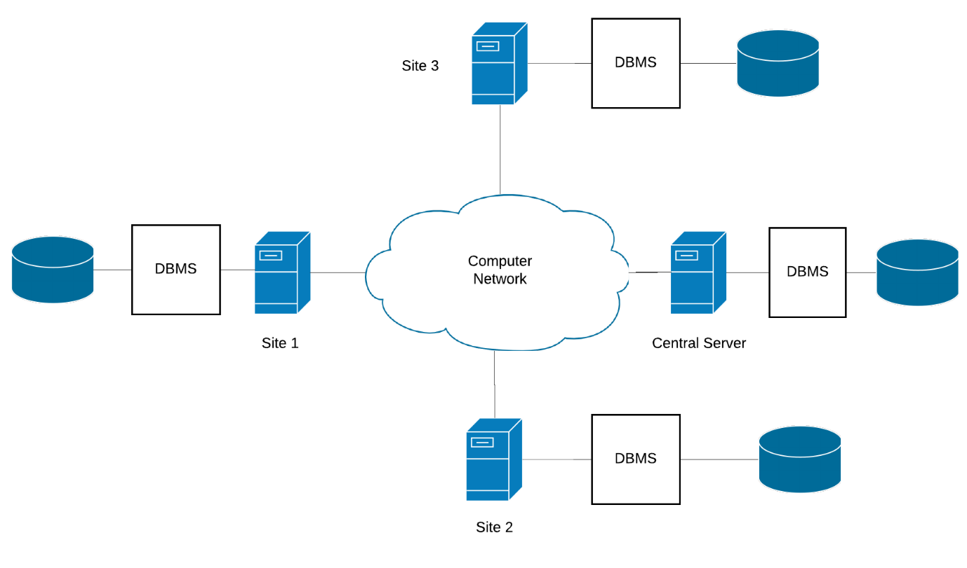

1.2 Application of distributed database to the company database.
As the head office is located in London this will be designed as the main server and all the data will be saved on this server. For the side, each clinic will have its database that will keep all the data of the clinic as customers, animals, visits, and treatments. An automatic backup will be done at the central server for all the clinics which will be helpful in case of failure on the system produce a loss of data, this data could be recovered from the central server and if for any reason the connection with the database is dropped while the clinics are open, will not be any necessity of stopping the work as the database could be able to access from the central server.
The next picture shows the distributed database.
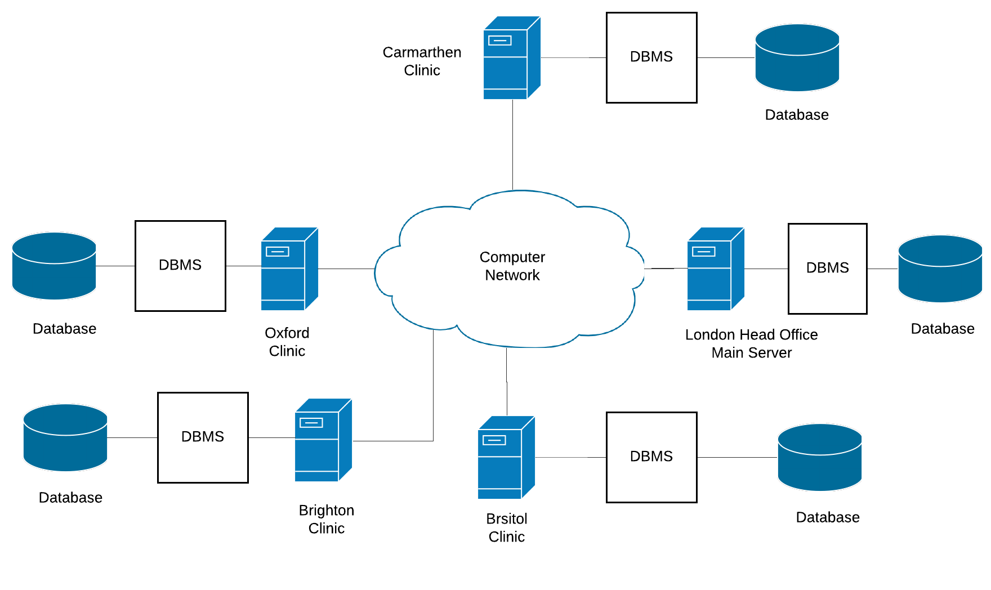
For another side the distribution of the tables will be the next one:
On the main server (London Head office) the tables Region, City, Vet clinic, and a backup of the other tables.
Then each clinic will keep the next tables on their databases, Customer so they can keep the information of customers of the clinic. Pet table to keep the information of the pests that are attending to the clinic or attended to the clinic. Visits table to have a register of the visits done. Treatment table to keep informed of the treatment available on each clinic. Finally, Treatment detail table to keep information about the treatment given on each visit.
2. Fragmentation
2.1 Definition of fragmentation and types of fragmentation.
Fragmentation on a database is the division of a database in two or more fragments that can be stored in different databases. Which gives some advantages to the functioning of the system. These advantages are:
- Security:
Local database kee only essential information preventing to keep unnecessary information. Giving more security to the databases.

- Efficiency:
Fragmentation divides the tables in smaller tables that keep fewer data. So the access to the data is faster, giving more efficiency to the system.

- Parallelism:
When more than one user needs data from the same table they cannot access the table until the previous user finish. But when fragmentation is implemented dividing the information of a table in more than one table, lets the users access to the information that they need by accessing to the fragment that contains the information that is needed.

- Reliability:
As the database is fragmented and each fragment is kept in a different database. Accessing the necessary information will be done through the database nearest to the system that needs it, which improves reliability. As the information is not exposed to a loss of data as is exposed when the data is stored in a database centralized, that takes more time to access and in the way, data is exposed to a loss.
On fragmentation exists three types:
- Horizontal:
Tables will be fragmented based on rows.

Fragment 1

Fragment 2
Table

table

Fragment 3

- Vertical:
Tables will be fragmented based on columns.

Fragment 3
Fragment 1
Fragment 2
Table

table

- Hybrid:
This is a combination of horizontal and vertical fragmentation.

Fragment 2
Fragment 1
Fragment 1
Fragment 3
Fragment 3
Fragment 2
Table

table

2.2 Application of fragmentation to the company database.
The next tables were created for the database bat, not all will be fragmented.

Region Table:
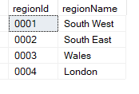

City Table:
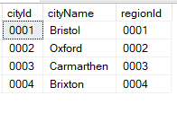

VetClinic Table:
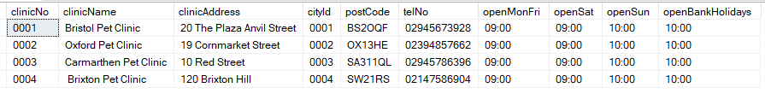
For this table the next fragmentation can be implemented.
Horizontal fragmentation to select all the data from clinics in the same city.
In this case the city selected is “0001” that corresponds to Bristol.
Hybrid fragmentation for select a few columns (clinicNo,clinicName,clinicAddress, postCode, telNo) of the clinics that are in the same city in this case “0002” that is Oxford.
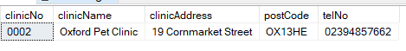
Customer Table:
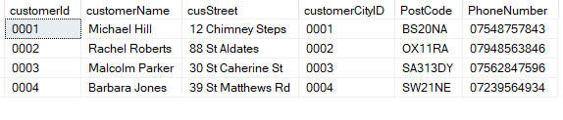

On this table a horizontal fragmentation can be implemented letting the user access the information of all the costumers in the same city in this case the city is Carmarthen.
Pet table:
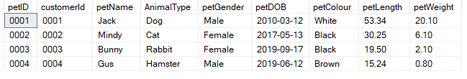
In this table two fragmentations can be implemented.
Horizontal, letting the user see all the information about a pet with the same owner using the customerId in the example the customer used is “0002”.
Hybrid, data of pets with the same animal type can be sorter by animal type without keeping the customer ID. In this case the data is from Dog.
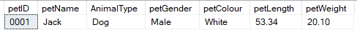
Visits Table:
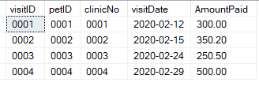

Treatment Detail Table:
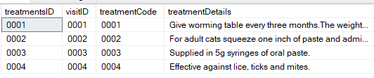

Treatment Table:
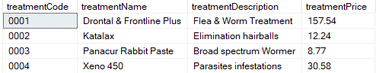

3. References:

References
Idera, n.d. Idera. [Online]
Available at: https://www.idera.com/productssolutions/sqlserver/sqldefragmanager/what-is-fragmentation
Rouse, M., 2018. TechTarget | Search Oracle. [Online]
Available at: https://searchoracle.techtarget.com/definition/distributed-database
TutorrialCup, n.d. TutorialCup. [Online]
Available at: https://www.tutorialcup.com/dbms/data-fragmentation.htm

