
Milk Run Logistics in retail supply chain: a critical literature review
Huy (Kieran) Tran

April 22, 2026
University of Wales Trinity saint david

Table of Contents
Abstract 3
1. Introduction 4
1.1 Problem Identification 4
1.2 Research Design, Scope, and Epistemic Positioning 4
1.3 Research Gap and Problematisation 7
1.4 Contribution to Knowledge 9
1.5 Research Question 10
2. Literature Review 11
2.1 Overview 11
2.2 Milk Run Logistics 12
2.3 Types of Milk Run Logistics 14
Direct Shipping 15
Direct Milk Run Shipping 16
Shipping via Nodes 17
Tailored Shipping 18
2.4 Comparison: Retail vs Industrial Supply Chain 18
Order Frequency 18
Volume and Physical Characteristic 19
Route Planning 20
2.5 Vehicle Routing Problem 21
Optimisation Techniques 23
3. Conclusion 24
Reference 26

Table of Figures
Figure 1. PRISMA flow diagram 5
Figure 2. Problematisation Framework 8
Figure 3. Milk Run Logistics Literature Review Structure 11
Figure 4. Historical Timeline of Milk Run Logistics 13
Figure 5. An Outbound delivery process 14
Figure 6. Direct Shipping Network 14
Figure 7. Milk Run Shipping to multiple locations 15
Figure 8. Shipping via DC 16
Figure 9. Comparison between the TSP (a) and the VRP (b) 20
Figure 10. Conceptual Framework. 23

Table 1. Example of core articles 7
Table 2. Research Gap Matrix. 8
Table 3. CIMO Framework. 11

Abstract
The purpose of this paper is to critically review the literature of Milk Run Logistics and present an overview of its historical development. Traditionally applied in an Industrial manufacturing setting, its use in a Retail context has received limited recognition; therefore, the paper analyses the existing literature and conducts a comprehensive comparison of supply chain management in Retail and Industrial settings. The study also discusses different types of algorithms and chooses the best approach that can be used to support the application of Milk Run on a daily operational basis. It is widely understood that Milk Run is an effective transportation method that can help consolidate different orders onto a single cargo to reduce the total number of delivery journeys. However, in a Retail environment, particularly for small and medium-sized organisations with limited capital investment, a high dependence on Third-party Logistics can be seen, which can negatively impact the business in the long term. As a result, the paper will also discuss the possibility of moving away from 3PL and gaining a competitive advantage thanks to in-house/self-managed operational capabilities.
Keywords: Supply chain, Logistics, Milk run, Algorithm system, Data analysis.

Introduction
In today’s volatile business environment, driven by unpredictable demand, rising operational costs, and increasing customers’ expectations, organisations compete to see who has more competitive advantages. Most importantly, supply chain and logistics are a key component that determines an organisation’s operational and financial health. A good supply chain network considers many aspects like service level, quality, cost, sustainability… Therefore, to satisfy all those aspects, supply chain managers are looking for a better delivery strategy that is more practical and optimal.

Problem Identification
Specifically in the retail sector, the pressure is more significant than ever. Customers demand quick arrival time and fast production cycles from the retailers, which then forces retailers to expect more from the suppliers to provide on-time delivery and higher delivery frequency. The pressure then piles as suppliers and manufacturers now demand their 3PL to satisfy the high demands. This recurring chain of pressure moves upstream through the network, forcing every node on the supply chain (retailers, suppliers/manufacturers, and 3PLs) to maintain a high service level, essentially contributing to the bullwhip effect, where small fluctuations in demand amplify the ordering patterns and operational instability across the supply chain (Sarac et al., 2010). Additionally, post Covid-19 saw a rising popularity of e-commerce, where a single mouse click can initiate a transaction thanks to online digital channels. Hence, the emphasis is on dynamic change and flexibility, because routes can’t be determined beforehand anymore if the customer wants next-day delivery (Du et al., 2007). And as expected, the traditional bulk cargo shipping method, while still popular, is predicted to face difficulties keeping up with the new trend. While it can help by increasing the number of trips, there are risks that those journeys won’t be able to have efficient route planning and space optimisation. Therefore, supply chain managers look back to an old delivery method that was once used a decade ago, the “Milk Run” delivery strategy. This method allows a single vehicle to drop off or pick up goods at multiple destinations using a predetermined route (Chopra and Meindl, 2016).

1.2 Research Design, Scope, and Epistemic Positioning
This early-stage Milk Run Logistics literature review will follow a systematic review approach. First, the study will survey the state of knowledge using existing research and offer a comprehensive background understanding of the topic. The paper will also highlight the current main issues, trends, and complexity to identify a potential direction for future research (Jesson and Lacey, 2011). Next, when conducting comprehensive research like this, it is important to identify the scope of the study to remain focused and avoid going beyond the boundaries. The scope is purposefully divided into four interconnected areas:
• The definition, evolution, and current state of Milk Run Logistics.
• The Vehicle Routing Problem (VRP) and optimisation techniques.
• A structural comparison between Retail and Industrial manufacturing.
• The relationship between the 3PL providers and 3PL users.

For a systematic approach in choosing relevant literature for this critical review, the PRISMA guideline was followed to ensure transparency and standardisation (Kahale et al., 2022). Google Scholar was used as the main academic database, as it also includes studies from various sources like ScienceDirect, Emerald, ResearchGate… Using a combination of keywords such as Milk Run Logistics, Order Consolidation, Heuristic Method, and Retail, with the appropriate publication date. Illustrated in Figure 1, the original search identified 5460 databases related to the topic. After a screening process of removing nearly 5000 sources without using automation tools, the paper has included 100 academic sources, and 17 of them were included in the study. The selection process reveals a significant gap in the literature, as most of the studies were removed because they focus exclusively on Industrial Manufacturing; on the other hand, the number of studies that focus on Milk Run within Retail was close to nothing. Additionally, articles with the keyword Just-in-time were all found to have an old date of publication, with some dating back to the 1990s, revealing that there is a large gap between the Just-in-time Milk Run application and Retail.
Identification of studies via databases and registers

Records removed before screening:
Duplicate records removed
(n = 650)
Records marked as ineligible by automation tools (n = 0)
Records removed for other reasons (n = 130)
Records identified from Google Scholar*:
Databases (n = 5460)
Registers (n = 36)

Identification

Records screened
(n = 4716)
Records excluded** (No Automation tools used)
(n = 4200)

Reports sought for retrieval
(n = 516)
Reports not retrieved
(n = 230)

Screening

Reports assessed for eligibility
(n = 286)
Reports excluded:
Reason 1: Not related to Milk Run Logistics (n = 130)
Reason 2: Published Date
(n = 52)
Reason 3: Non-Academic
(n = 4)

Studies included in review
(n = 100)
Reports of included studies
(n = 17)
Included

*Consider, if feasible to do so, reporting the number of records identified from each database or register searched (rather than the total number across all databases/registers).
**If automation tools were used, indicate how many records were excluded by a human and how many were excluded by automation tools.
Figure 1. PRISMA flow diagram (PRISMA Statement, n.d.).
Furthermore, table 1 shows example of some of the core literature that was gathered on Google Scholars. The papers are from various subjects, with different types of literature review that has strong contribution towards this Milk Run study.
Authors | Discipline | Type of Literature Review | Contribution
Almufti et al. (2023) | Algorithm System | Narrative Review | -Provides narrative review of the origins and developments of Meta-heuristic algorithms.  -Discusses the application of algorithm to solve various issues in Engineering, Supply Chain, Finance…
Braekers et al. (2016) | Supply Chain Management | Systematic Review | -Examines the Vehicle Routing Problem systematically by using different heuristic methods.  -Reviews how VRP significantly impact the costs and efficiency on transportation.
Chopra and Meindl (2019) | Supply Chain Management | Narrative Review | -Examines the definition and classification of different transportation methods for narrative literature review.  -Provides examples of Milk Run being applied onto Retail.
De et al. (2022) | Data Analysis | Narrative Review | -Reviews the process of Data Mining, including techniques on how to recognise pattern, extract and cluster data.
Akhlaqi and Hanapi (2023) | Supply Chain Management | Systematic Review | -Examines methods of task offloading, how to delegate resource intensive tasks to computers.
Ahmed et al. (2020) | Algorithm System | Narrative Review | -Discusses different Heuristic and Meta-heuristic algorithm methods.  -Discusses the Pros and Cons of algorithm systems and highlights its practical value.
Alidaee (2001) | Algorithm System | Systematic Review | -Systematically analyses the Greedy Method for order grouping selection, useful for Milk Run application and this study’s proposed method.
Butta et al. (2022) | Algorithm System | Narrative Review | -Explores different Data Clustering technique for order consolidation for small-sized organisation with limited capital.
Table 1. Example of core articles
At this early proposal stage, this literature review will use the qualitative research approach. By drawing on critical synthesis of existing knowledge and asking open-ended “Why” questions, the subject will be understood in depth and subjective knowledge will be generated (Efron and Ravid, 2018). In later stages, once surveys, sample sizes, and algorithm simulation have been designed, the paper will follow a pragmatic mixed-method framework by combining practical insights and objective data.

1.3 Research Gap and Problematisation
A critical examination of the existing literature shows a large gap that has remained unquestioned by scholars: Milk Run Logistics is currently only being used in an Industrial manufacturing setting (like electronics, automobile, or aeroplane) because they have a stable demand and ordering frequency thanks to a strict production schedule. Existing Milk Run research reflects a manufacturing bias as it assumes only predictable demand and stable routing. On the other hand, Milk Run Logistics has significant limitations when used in a Retail (fast-moving consumer goods, FMCG) setting due to the dynamic nature of demand, creating a theoretical blind spot in understanding how the Milk Run in retail can operate under volatile demands.
Take the cosmetic industry, for example, sales volumes can fluctuate due to many factors like store location, seasonality, and promotional campaigns. As a result, retailers have to place time-sensitive and small orders across a wide product range (different hair dye or lipstick colours). Current studies mentioned that for Milk Run Logistics to work effectively, it relies on a predictable volume, stable ordering pattern, and most importantly, an optimised routing schedule. Furthermore, with Toyota’s introduction of a just-in-time production system that popularised Milk Run in the 2000s (Nemoto et al., 2010), it further cemented its success in manufacturing and in turns, limited its adaptation in a retail context.

Gap Type | What is Missing? | Example | Your Contribution
Theoretical | No developed Milk Run framework for Retail usage. | Studies treat Milk Run as a fixed and static delivery method that can only be used in Industrial. | Theoretical repositioning of Milk Run to become a dynamic, manual process for Retail manufacturing.
Empirical | Lack of real-world simulation and data testing for Milk Run in Retail. | Limited evidence of Milk Run being used in Retail (only few examples found in Chopra and Meindl, 2019). | Test Milk Run within a Retail environment.
Contextual | Narrow focus, dominant assumption limited itself in Industrial context only. | Limited development seen for Milk Run in Retail, since it was established in early 20th century. | The study will problematise current trend, change dominant assumption.
Methodological | Over-reliance on traditional 3PL delivery method, weak self-managed logistics operations. | 3PL is the only delivery option for SMEs with limited capital investment. | Further research will act as a guideline for building a self-managed/in-house supply chain network from scratch.
Table 2. Research Gap Matrix.
With no dedicated approach and framework for using Milk Run in a Retail setting, this paper will challenge the current above-mentioned assumption and initiate the problematisation process by trying to design a daily order grouping and route planning process using heuristics or meta-heuristics algorithms. The study will offer a theoretical repositioning by eliminating a conceptual blind-spot that Milk Run is a context-specific and static technique that can only be utilised from a manufacturing perspective. By designing a flexible and tailored Milk Run route on a daily basis that can be handled in-house, retailers potentially have a new delivery strategy that can challenge the current dominant trend of depending on 3PLs. Figure 2 will recap what has been mentioned throughout this chapter.
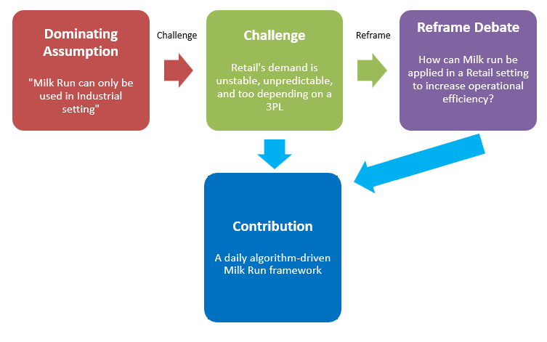
Figure 2. Problematisation Framework.

1.4 Contribution to Knowledge
This literature review will contribute by offering new theoretical and practical understanding of Milk Run. The aim is to expand Milk Run’s usage beyond its traditional manufacturing environment, particularly the retail and FMCG sectors. A positive evaluation of this Milk Run strategy will be modernised the concept and hopefully popularise its adaptation.
- Expanding from the current very limited existing knowledge of Milk Run Logistics in the Retail sector.
- Repositioning Milk Run as a viable option for Self-managed capability.
- Acting as a guide for the design of a daily algorithm-supported process, using heuristics approach (for example Nearest Grouping) to set up delivery route based on criteria like Volume, Delivery Time Window, and Location.
In addition to the theoretical and empirical expansion to the Milk Run concept, the study will also look into relevant theories that will be core phenomenon that provide different perspectives to shape the study in a meaningful and rigorous understanding.
- Resource Dependence Theory (RDT)
This supply chain management theory suggests that stakeholders should collaborate to seek long-term performance, instead of chasing short-term benefits at the expense of others (Sarkis et al., 2011). The main assumption is that it cannot be fully self-sustaining or survive without depending on resources from outside parties. This theory is closely related to the current logistics trend, where small and medium-sized organisations must depend on 3PLs to handle their supply chain. However, Sarkis et al. (2011) added that when depending on other firms, parties must manage this relationship carefully for sustainable development. This statement was further looked into, and a phenomenon was found called Dependence Asymmetry. This happens when one party in a relationship (for example, buyer and seller) relies on the other party more than the reverse, meaning that this is an imbalance of power between the two (Lai et al., 2013). In further research, this spectacle will be further investigated to see if it does happen in the real-world practise or not. As it has been established that it is small and medium-sized companies that have limited capability that normally seek to form relationships with developed parties, might there be a chance that they are being exploited to extract concessions?
- Resource-Based View and Dynamic Capabilities Theory
The Resource-Based View theory is a strategic framework that emphasises the importance of internal capability and resources to achieve competitive advantage (Cuervo-Cazurra et al., 2021). Dynamic Capabilities theory explains the possibility of firms gaining a competitive advantage in a volatile market by utilising, adapting, and reconfiguring external and internal resources (Siems et al., 2021). These two theories are being combined because of their complementarity. While Resource-Based highlights the importance of valuable, rare, inimitable and non-substitutable (VRIN) resources (Cuervo-Cazurra et al., 2021), in this case, vehicle fleets, logistics infrastructure, milk run planning systems… Dynamic Capabilities explain how firms use those resources to find opportunities and transform them into a competitive advantage. Further studies will integrate these two theories to create dynamic capabilities to deliver high efficiency and flexibility. Intending to develop an in-house, self-managed supply chain network using Milk Run, the study will first of all try to find an effective way to obtain those VRIN resources. After that, when Milk Run has been established, it has to be able to develop and sustain the volatile market of Retail.

1.5 Research Question
The CIMO (Context, Intervention, Mechanism, Outcome) framework will be used to design the research question for this topic. The framework is said to be useful for supply chain research because of the applied nature of logistics and is frequently used to transit from identifying problems to designing an actionable solution (Tanskanen et al., 2017). The proposed Milk Run approach will be applied to the CIMO framework in Table 3.

Context | In the retail industry, the demands are very unstable and unpredictable. The current 3PL-managed delivery system face difficulty in vehicle utilisation and space optimisation.
Intervention | A Milk Run algorithm that can group orders and plan routing daily.
Mechanism | Daily order consolidation, self-managed route planning, better control and visibility of the supply chain.
Outcome | Improve truckload efficiency, reduce transportation costs, increase supply chain efficiency.
Table 3. CIMO Framework.
Research Question: “Is Milk Run Logistics an effective method to improve cost and operational efficiency in a palletised retail environment to replace the traditional 3PL model?”
To further add to this, the following sub-questions will break down the main research question and ensure a comprehensive study:
- How influential is Third-party Logistics in today’s market?
- Why was Milk Run Logistics used mostly in an Industrial setting, not Retail?
- What are the challenges and opportunities of implementing an In-house Logistics network using the Milk Run concept as a baseline?
- Can the Milk Run delivery strategy be efficient enough to replace the traditional 3PL model?
- What technology (AI, algorithms…) can be used to make Milk Run an optimal option for Retail distribution?

Literature Review

2.1 Overview
This mind map layers the core elements that the paper will cover. First, the study will briefly introduce the Milk Run concept by stating the definition, historical development, and different types of Milk Run that are critically feasible for the adoption of Retail. Next, the paper will critically compare the difference between Retail and Industrial manufacturing to see why Milk Run is mostly being used in Industrial, and what problems Milk Run will have when being introduced to Retail. Lastly, the study will examine the most prominent challenge of Milk Run overall, which is the Vehicle Routing Problem (VPR). Different optimisation techniques will be critically reviewed to see which is best in this context.

Figure 3. Milk Run Logistics Literature Review Structure.

2.2 Milk Run Logistics
Today’s business landscape is not the same as it was before. For manufacturers, the production of goods does not solely focus on production activities (like scheduling or converting raw materials) but also on the supply chain activities, like raw material procurement and inventory control. Therefore, to have competitive advantages, it is important to balance between process efficiency and cost reduction. To deliver product consistently and at a low price, supply chain managers have to look into smaller operational costs like reducing transportation costs, inventory holding cost, and ordering cost (Minh et al., 2020). Hence, the concept of Milk Run Logistics, which has been extensively explored by Chopra and Meindl (2016) and Minh et al. (2020), is a viable option that can be utilised to replace traditional delivery methods to improve operational efficiency.
The term “Milk Run” was first used to depict milkmen back in the 20th century, as they followed a pre-determined route to pick up old bottles from previous deliveries and drop off fresh new bottles. Daily deliveries ensured that the milk is always fresh and not overstocked. From a logistics perspective, Minh et al. (2020) defined it as a strategy that uses a planning system to preset the route, which allows a single vehicle to arrive at multiple destinations to pick up or drop off goods. This strategy is best known because of its ability to reduce the total number of trips needed to satisfy all the requested orders. If the cargo is less than a truckload, the driver can consolidate different orders to fill up the cargo, ultimately reducing costs like fuel, maintenance, and greenhouse gas emissions. Figure 4 illustrates the historical development of Milk Run throughout the years. Such a useful strategy saw its application in different contexts, for example, in World War II, the Americans set up a convoy route called the Red Ball Express, where trucks stopped at a fixed location at a fixed time to drop off supplies. As the destination and time had been communicated privately beforehand, the soldier could safely pick up supplies under high-pressure conditions (Bamford, 2021). Since then, the concept has been slowly developed for logistical adaptations. Many scholars have investigated and developed theoretical foundations to optimise it. In 1959, George Dantzig and John Ramser introduced the Vehicle Routing Problem, a recurring problem that seeks to allocate and determine optimal routes for a fleet of vehicles, closely related to our Milk Run concept (Braekers et al., 2016). After that, Milk Run was integrated into Toyota’s Just-in-time manufacturing system, globalising the concept. Thanks to its core strength of picking up small, frequent orders of spare parts from multiple suppliers to its assembly location, Toyota was able to keep its inventory small while still having enough stocks to support batch manufacturing (Nemoto et al., 2010). Simultaneously, the concept was also used by Seven Eleven Japan and Walmart, the first recorded example of Milk Run being used in retail, where they consolidated all fresh and perishable products on temperature-controlled trucks, reducing the number of specialised vehicles required for deliveries while enabling frequent replenishment of low required stock (Chopra and Meindl, 2019, pp.75). And then lastly, since the 2000s, Milk Run became highly efficient with the integration of technologies like ERP systems and real-time GPS tracking. Hou et al. (2023) gave various examples when planning systems helped with dynamic route planning based on real-time traffic data, automated ordering using historical data, and real-time visibility for inventory management, increasing Milk Run Logistics’ potential to become a universal supply chain strategy.

Figure 4. Historical Timeline of Milk Run Logistics, adapted from You and Jiao (2014); Bamford (2021); Braekers et al. (2016); Elatar et al. (2023); Du et al. (2007); Nemoto et al. (2010); Chopra and Meidl (2019, pp.75); Hou et al. (2023).
Throughout its historical development, one thing that can be seen from Milk Run’s evolution is a clear trajectory toward greater speed and faster responsiveness. From a rigid and static route planning system used in the dairy industry, to route planning in response to radio communication in World War II, and to a complete dynamic and reactive system thanks to modern technology, completely aligns with today’s demands of a fast and responsive supply chain system. Especially in a retail context, characterised by volatile and unexpected demands, an opportunity reveals where this strategy can be leveraged and applied for FMCG pallet distribution. A responsive model like Milk Run could enable suppliers and manufacturers to move beyond their dependence on traditional transportation methods, like 3PL. However, achieving this potential isn’t that straightforward. In order to use Milk Run effectively, it is vital for an organisation to manage their own supply chain network, meaning that it has to own vehicles and manage its own warehouse system, with more capital investment is required to use a real-time or ERP system. Therefore, it is best to first understand the difference between variations of Milk Run Logistics before deciding to build one. The next chapter will demonstrate different types of Milk Run and evaluate its usefulness under different organisational contexts.
A critical observation across this Milk Run’s evolution process saw a recurring pattern of organisations internalising the supply chain activities to improve control and gain adaptability. From the self-managed convoy route in World War II, to Toyota's in-house Just-in-time manufacturing process, and later, when EPR systems were incorporated to improve real-time visibility. This is consistent evidence of parties shifting from external dependence toward internal ownership. This trajectory aligns with the Dynamic Capabilities Theory, where firms saw changes from external environment and managed to capitalise the opportunities by adapting and reconfiguring their resources. This raises a question for the current contemporary supply chain in retail: with the evidence being mentioned, should suppliers continue their reliance on 3PLs, or should there be a shift towards internal Milk Run development? This study favours the latter option by positioning Milk Run not just as an operational tool for improvement, but as a stepping stone for capability internalisation.

2.3 Types of Milk Run Logistics
It is important to point out that this critical literature review will only focus on the Outbound logistics process of delivering finished goods to the end customer. Historically, Milk Run logistics has mostly been applied in an Inbound context as per its intended use in an industrial setting. Take a train manufacturer, for example, where the author had previous experience, the Milk Run system was used to collect spare parts from multiple suppliers and deliver to a central manufacturing site; this is not the case for Retailing. In contrast, in a cosmetic manufacturing company, for example (another setting where the author had previous experience in), the inbound delivery process was much simpler, as they had finished products delivered in bulk to a central warehouse. The company then proceed with the complex Outbound process of breaking down and completing orders for individual retail stores. This is the first of many differences between Retail and Industrial. Figure 5 depicts an Outbound delivery process where a vehicle drops off deliveries to multiple retailers.
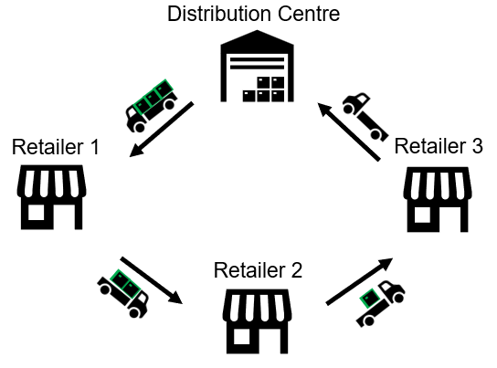
Figure 5. An Outbound delivery process, adapted from Minh et al. (2020).
When talking about Outbound delivery, two types are identified: open-loop and closed-loop. An open-loop delivery starts and ends at a different location, while a closed-loop run is a circular delivery that starts and ends at a different location (Mei et al., 2017). When a delivery does not end at the location where it starts, it usually involves another logistics node (for example, a distribution centre, a warehouse, or a cross-docking hub), which very much depends on the capabilities and physical infrastructure of a company.

Direct Shipping
This is the simplest form of delivery, where the supplier dispatches direct deliveries from its facility to each individual customer’s location (Chopra and Meindl, 2019, pp. 419). By having a local and specified location, the direct shipping method contains both advantages and disadvantages.
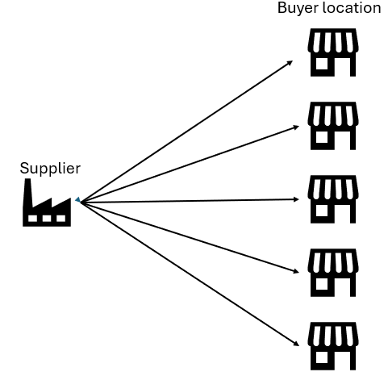
Figure 6. Direct Shipping Network, adapted from Chopra and Meindl (2019).
Questions can be raised to ask why this approach even exists in the first place, as there are superior options on paper. The answer is because it is suitable for specific scenarios: the buyer might need an urgent replenishment for their seasonal products, the location might be in a rural area, or the buyer might need a full truckload of stocks, so consolidation is not an option. Although retailers are characterised as having low volume orders or low ordering frequency, it is still the nature of Retail to have unexpected spikes in demand. Thanks to having minimal coordination requirements, suppliers can also have the option to set up weekly scheduled deliveries to big wholesale or high-street customers. However, these specific scenarios are not very common. Manufacturers usually advise buyers not to order like this, as spending one whole truck to satisfy just one order is not cost-efficient for both parties: higher transportation cost per unit for the buyer, and poor vehicle utilisation for the supplier. To summarise, this option is only used if the buyer urgently needs stocks or needs a full shipment of stock.

Direct Milk Run Shipping
This is where Milk Run is being used in shipping. As explained, this option allows a truck to go straight from the supplier to multiple customers’ locations, as shown in Figure 7. However, this option still hasn’t required any logistics infrastructure, which makes sense when the quantity is still too small for a full truckload (Du et al., 2007). Seven Eleven Japan and Walmart used this option for perishable products, as they have their own temperature-controlled trucks on site (Kunitomo, 1997).
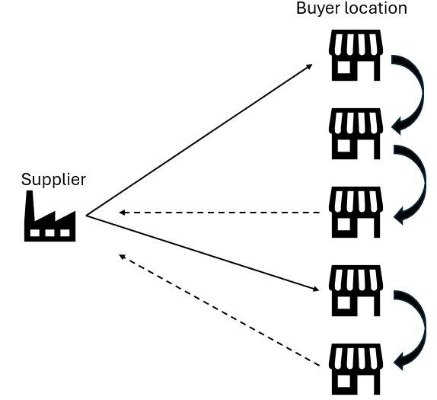
Figure 7. Milk Run Shipping to multiple locations, adapted from Chopra and Meindl (2019).

Shipping via Nodes
In this approach, the supplier starts by sending the cargo to a central node, where logistical activities like storing, bulk-breaking, palletising, packaging… happen depending on the buyer’s requirement. The central logistics node can also be a Cross-docking facility that was designed to fast-track the supply chain process by letting vehicles unload their cargo at the location and transfer immediately without needing time for storage (Mavi et al., 2020). Another central node option is a basic warehouse. Chopra and Meindl (2019, pp. 420) gave another example of W. W. Grainger, a distribution company: as they have many stores in rural areas, they set up 9 warehouses near the store vicinity to supply the smaller quantities they need.
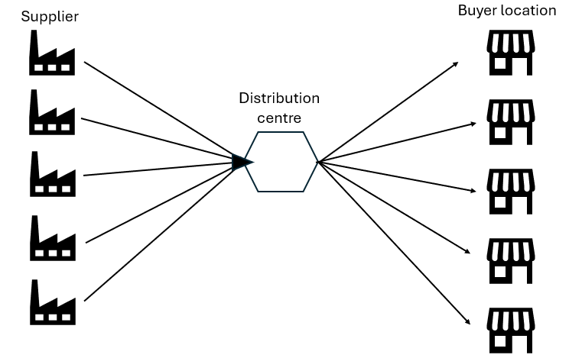
Figure 8. Shipping via DC, adapted from Chopra and Meindl (2019).
As one can imagine, this option is viable for companies that have the capabilities to set up different storage locations and a strong fleet to handle the large number of orders. However, with a fully developed supply chain network, the investment would be a massive stepping stone in terms of scaling the business to increase competitive advantage.

Tailored Shipping
A tailored shipping approach used all the above-mentioned options by combining Milk Runs, cross-docking or warehousing to obtain an adaptable and flexible environment. The aim is to choose an appropriate approach for every different situation, like direct shipping to replenish a high street store and using a DC to supply a smaller store (Chopra and Meindl, 2019, pp. 422). As appealing as it looks, users are advised to involve managing software to control all aspects.
The ideal supply chain trajectory is a progressive movement from the simplest option to the most complicated. Tailored shipping, in theory, is the superior choice that a supply chain manager should be looking toward. But in practise, the transition to fully tailored shipping is rarely straightforward. Moving beyond the obvious factors of capital investment in technology, infrastructure and ERP systems, deeper organisational challenges can emerge. For example, a hybrid option is susceptible to human errors or resistance to changes from both internal and external stakeholders. Therefore, it is debatable that staying within a manageable model like Milk Run direct shipping is unacceptable. Especially in an Outbound Retail environment, a well-managed and consistent Milk Run approach is more pragmatic than an overly ambitious system. The choice between practical feasibility and theoretical optimality is a nuanced gap that will be further investigated in later research. Next, the study will dive into a comparison between Retail and Industrial Supply Chain and see why Milk Run is more popular in the latter option.

2.4 Comparison: Retail vs Industrial Supply Chain
An examination of Milk Run Logistics applications illustrates significant contextual differences between Industrial and Retail manufacturing. As mentioned above, the application of Milk Run in Retail remains under-explored, while Industrial is the opposite. Therefore, this chapter aims to explain the reason for this phenomenon through three important dimensions: Order frequency, Volume and Physical Dimension, and Route planning. This comparison between the two sectors is not just merely a descriptive or highlight of contrasts, but also reveals structural differences in resource requirement, supply chain network design, and performance in different operational conditions.

Order Frequency
Minh et al. (2020) revealed that Milk Run in Industrial manufacturing can benefit thanks to its stable demands and high ordering frequency, and an industrial operation is designed to accommodate daily scheduled production. Again, let’s take a train factory as an example; the production is scheduled based on the assembly stage of the train. High-priority components like engines and wheels usually come early in the morning so the factory can start the assembly process early. In the evening, small and trivial products like bolts, paints, and screws are delivered to restock for the next assembly. Therefore, the ordering process has to be precise so that components arrive exactly when they are needed. Additionally, another prime example is Toyota, which used a Just-in-time lean production system that produces only the necessary parts in the required quantity, no more or no less (Nemoto et al., 2010). With that in mind, they used a re-occurring ordering process that replenishes a small quantity of stock every day.
As opposed to retail, especially in an industry that has a large variety of product types (cosmetics), their ordering frequency is also varied. Depending on the different store locations, the demand can be different: professional salons in populated areas can have more demand than salons in rural areas. The variability disrupts the repetitive rhythm that Milk Run usually offers and in turn increases the reliance on Third-party logistics to deal with the complexity. With that being said, the dominance assumption that Milk Run requires an industrial-style order frequency, as a result, limited its application in retail, despite the growing need for responsive stock replenishment and high-frequency daily ordering.

Volume and Physical Characteristic
There is a mixture of different perspectives when talking about volume. In an Industrial factory, thanks to having a strict production schedule and constant demand, the truckload cargo is always expected to be full. As opposed to retail, unless the delivery location is a high street retail, the cargo is not usually expected to be full. Retail palletised goods distribution, however, is characterised by having low volume per order with a mix of a variety of product types. Therefore, although historically seen as a barrier for traditional types of transportation, an opportunity emerges now for Milk Run if orders are being managed and consolidated properly to make small volume deliveries at multiple locations.
Salleh et al. (2023) studied the physical aspect of automotive production within the supply chain. They mentioned that the components required for cars, like the engines, seats, tyres, windshields, and even raw materials, are very bulky and would require special handling equipment to load. Additionally, physical characteristics are an important factor when considering truck load optimisation. Aspects that can directly affect the Milk Run are packaging of cargo, stackability of cargo, and unloading time… all of that can add up when consolidating orders. On the other hand, the physical characteristics of cosmetic retail are more “handleable” compared to Industrial. Although there is more different stock codes compared to Industrial’s components, the cargo size is nearly the same as they come in pallets, meaning that the loading and space optimising process is easier. This deep research into physical characteristics further differentiates the two industries, as retail goods distribution is generally more palletised and uniform, easier to load and optimised to reduce cargo space wastage. However, it introduces a vital constraint that supply chain managers sometimes overlook, which is flammability and chemical handling, which require additional attention and a separate cargo.

Route Planning
Routing is one of the main reasons why Milk Run is most common in industrial contexts. For Industrial manufacturing, the shipping location or dropping point is often recurring and predetermined as vehicles make the same round-trip deliveries, allowing for repeated deliveries with fewer variables and less complexity. For retail, however, the route planning process requires more flexibility because today's delivery might not be the same as yesterday’s delivery. This is why Milk Run in Retail needs a daily and manual optimisation process to satisfy the varied demands. That is the objective that this doctoral research is aiming at: designing an algorithm that can design Milk Run deliveries daily.
Furthermore, as the delivery locations of retail stores are mostly in urban areas, this adds more complexity to consider, such as congestion charges, traffic, and last-mile delivery. The drivers have to traverse in congested and tight areas, which can mostly add to the cost and duration of every delivery journey. Additionally, Nemoto et al. (2010) added an important fact that retailers’ warehouses in urban areas are often small because of limited space; therefore, their procurement process has to be precise for the space they have. This requirement for dynamic route planning further increases the dependency on third-party logistics, which are experts in managing complex last-mile transportation.

This critical review of literature reveals a large gap in the market for a dynamic and manual order consolidation system. It moves beyond mere description by adding theoretical knowledge and personal experience to illustrate practical and meaningful debates to problematise and tackle the current assumption. The three dimensions mentioned above have highlighted the reason why Milk Run has historically flourished in an Industrial setting; still, the literature also reveals positive factors that support the application of Milk Run within Retail. For example, the need for consolidation of small volume replenishment orders or the need for consolidation of dangerous goods into one specialised cargo. These characteristics further strengthen the case for Milk Run adaptation from a Resource-Based View (RBV). Unlike the irregular and bulky shape of Industrial components that require special handling equipment, the uniform pallet size and small volume per order of retail offer simplicity by easing the vehicle loading process and order consolidation. From an RBV perspective, these factors can be transformed into valuable capabilities that help the internalising process become easier. And with this simplified characteristic, firms not only can be cost-effective but also develop logistics routines that gain competitive advantages. This internalisation opportunity can again reduce dependency on 3PLs and form a strong foundation for a resilient, self-managed supply chain process.
By diving deep into the three dimensions, the paper hopes to highlight that there is practical evidence that Milk Run can be used in a Retail context, and it is possible to reposition Milk Run as a viable option for reducing dependence on 3PLs while still improving operational efficiency. The next chapter will look into the Vehicle Routing Problem, a more specialised and theoretically heavy topic, to understand how scholars solved Milk Run-related issues. It will also focus on different algorithms that can be used to help Milk Run work in retail.

2.5 Vehicle Routing Problem
The Vehicle Routing Problem (VRP) was first introduced by Dantzig and Ramser in 1959, aims to find the most optimal and efficient set of routes for a fleet of vehicles to serve multiple customer locations while minimising total distance and cost. It remains one of the most well-studied problems with more than 5400 research paper since it was first introduced (Gora et al., 2020). Braeker et al. (2016) mentioned that the VRP in the 60s were much different from the current one, as the original objective of those issues were to raise awareness of environmental footprint and climate change. However, in today’s world, it has been modernised to serve various supply chain problems like transport planning, fuel and distance cost calculation and waste management, and most noticeably, Milk Run Logistics.
The VRP is considered as a generalisation of the Traveling Salesman Problem (TSP), which is an optimisation problem that involve finding the shortest possible route to visit a set of location exactly once and return to the original starting point (Herdianti et al., 2021). While TSP seeks to find an exact answer by finding out a single route that can reach all location, VRP extends this to the whole supply chain (multiple vehicles and routes) to find the most optimal delivery process; therefore, it is personally considered more related to Milk Run as it incorporates different constraints, like vehicle capacity, traffic, time windows… (Herdianti et al., 2021). The figures below explain the difference between the two concepts, a single-route service versus a multiple-route service.
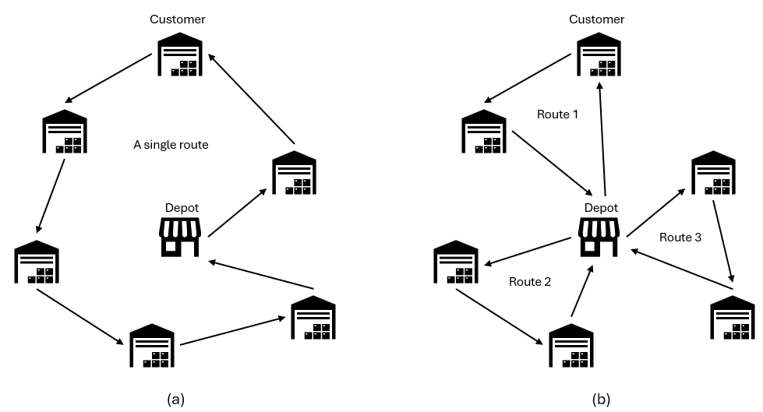
Figure 9. Comparison between the TSP (a) and the VRP (b), adapted from Herdianti et al. (2021).
Various studies, including Minh et al. (2020), Mei et al. (2017), You & Jiao (2014), Eroglu and Hofer (2011), etc., have shown that their method of solving VRPs consists of three main parameters: Volume (based on vehicle capacity), Time Window (or Time Constraint), and Distance. These criteria are not chosen randomly; in fact, they dictate the basic service trade-offs and necessary requirements for any multi-stop distribution system. Without needing much explanation, Volume is a vital component for order consolidation. By combining multiple small shipments together onto one cargo (while still within the vehicle’s capacity limit), Milk Run can potentially achieve greater efficiency by spreading transportation costs across every order. The objective is to minimise the travelling Distance as much as possible, because this is the main cost factor. The higher the distance travelled, the greater the cost for fuel, driver wages, vehicle maintenance, and emissions. Time windows, on the other hand, promote operational synchronisation and service reliability. This is considered the most complex criterion when designing a Milk Run, as there are external factors that cannot be predicted beforehand, for example: a customer might book a delivery slot that messes up the whole route planning, or there might be an accident that blocks the road and affects the travelling time. Therefore, these three parameters are interdependent and must be well-considered and balanced out.
There will be situations where trade-offs must be made to ensure a positive result out of the delivery, as it is impossible to satisfy all three criteria. But which criteria should take priority over others, and what factor can justify sacrificing a criterion to improve the overall outcome? There is no definitive right or wrong answer in this context; instead, the approach should be pragmatic and context-sensitive, which is: depending on the company’s direction. If the company is focusing on cutting costs, their Milk Run should cover the least distance possible; if they want to focus on efficiency, they should consolidate all orders to maximise the vehicle’s capacity; and if they want to build their brand or improve customer service, they should focus on delivering goods on time. And it is important that one should only choose to focus on one criterion, rather than focusing on all three. With this approach, the Milk Runs can also improve the “big picture” perspective by guiding the organisation to its desired outcome.
It has been established many times above that in Retail, the demand can be unexpected and highly trend-driven; volume and routing are also highly volatile. Therefore, these characteristics prevented deliveries from being planned beforehand like Industrial manufacturing. Recognising this gap, the Milk Run implementation in Retail requires a daily and manual optimisation plan to accommodate those fluctuating patterns. The following chapter will demonstrate different types of optimisation techniques and choose the one that fits the most.

Optimisation Techniques
Milk Run is essentially a sequence of processes; a good Milk Run is a set of correct sequences. Ahmed et al. (2020) mentioned that optimisation techniques are methods used to find the best solution to a complex problem, by minimising or maximising the objective outcome (minimising the total cost and maximising the total profit). Two types of techniques were classified: Approximate methods and Exact methods (Ahmed et al., 2020; Gavrilas, 2010). Exact methods are mostly used for scientific and mathematical calculations and require heavy computational resources and calculation time; therefore, they are not a good choice for daily Milk Run design. The Approximate methods, based on their name, are used to find a near-correct, approximate answer that is quick and optimal enough for basic use. There are two types of Approximate methods: Heuristics and Meta-heuristic methods.
- Heuristic method
Heuristic methods can be used to obtain a near-optimal solution for a calculation with an acceptable timeframe; this approach prioritises feasibility and speed over mathematical optimality (Salleh, 2023). A near-optimal answer is not necessarily an incorrect answer; it’s a practical approximation to a problem, especially when a precise answer is not possible to achieve (Salleh, 2023). They are transparent, easy to understand, and don’t require computational investment, making them good for daily operational usage. Simplifying a difficult question allows for quick decision-making; in this case, which orders should be on the Milk Run or which direction to go first. Even when a near-correct answer is generated, it still involves the use of human knowledge and expertise to make a decision. This reduces reliance on AI or any automation system, which is practical in industries where customers sometimes have specific or unique requirements that require human judgment.
- Meta-heuristics method
These are higher-level approaches that are used to find solutions to problems with a large domain space, where a traditional calculation approach is not possible to solve the problem (Gil-Rios et al., 2021). Experts said that meta-heuristic methods require historical data to improve their convergence efficiency and speed, and they also involve random factors when the calculation gets stuck (Almufti et al., 2023). They should be used with caution and a thorough industry-specific understanding of the problem. Furthermore, these methods require a strong investment in technology to support the analysis, although not as much as the Exact method, but still not viable for day-to-day use.

Although the actual Milk Run algorithm design hasn’t been finalised yet in this early-stage research, given the characteristics of a daily and manual process, this study favours a simple heuristic approach that prioritises speed and usability over optimality. Furthermore, the Dynamic Capabilities Theory suggests that in a highly unstable retail environment, the ability to adapt and reconfigure resources are important in gaining competitive advantage. As a result, heuristic approach that can rapidly create daily route planning is more vital than chasing small trivial gains through complex computational efforts. For example, the Clustering Algorithm, a technique that organises unlabelled data into groups based on their similarities, can be used to group orders together into one Milk Run (De et al., 2022). And each group of deliveries must satisfy the three criteria. Another heuristic method that can be used is Greedy Grouping, which is a strategy that chooses the “best” decision possible in the current situation (Alidaee et al., 2001). This method is useful for the actual route designing, by choosing the next best delivery location. The next best location can be the nearest location if the company choose to save money, or the location that matches the time window if the company choose to improve their customer service.
The chosen methods are intentionally human-centred so that logistics planners or even the driver can understand and execute them with judgment if there are real-world disruptions. While acknowledging that these heuristic strategies lack complexity and sacrifice optimality compared to meta-heuristic methods, these approaches link perfectly with the study’s contribution to knowledge, of creating a system that combats the high-frequency and volatile nature of Retail.

Conclusion
This critical literature review on Milk Run Logistics contained different types of delivery methods and identified the most suitable one, illustrated the difference between Milk Run within Retail versus Industrial manufacturing, and provided methods for solving Milk Run problems. The paper has successfully identified the gap in the knowledge and problematised it by challenging the current dominant assumption. It has been heavily implied that Milk Run hasn’t been utilised for retail purposes; hence, limited knowledge or recorded evidence in this context was found.
Drawing on the Resource-Based View and Dynamic Capabilities Theory that emphasise the importance of creating and adapting competitive advantage based on internal resources, the paper has also tried to develop a simple and manual heuristic approach that embeds three main criteria (volume, distance, time window). Although still in an early stage, the aim is to create a flexible, transparent, and adaptable tool for daily usage that directly addresses the volatile market of Retail.
In conclusion, while the current trend of 3PL dependence is still very high, suppliers and manufacturers should be aware of the long-term drawbacks if they don’t manage the relationship properly. In the later stage of the research, the findings will bridge the gap between this lean-inspired routing system and the practical real-world realities of the retail supply chain. The conceptual framework below will recap the relationship between the variables and the outcome that this study hopes to achieve.

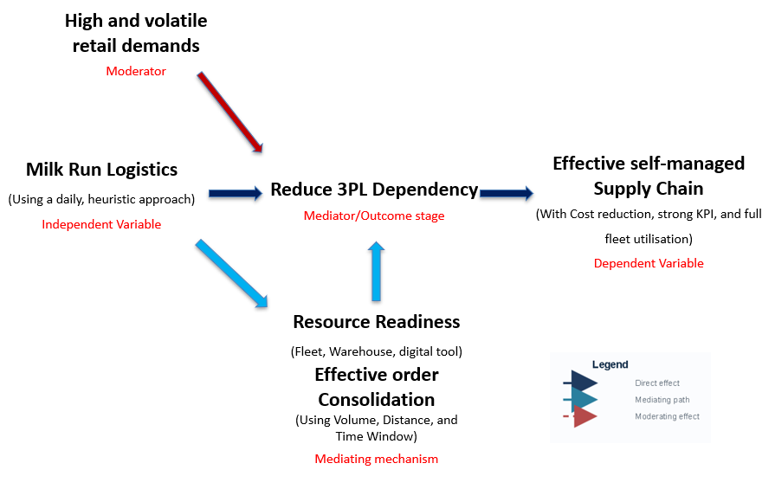
Figure 10. Conceptual Framework.

Reference
- Adida, E. and DeMiguel, V. (2011) 'Supply chain competition with multiple manufacturers and retailers', Operations Research, 59(1), pp. 156–172. Available at: https://doi.org/10.1287/opre.1100.0863.
- Agrawal, N., Smith, S.A. and Tsay, A.A. (2002) 'Multi-vendor sourcing in a retail supply chain', Production and Operations Management, 11(2), pp. 157–182. Available at: https://doi.org/10.1111/j.1937-5956.2002.tb00489.x.
- Ahmed, Z. E., Saeed, R. A., Mukherjee, A., Ghorpade, S. N. (2020) ‘10 - Energy optimization in low-power wide area networks by using heuristic techniques’, LPWAN Technologies for IoT and M2M Applications, pp. 199-223. Available at: https://www.sciencedirect.com/science/article/pii/B9780128188804000119
- Akhlaqi, M.Y. and Mohd Hanapi, Z.B. (2023) 'Task offloading paradigm in mobile edge computing-current issues, adopted approaches, and future directions', Journal of Network and Computer Applications, 212, pp. 103568. Available at: https://doi.org/10.1016/j.jnca.2022.103568.
- Alidaee, B., Kochenberger, G.A. and Amini, M.M. (2001) 'Greedy solutions of selection and ordering problems', European Journal of Operational Research, 134(1), pp. 203–215. Available at: https://doi.org/10.1016/S0377-2217(00)00252-6.
- Almufti, S., Ahmad Shaban, A., Ismael Ali, R., and A. Dela Fuente, J. (2023) ‘Overview of Metaheuristic Algorithms’, Polaris Global Journal of Scholarly Research and Trends, 2(2), pp. 10–32. Available at:https://doi.org/10.58429/pgjsrt.v2n2a144
- Amoako-Gyampah, K. and Gargeya, V.B. (2001) 'Just-in-time manufacturing in ghana', Industrial Management + Data Systems, 101(3), pp. 106–113. Available at: https://doi.org/10.1108/02635570110386562.
- Anand, N. and Grover, N. (2015) 'Measuring retail supply chain performance', Benchmarking: An International Journal, 22(1), pp. 135–166. Available at: https://doi.org/10.1108/BIJ-05-2012-0034.
- Andrejic, M. (2023) 'Modeling retail supply chain efficiency: Exploration and comparative analysis of different approaches', Mathematics (Basel), 11(7), pp. 1571. Available at: https://doi.org/10.3390/math11071571.
- Banerjee, M. and Mishra, M. (2017) 'Retail supply chain management practices in india: A business intelligence perspective', Journal of Retailing and Consumer Services, 34, pp. 248–259. Available at: https://doi.org/10.1016/j.jretconser.2015.09.009.
- Baltazar, J.R., Fernandes, C.I., Ramadani, V. (2023) ‘Family business succession and innovation: a systematic literature review.’ Review of Managerial Science, 17, pp. 2897–2920. Available at: https://doi.org/10.1007/s11846-022-00607-8
- Barratt, M. and Oke, A. (2007) 'Antecedents of supply chain visibility in retail supply chains: A resource-based theory perspective', Journal of Operations Management, 25(6), pp. 1217–1233. Available at: https://doi.org/10.1016/j.jom.2007.01.003.
- Bocewicz, G., Banaszak, Z., Rudnik, K., Smutnicki, C., Witczak, M. and Wójcik, R. (2021) 'An ordered-fuzzy-numbers-driven approach to the milk-run routing and scheduling problem', Journal of Computational Science, 49, pp. 101288. Available at: https://doi.org/10.1016/j.jocs.2020.101288.
- Bocewicz, G., Nielsen, I. and Zbigniew, B. (2019) 'A decision support model for prototyping in-plant milk-run traffic systems', IFAC-PapersOnLine, 52(13), pp. 814–819. Available at: https://doi.org/10.1016/j.ifacol.2019.11.230.
- Boysen, N., Stephan, K. and Schwerdfeger, S. (2024) 'Order consolidation in warehouses: The loop sorter scheduling problem', European Journal of Operational Research, 316(2), pp. 459–472. Available at: https://doi.org/10.1016/j.ejor.2024.02.042.
- Boysen, N., Stephan, K. and Weidinger, F. (2022) 'Efficient order consolidation in warehouses: The product-to-order-assignment problem in warehouses with sortation systems', IISE Transactions, 54(10), pp. 963–975. Available at: https://doi.org/10.1080/24725854.2021.2004336.
- Boysen, N., Stephan, K. and Weidinger, F. (2019) 'Manual order consolidation with put walls: The batched order bin sequencing problem', EURO Journal on Transportation and Logistics, 8(2), pp. 169–193. Available at: https://doi.org/10.1007/s13676-018-0116-0.
- Braekers, K., Ramaekers, K. and Van Nieuwenhuyse, I. (2016) 'The vehicle routing problem: State of the art classification and review', Computers & Industrial Engineering, 99, pp. 300–313. Available at: https://doi.org/10.1016/j.cie.2015.12.007.
- Brar, G. S. and Saini, G. (2011) ‘Milk Run Logistics: Literature Review and Directions’ Proceedings of the World Congress on Engineering 2011, 1. Available at : https://www.iaeng.org/publication/WCE2011/WCE2011_pp797-801.pdf
- Butta, R., Kamaraju, M. and Sumalatha, V. (2022) ‘4 - Heuristic methods for data clustering’ Artificial Intelligence in Data Mining, pp. 65-86. Available at: https://www.sciencedirect.com/science/article/pii/B9780128206010000033
- Cao, Z., Lin, C., Zhou, M., Zhou, C. and Sedraoui, K. (2023) 'Two-stage genetic algorithm for scheduling stochastic unrelated parallel machines in a just-in-time manufacturing context', IEEE Transactions on Automation Science and Engineering, 20(2), pp. 936–949. Available at: https://doi.org/10.1109/TASE.2022.3178126.
- Chen, J., Wang, K. and Huang, Y. (2021) 'An integrated inbound logistics mode with intelligent scheduling of milk-run collection, drop and pull delivery and LNG vehicles', Journal of Intelligent Manufacturing, 32(8), pp. 2257–2265. Available at: https://doi.org/10.1007/s10845-020-01637-3.
- Chicco, G. and Mazza, A. (2020) 'Metaheuristic optimization of power and energy systems: Underlying principles and main issues of the ‘rush to heuristics’', Energies (Basel), 13(19), pp. 5097. Available at: https://doi.org/10.3390/en13195097.
- Chopra, S., Meindl, P., Kalra, D. V. (2019) ‘Supply Chain Management: Strategy, Planning, and Operation’ (7th ed.). Pearson Education.
- Cuervo-Cazurra, A., Dieleman, M., Hirsch, P., Rodrigues, S.B. and Zyglidopoulos, S. (2021) 'Multinationals’ misbehavior', Journal of World Business: JWB, 56(5), pp. 101244. Available at: https://doi.org/10.1016/j.jwb.2021.101244.
- de Vass, T., Shee, H. and Miah, S.J. (2021) 'Iot in supply chain management: A narrative on retail sector sustainability', International Journal of Logistics, 24(6), pp. 605–624. Available at: https://doi.org/10.1080/13675567.2020.1787970.
- De, S., Dey, S., Bhatia, S., Bhattacharyya, S. (2022) ‘Chapter 1 - An introduction to data mining in social networks’ Advanced Data Mining Tools and Methods for Social Computing, pp. 1-25. Available at: https://www.sciencedirect.com/science/article/pii/B9780323857086000084
- Dror, M. and Hartman, B.C. (2007) 'Shipment consolidation: Who pays for it and how much?', Management Science, 53(1), pp. 78–87. Available at: https://doi.org/10.1287/mnsc.1060.0607.
- Du, T., Wang, F.K. and Lu, P. (2007) 'A real-time vehicle-dispatching system for consolidating milk runs', Transportation Research. Part E, Logistics and Transportation Review, 43(5), pp. 565–577. Available at: https://doi.org/10.1016/j.tre.2006.03.001.
- Dutta, P., and Mahanand, B. S. (2022) ‘Chapter 9 - Affordable energy-intensive routing using metaheuristics’ Cognitive Big Data Intelligence with a Metaheuristic Approach, pp. 193-210. https://www.sciencedirect.com/science/article/pii/B9780323851176000133
- Dumrongsiri, A., Fan, M., Jain, A. and Moinzadeh, K. (2008) 'A supply chain model with direct and retail channels', European Journal of Operational Research, 187(3), pp. 691–718. Available at: https://doi.org/10.1016/j.ejor.2006.05.044.
- Efron, S. E., and Ravid, R. (2018) ‘Writing the literature review: A practical guide’ Guilford Publications.
- Elatar, S., Abouelmehdi, K. and Riffi, M.E. (2023) 'The vehicle routing problem in the last decade: Variants, taxonomy and metaheuristics', Procedia Computer Science, 220, pp. 398–404. Available at: https://doi.org/10.1016/j.procs.2023.03.051.
- Eroglu, C. and Hofer, C. (2011) 'Lean, leaner, too lean? the inventory-performance link revisited', Journal of Operations Management, 29(4), pp. 356–369. Available at: https://doi.org/10.1016/j.jom.2010.05.002.
- Fedorko, G., Molnar, V., Honus, S., Neradilova, H. and Kampf, R. (2018) ‘The Application of Simulation Model of a Milk Run to Identify the Occurrence of Failures’ International Journal of Simulation Modelling, 17(3), pp. 444-457. Available at: https://www.researchgate.net/publication/327669749_The_Application_of_Simulation_Model_of_a_Milk_Run_to_Identify_the_Occurrence_of_Failures
- Fernandes, A.A.A., Koehler, M., Konstantinou, N., Pankin, P., Paton, N.W. and Sakellariou, R. (2023) 'Data preparation: A technological perspective and review', SN Computer Science, 4(4), pp. 425. Available at: https://doi.org/10.1007/s42979-023-01828-8.
- Forliano, C., Ferraris, A., Bivona, E. and Couturier, J. (2022) 'Pouring new wine into old bottles: A dynamic perspective of the interplay among environmental dynamism, capabilities development, and performance', Journal of Business Research, 142, pp. 448–463. Available at: https://doi.org/10.1016/j.jbusres.2021.12.065.
- Friedli, T., Goetzfried, M. and Basu, P. (2010) 'Analysis of the implementation of total productive maintenance, total quality management, and just-in-time in pharmaceutical manufacturing', Journal of Pharmaceutical Innovation, 5(4), pp. 181–192. Available at: https://doi.org/10.1007/s12247-010-9095-x.
- Ganesan, S., George, M., Jap, S., Palmatier, R.W. and Weitz, B. (2009) 'Supply chain management and retailer performance: Emerging trends, issues, and implications for research and practice', Journal of Retailing, 85(1), pp. 84–94. Available at: https://doi.org/10.1016/j.jretai.2008.12.001.
- Gaukler, G.M., Seifert, R.W. and Hausman, W.H. (2007) 'Item-level RFID in the retail supply chain', Production and Operations Management, 16(1), pp. 65–76. Available at: https://doi.org/10.1111/j.1937-5956.2007.tb00166.x.
- Ge, D., Pan, Y., Shen, Z., Wu, D., Yuan, R. and Zhang, C. (2019) 'Retail supply chain management: A review of theories and practices', Journal of Data, Information and Management (Online), 1(1-2), pp. 45–64. Available at: https://doi.org/10.1007/s42488-019-00004-z.
- Gora, P., Bankiewicz, D., Karnas, K., Kazmierczak, W., Kutwin, M., Perkowski, P., Plotka, S., Szczurek, A. and Zieba, D. (2020) ‘Chapter 2 - On a road to optimal fleet routing algorithms: a gentle introduction to the state-of-the-art’ Smart Delivery Systems, pp. 37-92. Available at: https://www.sciencedirect.com/science/article/abs/pii/B9780128157152000142
- Gil-Rios, M., Cruz-Aceves, I., Cervantes-Sanchez, F., Guryev, I. and Lopez-Hernandez, J. (2021) ‘Chapter 8 - Automatic enhancement of coronary arteries using convolutional gray-level templates and path-based metaheuristics’ Recent Trends in Computational Intelligence Enabled Research, pp. 129-153. Available at: https://www.sciencedirect.com/science/chapter/edited-volume/abs/pii/B9780128228449000050
- Grzegorz, B., Izabela, N., Arkadiusz, G. and Zbigniew, B. (2021) 'Reference model of milk-run traffic systems prototyping', International Journal of Production Research, 59(15), pp. 4495–4512. Available at: https://doi.org/10.1080/00207543.2020.1766717.
- Gyulai, D., Pfeiffer, A., Sobottka, T. and Váncza, J. (2013) 'Milkrun vehicle routing approach for shop-floor logistics', Procedia CIRP, 7, pp. 127–132. Available at: https://doi.org/10.1016/j.procir.2013.05.022.
- Hakim Gusti, M.L. and Aryanny, E. (2023) 'Determining the optimal milk distribution route using the ant colony optimization method on milk industry', Spektrum Industri, 21(2), pp. 141–148. Available at: https://doi.org/10.12928/si.v21i2.92.
- Herdianti, W., Gunawan, A.A.S. and Komsiyah, S. (2021) 'Distribution cost optimization using pigeon inspired optimization method with reverse learning mechanism', Procedia Computer Science, 179, pp. 920–929. Available at: https://doi.org/10.1016/j.procs.2021.01.081.
- Holl, A., Pardo, R. and Rama, R. (2010) 'Just-in-time manufacturing systems, subcontracting and geographic proximity', Regional Studies, 44(5), pp. 519–533. Available at: https://doi.org/10.1080/00343400902821626.
- Hosseini, S.D., Akbarpour Shirazi, M. and Karimi, B. (2014) 'Cross-docking and milk run logistics in a consolidation network: A hybrid of harmony search and simulated annealing approach', Journal of Manufacturing Systems, 33(4), pp. 567–577. Available at: https://doi.org/10.1016/j.jmsy.2014.05.004.
- Hou, J., Chen, G., Huang, J., Qiao, Y., Xiong, L., Wen, F., Knoll, A. and Jiang, C. (2023) 'Large-scale vehicle platooning: Advances and challenges in scheduling and planning techniques', Engineering (Beijing, China), 28(9), pp. 26–48. Available at: https://doi.org/10.1016/j.eng.2023.01.012.
- HUANG, M., HAO, Y., WANG, Y., HU, X. and LI, L. (2023) 'Split-order consolidation optimization for online supermarkets: Process analysis and optimization models', Frontiers of Engineering Management, 10(3), pp. 499–516. Available at: https://doi.org/10.1007/s42524-022-0221-5.
- Hübner, A. H., Kuhn, H. and Sternbeck, M.G. (2013) 'Demand and supply chain planning in grocery retail: An operations planning framework', International Journal of Retail & Distribution Management, 41(7), pp. 512–530. Available at: https://doi.org/10.1108/IJRDM-05-2013-0104.
- Hwang, H. and Chang, S.Y. (2005) 'Order consolidation for batch processing', Journal of Combinatorial Optimization, 9(1), pp. 121–138. Available at: https://doi.org/10.1007/s10878-005-5488-z.
- Jesson, J., Matheson, L., & Lacey, F. M. (2011) ‘Doing your literature review: Traditional and systematic techniques’ Thousand Oaks, CA: SAGE.
- Kahale, L. A., Elkhoury, R., El Mikati, I., Pardo-Hernandez, H., Khamis, A. M., Schünemann, H. J., Haddaway, N. R., and Akl, E. A. (2021) ‘Tailored PRISMA 2020 flow diagrams for living systematic reviews: a methodological survey and a proposal’. F1000Research, 10 (192). Available at: https://doi.org/10.12688/f1000research.51723.3
- Kang, K., Hong, K., Kim, K.H. and Lee, C. (2017) 'Shipment consolidation policy under uncertainty of customer order for sustainable supply chain management', Sustainability, 9(9), pp. 1675. Available at: https://doi.org/10.3390/su9091675.
- Kent, J.L. and Mentzer, J.T. (2003) 'The effect of investment in interorganizational information technology in a retail supply chain', Journal of Business Logistics, 24(2), pp. 155–175. Available at: https://doi.org/10.1002/j.2158-1592.2003.tb00050.x.
- Kiani Mavi, R., Goh, M., Kiani Mavi, N., Jie, F., Brown, K., Biermann, S. and Khanfar, A. A. (2020) 'Cross-docking: A systematic literature review', Sustainability, 12(11), pp. 4789. Available at: https://doi.org/10.3390/su12114789.
- Kilic, H.S., Durmusoglu, M.B. and Baskak, M. (2012) 'Classification and modeling for in-plant milk-run distribution systems', International Journal of Advanced Manufacturing Technology, 62(9-12), pp. 1135–1146. Available at: https://doi.org/10.1007/s00170-011-3875-4.
- Kim, T.H., Choi, B., Lee, J. and Sambamurthy, V. (2021) 'Portfolio effects of knowledge management strategies on firm performance: Complementarity or substitutability?', Information & Management, 58(4). Available at: https://doi.org/10.1016/j.im.2021.103468.
- Kitamura, T. and Okamoto, K. (2012) 'Automated Route Planning for Milk-run Transport Logistics Using Model Checking', IEEE, pp. 240–246. Available at https://ieeexplore.ieee.org/document/6424570.
- Kluska, K. and Pawlewski, P. (2018) 'The use of simulation in the design of milk-run intralogistics systems', IFAC-PapersOnLine, 51(11), pp. 1428–1433. Available at: https://doi.org/10.1016/j.ifacol.2018.08.314.
- Korytkowski, P. and Karkoszka, R. (2016) 'Simulation-based efficiency analysis of an in-plant milk-run operator under disturbances', International Journal of Advanced Manufacturing Technology, 82(5-8), pp. 827–837. Available at: https://doi.org/10.1007/s00170-015-7442-2.
- Kovacs, A. (2011) 'Optimizing the storage assignment in a warehouse served by milkrun logistics', International Journal of Production Economics, 133(1), pp. 312–318. Available at: https://doi.org/10.1016/j.ijpe.2009.10.028.
- Kumar, P.S., Michael, L.K., Mathew, A.O. and Sriram, K.V. (2019) 'Optimisation of milk run logistics for an automotive component manufacturer – A case study', Calitatea, 20(171), pp. 27–34. Available at: https://www.proquest.com/docview/2262015744?pq-origsite=gscholar&fromopenview=true&sourcetype=Scholarly%20Journals
- Kunimoto, R. (1997) ‘Seven-Eleven is revolutionising grocery distribution in Japan’ Long Range Planning, 30(6), pp. 877-889. Available at: https://www.sciencedirect.com/science/article/pii/S0024630197000733
- Lai, F., Chu, Z., Wang, Q. and Fan, C. (2013) 'Managing dependence in logistics outsourcing relationships: Evidence from China', International Journal of Production Research, 51(10), pp. 3037–3054. Available at: https://doi.org/10.1080/00207543.2012.752591.
- Lara, C.L. and Wassick, J. (2023) 'The future of supply chain - a perspective from the process and online retail industries', Computers & Chemical Engineering, 179, pp. 108401. Available at: https://doi.org/10.1016/j.compchemeng.2023.108401.
- Lenstra, J. K., & Kan, A. H. G. (2006) ‘Complexity of vehicle routing and scheduling problems’ Networks, 11(2), pp. 221-227. Available at: https://www.researchgate.net/publication/229563032_Complexity_of_vehicle_routing_and_scheduling_problems
- Lochan, S.A., Rozanova, T.P., Bezpalov, V.V. and Fedyunin, D.V. (2021) 'Supply chain management and risk management in an environment of stochastic uncertainty (retail)', Risks (Basel), 9(11), pp. 1–14. Available at: https://doi.org/10.3390/risks9110197.
- Lyu, Z., Lin, P., Guo, D. and Huang, G.Q. (2020) 'Towards zero-warehousing smart manufacturing from zero-inventory just-in-time production', Robotics and Computer-Integrated Manufacturing, 64, pp. 101932. Available at: https://doi.org/10.1016/j.rcim.2020.101932.
- Mackelprang, A.W. and Nair, A. (2010) 'Relationship between just-in-time manufacturing practices and performance: A meta-analytic investigation', Journal of Operations Management, 28(4), pp. 283–302. Available at: https://doi.org/10.1016/j.jom.2009.10.002.
- Mao, Z., Huang, D., Fang, K., Wang, C. and Lu, D. (2019) Milk-run routing problem with progress-lane in the collection of automobile parts Springer Science and Business Media LLC.
- Mazanai, M. (2012) 'Impact of just-in-time (JIT) inventory system on efficiency, quality and flexibility among manufacturing sector, small and medium enterprise (SMEs) in south africa', African Journal of Business Management, 6(17) Available at: https://doi.org/10.5897/AJBM12.148.
- Mei, H., Jingshuai, Y., Teng, M.A., Xiuli, L.I. and Ting, W. (2017) 'The modeling of milk-run vehicle routing problem based on improved C-W algorithm that joined time window', Transportation Research Procedia (Online), 25, pp. 716–728. Available at: https://doi.org/10.1016/j.trpro.2017.05.453.
- Mia, L. (2000) 'Just-in-time manufacturing, management accounting systems and profitability', Accounting and Business Research, 30(2), pp. 137–151. Available at: https://doi.org/10.1080/00014788.2000.9728931.
- Minh, N.D., Kien, D.T. and Hau, P.K. (2020) 'Applying milk-run method to optimize cost of transport: An empirical evidence', International Journal of Supply and Operations Management, 7(2), pp. 178–188. Available at: https://doi.org/10.22034/IJSOM.2020.2.6.
- Nemoto, T., Hayashi, K. and Hashimoto, M. (2010) 'Milk-run logistics by Japanese automobile manufacturers in Thailand', Procedia - Social and Behavioral Sciences, 2(3), pp. 5980–5989. Available at: https://doi.org/10.1016/j.sbspro.2010.04.012.
- Oke, A. and Gopalakrishnan, M. (2009) 'Managing disruptions in supply chains: A case study of a retail supply chain', International Journal of Production Economics, 118(1), pp. 168–174. Available at: https://doi.org/10.1016/j.ijpe.2008.08.045.
- PRISMA Statement (n.d.) ‘PRISMA Flow Diagram’. Available at https://www.prisma-statement.org/prisma-2020-flow-diagram
- Purba, H.H., Fitra, A. and Nindiani, A. (2019) 'Control and integration of milk-run operation in Japanese automotive company in Indonesia', Management and Production Engineering Review, 10(1) Available at: https://doi.org/10.24425/mper.2019.128246.
- Quan, C., He, Q., Ye, X. and Cheng, X. (2021) 'Optimization of the milk-run route for inbound logistics of auto parts under low-carbon economy', Journal of Algorithms & Computational Technology, 15 Available at: https://doi.org/10.1177/17483026211065387.
- Randall, W.S., Gibson, B.J., Clifford Defee, C. and Williams, B.D. (2011) 'Retail supply chain management: Key priorities and practices', The International Journal of Logistics Management, 22(3), pp. 390–402. Available at: https://doi.org/10.1108/09574091111181381.
- Salleh, N.A.M., Ahmad, S.F., Shaharudin, M.R. and Rahim, S.A. (2023) 'Evaluation of transportation distance optimization route for milk run logistics system', International Journal of Supply and Operations Management, 10(3), pp. 295–318. Available at: https://doi.org/10.22034/IJSOM.2022.109361.2347.
- Sarac, A., Absi, N. and Dauzère-Pérès, S. (2010) 'A literature review on the impact of RFID technologies on supply chain management', International Journal of Production Economics, 128(1), pp. 77–95. Available at: https://doi.org/10.1016/j.ijpe.2010.07.039.
- Sarkis, J., Zhu, Q. and Lai, K. (2011) 'An organizational theoretic review of green supply chain management literature', International Journal of Production Economics, 130(1), pp. 1–15. Available at: https://doi.org/10.1016/j.ijpe.2010.11.010.
- Shin, S. and Eksioglu, B. (2015) 'An empirical study of RFID productivity in the U.S. retail supply chain', International Journal of Production Economics, 163, pp. 89–96. Available at: https://doi.org/10.1016/j.ijpe.2015.02.016.
- Siems, E., Land, A. and Seuring, S. (2021) 'Dynamic capabilities in sustainable supply chain management: An inter-temporal comparison of the food and automotive industries', International Journal of Production Economics, 236, pp. 108128. Available at: https://doi.org/10.1016/j.ijpe.2021.108128.
- Singh, G. and Singh Ahuja, I. (2014) 'An evaluation of just in time (JIT) implementation on manufacturing performance in Indian industry', Journal of Asia Business Studies, 8(3), pp. 278–294. Available at: https://doi.org/10.1108/JABS-09-2013-0051.
- T. Qu, Y. D. Chen, Z. Z. Wang, D. X. Nie, H. Luo and G. Q. Huang, (2015) 'Internet-of-Things-based just-in-time milk-run logistics routing system', 2015 IEEE 12th International Conference on Networking, Sensing and Control pp. 258–263. Available at: https://ieeexplore.ieee.org/document/7116045
- Tanskanen, K., Ahola, T., Aminoff, A., Bragge, J., Kaipia, R. and Kauppi, K. (2017) 'Towards evidence-based management of external resources: Developing design propositions and future research avenues through research synthesis', Research Policy, 46(6), pp. 1087–1105. Available at: https://doi.org/10.1016/j.respol.2017.04.002.
- Souza, R.D., William, L. and Lee, C.K. (2019) ‘Marginalizing Last Mile Logistics Cost through 4th Party Milk Run’ Advances in Science, Technology and Engineering Systems Journal, 4 (4), pp. 462-467.Available at: https://www.astesj.com/publications/ASTESJ_040456.pdf
- Vlachos, I.P. (2014) 'A hierarchical model of the impact of RFID practices on retail supply chain performance', Expert Systems with Applications, 41(1), pp. 5–15. Available at: https://doi.org/10.1016/j.eswa.2013.07.006.
- Wen, X., Choi, T. and Chung, S. (2019) 'Fashion retail supply chain management: A review of operational models', International Journal of Production Economics, 207, pp. 34–55. Available at: https://doi.org/10.1016/j.ijpe.2018.10.012.
- Wenzel, M., Danner-Schoroder, A., and Spee, P. (2021) ‘Dynamic Capabilities? Unleashing Their Dynamics through a Practice Perspective on Organizational Routines’ Journal of Management Inquiry, 30(4). Available at https://journals.sagepub.com/doi/10.1177/1056492620916549
- Xiao, Y. and Watson, M. (2019) 'Guidance on conducting a systematic literature review', Journal of Planning Education and Research, 39(1), pp. 93–112. Available at: https://doi.org/10.1177/0739456X17723971.
- Xu, Y. and Chen, M. (2018) 'An internet of things based framework to enhance just-in-time manufacturing', Proceedings of the Institution of Mechanical Engineers. Part B, Journal of Engineering Manufacture, 232(13), pp. 2353–2363. Available at: https://doi.org/10.1177/0954405417731467.
- Xu, Y. and Chen, M. (2016) 'Improving just-in-time manufacturing operations by using internet of things based solutions', Procedia CIRP, 56, pp. 326–331. Available at: https://doi.org/10.1016/j.procir.2016.10.030.
- Yang, C., Lee, Y. and Lee, C. (2025) 'Data-driven order consolidation with vehicle routing optimization', Sustainability, 17(3), pp. 848. Available at: https://doi.org/10.3390/su17030848.
- Yavuz, M. and Akçali, E. (2007) 'Production smoothing in just-in-time manufacturing systems: A review of the models and solution approaches', International Journal of Production Research, 45(16), pp. 3579–3597. Available at: https://doi.org/10.1080/00207540701223410.
- You, Z., Jiao, Y. and Wu, H. (2014) 'Development and application of milk-run distribution systems in the express industry based on saving algorithm', Mathematical Problems in Engineering, 2014(1) Available at: https://doi.org/10.1155/2014/536459.
- Zahra, S.A., Petricevic, O. and Luo, Y. (2022) ‘Toward an action-based view of dynamic capabilities for international business’, J Int Bus Stud ,53, pp. 583–600. Available at https://doi.org/10.1057/s41267-021-00487-2
- Zairi, M. (1998) 'Best practice in supply chain management: The experience of the retail sector', European Journal of Innovation Management, 1(2), pp. 59–66. Available at: https://doi.org/10.1108/14601069810217239.
- Zhang, J., Chen, Y., Li, Q. and Li, Y. (2023) 'A review of dynamic capabilities evolution—based on organisational routines, entrepreneurship and improvisational capabilities perspectives', Journal of Business Research, 168. Available at: https://doi.org/10.1016/j.jbusres.2023.114214.
- Zhang, Y., Huang, M., Hu, X. and Sun, L. (2018) 'Package consolidation approach to the split-order fulfillment problem of online supermarkets', The Journal of the Operational Research Society, 69(1), pp. 127–141. Available at: https://doi.org/10.1057/s41274-017-0230-7.
- Zhang, Y., Sun, L., Hu, X. and Zhao, C. (2019) 'Order consolidation for the last-mile split delivery in online retailing', Transportation Research.Part E, Logistics and Transportation Review, 122, pp. 309–327. Available at: https://doi.org/10.1016/j.tre.2018.12.011.
- Zhu, P., Lv, X., Shao, Q., Kuang, C. and Chen, W. (2024) 'Optimization of green multimodal transport schemes considering order consolidation under uncertainty conditions', Sustainability, 16(15), pp. 6704. Available at: https://doi.org/10.3390/su16156704.

