UNIVERSITY OF WALES: TRINITY SAINT DAVID PRIFYSGOL CYMRU: Y DRINDOD DEWI SANT

Unit Code: LCBB4004
Marketing Fundamentals

Blogs as part of communication activities

Module lecturer: Efua Adams
Student name: Ionut-Adrian Voinea
Student ID: Student: 2008573
Dated: 24th of February 2021
Words: 1823

Contents
Introduction 2
Theoretical notions 2
ZZuppa Blogs 4
References 13

Introduction
Current paper aims to present a summary of marketing core principles and a practical application of blogs, as part of communication activities for a new idea of venture, ZZuppa.

Theoretical notions
Among the various definitions for marketing will remind the one provided by the “marketing father”, Philip Kotler that defined marketing as: “the science and art of exploring, creating, and delivering value to satisfy the needs of a target market at a profit. Marketing identifies unfulfilled needs and desires. It defines, measures, and quantifies the size of the identified market and the profit potential. It pinpoints which segments the company can serve best and it designs and promotes the appropriate products and services.” (Kotler, 2018).
The organizations operate in the marketing environment, defined as the sum of factors (internals and externals) that border the organizations and that influences in a significant way the business decisions, strategy, and actions (Megha, 2015).
The internal factors refer at: staff, customers, shareholders, and the external factors are evaluated most frequently through PESTLE framework measuring the political, economic, social, technologic, legal and environment factors. Most of the organizations cannot influence these factors but can control them using business decisions in their operations in relationship with the factor’s evolution, on continuous basis. In order to have the ability to overcome the potential negative impact of external factors, organizations must evaluate in an objective way the marketing environment (Megha, 2015).
Marketing environment, presented in figure 1 below, refers to:
- internal marketing environment, can be entirely controlled by the organization and are within the organization
- microenvironment, can be controlled in some degree by the organization and this can influence them
- macroenvironment, cannot be controlled by the organization, must be evaluated periodically to prevent their potential negative influence, these factors are not directly linked with the organization operations

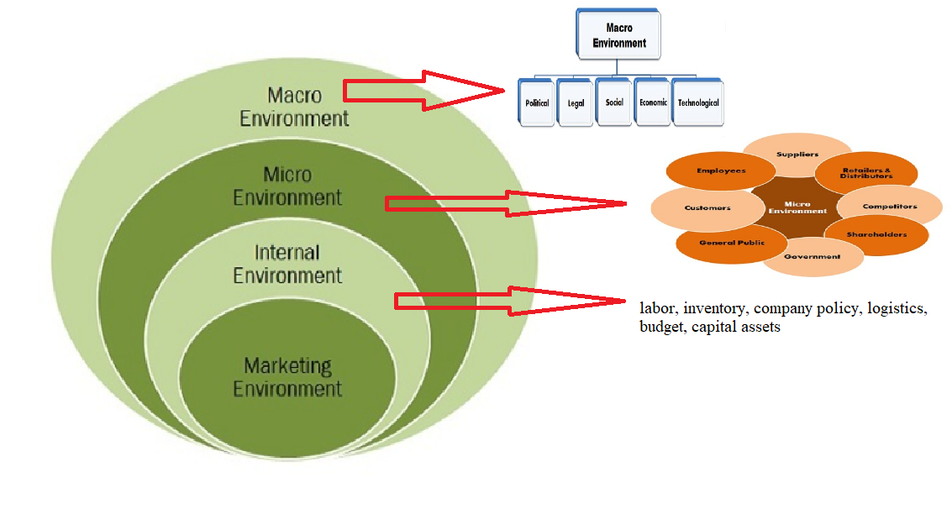
Figure1: Marketing environment (designed by author)
Marketing mix, term used for the first time in 1949 by Neil Borden was developed initially with four elements (product, price, promotion, place), being extended in 1981 by Booms and Bitner towards nowadays 7P marketing mix, detailed in figure 2 below. As noticed from the figure, in the focus and central point of all marketing activities is placed the targeted market, the customers aimed by the organizations to buy/consume their products or services.
As part of their communication strategy organizations use blogs, defined as written content on a website, providing a direct connection with the readers, sharing ideas (Blog Starter, 2021). The main characteristic of a blog is the chronology, thus the most recent post is seen firstly.
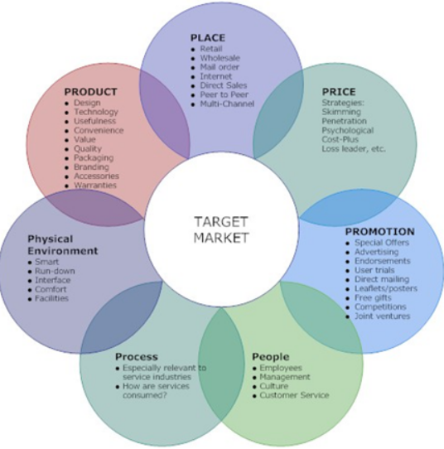
Figure 2: 7P Marketing mix (Kerne, 2020)

ZZuppa Blogs
Slide 1

Slide 2

Slide 3

Slide 4

Slide 5

Slide 6

Slide 7

Slide 8

Slide 9

References
Blog Starter (2021) How to start a blog in 2021 Available from: https://www.theblogstarter.com/?gclid=Cj0KCQiAj9iBBhCJARIsAE9qRtDI3lqMUpPLNt-xxRswNlFLl8-roXJo9IY1L2kDWYmqNhjKfuyx6MUaAmtKEALw_wcB [viewed 15 February 2021]
Megha M., (2015) Marketing Environment. Available from: https://businessjargons.com/marketing-environment.html [viewed 15 February 2021]
Skrba, A. 2021) How to start a blog Available from: https://firstsiteguide.com/start-blog/ [viewed 16 February 2021]

Kotler, P. (2018) Principles of marketing, 17th, global ed., Pearson Harlow

