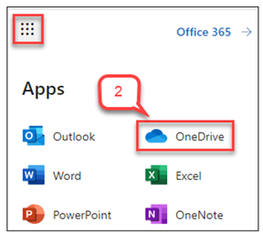
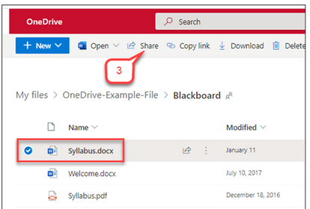
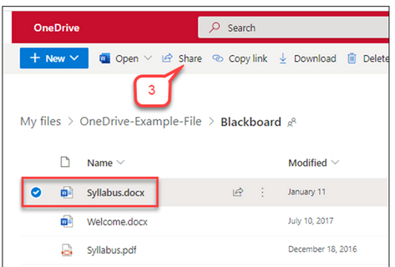
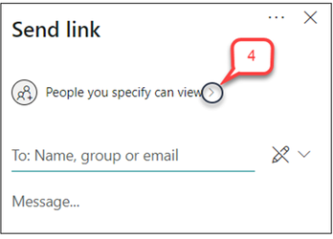
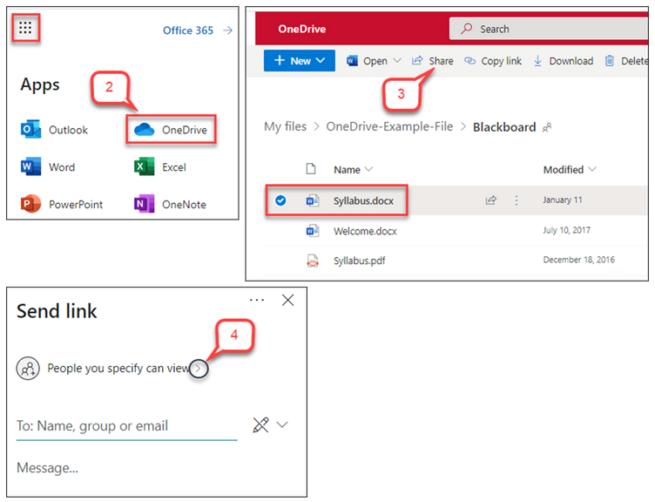
Student No: 2434168
SADIA NADEEM
HOW TO SHARE A FILE ON ONE DRIVE
- Open Office 365 App Launcher
To start the process of sharing a file through OneDrive, first log in to your
Office 365 account using your web browser. Once logged in, look at the top left
corner of the screen where you will see the App Launcher icon represented by
a small grid of nine dots. This icon gives you quick access to various Microsoft
apps. Click on it to expand
the menu of applications. From this menu, you will
be
able
to
select
the
appropriate
service
you
want
to
use
in
this
case,
OneDrive.
- Select OneDrive
After clicking on the App Launcher, a menu displaying various Microsoft 365
applications
such
as
Outlook,
Word,
Excel,
PowerPoint,
and
OneNote
will
appear. Look for the OneDrive icon, which is represented by a blue cloud, and
click on it. This will redirect you to your personal or organisational OneDrive
storage
area.
OneDrive
serv
es
as
a
cloud
storage
platform
where
you
can
upload, access, and manage your files securely from any device with internet
access.
- Choose the file to share
In OneDrive, go to the folder with your file (e.g., "Syllabus.docx"), check
the box next to it, then click the "Share" button in
the top menu to choose
how and with whom to share it.
- Configure Share Settings
Click “Share” to open the “Send Link” panel and adjust access permissions
).
e.g., allow editing, set expiration
(

Enter the recipi
ent’s email or name, add an optional message, then click
Send to share the file.
- Send the Link

Click the “Send” icon to email the link, or choose “Copy link” to share
manually.

Recipi
ents can access the file based on your set permissions, which
you can update anytime.
Overall steps by procedure:

