
Master of Business Administration
Evaluating the Strategic Position of Tesla in the United Kingdom Market

Module Name: Strategic Management
Module Code: LCMB7003

Student Name: Hira Akter
Student ID: 2530059
Lecturer’s Name: Gladius Kulothungan

Word Count: 5,000 words (±10%)
Submission Deadline: 12th August

Table of Contents
Table of Contents 2
List of Figures 3
List of Tables 3
Section 1: Strategic Analysis 4
1. Organisational Context and Overview 4
2. External and Internal Analysis 6
2.1 External Analysis: PESTEL 6
2.2 Internal Analysis: VRIO 9
2.3 SWOT Synthesis 11
3. A Holistic View: CSR and the Balanced Scorecard 13
3.1 Corporate Social Responsibility and Strategic Alignment 13
3.2 Balanced Scorecard 13
4. Strategic Choices and Implementation 16
4.1 Business-Level Strategic Options 16
4.2 Implementation Challenges and Mitigations 19
Section 2: Reflective Account 21
Description 21
Feelings 21
Evaluation 21
Analysis 22
Conclusion 23
Action Plan 23
Reference List 24

List of Figures
Figure 1: BYD overtakes Tesla in UK registrations, 2024–2025
Figure 2: UK BEV market growth versus Tesla's decline
Figure 3: Tesla global revenue by segment, 2025
Figure 4: Tesla operating margin, 2022–2025
Figure 5: PESTEL materiality for Tesla's UK position
Figure 6: VRIO assessment of Tesla's key resources
Figure 7: Porter's five forces in the UK EV market
Figure 8: Ansoff positioning of the recommendation
Figure 9: Balanced-scorecard illustrative targets
Figure 10: Recommendation priority matrix

List of Tables
Table 1: Prioritised PESTEL analysis (Section 2.1)
Table 2: VRIO analysis of Tesla's resources (Section 2.2)
Table 3: SWOT summary (Section 2.3)

Section 1: Strategic Analysis

1. Organisational Context and Overview
Tesla is a strange company to assess right now, because it is winning and losing at the same time. Founded in 2003 and led by Elon Musk since 2008, it grew from a niche maker of electric sports cars into the company that forced the entire car industry to go electric. Its mission is plain: to accelerate the world's transition to sustainable energy (Tesla, 2026). The vision follows from it, a world running on solar power, battery storage and electric transport. The business model is unusual for a carmaker. Tesla sells directly to customers rather than through dealers, controls its own charging network, updates its cars over the air like phones, and increasingly sells software, Full Self-Driving, as a subscription.
The history matters because it explains both the strength and the current weakness. Tesla's Roadster (2008) proved an electric car could be desirable rather than worthy. The Model S (2012) made it a credible luxury product. The Model 3 (2017) took it to volume. Each step widened the market, and by the early 2020s Tesla was the most valuable carmaker in the world and the default EV brand. That first-mover advantage built the brand, the charging network and the manufacturing scale that still matter today. But the same history left a line-up that is now ageing: the Model Y refresh has stalled, and the affordable model long promised has not arrived, which is precisely the gap rivals have exploited.
This report focuses on one market and one product line: Tesla's passenger electric vehicles in the United Kingdom. This narrowing is deliberate. Tesla operates globally across cars, energy storage and services, and a report attempting to address all of these areas would offer limited insight into any of them. The UK market is significant because it constitutes Tesla's largest European market and, in 2025, the context in which its central strategic problem became most apparent (Reuters, 2026).
The relevant industry is the UK's new-car market and, specifically, its fast-growing battery-electric segment. This segment grew strongly in 2025, with battery-electric vehicles reaching well over a fifth of all new registrations (SMMT, 2026). Tesla was, for a number of years, the clear market leader, its principal competitors being the legacy carmakers, Volkswagen, BMW and Ford, as they gradually electrified their ranges. That position has since changed, and the most significant competitor is now BYD, the Chinese manufacturer that entered Britain rapidly and at low cost. Tesla's market position in early 2026 is consequently uncomfortable: it remains a strong and recognised brand, and the best-known EV name, yet it is no longer the best-selling EV brand in Britain, having been overtaken by a rival that barely registered two years earlier (New AutoMotive, 2026). This reversal frames the analysis that follows.
Tesla's competitive set in the UK has widened considerably, and three groups now exert pressure on its position. Legacy premium brands, including BMW, Mercedes and Audi, have electrified their ranges and reclaimed affluent buyers who previously defaulted to Tesla. Volume incumbents, led by the Volkswagen Group as the largest BEV seller in Britain at approximately 20% of the segment, together with Hyundai-Kia at around 10%, compete vigorously on price and range. The Chinese entrants, most notably BYD, have arrived rapidly: since Britain, unlike the EU, imposes no tariff on Chinese-made EVs, BYD has expanded from a near-standing start to overtake Tesla in individual months of 2026 (Electrek, 2026). Tesla remains the best-selling single EV brand in Britain, but it now defends that position rather than extending it.
A single financial consideration frames the entire assessment. In 2025, Tesla's global revenue declined 3% to $94.8bn, automotive revenue fell 10% to $69.5bn, and net income dropped 46% to $3.8bn, while deliveries fell 8.6% to 1.64 million and the company lost its position as the world's largest EV manufacturer to BYD (Tesla, 2026; CNBC, 2026). The energy business, however, grew by 27%, and fourth-quarter margins recovered. This is not a company in decline, but rather one whose core automotive business is under pressure while a distinct part of the enterprise continues to prosper. This divergence underlies the analysis that follows.
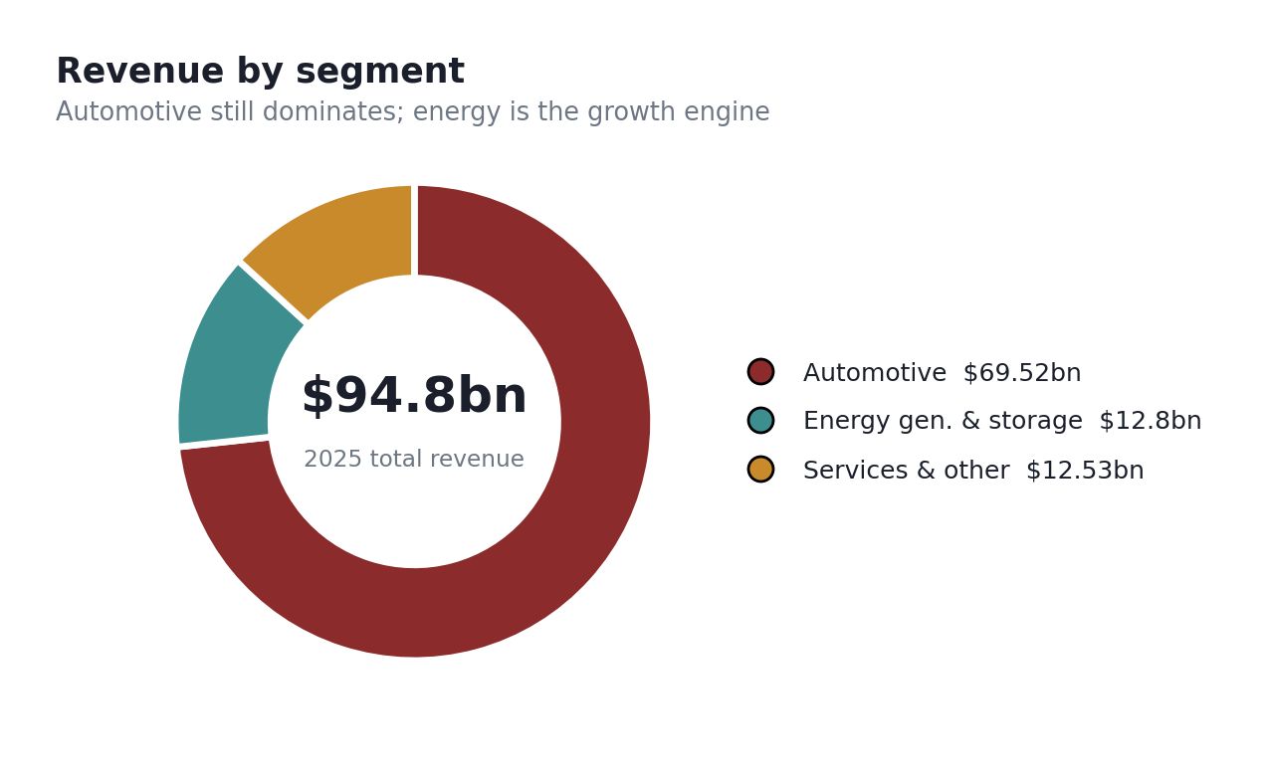
Figure 3: Tesla global revenue by segment, 2025 (Tesla 8-K filings, 2026).

2. External and Internal Analysis

2.1 External Analysis: PESTEL
A comprehensive treatment of all six factors would be systematic but of limited analytical value. For Tesla in the UK, two or three external factors determine the outcome, while the remainder are of secondary importance. The decisive factors are competitive and political-legal in nature: the entry of low-cost Chinese EVs into a market that, unlike the EU, has not imposed tariffs on them, and the evolving framework of EV policy and incentives. Table 1 presents the prioritised analysis, and the discussion identifies the factors of genuine strategic consequence.
Factor | Most relevant issue for Tesla UK | Opportunity / Threat
Political | No UK tariffs on Chinese-made EVs, unlike the EU; the ZEV mandate compels rising EV sales share. | Threat + Opportunity
Economic | Cost-of-living pressure pushes buyers towards cheaper EVs; Tesla's premium pricing is exposed. | Threat
Social | Consumer backlash against Musk's political activity dampens brand appeal in the UK/Europe. | Threat
Technological | Tesla leads on software, charging and autonomy; rivals are closing on battery and range. | Opportunity
Environmental | Net-zero targets and EV adoption support long-run demand for the category. | Opportunity
Legal | ZEV mandate quotas and evolving autonomy regulation shape what can be sold and when. | Mixed

The single most important external factor is competitive in nature, and it is enabled by policy. Britain did not follow the EU in imposing tariffs on Chinese-made electric vehicles (Yahoo Finance, 2026), and the consequence was immediate. BYD's UK registrations rose from 8,788 in 2024 to 51,422 in 2025, overtaking Tesla's 45,513 and establishing BYD as the UK's best-selling EV brand (CleanTechnica, 2026). The policy gap afforded a fast-moving, low-cost competitor an open route into the market, which it exploited fully.
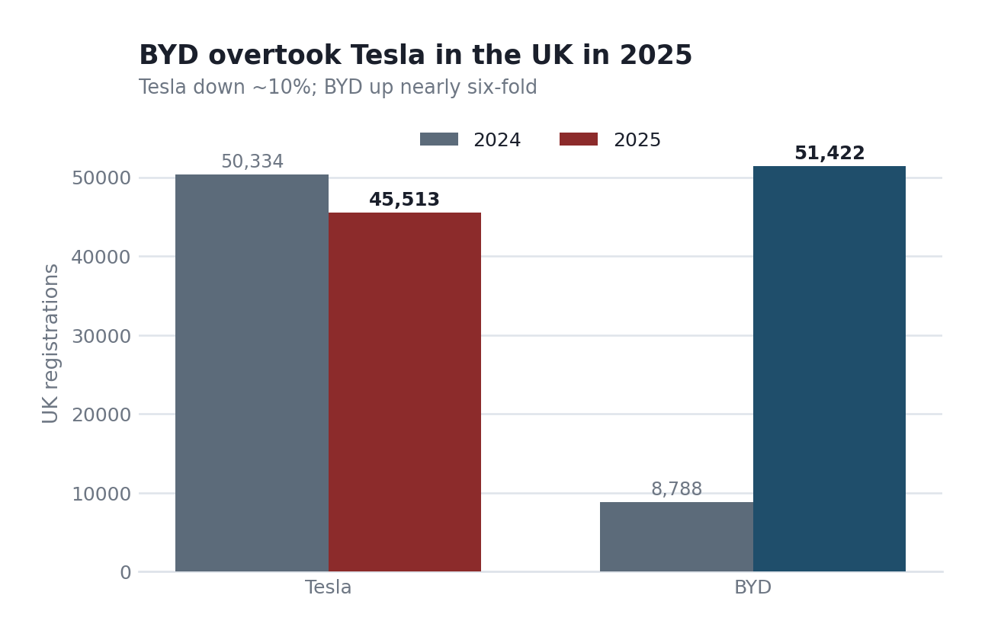
Figure 1: BYD overtakes Tesla in UK registrations, 2024–2025 (New AutoMotive, 2026; SMMT, 2026).
The threat is sharpened by a fact that should worry the board more than the raw numbers. Tesla lost ground while the market expanded. The UK battery-electric market grew roughly 24% in 2025, yet Tesla's UK sales fell about 10% (CleanTechnica, 2026). A brand can lose sales in a shrinking market and blame the weather. Losing sales in a growing one is a positioning problem, not a demand problem.
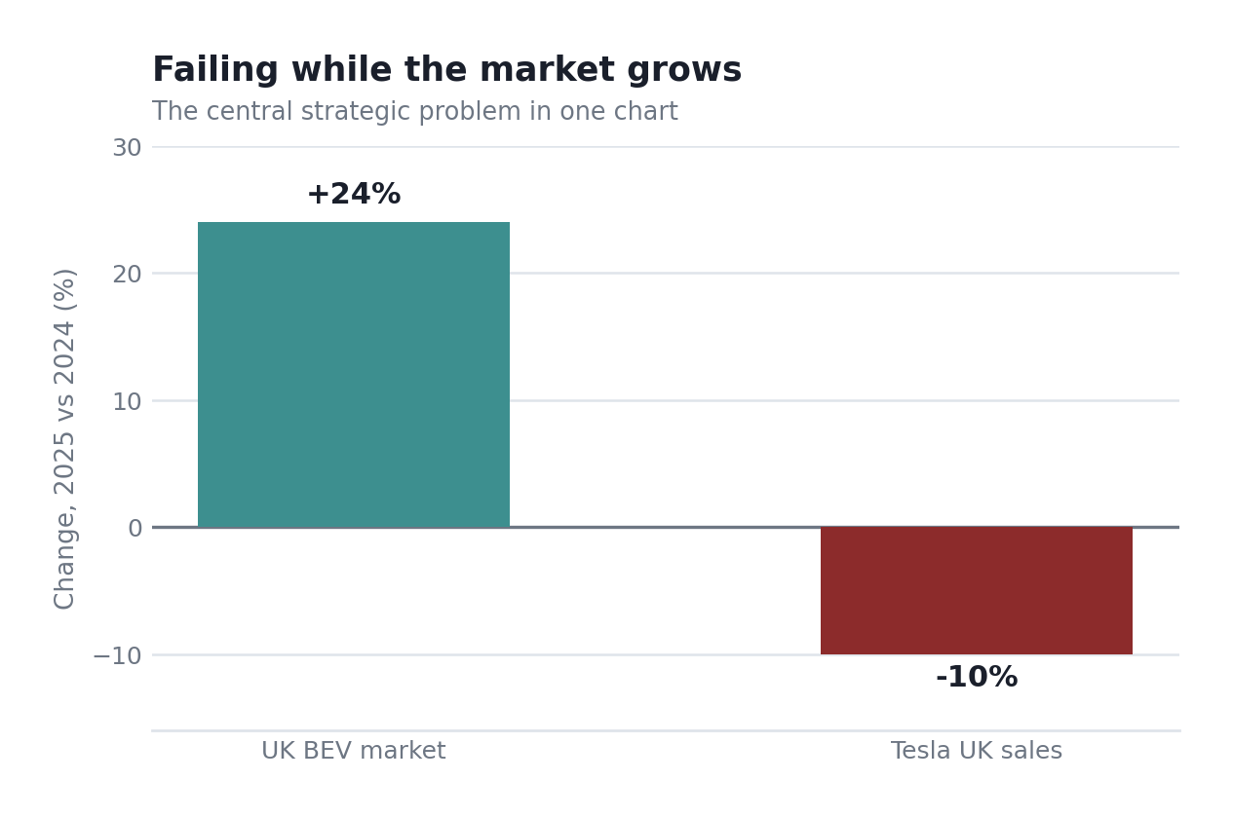
Figure 2: UK BEV market growth versus Tesla's decline, 2025 (author's compilation from SMMT and CleanTechnica data, 2026).
Two further threats, one social and one economic, compound the competitive pressure. The first is price. Cost-of-living pressures have shifted UK buyers towards cheaper electric vehicles, and Tesla's most affordable model remains considerably more expensive than BYD's entry-level offerings, with the result that the premium once signalling market leadership now reads as a cost disadvantage. The second concerns the chief executive. Surveys across Europe associate declining Tesla demand with consumer discomfort regarding Elon Musk's political activity (MEXC, 2025). For a brand whose value was once inseparable from its founder, that same association has become a liability. These are the opportunities and threats of genuine strategic consequence; charging infrastructure and currency exposure, though real, do not determine Tesla's future in the UK.
Politically, the decisive factor is the UK's Zero Emission Vehicle mandate, which requires a rising share of each manufacturer's sales to be electric, 28% in 2025, climbing towards 80% by 2030. For a pure-EV maker this is a structural tailwind: rivals must scramble to hit quotas Tesla already clears, and the mandate has historically let Tesla sell surplus regulatory credits. The offsetting political risk is reputational, and it is self-inflicted. Musk's political interventions in Europe have measurably cooled the brand among the environmentally minded buyers who formed Tesla's original UK base (Reuters, 2026), which is why the political column cuts both ways.
Legally and environmentally, the factors mostly favour Tesla: a decarbonising grid steadily improves the lifetime-emissions case for every car, and the direction of regulation rewards pure-EV makers. The economic column is where genuine threat sits. Because most UK cars are bought on monthly PCP finance, elevated interest rates and the cost-of-living squeeze hit premium-priced EVs hardest, which is precisely the pressure that has forced Tesla into repeated price cuts and the margin compression the financial analysis identifies.
There are genuine opportunities, and an honest analysis names them too. The category is still growing, net-zero policy still favours it, and Tesla still leads on the things that are hardest to copy: charging, software and autonomy. The opportunity is not to out-cheap BYD, which Tesla cannot do, but to compete where its technological lead still counts.
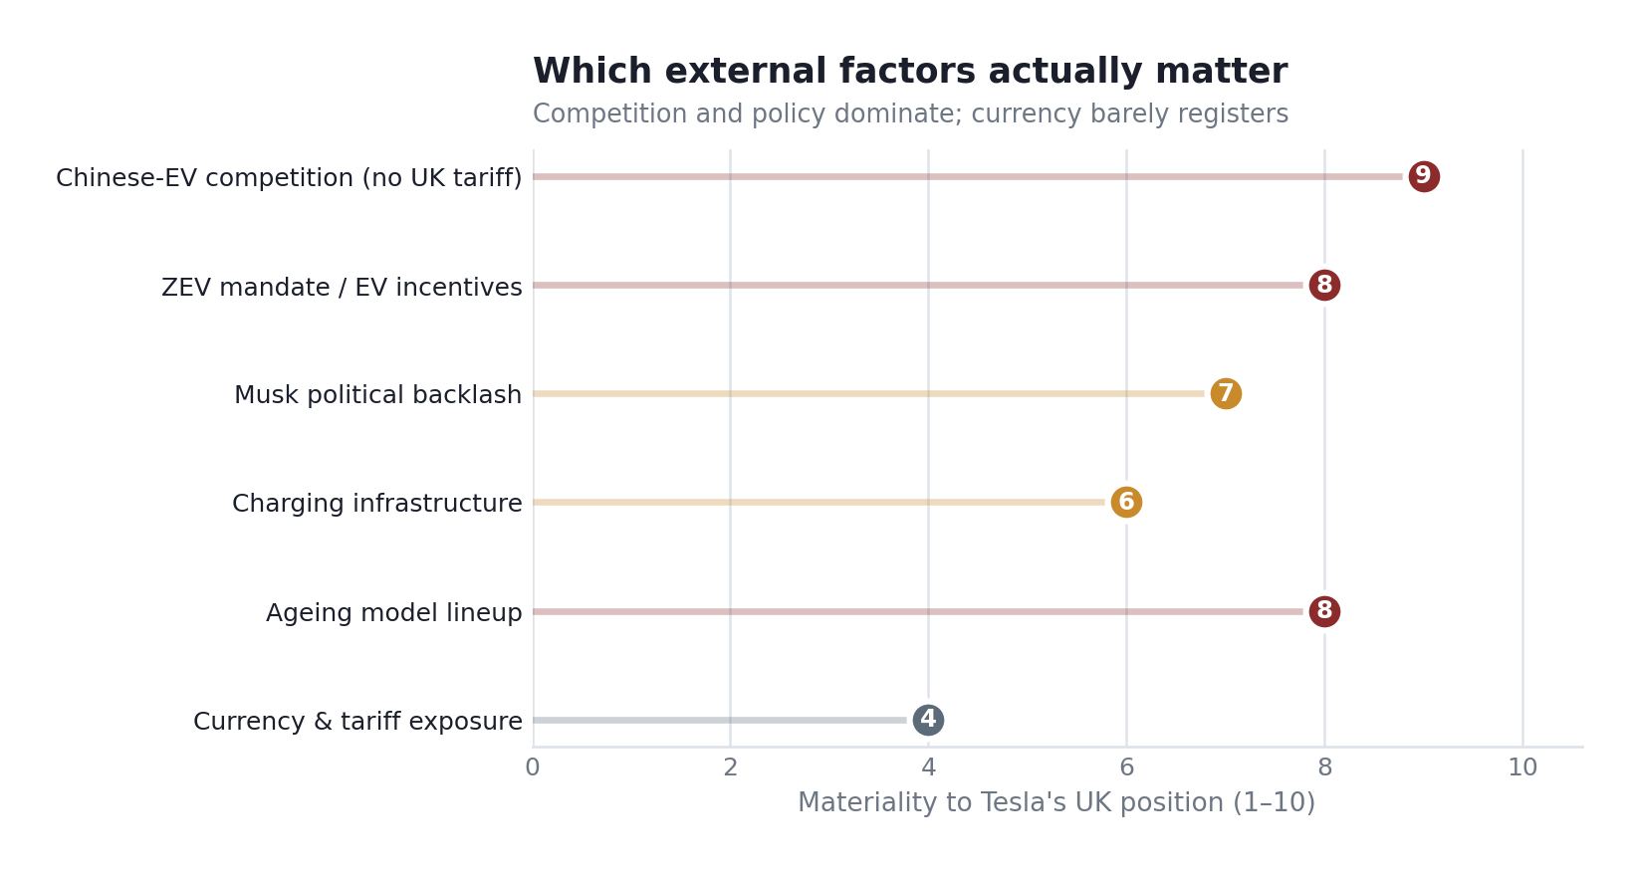
Figure 5: PESTEL materiality for Tesla's UK position (author's assessment).

2.2 Internal Analysis: VRIO
The resource-based view asks a hard question: which of a firm's resources are valuable, rare, hard to imitate, and well organised to exploit (Barney, 1991)? Applied honestly to Tesla, the answer is uncomfortable, because several assets that once gave a durable edge are now merely temporary advantages. Table 2 sets out the assessment; forcing everything into the sustained column would be the easy lie.
Resource | Valuable / Rare? | Hard to imitate? | Organised? | Verdict
Supercharger network | Yes | Yes | Yes | Sustained advantage
Battery & software technology | Yes | Partly | Yes | Temporary advantage
Brand & first-mover status | Yes | No | Weakening | Eroding advantage
Manufacturing scale & cost | Yes | Partly | Yes | Temporary advantage
Direct-sales & OTA model | Yes | Partly | Yes | Temporary advantage

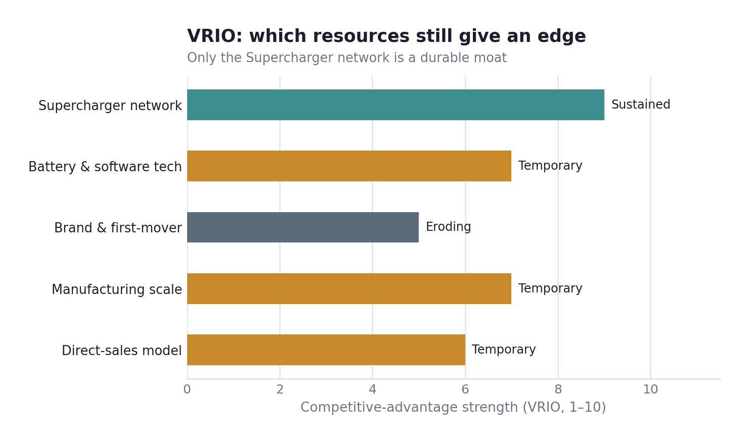
Figure 6: VRIO assessment of Tesla's key resources (author's assessment).
Only one resource clears every VRIO hurdle: the Supercharger network. It is valuable, genuinely rare, expensive and slow to replicate, and Tesla runs it well. It is the closest thing Tesla has to a moat, and tellingly, rivals now pay to use it rather than build their own, which turns a cost centre into a revenue stream and a lock-in. That is a sustained advantage in the strict VRIO sense.
The rest are weaker than Tesla's reputation suggests, and this is the part the board needs to hear plainly. The battery and software lead is real but shrinking; BYD's batteries are competitive, and its software is improving. Manufacturing scale still gives cost advantages, but BYD, which makes its own batteries, may now undercut Tesla on cost. The direct-sales and over-the-air model is clever and still relatively rare but imitable over time. And the brand, once Tesla's greatest asset, is the clearest case of erosion: it is no longer rare in a market full of credible EVs, and the Musk association is actively damaging it. A resource that is becoming a liability is not a strength, however famous.
Each resource merits individual consideration. Tesla's battery and powertrain engineering is valuable and rare but no longer inimitable, since BYD, which originated as a battery manufacturer, arguably now leads on both cost and its blade-cell technology, rendering this a temporary advantage that is eroding in real time. The software and over-the-air update capability are genuinely ahead of most competitors and difficult to replicate quickly, representing a real but time-limited advantage as legacy manufacturers invest substantially to close the gap. The direct-sales model, based on online sales and company-owned showrooms rather than franchised dealers, is valuable and still relatively uncommon in the UK, yet it is organisationally imitable, and several competitors are adopting it. Manufacturing scale is valuable and costly to replicate, though BYD now operates at a greater global scale. The brand, formerly Tesla's deepest source of advantage, is the clearest instance of a resource losing its potency: it remains valuable, but both its rarity and its inimitability are weakening as the controversy surrounding Musk creates space for competitors to position themselves as the more responsible EV choice.

2.3 SWOT Synthesis
Pulling the external and internal analyses together, the SWOT is only useful if it cross-references rather than lists. Table 3 does that: each entry is evidenced from the PESTEL or VRIO above rather than asserted.
Strengths | Weaknesses
• Supercharger network (sustained VRIO advantage) • Software, OTA and autonomy lead • Strong energy-storage business ($12.8bn, +27%) • High Q4 automotive margin (17.9% ex-credits) | • Premium pricing exposed to cheaper rivals • Ageing model line-up (no Model Y refresh) • Brand tied to a divisive CEO • Falling deliveries and net income (–46%)
Opportunities | Threats
• UK BEV market still growing (~24%) • Opening Supercharger network to rivals for revenue • Software/FSD subscription growth • Energy + storage cross-sell | • BYD and Chinese EVs, no UK tariff shield • Price competition eroding margin • Musk-related demand loss • Legacy carmakers electrifying fast

The SWOT points to one conclusion. Tesla's strengths are increasingly in software, charging and energy, not in being the cheapest or newest car on the forecourt. Its weaknesses and the threats it faces both cluster around price and brand. A strategy that leans on the durable strengths and stops trying to defend the eroding ones is the only sensible reading, and Section 4 builds exactly that.
Cross-referencing the quadrants is where the SWOT earns its place, and two pairings matter most. The first is a strength-threat match: Tesla's Supercharger network and software (strengths) are the natural defence against BYD's price assault (threat), because they raise switching costs in a way a cheaper rival cannot instantly copy. The second is a weakness-opportunity gap that should worry the board: the ZEV mandate and a growing BEV market (opportunities) are wide open, but Tesla's ageing line-up and premium-only pricing (weaknesses) stop it capturing them. In plain terms, the market is handing Tesla growth it is not equipped to take. That single mismatch, open opportunity blocked by an internal weakness, is the strategic problem the rest of the report sets out to solve.

3. A Holistic View: CSR and the Balanced Scorecard

3.1 Corporate Social Responsibility and Strategic Alignment
For most companies, corporate social responsibility is an appended function. Tesla is distinct in this respect, since sustainability is not a peripheral programme but the product itself. The company's mission, accelerating the transition to sustainable energy, means that every vehicle sold and every battery installed constitutes the CSR strategy in practice. On the environmental pillar, this alignment is genuine and strong: Tesla's vehicles and its fast-growing energy-storage business (which rose 27% to $12.8bn in 2025) directly reduce fossil-fuel reliance, while its Powerwall virtual-power-plant network helped households save over $1bn on electricity bills (Tesla, 2026). This represents CSR and commercial strategy operating in alignment, precisely the configuration the theory recommends (Porter and Kramer, 2011).
A rigorous board report should not confine itself to the more favourable pillar. On the social and governance dimensions, the alignment is considerably weaker, and to suggest otherwise would be a disservice. Tesla has faced sustained criticism regarding labour conditions and union resistance, the sourcing of raw materials such as cobalt and lithium, and governance concentrated around a single dominant and politically active chief executive. This final point is not abstract. The very governance characteristic that CSR frameworks would identify as a concern, namely an unusually powerful CEO subject to limited oversight, is precisely what is now damaging the brand in the UK. The overall picture therefore divides clearly: on environmental grounds, strategy and responsibility are closely aligned, whereas on social and governance grounds they diverge, and this gap constitutes a genuine business risk rather than merely a reputational one. Addressing it is therefore a commercial priority rather than a compliance matter.

3.2 Balanced Scorecard
Kaplan and Norton's (1992) balanced scorecard exists to stop managers steering by the financials alone. It reads performance through four linked lenses, financial, customer, internal process, and learning and growth, on the logic that the last three drive the first. Applied to Tesla's UK business, it turns the strategic problem into measurable targets. Figure 9 illustrates a set; the discussion below sets out objectives, KPIs and initiatives for each perspective.
Financial perspective. The objective is to defend margin and revenue in the UK without a destructive price war. The relevant KPIs are UK revenue, gross margin per vehicle, and revenue from software and charging. Targets should hold automotive margin near the recovered Q4 level (17.9% ex-credits) while lifting the share of revenue from high-margin software and energy. The initiative is to shift the profit mix away from the car alone, exactly where Tesla's durable advantages lie.
Customer perspective. The objective is to arrest the loss of market share and rebuild consideration among UK buyers. The relevant KPIs are UK BEV market share, customer-satisfaction scores and brand-consideration surveys. A realistic target would be to recover UK BEV share towards the high-teens or low-twenties in percentage terms over two years, following the loss of position to BYD. The key initiative, though uncomfortable, is necessary: to reduce the brand's dependence on the chief executive's personal profile and to compete on product quality and price accessibility rather than on personality.
Internal-process perspective. The objective is manufacturing and delivery efficiency that supports a lower-priced model without gutting margin. KPIs are cost per vehicle, delivery-cost index and production-to-delivery cycle time. The target is a meaningful reduction in unit cost to enable a sub-£30,000 UK model. The initiative is the long-promised affordable platform, the single most important internal project for the UK's future.
Learning-and-growth perspective. The objective is to maintain the technological lead that the VRIO analysis identified as Tesla's genuine advantage. The relevant KPIs are the FSD and software attach rate, R&D as a proportion of revenue, and Supercharger utilisation by third parties. Targets should aim to increase both software attachment and third-party charging revenue. The associated initiative is continued investment in autonomy, software and charging, funded by the margin that the financial perspective is designed to protect. The four perspectives are mutually reinforcing: process efficiency enables an affordable vehicle, which attracts customers, which sustains the financial position, which in turn funds the learning that preserves the technological advantage.
The four perspectives are mutually reinforcing. Process efficiency enables the production of an affordable vehicle, which attracts customers, whose custom sustains the financial position, and the resulting revenue funds the learning that preserves the technological advantage. Each KPI is linked to a specific initiative, which is what renders the scorecard a management tool rather than merely a reporting dashboard.
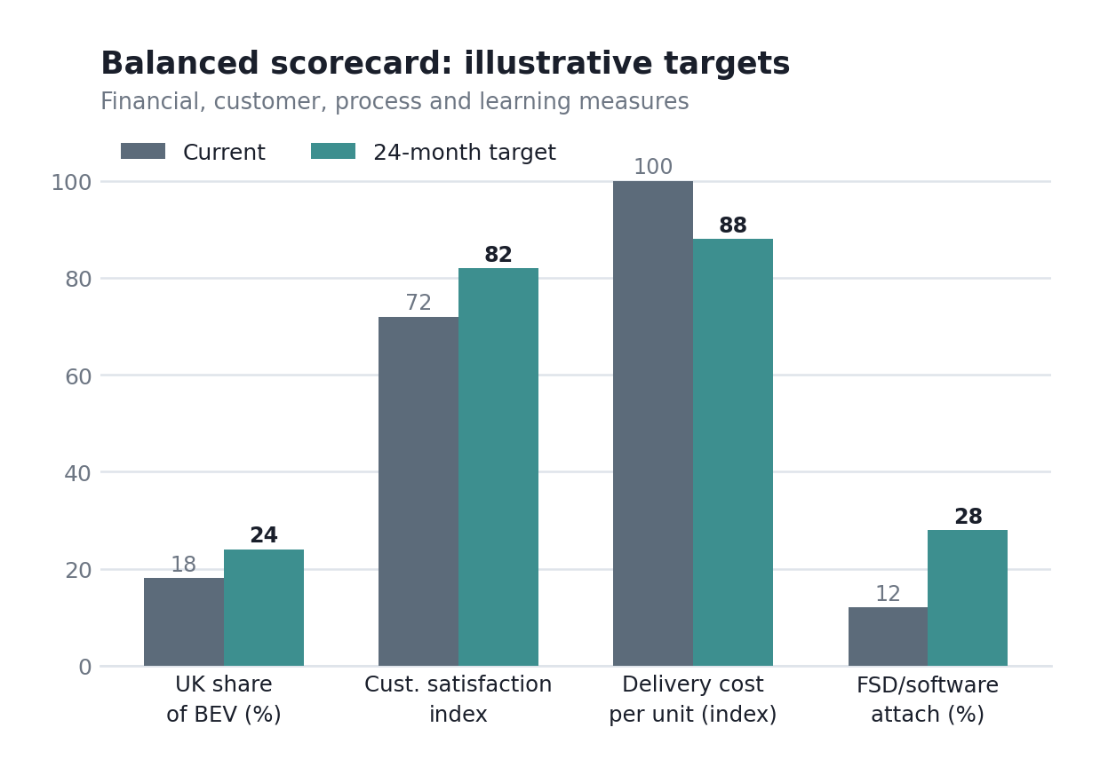
Figure 9: Balanced-scorecard illustrative targets across the four perspectives (author's construction; framework after Kaplan and Norton, 1992).

4. Strategic Choices and Implementation

4.1 Business-Level Strategic Options
At business level, Porter's (1985) generic strategies frame the choice: cost leadership, differentiation, or focus. Tesla built its position on differentiation, technology, brand, charging, and the direct-sales experience, and for a decade that was the right and winning choice. The question the Board faces now is whether differentiation still works when a rival is beating it on price in a growing market.
Cost leadership is not a viable option, and the reasons warrant a clear statement. Tesla cannot achieve a lower cost base than BYD, which manufactures its own batteries, operates with lower labour costs, and has demonstrated a willingness to price aggressively. A price war against a lower-cost competitor is a contest Tesla would lose while simultaneously eroding its own margin, and margin is precisely what funds its technological lead. Pure cost leadership is therefore not a feasible strategy.
Pure differentiation, continuing exactly as before, is also failing, which the sales data already proves. The differentiation that once justified a premium has narrowed: rivals now offer credible range, software and design, and the brand premium is eroding. Charging more for a similar product against a cheaper, improving competitor is precisely the position the 2025 numbers punish.
The appropriate strategy is therefore a hybrid: differentiation focused on what remains genuinely distinctive, combined with a deliberate move down-market on price through a new, cheaper model. In Porter's terms this is a broad differentiation strategy defended by selective cost discipline, not cost leadership but cost credibility. Tesla keeps competing on the things BYD cannot easily match, the Supercharger network, software, autonomy, and energy integration, while removing the price barrier that is currently handing BYD the volume. Validated against Porter's five forces (Figure 7), the logic holds: competitive rivalry is the dominant, intense force, buyer power is high and price-sensitive, and the threat of substitutes among cheaper EVs is real, so a strategy that neutralises the price objection while exploiting the hard-to-imitate strengths attacks exactly the forces that are hurting Tesla.
Ansoff's matrix clarifies the appropriate source of growth. Market penetration alone, that is, selling more of the same vehicles to the same UK buyers, is demonstrably failing, as the market-share figures indicate, while diversification would dissipate the firm's focus. The credible path is product development: a new, lower-priced model directed at the existing UK market, which is the quadrant aligning Tesla's actual weakness (an excessively narrow and expensive range) with its actual opportunity (a growing, mandate-driven market). A sub-£30,000 Tesla is not a minor line extension but rather the single product decision that will determine whether Tesla grows in step with the UK market or cedes it to BYD.
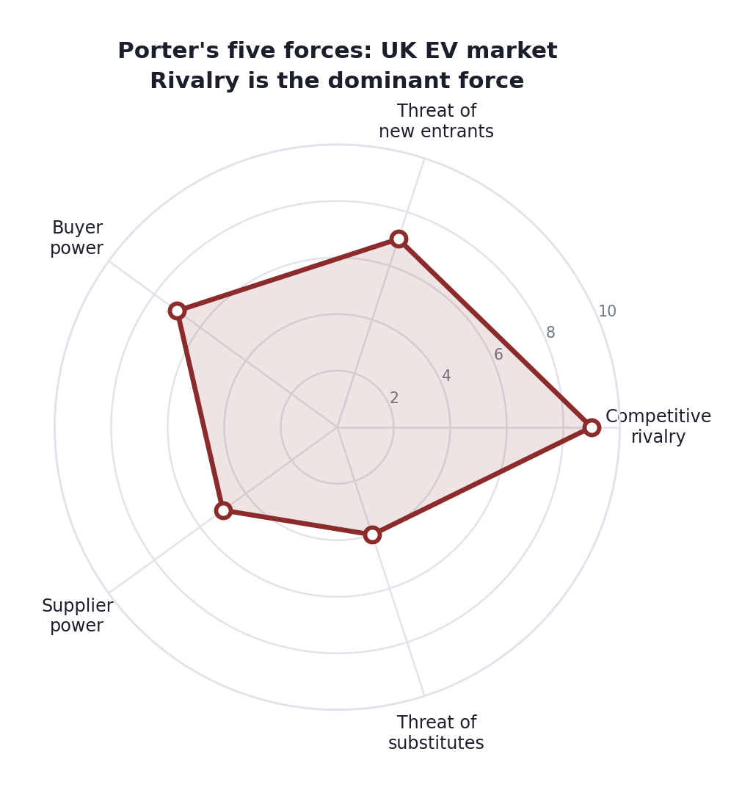
Figure 7: Porter's five forces in the UK EV market (author's assessment).
On Ansoff's (1957) matrix, the recommended move is product development, an existing market served with a new product. Tesla stays in the UK BEV market it knows and introduces a genuinely affordable model, roughly £25,000, to reach the price-sensitive buyers now defecting to BYD (Figure 8). This is lower-risk than diversification and more promising than trying to squeeze more from an ageing line-up through market penetration. The strategic logic and the growth-direction logic agree, which is a good sign the recommendation is sound rather than merely plausible.
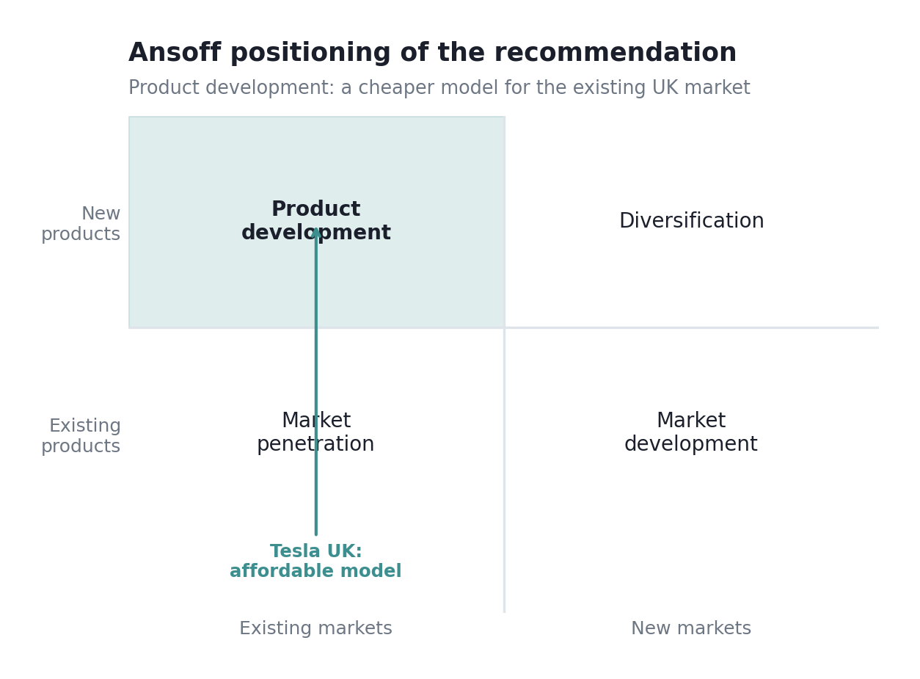
Figure 8: Ansoff positioning of the recommendation as product development (framework after Ansoff, 1957).
How does this deliver optimum performance and defend the advantage? By competing on two fronts at once. The affordable model attacks the volume BYD is taking; the retained differentiation, charging, software, and energy protect the margin and the moat. The theory here is Porter's: that a firm must choose a defensible position rather than be stuck in the middle, but Tesla's real-world assets let it hold a differentiated position at a more accessible price, much as Apple sustains premium differentiation while offering lower-priced models to widen the base. The energy business, growing at 27%, provides the profit cushion to fund the transition, a genuine advantage BYD does not share.
There is a real-world precedent for the danger of getting this wrong. When Tesla chased volume through blunt price cuts in 2023-24, it protected market share but gutted the margin that funds its technology lead, exactly the trap a pure cost response creates for a differentiator. The hybrid strategy avoids that by competing on total cost of ownership rather than sticker price: Supercharger access, software, resale value and running costs let Tesla justify a modest premium while an affordable model widens the addressable market. This is the same logic that lets Apple hold price in a commoditising phone market: differentiation deep enough that customers accept a premium, paired with enough scale to keep costs disciplined.
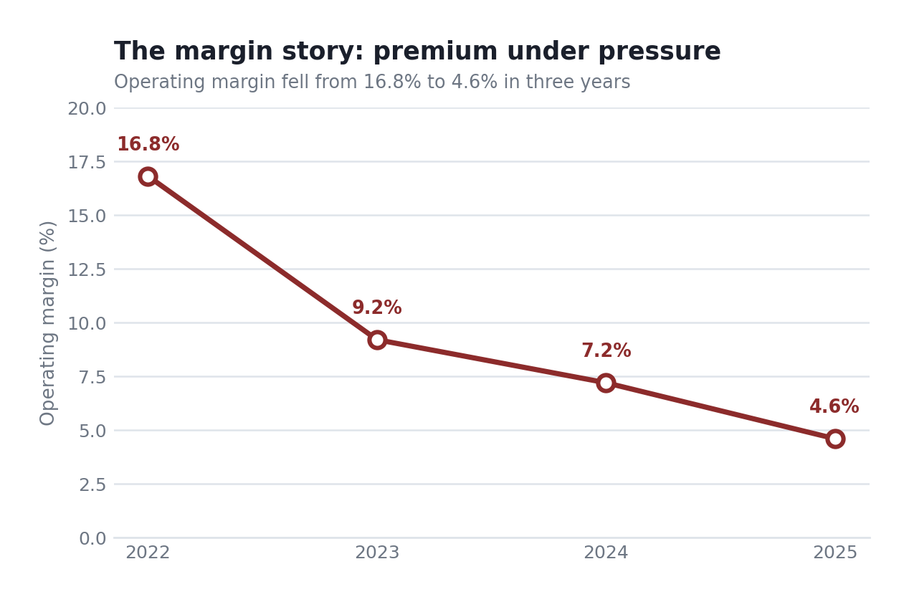
Figure 4: Tesla operating margin, 2022–2025 (Tesla 8-K filings, 2025–2026).

4.2 Implementation Challenges and Mitigations
Three challenges will determine whether this strategy succeeds, and each requires a concrete response rather than optimism. The first is margin risk. A lower-priced vehicle could cannibalise higher-priced models and erode the margin that funds the strategy; the appropriate response is to engineer the new model to a cost target from the outset, drawing on manufacturing efficiencies rather than discounts, and to protect the profit mix through software and charging revenue. The second is brand risk. The association with Musk is actively deterring UK buyers, and no product alone can resolve a brand problem; the appropriate response is to decouple the brand from the chief executive's personal profile in UK marketing and to allow the product to convey the message. The third is execution risk. Tesla has previously promised an affordable model and repeatedly delayed it; the appropriate response is disciplined project governance with clear delivery milestones, funded by the $20bn-plus capital programme already committed, and treated as the UK's single most important initiative rather than one among many.
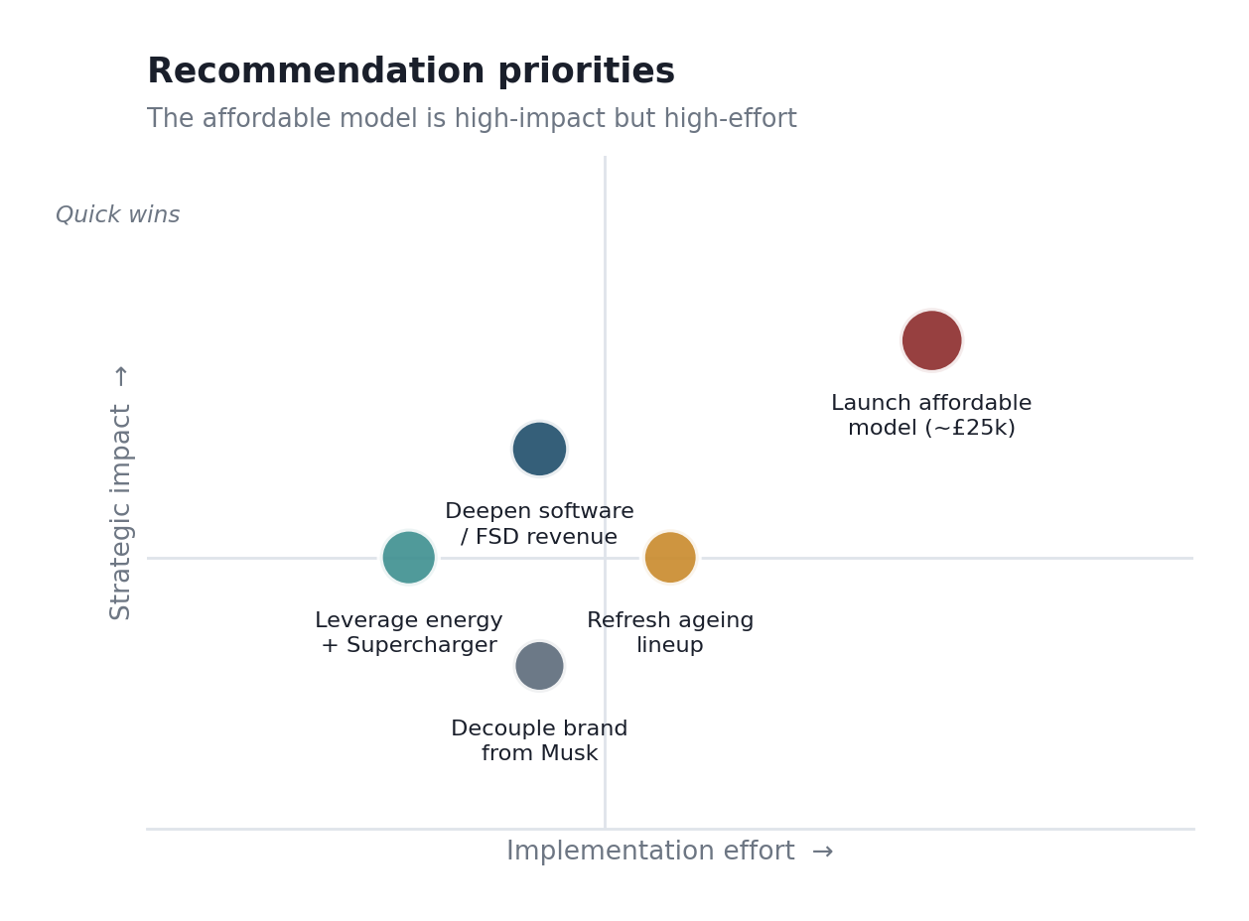
Figure 10: Recommendation priority matrix (author's assessment).
The conclusion for the board is clear. Tesla's difficulty in the UK is not that electric vehicles have fallen out of favour, since they are selling more rapidly than ever. Rather, it is that Tesla has been charging premium prices for an ageing product associated with a divisive brand, while a cheaper and improving competitor captured the volume. The appropriate response is not to abandon differentiation but to render it affordable: to retain the competitive moat, remove the price barrier, and allow the energy business to fund the transition. Pursuing this course would enable Tesla to defend a position worth defending; failing to do so would reduce it to a premium niche within a market it once defined.

Section 2: Reflective Account
This reflection uses Gibbs' (1988) six-stage cycle: description, feelings, evaluation, analysis, conclusion and action plan.

Description
I was asked to act as a strategic consultant, evaluate a company's position in one market, and write a board report. I chose Tesla in the UK EV market. The work ran in stages. First I gathered Tesla's financial filings and current UK sales data. Then I applied the frameworks PESTEL, VRIO, SWOT, the balanced scorecard, Porter and Ansoff and only then shaped it into a report with a single argument. I worked on it in the evenings at home, across roughly two weeks, fitting the reading and drafting around everything else rather than in one block.

Feelings
The moment that surprised me was finding that BYD had actually overtaken Tesla in the UK. I had started assuming Tesla was still the dominant EV brand and that I would be writing about a leader defending its lead. The data said otherwise, and it forced me to rethink the whole report around a company that is losing rather than winning. That was uncomfortable, because it meant abandoning my first plan, but it made the analysis far sharper. My honest first reaction was annoyance: I had already sketched a plan around Tesla-as-leader, and the data meant scrapping it. That irritation faded once I saw the losing-while-the-market-grows angle was a far more interesting story to tell.
There was also a quieter confusion that took longer to resolve. Tesla is profitable, cash-rich and technologically admired, yet losing share and sales; for a while I could not decide whether I was analysing a strong company with a wobble or a weak one flattered by past success. Sitting with that discomfort, rather than forcing an early verdict, turned out to be the point where the real analysis started.

Evaluation
What went well was letting the evidence set the argument instead of the reverse. The finding that Tesla fell while the market grew gave me a genuine thesis: that the problem is positioning, not demand, and everything is organised around it. What went less well was resisting the temptation to make VRIO tidier than it was; I kept wanting to call every Tesla resource a sustained advantage, and I had to force myself to admit that only the Supercharger network really qualifies. My clearest process weakness was spending too long on the charts. I polished visuals before the argument they were meant to support was settled, which is effort in the wrong order, and I had to redo a couple once the analysis moved on.
The other thing I would judge a qualified success is scope discipline. The brief demanded a single market and product, and it was tempting to drift into Tesla's energy business or its US position whenever the UK story got uncomfortable. Holding the boundary, one market, one product line, made the analysis sharper, though I noticed how often I had to pull myself back to it.

Analysis
Two ideas from the module did most of the work. The first was Porter's warning about being stuck in the middle, which turned out to be exactly Tesla's danger: too expensive to compete on price and no longer distinctive enough to command the premium. The second was the resource-based view, which stopped me confusing fame with advantage: Tesla's brand is famous but no longer rare, and VRIO made that distinction impossible to dodge. Seeing a celebrated company through an honest framework, rather than through its reputation, was the real learning. Johnson's Exploring Strategy was the text I leaned on most for both, and Barney's original work on the resource-based view sharpened how strictly I applied the VRIO tests rather than treating them loosely.
One framework fit less neatly than the textbook promises, and saying so honestly matters. Porter's generic strategies present cost leadership and differentiation as a clean either/or, with 'stuck in the middle' as the failure state. Tesla did not sort cleanly into either box, and my recommendation, a hybrid of deep differentiation with cost discipline, is exactly the position Porter warns against. Reconciling that took real thought: the resolution is that Porter's warning applies to firms with no advantage in either dimension, whereas Tesla has genuine differentiation and genuine scale, so a disciplined hybrid is defensible rather than fatal. Working out where a canonical framework's rule does and does not bind was more instructive than any clean application would have been.

Conclusion
The skill I improved most was building one clear argument from messy, contradictory evidence, a company simultaneously profitable and declining, admired and damaged. The weakness I still have is reading dense financial filings slowly, which ate up time I could have spent refining the recommendation.

Action Plan
Next time I would fix my central argument earlier rather than letting it emerge late, and I would budget my time against the marks each section carries so the analysis-heavy parts get the hours they need. On time management specifically, I plan to set section deadlines at the start and treat them as fixed because the parts I wrote last, the implementation challenges, felt rushed against the parts I wrote first.

Reference List
Ansoff, H.I. (1957) 'Strategies for diversification', Harvard Business Review, 35(5), pp. 113–124.
Barney, J. (1991) 'Firm resources and sustained competitive advantage', Journal of Management, 17(1), pp. 99–120.
CleanTechnica (2026) 'Tesla's dramatic fall in the UK in 2025, and BYD's rise'. Available at: https://cleantechnica.com/2026/01/08/teslas-dramatic-fall-in-the-uk-in-2025-and-byds-rise/ (Accessed: 7 August 2026).
Gibbs, G. (1988) Learning by doing: a guide to teaching and learning methods. Oxford: Further Education Unit, Oxford Polytechnic.
Kaplan, R.S. and Norton, D.P. (1992) 'The balanced scorecard: measures that drive performance', Harvard Business Review, 70(1), pp. 71–79.
MEXC (2025) 'Tesla's sales slide in Europe as Chinese EV makers gain ground'. Available at: https://www.mexc.com/news/82108 (Accessed: 7 August 2026).
New AutoMotive (2026) Electric vehicle registration data, December 2025. Available at: https://newautomotive.org (Accessed: 7 August 2026).
Porter, M.E. (1985) Competitive advantage: creating and sustaining superior performance. New York: Free Press.
Porter, M.E. and Kramer, M.R. (2011) 'Creating shared value', Harvard Business Review, 89(1/2), pp. 62–77.
Reuters (2026) 'Tesla UK car sales slump in December as Chinese brands gain ground'. Available at: https://uk.marketscreener.com/news/tesla-uk-car-sales-slump-29-in-december-as-chinese-brands-gain-ground-ce7e59dfd980f224 (Accessed: 7 August 2026).
Society of Motor Manufacturers and Traders (2026) Car registrations 2025. Available at: https://www.smmt.co.uk (Accessed: 7 August 2026).
Tesla (2026) Q4 and full year 2025 update. Available at: https://assets-ir.tesla.com/tesla-contents/IR/TSLA-Q4-2025-Update.pdf (Accessed: 7 August 2026).
Yahoo Finance (2026) 'BYD overtakes Tesla in UK and Germany EV sales'. Available at: https://finance.yahoo.com/news/byd-overtakes-tesla-uk-germany-153057360.html (Accessed: 7 August 2026).

