Author: Liliya Hristova
Student ID: 1816238
Date: 05.01.2020
Professor’s name: Tushara Balendran
Program study (LCBB4004)

MARKETING FUNDAMENTALS

QUESTION 1
THE MARKETING PROCESS and MARKKETING MIX
Definition of Marketing
Marketing is a managerial process (illustrated in fig.1) that helps people and group of people to gain what they need and wants by exchanging value with services or products (Kotler and Armstrong, 2016).

Fig.1 The Marketing PROCESS DEFINITION
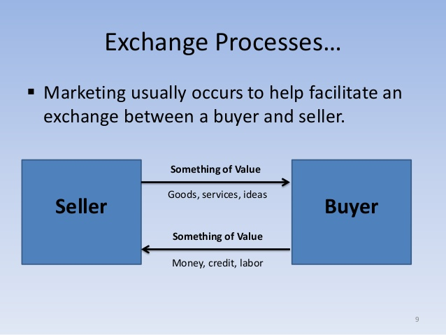
Source: https://www.slideshare.net/hellkid1/marketing-46547467
The marketing process definition
Marketing process is the initiatives of an Organisation in creating awareness of a product or service. It includes planning of tactics and strategies to achieve the organisation objectives and the main centre/ point of the marketing plan is the customer. Marketing includes all the processes and activities that Company do in order to offer value, trust, satisfaction for new and existing customers, and creating beneficial, strong and loyalty relationship by adding value and receiving value in return. Marketing plays crucial role in building, managing and maintaining the relationship with customers not only while and when they buy the product, but even when the product has been sold. Marketing is influencing the Organisational and customers behaviours and cultures.

2. STAGES IN THE MARKETING PROCESS
Mission statement of the Company:
Jack Daniels is a brand built through vision, hard work and excellence – all wrapped in a spirit of independence
“EVERY DAY WE MAKE IT (the whiskey), WE’LL MAKE IT THE BEST WE CAN.” - J. Daniels’ Moto (Jack Daniel, 2019).
The main stages in the marketing process/plan are: Situational analysis/ Plan, objective, strategies, Implementation and control.
Situational analysis/ Plan - Where we are now?

Where

Objectives – W here we want to be?

Strategies – How do we get there

Implementation – Action, the work to get there

Control /Evaluation – Are the objectives achieved and if not why?

Situational analysis/plan answers the question ‘Where we are now’?
The best way to find out ‘Where we are now?’ is to see the current state of the company and where is positioned compared to their competition, using benchmarking comparison with the competition and to check whether the Company is achieving its mission and vision. And the best way to do it is through SWOT, Potter’s five forces and PESTE analyses.
Objectives answers the question, ‘Where we want to be’?
The objectives are the Companies’ to set certain goals such as (1) identifying and predicting specific promotions of product and services to new and existing customers, (2) estimating the cost for the necessary tasks, (3) setting what should be achieve within a time frame. They have to be SMART (See fig. 2). and for all level of management.

Strategies answer the question ‘How do we get there’?
Strategies are developing a plan in achieving Companies’ goals and adjusting the strategies according to the changes in marketing opportunities and threats. Acting and reacting on the MICRO and MACRO forces.
According to (Hosted Data, 2018, p.26) these are some of the main strategies that will help the Company to achieve their objectives
- “ACTIVE PORTFOLIO MANAGEMENT
- SUPERB BRAND BUILDING
- EXCELLENT CAPITAL DEPLOYMENT
- A STRONG GOVERNANCE SYSTEM
- GREAT PEOPLE WORKING IN A GREAT CULTURE”

The priorities for the Brown - Forman Company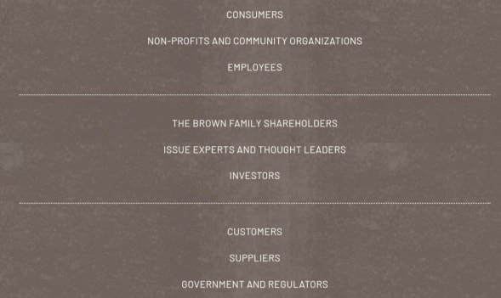
https://www.facebook.com/marketplace/london/propertyforsale/?sort=BEST_MATCH

Implementation is the application, or the work put in, in order to achieve the set strategies right and at the right time with the resources.
Control/ Evaluation is the process to see whether the Company achieved the first formulated objectives, and if not, what went wrong. And once identified the reasons why The Company failed to achieve their objectives, the company must take measures in correcting the strategies by adjusting or changing them. The company need to evaluate and see why the objectives haven’t been achieved. Maybe some of the reasons for failure the strategies were wrong, for example we put wrong price, or wrong promotions, or the implementation was wrong. Or maybe we targeted the wrong customer groups, or the wrong brand image, or the objectives were unpracticable or too high. Or MACRO or MICRO factors, for example BREXIT could directly affected the Companies strategy.

SITUATIONAL ANALYSIS - (WHERE ARE WE NOW?)
The best way to find out where ‘we’ the company is now by benchmarking the company with companies from the same industries by using the MICRO and MACRO analysis.

PESTEL
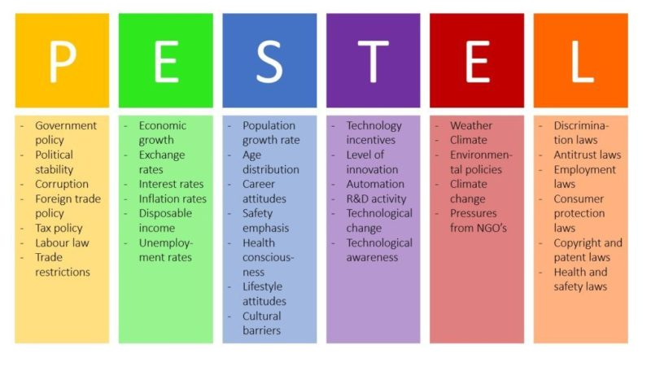
https://www.business-to-you.com/scanning-the-environment-pestel-analysis/

POLITICAL
Some of the factors that can affect Jack Daniels’s business is higher taxes, political instability, future regulation and guidance for selling and producing alcohol drinks. The changes will lead to higher price for the product and this could lead to less product purchases by the consumers. So is unfavourable for the company. For example, Jack Daniels’s tax levy (Telegraph, 22 Nov 2011)

ECONOMICAL
The MICRO and MACRO economic factors and conditions can affect the Company and the customers, such as inflations, budget deficits, government debts, deflation, etc. The fluctuating of the currency rate change also can impact the Company and the Consumers. And if this happen it’s going to be unfavourable for both sides, Company and Consumers. (Bloomberg, 2018).

SOCIAL
The labour factor such as unemployment, high interest rates, changes in the labour policies and condition, health pandemic, changes in consumers patterns of purchasing the products of Jack Daniel, health and well-being tendencies could also affect the purchases, so these are also unfavourable factors for the Company. Negativity publicity also could affect the consumption and purchases of alcohol drinks. (The Grocer,2019).

TECHNICAL
Jack Daniel are keeping their original process. They patent their way of making whiskey. But there is always a risk of new rival to copy the recipe and make similar product to theirs and to sell it cheaper. The company use open approach how they make whiskey, so the product is so well known that even if another company is trying to copy their methods, they will lose the competition to JD. The Company use the modern technology in their production. They are becoming more environment friendly and because of these factors its favourable for the Company (Jack Daniel, 2019)

LEGAL
The legal factors are connected with the new regulations and policies about the trade imports and export on local and worldwide scales. Changes in the labels, pricing, production, sales, distributions, or beverage consumption could affect the Company. This is unfavourable for the Company, because the company needs to comply with the changes, and it will cost money and efforts and time consumption. For example, Brexit or legalisation of Marijuana will have some impact the Company. (morning advertiser, 2016)

ENVIRONMENT
Jack Daniel as owned by Brown Forman has the same obligation about the Environment performance to be Environment friendly and to use the natural resources with care, because they are very depending on the natural resources and raw materials, such as water, woods, energy, etc. The Company create Environment Performance (Policy 685) to make sure they are doing their best to help with the Global Worming. These factors are favourable, because Jack Daniels in the last 40 year have been working towards this. (Brown-Forman, 2014).

PORTERS 5 FORCES - MICRO ENVIRONMENT
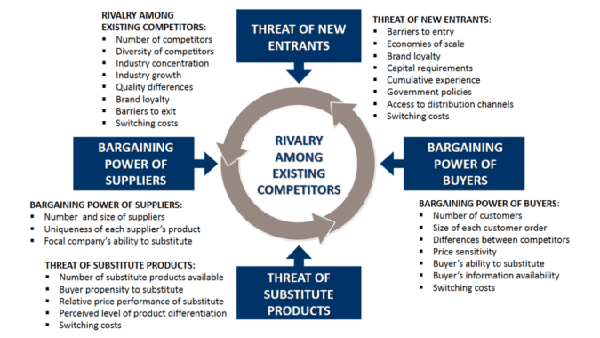
https://www.business-to-you.com/porters-five-forces/
COMPETITIVE RIVALY
The current competitors competing for our market shares with us are the Companies’ industry rivals is HIGH. The competition will be more intense if they produce similar product and the difference between our product, they will go for the same target market. Another factor is the number competitors. The competitors of Jack Daniels are a lot in the ranking list of 2017 by Forbs. And they competitors are on the first four position whiskey produced in India, Officer’s choice (1), McDowell’s (2), Imperial Blue (3),Royal Stag Whisky(4),and on the fifth is Johnnie Walker(Scotland) and the sixth position is Jack Daniels( U.S). And followed by Jim Beam, Jameson, Mark’s Mark, Woodward reserve, etc. (Forbs, 2019). Therefore, the strength of the force is high, and the industry is less profitable because of the many rivals. Jack Daniels use their strong Branding to fight their competition. Another example is Jack Daniel is constantly monitoring what is happening with their rivals. And there are different rankings which they can use to benchmark their position in comparison with their competitors, such as Markers’ Mark. (The spirit business, 2019).
According to the Spirit business (2017) Jack Daniels continue to be the best seller. in 2018 the company grew by 2,7%. To reach 13.3m cases. Even though Jack Daniels’ rival, Marker’s Mark, doubled their sells that they are still behind Jack Daniels in the rank list.
Monitoring the Competition is to know their market share, how much finances they have, what are their strategies and objectives and what was their last year profit. It is essential to know their strategy so we can make our Marketing Mix differently to get advantage from this. We might see some weaknesses that we can use as our opportunity. The monitoring will help us to find out how they are threatening our business as well. Getting the results from this monitoring we can use it in our planning and decision making. The process is called Competitive intelligence.
THREAT OF NEW ENTRY
When they entry barriers are low there is more threat for the Company of new entries that will attempt to still part of the Company’s market share. And some of these barriers are strong brand name and good reputations, brand loyalty customers, economies of scale and experience and contracts are high barriers for the new entries. The larger to Company becomes it becomes harder for the new entry to enter and to compete with the Company. And the reason is that they can produce in large amount(bulks) the product which will lower the final cost.
In the case of Jack Daniels and the new entry “Uncle Nearest”, named after Nathan “Nearest” Green, who was the mentor of Jack Daniel in teaching him how to make whiskey. The “Uncle Nearest” leadership are using as a strategy to enter the market easier. Also, they have a similar product as Jack Daniel, the colour the packaging of the whiskey looks similar. They connected their product with the story of Jack Daniels’. (CBS This Morning, 2017). The advantage in comperes on for example of the new entry “Uncle Nearest” because they have the experience and the economies of scale. Jack Daniels have created high barriers for the new entries by maintaining their brand image and reputation.
In general, the strength of the force is low because of the barrier to entry Jack Daniels created, with some exceptions for example “Uncle Nearest”, because they are part of the story of Jack Daniels.

THE BUYER POWERS
The power of the customers is the freedom, they have not bound by contracts, to switch to competitors or different substitutes. They don’t have to use the products only from one company. Another reason for customer to gain power if the company is only focusing on niche market, small group of customers. Many companies use it as an entry strategy, but once they enter, they should start to broaden their market scope, otherwise they will be stack with the small group of customers. Other factors are the size of the orders, price sensitivity, ability to substitute, and cost of changing. This will give the customer high buyer powers.
In Jack Daniels case they have created a large range of products, with different size, packaging, flavours and price. The last 150ish year Jack Daniels have been successfully identifying the needs and wants of customers better than their competitors. They are still on the market with growing sells, which means that they research and monitor the changes needs and preferences. To keep existing customer and attracting new customer they create diversification products. The customers have medium to high buyer power. (Jack Daniel, 2019)

THE SUPPLIERS:
The suppliers play crucial role, because they supply the business with the products the company needs in order to function on a daily basis. They supply with the raw materials, or with the product or services, as equipment and fuel. The company have to create and maintain a good relationship with the suppliers. Also, have to try to find more than one supplier so it could take the power of the Supplier. In Jack Daniels case they have successfully becoming their own supplier, by producing what raw material they need. For example, they use the cave water, which is in their property. They plant the trees they need for the barrels. They also grown their own corn and supporting the farmers, who grow the corn, barley and so on. By producing most of the ingrediencies they need for making the whiskey they control the quality, quantity and they took the barging power of the suppliers, which means that the supplier’s power is very low. And for the rest of the items they need they have created a good network of suppliers, signed contracts, by providing fair agreements, treating them ethically. Which means that they almost took the power of the suppliers So, the force is low. (Spotify, 2019)
THREAT OF SUBSTITUTION
The treat of substitute is a product that offers the same or similar benefits as ‘the original’ performance from another industry. The substitute of Jack Daniels could be rum, vodka, liquor, beer, etc. The main reason they might be a threat is the price and the demand of the original product. This will give power to the buyer if they can switch to these alternatives. The treat of substitution is high, because all the spirits will give the same result (get drunk), but for the loyal customers its low, because their brand loyal.

Advantages of the Porter’s five forces framework are that the Potter’s 5 forces (1) can be used for a short-term strategy (Mind tool, 2019). The Framework, Potter 5 forces is a (2) good tool to understand the competitiveness environment of our business, and (3) to find strategies that can be used to help the profitability of the Company. (4) The main advantage is to check whether the industry is attractive. And, is it the right time to enter or exit the industry?
Disadvantages of Porter’s 5 forces are that when the framework he creates (1) there was no globalisation and the technology was not developing rapidly. (2) The model is a statistic which means that at some point it seems like a snapshot in the past. People use it wrongly not the way it was meant to be used. (3) You cannot define the industry clearly (Investopedia, 2019). (4) If the Company has a partnership the Potter 5 forces analysis do not cover it. (5) This module cannot be used in isolation, because it cannot cover the Macro (PESTEL) and the Internal (SWOT) influences of the forces. When we combine the frameworks of Potter’s 5 forces with PESTEL, and SWOT only then will find Where we are now, as a company, or in other words this is the Situational analyse.

STAGE OF THE COMPANY AND THE RPDUCT LIFESTYLE
The Company, Jack Daniel is one of the pioneers in the Whiskey industry. They are the pioneers in making Tennessee style whiskey Jack Daniels old 7 since 1866. The Company is in the mature state now after 150 years they are still the leading Whiskey seller in the world. The Company is defending their position on the market by continuing building their brand stronger by increasing customer satisfaction and loyalty. They make it easier for their customer to buy their products, by encouraging and simplifying the repeat purchases. (Jack Daniel, 2019).
The product Jack Daniel old 7 is an original way of making whiskey. They differed from the Bourbon, because they add another stage in the process of producing Whiskey. They add the “Mellow charcoal” process. And the product JD ‘Old 7’is in the mature stage. The company is working on keeping the high quality and the uniqueness of the product. One of the company’s goal is to keep it in the mature stage for as long as possible so it never enters the decline stage, because this product is the core (the heart and soul) of the Company. It’s the first product and the basic for many of their products. According t the company the product can be improved, because is already the best that can be. They use various places, direct and indirect, to make the product available to all over the legal age (18 or 21 depends on the country) for consummation of alcohol. The company uses various promotions to keep introducing the product to new customers and to keep the existing customers by creating personal relationship and memories (experiences social gatherings and musical events) with the brand. Sold in more than 170 countries worldwide, global growth of 4% (6% as reported outside the U.S. (Hosted Data, 2018).
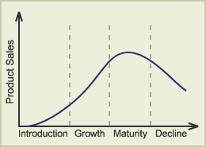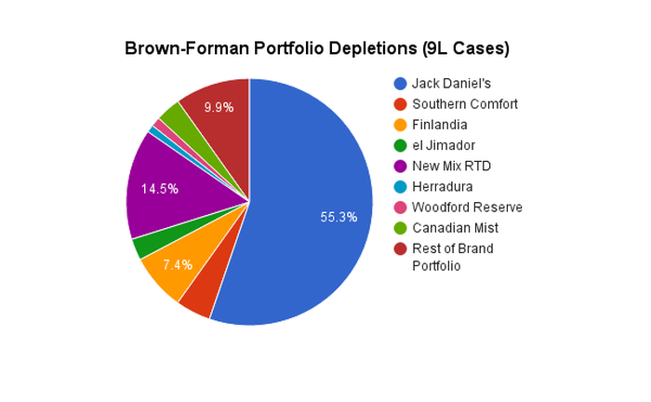
https://www.fool.com/investing/2016/09/05/for-brown-forman-corporation-jack-daniels-is-more.aspx

U.S. Market Share of Major Whiskey Brands
Brand | Distiller | U.S. Market Share
Jack Daniel's Black Label | Brown-Forman | 10.47%
Crown Royal Regular Blended | Diageo | 7.62%
Fireball | Sazerac | 7.57%
Jim Beam Regular Bourbon | Beam Suntory | 5.71%
Jameson Irish Whiskey | Pernod Ricard | 4.34%
https://www.fool.com/investing/2016/09/05/for-brown-forman-corporation-jack-daniels-is-more.aspx
STRATEGY
The main strategies for Marketing are segmentation, targeting, positioning and the Marketing Mix. They help us to achieve our objectives and to be where we want to be. The three stages of STP (segmentation, targeting and positioning are connected and help to create the Companies Marketing Mix (Kotler and Armstrong, 2016).

STP (Segmentation, targeting and position) for Jack Daniel
SEGMENTATION
Demographic: The Company Jack Daniels as a spirit product automatically make the demographic segmentation group of consumers, who can purchase and use the product. And depending on which country the age can vary from one country to another. In some countries there are some age consumption restrictions (Wikipedia, 2020). The products of the Company are available for any gender as long they have the certain age. From the ‘Numerator analysis’ the age consumers of Jack Daniels are from any age and mainly young adults, and age range from 45 to 65. The consumers are from different lifestyle, education and different nationalities. (Numerator, 2019).
Geographic: The MICRO and MACRO culture will influence the marketing for Jack Daniel with the variable of age restrictions and prohibition law alcohol consumption in some countries. Jack Daniels is Global Company selling their product in over 170 countries, and the product is standardised, the same, in every country. The strategies used to sell the products is mainly indirect marketing, through wholesaler and retailers. And a small percent is direct marketing, purchasing directly from the distillery (Wikipedia, 2019)

Psychographic: Jack Daniels is organising various campaigns to market customers based on their lifestyle, such as musical festivals, competitions, and sponsorships of events. (Campaign, 2019). Another approach of JD is to reach for consumers based on their lifestyle of young people, who are music fans through the App in creating their own music and receive information for all the events happening in Spain. (Mobil marketer, 2017).

TARGETING
Jack Daniels use Differentiated marketing, which means they target more than one market segment and design for each segment different offers. They create Marketing mix specially to meet those segment’s needs. For example, they make marketing mix only for adults for their alcohol drinks and separate marketing mix for their non-alcoholic drinks and foods. And another marketing mix for their brand extension series of items, such as t-shirts, hats, coffees, flavour bags, bags, chairs, tables, etc. (Work design group, 2018)

POSITIONING (BRAND IMAGE)
Jack Daniel are one of the pioneers in whiskey industry. Mr. Jack Daniel created original way of making Tennessee whiskey. Jack Daniel through the years build a strong brand with their first product Old 7. One of the company advantages is their unique way of producing whiskey and the square bottle and liable help the customer to identify their products. Another advantage is the way they use to promote their products through different type of promotions and especially the story telling about the product, Mr. Jack and the Company made their brand strong through their history which help them to be positioned as one of the founders of Tennessee way of making whiskey, which is parentage or history strategy to position themselves where they are now. They created and maintained brand loyal consumers. And this give the Company power over the middlemen, wholesaler and retailers. Jack Daniels use the Corporate umbrella branding, because their main product is called Jack Daniel Old 7, and all the following products produced by the Company contained the name Jack Daniel, even though the Company is owned by Brown-Forman. (Brown-Forman, 2019)

THE 4Ps MARKETING MIX
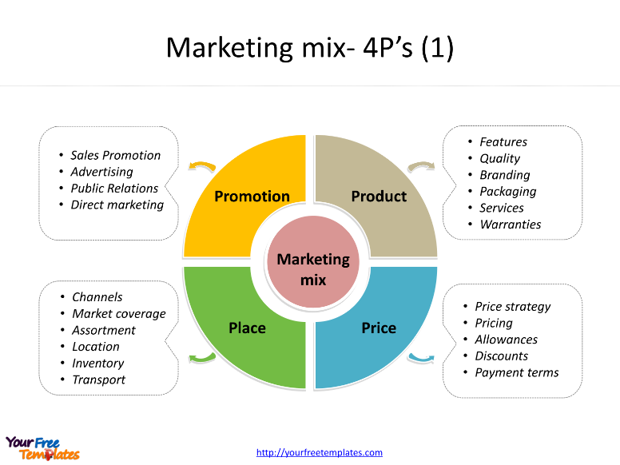
https://yourfreetemplates.com/marketing-mix-template/

MARKETING MIX Includes the 4ps (Product, prise, place and promotion).
PRODUCT is the goods and services or an idea, or a combination of them that the company offers to their target markets. The products include all the attributes, quality, size, benefits and features, packaging, labelling and the support service and warranties. How whiskey is made and the qualities of the ingredients (Brandmade.TV, 8 Dec.2015). Jack Daniels use unique products with unique packaging for each product, using labels and different sizes and their brand guaranties for the quality the consumer can expect and if there is a fault, they give guaranties or return and replacement of the products Jack Daniel, 2019). Consumer buy what the product can do for them.
PRICE is the amount the customer has to pay so he or she can obtain the product. Each product has its own price. The variables for price are discounts, allowances, pay periods, credit terms, etc. In Jack Daniels case they have a large range of prices from £20 to £1200 (Master of Malt, 2020). And another example of their price range compares to the 50 other whiskey brands (Damage, 2019).
PLACE the ways the products are made available by the Companies so the customers can obtain it. It could be direct and indirect channels (Kotler and Armstrong, 2016). Jack Daniels way of making the product available is mainly through indirect using wholesalers and retailer to sell the product. And small percentage is from direct marketing one of the places they sell the product is Lynchburg as a souvenir at the distillery, because their region is ‘dry’, which means selling spirits is prohibited. And the other option for direct purchasing of the product is online though their official web page and many other websites, who are selling their products.
PROMOTION is used by the Companies to communicate the products benefits and features and encourage and persuade the customer to buy the product. Jack Daniel use various way of communicating though social media, Newspapers, Radio, Podcasts, etc. Some of the places on the internet they advertised they products are:
- TUBE ADDVERTS of JD https://www.vice.com/en_uk/article/3k4w55/the-true-story-behind-those-jack-daniels-tube-adverts
- Jack Daniels TV SPOT videos: https://www.ispot.tv/brands/deq/jack-daniels
- Ads of the world and TV ADDs: https://www.adsoftheworld.com/taxonomy/brand/jack_daniels
- TWITER JD: https://twitter.com/JackDaniels_US
- FACEBOOK: https://www.facebook.com/jackdanielsuk/?brand_redir=105868097300.
- Podcast : The 12 episodes series, “Around the Barrel with Jack Daniels” (new consumer facing show -https://www.breakthrubev.com/news/jack-daniels-consumers?fbclid=IwAR3XiyB599bivxrMHeM6bFyzONOD-18CATxQG8X3Cd51Swi_u6sXDCzC5E8
- Their official webpage: www.jackdaniel.com
- News releases: http://pressroom.jackdaniels.com/?trust=yes

QUESTION 2
THE ADVANTAGES OF MARKETING TO CONSUMERS

SOCIATIAL MARKETING CONCEPTS
Jack Daniel is doing helping with $25,000 to “The Fire Family Foundation”. The company feels very empathy about the fires, because in the past the they had some issues connected with fire in the distillery. (The spirit business, 2018).
Brown-Forman, the owner of Jack Daniel is giving back to the communities where their business properties are located. As Brown-Forman website says: “We donate our time, talents, and treasure (cash contributes) to support organisations focused on arts and culture, social welfare, environment, youth and education, and other specific areas determined by local needs.” (Brown – Forman, 2019). They give grant to organisation that will help with cultural living, education, supporting social services and well- being, and organisation that are helping people to moderate and reduce drinking and the consequences that comes from drinking irresponsibly (Brown Forman, 2019). The Company Brown-Forman, and Jack as part of the Company have emphasizing on Drinking responsibly. There is some contradiction on firs look at sponsorship at NESCAR, because driving and spirits do not go together. So, this is why Jack Daniels spends a lot of resources in trying to educate people in drinking responsible. (Brown-Forman, 2008). All these factors and others I didn’t mention in this report add values to the customers in many ways, for example by being environment friendly the company is saving resources for the future generations and helping to reduce the global warming. Helping the community adds value because improves the place where people work and live.

ADVANTAGE OF BRANDING
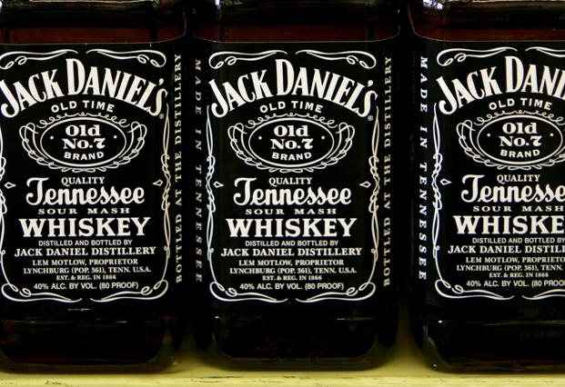
https://www.livemint.com/Companies/VXXSsl6GaNZ09g4qbM0J2I/Jack-Daniels-angers-rivals-over-Tennessee-whiskey-rule.html

Definition of Branding and strategy the company use. And how does add value to the customer?
The use of the term ‘BRAND’ includes the symbol, sign, design and everything that gives meaning to the customer about the producer or seller of the service or product. Branding is helping the customers to learn more about the Company offering the product and the product itself. For example, product quality, consistency, benefits and features, packaging materials and design. The labels used by the company also helps the customer find more information about the product, such as who is producer, where was made, content and so on. (Kotler and Armstrong, 2016). Each Company is trying to create image in the mind of the costumer by creating Logos and labels, so the customer can easier recognise and identify the Company. Nowadays most of the company that are on the market are investing time and resources in either building or to position and reposition their brands to make it even stronger and more recognisable for the customers. In the annual report of JD says: “The global strength of the Jack Daniel’s name has enabled us to build what is now a family of Jack Daniel’s brands..” (Hosted Data, 2018)
The Branding strategy of Jack Daniels is their stories and lore about the Company, Mr. Jack and the products. Epps says: We’re a storytelling brand build on authenticity and heritage”. (Vice, 2018)
Branding adds value to the customers by informing them about the product and services. Also, helps them to identify the Company’s product easier, so the customer makes better choices. Daniel’s Marketing Manager says, “Jack Daniel’s is uniquely positioned and a distinct brand, as it is one of the very few brands that can let the product speak for itself, without needing an artificial world created around it. This independent authenticity is embodied in the iconic Old No. 7, through which product and storytelling are synonymous” (Fast moving, 2017). Jack Daniels’s employees are brought to Jack Daniels Distillery to Lynchburg in small groups for few days to experience Camp Jack, participating in making whiskey and learning about the legends and lore of the Company (Fortune, 2011). The last 40 years Jack Daniels have been working on improving the process of producing and manufacturing their product b becoming more environment friendly, by trying to have zero wastage. They use the natural resources the best way they can. They protect the spring cave water, help farmers to plant corn. Use the left-over materials from the barrels for some other procedure in manufacturing the product. They plant trees, white oak, which they use for their barrels (Podcast, 2019).

THE ANSOFF METRIX – Advantages of marketing to consumers
The way marketing adds value to the customers is by making awareness of a product or service. Marketing explain the futures of the new product and what can do for the customer and how benefit the customer. Marketers create a need for the customer.

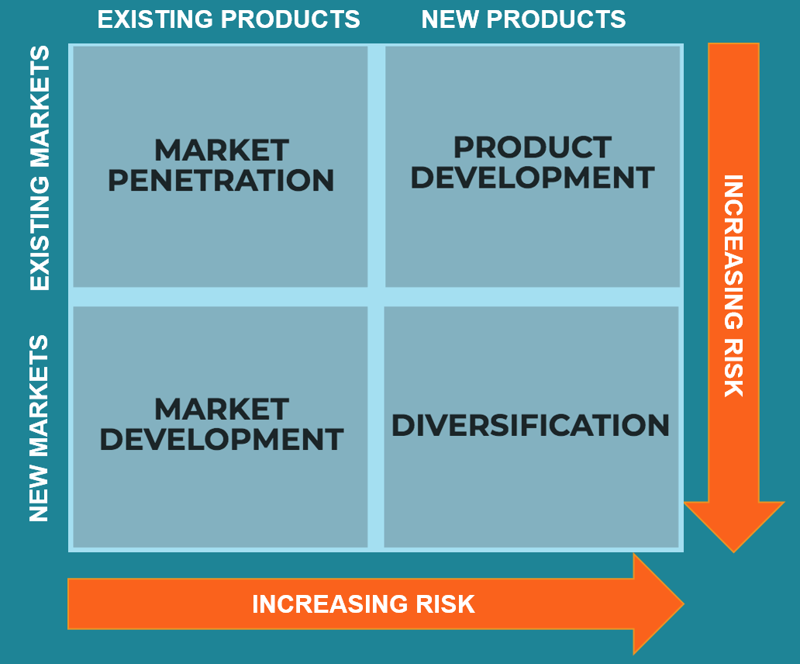
https://corporatefinanceinstitute.com/resources/knowledge/strategy/ansoff-matrix/

PRODUCT DEVELOPMENT
The product development add value to the customers by providing variety of whiskeys with different flavours. They started with ‘Old No 7’ and still make it by the original recipe. But the Company created new products such as: Tennessee Honey, Gentleman Jack, Tennessee Fire, Single Barrel, Green Label, Silver Select, 1907, Winter Jack, Single Barrel Rye, Single Barrel Barrel Proof, Sinatra Century, Sinatra Select, 27 Gold (Jack Daniel, 2019). These are the new products using new methods and new technologies to continue attracting customers and to provide them with bigger choice. Keeping the original recipe for Old 7 adds value to existing customers that are used to the taste and by creating new products and improving them Jack Daniels attracts new customers and adds value to them by providing them with more variety.

DIVERSIFICATION
They created new products in new industries and target new market (customers). Some of the diversification products are non-alcoholic (Threespiritdrinks, 2019)
Another diversificated product is Coffee with whiskey flavour, non-alcoholic (Pressroom Jack Daniel, 2019).
Various products, such as coffee, Pecan whiskey cake, Vanilla Tenn whiskey cake, Whiskey praline pecans, JD rubs (chicken, beef, pork and stake), JD Charcoal BBQ Smoking pellets, wood smoking chips (Store, 2019).
Jack Daniels by making product development and diversification of their product is adding value to the customers, because it gives the customers better products and more variety. Also, the features, design, packaging, quality and brand name of the company add value to Jack Daniel’s customers (see fig.2). Guarantee for the quality is the Brand name of Jack Daniel.
.
Fig.2.Customer value diagram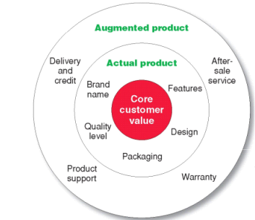
https://quizlet.com/79835053/fob-marketing-flash-cards/

QUESTION 3 STAKEHOLDERS
- Definition of a Stakeholder. Stake holders are group of people or individuals, who rely on the Company to achieve their own strategies and on whom, in return the organisation rely on. (Gerry Johnson at al., 2017).
- External and internal and relate to Jack Daniel. There are five overlapping type of stakeholders. The first one is economic stakeholders (owners, shareholders, banks, distributors, suppliers and customers), Social political stakeholders (local councils, government agencies, policy-makes, regulators),Technological (standards agencies, key adopters, ecosystem members), Community stakeholders ((lobby groups or activists) and internal stakeholders ( all employees on all levels in the organisation). Individuals may belong to more than one stakeholder group.

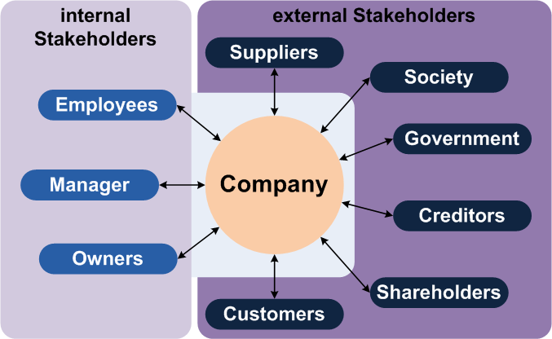
http://textbook.stpauls.br/Business_Organization/page_52.htm

Internal stakeholders

- Jeff Arnet - Internal stakeholder/ employee
He is one of the employees of Jack Daniels. He is the master distiller since 2008. He is one of the little people in the history of Jack Daniels who have the title Master Distiller. In 2017 he was recognised by the Whiskey Magazines as “Master Distiller of the year”. In 2001 he moved to Lynchburg. (Pressroom Jack Daniel, 2019).

- Criss Fletcher – Internal stakeholder/ employee
He is the assisted master distiller. Born and raised in Lynchburg. He has a degree in chemistry. He used to be a tour guide. He worked for Brown-Forman Corporation as a quality control f Jack Daniels. He worked two years in North America. And from 2014 he is back in Jack Daniel distillery. His grandfather was the fifth master distiller in Jack Daniels (1966-1989) (Pressroom Jack Daniel, 2019).

- Competitor is an external stakeholder. For example, Diego PLC is one of JD competitor. They are Corporate umbrella branding of few famous brands, such as Smirnoff, Jonnie Walker, Baileys, Crown Royal and Guinness. They have argument with Jack Daniels’s about the ‘Tennessee whiskey’ rule. (Livemint, 2014).

- Customers are external stakeholders. They are the once who use the product of the Company. The main target for Jack Daniels is the male and especially the young adults age above 20 (Blog dropbox, 2018)., and another target is the travellers. (Netfluential, 2014)

- State how the company communicates with its internal and external stakeholders
The company communicate with the internal and external stakeholders by using mobile, and internet. The main communication with internal stakeholders in the company is Flow (Blog Dropbox, 2018). And with the external stakeholders the company communicate through the social media (Facebook, twitter, their official webpage, etc.) (Digiday, 2012)

- Explain how stakeholders influence the company’s marketing strategy
In general, all the stake holders influence the Company’s marketing strategies. The external stakeholders, such as Rivals, or Government can have positive or negative affect on the company and the company act or react depending on the impact they have. And internal stakeholders have influence in the company on each level, because some of the internal stakeholders are the leadership and management of the company, which means they make decisions and implement them. And the lower level employees do them. Jeff Arnet and Criss Pletcher have key roles in making sure that the products of Jack Daniels are at the quality and taste they should be.

QUESTION 4 / (1B) Promotion
Integrated marketing communication (IMC)
- definition of communication and communication model. (Illustrated in fig.3)

Fig. 3

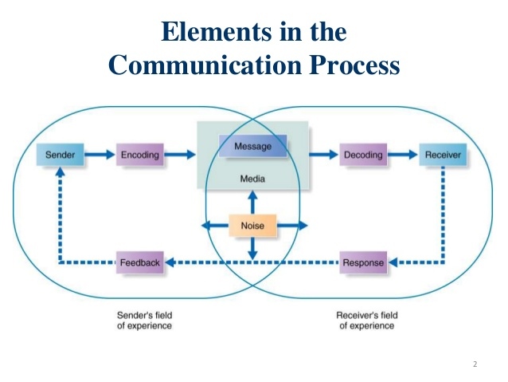https://www.tes.com/lessons/RAeN2TP-lYMorw/exceptional-customer-service
The communication process includes nine elements. The most important are the ‘sender’ and the ‘receiver’, the communication tools used are ‘massage’ and ‘media’, and another four elements are ‘coding’, ‘decoding’, ‘response’ and ‘feedback’. And the last element is ‘noise’. The sender (the company or advertiser) sends the information to another party, and then the information is encoding (putting sounds, words and images) that are relevant to their customers. Transmitting the massage is symbols (the actual adds), and Media (TV, Newspaper, magazines, radio, etc.) is the channels use for communication moving the information from sender to receiver, and decoding is the interests the sounds, words and images, by assigning meaning. Receiver is the customer or target market, who receiving, interpret the massage. Then they give their responds/ feedback, and as Kotler and Armstrong (2016) said: “the reaction of the receiver after being exposed to the massage” (Kotler and Armstrong p.453). Feedback is the response given by the customer to the Company, criticizing or praising the advert, the massage. And Noise is the surrounding distraction and distortion that interrupt or are obstacles the information to be received and key points are lots. (Kotler and Armstrong, p.453).
There are two types of communications channels, Personal and None personal. The personal is direct communication ‘face to face’ (via email, on the phone, email, chats, texting, etc.) Receiving personal or direct feedbacks. And Non personal is ‘one to many’ (newspapers, TV, radio, magazines, etc.). Indirect feedback.
- Definition of integrated marketing communication (IMC)
In the past marketers use the mass media (newspapers, TV, etc.) to advertise, but with the development of the technology there is a new way, the media (Social media, twitter, Facebook, YouTube, Instagram, google+, etc.) to send the message to the targeted customers. And because of the various way to send the message to the customers there were some challenges in sending clear, standardised and synchronise massage to the customers. Nowadays marketers use integrated marketing communication in order the Customers to receive compelling, consistent and clear massage about the brand and the Company (Kotler and Armstrong, p.449).
- Different combination of promotions used by Jack Daniel
From the foundation of the Brand Jack Daniels promotion plays important role. In the beginning (until 1950) the type of promotion is word of mouth. In 1951 an article in Fortune magazine was published about Jack Daniel. And another article was published, in True, in 1954, which was one of the most popular back then, saying that Jack Daniels is a celebrities’ choice of drink. Celebrities such as Sinatra, Ava Gardner. Jackie Gleason, Winston Churchill, John Huston. Sinatra said for Jack Daniel’s whiskey is a “nectar of the gods”. (J. Stengel, 2011, p. 90). What is interesting between 1950 and 1970s the demand was bigger than the supply. And when other whiskey or bourbon company stop advertising Jack Daniels continue to advertise their product.
From 1954 for over four decades Jack Daniels used “Postcard” advertisement in U.S. newspapers and magazines (The drinks business, 2016).
1955 Jack Daniels start to use “one-page marketing plan”, which focus on telling the legends about Jack Daniel’s stories and the real people who made the whiskey at Lynchburg. 1960 Jack Daniel Distillery opens for brand experience for the first tourist tour centre. More than 200 000 people visit the distillery every year. From 1950 to present time many famous people were fans of Jack Daniel’s whiskey, such as: Paul Newman, Frank Sinatra, Keith Richards, Slash, Ke$a, etc. No one was paid to advertise Jack Daniels. From 1973 to 1986 grew to Global business. From the growth they started to sponsor events, such as barbeque competition (since 1980), professional Bull Riders (since 1995), Motor racing teams in USA and Australia. (J. Stengel, 2011, p. 93). The Company, Jack Daniels sponsored NASCAR, RUMBLEE, Musical festivals, etc. (Campagnlive, 2011). Some of the events Jack Daniels is sponsoring (Pinterest, 2019).

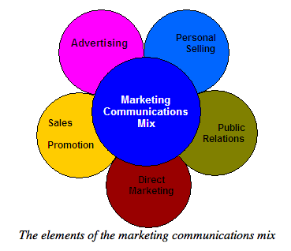
http://e-fairbank1013-ent.blogspot.com/2011/12/task-3-research-on-marketing.html

Jack Daniel use Social medial (Facebook, twitter, Twitter web page, YouTube, TV spot videos, etc.) to communicate with the new and existing customers.
To communicate with the targeted customers Jack Daniel, use digital marketing to make aware the customers about their existing and new products. https://digiday.com/marketing/jack-daniels-content-driven-digital-strategy/. For example, they use:
- Jack Daniels TV SPOT videos: https://www.ispot.tv/brands/deq/jack-daniels
- Ads of the world and TV ADDs: https://www.adsoftheworld.com/taxonomy/brand/jack_daniels
- TWITER JD: https://twitter.com/JackDaniels_US
- FACEBOOK: https://www.facebook.com/jackdanielsuk/?brand_redir=105868097300
- Their official webpage: www.jackdaniels.com
- Public relation http://pressroom.jackdaniels.com/contacts-2/
- Podcast: https://open.spotify.com/show/7A3zHNl1yHEWNJbDubrxTW
- JD view of using social media. https://digiday.com/marketing/jack-daniels-content-driven-digital-strategy/
- Targeting travellers https://www.netfluential.com/communication-work#brown-forman
- https://static.brown-forman.com/wp-content/uploads/2014/08/BF_Marketing_Promotional_Policy.pdf
Brown-Forman corporation’s marketing advertising and promotional policy for beverage alcohol.

And in the Media, newspapers, posters, etc. for example they use Tube adverts of Jack Daniel https://www.vice.com/en_uk/article/3k4w55/the-true-story-behind-those-jack-daniels-tube-adverts
The two type of promotions which will discuss advantages and disadvantages are: Jack Daniels TV and podcasts.
TV
Advantages are many people can see the ads they show on the TV. The noise and the images capture the audience attention. The company can target Niche market channel.
Disadvantages are its expensive tool to be used by the Company. The time frame is short up to 30 sec. and there is a ‘noise’, many distractions that can distract the customer from the ads.
PODCAST
Advantages are Indore and outdoor reach. Only certain group, who listen to podcast might listen to the ads or info, so its Niche market. The cost is less than the TV. And is very informative with a lot of details. For example, Jack Daniel just launched “Around the barrel” (12 episodes).
Disadvantages are It is not multisensory media. Noises and distractions could decrease the attention of the customer.

CONCLUSION
Marketing process is used by the Company to create awareness about their products. This is a process of planning the different approaches and strategies for the company to make aware their products to the customers. They do research to find out the needs and wants of the customers. And once the Company finds their needs and wants, they create strategy by creating Marketing Mix to target this segment of groups. The Marketing Mix includes the product, place, price and promotion. All of them are connected. The Companies has a mission and vision and creates their strategies Situational analysis, objectives, strategies, implementation and control. The Situational analysis is covered by the three frameworks SWOT, PESTEL and Potter’s five and it’s a good way to find all the MACRO and MICRO factors how they impact the Company. There are some shortcomings on each framework, but together they cover the MACRO and MICRO forces. Branding is the way the company creates an image in the minds of the customers. So, they become recognisable and identifiable by the consumers. This is one way for the Company to create barriers for the new rivals who are entering the same market industry. Jack Daniel is one of the best in doing advertising and promotions to build their brand strong. Jack Daniels is working on their societal marketing concept by doing charities and donating money and sponsoring various events and festivals. They are working add value to the customers by using the Ansoff Metrix, product development and Diversification. Which means they use new technology and apply them in the process of making better products and more variety. And diversification is entering new markets and creating new products. Important part of the Company dealing is with the internal and external stakeholders. Some of them have bigger impact on the Company then others, but all play their role to help the Company to achieve its goals. Money always have been important part of Jack Daniels They use various ways to communicate with their new and existing customers. Everything that the Company have been doing the last 150 years help them to be on the position there are now. And to be one of the leading companies in the whiskey industry and to be well known around the world.

RECOMENDATION:
Jack Daniels can use the Ansoff’s Metrix by creating new product and new market – Diversification trying to enter in a new industry, providing more variety by creating new products.
- Use the Water from the cave/ producing mineral waters or soft drinks
Jack Daniels have their own water source. They do not use all the water for making the whiskey. So, there is a water that they can use to bottle water and sell it. Also, they can start doing Soft drinks as well using the water resource.
- Snacks with taste of whiskey (non-alcoholic)
Jack Daniel can start making snacks with whiskey flavours. I think people will like it. And people who are minors and can’t drink can at least taste the flavour of Jack Daniels’s products. And in the future the same minor/ young people might become one of the most loyal customers for a long period of time.
- App “go home”
They can work with in partnership with an app creator and make an app that for example can be called ‘go home safe’. People who get drink can use it to call taxi and sends automatically the location from point A (bar, restaurant, etc.) to Point B (home) or their family, friends to come and collect them. So, in the end the person gets home safe.
- Alcohol and driving restriction sensor.
Jack Daniel can work in partnership with a car industry to create an alcohol sensor in the while that will lock the car and not give the driver of the vehicle to drive after consumption of alcohol.

REFERENCES:
Blog Dropbox (2018) “How Jack Daniel’s created an iconic brand by staying true to itself”, By Liz Armistead, published August 09,2018), Phil Epps interview. [Online] Available at: https://blog.dropbox.com/topics/work-culture/phil-epps-interview, (Accessed on 22.11.2019).
Bloomberg, (2018). “Jack Daniel’s Is Set to Get More Expensive in the EU”, By Jannie Wolf. June 25,2018 [online] Available at : https://www.bloomberg.com/news/articles/2018-06-25/jack-daniel-s-maker-tastes-trade-war-impact-as-shares-slide?fbclid=IwAR1UfNz8FvFaptH3BAPg4Mw90FCTijGyuicgrpzLVvgUkc8KqgYmcDzV4Mk (accessed on 5.12.2019)

Brandmade.TV (2015) “How Jack Daniel’s Tennessee Whiskey is made”. [Online] YouTube video Available at: https://www.youtube.com/watch?v=V01ME8yNKeY (Accessed 2.12.2019).

Brown-Forman (2007).”Our long-term perspective Brown-Forman corporate responsibility report “(2007-2008) [Online] Available at: https://static.brown-forman.com/wp-content/uploads/2014/08/BF_CRR2007_08.pdf. (Accessed on 11.12.2019)
Brown Forman (2018).Annual report” Icons of American Whiskey” [Online] Available at: http://www.annualreports.com/HostedData/AnnualReports/PDF/NYSE_BF_2018.pdf (accessed on 1.12.2019)
Brown - Forman (2019). Environmental Performance (Policy 985). [online] Available at: https://static.brown-forman.com/wp-content/uploads/2014/08/EnvironmentalPerformancePolicy.pdf (accessed on 2.12.2019)

Brown-Forman (2019) “Community involvement”[online] Available at: https://www.brown-forman.com/community-involvement/ (Accessed on 11.11.2019).

Campaign (2019) “Inside Jack Daniels Tennessee pop up amplify”. [online] Available at: https://www.campaignlive.co.uk/article/inside-jack-daniels-tennessee-pop-up-amplify/1443969. (accessed on 3.12.2019).
Campignlive (2011) “Jack Daniels boost focus live music ties”, by Sarah Sherman, September 08,2011 [Online] Available at: https://www.campaignlive.co.uk/article/jack-daniels-boost-focus-live-music-ties/1089406 (Accessed on 2.11.2019).
CBS This Morning (2017). “The lost story of the slave who thought Jack Danie how to make whiskey” [ online] YouTube video, 28 Nov. 2017. [Online] Available at: https://www.youtube.com/watch?v=hshIicm-auk&t=326s. (Accessed on 3.11.2019).

Damage (2019). “Finest whiskies of the world you need to try at least once in your life”,13 Feb. 2019. [Online] Available at: https://www.dmarge.com/2019/02/whiskey-brands.html (Accessed on 7.12.2019).

Digiday (2010-2020) “Marketing, Jack Daniel content driven digital strategy” , by Giselle Abramovich June 8, 2012.[ Online] Available at: https://digiday.com/marketing/jack-daniels-content-driven-digital-strategy/. (Accessed on 14.11.2019).

Fast Moving (2017). “Jack Daniels does TV “his way””, by Ofyt Jun 20th, 2017. [Online] Available at: http://www.fastmoving.co.za/activities/jack-daniel-s-does-tv-his-way-7993 (Accessed on 17.12.2019)

Forbs (2019) “The best 25 selling whiskey brands in the world”. [ online] Available at: https://www.forbes.com/sites/felipeschrieberg/2018/11/27/the-25-best-selling-whisky-brands-in-the-world/#6dbf281b2e83. (Accessed on 5.11.2019).

Fortune (2011) Jack Daniel Marketing magic.[Online] Available at: https://fortune.com/2011/12/08/jack-daniels-marketing-magic/ (Accessed on 13.11.2019).

Gerry Johnson at al. (2017). Exploring strategy 11th edition, p.134, Pearson 2017

Jack Daniel (2019) [online] Available at: www.Jackdaniel.com accessed on (22.10.19)

Investopedia (2019). “The pitfalls of Potter’s 5 forces”, by Andrew Beattie [Online] https://www.investopedia.com/articles/investing/103116/pitfalls-porters-5-forces.asp (Accessed on 19.12.2019).

Kotler, F. and Armstrong, G. (2016) “Principle of marketing”, Pearson

Livemint (2014). “Jack Daniel’s angers rivals over ‘Tennessee whiskey’ rule”, by Juliette Michel, 30 Mar 2014) [Online] Available at: https://www.livemint.com/Companies/VXXSsl6GaNZ09g4qbM0J2I/Jack-Daniels-angers-rivals-over-Tennessee-whiskey-rule.html (Accessed on 16.11.2019).

Master of malt (2020) Jack Daniel’s. [Online] Available at https://www.masterofmalt.com/distilleries/jack-daniels-whiskey-distillery/. (Accessed on 7.11.2019).

Mind tools (1996-2020). “Potter’s five forces”. [Online] Available at: https://www.mindtools.com/pages/article/newTMC_08.htm. (Accessed 2.01.2020).

Mobil Marketer (2017). “Jack Daniel’s whiskey brand adds mobile to marketing mix” [online] Available at : https://www.mobilemarketer.com/ex/mobilemarketer/cms/news/music/3776.html (Accessed on 10.12.2019)

Morning advertiser (28. Nov.,2016) “Jack Daniel master distiller on marijuana, Brexit and Trump” , by Nicol Robinson. {online] Available at: https://www.morningadvertiser.co.uk/Article/2016/11/28/Jack-Daniel-s-master-distiller-on-marijuana-Brexit-and-Trump (accessed on 17.12.2019)
Netfluential (2014) “Communication work, Brown-Forman”. [Online] Available at: https://www.netfluential.com/communication-work#brown-forman
Numerator (2019). Jack Daniel. [Online] Available at: https://snapshot.numerator.com/brand/jack_daniels (Accessed on 7.11.2019).

Podcast (2019). “Every day we make it we make it well make it the best we can”. [Online] Available at:https://podcasts.apple.com/us/podcast/every-day-we-make-it-well-make-it-the-best-we-can/id1341153649?i=1000440081428&fbclid=IwAR2fSu3vQyb8GI_PpBKfKethwYrXwyuv2nl8a76KVVLt1GE-rrvXMV-lqW8 (Accessed on 17.12.2019)
Pinterest (2019) “Jack Daniel’s Events”. [Online] Available at: https://www.pinterest.co.uk/thewhiskeycave/jack-daniels-events/ (Accessed on 18.12.209).
Pressroom Jack Daniel (2019) “Jack Daniel introduced new coffee in partnership with world of coffee”. [Online] Available at: http://pressroom.jackdaniels.com/jack-daniels-introduces-new-coffee-in-partnership-with-world-of-coffee/ (Accessed 20.12.2019).
Pressroom Jack Daniels (2019). Jeff Arnett master distiller [Online] Available at: http://pressroom.jackdaniels.com/jeff-arnett-master-distiller/ (Accessed on 17.11.2019).
Pressroom Jack Daniels (2019). Chris Fletcher [Online] Available at: http://pressroom.jackdaniels.com/bios/chris-fletcher/ (Accessed on 17.11.2019).
Spotify (2019). Jack Daniel, “Around the Barrel with Jack Daniel”. [online] Available at: https://open.spotify.com/show/7A3zHNl1yHEWNJbDubrxTW. (Accessed on 12.12.2019).
Stengel, J. (2011) “Grow”. Crown briskness, New York
Store (2019) [Online] Available at: https://store.jackdaniels.com/jdr/dept.asp?dept_id=14100 (Accessed on 19.12.2019).
The drinks business (2016). “Jack Daniel’s: the illusion of discovery”, by Db-staff, 12th October 2016. [Online] Available at: https://www.thedrinksbusiness.com/2016/10/jack-daniels-the-illusion-of-discovery/ (Accessed on 13.12.2019).
Telegraph, 2019. Jack Daniel's tax levy blocked over job fears, By Jon Swaine, Washington
22 Nov 2011 [ Online] Available at : https://www.telegraph.co.uk/foodanddrink/foodanddrinknews/8907813/Jack-Daniels-tax-levy-blocked-over-job-fears.html (accessed on 1.12.2019)

The Grocer (2019) “Brits paying more for whiskey as EU tariffs start to take effect”, by Daniel Woolfson,19 September,2019. [online] Available at: https://www.thegrocer.co.uk/alcohol/brits-paying-more-for-us-whiskey-as-eu-tariffs-start-to-take-effect/597691.article (Accessed on 2.11.2019).

The spirit business (2017). “The top 10 best-selling world whisky”, by Annie Hayes, 26th, June 2017. [online] Available at: https://www.thespiritsbusiness.com/2017/06/the-top-10-best-selling-world-whisky-brands/11/ . (Accessed on 3.01.2020).
The spirit business (2018) “Jack Daniels donates 25,000 to support firefighters”, by Owen beellwood,9th March,2018. [Online] Available at: https://www.thespiritsbusiness.com/2018/03/jack-daniels-donates-25k-to-support-firefighters/ (Accessed on 7.01.2019).

The spirit business (2019) “World whiskey brand champion 2019 Jim beam” https://www.thespiritsbusiness.com/2019/06/world-whiskey-brand-champion-2019-jim-beam/ . (Accessed on 3.01.2020).

Threespiritdrinks (2019) [online] Available at: https://threespiritdrinks.com/ (Accessed on 22.11.2019).

Vice (2018) “The true story behind those Jack Daniel’s tub adverts”, by Oscar Rickett, 21 June 2018. [Online] Available at: https://www.vice.com/en_uk/article/3k4w55/the-true-story-behind-those-jack-daniels-tube-adverts (Accessed on 8.11.2019).

Wikipedia (2020). “Legal drinking”. [Online] Available at: https://en.wikipedia.org/wiki/Legal_drinking_age (accessed on 1.10.2019).

Work design group (2019) “Brand extension series: Jack Daniels and the spirit of America” by Taylor Getler, January 15th, 2018. [Online] Available at: http://www.worksdesigngroup.com/brand-extension-series-jack-daniels-spirit-america/ (Accessed on 1.12.2018)

