Cheng Chen (2305261)
UNIVERSITY OF WALES TRINITY SAINT DAVID
BSc Applied Computing
L5 - DATA SECURITY AND COMPLIANCE (FT - ACCA5034)
Research and case scenario in Data Security and Compliance
Content
Research in Data Security and Compliance 2
Abstract 2
Introduction 2
Literature Review 2
Security Frameworks 3
Security Technologies 4
Intrusion Detection and Prevention Systems (IDPS) 5
Physical Security 6
Implementing Information Security 7
Security and Personnel 8
Information Security Maintenance 9
Discussion and Critical Evaluation 9
Conclusion 10
Case Scenario 11
Introduction 11
Organizational Structure/Chart 11
Policies and Procedures 12
Compliance (Laws and Ethics) 13
Governance and Strategic Planning for Security 13
Risk Management 14
Contingency Planning 15
Protection Mechanisms 16
Conclusion 17

Research in Data Security and Compliance
Improving Organizational Security in Contemporary IT Settings

Abstract
The rising digitalization of modern enterprises has led to a surge in security threats, so it is essential to create an environment that protects, detects, reacts, and preserves IT infrastructure and applications. The ISO 27000 and NIST frameworks, firewalls, encryption, and Intrusion Detection and Prevention Systems (IDPS) are just a few of the security frameworks, technologies, and methods that are examined in this study. To achieve strong organizational security, it also examines the significance of maintaining information security, human security, and physical security. Future trends are covered in the paper's conclusion, which also highlights the necessity of a thorough, proactive security strategy to guard against ever-changing cyberthreats.

Introduction
Because of their dependence on networked systems, cloud infrastructure, and massive data storage, modern businesses face previously unheard-of security challenges. Cyberthreats that target sensitive data and assets, like ransomware, phishing, and advanced persistent threats (APTs), are getting more complex. It is crucial to have a thorough IT security plan that includes detection tools like SIEM and IDS in addition to proactive defenses like firewalls, encryption, and access controls. To give businesses strategies for creating a strong security posture that addresses and mitigates changing cybersecurity risks, this article examines important security frameworks, technologies, and practices, including ISO 27000, cryptography, and physical security.

Literature Review
According to recent studies and industry standards, a proactive security environment is crucial to combating the increasingly complex nature of cyberthreats. Ransomware, phishing, and data breaches are the main causes of the sharp increase in cybercrime expenses, which is expected to reach $10.5 trillion by 2025, according to a 2023 Cybersecurity Ventures report. Organizations require comprehensive security frameworks to handle these changing threats, and the NIST Cybersecurity Framework's five pillars—Identify, Protect, Detect, Respond, and Recover—offer an organized method. These guidelines provide a systematic approach to risk management that works for all sectors. Furthermore, a strong framework for putting in place an Information Security Management System (ISMS), which aids in managing sensitive data and reducing risks, is provided by the ISO 27000 series, especially ISO 27001.

Organizations must give adaptive security and ongoing monitoring top priority as security threats become more subtle. The significance of endpoint protection, real-time threat detection, and incident response was highlighted in a 2022 study by the SANS Institute, particularly considering the expansion of cloud services and remote work. Tools like VPNs and endpoint security are essential for ensuring secure access as traditional network perimeters are increasingly abandoned.

Strong Intrusion Detection and Prevention Systems (IDPS) and Security Information and Event Management (SIEM) systems that use machine learning to identify anomalies are essential given the rise of Advanced Persistent Threats (APTs), which can go unnoticed for long periods of time. However, there are obstacles to putting these technologies into practice, such as a lack of cybersecurity experts and budgetary limitations, particularly for smaller companies. Implementing security is further made more difficult by adhering to legislative frameworks like the CCPA and GDPR, which call for stringent access control and data privacy safeguards.

Security Frameworks
The International Organization for Standardization (ISO) and the International Electrotechnical Commission (IEC) created the ISO 27000 series, which offers an organized method for handling information security. The foundation of this series is ISO 27001, which lays out the requirements for creating, putting into practice, preserving, and enhancing an information security management system (ISMS). Focusing on the Confidentiality, Integrity, and Availability (CIA) triangle to guarantee that data is correct, available when needed, and only accessible by authorized users, this system assists businesses in identifying, evaluating, and mitigating security issues. Due to its explicit security rules and compliance with regulations such as the CCPA and GDPR, ISO 27001 is essential for enterprises. ISO 27001 is a highly appreciated certification by stakeholders because it requires enterprises to regularly identify risks, install controls, and review their operations to establish continuing security improvements.

The National Institute of Standards and Technology developed the NIST Cybersecurity Framework, a risk-based, voluntary approach to cybersecurity risk management. It was first created for critical infrastructure, but because of its adaptability and emphasis on risk management, it has been widely used in a variety of industries. The five roles of the framework—Identify, Protect, Detect, Respond, and Recover—help firms comprehend hazards, safeguard resources, keep an eye on threats, react to incidents, and resume operations. The flexibility of the NIST framework, which enables companies to connect it with other standards like ISO 27000 and tailor it to their own requirements, makes it extremely valued.

Critical Analysis
Formal certification, established standards, and solid regulatory compliance are just a few of the obvious advantages that make ISO 27000 the perfect choice for businesses that need systematic controls. Nevertheless, the certification procedure may be costly and inflexible, which could restrict its flexibility in quickly evolving contexts.

However, the NIST Framework is more adaptable, enabling businesses to customize it to meet their requirements and easily incorporate it with other standards. Its emphasis on resilience is essential for managing changing cyberthreats, particularly through the "Respond" and "Recover" pillars. Its lack of certification, however, may put off highly regulated sectors that place a premium on official confirmation.

Combining the flexibility and resilience focused approach of the NIST framework with the structured, risk-based methodology of the ISO 27000 series can help many firms develop a strong cybersecurity plan that strikes a compromise between compliance and flexibility.

Security Technologies
Setting Up Secure Network Boundaries Using VPNs and Firewalls
Virtual Private Networks (VPNs) and firewalls are crucial technologies for safeguarding data in transit and securing network perimeters. By examining and filtering incoming and outgoing traffic according to pre-established security criteria, firewalls distinguish between trusted internal networks and untrusted external networks, such as the internet. These gadgets, which can be either software- or hardware-based, aid in thwarting hacking efforts and preventing unwanted access. Usually placed at network entry points, firewalls make sure that only authorized traffic can flow through.

By encrypting data as it moves over potentially unsafe networks, including public Wi-Fi hotspots, VPNs improve this perimeter security. VPNs shield private data from interception and eavesdropping by establishing a secure "tunnel" between a device and a distant network. Since they enable employees to safely access company resources from any place without exposing data to outside risks, they are particularly crucial for remote workers.

Mechanisms for Access Control
To stop unwanted access to sensitive data and important systems, access management is essential. By forcing users to authenticate using two or more factors—something they know (password), something they possess (phone or token), or something they are (biometric data), Multi-Factor Authentication (MFA) improves security. Even if one factor is compromised, it is far more difficult for attackers to obtain illegal access thanks to this multi-layered method.
By limiting access to data according to a user's job within an organization, role-based access control, or RBAC, further improves security. The danger of data breaches is reduced because users are only given access to the information required for their jobs.

Using encryption and cryptography to preserve integrity and confidentiality
Maintaining the confidentiality and integrity of data requires encryption. It ensures that only individuals with the right decryption key can access readable material by transforming it into a format that is incomprehensible to unauthorized users. Both data at rest (stored on devices) and data in transit (such as transmission over networks) require this security.
Secure Sockets Layer (SSL) and Transport Layer Security (TLS) are two protocols that offer encrypted communication channels for the transmission of private data over the internet. Data integrity and confidentiality are preserved via encryption techniques like AES (Advanced Encryption Standard), which guard against illegal access and manipulation.

Layered Security Architecture as an Example
Networks, systems, and data must be protected using a layered security architecture. A multi-layered defense strategy's use of security technologies is depicted in the diagram below.
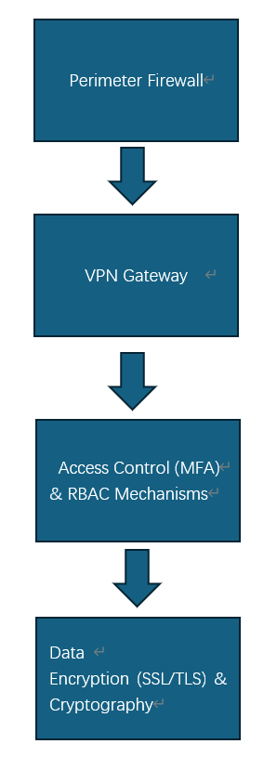
According to security standards, the firewall in this design filters both incoming and outgoing traffic.
Secure data transfer and encrypted communication for distant users are guaranteed by VPN.
Only authorized users are granted access by access control (MFA and RBAC) according to their role and identity.
Even if data is intercepted, encryption makes sure that it cannot be decrypted without the decryption key.
This multi-layered strategy greatly improves an organization's overall security posture since each layer provides a different kind of protection.

Intrusion Detection and Prevention Systems (IDPS)
Intrusion Detection and Prevention Systems (IDPS) are made to keep an eye on system activity or network traffic for indications of questionable behavior, identify threats, and take appropriate action. Intrusion Prevention Systems (IPS) actively block and stop attacks from reaching its targets, whereas Intrusion Detection Systems (IDS) concentrate on finding intrusions and producing alarms.

IDPS types include:
Network traffic is monitored by Network-Based IDPS (NIDPS) for anomalies, known attack signatures, or odd patterns that might point to malicious activity. To identify external threats, it is usually placed near a network's perimeter.
Host-Based IDPS (HIDPS): Keeps an eye on system-level operations on specific hosts or devices, like file modifications or illegal access attempts. It offers more detailed endpoint monitoring.
Extra Tools for Security:

Through file and application scanning, antivirus software finds and stops malware infections, including viruses, worms, and Trojan horses. It might overlook more advanced or recent malware, though.
Security Information and Event Management (SIEM): Offers real-time insights into possible risks by centrally monitoring and analyzing security event data from several sources. Setting up a SIEM can be difficult and resource intensive.
Vulnerability scanners: Find holes in systems, apps, or networks that an attacker could exploit. Although they are good at finding known vulnerabilities, they could miss more sophisticated or undiscovered threats.

Comparative Analysis Chart
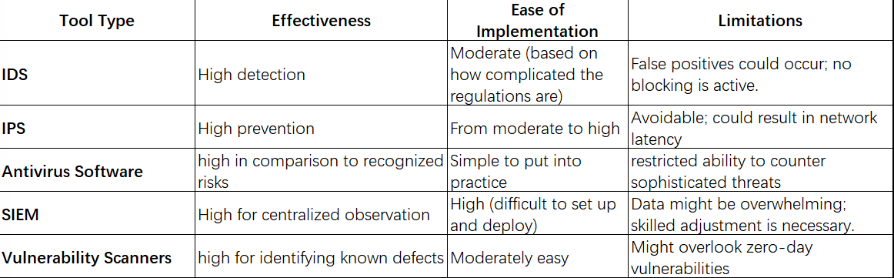

Physical Security
To prevent physical attacks and unwanted access to data centers and critical infrastructure, physical security is essential. It entails several protections for the structure and the machinery it contains. Important elements consist of:

Access controls: These use biometrics (such as fingerprint or iris scans), badges, and PINs to restrict access to authorized personnel.
Surveillance: By keeping an eye on and documenting activity, cameras can assist detect intruders and discourage malevolent behavior.
Barriers: Secure doors, fences, and gates are examples of physical barriers that keep people out of buildings.
Physical security guards against theft and tampering, two direct risks to hardware. Even the most robust cybersecurity protections can be circumvented if hackers manage to physically access servers or storage devices.

Comparing Physical and Digital Security
While cybersecurity seeks to defend digital assets, networks, and data from online attacks, physical security concentrates on protecting the physical environment. Despite their differences, the two are closely related. Cybercriminals can access digital systems by taking advantage of physical security flaws, such sneaking into server rooms. complete protection is offered by a complete strategy that combines cybersecurity and physical measures, bolstering defenses against both physical and virtual threats.

Implementing Information Security
Organizations must create thorough security policies and adhere to industry best practices to guarantee effective information security. This entails first identifying important resources, hazards, and threats, and then developing policies that specify data management, incident monitoring, response procedures, and access controls. These guidelines ought to cover data security, encryption, access control, and adherence to laws such as the CCPA and GDPR. They should also be updated frequently to consider new legal requirements and developing threats. Standardizing security efforts and encouraging continuous improvement are two benefits of implementing frameworks like ISO 27001 and the NIST Cybersecurity Framework.

An essential part of any security plan is employee training. Employees who receive frequent training are better able to identify threats, securely handle passwords, and comprehend incident reporting protocols, as human errors—such as falling for phishing attacks—are a major contributor to security breaches. Organizations can drastically lower the likelihood of security incidents brought on by employee carelessness by cultivating a security-aware culture.

Example: A Flowchart Outlining the Procedures for Putting an Information Security Policy into Practice
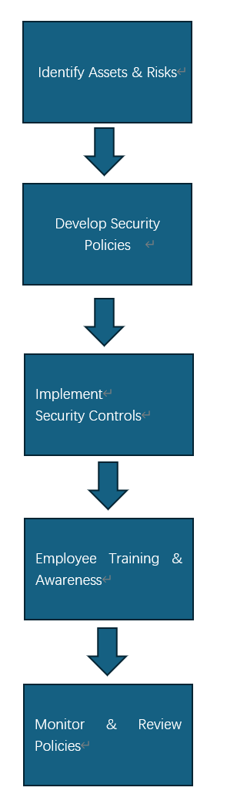
The main procedures for putting an information security policy into practice are shown in this flowchart, which guarantees thorough coverage from risk assessment to ongoing improvement.

Security and Personnel
Maintaining an organization's cybersecurity posture requires security experts. IT managers oversee servers and firewalls to make sure networks and systems are set up safely and shielded from unwanted access. Designing and protecting network infrastructures is the main responsibility of network engineers, who also make sure that firewalls and routers are set up correctly to reduce risks. Cybersecurity analysts do incident response, security analysis, and threat assessments to keep an eye out for and address security threats.

Continuous training and personnel screening are essential for protecting sensitive data. Background checks reveal possible dangers, and frequent training keeps staff members up to date on new threats and security best practices. Network security competence is further ensured by security certifications such as CISSP or CEH.

Information Security Maintenance
Sustaining robust information security requires ongoing monitoring and auditing. Frequent audits assist in locating weak points, guaranteeing adherence to security guidelines, and revealing potential inefficiencies in security measures. Proactive steps to mitigate possible threats are offered by security assessments, which include vulnerability scanning and penetration testing. Continuous system and network monitoring also enables businesses to identify unusual activity instantly, enabling prompt reactions to possible threats or breaches. To fix recently found vulnerabilities and fortify defenses, regular software upgrades and security patches are essential.

For a company to be able to respond to security issues in an efficient manner, incident response planning is equally important. In the case of a breach, a well-defined incident response plan specifies precise steps to take, such as locating, containing, eliminating, and recovering from the attack. It lessens the impact of a breach, cuts down on downtime, and makes it possible to quickly resume regular operations. Frequent exercises and plan revisions guarantee preparedness and enhance the organization's overall security posture.

Discussion and Critical Evaluation
Advantages and Drawbacks
Standardized security procedures, better risk management, and increased regulatory compliance are just a few benefits of putting security frameworks and technologies into practice. Organizations can create systematic methods to data and system security with the aid of frameworks like ISO 27001 and NIST, which guarantee uniform protection throughout operations. Real-time defense against changing cyberthreats is provided by technologies like intrusion detection systems, firewalls, and encryption, which enhance data availability, confidentiality, and integrity. Furthermore, centralized monitoring and quicker incident response are made possible by security solutions like SIEM systems.

There are restrictions, though. Because security frameworks require maintenance and implementation, they can be expensive to adopt, especially for smaller firms. Strict adherence to frameworks can also reduce flexibility, which makes it more difficult for businesses to react swiftly to new risks. Additionally, there may be a skills gap because security systems frequently call for specific knowledge to configure and manage efficiently.

Upcoming Patterns
Future developments in cybersecurity are probably going to involve combining machine learning and artificial intelligence (AI) for more sophisticated threat detection. AI can improve the speed and accuracy of responses by analyzing large volumes of data to find patterns and abnormalities that can point to a breach. There will also be an increase in the use of adaptive security architectures, which change in real time according to the type of threats. These technologies will ensure more effective defense against more complex attacks by constantly adjusting security measures based on current threats.

Conclusion
For modern enterprises to protect their digital assets and maintain business continuity, a comprehensive strategy to IT security is essential. The dynamic and ever-changing nature of cyber threats necessitates an integrated approach that includes prevention, detection, and response. Strong security frameworks, cutting-edge technologies, and continuous monitoring enable firms to proactively safeguard confidential information, quickly detect possible breaches, and efficiently handle events. Long-term success in a digitally linked environment is ensured by a comprehensive security posture, which not only reduces risks but also builds trust with partners, clients, and regulatory agencies.
Case Scenario
Report: Designing an Information Security Unit for CyStresSolution (CSS)

Introduction
The positioning of CyStresSolution (CSS) is that of a rapidly expanding threat intelligence and consulting firm. Building a strong Information Security Unit (ISU) is essential as it grows its clientele and online presence to protect client information, guarantee compliance, and preserve business continuity. By covering organizational structure, policies, governance, risk management, compliance, contingency planning, and protection measures, this report provides a thorough approach to meeting CSS's demands. When taken as a whole, these elements offer a solid basis for resilience, threat detection, and operational security.

Organizational Structure/Chart
The ISU will operate as a separate department that integrates with other business processes, including cloud services and consulting. A suggested organizational structure for CSS's ISU is shown below:

Role | Responsibility
Chief Information Security Officer (CISO) | Overall governance, compliance monitoring, and security approach.
Security Operations Center (SOC) Manager | Oversees incident response, threat identification, and real-time monitoring.
Compliance Officer | Guarantees compliance with legal requirements, rules, and moral principles.
Risk Manager | Determines, assesses, and reduces risks in services and infrastructure.
Security Analysts | Perform forensic investigations, keep an eye on systems, and react to threats.
Cloud Security Specialist | Focuses on making sure that setups are secure and safeguarding cloud-based assets.
Policy and Training Officer | Creates security guidelines, trains staff and oversees awareness campaigns.

Organizational Chart
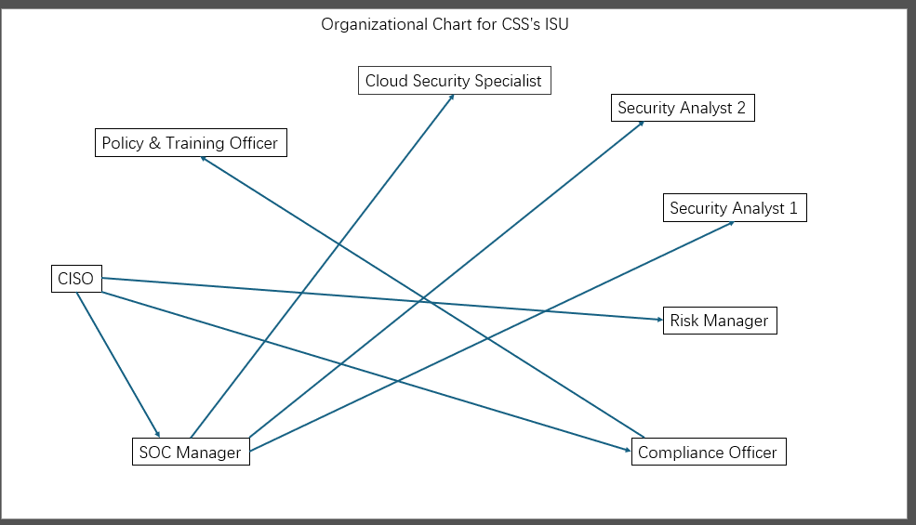
Readers can better understand the hierarchy and role relationships thanks to this illustration.

Policies and Procedures
Strong rules and processes that ensure dependable and effective security measures will oversee the ISU's activities, guaranteeing both the safety of sensitive assets and adherence to legal obligations. These regulations create a strong foundation for successfully managing hazards and reducing risks.

- The Acceptable Usage Policy outlines how to use company IT resources appropriately to lower the risk of insider threats and unintentional or deliberate misuse. To ensure secure integration, this policy also covers rules for Bring Your Own Device (BYOD) situations.
- Role-Based Access Control (RBAC) and Multi-Factor Authentication (MFA) are used in the Access Control Policy to impose stringent access controls. As responsibilities change, regular access evaluations guarantee that rights are updated or terminated.
- An incident response plan, or IRP, offers a methodical way to identify, handle, and recover from security issues. To reduce damage and downtime, it has escalation procedures and responsibilities that are predefined.
- By implementing secure data storage, access controls, and breach notification procedures, the Data Protection and Privacy Policy ensures adherence to laws such as the CCPA and GDPR.
- Through risk assessments, approval processes, and rollback plans, the Change Management Policy makes sure that infrastructure updates are handled securely to avoid interruptions or vulnerabilities.

Regular vulnerability scans with cutting-edge tools, prompt software and system patches to close security flaws, and routine audits to verify policy compliance are all part of the procedures. In addition to these protocols, regular staff training will promote a security-aware culture throughout the company.

Compliance (Laws and Ethics)
To maintain compliance and foster client trust, CSS must abide by the following regulations and moral standards:

- The General Data Protection Regulation (GDPR), which contains rules for data breach notifications, data subject rights, and severe fines for noncompliance, enforces the protection of personal data for European consumers. CSS must put policies in place to document processing operations, restrict access, and encrypt data.
- The California Consumer Privacy Act (CCPA) governs how Californians' personal information is protected and mandates that CSS respect their rights to data access, deletion, and opt-out from data sales.
- A cybersecurity standard known as Cybersecurity Maturity Model Certification (CMMC) requires CSS to exhibit procedures including incident response, risk management, and access control to be eligible for government contracts in the United States.

To uphold moral principles:
- To give clients clear information about how their data is gathered, handled, and stored, CSS must ensure transparent data processing.
- Only with express customer approval should ethical hacking be carried out, making sure that penetration tests are carried out appropriately to find and fix vulnerabilities.

To keep CSS informed of updates and in line with changing requirements, the Compliance Officer will monitor legal and regulatory changes with the help of automated methods such as compliance management software. To confirm conformity, routine compliance audits will be carried out.

Governance and Strategic Planning for Security
Effective governance, which incorporates security practices into CSS's larger strategic goals, guarantees that security measures are in line with business objectives. Governance supports corporate growth by guaranteeing consistency, accountability, and resource allocation in the management of cybersecurity threats.

- Security Governance Framework:
CSS can use COBIT, which synchronizes IT governance with overarching business goals, or ISO 27001, which offers a methodical approach to security management. These frameworks guarantee alignment with stakeholder expectations and regulatory requirements by offering an organized technique for risk assessments, control implementations, and continuous improvement.
- Strategic Planning Goals:
Strategic planning will concentrate on creating a security roadmap that supports corporate expansion objectives, such growing cloud services while maintaining strong defences. Metrics like the number of threats detected, incident reaction times, and compliance standard adherence are examples of Key Performance Indicators (KPIs). These KPIs offer quantifiable standards for evaluating the security program's efficacy.
- Committee for Security Steering:
To guarantee cross-functional cooperation and alignment with organizational goals, a Security Steering Committee consisting of department leaders and presided over by the CISO is necessary. To approve projects, examine security budgets, and modify strategic priorities, the committee will convene every three months. This cooperative strategy guarantees that security will always be a crucial part of corporate operations and promotes an organizational commitment to asset protection.

Risk Management
A systematic approach to risk management is essential for identifying, assessing, and mitigating threats. This allows CSS to proactively address vulnerabilities and reduce potential effects on its services and operations. This strategy makes sure that risks are methodically recognized, ranked, and reduced to comply with legal and corporate goals.

- The Risk Assessment Process:
- Determine: To find vulnerabilities in networks, systems, apps, and cloud infrastructure, conduct assessments on a regular basis. This entails assessing firewalls, third-party connectors, and endpoints.
- Assess hazards using a risk matrix according to their impact (from minor to major) and likelihood (from low to high). High-risk vulnerabilities are clearly prioritized thanks to this methodical methodology.
- Mitigate: Reduce exposure to hazards by putting strong controls in place, such as firewalls, encryption methods, and role-based access. While some risks are managed on a schedule, high-priority hazards should be addressed right away.

- Register of Hazards:
Risks, their seriousness, countermeasures, and deadlines will all be recorded in a centralized risk registry. In addition to updating mitigation progress and providing a historical record for audits and reviews, this enables the ISU to keep an eye on persistent threats.

- Resources for Risk Reduction:
- Nessus or comparable programs will search assets for vulnerabilities, assisting in the discovery of unpatched software or incorrect setups.
- Real-time monitoring and analysis of system logs by Security Information and Event Management (SIEM) systems, such Splunk or IBM QRadar, can facilitate prompt threat identification and reaction.
- Technology advancements and frequent evaluations of the risk register will guarantee that the program changes to keep up with new risks.

An illustration of the organization's risk assessment and prioritization process
 | Impact | Likelihood | Risk Level
Scenario 1 | High | High | Critical
Scenario 2 | High | Medium | High
Scenario 3 | Medium | High | Moderate
Scenario 4 | Low | Low | Low

Contingency Planning
By preparing for contingencies, CSS can withstand disruptions, protecting operations and upholding customer confidence in the face of unanticipated circumstances. A strong contingency plan reduces downtime and data loss by combining preventative actions with continuous assessment.

- BCP, or business continuity plan:
Recovery Time Objective (RTO), which is the maximum allowable downtime, and Recovery Point Objective (RPO), which is the maximum allowable data loss expressed in time, are examples of recovery objectives that are defined by the BCP. To provide redundancy and smooth failover capabilities, CSS will make use of extra data centers and cloud-based backups. These measures' dependability and preparedness will be confirmed by routine testing.
- Establish an Incident Response (IRP) plan:
The IRP provides detailed procedures for managing events like ransomware attacks and data breaches. A playbook will offer precise instructions for actions related to containment, elimination, and recovery that are suited to threats. To train employees and make sure they are ready to carry out the strategy under duress, CSS will use tabletop exercises and simulations.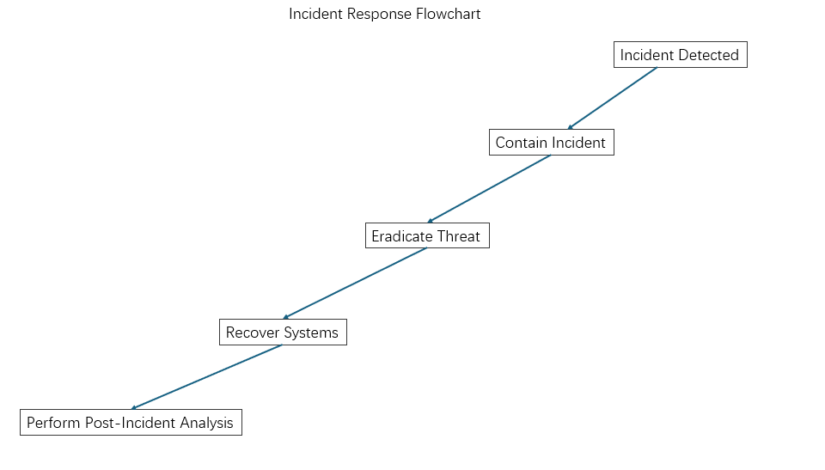
It simplifies the process by providing a visual representation of the actions required to manage and recover from an incident.
- Plan for Disaster Recovery (DRP):
The DRP's primary objective is to restore critical data and infrastructure after major events. CSS will maintain secure, encrypted backups of all important data and systems both on and off site. Every three months, backup restoration protocols will be reviewed to ensure data accessibility and integrity are preserved. This plan ensures that CSS can quickly resume normal operations even in the case of a catastrophic disaster.

CSS guarantees operational resilience and quick recovery from interruptions by combining these plans.

Protection Mechanisms
To safeguard its resources, CSS's ISU will employ a multi-layered security strategy:
1. Technical Defenses:
- Firewalls: Next-generation firewalls (NGFW) to be installed to monitor and filter traffic.
- Intrusion Detection/Prevention Systems (IDPS): For real-time threat detection, use programs like Snort or Suricata.
- AES-256 encryption should be used for both in-transit and at-rest data.
2. Safety of the Body:
- Put in place access controls for on-premises data centers, such as CCTV surveillance and biometric authentication.
3. Security of the Cloud:
- For cloud services, use secure setups and ongoing monitoring.
- To find configuration errors, activate Cloud Security Posture Management (CSPM) tools.
4. Awareness and Training of Employees:
- All employees will receive regular security awareness training to make sure they understand social engineering attacks, phishing risks, and the best ways to protect sensitive data.
- To provide an additional degree of security, staff members will be urged to use multi-factor authentication (MFA) when logging into internal systems and apps.
5. Reaction and Recovery to Incidents:
- To guarantee prompt, well-coordinated action in the case of a breach, an incident response plan will be created and tested on a regular basis.
- Systems for disaster recovery and backup will be put in place to guarantee data integrity and business continuity in the event of an emergency. To avoid data loss, this will need both off-site and on-site backups.

CSS's ISU will make sure that its resources are adequately safeguarded against a variety of potential threats by combining these tactics.

Conclusion
The Information Security Unit (ISU) of CSS must be built to handle the ever-changing threat landscape while guaranteeing adherence to industry norms and laws to successfully protect its clients and uphold confidence. The ISU will put in place a thorough security structure that incorporates state-of-the-art technology, strong risk management procedures, and a proactive strategy for spotting and thwarting new threats.

Using cutting-edge technologies like intrusion detection/prevention systems (IDPS), next-generation firewalls, and encryption methods like AES-256 for data protection, the ISU will concentrate on both preventative and corrective security measures. To stay ahead of possible security breaches, real-time threat intelligence and ongoing monitoring will be used. The ISU will anticipate and protect against future threats in addition to addressing current weaknesses by upholding a culture of continuous improvement.

The ISU will create and implement robust security rules in addition to technology solutions, making sure that all staff members follow industry best practices for privacy and data protection. Frequent training sessions will increase knowledge of cybersecurity risks, enabling employees to identify and address possible hazards.

A well-organized governance framework with distinct accountability for all cybersecurity projects will also be made available by the creation of the ISU. CSS's ISU will become a cybersecurity consulting leader by fusing state-of-the-art technology with organizational know-how, establishing a benchmark for security excellence in the sector. This all-encompassing strategy will increase client confidence, foster resilience, and lessen financial and reputational threats.

