Task-3 Reflection Portfolio

Student Name: Azza Abdelmutaleb

Student ID: 1913457
Module Code: BMSW 4005
Module: Professional and Career development
Lecturer Name: Charles Nimoh

Introduction
This reflection portfolio provides an audit of the skills and competencies learned in the class. Moreover, different methods and theories are discussed that can help in learning and development. The aim of this reflection portfolio is to emphasise effective learning skills and strategies in career development. Reflection on the experience before the start of the course and after it is provided.

Skills and Competencies
Skills and competencies are defined as the abilities that an individual possesses or has acquired through professional experiences and training. The two terms have a different meaning. The word ‘skills’ refers to the activities that a person learns from practicing it daily or things and activities that vary widely in terms of complexity. On the other hand, competencies is a mixture of skills, knowledge and abilities. It helps a person in performing a task or job with greater perfection (Garavan & Mcguire, 2001).
The self-awareness tool I will be using to analyse my skills and competencies is personal SWOT analysis. It helps in evaluating the strengths, weaknesses, opportunities and threats of an individual (Bonnici & Galea, 2015):

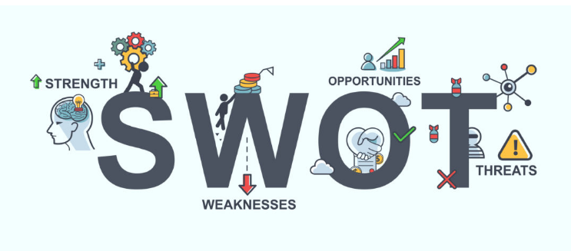
Figure 1 SWOT analysis, Source: (REDWOOD, 2020)

Strengths:
- I have a good communication skill that can help in interacting with clients and team members effectively
- I am very creative in developing ideas and thoughts that can help bringing efficiency in an organisation
- I am sincerely committed towards the tasks that are assigned to me.
- I have the ability and interpersonal skills to explore and groom myself according to my job role.

Weakness
- I lack teamwork
- I am quiet emotional at times and this can affect my decision-making process
- I often get nervous when things get out of control

Opportunities
- My ability to explore and learn new things can help me in achieving long-term success
- The competencies I have within me, professionally, is one of the major aspects that can be an opportunity for me to achieve my own and the organisation future goals.
- I wanted to become an elderly home carer and there are several facilities near me that are offering opportunities related to this role

Threats
- People who are better than me can make it hard for me to find my ideal job
- Sometimes overwork and extra assigned tasks impacts on my creativity negatively
- The current pandemic can make it hard for me to find employment opportunities

Skills Requires for the Career of Choice
Planning a career is one of the most complicated and tough tasks that an individual is required to complete. It is very important to choose the right career path that helps a person in achieving their future goals. A person should always choose a job that they can do well or like (Al- Abri & Kooli, 2018). The career that I have selected for myself is ‘elderly people’s home carer’. It is important and necessary for an individual to develop effective attributes within themselves so that they can do well in their job. Looking after an elderly is a challenging job and also one of the most fulfilling careers. The skills that are required for this career include being reliable and observant, being good at communication, caring and competent, being respect of other people including elderly, and being informed about basic health standards and hygiene.

Evaluating Skills in Comparison towards the Chosen Career
Individual who are good with their job role and have a broad range of skills in addition to good qualification are more likely to find work at a decent organisation (Ali, et al., 2014). The current job position that I am looking is challenging and requires several skills.
This job role helps in grooming and experiencing different techniques and forms of taking care of an individual. The skills that I have currently make me a good candidate for the job. I have good communication and interpersonal skills, which would help me communicate and interact with the elderly individuals and their families. It is important to understand and have enough knowledge about basic healthcare and hygiene. I know about this which would help me take good care of elderly individuals. Developing an effective relationship with your client and helping them significantly helps in promoting change and gives an ability to build a strong relationship with them. I am also reliable and observant and this would help ensure that I don’t ignore the elderly or forget about them. I am also caring and competent and I am respect towards other people, especially the elderly. This is one of the advantages that would help me in performing my job effectively and professionally. Managing my skills and experience according to the tasks and responsibilities assigned as a carer for elderly people home would be important.

Theories and Methods


Individuals have different learning style based on their experiences, abilities, habits, and nature (Hatami, 2013). It is very important to know what skills are required based on a professional perspective. There are different learning styles that includes different theories and methods that are used and are effective in building and developing a professional career aspects within an individual. Being the manager, there are two different learning theories that can be adopted in terms of developing and building learning techniques and strategies among the new employees. The two theories include;
- Kolb’s Experiential Learning Theory (Richmond & Cummings, 2005).
- Peter Honey and Alan Mumford Learning Style (Maric, et al., 2015).
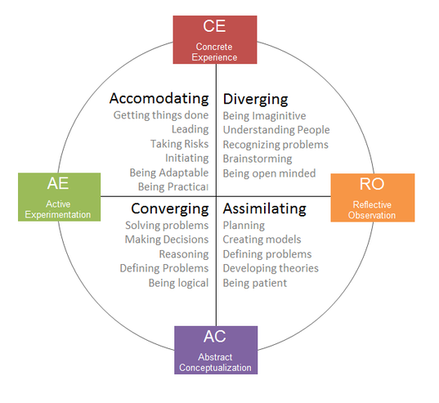
Figure 2, Learning theory (Wigley, 2020)

Kolb’s experiential learning theory includes four learning styles namely accommodative, assimilative, divergent, and convergent. The reason for choosing Kolb’s learning theory is to develop the major and much needed aspects that are required for a new team of employees. For example, accommodative learning style can help them develop risk-taking abilities. The assimilative can help them to focus more on ideas and concepts allowing them to use theoretical models in their learning techniques and styling. The convergent is about intelligence tests and this helps an individual in solving problems and making decisions. The divergent method is based on creating creativity and effective planning strategies such as brain-storming. This particular method can help the employees in terms of socially interacting as well as taking different perspectives and views (Richmond & Cummings, 2005). These different learning styles of Kolb can prove to be an effective learning source. They can help in adapting new professional skills and techniques that can assist a person professionally and have an effective and positive impact on their interpersonal skills.
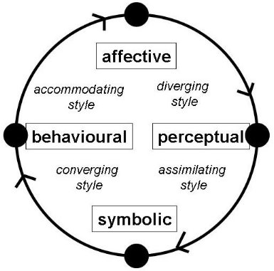
Figure 3 Kolb’s learning environment, Source: (Kakouris, 2009)
Kolb has also defined four different environments that are considered conductive for accommodating the above learning styles. These different environments help in making learning easier for people. The four different learning environments include affective, symbolic, perceptual, and behavioural environment. The reason of using these four different environment in the development process of new employees is to make them learn how things can be build and implemented on the basis on environmental change in the learning style. The affective learning environment helps in articulating concrete experiences that helps them in supporting the different learning styles that there are associated with or the ones that they adopted. The symbolic learning environment helps a person in getting to solution in terms of problem-solving for which they can have the right answer and correct solution with the help of analysing different data by reading, observing and searching for latest researches. The perceptual learning environment has a main goal of identifying and understanding the relationship among different concepts and theories. The behavioural learning environment emphasises more on applying knowledge, skills and information to a practical problem. These environment are effective and helps in knowing the solution and how these can be implemented keeping others things in mind.
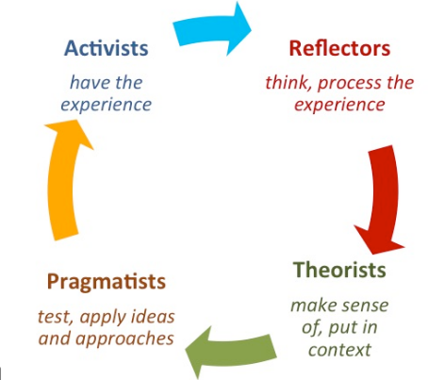
Figure 4, Learning Style, Source: (Stevenson, 2015)

The learning style of Honey and Mumford is based on the work of Kolb, however they have developed four different learning styles. These styles includes activist, theorist, pragmatist and reflector. These four are the approaches that are necessary and required for individuals in terms of maximising their personal learning skills. The reason for choosing Honey and Mumford learning styles is to ensure effective development of the new employees. The activists are those individuals who grow and learn things by participating. The activist attributes helps a person in developing an open-minded approach in order to learn, get involved, and experience new things. The activities that are involved in activist learning style include problem-solving, encouraging group decisions, competitions, and role-play. Theorists are defined as learners who are more interested in understanding the main motive and ideas behind the actions. Thus they require models, different stats, concepts and factors in order to engage themselves in the learning process. The main objects of interests for a theorist are models, statistics, background information, different theories and perspectives. Pragmatist learners test and apply ideas and approaches. This helps a person to develop a character that is more focused on experimenting, trying new things, new techniques, ideas, thoughts, and theories in terms of making effective development process and out different ideas into action. The objects are discussing different views and ideas, problem-solving, apply learning and thoughts into real life scenarios. The reflector are the people who learn on the basis on their observation and thinking about certain situations or conditions. This style of learning allows individuals to learn things on the basis of observation and observation. These people are usually the one who believe in experiencing different perspectives and collecting data on the basis of observational activities or actions performed in front of them. These learning styles help a person in adapting and integrating different aspects of knowledge within the job roles and responsibilities. These are effective sources of understanding and building a professional career. Honey and Mumford have provided an effective way of making learning styles efficient and necessary for every individual.

Reflection on Experiences
Professional learning is considered a complex process that helps in development of various learning aspects and factors. Reflection is a part that is initiated in the learning experience as an effective tool for documenting and accompanying educational values (Silvia, et al., 2012). It is an important tool that helps in building professional disciplines such as planning and surveying and linking these in a professional practice (McCarthy, 2015). Reflection also helps an individual in identifying and exploring potential transformation and learning that includes various methods and practices (McCarthy, 2015). It is an effective way of determining how effective the experience has been for an individual (Silvia, et al., 2012).
The course ‘Professional and Career Development’ is one of an effective courses that can help a person in their developmental growth in terms of choosing a career pathway in the future. The experience that has been built with this course has an effective impact on my learning process as well as professional practices and techniques. Professional and career development is necessary for students for their growth and development. This course helped in knowing different things and practices that are essential for career development. For example, I was not aware of what a mock interview is but with the help of this course, I got to know everything that a mock interview entails. I was able to find out that it helps an individual in refining skills for interview. A mock interview helps in developing and practicing interview skills within an individual (Harchar, 2005). This course subject has also helped in learning new professional techniques that could help in building and planning for a career pathway. It has also taught the understanding of employment opportunities and how these opportunities can be explored. There are various different elements and aspects that are much easier to understand now after learning about them in the course. For instance, I was not aware of what self-awareness is, how a person can improve these awareness and use them in a professional life. Making CV (Curriculum Vitae) is essential in terms of developing a career. It is one of the main and important tools that are required when a person is searching for a job. This course has given me the opportunity to know all of these important aspects of developing a professional careers. These important aspects include mock interviews, employment opportunities, CV, facing interviews, career development, how are career opportunities identified and how the development process take place and is initiative. Hence now I know all about these major and important professional aspect related to career development. Learning these aspects has made the career development process adaptable and easier comparatively to other professional practices.
Career development is one of the important procedures for the one who aim to have an effective and successful career. The course has proven to be one of the best learning material that helps in adopting, developing, learning, building, grooming and building a successful and meaningful career. It helps a person in improving an individual morale and motivation towards building their careers. It also contains a clear understanding and knowledge of how, when and where to use these learning skills, methods and theories in the career building procedure. The course has helped in utilizing the right source related to skills, change and development of an individual in their career development procedure. The course has also increased the awareness of employment opportunities, career development, effective skills, and methods and theories that can help in developing effectiveness within a person related to their professional growth and understanding. There are various positive impacts that help in developing a person’s attitude and behaviour as an employee. It provides a better ability to build and develop understanding and knowledge. The course of professional and career development has all the necessary and important aspects, facts and major important objects that needs to be developed within an individual to groom themselves in the professional world. Keeping all the major facts and aspects it helps in growing effectively and efficiently. The most important thing for a person is to know the basic understanding and knowledge before planning their career pathways and this course has given all the needed and required understanding that a person should have and know before they plan to build a career. This will initially help every individual in building an accurate and appropriate understanding of professional career development.

Conclusion
Reflection portfolio is an important process of developing self-awareness including opportunities to provide learning skills and methods within an individual. It is considered as a flexible process that enable effective learning among the students. This reflection portfolio is based on professional and career development of a student. It includes all the major factors that are necessary and important for them to learn and adapt. There are certain areas that are needed to be learned briefly. This is an effective way of learning aspects like career development, employment opportunities, learning skills, learning strategies. The two different theories and methods that has been used in this reflection portfolio are Kolb’s experiential learning theory and Peter Honey and Alan Mumford learning styles. This helps in improving professional career skills.

References
Al- Abri, N. & Kooli, C., 2018. Factors Affecting the Career Path Choice of Graduates: A Case of Omani. International Journal of Youth Economy, 2(2), pp. 105-117.
Ali, R., Baloch, S. R. & Shah, N., 2014. THE SIGNIFICANCE OF AWARENESS ABOUT SELECTION AND RECRUITMENT PROCESSES IN STUDENTS' CAREER DECISION MAKING. European Scientific Journal , 10(14), pp. 1857-7880.
Bonnici, S. T. & Galea, D., 2015. SWOT Analysis. In: Wiley Encyclopedia of Management. Hoboken: John Wiley & Sons, Ltd, pp. 1-8.
Garavan, N. T. & Mcguire, D., 2001. Competencies and workplace learning: Some reflections on the rhetoric and the reality. Journal of Workplace Learning , 13(4), pp. 144-164.
Harchar, R., 2005. Mock Interview Strategy: An action research study of administrator and teacher candidates preparation for interview field experience. Journal of Scholarship of Teaching and Learning, 5(1), pp. 35-48.
Hatami, S., 2013. Learning styles. English Language Teaching Journal , 67(4), pp. 488-490.
Kakouris, A., 2009. Online platforms for entrepreneurship education: an instructional design approach. Athens , Academic Conferences Limited.
Maric, M., Penger, S., Todorovic, I. & Durica, N., 2015. Differences in Learning Styles: A comparison of Slovenian Universities. Procedia - Social and Behavioral Sciences , 197(12), pp. 175-183.
McCarthy, J., 2015. Reflective Writing, Higher Education and Professional Practice. Journal of Education in the Built Environment , 6(1), pp. 29-43.
REDWOOD, 2020. What is a SWOT Analysis?. [Online]
Available at: https://www.redwoodlogistics.com/what-is-a-swot-analysis/
[Accessed 29 September 2020].
Richmond, S. A. & Cummings, R., 2005. Implementing Kolb's Learning Styles into Online Distance Education. International Journal of Technology in Teaching and Learning, 1(1), pp. 45-54.
Silvia, B., Dimonte, V. & Garrino, L., 2012. The reflective journal: A tool for enhancing experience- based learning in nursing students in clinical practice. Journal of Nursing Education and Practice , 45(9), pp. 1379-1388.
Stalmasekova, N., Genzorova, T. & Corejova, T., 2017. EMPLOYEE BENEFITS AS ONE OF FACTORS OF WORK MOTIVATION. CBU International Conference Proceedings, 5(2), p. 448.
Stevenson, T., 2015. Honey and Mumfords’ Learning Styles. [Online]
Available at: https://changingmindz.wordpress.com/2015/11/18/honey-and-mumfords-learning-styles/
[Accessed 29 September 2020].
Wigley, T., 2020. Learning Styles. [Online]
Available at: https://sites.google.com/site/learningstylesolt528/kolb-s-learning-style
[Accessed 29 September 2020].

