Student Name: Aida Lamer
Student Number: 1706552
Module Code: ACCB5004
Module: Wireless Networks and Simulation

Table of Contents
Research and Evaluation of Modulation Schemes 3
Function of modulation in a communication system 3
How computer network simulations relate to communication systems 3
Fundamentals of QAM 3
Advantages and disadvantages of QAM 3
Implementations 4
Pros and cons of using simulations over other methods 4
Wireless sensor network design and evaluation 5
Wireless networks and communication systems 5
Internet of Things and smart city 5
Security imaging technology for detecting concealed weapons 6
Smart farm design 6
Conclusion 9
References 11

Research and Evaluation of Modulation Schemes
The following section discusses the evaluation of modulation schemes. Simulation shows how the real-world process, or a system would turnout overtime. It also allows for different scenarios to be played out so the system can be monitored and examined over time. By doing this it solves a wide range of real-world problems. The chosen modulation scheme is Quadrature Amplitude Modulation. This method combines two amplitude modulated signals into a single channel which results in doubling the effective bandwidth.

Function of modulation in a communication system
The following section discusses the function of QAM in a communication system. “QAM is a method of combining two amplitude modulated signals into a single channel, thereby doubling the effective bandwidth. QAM is used with pulse amplitude modulation in digital systems, especially in wireless applications.” [1] The research found shows how QAM works and where it would be used. QAM would be used from cellar phones, Wi-Fi and other forms of high-speed data communication systems.

How computer network simulations relate to communication systems
The following section discusses how computer network simulations relate to communication systems. Computer network simulations show have real life situations would play out in future communication systems before they are created. This saves cost and time in the creation of the system and makes it more affordable in long term. It can also be used by industries and businesses to test new products and services before creating them. This also allows for the system to be examined under different conditions and it overall provides better view and understanding how to system will work.

Fundamentals of QAM
The following section is discussing the fundamentals of QAM modulation. Qam combines two amplitude modulated signals into one single channel by doing this it doubles the effective bandwidth. This saves bandwidth. Multiple analogue signals can be placed on one single carrier. QAM is often used in radio communication systems. “QAM is a technique used to transmit two digital bit streams or two analogue signals by modulating or changing amplitudes of two carrier waves so that they differ in phase by 90 degrees, a quarter of a cycle, hence the name quadrature.” [2] This research shows that QAM works by combining the two carriers and sending combined signals in a single transmission to be separated and extracted at the destination.

Advantages and disadvantages of QAM
The following section is discussing the advantages and disadvantages of QAM modulation. QAM represents a large number of bits per carrier, due to this, one of the major benefits of QAM is efficient usage of bandwidth. A disadvantage for QAM would be that it “uses amplitude components of signal to represent binary data, linearity need to be maintained and hence linear amplifier is needed which consumes more power.” [3] This research shows that due linearity needing to be maintained, a liner amplifier would be needed which would need more power and it would cost more. Another disadvantage would be that QAM is more likely to be affected by noise as QAM is more complex compared to receivers of other modulation types.

Implementations
The following section will provide examples of QAM implementations. Some research found that “QAM systems are used by multi system operators and the cable television industry to deliver data, voice and video services. QAM is used to format services in head ends and hubs. These facilities process and distribute signals over a cable system and deliver them to use user’s homes where embedded multimedia terminal adapters, cable modems and set top boxes convert the QAM signals back into useful video, data and voice.” [4] This shows that QAM would mainly be used by multi system operators where services are formatted in head ends and hubs. After this the signals are processed and distributed over a cable system before they are delivered to the user’s home. QAM is widely used in video on demand, broadcast cable television and high-speed Internet.

Pros and cons of using simulations over other methods
The following section discusses the advantages and disadvantages of using simulations over other methods such as test beds and mathematical methods. A commonly used simulation would be NetSim that provides simulation of various protocols working in various networks. Some of these include Internet works, solar networks, wireless sensor networks and Internet of Things. NetSim is useful as the user can create an experiment and set conditions as desired. The different experiments conducted can be analysed using the analytics option. Another simulation example would be Matlab. The simulation includes an add on which is Simulink. “Simulink is widely used in automatic control and digital signal processing for multidomain simulation and model-based design.” [5] This research shows what Simulink can be used for. Both simulations can be carried out, where different factors can be added where and different simulations can be conducted. The results can be compared where different factors were present. This is a cheaper alternative to be able to have conduct experiments to gather expected outcomes under different conditions. Simulations are often used by industries and businesses as a first stage of testing new products and services. This stage is used before testbed, trials and implementing in in the physical world. Another method to use would be test bed. This is a real-world production system which is reliable and valid for collecting data. It is flexible in the scope of production and it offers a hands-on experience. Another advantage for testbed is easier changes to the production system, holistic analysis possibilities and decreases the budget and space limitations. Testbed also has some disadvantages these include it can be costly and time consuming to implement it in an industrial environment. The scope would also be limited to the current production. Another type of method would be mathematical method. Mathematical models work by using symbolic notation and mathematical equations to represent a system. Some examples of mathematical models would be linear or none the neural models, continuous time or discrete time models and continuous state or discrete state models. Some disadvantages of using mathematical models would be that the model is the simplification of the real problem which does not include different aspects of the problem. Another disadvantage would be that the model would only work in certain situations. Some advantages of mathematical models would be that they represent the real problem situation and help make decisions faster and more accurately from a management point of view. This would result normally in cost advantages by gaining more information on real life situations.

Wireless sensor network design and evaluation

Wireless networks and communication systems
One of the communication systems is long range communication system. Long range communication system was developed by Semtech and it was designed for long range low power communications. It was designed mainly for man to man and for internet of things networks. This technology allows users to connect applications that run on the same network. Some research found that “LoRa gateway has the ability to handle up to millions of nodes. This signal can span a significant distance, which means that there is less infrastructure required, making constructing a network much cheaper and faster to implement.” [6] This research shows that by using LoRa, the overall build work would be cheaper the time scale would be faster to achieve.
Another communication system would-be short-range communication system which is wireless communication technology allowing automobiles an intelligent transportation system to communicate between each other. This communication system uses signals travelling from whew inches to several metres. Some examples of short-range wireless communication systems would be Wi-Fi, ZigBee and WLAN.
Another communication system would be satellite. Satellites can receive signals from earth and transmit them back with the use of transponder. Satellites use radio waves to send signals to antennas. The antenna captures the signals and process is the information send from the signals. An advantage of satellites is that one satellite can cover a large area. These signals transmitted would be used for televisions, telephones, radios, internet and another communicational purposes.
Another communication network is cellular communication. This form of communication allows use of mobile phones. This technology has small interconnected transmitters instead of one big one. Cellular technology is multiple access which allows multiple connections into single radio channel. Cellular network use radio waves to transport digitised voice and data.

Internet of Things and smart city
Internet of Things is a network that connects objects and allows users to collect and exchange data. These objects collect the data and that is stored on the Internet and it can be accessed by other authorised objects. Internet of Things work by acquiring data from surrounding environments such as embedded sensors, processors and communication hardware. Some devices that use Internet of Things include thermostats, cars and commercial environments. An advantage for IoT devices would be that they allow users to have better ways of monitoring their data. A disadvantage for IoT devices would be users becoming too reliant on the technology. Some cities use Internet of Things to collect data and based on their findings manage assets, resources and services efficiently. Smart city technologies and programmes are used and Singapore, Dubai, Amsterdam, Barcelona and New York. “Smart cities are designed for optimum usage of space and resources along with an efficient and optimum distribution of benefits. It also aims at increasing connectivity at various level among citizens, as well as between the administration and population.” [7] This research shows why smart cities are needed and what they are designed to do. A disadvantage of smart cities would be data privacy and security threats. Some advantage of smart cities would be safer communities, reduced environmental footprint, improved transportation and many more.

Security imaging technology for detecting concealed weapons
This following section will be discussing technology that can be used to detect concealed weapons such as large knives and guns. Some commonly known technology that is used to detect weapons would be airport scanners which work by using nonionizing radio frequency waves to detect threats. Smart surveillance allows electronic equipment such as CCTV cameras to monitor activity, behaviour pattern and change in environmental conditions. These could also monitor people who might be a potential threat and detect if they are carrying weapons. Sensors placed around cities can monitor citizens and analyse the transmitted data by government or local authorities in order to prevent crimes. Another way to monitor citizens would be by using video surveillance. In some cities police also wear body worn cameras with facial recognition software to identify potential criminals in crowds and enabling quick reaction. This would be helpful in a smart city as it could detect concealed weapons that might not be obvious to the naked eye. Another surveillance application that is used in the United States is a network of wireless microphones that detect and alert authorities if the sound of a gunfire was detected within 20 seconds of detecting gunfire. This could also be implemented in order to detect people in the possession of weapons. Another technology using surveillance cameras number plate recognition systems could be used to detect potential criminals and monitor their activity. These cameras also offer facial recognition which could help the authorities keep track of people on their watch list, recently released criminals, people on bail and wanted criminals who could potentially pose a threat.

Smart farm design
The following section is proposing a wireless monitoring system that can be used to resolve ongoing predial larceny problems in the Caribbean islands. The system is designed for farmers who are affected by theft of agriculture crops and livestock. Another issue is the increase in robbery within the cities and major town centres. Robbers use concealed weapons to conduct the crimes. Most farms are raided at night and the farms are accessed despite safety measures such as high fencing being in place.
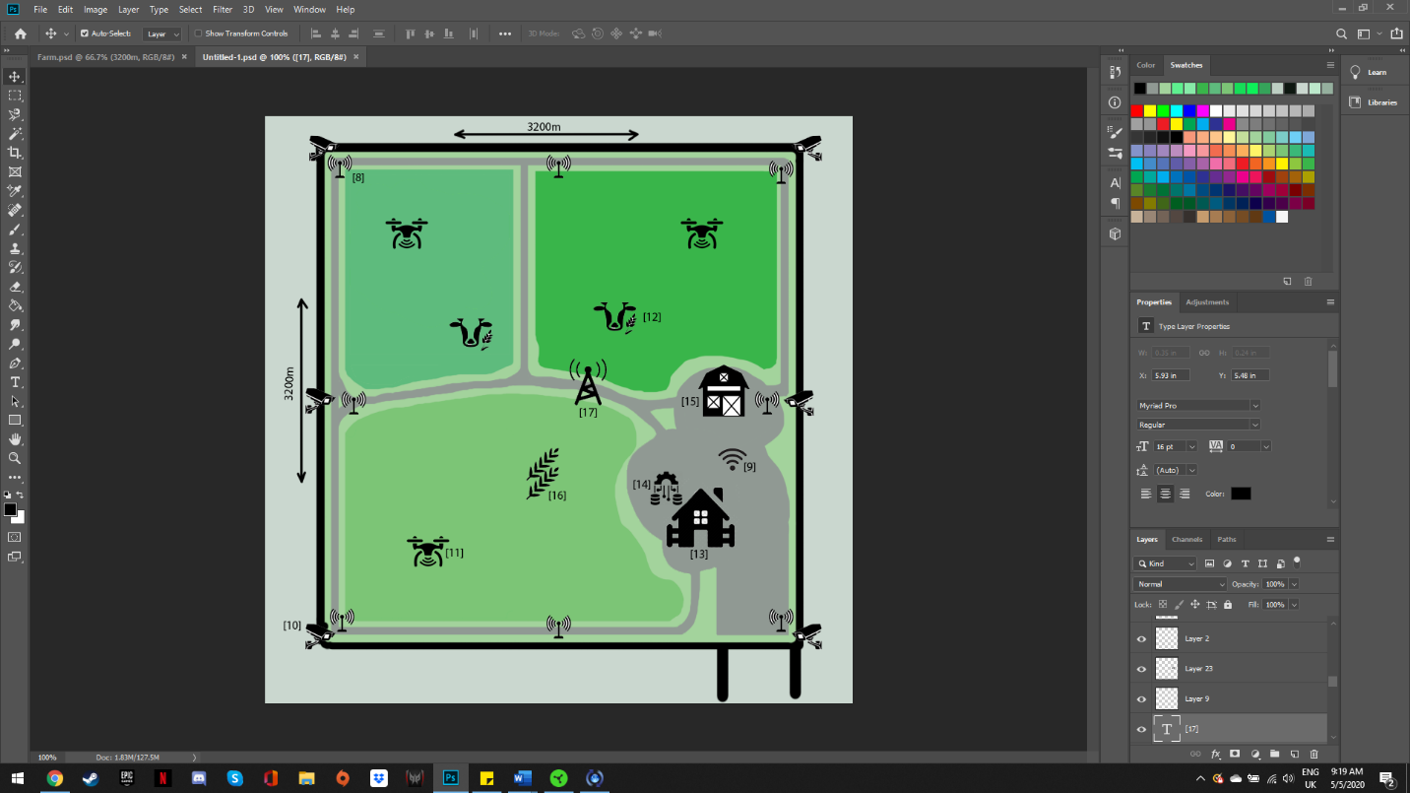
The image above shows how the design off the wireless monitoring system of the smart farm being created.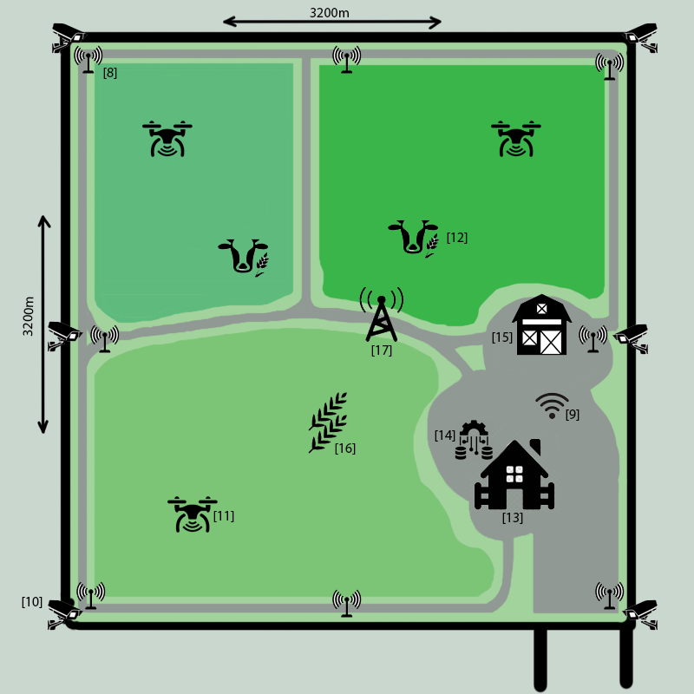The image above shows the wireless monitoring system of a smart farm created to address a number of problems in the Caribbean islands. The image above labels features the farm includes. The farm includes wireless sensors [8], Wi-Fi [9], CCTV [10], aerial surveillance [11], cows [12], farmhouse [13], farm database [14], barn [15], hayfields [16] and cellular network [17]. Wireless sensors are used to aid farmers detect intruders and a lot of time to notify authorities. This allows farmers to be aware of criminal events taking place on the farm. This would benefit farmers by preventing intruders from entering the farm and taking the cattle or crops. The sensors are laid out to cover the entirety of the farm. The farm also has Wi-Fi to allow communication across the farm. A recommendation for Wi-Fi to use would be “AC2300 wireless MU-MIMO Gigabit router” [18]. This router is very powerful, fast and provides smooth performance. Due to the coverage range being 110 feet, more Wi-Fi devices should be placed across the farm to provide coverage across the entire the farm. The design of the farm also includes CCTV. CCTV would provide security measures by using facial recognition which would alert if known criminals were attempting to access the property. Thermal heat detection and smart surveillance would also be useful. This would alert the farmer if unexpected visitors were trying to access the property. Another benefit of this would be access control management. This would be located by the front gate of the farm and would only allow vehicles with access to the farm to enter. The CCTV used would be “Fujifilm SX800” [19]. This equipment can monitor areas as far as 1Km away. Another feature that would benefit farmers is the optical zoom which would be able to detect trespass is. This product is used by airport security illustrates how reliable the coverage range is. This product would be useful for the farm’s security as it covers a lot of area. The cameras cover the area along the fence of the farm. If the CCTV activated, it would link to the nearest police station and alert authorities. Another feature the farm would use are drones for aerial surveillance. These drones would allow farmers to monitor if there are any trespassers on the farm. Drones could also be used to monitor the animals and the crops. A drone suitable for this task would be “DJI AGRAS MG-1S” [20] drone. This device is often used in agriculture due to its reliability. These drones are in three fields on the farm to be able to monitor the cows and hay. The cattle on the farm are in a location where the only access is through the driveway. An intruder would have a difficult time accessing this location due to the sensors and the CCTV in place. The farmhouse is in the centre of the farm. This provides easy access to all locations on the farm. This would benefit the farmer as if any sensors or cameras were set off, they would have quick access to the location. The farm's database is also located and the farmhouse. This allows for the database management system to operate reliably. The farm’s barn is located near the farmhouse to allow the farmer to be able to react quickly in case of robbery. In current state the barn does not have many safety features other than one sensor that would notify the farmer. In the future, alarm systems could be put in place to provide more security. The hay fields are located and the bottom left corner which can only be accessed from the main entrance. These fields are also monitored by drones which both provide security measures and information on the hay. A cellular network would also be in the centre off the farm. This would provide communication across the farm between the farmer, staff and visitors. This would also ensure ability to notify authorities if trespassing or robbery has taken place.

Conclusion
In conclusion, a virus monitoring system was designed to resolve crimes taken place on the Caribbean islands. The farm has taken some strong security measures by ensuring full coverage with the use of sensors and CCTV. The layout of the farm has been taken into consideration and strong security measures have been put in place such as tall fencing and single access point to the farm. The single access point to the farm would only be accessible to vehicles who have granted access to the farm. The farmer can have quick access to any location on the farm with the use of roads around the property. In future, the farm should consider using more cameras in more locations on the farm to avoid any blind spots. The cellular network requires further research and information on what device would be best and how much area are needed to be covered. This would also depend on how far the nearest police station is, to allow the farmer contact. Due to most farms being raided at night it would be recommended in future to use automatic floodlights that activate if they sense motion. Another security measure that could be put in place in the future is an alarm system that would sound and scare off trespassers. The combination floodlights and a loud alarm sounding would scare off trespassers and alert the farmer. Overall, all proposed problems have been addressed and future recommendations have been suggested.

References
[1]"What is QAM (quadrature amplitude modulation)? - Definition from WhatIs.com", SearchNetworking, 2020. [Online]. Available: https://searchnetworking.techtarget.com/definition/QAM. [Accessed: 05- May- 2020].
[2]"What is Quadrature Amplitude Modulation (QAM)? - Definition from Techopedia", Techopedia.com, 2020. [Online]. Available: https://www.techopedia.com/definition/9039/quadrature-amplitude-modulation-qam. [Accessed: 05- May- 2020].
[3]"Advantages of QAM | Disadvantages of QAM | 16QAM,64QAM,256QAM", Rfwireless-world.com, 2020. [Online]. Available: https://www.rfwireless-world.com/Terminology/Advantages-and-Disadvantages-of-QAM-types.html. [Accessed: 05- May- 2020].
[4]"Quadrature Amplitude Modulation (QAM) for Network Operators", SignalBooster.com, 2020. [Online]. Available: https://www.signalbooster.com/blogs/news/quadrature-amplitude-modulation-qam-for-network-operators. [Accessed: 05- May- 2020].
[5]"Simulink", En.wikipedia.org, 2020. [Online]. Available: https://en.wikipedia.org/wiki/Simulink. [Accessed: 05- May- 2020].
[6]"Introduction to LoRa Technology – The Game Changer", Digikey.com, 2020. [Online]. Available: https://www.digikey.com/en/maker/blogs/introduction-to-lora-technology. [Accessed: 05- May- 2020].
[7]"Why We Need Smart Cities", BW SC, 2020. [Online]. Available: http://bwsmartcities.businessworld.in/article/Why-We-Need-Smart-Cities/19-02-2019-167307/. [Accessed: 05- May- 2020].
[8]Media.istockphoto.com, 2020. [Online]. Available: https://media.istockphoto.com/vectors/motion-sensor-monochrome-icon-vector-id1149248808?b=1&k=6&m=1149248808&s=170x170&h=VAatRfZ_zneEKQ7CJUPfWTPUhIXdM_KWsagcI53LRjs=. [Accessed: 05- May- 2020].
[9]Media-eng.dhakatribune.com, 2020. [Online]. Available: https://media-eng.dhakatribune.com/uploads/2020/03/bigstock-wifi-icon-isolated-on-white-ba-339777238-1584201534586.jpg. [Accessed: 05- May- 2020].
[10]Cdn.clipart.email, 2020. [Online]. Available: https://cdn.clipart.email/80cc4375e89bb8f45bd99a09e83817d8_surveillance-camera-svg-png-icon-free-download-cctv-camera-logo-_820-734.jpeg. [Accessed: 05- May- 2020].
[11]Static.thenounproject.com, 2020. [Online]. Available: https://static.thenounproject.com/png/375028-200.png. [Accessed: 05- May- 2020].
[12]Encrypted-tbn0.gstatic.com, 2020. [Online]. Available: https://encrypted-tbn0.gstatic.com/images?q=tbn%3AANd9GcT3Qhd2DK15cVHI48vwga4K8BVhYpMAzG0X8z5eCDSuD1ETQjiM&usqp=CAU. [Accessed: 05- May- 2020].
[13]P7.hiclipart.com, 2020. [Online]. Available: https://p7.hiclipart.com/preview/609/540/7/computer-icons-farm-building-agriculture-farm-home-house-icon.jpg. [Accessed: 05- May- 2020].
[14]Cdn3.iconfinder.com, 2020. [Online]. Available: https://cdn3.iconfinder.com/data/icons/database-34/66/89-512.png. [Accessed: 05- May- 2020].
[15]Static.vecteezy.com, 2020. [Online]. Available: https://static.vecteezy.com/system/resources/previews/000/330/060/non_2x/vector-barn-glyph-black-icon.jpg. [Accessed: 05- May- 2020].
[16]Encrypted-tbn0.gstatic.com, 2020. [Online]. Available: https://encrypted-tbn0.gstatic.com/images?q=tbn%3AANd9GcQWpaq_bDcwDp-dUQiS-mEwJhfkwD1pHJMeCi7e3ySVRT4RrzyN&usqp=CAU. [Accessed: 05- May- 2020].
[17]W0.pngwave.com, 2020. [Online]. Available: https://w0.pngwave.com/png/271/390/telecommunications-tower-cell-site-radio-computer-icons-cellular-network-radio-icon-png-clip-art.png. [Accessed: 05- May- 2020].
[18]"Archer C2300 | AC2300 Wireless MU-MIMO Gigabit Router | TP-Link United Kingdom", Tp-link.com, 2020. [Online]. Available: https://www.tp-link.com/uk/home-networking/wifi-router/archer-c2300/. [Accessed: 05- May- 2020].
[19]"FUJIFILM SX800｜Product Information｜FUJIFILM", Optics.fujifilm.com, 2020. [Online]. Available: https://optics.fujifilm.com/security/en/. [Accessed: 05- May- 2020].
[20]"Agras MG-1S - Agricultural Solutions - DJI", DJI Official, 2020. [Online]. Available: https://www.dji.com/uk/mg-1s. [Accessed: 05- May- 2020].

marking criteria and Student FEEDBACK

This section details the assessment criteria. The extent to which these are demonstrated by you determines your mark. The marks available for each criterion are shown. Lecturers will use the space provided to comment on the achievement of the task(s), including those areas in which you have performed well and areas that would benefit from development/improvement.

Common Assessment Criteria Applied (Assignment 1) | Marks available | Marks  awarded
1. Engagement with Literature Skills
Extent of research and/or own reading, selection of credible sources, application of appropriate referencing conventions.
You have discuss key concepts. You have use the appropriate referencing convention. However, your sources are all website. You need to engage with academic peer review article to make your work credible. Websites require careful consideration. (Grade mark: 46.67%) | 15 | 7
2. Knowledge and Understanding Skills
Extent of knowledge and understanding of concepts and underlying principles associated with the discipline.
You have demonstrated knowledge and understanding for most areas of the assignment. However, see comment above which is lacking in this report. You have not used the IEEE report formatting. (Grade mark: 53.33%) | 15 | 8
3. Cognitive and Intellectual Skills
Analysis, evaluation and synthesis; logic, argument and judgement; analytical reflection; organisation of ideas and evidence
Your task 1 discusses the QAM modulation technique. A Simulink model wasn’t explained or discussed. You were required to do a Simulink creation of a modulation technique. Task 1 was not completed due to the missing Simulink creation of a modulation technique. This was covered in the tutorial by Paul with e.g. of QPSK and QAM 64, along with SNR and aWGN. These were carried out in tutorial by students along with excel line graph. You have discuss relevant solutions for the case study (Grade mark: 60.00%) | 30 | 18
4. Practical Application Skills
Deployment of methods, materials, tools and techniques; application of concepts; formulation of innovative and creative solutions to solve problems.
You have done physical designs of the case study. These were discussed. (Grade mark: 62.86%) | 35 | 22
5. Transferable Skills for Life and Professional Practice
Attributes in professional practice: individual and collaborative working; deployment of appropriate media; presentation and organisation.
Your work could do with formatting alignment. There are some grammatical errors; spell out all acronyms first time used. Some paragraphs are too long; try to start new discussion in a new paragraph. (Grade mark: 56.00%) | 5 | 2.8

Assignment Mark (Assessment marks are subject to ratification at the Exam Board. These comments and marks are to give feedback on module work and are for guidance only until they are confirmed. ) | Late Submission Penalties (tick if appropriate) |  | 58%
 | Up to four weeks late |  | 58%
 | First Attempt? |  | 58%

