

STUDENT NAME: Nishtha Savaliya
STUDENT ID NUMBER: 2530041

PROGRAMME: MASTER OF BUSINESS ADMINISTRATION

MODULE: INTERNATIONAL BUSINESS CONCEPTS
MODULE CODE: LCMB7034

LECTURER: Dr.Gladius Kulothungan

ASSIGNMENT TITLE: ASSESSMENT COMPONENT-INDIVIDUAL REPORT

Table of Contents
Introduction 3
Section 1: 4
1. Organisational Classification and Global Strategy 4
1.1 Strategic Categorisation 4
1.2 Global Configuration 5
2. Macro-Environmental Appraisal and Market Attractiveness 6
2.1 Host Country Analysis 6
2.2 Market Entry 11
3. Entry Mode Strategy and Strategic Synthesis 13
3.1 Historical Pattern Recognition 13
3.2 Strategic Fit & Justification 13
3.3 Conclusion & Recommendations 16
Section 2: Reflective account 17
References 21

Introduction
In the modern globalised business environment, companies are actively accomplishing their competitive structure of market engagement with dynamic marketing strategies and integration to support their operational bindings (Islami et al. 2024). Strategic decision-making, diversified market entry strategic modes and formatted customer engagement are becoming strategic for firms to align their key competitive operational efficacy with their customers' demand in international marketplaces. Highlighting these key operational structures, the leading business processes of Marks & Spencer in the UK market are going to be evaluated in the report. As M&S is a giant retail company in the UK which has been running its business in the UK since 1884 with a successful structure of operational balance (Marks and spencer, 2026a). Alongside, the company has generated approximately £17.37 billion in sales revenue in the current fiscal year of 2025, which has been estimated as a 24.8% increase from the previous year (Statista, 2026).
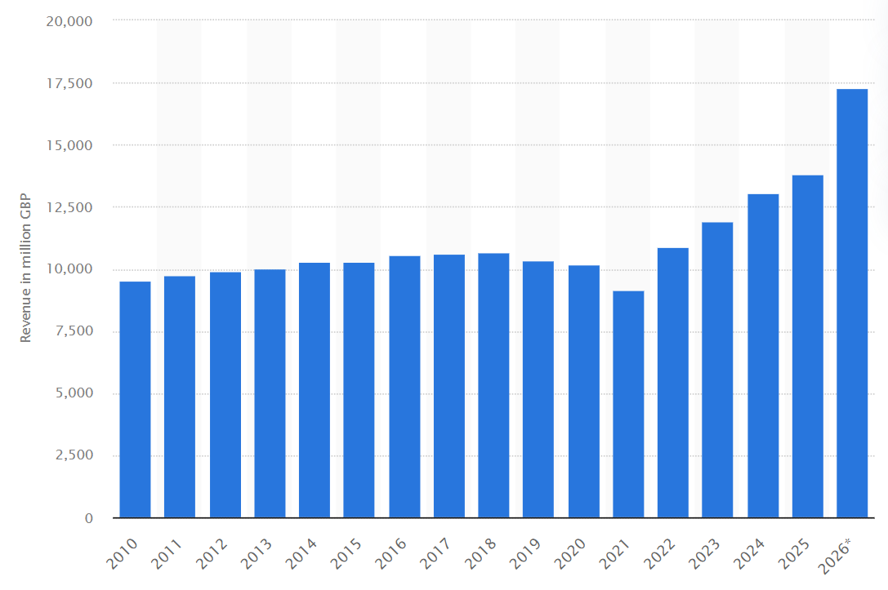
Figure 1: Sales revenue of M&S in the UK 2026
(Source: Statista, 2026)
Considering the key operational efficacy of M&S in the UK, operational expansion of the firm in the retail market of Canada is going to be illustrated in the report. In addition, global operating structures, classified strategic resources including the market entry mode and competitive functionalization are also going to be demonstrated in the report in an effective way.

Section 1:

1. Organisational Classification and Global Strategy

1.1 Strategic Categorisation
As per the sustainable business association and competitive strategic practices for M&S, categorising their specific choice of business categories and international ways of balancing the changed formulation for company goals are required to be outlined, underpinning Bartlett and Ghoshal's model (1989) of internationalisation.
Bartlett and Ghoshal’s model (1989) of internationalisation
In the words of Benabed (2024), the strategic framework mainly helps companies to select their own management structure for international operations and evaluate their structures of internationalisation with a sense of stability. International, global, transnational and multi-domestic strategic functions, according to the international market process-oriented balances, refer to further internationalisation ways for that firm to expand their competitive goals in the operating area.
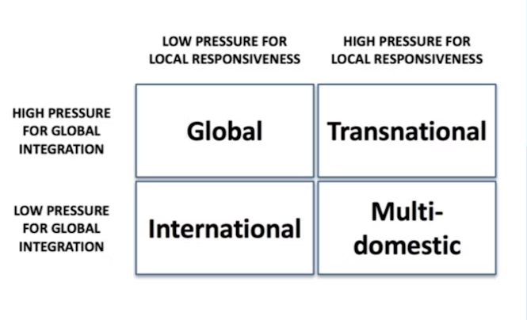
Figure 2: Bartlett and Ghoshal’s model (1989) of internationalisation
(Source: Benabed, 2024)
According to the competitive market goals and development of M&S, the implication and acquisition of the transnational strategy as the concept of internationalisation will be effective for the company to integrate. As the strategic components highlight that an organisation will have a high pressure of global integration and local responsiveness for balancing their local adaptation formats by managing global responsibilities in different constraints. Similarly, for M&S, the transnational strategy well defines global expansion, stability and multi-segment-based retailing capacity of the company in every single country. Additionally, while the concept comes to Canadian culture and structure, local adaptation, selling local products in clothes, groceries, food, and personal care would ensure the stability of the company in their new competitive segment. For that, prospering the business motives with sharing the UK-based operating knowledge while designing the core team in Canadian stores and business environment will support the company to maximise their sales easily. As well as emphasising their local adaptation will also integrate the company approaches by maintaining their responsibility to coordinate with the local customers to meet their necessities effectively.

1.2 Global Configuration
In the current UK-based operational structure and current geographic footprint of M&S, the company has 1,047 store locations across the country, with its business spread across 645 cities (Marks and spencer, 2026). As the retail giant in the UK, approximately 86% of the total UK footprint is in England, as well as the company also has '645 distinct urban municipalities and commercial centres across the UK. Additionally, the company has currently created around 800 new jobs as well as 500 other new locations targeted to expand their business in the UK (Marks and spencer, 2026). Depending on which modernised logistics, operationally credible structures for business conceptualisation have also been estimated as developed by the company in an effective way.
Moreover, in the current competitive structure, M&S is centralising their international operations and strategic approaches by focusing on the 'franchise partnerships, localised multi-platform e-commerce, and targeted regional growth' (Marks and spencer, 2025). Integrating the streamlined model of business acquisition, the company has already developed more than '434 international stores and 39 global websites'. Considering the specific process and growing structure of competitive integration in the current business environment, M&S is set to emphasise its 'capital-light franchise model' for their international structure of expansion. Underpinning the specific business model, the company will be able to add value with local market-based process adaptation, strategic ways of local and global partnership and risk diversification to emphasise its business in the high-growth regions entitlement (Marks and spencer, 2026c). Therefore, utilising a similar internationalisation process and operational practices, M&S can have an effective structure of business process growth in Canada in the recent competitive segmentation for changes.

2. Macro-Environmental Appraisal and Market Attractiveness

2.1 Host Country Analysis
In order to ensure the business expansion structure of M&S, Canada is selected as the host country for the company, which will add more stable operational support, business integrity functions and consistent business acquisition for the company in their further targeted areas. Canada is considered as the most reliable business country, with a high-income customer base, strong trading relationships maintained with the UK and a sophisticated retailing structure managed by the country, which aligns with the company's goals are noticed (Gov, 2026a). Even Canada has strong legal regulations and macroeconomic conditions for positioning businesses in the competitive environment by employing their omnichannel strategic acquisition more significantly in the competitive market. Thus, outlining the external market structure of Canada according to the successful internationalisation for M&S would be most effective to emphasise the competitive operational scalability management for the firm in their targeted segment.
External environmental factors analysis
Political factor
Key factors
- Canada is the 16th-place holding country in low corruption, as well as scoring 75 out of 100 in the context of transparent governance in their parliament (Transparency canada, 2026). The country formally has 47% regulations of judicial integrity and 32% of active operational ways of practice management that help to balance the area of their regulatory compliance management.
- Institutional lower political risk and emphasised the 'UK–Canada Trade Continuity Agreement' to balance the long-term trading concepts for the companies (Gc, 2026). Additionally, Canada is tracking almost '3.0% of nominal GDP' to align with the concept of their FDI process acquisition effectively (Unctad, 2026).
Benefits
- Canadian political stability and governance can support the long-term investment support of flagship stores running capacity for M&S, as well as sustainable digital retail infrastructure management goals of the company.
- Canada's FDI inflows and investment infrastructure will also emphasise the global trading stability for M&S, including the local segments analysis (Canada, 2026).
Limitations
- Due to global geopolitical trading tensions and uncertainty, Canadian retail companies are witnessing strong supply chain disruption issues and increasing trade protectionism.
- The diversified sourcing structure of M&S from Europe and Asia may outweigh the local competitors' process management issues for the firm to continue its operations.
Strategic initiation by M&S as per the impact
Intending to expand its business in the Canadian market, the company is required to minimise their geopolitical exposure by establishing its Canadian regional segment of distribution process and being able to increase its sourcing from North American suppliers in some of the specific product categories. For that, localisation in the Canadian structure would support the supply chain resilience of the company by reducing their transportation emissions more effectively.
Economic factor
Key factors
- Currently, the inflation rate in Canada is around 2.8%, which has declined from last quarter of the year (Trading economics, 2026). The country's substantial economic opportunities ensure systematic financial stability and continuous domestic resilience without the impact of the population's influence.
- Almost 2.25% is the current banking interest rate in Canada, which is estimated as lower according to the operational structures (Bank of canada, 2026). The high disposal urbanisation, incomes and the sophisticated ways of shopping behaviours by the customers of Canada are also estimated as developed.
Benefits
- The sophisticated customer base of Canada may help to increase the demand for premium imported foods, organic products, ready meals and sustainable food packaging structures, thereby adding capacity to the firm. Additionally, the private label differentiating capacity of the company by managing their product quality and categorised innovation techniques would also be emphasised.
- The minimal banking interest rate of the country may also present the opportunity for affluent professional management by the company to serve premium quality-based clothing and ethical sourcing credibilities of M&S in their competitive environment.
Limitations
- The higher living costs and the inflationary pressure in the global economic conditions are directly affecting the price-sensitivity mindset of Canadian customers, which may limit the operational expansion of the firm.
- Canada's retail market has a highly competitive structure with increasing rental prices for the new international retailer to expand their operational scalability. For that, the risk of limited availability of premium locations and delays in expansion in 'metropolitan areas such as Toronto and Vancouver' may also affect the operational stability for the company to balance.
Strategic initiation by M&S as per the impact
According to the economic structure of M&S, the company is required to adapt their initial entry mode and strategies depending on the economic structure and cost efficiency in cities like 'Toronto, Vancouver, Calgary, and Montreal'. Based on that, a specification about the company-centric differentiation and scalability to integrate their competitive operational functions would also evolve. As well as a combination of the flagship experience of stores within the e-commerce fulfilment with the omnichannel approaches would help to emphasise the market coverage of the company effectively.
Legal factor
Key factors
- 'Canada Consumer Product Safety Act, the Consumer Packaging and Labelling Act, Sale of Goods Acts and Business Practices and Consumer Protection Acts' are adhered to as one of the most structured and effective pieces of legislation in Canada to manage their legal changes (Canada, 2025). The key frameworks ensure 'transparent, predictable, and highly supportive of international investment' to maximise competitive operational changes accurately.
- 'PIPEDA (Personal Information Protection and Electronic Documents Act) and Provincial Privacy Laws' define the personal data protection of customers' engagement process in Canada differently (Canada, 2025). Therefore, stronger contract enforcement, IP protection, and consumer protection-based legislation are also estimated to be supported effectively in Canada.
Benefits
- The strict Canadian food and safety legislation regarding the 'nutritional labelling, allergen declarations, packaging compliance' for imported foods may ensure a transparent customer engagement opportunity for M&S.
- Transparent product labelling, pricing, and advertising accuracy as per return policies will also solidify the operational concepts of the company effectively.
Limitations
- Employment regulations of Canada vary based on the changed regional divisions, overtime rules, wages and working hours specifications, which drive operational complexity issues with legal systems.
- Legal obligations for the strategic data security functions may also sometimes impact the changed operating credible structure of M&S during their international expansion.
Strategic initiation by M&S as per the impact
Underpinning the restricted Canadian privacy laws as per the essentiality to integrate the balanced process of changes could be reliable for M&S to sustain their strategic business aspects management in the competitive operational environment with efficacy. Additionally, exceeding the ‘minimum environmental, food safety, and consumer protection standards’ would also be the strategic intention by M&S to emphasise the sustainable operational validity of the company in their Canadian operational segments.
Cultural factor
Key factors
- Canada represents a multicultural society with diverse views, where multiculturalism significantly shapes 'consumer values, brand loyalty, and product preferences' across the overall Canadian diverse demographic groups differently (Maplediversity, 2026). Especially, one-fifth of the Canadian population is estimated to be immigrants, which creates higher diversification and product standardisation in the market and limits market acceptance.
- Demand for cultural authenticity, as per international goods and activities management, defines the key cultural integration of Canada as per the changed functional areas.
Benefits
- Strategic food assortments within the M&S functional efficacy for international flavours management would help to integrate premium heritage management for the firm in their competitive segments.
- ‘Canada's diverse climatic conditions, cultural preferences, and seasonal variations’ may validate fashion to accommodate processes for cultural engagement.
Limitations
- Changing sustainability preferences and initiatives in Canada may influence the imported operational strategies of M&S in their targeted operational changes.
Strategic initiation by M&S as per the impact
Introduction of the digitalised seamless engagement with the customers by M&S, including the process of 'tracing garment origins, manufacturing practices, carbon footprints, and recycling guidance through QR technology ', would ensure the transparent cultural functionalisation of the company in their competitive environment. Furthermore, integration of the 'physical stores, mobile applications, online ordering, click-and-collect services, and personalised digital experiences' would also help to support the changed functional efficacy of the company to emphasise the cross-cultural integration of the company effectively.
Critical evaluation of the overall business impact
Analysing the overall key competitive business factors of M&S for its business expansion in Canada, representation of the better investment environment, successful spending with less dependent macroeconomic conditions to design more effective strategic adaptation procedures effectively. Politically, favourable trading agreements and institutional stability may substantially reduce investment risks and improve the international market integration capacity of M&S. Economically, the competitive marketing structure and inflation pressure may design a disciplined operational environment for the company to manage their expansion. Legally, the legal regulatory structure of Canada supports the long-term investment process, whether, considering that food safety, employment, data privacy and sustainability goals are required to be contemplated as understood by M&S to maximise their operational performance changes. Furthermore, culturally, balancing the local customers' preferences and their demand as per their cultural heritage will support the competitive ownership management capacity of the company. Therefore, it can be outlined that the Canadian retail structure is offering a "Premium Localisation Strategy" inclusion facility to M&S in their current competitive market, where adding location advantages is effective. Although local operations-specific process changes, including 'climate-specific fashion collections, AI-enabled omnichannel retailing, regional sourcing partnerships, and advanced sustainability initiatives', will also help M&S to maximise their changed competitive goals and management functions effectively.

2.2 Market Entry
A strategic market entry plan for an organisation, presented as comprehensive, helps distribute goods and services and addresses brand-related operational factors for the new market segment (Tyukhtenko et al. 2024). 'Exporting, licensing or franchising, and joint ventures or wholly owned subsidiaries' are mainly used as key international market entry strategies for companies, helping to develop competitive operational elements and optimise resource acquisition for the firm in current competitive segments. Ensuring the key process-based integration for M&S in their internationalised market entry in Canada, analysing the market stability, growth segments and international process acquisition are required to be analysed by using the OLI framework. Such as,
OLI framework
The Eclectic Paradigm is contemplated as the economic model that is used to evaluate an organisation's process of undertaking their internationalised expansion and formal practices maximising goals effectively. Underpinning the foreign direct investment (FDI) of a specific target company as well as identifying the core market-based advantages, 'ownership, location, and internalisation' are contemplated by the companies as their key types to align their operational procedures with those localised functions (Batschauer da Cruz et al. 2022).
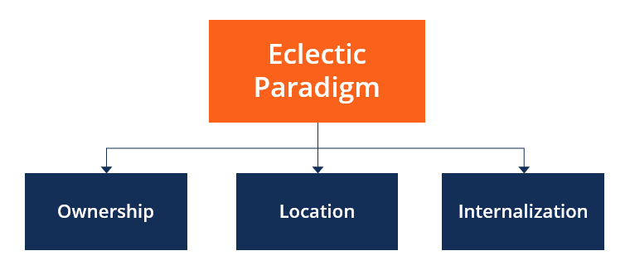
Figure 3: OLI framework
(Source: Batschauer da Cruz et al. 2022)
In order to analyse the host country value and localisation facilities of M&S in Canada, demonstration of the long-term success factors and the key operational segmentations would be reliable for the company to emphasise their further operational changes. For example,
Ownership advantages- Utilising core business assets of the company according to their competitive market inclusions could be effective to develop. For example, designing a strong premium branding structure with AI-enabled operational support in the retail market will help to structure the automated logistic functions as well as enable easy new segment-based storage balancing practices differently (Goswami et al. 2025). Based on that, omnichannel retailing capability and private label innovation structure balancing efficacy of M&S in their competitive segmentation will also be validated. Making a sustainable differentiation depending on the difficulties in managing competitors' influence from the changed operational segmentation with M&S's ownership in the competitive plans will also be emphasised.
Location advantages- Favorable UK and Canadian trading relationship with the legal agreement may support the localisation process of the company to emphasise their changed operational goals. Apart from that, multicultural populations influence up to 26.5% to 30% of the population are immigrants which defines the demographic shifts of the companies to maximise their changed competitive operational divisions (Gc, 2025). Based on that, affluent consumers, coordinating with a transparent legal system of projection, will also be balanced by M&S in Canada, where long-term market-based conduct would also be structured.
Internalisation advantages- Implementation of the 'Online Streaming Act via the CRTC, defined with federal USD 2 billion Sovereign AI Compute Strategy' has been developed as the key operating structure in Canada to strengthen their digital business system (Gov, 2026b). Even the projected market growth has also been estimated to be around CAD 92.5 billion in 2026, which compounds the annual growth factors around 24.96% within 2031 (Gov, 2026b). Moreover, greater control-based quality and the sustainable customer experience can ensure further online business expansion support for M&S in their current competitive stages effectively.
Thus, analysing the internationalised operational credibility assessment for M&S, adapting the 'joint venturing supported by an omnichannel retail model' can be effective for the company to emphasise their changed business acquisition goals. For that, the official company-operated business method, integrated Canadian system estimation, including the process of global retailing ecosystem management efficacy for the company as per their proportional functional changes, will also be balanced according to the changed operational stabilities. Even so, the specific approach will extend traditional internationalised process acquisition for M&S to create a dynamic process of business stages alignment as well as finding the replicated process acquisition of the companies in the competitive segmentations.

3. Entry Mode Strategy and Strategic Synthesis

3.1 Historical Pattern Recognition
Specific market entry mode represents an organisation's capacity to expand its business in a completely new target market position to emphasise its key competitive process integration effectively. Managing the process, 'Exporting, Licensing, Franchising, International Partnership, Joint Ventures, Wholly Owned Subsidiaries', is contemplated as the key operating procedures of the companies to emphasise their key competitive function changes effectively (Lubis and Muniapan, 2024). As per the historical pattern of international market expansion and credible operational goals management, M&S followed a franchising with international partnerships strategy to expand their international business structure management approaches. In internationalisation, M&S mainly focused on franchising, which helped to support their local operational structures by differentiating their product selling platforms as per the necessities of their customers in the current competitive environment (Marks and spencer, 2022). For example, expansion in India and the Middle East, M&S used a franchising approach to manage their retailing space and limit their direct exposure capacity to create a balance of their international operating function management goals differently. Thus, a validated form of global expansion and supported business expenditure with the company goals are also estimated to influence differently.

3.2 Strategic Fit & Justification
M&S is strategically operating through their area of business operations across all its international markets, which emphasises franchises and the concept of international partnership goals effectively. In this context, the particular international market-based strategic mode creates different beneficiary approaches and limitations for the firm to emphasise their core conceptualised factors of credible process assessment effectively. For instance,
Benefits
Firstly, using the franchise process in the international market segment will help to reduce the financial risks for the company to emphasise their international retail stores, property acquisition, and local staffing to manage their day-to-day operations. The process will allow M&S to expand their substantial capital expenditure while accommodating the changed international market-based segments.
Secondly, franchises with partners mostly contributed to the valuable local market-based knowledge development for M&S to sustain their international business development. Independent foreign firming capacities, including 'consumer preferences, retail regulations, supplier networks, labour markets, and cultural expectations', would ensure early adaptation of the firm effectively.
Thirdly, franchises help to enable rapid market-based expansion for an organisation with relatively lower operational complexities, instead of managing direct operational overseas procedures (Ghani et al. 2022). Therefore, M&S franchise concentration may evolve product categories development structure, strategic ways of planning and brand operating management efficacy of the company in their new competitive segments.
Limitations
- Reduced strategic control is one of the major limitations of the franchise model, which impacted ethical and quality-based product sharing capacity for the companies in their new competitive market (Putra et al. 2022). For that, M&S may struggle to manage sustainable sourcing, omnichannel integration, and balancing merchandising as well as inventory management qualities by themselves.
- The franchise model will limit the digitalised customer experience gaining and strategic management partnership assessing capacity of the companies to directly connect with their customers as per their necessity to manage (Hu et al. 2025).
- In franchise operations, designing specific ESG standards according to a specific company is considered as challenging and impacts different local variants to manage their circular economic process of programming effectively (Calderon-Monge and Huerta-Zavala, 2025). For that, new company-centric transparency management for that firm is also estimated to be difficult to continue.
Outlining risk assessment dimensions
Outlining the key influence and effectiveness of using the franchise model by M&S, assessment of using the model risks in the Canadian market as per the changed formulated approaches are going to be demonstrated in the section below.
Dimension of risks | Franchises benefit in Canada | Strategic outlining for Canada
Financial risk | Low | Attracting large financial partners with sustainable growth functions would support the capital investment practices.
Political risk | Low | As the Canadian market is estimated to be potential and stable, whether the application of the franchise model would limit the additional benefits of gaining capacities.
Operational risk | Moderate | Operational consistency and service quality may vary as per the franchise locations.
Brand reputation risk | High | Poor performance on the franchise may impact M&S's premium brand-oriented image.
Technological integration risk | High | Omnichannel systems, difficulties with integrated AI systems and customer analytics may affect the operational changes.
Strategic flexibility | Moderate | Any contractual agreements may also reduce the speed and stability of operational adaptation by the company.
Table 1: Risk assessment
(Source: Self-developed)
Application of alternative strategic mode
Instead of focusing on the traditional pattern of model assessment and international operating structure alignment, M&S is required to integrate their joint venture strategic approach to align the functional changes effectively. The strategic joint venturing process shares the advantages of combined process development with the greater strategic control structure and the local partnership management efficacy of the firm in their new market segment. As the developed Canadian business regulation balancing expertise and digitalised infrastructure management would strengthen better customer insights management by M&S. As well as the process ensures hybrid operating approach management efficacy for the company to ensure their 'control and flexibility' in the new Canadian market segmentation.

3.3 Conclusion & Recommendations
The report has critically demonstrated the market expansion structure and strategic approaches of Marks & Spencer to ensure their competitive business expansion in the new Canadian environment. External environment analysis of the host country by defining the political, economic, legal and cultural factors of Canada has been analysed as per the functional efficacy of M&S to expand their business practices in the recent competitive environment. Apart from that, the joint venture-based market engagement and operational scalability-based international market entry mode have also been outlined in the report according to the sustainable operating process of M&S. In conclusion, it can be asserted that focusing on the joint venture mode to expand business in Canada will strengthen the sustainable operational scalability of the company with its customer base.
In terms of the future stability and growth aspects of M&S, establishing a majority-owned strategic mode of joint venture with the leading Canadian retail as well as logistics partners could be effective to strengthen their further operational stability. Launching an 'AI-enabled omnichannel flagship' in Toronto and Vancouver will ensure the combination of heritage and locally adapted production structure of the retail company to meet the necessities of Canadian customers (Furtick, 2025). Alongside, the process will emphasise sustainable sourcing capacity, personalised digital experiences management options and accelerated customer loyalty and growth, gaining efficacy in the new expanded market in an effective manner.

Section 2: Reflective account
Analysing my overall experience to complete the assignment and outline each understood finding according to the functional differences, utilising the Gibbs reflective model with key stages would be effective for me to elaborate on the experiences. Such as,
Gibbs reflective model
As per the view of Praveena et al. (2025), the model exemplifies the six-stage analysis model that helps individuals to reflect on their own determination, their capacities and observe their weaknesses as per the changes. The model helps to elaborate everyday experiences and core thoughts, analysing the ability of individuals to turn their understanding into a meaningful structure of elaboration. Following these key stages of the reflective model, clarification of my own development and the academic process evolving would also be managed effectively.
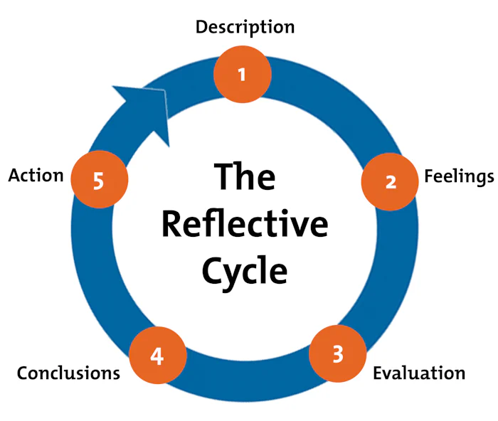
Figure 4: Gibbs reflective model
(Source: Praveena et al. 2025)
Description
In the assignment, I learned about different international business functions and the diversified functional structure of a company to continue their operation in different countries. The key concepts of internationalisation, brand expansion, strategic competitive area development, and the production and operating facilities of that company to balance their operational stability have also been outlined by me during the assignment. Through the assignment, I developed my market analysis skills by outlining Marks & Spencer's UK-based operational structures, their traditional international market expansion mode and understanding their procedures to only focus on high-quality product engagement formats. Alongside, strong business expansion-related regulatory governance, economic stages and the key operating credibilities essential for that company to meet the targeted market-oriented needs have also been outlined (Akang, 2023). Based on that, I started understanding how a company ranks their business divisions, changes its prospects and assures its international marketing categorisation ability in the competitive market segments in an effective manner. Apart from that, during the assignment I also learned about different cross-border issues, political agreements and the trading scalability for the company to strengthen their competitive expansion in that competitive operational environment effectively.
Feelings
During the assignment, I felt that I have strong research skills to analyse the different operational activities and competitive projection related structures of the company in their competitive segment. During the M&S-based assignment, I researched the historical background of the company to define their competitive operational structure as well as the recent business localisation ability of the company according to their structure of acquisition. Alongside, I also observed that I have good interpretation skills about the research structure by which I am able to make my audience understand about how the overall company-based process has developed and structured according to the functional stages differences. On the other hand, I also felt that I have poor presentation skills, for which I struggled to represent the home and host country based on information and aligned contexts with M&S as per the recent competitive market. Alongside, limited business skills are another major pitfall of mine, which I have also outlined during the assignment, as I struggled to understand the suitable international market entry mode for M&S to expand their key competitive process in the Canadian environment.
Evaluation
Through the assignment, I realised that before selecting a company to develop an assignment, I need to know every single business area, competitors and the sustainable market positioning capacity of that company in the recent operating environment. However, during the assignment, I understood that the international market balances, including their different macro environmental factors and their implications, have also started to develop with the functional ways of acquisition. A new market engagement for an organisation reflects the strategic adaptation of their local business venture, customers' preferences, and changed methods of automation to completely establish the key segmentation for that firm in an effective way (Aaker and Moorman, 2023). Following similar goals, I also analysed the key segmented structure of the Canadian retail market and its changed functional efficacies, and their customers' transition towards mobile shopping functions to continue their way of company engagement differently. Based on that, my observation about the different international and domestic market-based factors and their applications to balance strategic business structures for a company in their competitive environment has also been developed.
Analysis
Furthermore, the assignment helped to make me realise that I have poor time management skills due to my delayed process of Canadian market-based data presentation and practice acquisition as per the frequency changes. Even initially, I failed to meet the first deadline of the assignment and rushed up to complete my work according to the necessities relayed with the assignment brief. Apart from that, I also noticed that I have poor cognitive decision-making skills as per the essentiality of certain situational factors. For that, I struggled to manage the initial decision to focus on the specific Canadian market-based data as well as failed to decide the transforming functional adherence of the international marketing functions of the assignment in an effective manner. Therefore, I observed my clarified understanding and analysis of M&S to outline how the process is developing and integrated the structure of change according to my critical assignments and analysis abilities differently.
Conclusion
Throughout the assignment, my basic knowledge and understanding of the company's internationalisation strategy, their transformed operational thoughts and the integrated functions of collaboration to balance their process of business expansion have been developed by me. Alongside, the assignment has contributed to my practical business association and competitive market differentiation understanding capacity, for which I have the ability to enhance my scale of knowledge about the practical operational segmentations that would also be estimated as evolved in an effective way in my future.
Action plan
Required area of improvement | Strategies | Time-frame
Improving my presentation skills | Keeping focus on the digitalised structures of presentation by underpinning different software languages would be effective to improve individuals' presentation skills (Makhachashvili and Semenist, 2022). | Within the next 8 months
Enhancing time management capacity | Developing an everyday schedule of each essential and non-essential working structure with its own leisure time would help to enhance time management efficiency of individuals (Martin, 2025). | Within the next 9 months
Develop cognitive decision-making skills | Adapting different cognitive skills and preparing the mindset of accepting the changes would ensure the effective development of cognitive decision-making capacity by individuals accurately (Begum et al. 2025). | Within the next 1 year
Table 2: Action Plan
(Source: Self-developed)

References
Aaker, D.A. and Moorman, C., 2023. Strategic market management. John Wiley & Sons.
Akang, A.U., 2023. Regulatory compliance and access to finance: implications for business growth in developing economies. Sciental Journal of Education Humanities and Social Sciences, 1(2), pp.8-23.
Bank of canada, 2026. Policy interest rate. [Online] Available at:<https://www.bankofcanada.ca/core-functions/monetary-policy/key-interest-rate/>
Batschauer da Cruz, C.B., Eliete Floriani, D. and Amal, M., 2022. The OLI Paradigm as a comprehensive model of FDI determinants: a sub-national approach. International Journal of Emerging Markets, 17(1), pp.145-176.
Begum, R., Solangi, M.W., Shaikh, A. and Ali, A., 2025. The role of cognitive flexibility in adapting to climate change: AI-driven educational strategies for developing adaptive thinking. The Critical Review of Social Sciences Studies, 3(1), pp.2500-2515.
Benabed, A., 2024. The Importance of Multinational Companies (MNCS) and Small and Medium Sized Enterprises'(SMES') Internationalization as Business Drivers în Globalization and Slowbalization: Mutual Survival and Growth for Business Values. Eastern European Journal for Regional Studies (EEJRS), 10(2), pp.9-33.
Calderon-Monge, E. and Huerta-Zavala, P., 2025. Exploring the evolution and future research on sustainability in franchising: a systematic review of the literature. Future Business Journal, 11(1), p.183.
Canada, 2025. Retail associations. [Online] Available at:<https://www.canada.ca/en/financial-consumer-agency/services/industry/regulated-entities/retail-associations.html>[Accessed on 27th July, 2026]
Canada, 2026. Key facts about Canada’s competitiveness for foreign direct investment. [Online] Available at:<https://international.canada.ca/en/global-affairs/corporate/reports/chief-economist/international-investment/2026-05-key-facts?utm_source=chatgpt.com>
Furtick, J., 2025. AI-Powered Omnichannel Retail: Transforming Consumer Experience. Muma Business Review, 9, pp.253-265.
Gc, 2025. Content changes for the 2026 Census of Population: Ethnic. [Online] Available at:<https://www12.statcan.gc.ca/census-recensement/2026/ref/98-20-0004/2026003/98-20-00042026003-eng.cfm>
Gc, 2026. Canada-United Kingdom Trade Continuity Agreement. [Online] Available at:<https://www.international.gc.ca/trade-commerce/trade-agreements-accords-commerciaux/agr-acc/cuktca-acccru/index.aspx?lang=eng>
Ghani, M.F.A., Hizam-Hanafiah, M., Isa, R.M. and Abd Hamid, H., 2022. A preliminary study: Exploring franchising growth factors of franchisor and franchisee. Journal of Open Innovation: Technology, Market, and Complexity, 8(3), p.138.
Goswami, S.S., Mondal, S., Sarkar, S., Gupta, K.K., Sahoo, S.K. and Halder, R., 2025. Artificial intelligence-enabled supply chain management: Unlocking new opportunities and challenges. In Artificial intelligence and applications (Vol. 3, No. 1, pp. 110-121).
Gov, 2026a. Canada - Market Opportunities. [Online] Available at:<https://www.trade.gov/country-commercial-guides/canada-market-opportunities>
Gov, 2026b. Canada Country Commercial Guide. [Online] Available at:<https://www.trade.gov/country-commercial-guides/canada-digital-economy>
Hu, T.L., Chao, C.M., Wu, C.C., Lin, C.H. and Chi, S.C., 2025. Digital Franchising in the Age of Transformation: Insights from the Motivation-Opportunity-Ability Framework. Journal of Theoretical and Applied Electronic Commerce Research, 20(2), p.107.
Islami, M.M., Rahyuni, S. and Rukayyah, A., 2024. Strategic branding: Building market positioning and business growth through integrated management practices. Advances in Business & Industrial Marketing Research, 2(2), pp.110-122.
Lubis, M. and Muniapan, B., 2024. International market development Strategies for enhancing global expansion in the export industry. Involvement International Journal of Business, 1(1), pp.14-28.
Makhachashvili, R. and Semenist, I.V., 2022. Dynamic e-skills development for foreign languages education in the emergency digitization paradigm. Education And New Learning Technologies, 14, pp.6900-6907.
Maplediversity, 2026. The Multicultural Consumer Landscape in Canada: 2026 Outlook. [Online] Available at:<https://maplediversity.ca/the-multicultural-consumer-landscape-in-canada-2026-outlook/>
Marks and spencer, 2022. International Update: Istanbul Presentation - Marks & Spencer. [Online] Available at:< https://corporate.marksandspencer.com/sites/marksandspencer/files/Annual%20reports/2013/investor-event-international-1.pdf>
Marks and spencer, 2025. M-and-S-Strategic-Report-2025.pdf - Marks & Spencer. [Online] Available at:<https://corporate.marksandspencer.com/sites/marksandspencer/files/2025-05/M-and-S-Strategic-Report-2025.pdf>
Marks and spencer, 2026a. Our History - Marks & Spencer - M&S. [Online] Available at:<https://corporate.marksandspencer.com/about-us/our-history>
Marks and spencer, 2026b. M&S Expands Search For Potential New Sites As It Picks Up The Pace On Store Renewal. [Online] Available at:<https://corporate.marksandspencer.com/newsroom/press-releases/ms-expands-search-potential-new-sites-it-picks-pace-store-renewal>
Marks and spencer, 2026c. Our strategic priorities | Marks & Spencer. [Online] Available at:<https://corporate.marksandspencer.com/sites/marksandspencer/files/2026-04/m-and-s-strategic-priorities-and-business-strategies.pdf>
Martin, M., 2025. Maximizing Efficiency: Practical Strategies for Time Management, Goal-Setting, Productivity, and Balance. Martin Press.
Praveena, K.S., Juslin, F., Patil, C.M. and Bhargavi, K., 2025. Using gibb's reflective model approach for enhancing project-based learning among students through reflective assessment. Journal of Engineering Education Transformations, pp.148-155.
Putra, A.R., Hardyansah, R. and Wibowo, A.S., 2022. Ethical Foundations of Franchisor-Franchisee Relationships and Their Influence on Business Performance Outcomes Across Franchise Systems. Journal of Social Science Studies, 2(2), pp.279-284.
Statista, 2026. Revenue of Marks & Spencer worldwide from financial year 2010 to 2026. [Online] Available at:<https://www.statista.com/statistics/413349/group-revenue-marks-and-spencer-mands/>
Trading economics, 2026. Canada Inflation Rate. [Online] Available at:<https://tradingeconomics.com/canada/inflation-cpi>
Transparency canada, 2026. Canada hits all-time low on Corruption Perceptions Index. [Online] Available at:<https://transparencycanada.ca/news/cpi-2025-press-release-feb10>
Tyukhtenko, N., Churkina, I., Pavlovych, O., Mokhnenko, A. and Burak, V., 2024. Foreign market entry strategy as a key to the competitiveness of enterprises. Ekonomika APK,(31 (5), 86-98. https://doi. org/10.32317/ekon. apk/5.2024. 86.
Unctad, 2026. World Investment Report 2026. [Online] Available at:<https://unctad.org/system/files/non-official-document/wir_fs_ca_en.pdf>

