
Problem Solving and Decision Making
BMSW4004_LON


STUDENT: LEONARD HONDOR (2115347)
LECTURER: HOSSEIN SHOKRI

Table of content
Introduction 2
Define the problem 2
Fishbone analysis 2
Pestle analysis 3
SWOT analysis of the company 5
Alternative solution 6
SMART plan for implementing the solution 6
Monitoring and review the techniques 8
Conclusion 8
Reference 9
Appendix 11

1 Introduction
This report's goal is to analyse the problem the employee has and recommend the best solution. In this case, the main problem being the lack of health and safety provided by Amazon for its drivers, as a result of which our customer had two auto accidents.

Define a problem
According to SOC analysis, delivery targets set by Amazon are blamed for creating hazardous working conditions for DSP operators (drivers) and a significant worker compensation insurer. However, Amazon has concentrated on tracking driving habits using its Mentor app and AI cameras, disregarded data showing that production pressure is a factor in both risky driving and auto accidents.

Amazon also sets excessively high targets for drivers, according to DSP operators and the complaints they made, Amazon requested each DSP operator in London to deliver between 350 and 400 parcels per day, per van during peak periods (the busiest period of the year). Being part of the work as a DSP operator, “drivers would need to park, sort, distribute, and document a delivery roughly every 1 to 2 minutes—assuming they do not take any breaks—in order to finish this many deliveries in a 10-hour shift.”

“SOC’s analysis found that drivers for Amazon DSPs experienced one injury per five full-time-equivalent workers in 2021– a nearly 40percent increase above the previous year’s injury rate.”
(SOC)
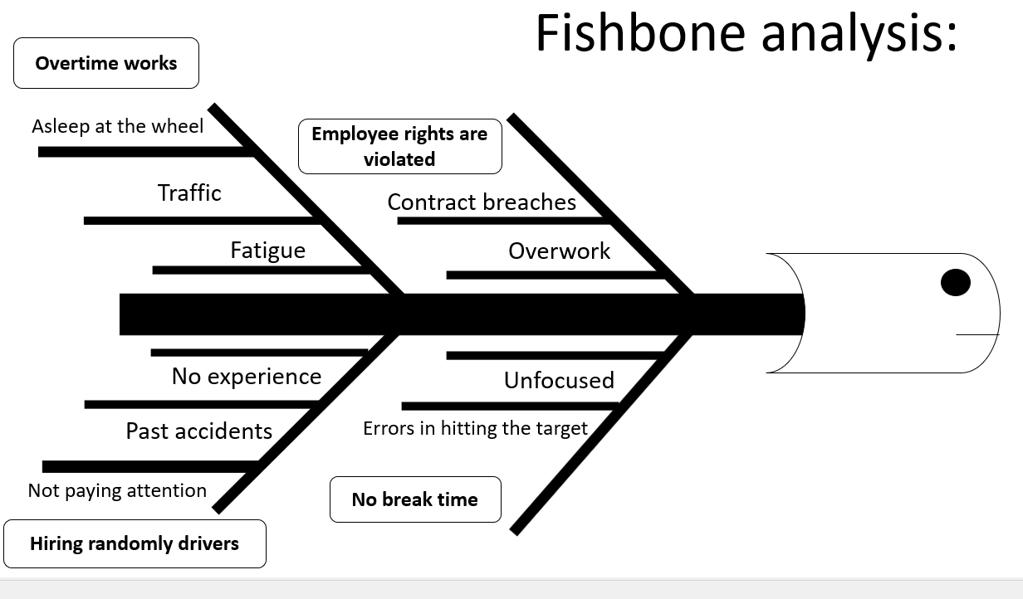
3
A fishbone diagram is a tool for evaluating cause and effect. The fishbone diagram gets its name from its shape, which is a structure with branches that offer causes that come from a central line that indicates to an issue. The overall picture aids in categorising concepts in order to better understand their impact on the core problem.
The fishbone diagram is a technique in fishbone theory that is frequently used in root cause analysis, which aims to identify the source of a problem in order to produce better overall system solutions. This diagram is commonly used by groups to solve problems, but it can also be useful for individuals. ( Chelsie Wheeler )
In the diagram above we can easily see the main causes that cause this lack of health and safety and cause car accidents so often.

4 Pestle analysis
A PESTEL analysis is a common analytical framework used to examine the business environment in which an organisation works. Previously, the framework was referred to as a Political, Economic, Social, and Technological (PEST) study; however, the scope of the framework has since been broadened to incorporate environmental and legal elements as well. (Kyle Peterdy)

In this case, I chose to use Pestle analysis to Investigate political, economic, social, technological, legislative and ecological factors that can generate marketing ideas and solutions to complex problems.

Political | Drivers hired from the former Soviet republics have claimed that they were given orders on how to hack time-tracking devices so they could drive unsafely and for an excessive amount of time in western Europe. (The worst mile)
Economical | Despite Amazon's assertions that it invested $300 million in worker safety initiatives in 2021, more employees suffered injuries at delivery stations, sorting facilities, and DSPs in 2021 than in 2020. Additionally, SOC's investigation revealed that employees at Amazon DSPs and delivery stations suffered injuries at significantly higher rates and with more serious consequences than those at non-Amazon delivery firms. Moreover, due to Amazon's significant use of ostensibly independent contractors, the actual magnitude of injuries is concealed from Amazon's own statements of its safety record.
Social | Amazon has reduced the number of temporary employees it needed as it utilises more robots during the holiday shopping season, according to Citi analyst Mark May, who spoke to CNBC on Friday.  "We've seen an acceleration in the deployment of robotics within their fulfilment centres, and that has correlated with less and fewer employees that they are recruiting during the holidays," the internet expert said on "Squawk Alley."  Because of the robotic additions, Amazon's temporary jobs were flat from the previous year for the first time in 2017.  According to May, the internet company expects to hire 100,000 seasonal workers this season, 20,000 less than last. (M. MAY)
Technological | From my own experience I can say that Amazon is trying to find the right technology to reduce the level of car accidents produced annually, but the level of accidents that happened last year is much higher than the previous year.
Legal | “Amazon delivery drivers regularly work "illegal" hours and receive less than the minimum wage, it has been claimed.”  Drivers for companies the internet giant hired said to an undercover journalist that they were required to deliver up to 200 packages every day.  Some admitted driving over the speed limit to keep up with the schedule, while others claimed there was no time for toilet breaks. (BBC)
Environmental | Amazon stated that it is "innovating and investing to be net zero carbon by 2040 and run on 100% renewable energy by 2030" in a written statement to TechTarget and also Amazon mentioned that it works with manufacturers to decrease waste and enhance packaging, which has resulted in a 27% reduction in packing weight and the removal of more than 810,000 tonnes of packaging material since 2008. (M. K. Pratt)

5 SWOT analysis of Amazon

A SWOT analysis can assist you in identifying the project's or your overall business plan's strengths, weaknesses, opportunities, and threats.

Strengths | - Strong brand – Amazon is global one of the most known e-commerce successful company.  - Valuation – According to Interbrand’s Global Brand Ranking 2021, Amazon is ranked at second place with a valuation of $249 billion.  - Customer oriented – Amazon provides inexpensive prices for a huge number of costumers daily.  - Market leader – With more than $1.6 trillion market capitalization and above $386 billion annual revenues.
Weakness | - Treating employers more like numbers than people - Amazon has recently come under fire from lawmakers, the press, and governments for their treatment of employees.  - Using Third Party Data - Amazon is having issues with tax evasion and employees. It is also facing criticism from governments and sellers for utilising their data to generate new goods and increase sales.  - Tax evasion - Amazon is being sued by countries such as Japan, the United States, and the United Kingdom for evading taxes.
Opportunities | - Partnership – In order to realise its retail industry ambition, Amazon must collaborate with more local businesses.  - Global Expansion - Despite its rapid growth, Amazon still has more areas to enter and establish its brand in. Consider the African and Asian markets.
Threats | - Fake Reviews - Amazon has a significant volume of false reviews on its network's products. During the pandemic, it was even more difficult for buyers to find high-quality products, which e-commerce companies should prioritise for a positive user experience.  - Increasing Competition - Amazon's competitors include Flipkart and eBay in e-commerce, Microsoft and Google in the cloud, Target and Walmart in retail, and Google in AI virtual assistants. There were only a handful, but there are many more to come.  (Mohanraj)

6 Alternative Solutions
Alternative solutions depend heavily on decision making and problem solving. They are all different types of successful thinking. However, there are some differences between them. You can think creatively, for example, by having an innovative thought without making a decision or solving an issue. (John Adair)
-Amazon must employ a high number of experienced employees to reduce the number of packages offered to current drivers-
With this solution, the level of stress that drivers now hold will drop drastically. It will make them go to work with a totally different thinking, from a very high level of negativism, to pleasure and satisfaction with the workplace. As our lecturer Dr. Hussein told us during the class, 63% of the employees worldwide are "not engaged" at work. The fewer packages for drivers, the more time for them. Toilet breaks can occur as a result of this act, recess breaks and minimized fatigue levels that increase the level of attention of drivers and reduce the level of car accidents.

SMART plan for implementing the solution
SMART | Goals | How it helps | How to implement | Time Frame
Specific | To increase DSPs salary. | It motivates the workers and makes them happy. | Regional Managers are responsible for salary negotiation or pay rise. | 4  weeks
Measurable | To reduce the DSPs workload. | It will reduce the level of stress DSPs are getting now and gives them more social time. | As well as above, Regional Managers should take care of this complex problem as DSPs are complaining about the workload. | 2  weeks
Aggressive | Prohibition of superiors from giving extra unpaid work to DSPs. | They will stop working for free. | Drivers should stop accepting extra unpaid work from their superiors. | 0  weeks
Realistic | To provide DSPs with visibility vests and safety boots. | This will help the DSPs to be more visible in traffic and reduce the risks of incidents. | The company should provide safety equipment for DSPs. | 1  weeks
Time-bound | to reduce DSPs working hours. | DSPs will have more personal time. | The HR staff should reduce the 10 hour shift to 8. | 4  weeks

Monitoring and review techniques
To ensure that a project moves toward its objectives and goals, project monitoring and evaluation procedures employ supervision, evaluation, appraisal, and feedback. Monitoring is a continuous process that determines how well project inputs are converted into outputs. In contrast, evaluation measures progress toward goals and objectives. Evaluation entails assessing performance, progress, efficiency, impact, and relevance to project needs on a regular basis. ( Alana G)
This initiative solves the problem in relation to health and safety. After these implemented solutions, the level of accidents should decrease and the employees should work in a much safer and more pleasant environment.

9 Conclusion

The ressult of the analysis made about Amazon, in connection with the lack of health & safety provided to drivers, shows that the company treats its employees more as numbers than as people. With the help of the diagrams we learned during the course taught by dr. Hussein, we found the solutions to these problems and how to implement them.

Reference

Caitlin, H., 2021. “Some Amazon Drivers Have Had Enough. Can They Unionize?”, available at: https://www.wired.com/story/some-amazon-drivers-have-had-enough-can-they-unionize/ , [accessed] 13 August, 2022.
Strategic Organisation Centre, 2022. “The worst mile”, available at: https://thesoc.org/wp-content/uploads/2022/05/The-Worst-Mile.pdf , Pag. 1-10, [accessed] 13 August, 2022.
Felicity, L., and David, P., 2020. “Drivers for Amazon contractor allege safety and wage abuses”, available at: https://www.theguardian.com/technology/2020/sep/03/drivers-for-amazon-contractor-allege-safety-and-wage-abuses , [accessed] 13 August, 2022.
Marry, K., P., 2020. “Amazon's Environmental Impact Delivers Climate Change Concerns”, available at: https://depts.washington.edu/sctlctr/news-events/in-the-news/amazons-environmental-impact-delivers-climate-change-concerns , [accessed] 14 August, 2022.
BBC, 2016. “Amazon drivers 'work illegal hours”, available at: https://www.bbc.co.uk/news/uk-england-37708996 ,
[accessed] 14 August, 2022.
Chelsie, W., 2021. “Fishbone Diagrams”, available at: https://study.com/learn/lesson/fishbone-diagram-analysis-examples.html , [accessed] 14 August, 2022.
Thomas, B., 2019. “PESTLE Analysis Explained (With Examples)”, available at: https://pestleanalysis.com/pestle-analysis-explained-with-examples/#:~:text=%20When%20referring%20to%20countries%2C%20here%E2%80%99s%20what%20PESTLE,the%20country%E2%80%99s%20impact%20on%20the%20environment%3F%20More%20 , [accessed] 14 August, 2022.
Amazon Delivery Partners, 2020. “Pinnacol Assurance”, available at: https://thesoc.org/wp-content/uploads/2022/05/The-Worst-Mile.pdf , [accessed] 13 August, 2022.
John., A., 2010. “Decision Making and Problem Solving Strategies”, pag. 54-56.
Annie., P., 2022. “Nearly one in five Amazon delivery drivers suffered injuries in 2021, study finds”, available at: https://www.cnbc.com/2022/05/24/study-nearly-one-in-five-amazon-drivers-suffered-injuries-in-2021.html [accessed] 24 July, 2022.
Tylor., C., 2018. “Reduced holiday temp hiring is a sign Amazon is turning to more automation and robots: Citi”, available at: https://www.cnbc.com/2018/11/02/citi-mark-may-amazon-relies-on-robots-less-temporary-holiday-hires.html [accessed] 24 July, 2022.

Appendix



