Data Analysis

This chapter leads on from the methodology chapter in which the researcher explained how they would carry out and conduct research by using their chosen methodology in order to obtain data. In this chapter, the researcher will use the collected data from the responses obtained, to analyse and draw correlations and differences from, the results of which will be reviewed with the research objectives of the project.
The survey in which the data was collected from was open for two weeks, and was sent out online primarily to parents, but all persons over the age of 18 were encouraged to participate in the survey. On closure of the survey, a total of 55 responses were obtained, the number of engagements with the survey hit the researcher’s minimum engagement goal of 50.

Demographic

Figure 1 represents the question, are you a parent? The graph shows that 80% were a parent at the time of the survey, and after the introduction of the Children (Abolition of defence of reasonable punishment) (Wales) Act 2020.
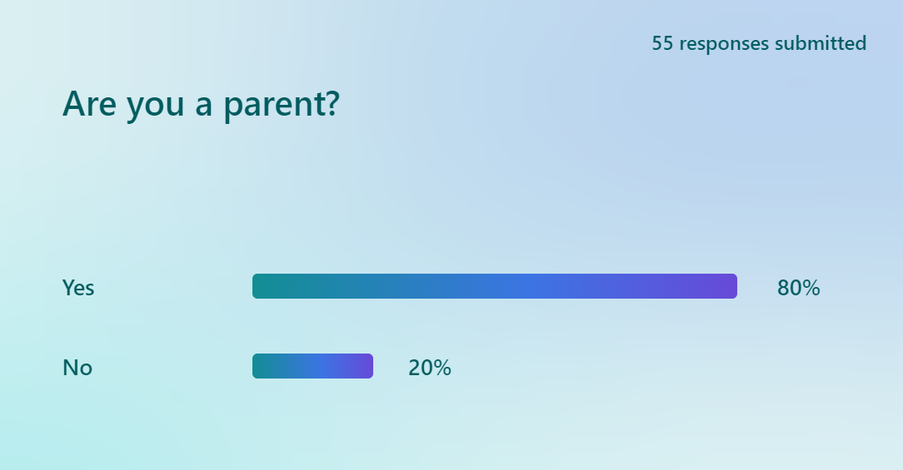

Figure 2 represents the question; what age bracket are your children now? This graph gave the participants multiple choices, and highlights that that 50% of participants had children over the age of 18, and 19% either didn’t have a child or had one between the age of 0 to 5.
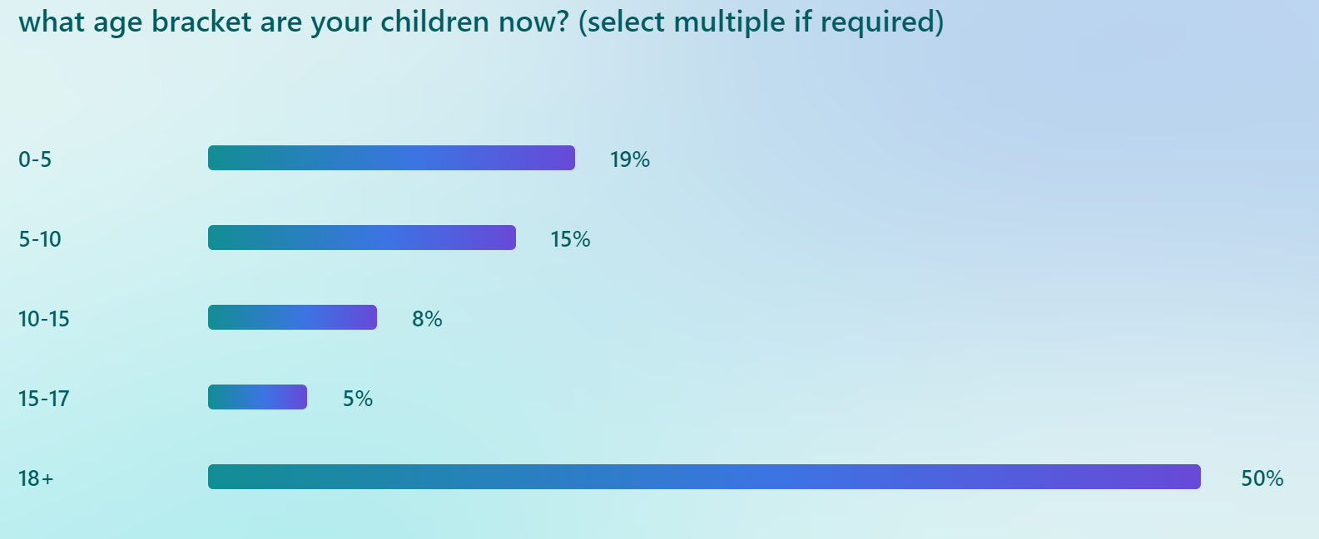

Opinions on physical punishment and the law
Figure 3 represents the question; Do you support the ban on child reasonable physical punishment? 69% of respondents supported the ban, 9% of respondents didn’t have a clear answer.
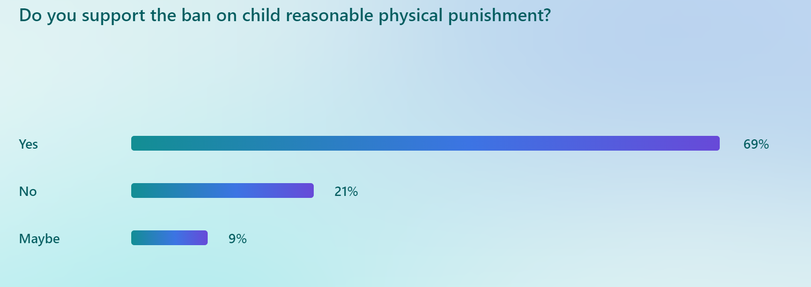

Figure 4 represents the question; were you physically punished as a child? 72% of respondents said yes, 5% could not remember.
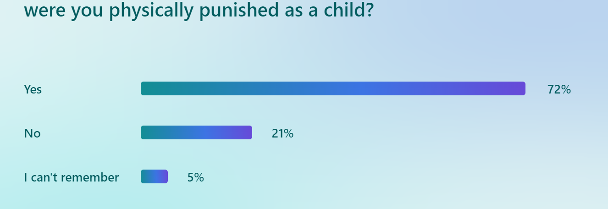
Figure 5 leads on from figure 4 and represents the question; if yes, how did this effect your development and behaviour as a child growing up? 44% of respondents said it had a positive effect, 30% thought it had a negative effect, and the remained stated they were not sure, or it had no effect.
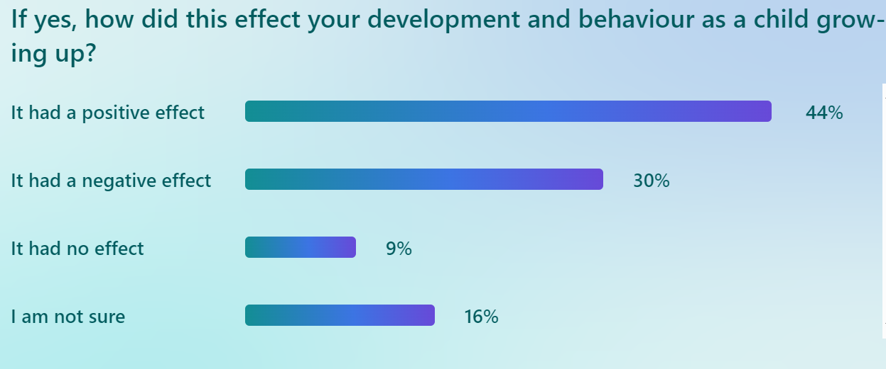

Figure 6 represents the question; before the ban, did you use physical punishment to discipline your child? 76% of respondents answered no.
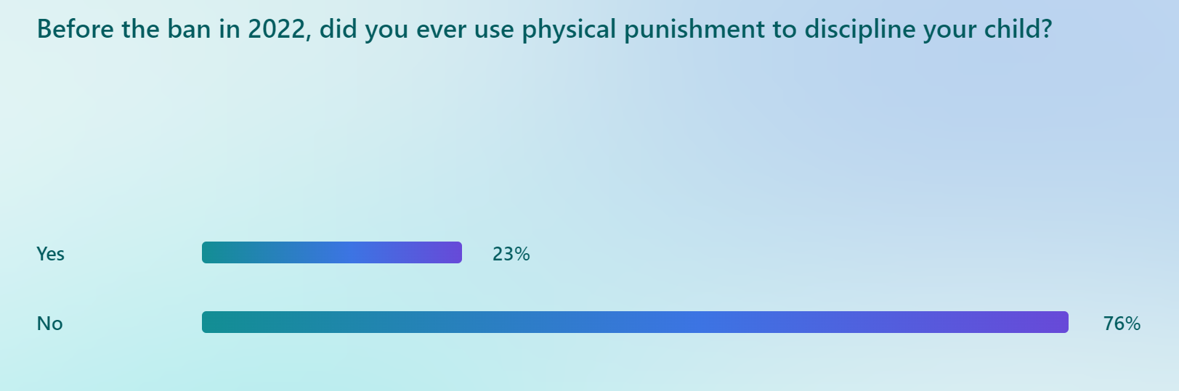

Figure 7 shows that of those who answered yes to figure 4, 10 out of 11 of them believed physical punishment helped to discipline and improve their child’s behaviour. None of them believed it made their child’s behaviour worse.
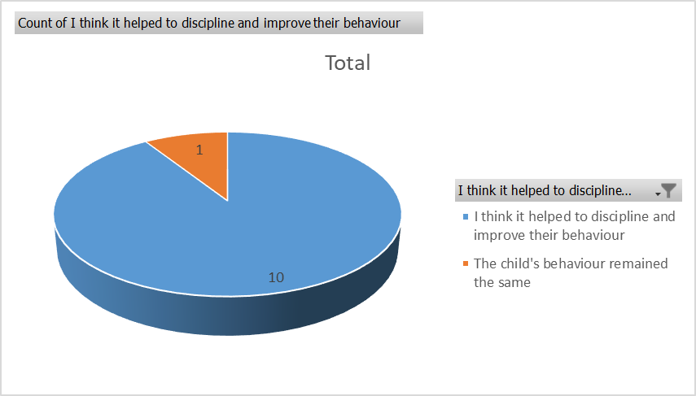

Impact of the new legislation

Figure 8 represents the question; Did you know the “reasonable” physical punishment of children was made illegal in Wales in 2022? 85% of respondents said yes, and 14% said no

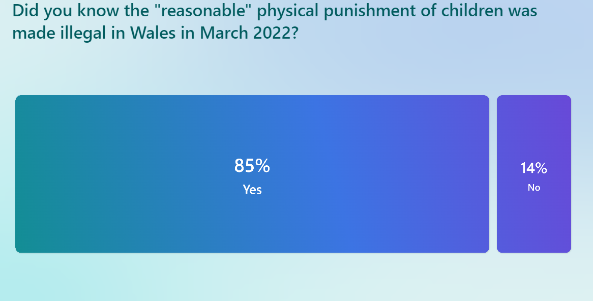

Figure 9 represents the question; Has the ban on physical punishment impacted your ability to discipline your child? 91% of respondents believed that the ban did not have an impact.
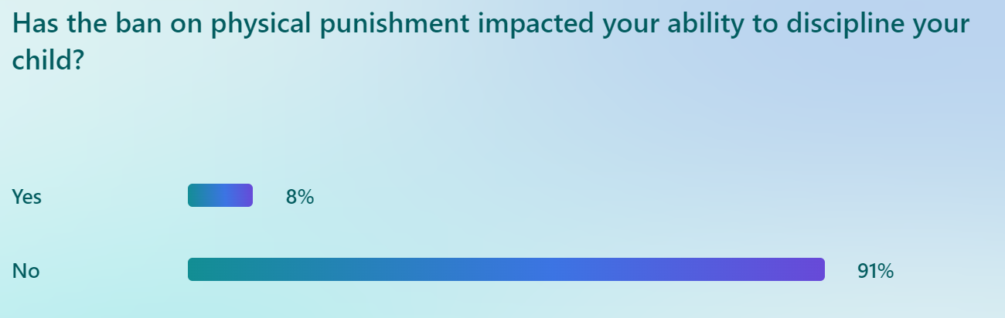

Figure 10 represents the question; What form of discipline would you use now? This question was open text so the respondents could suggest what they wanted. The answers have been collected and grouped into the below graph. Out of 50 responses, 21 respondents use restriction of privileges such as removing access to mobile phones as punishment. 14 people stated they had a discussion with their child and 4 people used isolation methods such as grounding them. Most responses indicate however that a combination of all is used.

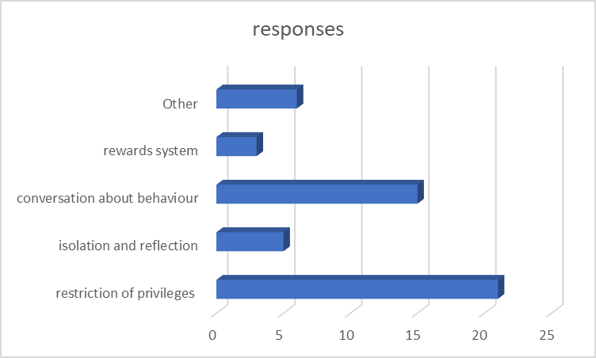

Figure 11 represents the question; is their chosen form of discipline more or less effective than physical punishment? The graph shows that 52% of respondents thought their way of disciplining their child was more effective than physical punishment, and only 12% thought it was less effective.
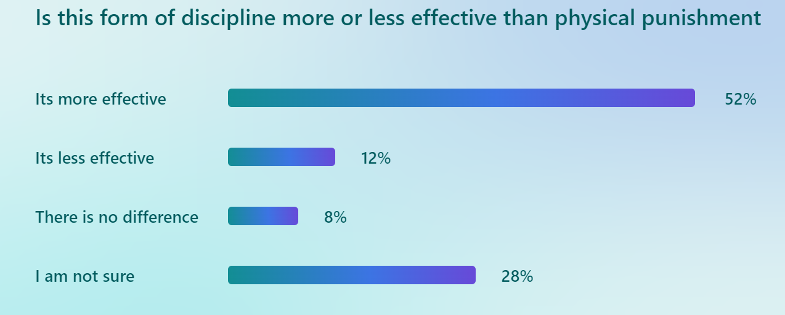

Figure 12 represents the question; would you fear being prosecuted for using reasonable physical punishment on a child? The graph shows that 50% of respondents would fear being prosecuted, 24% wouldn’t and the remained is unsure.

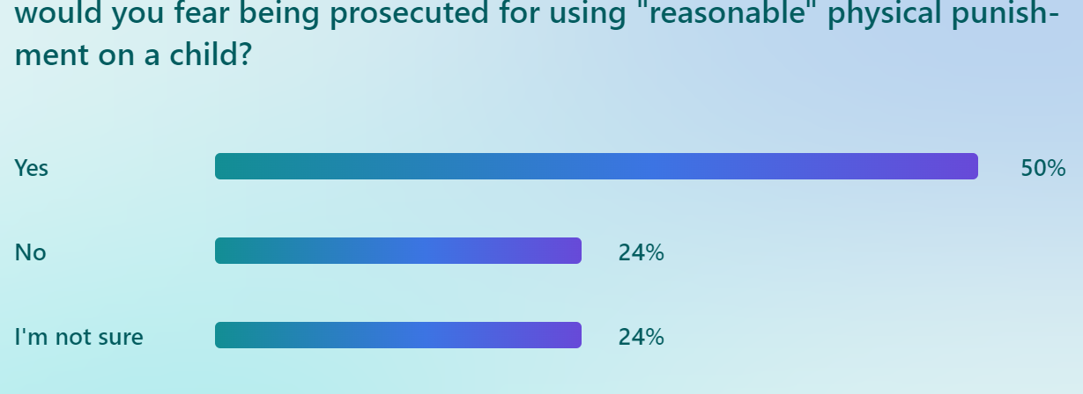

Figure 13 represents the question; Do you think the ban on reasonable physical punishment protects children? The graph shows that 65% of respondents believes it does, only 9% of respondents think it doesn’t protect them.

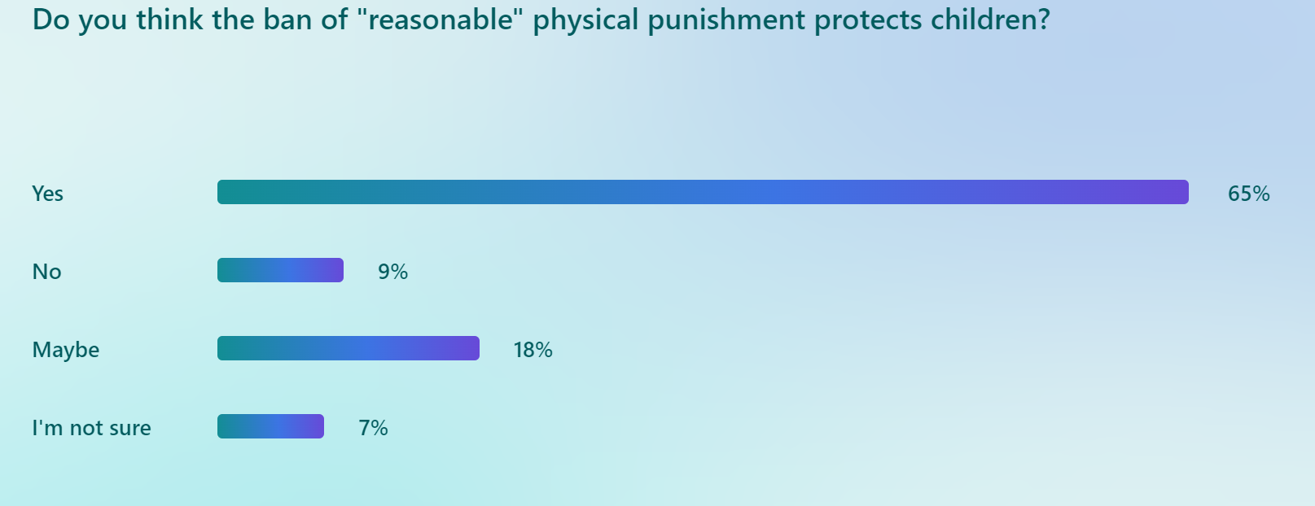

Areas of improvement

Figure 14 represents the question; Do you think the current law in Wales on physical punishment is fit for purpose? The graph shows that only 36% of respondents believes it is, and 23% believing it is not, the remained are uncertain.

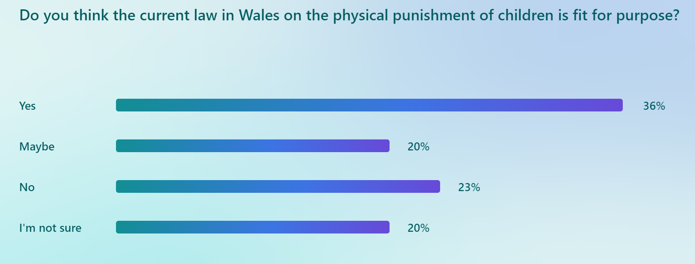

Figure 15 shows the results of an open text question “How do you think it could be improved?”, the results of which have been grouped into categories and show in the below graph. Out of the 55 total respondents, only 35 answered this question. 10 respondents believed that more education was needed, and 8 respondents stating that physical punishment should be allowed, at very low levels and these levels need to be better defined under law. Only 2 respondents believed harsher punishments are needed, and the remained opted for a multi-agency approach, or was unsure of the question

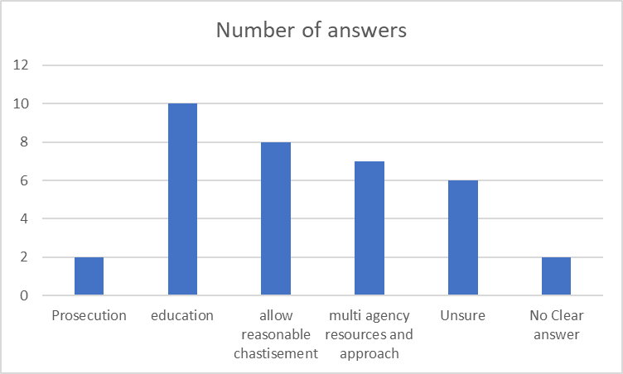

Figure 16 represents the question; Do you think adults who still physically punish their child should face prosecution or repercussion in any form? The graph shows that 41% answered yes, 36% believes they should but only in extreme cases, and 18% believe people should be educated and not punished.

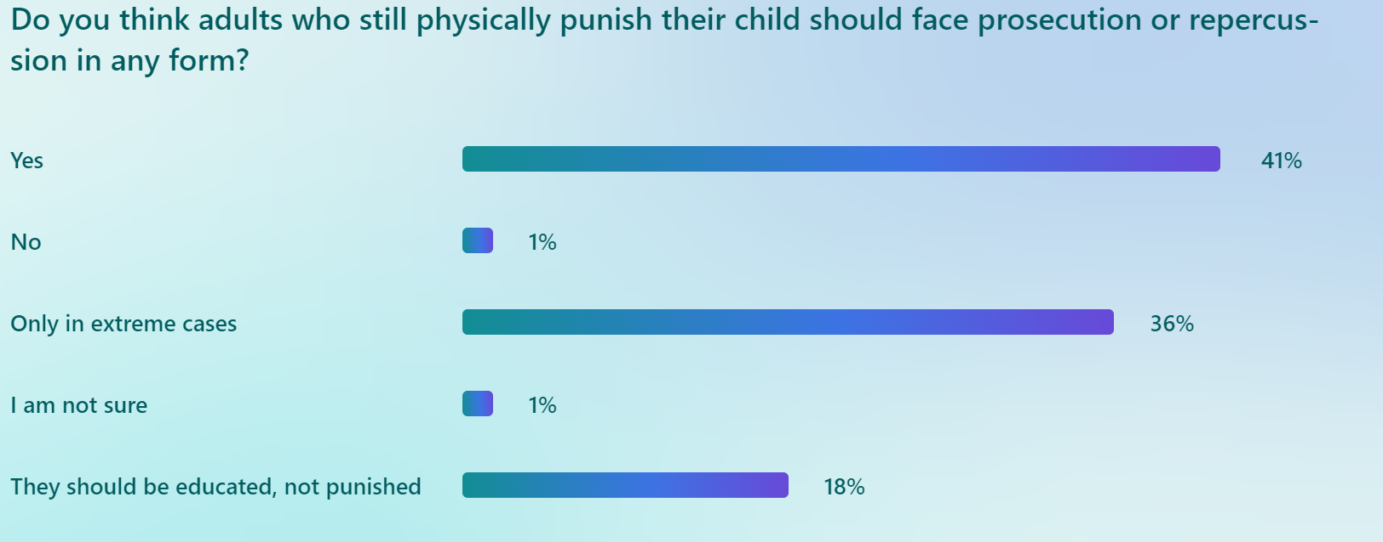

Figure 17 shows the results of how much the respondents agreed or disagreed with the following statement: “The ban on physically punishment of children only punishes parents who are trying to reasonably discipline their child and does nothing to stop more extreme punishment such as abuse and neglect". The graph shows that 54% of respondents agree with this statement in some manner, with 14% having no opinion.
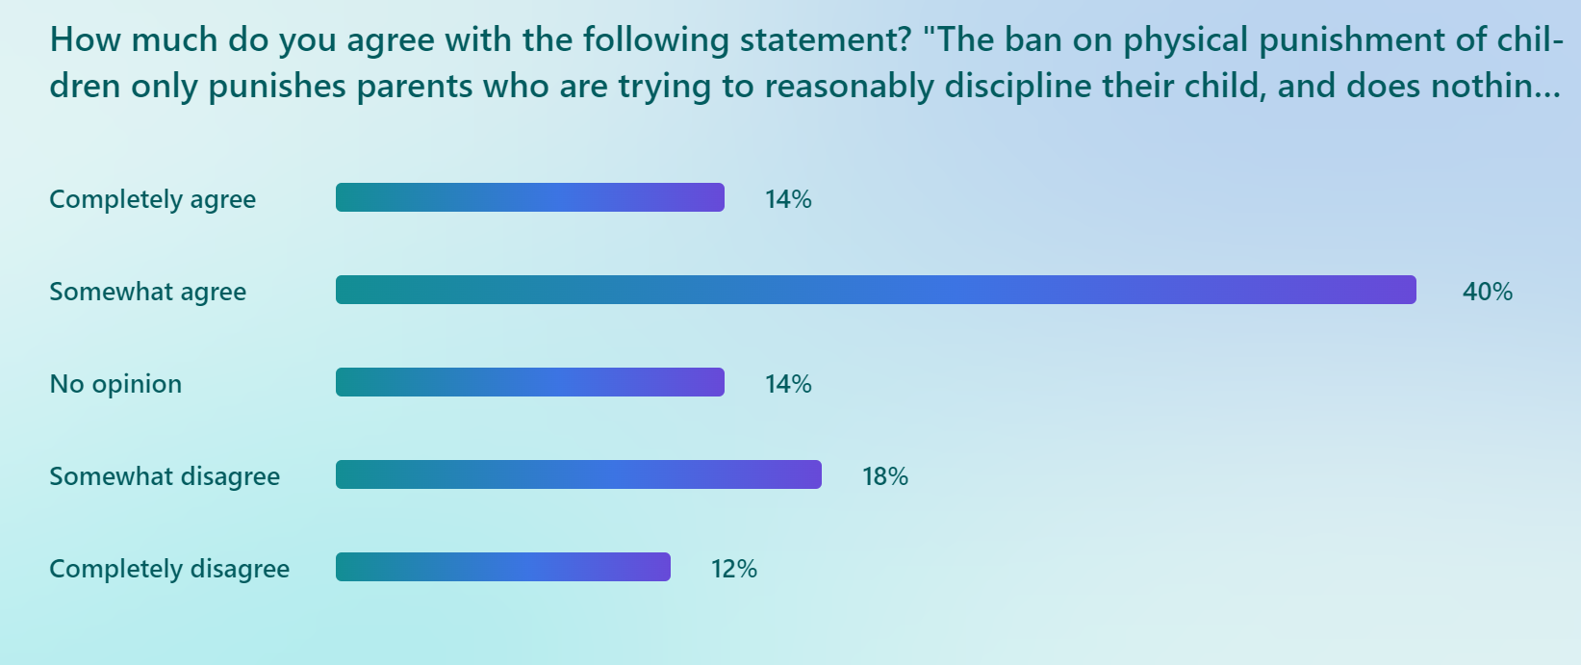

Conclusion

The chapter has presented the findings of primary research from 55 surveys completed by members of the public, primarily of which are parents. The survey responses were analysed using text analysis techniques and were reviewed against the research objectives. The next chapter will discuss the results and use them to draw conclusions.

