

EXAMINATION PAPER
MARKS AND COMMENTS SHEET

PROGRAMME | OME Degree Apprenticeship
LEVEL | 4
MODULE | ACDB4011 Chemistry
STUDENT I.D. | 2413011
EXAMINER | Ewa Kazimierska | INTERNAL VERIFIER
Once completed marks only should be transferred onto the front of the examination paper (no comments other than ticks or crosses on the examination paper)

Question  Number | Comments | Marks available | Marks awarded | 2nd marker (sample) | 3rd marker (where necessary)
1 | Strong performance on True/False with only one error. Shows good understanding of basic concepts across reactions, bonding, and forces. | 15 | 13.5
2 | Bohr model shown but lacked detail on particles. Incorrect ionic charge, and misunderstanding in bond comparison question | 11 | 1.5
3 | Misuse of equations for photon energy and electron configuration. Explanation of emission lacked key concepts. | 10 | 0
4 | No attempt made | 15 | 0
5 | No attempt made | 16 | 0
6 | No attempt made | 7 | 0
7 | No attempt for heating curve or phase transitions, but correctly answered bond-related and application questions. | 11 | 6
8 | No attempt made. | 5 | 0
9 | No attempt made. | 5 | 0
10 | Oxidation numbers not identified correctly. Redox roles also not answered. | 5 | 0
 |  |  | 21

1st Marker Name | Ewa Kazimierska | 1st Marker Signature | 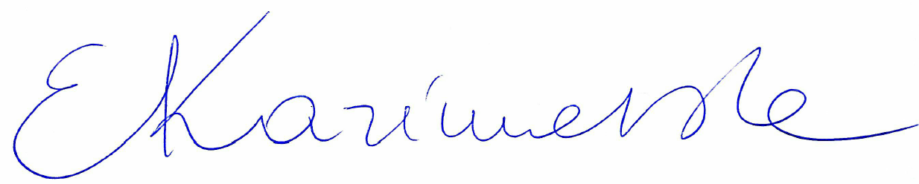
2nd Marker Name |  | 2nd Marker Signature
3rd Marker Name |  | 3rd Marker Signature
Reasons for awarding the final mark where there is more than one marker
Notes:
- The 3rd marker may be used where there is more than a 10 percentage point difference (in the TOTAL mark) between markers 1 and 2 OR when it is not possible to get agreement between markers 1 and 2. Reasons must be given where an agreed mark is given.
- This form is for internal use only and is NOT to be returned to the student. The final agreed marks must be transferred to the student feedback sheet in the assignment specification.
- The external examiner MUST be shown this form.

