Benjamin John (1707698)
Chapter 3 – Research Design and Methodology (Draft) (Word Count – 1845)
3.1 Chapter Introduction
The previous chapter has discussed and analysed the available literature that was made available to the researcher to understand the different factors that impact customer loyalties towards a supermarket. This chapter of the dissertation is going to be analysing the research design and methodology implemented by the researcher to complete the proposed research.
This chapter will discuss how the researcher structured the research for the dissertation by implementing the stages as set out in the ‘Research Onion’ model as developed by Saunders et.al, (2019). The chapter will analyse each stage of the model and will use a range of academic sources to explain the reasoning behind why each stage was chosen for the research for this particular dissertation. Finally, the chapter will also be discussing the different limitations faced by the researcher as well as the ethical considerations that needed to be taken into account to ensure the success of the research.
This chapter will achieve the second objective of this dissertation:
- To undertake primary research through the use of a survey aimed towards those who possess a Clubcard to better understand the extent in which the Clubcard plays a role in the loyalty of consumers when choosing a supermarket.
3.2 Research Onion
To ensure successful and meaningful research, a model developed by Saunders et.al (2019) called the ‘Research Onion’, outlines the six stages that are required to be used when conducting research. The model, when used within research ensures the development of a coherent and justifiable research design (Muranganwa, 2016). Similarly, Raithatha (2017) claims that the use of the model allows for the appropriate research methodology to be designed in a step by step process to ensure success in the research.
The six stages of the Research Onion as mentioned previously are, Philosophies, Approaches, Strategies, Choices, Time Horizons, and Techniques and Procedures (Saunders et.al 2019). Figure 3.1 indicates the pathway that the researcher followed to conduct the research for this dissertation.
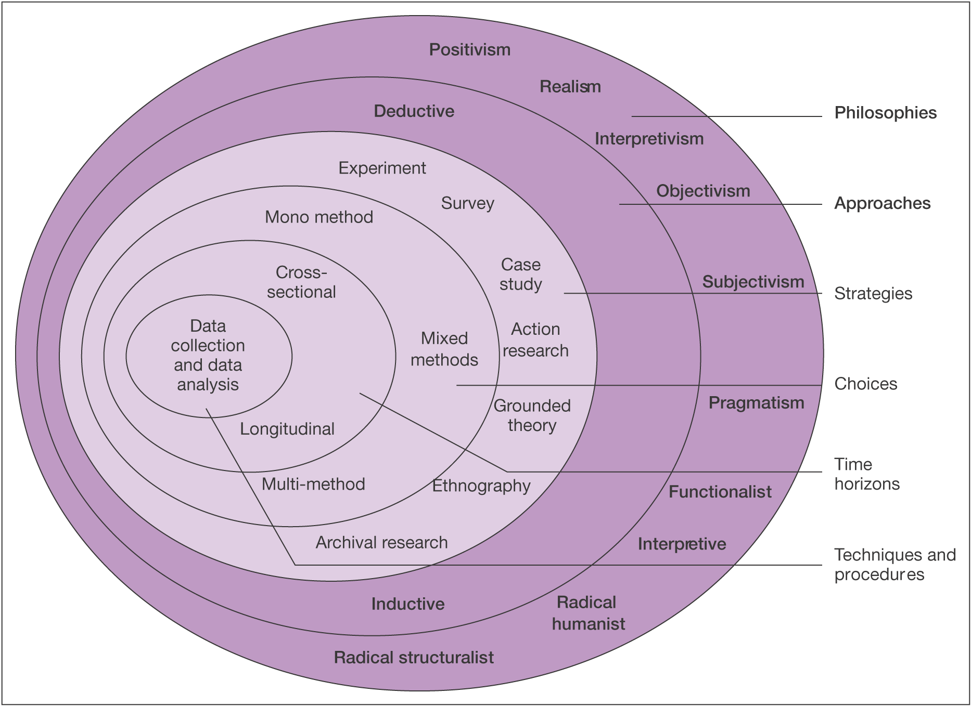

Figure 3.1 ‘Research Onion’ (Saunders et.al, 2019).
3.2.1 Research Philosophy
As seen in figure 3.1, the research philosophy is the outermost layer of the Research Onion. According to Saunders et.al (2009), the philosophy that is utilised by the researcher will underpin the research strategy and the methods used for the research. Figure 3.1 indicates that there are ten possible philosophies that can be utilised by the researcher when conducting research. The philosophical approach that this dissertation utilised was the positivism approach. According to Buchanan (2018), the positivism philosophy approach to research depends on the observations that lead to results from scientific analysis. Crowther and Lancaster (2008), state that as a general rule, the positivism philosophy adopts the deductive approach to research and therefore, the deductive approach was utilised within the research.

3.2.2 Research Approaches
As previously stated, the approach used for this research was the deductive approach. The deductive approach to research allows for theory to be applied to a hypothesis and allows for that theory to be tested against existing theory (Wilson, 2010). Saunders et.al (2019), argue that this approach to research is seen as a more scientific approach as it allows for theory to be rigorously tested. Using this approach alongside the positivism philosophical approach is the most appropriate for this particular research as the researcher established a hypothesis before conducting the research.

3.2.3 Research Strategies
The primary data collection method that was adopted within the research to ensure the successful completion of the aim and objectives of the dissertation was a questionnaire. A questionnaire is a data collection method that allows for the collection of primary data (Harland, 2020) and according to Patten (2017), the use of a questionnaire allows for the most efficient collection of such data. The questionnaire was created using Google Forms and posted on social media channels such as Facebook to allow for the researcher to gather a substantial data set that could be later used for statistical testing to aid the research. Using online surveys and social media platforms allows for the researcher to gather a larger range of responses in the most efficient and timely manner (Wright, 2017). As well as this, other benefits to both the researcher and the participants of the online questionnaires include the ease of reaching participants and the availably of the participant to remain anonymous at all times during their participation in the research (Ball, 2019). For these reasons, the use of a questionnaire was deemed the most appropriate to complete the research for this dissertation.
3.2.4 Research Choices
The research choice that was selected by the researcher was the mono method. The mono method approach was suitable for this research as the researcher was using only one data collection method along with only one corresponding data analysis method (Saunders et al. 2019). The researcher used a questionnaire in order to gather primary quantitative data. The quantitative data once collected was put into numerical form and was tested utilising quantitative data analysis techniques to enable the raw data collected to be turned into meaningful data to aid in the understanding of the research (BRM, 2021).

3.2.5 Time Horizons
The researcher had a limited time scale to complete the research, therefore, it was required that a cross-sectional time horizon was chosen. The use of the cross-sectional time horizon allows the researcher to collect data over one short period of time as appose to collecting data over a longer time scale (Sedgwick, 2014). As the data collection took place over a four-week period during March 2021, the cross-sectional time horizon was the most appropriate.
To ensure that all tasks which were required for the research were completed on time, the researcher created and used a Gantt Chart. Geraldi and Lechter (2012), found that the use of a Gantt Chart allows for the practical and efficient way to plan activities and their intended durations to aid within the strategic planning of any project. The Gantt Chart created and utilised by the researcher can be seen as Appendix D.
3.2.6 Techniques and Procedures
3.2.6.1 Data Collection
As previously mentioned, the researcher used the mono method approach to collect quantitative data for the research and the method chosen was surveys in the form of a questionnaire. Questionnaires are considered the main tool used for data collection within quantitative research (Lavrakas, 2011). Questionnaires allow for a standardised set of questions to be asked to participants in order to gather data for specific questions (ibid). Questionnaires allow the researcher to analyse and compare the responses that were provided in order to have a deeper understanding and to help in the research (Ghauri et.al., 2020; Nardi, 2018).

3.2.6.2 Questionnaire Design
Kotler et.al (2020), mention that the use of questionnaires in research provides great flexibility and allows for the researcher to ask both open and closed-ended questions in order to gather a substantial and effective data set. According to Brace (2018), questionnaires are only an effective form of data collection if the questions asked to the participants are relevant as the responses from the participants are only as good as the questions that they are asked. To ensure that the questions asked in the questionnaire were relevant and effective in providing the researcher with information that would benefit the research, the questions were drafted after the analysis of the available literature which was discussed in chapter two. The questionnaire matrix that was produced by the researcher that shows each of the questionnaire questions and their link to the literature discussed in chapter 2 can be seen in figure 3.2 below.
INSERT QUESTIONNAIRE MATRIX HERE

3.2.6.3 Data Analysis
The researcher used statistical software in order to analyse the responses that were gathered from the participants of the questionnaire. As the majority of the questions asked to the participants utilised a Likert scale which enabled the researcher to easily convert answers into numbers, SPSS software which allows for advanced statistical analysis for quantitative data (IBM, 2020) was used to ensure the most significant findings were outlined.

3.3 Sample
The researcher used a non-probability sample also known as a convenience sample in order to collect a data set for the research. A convenience sample allowed the researcher to collect data from those who were most convenient and most easily accessible to the researcher for data collection (Etikan, 2016). As the data was collected using the most convenient participants available to the researcher via social media channels this was considered a convenience sample (Dudovskiy, 2016).

3.4 Reliability and Validity
Validity is a fundamental concept regarding the credibility of any research (Maxwell cited in Wyse et al. 2017). Validity has been defined as the extent to which the research accurately measures the concept in question (Heale and Twycross, 2015). Similarly, the reliability of the research is also a very important factor and can be measured based on whether or not the results would be the same in the research was conducted on repeated occasions (ibid). The use of a well-designed questionnaire and the assurance of anonymity which increase the likelihood of honest responses from those who participate in the research (Murdoch et al. 2014) ensure the validity and reliability of the study.

3.4.1 Pilot Study
Before research was conducted and before the questionnaire was distributed among the participants a pilot study was conducted. The pilot study conducted was essential to allow the researcher to understand the quality and efficiency of the research questions and to ensure that the data collected was of the highest quality (In, 2017). The pilot study allowed for the researcher to assess the feasibility of the research questions and adapt those which were needed, by asking a small group of participants before distributing the questionnaire to the larger participant group (Morin, 2013).

3.5 Ethical Considerations
Before the researcher began any data collection, ethical considerations for the research needed to be examined to ensure that all participants as well as the researcher were protected at all times throughout the entirety of the research. The ethical considerations ensure that all research participants are protected against any potential risks that could arise as a result of their participation as well as ensuring that each participant has given full consent to be included in the research (Bryman and Bell, 2007). The researcher ensured the anonymity of participants and ensured that the data collected was stored in a safe and secure location at all times to eliminate any potential risk of data misuse.
The research was conducted upon an ethical assessment being approved by the ethics committee at UWTSD. A complete ethical assessment can be seen as Appendix E.

3.6 Chapter Summary
In summary, this chapter has identified and outlined the research design and methodology that was utilised to ensure successful data collection within this dissertation. The chapter discussed and analysed the different layers of the research onion developed by Saunders et al. (2019) and how each layer was utilised within this research. This chapter has also identified the ethical considerations and limitations that needed to be considered during the research process.
Chapter four will analyse the primary data that was collected from participants of the questionnaire using IBMs SPSS software package.

References
Ball, H., (2019). Conducting Online Surveys. Journal of Human Location, 35(3), pp.413-417.
Brace, I., (2018). Questionnaire Design. 4th ed. Kogan Page, pp.1-6.
BRM., (2021). Quantitative Data Analysis. [online] Available at:< https://research-methodology.net/research-methods/data-analysis/quantitative-data-analysis/> [Accessed 11 February 2021].
Bryman, A. and Bell, E., (2007). Business Research Methods. 2nd ed. Oxford University Press
Buchanan, I., (2018). A Dictionary of Critical Theory. 2nd ed. Oxford University Press.
Crowther, D. and Lancaster, G., (2008). Research Methods: A Concise Introduction to Research in Management and Business Consultancy. 2nd ed. Butterworth-Heinemann.
Dudovskiy, J., (2016). The Ultimate Guide to Writing a Dissertation in Business Studies: A Step-By-Step Assistance. 1st ed. Research-Methodolgy.net.
Etikan, I., (2016). Comparison of Convenience Sampling and Purposive Sampling. American Journal of Theoretical and Applied Statistics, 5(1).
Geraldi, J. and Lechter, T., (2012). Gantt Charts Revisited. International Journal of Managing Projects in Business, 5(4), pp.578-594.
Ghauri, P., Gronhaug, K. and Strange, R., (2020). Research Methods in Business Studies. 5th ed. Cambridge. Cambridge University Press.
Harland, B., (2020). How to Do a Quantitative Research Questionnaire. [online] Available at: https://sciencing.com/how-to-do-a-quantitative-research-questionnaire-12748929.html [Accessed 11 February 2021].
Heale, R. and Twycross, A., (2015). Validity and Reliability in Quantitative Research. Evidence-Based Nursing. 18(3). pp.66-68.
IBM, (2020). IBM SPSS Software. [online] Available at: <https://www.ibm.com/analytics/spss-statistics-software> [Accessed 22 February 2021].
In, J., (2017). Introduction of Pilot Study. Korean Journal of Anesthesiology. [online] 70(6), pp.601-605. DOI: 10.4097/kjae.2017.70.6.601 [Accessed 23 February 2021].
Kotler, P., Armstrong, G., Harris, L. and He, H., (2020). Principles of Marketing. 8th ed. Pearson, pp.116-124.
Lavrakas, P., (2011). Questionnaire. Encyclopedia of Survey Research Methods. Sage. DOI: https://dx.doi.org/10.4135/9781412963947.n424 [Accessed 13 February 2021].
Morin, K., (2013). Value of Pilot Study. Journal of Nursing Education. [online] 52(10), pp.547-548. DOI: https://doi.org/10.3928/01484834-20130920-10 [Accessed 23 February 2021].
Muranganwa, R., (2016). Design and Implementation of a Multi Agent Opportunistic Grid Computing Platform. University of Fort Hare.
Murdoch, M., Simon, A., Polusny, M., Bangerter, A., Grill, J., Noorbaloochi, S. and Partin, M. (2014). Impact of Different Privacy Conditions and Incentives on Survey Response Rate, Participant Representativeness, and Disclosure of Sensitive Information: A Randomised Controlled Trial. BMC Medical Research Methodology. 14(90). DOI: 10.1186/1471-2288-14-90.
Nardi, P., (2018). Doing Survey Research: A Guide to Quantitative Methods. 4th ed. New York. Routledge.
Patten, M., (2017). Research: A Practical Guide. 4th ed. New York: Routledge
Raithatha, Y., (2017). Understanding the Economic Impact Terrorism has on the Destination Decision Making: Northern Irish Tourists. Dublin Business School.
Saunders, M., Lewis, P. and Thornhill, A. (2019). Research Methods for Business Students. 8th ed. London: Pearson Education.
Saunders, M., Lewis, P. and Thornhill, A., (2009). Research Methods for Business Students. 5th ed. Harlow: Pearson Education, pp.100-125.
Sedgwick, P., (2014). Cross Sectional Studies: Advantages and Disadvantages. BMJ. [online] pp. g2276. Available at: https://www.researchgate.net/publication/275427950_Cross_sectional_studies_advantages_and_disadvantages [Accessed 12 February 2021].
Wilson, J., (2010). Essentials of Business Research: A Guide to Doing Your Research. Sage Publications, p.12.
Wright, K. (2017). Researching Internet-Based Populations: Advantages and Disadvantages of Online Survey Research, Online Questionnaire Authoring Software Packages, and Web Survey Services. Journal of Computer-Medicated Communication. [online] 10(3). Available at: https://academic.oup.com/jcmc/article/10/3/JCMC1034/4614509 [Accessed 11 February 2021].
Wyse, D., Selwyn, N., Smith, E., and Suter, L., (2017). The BERA/SAGE Handbook of Educational Research. 1st ed. BERA/SAGE.

