INTRODUCING THE MODERN WORKPLACE
ORGANISATION BEHAVOIR
- Assessment 2 -

Students:
George TIVGA (2024060)
Velichka PETROVA (2022689)
Mariana COCOS (2024061)
Anna BUONOCORE (2022563)
Plamen PELOV (2024898)
MODULE: LCBB4003
Module coordinator: NADEEM MIRZA
George TIVGA (2024060)

For framing the reflection on the knowledge acquired through the Introduction to Modern Workplace module, I will use Schön's method, 1983 - reflection before, during and after a learning process - because it helps me to evaluate the level of assimilation.
Before we started the module I thought that there will be some things that I will understand less and probably I will not be able to implement the principles that I will learn fast enough. The challenges I set myself was to understand what I will learn by going through the lessons and identify the key principles that the new knowledge encompasses. To be well prepared for these experiences, I decided to force myself to reach three progressive levels of awareness of the information to be reached at equal intervals and to create a self-verification procedure. I decided to calculate the option in which we fail to complete our work and assess the risks.
During the classes, the teacher informed us that we need to present the structure of a UK retail company and to write this reflective report as a team with four colleagues. To be able to communicate quickly, our class has a WhatsApp group where we exchange information between us. Because two groups had already been formed, I decided to take the initiative and form a group to include colleagues who feel they want to collaborate. The decision was quick and I feel that it was a good one because I visualized the goal, that of forming a multi-cultural team with different visions. The choice of the company was common, with everyone agreeing - we decided to talk about the Sainsbury's chain of stores.
Because the group needed a team leader, my colleagues and I were advised who to choose. Through a democratic system, my colleagues chose me to represent them. Teamwork is a complex process and I decided to apply what I learned in class. Although I am not completely satisfied with the result obtained, I consider it a first step towards the development of my managerial spirit and I can say that the result of our collective effort is a promising one.
Using my knowledge of leadership, I decided to influence the team's outcome. While writing my paper, I asked my colleagues to send me their parts a week before the deadline because I wanted to give them feedback on what they were working on. This planning process is part of the management culture, the process being a reflection of the function. They were late to send me the works for a few days, but I was expecting this because human nature intends to leave things to the last minute.
I think I'm dealing with challenges well because I plan what will happen and I manage to control what happens under my leadership. For a good performance of the team, I kept everyone informed about the progress made by each member and gave them feedback on what they had prepared. Also, for the presentation we coordinated our movements so that the speech has fluency.
I consider that within the team a psychological contract has been formed through which we depend on each other and we do everything we can to influence for good the common final result. Because our group is multicultural, I used The Lewis Model to provide feedback to colleagues, changing according to each person's emotional nature. From this experience I learned that team members should be treated differently depending on each person's internal emotional needs.
After I finished making the presentation and later this report, I made a self-assessment of my behavior in the team and I understood using already validated methods I will get the desired result from the others. I also understood that sometimes it is enough to just give a boost or not to intervene for the team to perform. I believe that each member of the team has formed a satisfaction because we managed to complete the tasks.
Looking back, I believe that things went well and that each member put their knowledge to work to achieve the goal. I also noticed that there were exchanges of information between colleagues for a good understanding of the tasks within the team. I believe that a team in which there is communication can have an increased performance and the work can become easier because everyone understands what must do.
Analyzing the team's behavior during the process, before we started I would have done a questionnaire to understand the knowledge of each colleague. Depending on the results, I would have distributed them to make their work easier. On the other hand, for increase their knowledge, I would have assigned them tasks that they understood less.
From this experience I understood that teamwork is a complex process that can have different results depending on the behavior of each. Without knowing the behavior of each member, it is more difficult to understand what the final result of his work will look like. I believe that the behavior of each member can be positively or negatively influenced by the other members and the team leader. I also deduced that a team without a leader will not have good results. I believe that a team with a well-defined structure and a developed culture will be able to perform tasks quickly and well. The team leader or his superior has the mission to define the structure and culture of the team.
In conclusion I deduced is that the team leader represents the team and is the role model. I can say that he is the ambassador of team values. Managerial work has a direct influence on team performance. The quality of a team's structure and culture overlaps with its performance. The manager and team leader must identify the needs and resources of the team, plan and make decisions.

Velichka PETROVA (2022689)

In my Power Point presentation, which is a part of our group project, I explored and described the relationship between organizational structure and the performance of Sainsbury’s. I have been a freelance artist for many years, I do not work for an organization and I have no experience of working in a team. I will try to explain our joint work on the case with the trade company Sainsbury’s and my conclusions about myself. I will try to analyze the process through the knowledge from the lectures we went through in this module. In my opinion, building a team and working in it is the most important condition for successful business management.
We were tasked with making a group presentation to a strategic department based on a case study. I and four other colleagues had to work together on a joint presentation that met well with the expectations that modern approaches to organizational behavior and the scope of application in Sainsbury’s organization should bring. In the first stage we received instructions from the teacher to understand the task. In the second stage we had to choose a leader to set the tasks and adjust the implementation. We were all unanimous in choosing a leader. Although we had a leader, decision-making was decentralized. I think the type of organization that came spontaneously was a flat organization because we had very easy communication and we made decisions quickly. As a team we helped each other to achieve the goal. This type of structure is convenient when a business needs to change or adapt to new unforeseen circumstances. In my opinion, this structure is suitable for smaller organizations and businesses. At the beginning of the process when the roles had to be assigned, all colleagues naturally supported the decision-making process and directing it according to their personal qualities. As a team we successfully achieved the goal. Our presentation was very clear and without unnecessary information.
My strengths are taking leadership and allocating tasks if there are times which everyone feels ambiguity. My contribution was to give more clarity to the task and to get involved in those times when the team needed to obtain responsibilities to each one individually.
I think it is much easier to work in a team than alone, because of the distribution of responsibilities and the burden. I felt confident to distribute tasks and make quick decisions, because I am used to working alone and be responsible for the quality and exact timing of my work. Our team had excellent communication, trust and information sharing for more clarity on the assigned case. We agreed on the topics that each member will develop and present. It was very difficult to find enough information about the structure and culture of Sainsbury’s, but with the help of colleagues this problem was overcome.
The positive aspect of the task is that I have been starting to build the necessary qualities for teamwork. I have significantly improved my attitude to teamwork and I think that in the future I will have confidence in the processes that are happening and the difficulties that are being overcome. I increased my confidence that I can lead a team and assign tasks. I learned to accept the feedback about my work as something positive, not as a critique, and to share my personal point of view without worry.
I developed my skills for researching theories, analyzing them and their practical application. In addition, I think that being aware of your own strengths and weaknesses will help to be effective and avoid bad practices. Teamwork is a process by exploring and understanding oneself, one's values ​​and beliefs. What I didn't like was our presentation skills. We all need more practice and confidence to present results. I think this could be achieved with more practice and more teamwork. Confidence can be achieved by giving positive feedback and encouragement, not by sharp criticism.
What I found through research on the relationship between the type of organization and the performance of Sainsbury’s could be applied to our presentation. Our organization was adaptable and flexible and we motivated each other by encouraging and sharing information. Our team did not have a sense of competition and proving qualities, as well as duplication of functions. We had aim-oriented behavior and achieving tactical goals for the week and pursuing a strategic goal. All contributed to the planning, distribution of roles and achieving the common goal. Our team had very good coordination, cooperation and lack of any conflicts. Now I understand better the role that strategic management has along with the qualities needed by the manager for efficiency and success of the company. I think that each person has natural inclinations and qualities that are good to use in teamwork. And if a person does not want to be a leader, he should not be forced to lead a team and assign tasks. Each team should benefit from the natural qualities of its members. But the leader must be aware of the task in details and must be able to gives positive feedback to each member.
In conclusion, I learned how important are the team spirit and effective timely communication to achieve a common goal. I learned the pros and cons of each type of organization and how to recognize them in practice. From this experience I will use the acceptance of positive feedback and listening to different opinions on a problem for my future projects. Close cooperation and participation in the decision-making process will also be very useful to me. I learned to do research by searching in different sources - books, magazines, articles, websites, to analyze information, to systematize it and to draw conclusions. On the other hand, I hope to be able to use theories and models for different types of organizations, what are their pros and cons and how they can be improved in practice. Nothing is static in reality, everything changes under the pressure of political events and businesses must be able to quickly analyze changes and take advantage of them, making a profit and at the same time making people's lives easier. The structure of companies is key to their implementation, as well as the distribution of roles in the organization and responsibilities.

Mariana COCOS (2024061)

The main aim of this report is to reflect on project activity conducted in a team. The main tool used for the analysis is the Gibbs reflective circle. It includes the following stages: the description of activity, the feelings related to it, the evaluation of the experience, the analysis of strengths and weaknesses, conclusion and further action that could be taken to improve the skills and knowledge. (Gibbs, 1988).
I was tasked to give a group presentation of strategic department based on case study. Me and other four colleagues had to work to work together on a presentation that well meet the expectations which were to bring contemporary approaches of organisational behaviour and scope of application in Sainsbury organisation. As a team we have collaborated closely to achieve the objectives. Based on Tuckman theory a team goes through five stages which are forming, storming, norming, performing and adjourning. (Jones,2019). Our team went through the same process. In the forming stage we have received guidance from our teacher and the process of working wasn’t very clear in the beginning.
After having a better understanding of the team goal, we couldn’t decide on who will lead the team and how to distribute the tasks. We all have contributed by mentioning skills such as strategic thinking, planning, and delivering, people management, excellent communication skills. Two candidates met the criteria and accepted the responsibilities however, we have voted and choose one team leader. In the next stage the team leader proposed Belbin’s team roles to assess strengths and weaknesses of the team. Based on Belbin’s theory their action-oriented roles, people-oriented roles, and cerebral roles. (Aritzeta, 2007) I had people-oriented role as a resource investigator. My main strengths were communication skills, ability to analytically analyse potential opportunities, research resources and develop contacts. We have reached an agreement on topics each member will present. My contribution to the team was to research and present about tasks and skills a strategic manager can apply to ensure operational effectiveness in Sainsbury. As a team we have successfully achieved the goal. In the adjourning stage we felt good about task competition and overall performance of our team.
In the beginning, I felt as a stranger and less confident in speaking my mind. Also, I had doubts regarding the role I have in the team. However, after receiving guidance from our teacher and conducting discussions with team member I felt a good team spirit, effective leadership. Also, I felt I had power in decision making process and it boosted my interest in working towards our common goal. I felt mutual trust which is a good sign of a high performing team, it somehow encouraged me to work even harder towards our objectives. I didn’t know much about Sainsbury’s organisation so I had no clue where I can start my research. However, the brainstorming activity conducted with team member made me feel more confident as we shared expertise and good ideas with each other. Besides that, previous topics covered in the Introducing the Modern Workplace Module boosted my understanding and I felt that I have the right skills to achieve this goal.
The positive aspect of the experience is that I have gained teamwork skills. I have developed my confidence in participating in a group, sharing my ideas, and participating in decisions making process which I think is very important. Moreover, I have improved my research skills by consulting various sources and comparing various points of view. As can be seen from my presentation slides (Appendix – Image 6 and Image 7) I have identified management roles and strategic management functions that helped identify the key tasks and skills required by Sainsbury’s strategic manager. Also, I have provided an explanation of each element and how this contribute to effective operations in Sainsbury organisation. On the other hand, I could have spent more time on improving my presentation skills to make more attractive.
Based on my experience working in a team I have improved my transferable skills such as problem solving, teamwork, delivering presentation, communication skills. While working on this project I have studied (Caramela, 2018). This helped me to have a better understanding of the requirements and to deliver a presentation supported by reliable sources. These skills not only can be applied during my studies, but I can use them at my current workplace as well. In addition to that I have improved my team attitude. I have applied into practice the knowledge learned. For example, now I have a better understanding of a role strategic management has along with qualities required by the manager for effective operations and company success.
In conclusion I have learnt, the importance of a teamwork, the power of effective communication when achieving a common goal. In addition to that, I have learnt to apply theoretical knowledge related to roles management and skills into practice by evaluating a specific organisation.
From my experience there are good practices that I will use in my future projects and activities such as close collaboration with team members, participating in decision making process and use various viable sources for research such as books, articles, websites etc. In addition to that I will make use of models and theories to evidence the data. On the other hand, the negative practices have been used but should be avoided in the future are failing to use the time accordingly and poor communication with colleagues. Some good practices that should have been used for a more effective result and I will use in future projects include usage of technology in communication, provide constructive feedback on performance by measuring the effectiveness. In addition to that, I think that being self-aware of strengths and weaknesses will help to improve performance and avoid poor practices.

Anna BUONOCORE (2022563)

Strong leadership is vital to encourage employees to attain personal and company goals and influence company progression. It is important for business organisations to have a successful leader and manager.
Leadership is not confined to the top of the hierarchy in companies, but rather something that is also required at lower levels. When leadership is well applied it can boost morale amongst lower ranks.
Leadership is required, as it brings order and structure. With good leadership employees have a sound understanding of their duties and responsibilities. Thus, helping the company itself fulfil its own goals. ( Kotterman, J., 2006)
There are four possible leadership styles that are found in any organisation around the world:
- Democratic
- Autocratic
- Bureaucratic
- Laissez-faire
Democratic, transformational, bureaucratic and autocratic leaderships have a positive impact on organizational performance, however, charismatic and transactional leaderships have a negative impact on organizational performance, as they do not provide employees with opportunities and freedom.
In this Reflective paper, there is a brief description of personal development which I have gained through my work experience.
According to my understanding, having strong leadership in an organisation is important. A good leader must possess the skills and knowledge that will aid employees and the company in attaining their goals which will improve the company’s success.
From this course I have learnt that we each have different ways of handling work which determine the leadership style we are best equipped to utilise.
I had my first introduction to the world of leadership during my years working in Yamamay. Yamamay is an Italian brand, that started 15 years ago, it focuses primarily on the sale of lingerie and under garments. Finding a company that values young people is difficult however Yamamay gave me the opportunity to enter the world of work at a young age. When I started working for the company, I was assigned the role of sales assistant support, at the beginning I felt anxious as everything was new to me such as the different levels in the chain of command in the shop and company however I was enthusiastic and eager to learn new things. From the moment I accepted the job I knew I would learn various new things.
After growing in confidence, I started to look for a different position in the same company to expand my knowledge. After 4 years of working through different positions I finally became a key decision maker and leader in the store.
There are two things I have learnt from my experience over the years, on the one hand positive things, the fundamental power of a good leader and leadership style in the company, on the other hand the loss that the company gets if the leader are not well qualified.
I used my time working in various positions to evaluate every leader in the company, their approaches and techniques and the outcome their leadership style had on the employees and the company. When I became a leader, I was excited to finally be able to have my say but I was also scared of the responsibility the position came with.
I spent many days researching different leadership styles in order to find a style that enabled me to cover the position successfully. I also took some time off before beginning my role as a leader to ensure I was fully prepared. During that time, I was inspired by great leaders such as Steve Jobs who had an autocratic style, his skills made Apple a distinct and successful business. (Dudovskiy, 2019)
From my time at Yamamay I felt that no leader used an effective leadership style such as the four principal techniques.
From my research I decided to utilise an autocratic leadership style, “Do as I say”, this approach is typical of the leadership styles of the past, however it is does not hold much weight in today companies (Iqbal, 2015)
I knew that this style would not suit my working methods for an extended period, but it was necessary to show other employees that I was present and was in control. This style portrayed that I had my own ideas and would enforce them. After a few months, my responsibility grew and I was managing two shops. I decided to change my leadership style to democratic. I decided to involve the staff in decision making and arranged a meeting to provide them with a platform for their ideas. Previous leaders had used different motivational strategies such as increasing salaries, however during my time as an assistant I realised that the employees needed a space for their ideas instead of more money to improve their performance.
The outcome of my leadership style and motivation theory was an increase in sales over a one year period and no staff members quitting. If I had the option to go back, I would accept the job again and the great responsibility it brought, I grew a lot during the experience in terms of personal knowledge and team development.
However, I would make some changes to my techniques such as seeking support from someone qualified or enrolling on courses that would prepare me for the role so that I could make beneficial decisions in difficult times.
At the end of my experience, I realised that the skills and knowledge I had learnt on my own were not enough for a career in a big company, so I chose this course to help me develop skills that will benefit me in the future.
Most companies around the world utilise one consistent leadership style or they develop their own methods after years of experience that would suit their requirements and employee needs such as Sainsburys who aim to have their own style by 2024.
In order to adapt to business changes and to operate successfully at an organizational level, a company should have a good leader, because they could make the difference in the company’s success. I think that in this dynamic business world continual learning fosters development and inculcates various skills required for a successful career.
I believe that I born with leadership skills and this course, my past experience and the future will help me to be a brilliant leader.

Plamen PELOV (2024898)

Sainsbury’s is one of the leading merchandise sellers in the UK. The organisation operates through three segments property investment, retail and financial sector. The property investment offers numerous commodities, including loans, savings insurances, and credit cards. In addition, the group owns Sainsbury bank that offers financial services. At the same time, the retail section is engaging in running supermarkets (About Sainsbury, 2021). The company’s headquarters are located in London, UK.
The organisational structure is a vital component in a firm and is concerned with issues such as communication and managing employees. The organisational structure serves as a guide to the workers by outlining the official relationship that government the workflow in the business (Rydzak and Monus, 2018). Without an organisational structure, it might be unclear on the final responsibility and whom to officially report to. In addition, a thoroughly outlined organisational structure offers a roadmap for promotion allowing the institution to create a track of entry-level workers.
Sainsbury has a formal and hierarchical organisational structure. The company has different levels of authority that connect multiple management levels within the firm. The decision-making process in the institution is formal and flows across the departments or from top to bottom. The hierarchical organisation structure is critical for Sainsbury Company because it offers a clear line of reporting and authority within the business. The employees at each level have an opportunity to develop, gain extra skills and remain loyal to the institution. Sainsbury’s organisational structure creates uniformity throughout the businesses because of central administrative control, which ensures the performance of various activities. The standardised methods and procedures help to considerably reduce office expenses.
The managers in Sainsbury company require both interpersonal, conceptual, and technical skills to be effective. Interpersonal skills can enable managers to relate, work and interact with people within the company. Interpersonal skills let managers motivate employees for greater accomplishment. Interpersonal skills are critical for managers in all the departments within the business.
The conceptual skills entail the tactics leaders portray in the form of ability and knowledge for formulating an idea and abstract thinking. The managers can diagnose, analyse or see the entire issue affecting the organisation and find a better solution. The conceptual skills allow the management to predict problems before they affect the company.
The technical skills allow leaders to use numerous procedures to attain a certain outcome. The skills involve not only operating software and machine but also the skills needed to boost sales and market the services and commodities. Technical skills are not only related to manufacturing tools or machines. They are also the skills desired for the organisation to market services and products, design different types of services and products, and raise sales.
Leaders should also have strategic thinking and actioning skills. Sainsbury must remain responsive and number to change. Strategic thinkers take a long and broad-range approach to decision-making and problem solving (Bonau, 2020). The leaders also make designs based on objective planning, thinking ahead, and analysis. The strategic thinkers identify the best route to get the outcomes that exceed the expectations of the individuals they serve. Leaders can achieve success in their apartments by setting a clear mission and vision.
Worker motivation is the level of commitment that staff hold on a daily basis when performing respective tasks (Schroeder and Liben, 2020). Motivation is a fundamental tool that ensures business success. Without motivation, workers experience reduced levels of output, productivity and they are unlikely to reach crucial goals.
What I learned from the lectures is that leaders can inspire employees to improve their performance by setting measurable and clear goals. Setting goals energise workers, and they offer a framework for offering assignments to different groups. Measurable and clear goals enable workers to motive their progress and performance and correct their efforts when needed. In addition, if the workers understand what is to be achieved, they can identify barriers that arise in future.
Leadership can promote work-life balance and flexibility. Providing a flexible remote and flexible workday inspires motivated spirit and productivity. In addition, the employees able to achieve a peaceable balance between life at work and home are more satisfied and engaged within their careers.
I think that compensation plays a fundamental role in employee satisfaction. An organisation can employ numerous compensation schemes, and some of them can be more valuable than paychecks. The flexible schedule, ample sick days, paid health care, and paid holidays are slightly more motivating than paychecks. The workers who feel they are fairly compensated are more likely to remain engaged.
Also, I think that the work environment plays a fundamental role in motivation. The office should prioritise personal space, natural light, low noise pollution, and interaction. The management should consider circulating a survey to identify the employee’s preference. The manager should loosen restrictions to allows employees to discover their motivation.
The group behaviour is influenced or affected by certain significant factors and variables. The major factors include group cohesiveness, the composition of the group, size, groups status, norms, roles, and formal leadership (Oroszi, 2020).
Group cohesiveness is the extent to which members are attracted to each other. Factors that can aid in enhancing group cohesiveness entail stimulating competition among members, increasing the status of the group, and making the team smaller.
The composition of the team impacts its behaviour. When the groups are heterogeneous in terms of knowledge, abilities, skills, opinions, personalities, educational background, race, gender, and age, it can be effective in completing various assignments.
The size of the group can influence its behaviour. The smaller groups are effective at completing tasks when compared to large groups. Therefore, small groups are effective at achieving productivity. On the other hand, groups status is the social position or rank given to the team (Sinambela, 2020). The status is vital for group members.
The group’s norms are the acceptable standards of behaviour that members of the team share. The norms exist in the company’s manual, and all members are supposed to follow the regulations and rules. The norms define how individuals within the group interact with each other. The group roles also influence behaviour. For example, the group’s roles are critical during conflicts when setting expectations and in identity.
Groups tend to have a structure, either formal or informal. The common titles of the leaders can be director, chairman, general manager, department manager, project leader, foreman, or superior. The leaders play a vital role in the team’s success.

References

About Sainsbury, 2021. [Online]
Available at: https://www.about.sainsburys.co.uk/
[Accessed 9/8/2021].

Bonau, S., 2020. Strategic leadership, commitment, and employee motivation: what influences attitudes towards the workplace. Köz-Gazdaság, 14(4), pp. 141-149.

Aritzeta, A., 2007. Belbin's Team Role Model: Development, Validity and Applications for Team Building. Journal of Management, 44(1), pp. 96-118.

Caramela, S., 2018. Mintzberg identified some basics of management. [Online]
Available at: business.com
[Accessed 6/08/2021].

Chapman, B. (2019) Sainsbury's to shut 125 stores but open even more as part of major overhaul [online] Independent
Available at: https://www.independent.co.uk/news/business/news/sainsburys-shut-store-closures-argos-convenience-overhaul-a9119861.html
[Accessed 15/08/2021].

Dudovskiy, J. (2019). Apple Leadership: a brief overview - Research-Methodology. [online] Research-Methodology.
Available at: https://research-methodology.net/apple-leadership-and-apple-organizational-structure/
[Accessed 9/8/2021].
Gibbs, G., 1988. Learning by Doing: A Guide to Teaching and Learning Methods.
United Kingdom: FEU.

Iqbal, N., Anwar, S. and Haider, N., 2015. Effect of leadership style on employee performance. Arabian Journal of Business and Management Review, 5(5), pp.1-6.

Jones, A., 2019. The Tuckman's model implimentation.
Journal of Management, 6(4), pp. 23-28.

Kotterman, J., 2006. Leadership versus management: What’s the difference.
The Journal for Quality and Participation, 29(2), pp.13-17.

Lewis, R. D. The Cultural Imperative: Global Trends in the 21st Century,
Nicholas Brealey (2007).

Oroszi, T., 2020. Group interaction and behavior in meetings: a new assessment tool to monitor group behavior. Creative Education, 11(04), pp. 596-604.

Rydzak, F. and Monus, P., 2018. Shaping organizational network structure to enable
sustainable transformation. System Dynamics Review, 34(1-2), 255-283.

Sainsbury’s.co.uk (2021) Results, Reports and Presentations [online]
Available at: https://www.about.sainsburys.co.uk/investors/results-reports-and-presentations
[Accessed 6/09/2021].

Schön, D. The reflective practitioner: how professionals think in action.
New York: Basic Books (1983).

Schroeder, K. and Liben, L., 2020. Felt pressure to conform to cultural gender roles: correlates and consequences. Sex Roles, 84(3-4), pp. 125-138.

Sinambela, S., 2020. The effect of workload on Job stress, work motivation, and employee
performance. International Journal of Psychosocial Rehabilitation, 24(04), pp. 1373-1390.

Stalker, K. ‘The Individual, the Organisation and the Psychological Contract’,
British Journal of Administrative Management, July/August 2000, pp. 28–34.

Sweney M. (2019) Sainsbury’s falls behind Asda to become UK's third biggest supermarket chain [online] The Guardian
Available at: https://www.theguardian.com/business/2019/apr/02/sainsburys-asda-uk-supermarket-aldi-lidl
[Accessed4/09/2021].

Appendix

Image 1
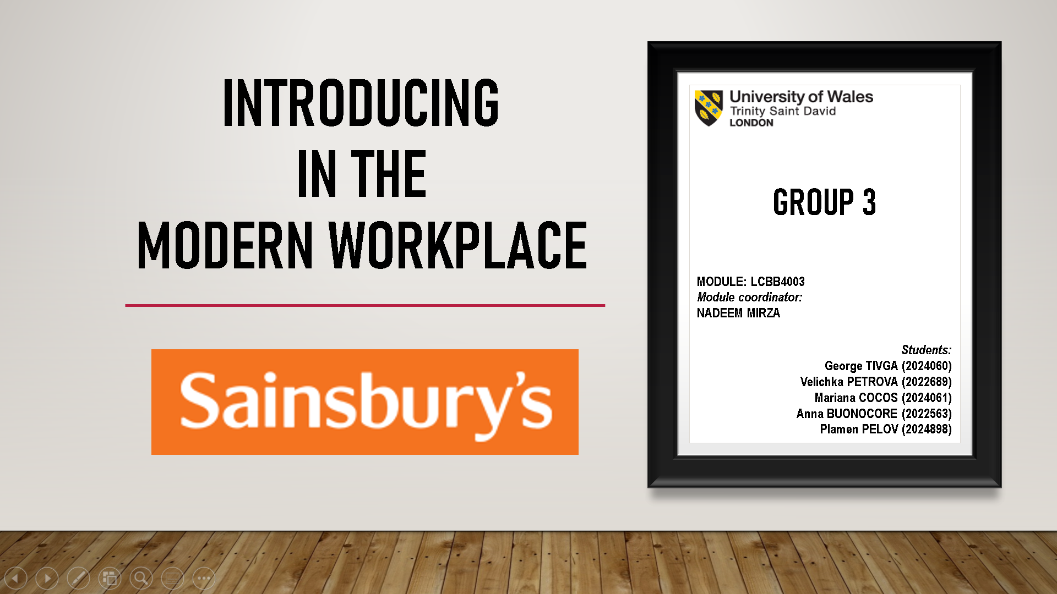

Image 2
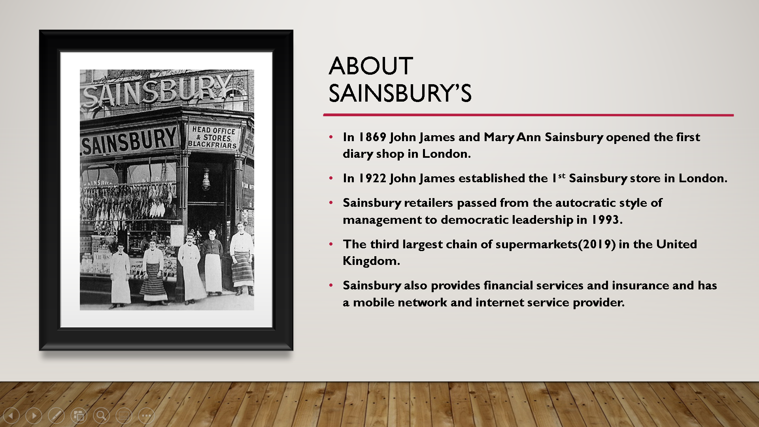

Image 3
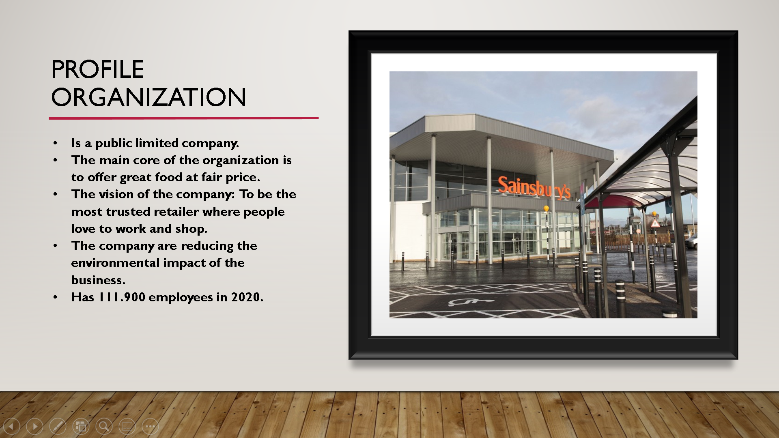

Image 4
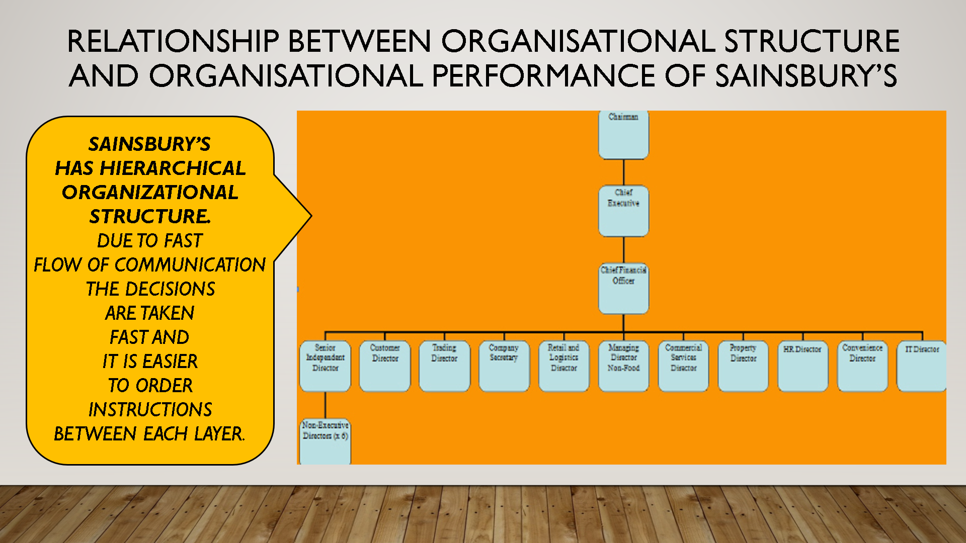

Image 5
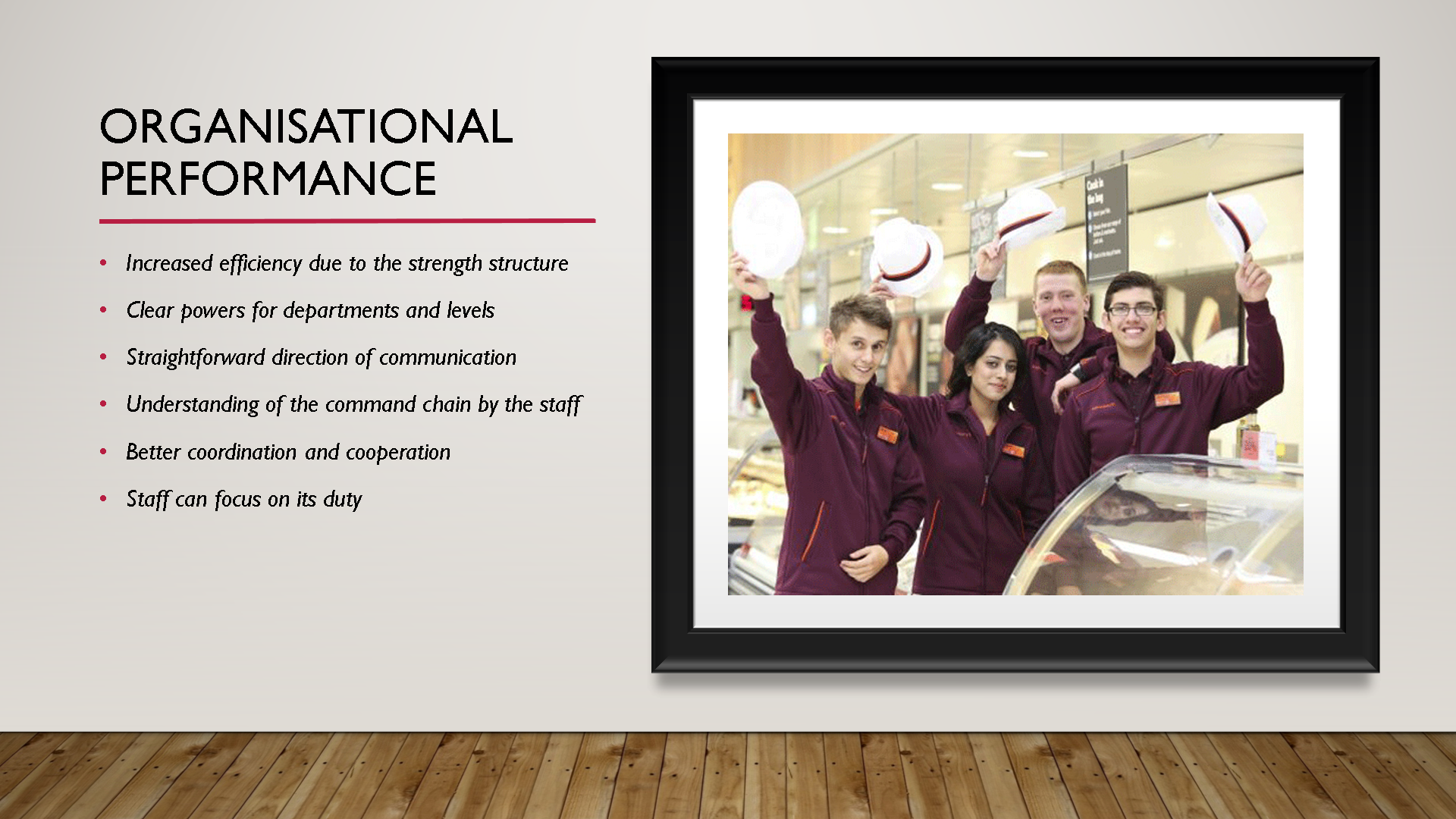

Image 6
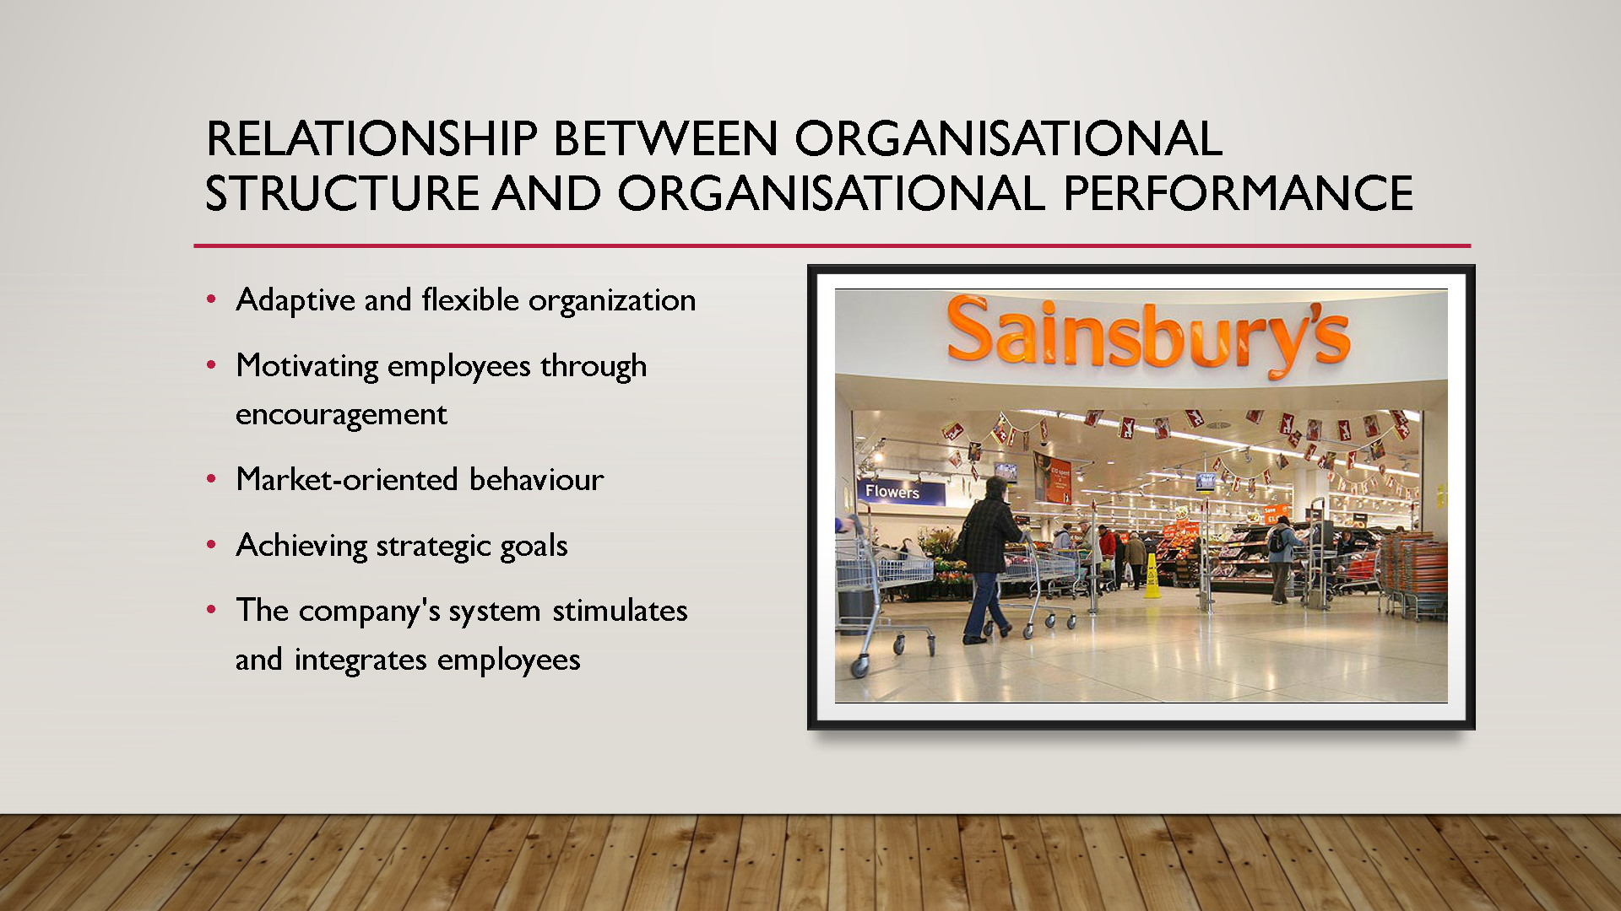

Image 7
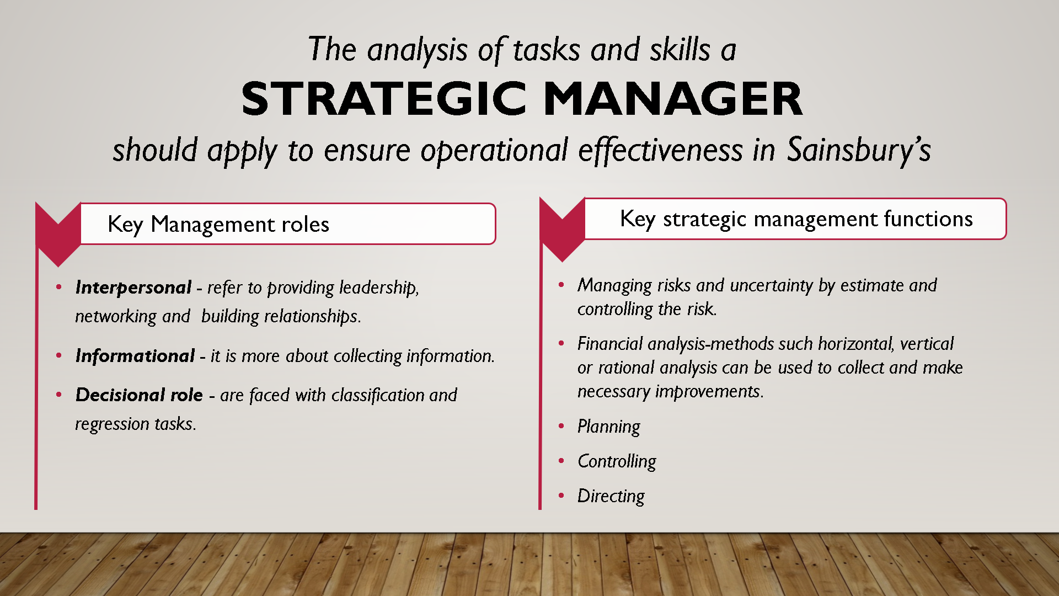

Image 8
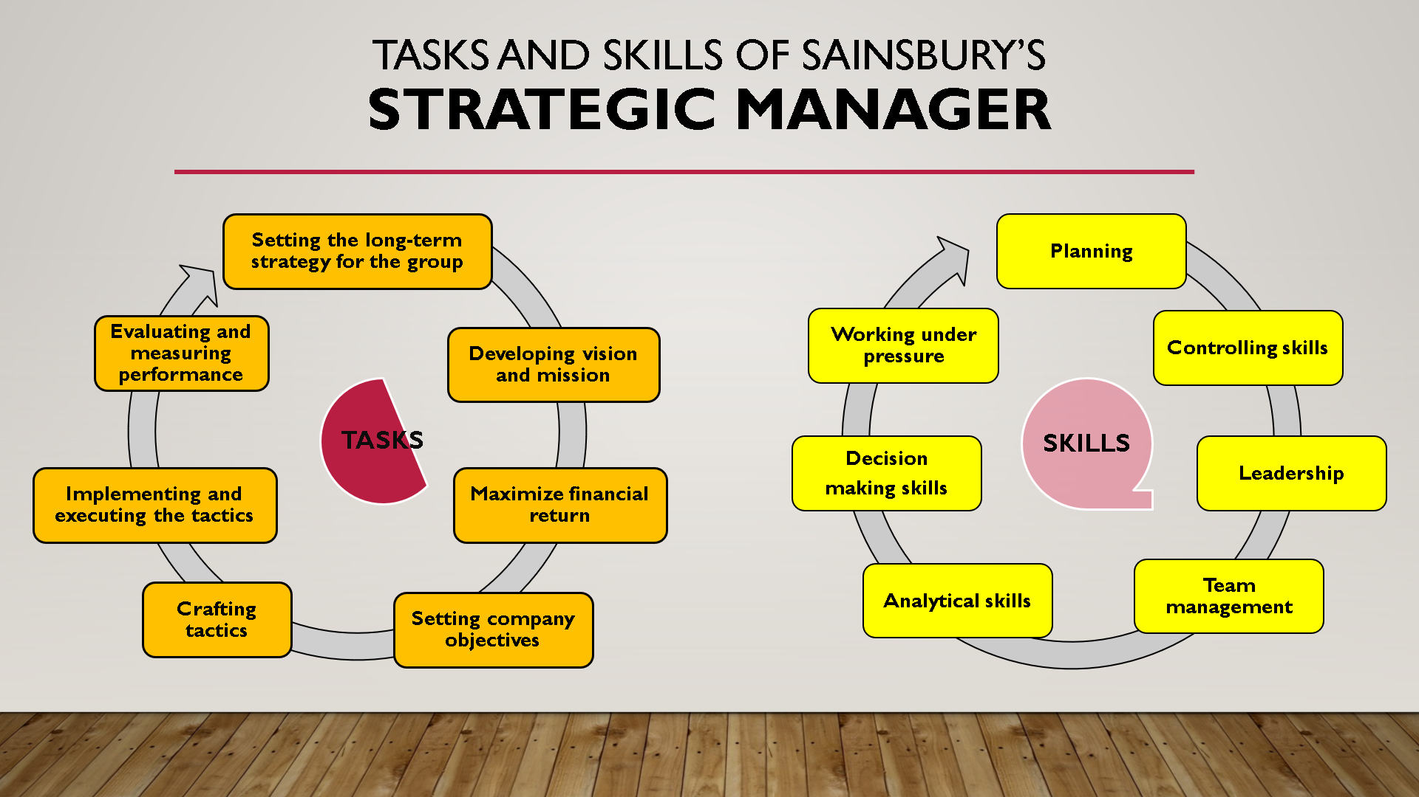

Image 9
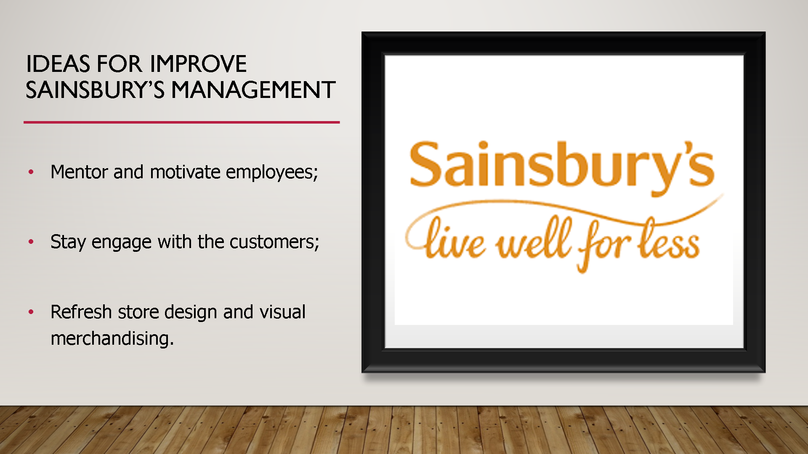

Image 10
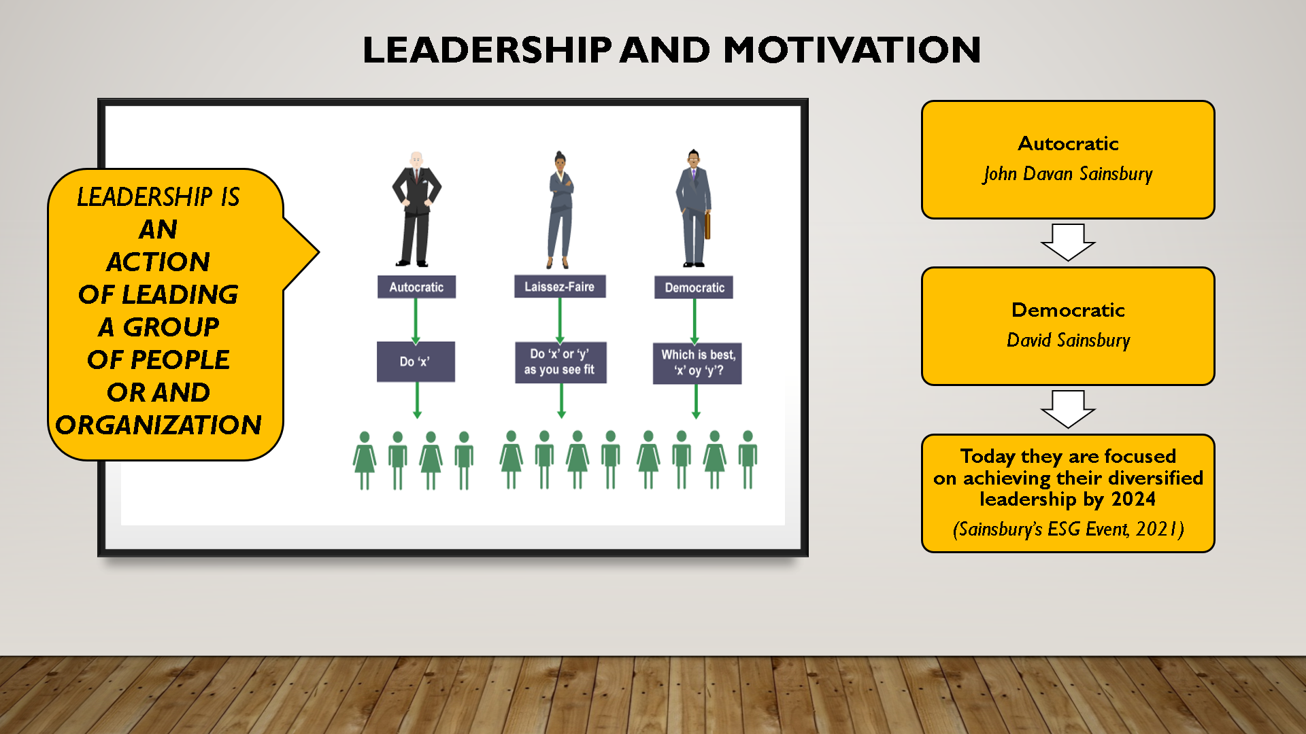

Image 11
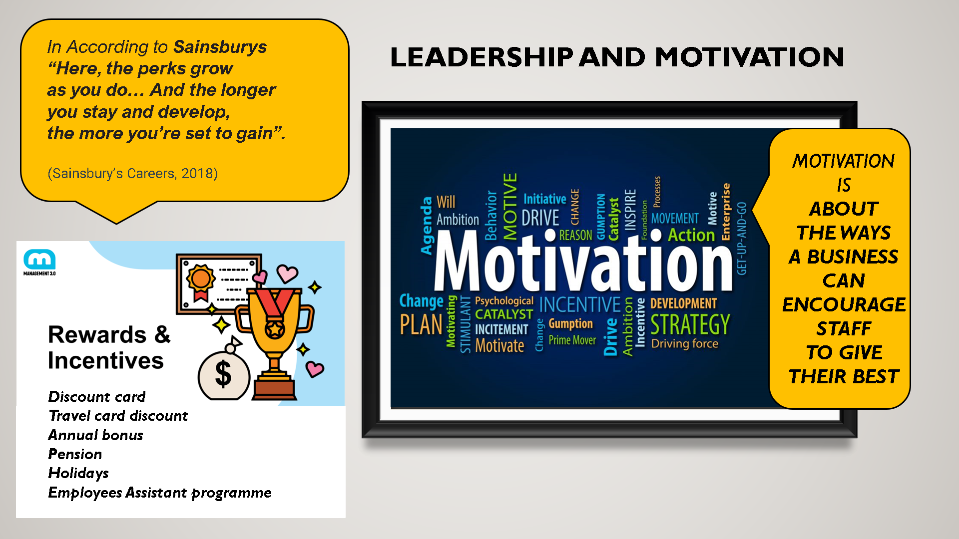

Image 12
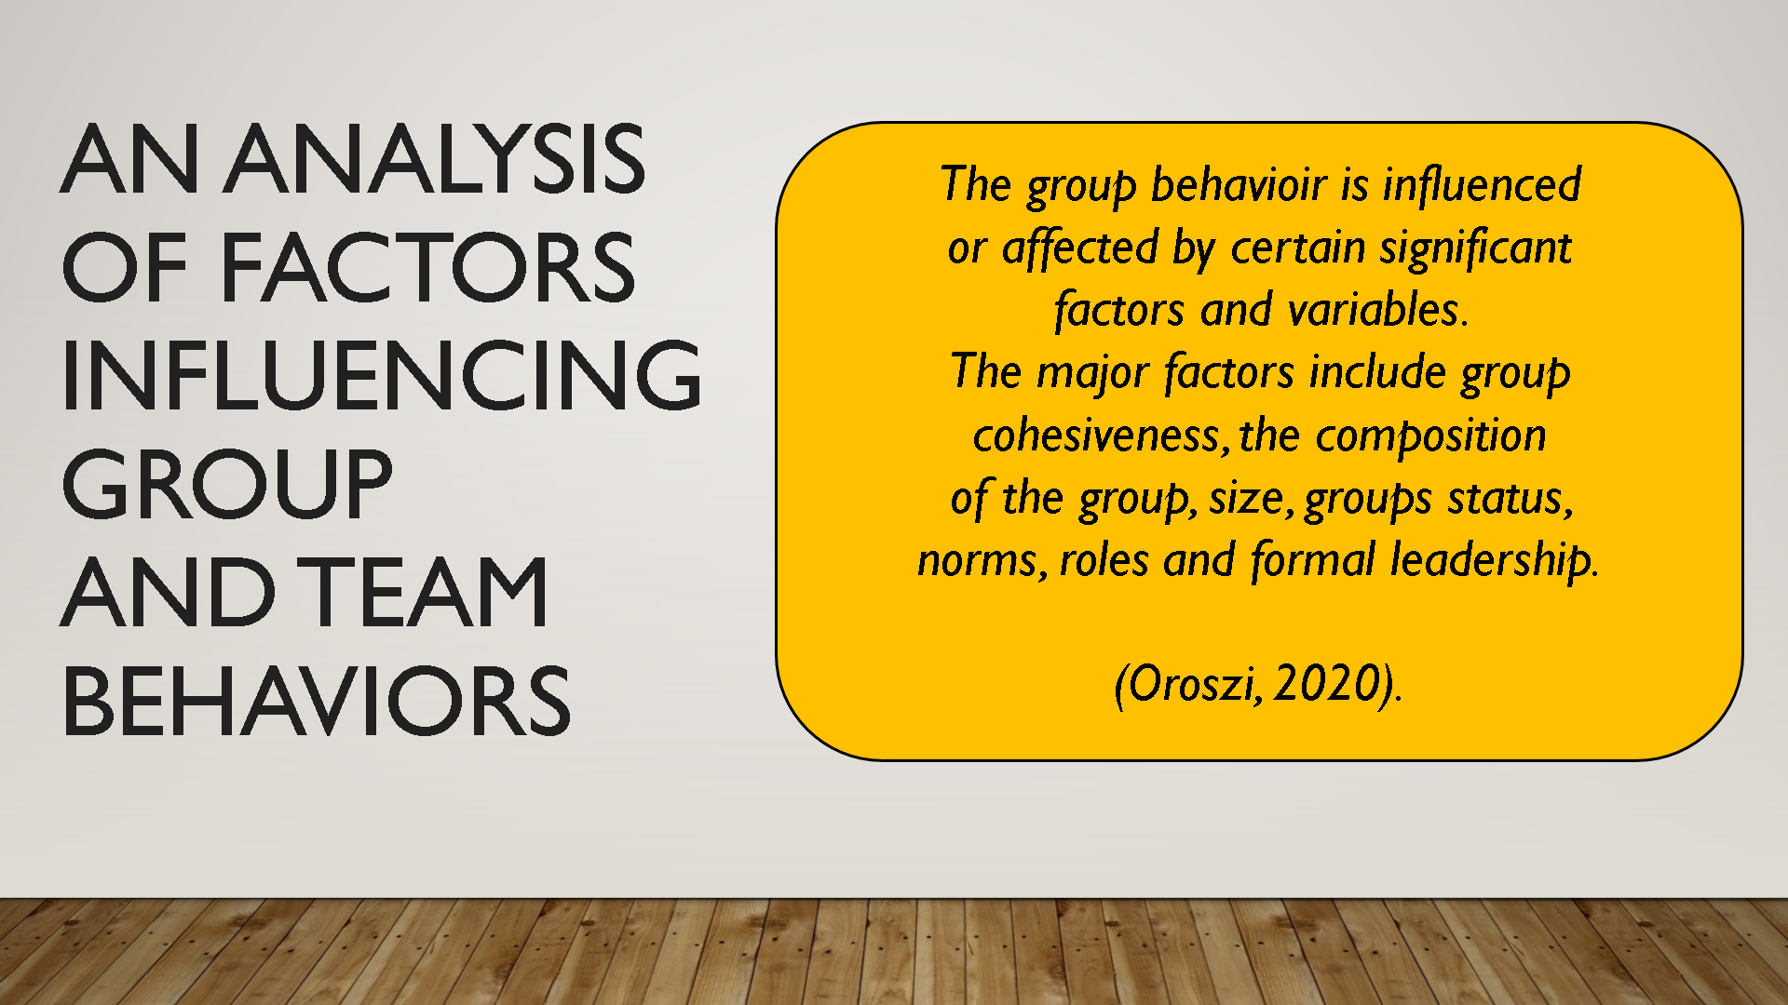

Image 13
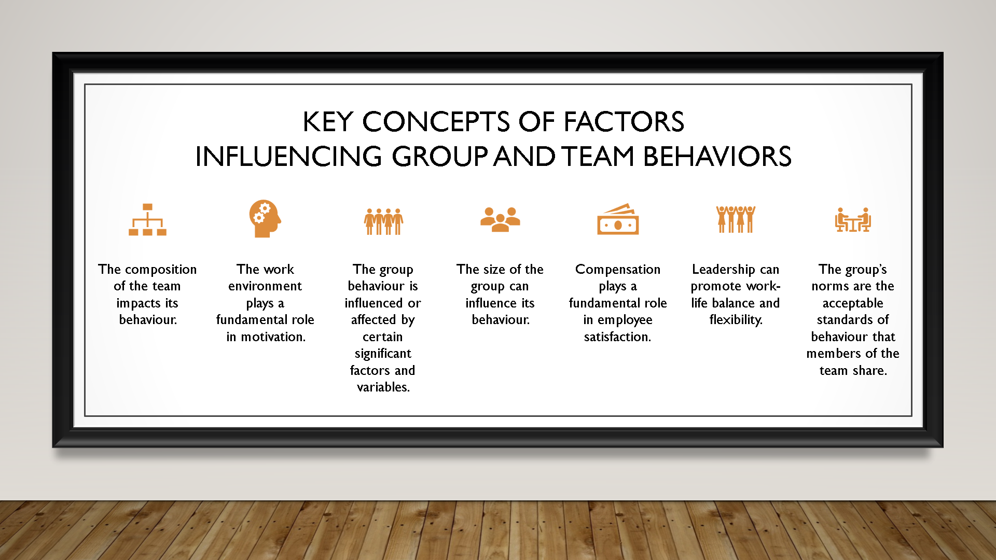

Image 14


Image 15
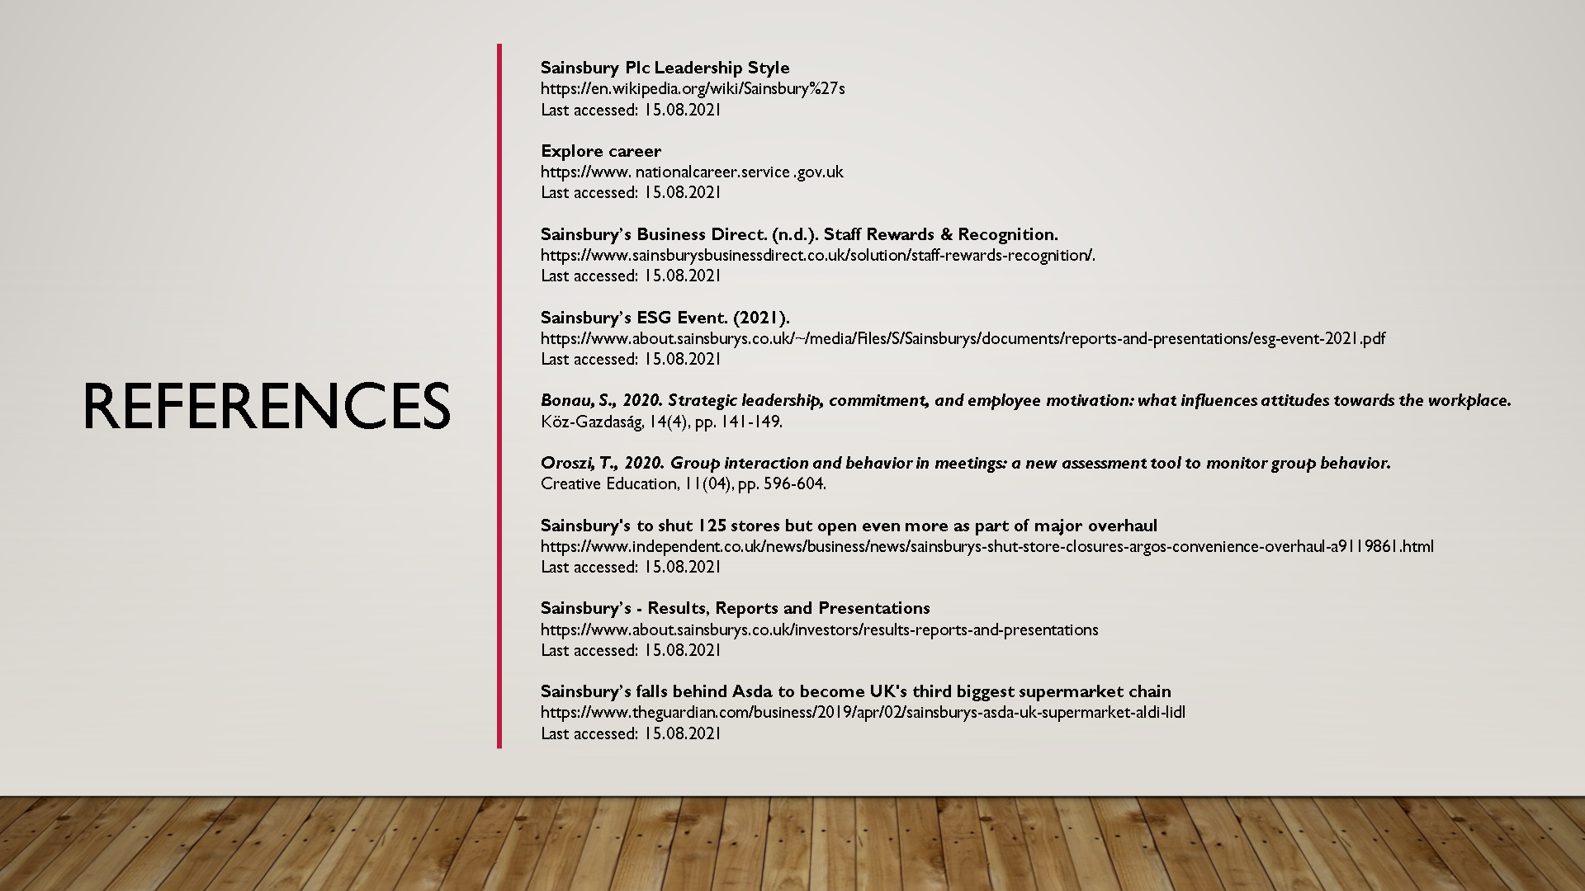

Image 16


