Database Management Systems
Assignment 2

Name: Ion Gabriel Matei
Student Number: 1816251
Module Title: Database Management Systems (ACCC5001_LON)
Assignment Title: Assignment 2- OCT 2020
Lecturer: Koushik MODAK

Contents Page

Introduction 2
Report 3
Standard Database Auditing 4
Triggers 6
Queries /Views 7
Triggers-advantages 8
Transactions and Concurrency 9
Bibliography 13

Figures

Fig1. Create Audit 4
Fig2. Create Server Audit Specification 5
Fig.3 Create Server Audit 5
Fig4. Create Audit Trigger 6
Fig5. Triggers List 7
Fig6. Events View 7
Fig7. Tables View 8
Fig8. Lease Log Table 9

Introduction
According with [1] we have next scenario where “...the management of the To-Rent Estate Agent require a report showing mitigating approaches that you have put in place and how this functionalities work.”
Requests:
- Document the strategies that can be employed by To-Rent estate agent to prevent further fraudulent activities (“staffs creating tables to hide property and client details through some activities made and leased property records are being deleted from the property table.”)[1]
- Identify the advantages to be gained from your proposed solution and use appropriate examples from your solution.[1]
- Show queries that can be ran using the database. [1]
- Discuss the term Transaction and Concurrency as used in the DBMS.[1]
- Explain the ACID properties of Transaction and why they are necessary?[1]
- Discuss the three anomalies such as Dirty Read, Unrepeatable Read and Lost Update caused by interleaved schedule with suitable example for each anomaly.[1]
- Explain the two-phase locking and demonstrate how two-phase locking would help to avoid problem caused by Dirty Read. [1]

Report

Database vulnerabilities where exploited at To-Rent Estate Agent (TREA) and then are necessary actions to be taken in order to detect fraudulent transactions and to conserve data integrity against any member who access Database Management System (DBMS).
A set of practice, including SQL Server Audit and System Triggers will provide traceability and a better control of insert, delete or update activities over DBMS.
When incidents get identified will allow the administrators to take recovering actions and corrective measures against employees responsible.
According with [2] auditing activities may include but not only:
- Logons
- Configuration
- Audit configuration
- Schema modification
- Data modifications
Data Definition Language (DDL) auditing solutions contain standard auditing and system triggers. [3]
DDL statements are necessary to control data storage into table structure and storing code functions.
According with [3] “monitoring, auditing and logging changes to DDL are key components of a database security program, especially when supporting Enterprise Resource Planning (ERP) solutions such as SAP, PeopleSoft, and the Oracle E-Business Suite.”
Once enabled, system triggers needs such called “execution time” for operation that actually means writing data into a specific table and that will cause extra time consuming if we compare the solution with already available check constraints execution time equal with zero.

Standard Database Auditing
Enabling standard database auditing requires the “start up parameter audit_trail” to be set at a certain value or any other than” NONE.” [3]
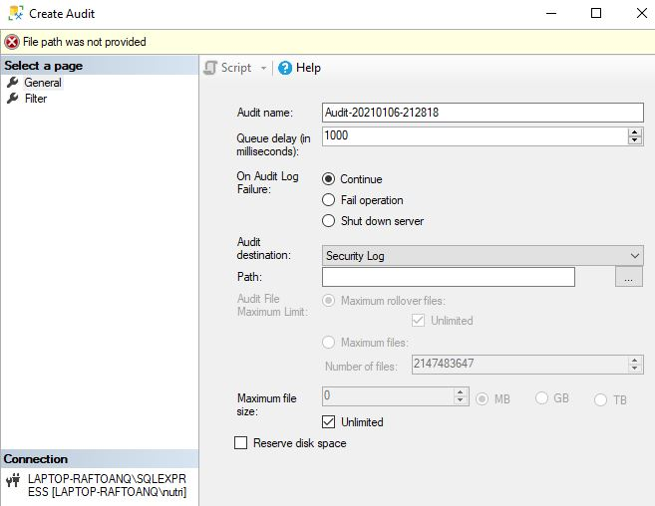
Fig1. Create Audit
Audit logs can be written into database or Syslog and will be configured as [3] show below:
AUDIT TABLE BY ACCESS;
AUDIT VIEW BY ACCESS;
AUDIT PROCEDURE BY ACCESS;
Read audit logs data in the following [3] tables and system views:
DBA_AUDIT_TRAIL (SYS.AUD$)
DBA_COMMON_AUDIT_TRAIL

SQL Server database auditing has the scope of “tracking and logging events” for monitoring security and integrity of DBMS.[6]

Audited objects register “single instance of server- or database-level actions”. [6]
According to [6] audits will be created before enabling server audit specification for each one of it and when the audit specification is created is automatically in disabled state.
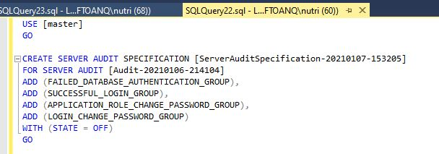
Fig2. Create Server Audit Specification
Multiple audits may be created as situation require for each server instance.
When the transaction is rolled back, the statement is also rolled back. [6]
We will create server audit specification for each audit, with the same scope and monitoring same specific activities as shown below:
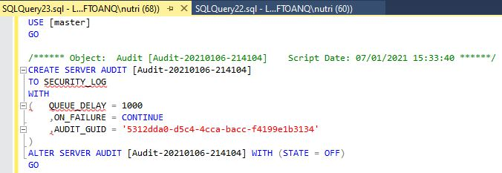
Fig.3 Create Server Audit
A set of permissions accomplish the system audit on DBMS, such as:
- ALTER ANY SERVER AUDIT or the CONTROL SERVER permission.[6]
- Users with the ALTER ANY SERVER AUDIT permission can create server audit specifications and bind them to any audit.[6]
- After a server audit specification is created, it can be viewed by principals with the CONTROL SERVER or ALTER ANY SERVER AUDIT permissions, the system admin account, or principals having explicit access to the audit.[6]
“While recommended for a comprehensive security program”, standard auditing usage is affected by” misconceptions about the performance” conclude [3].

Triggers
“A trigger is a special type of stored procedure that automatically runs when an event occurs in the database server” stated at [6].
DML triggers fires when is detected that a user tries to modify data using manipulation language (DML) by creating events such as insert, delete or update.[6]
DDL triggers fires as response to data definition language (DDL) events such as transactions create, alter, drop statements, and different procedures stored into DBMS that perform DDL specific operations.[6]
Triggers are used to control DDL changes as [3] shows below:
“CREATE OR REPLACE TRIGGER <XXX_YOUR_DDL_TRG> AFTER DDL”
New deployed table will save changes when trigger get enabled.
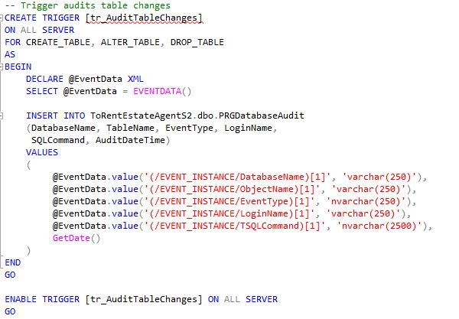
Fig4. Create Audit Trigger
The table or view on which the DML trigger fires is the trigger table or trigger view where modified data, table affected, user identity and other table-specific info are saved.[6]

Queries /Views
ToRent Estate Agent request a set off views in order to list the deployed triggers such as audit triggers and Lease Table events history views for update, insert, delete activities that will be reported to the management for future actions.
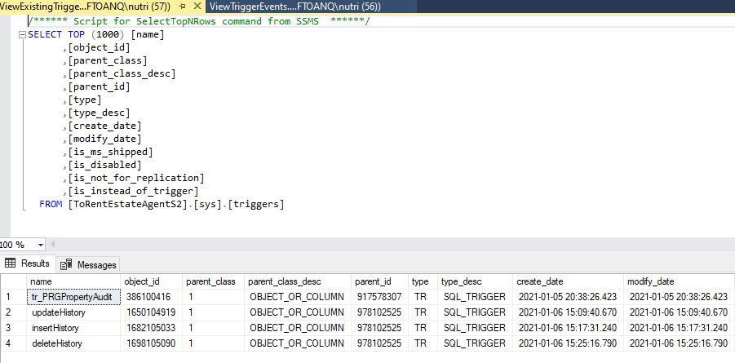
Fig5. Triggers List
Available query views contain triggers events information such as command executed, user identity, affected fields and table, database, etc.
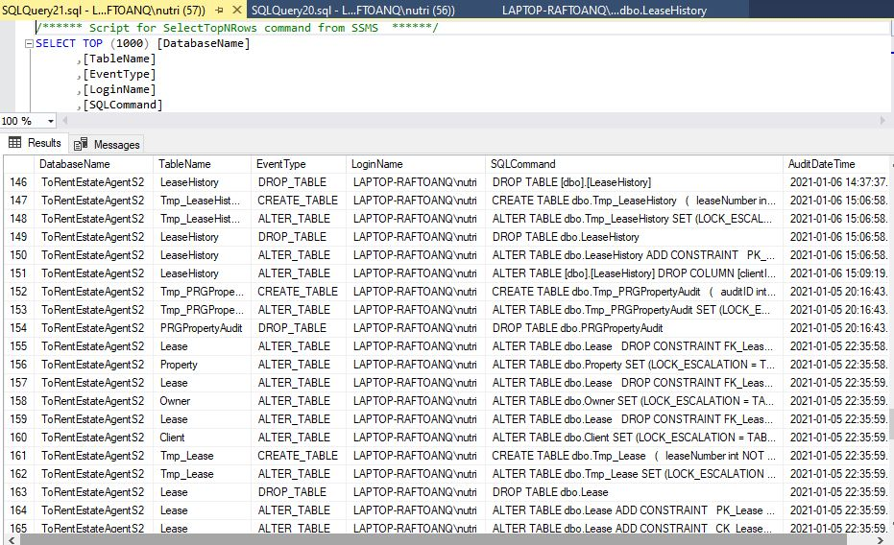
Fig6. Events View

Triggers-advantages
Constraints integrity is well secured over DBMS in the most vulnerable scenario when the “primary key and foreign key constrain are not defined.” [2]
SQL code deployment remains simplified and accessible for developers. [2]
Tracking logs events and modifications, data analysis, statistic reports are facilitated by introducing audit tables. [2]
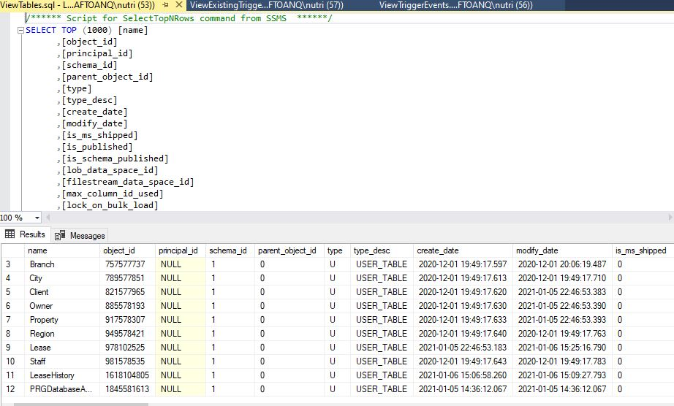
Fig7. Tables View

Third Party Tools
DDL audit is even more facilitated by new third party and well developed, ready to use tools. According to [3] third party solutions relay on “agents placed on the database server(s) and/or network taps to intercept network packets going to the database”.
These solutions deliver tools (IBM Guardian) developed for different platforms and “allows for a potentially much stronger segregation of duties between DBAs” when audit solution and the audit data get available. [3]
Third party solutions tools (Imperva) are created to “audit a large number of databases where economies of scale can be achieved” sustain [3].
Information security can be reduced from global database environment to local table level where access statements and exiting data manipulation is audited and analysed by using data manipulation language (DML).
DML statement events are registered only after transaction gets committed. [4]
A single DML statement it refers to a database controlled transaction unit. This transaction is committed or rolled back if requested. [4]
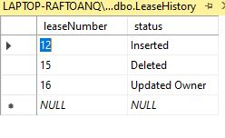Fig8. Lease Log Table

Transactions and Concurrency
Defined at [5] a transaction (TNX) is related to logical database statement such as programs, procedures or single commands (INSERT or UPDATE) that include DBMS services. The deployment of an application program is considered as “one or more transactions with non-database processing working in between.” [5]
Transactions manipulate data by using read and write operations. [5]
Database integrity is enhanced when certain transaction properties are followed, such-called “ACID properties.” [5]
Atomicity
“All or nothing rule” or atomicity it refers to the property when transactions are considered a single unit ready for completion or rollback and include next operands:
- Abort (Database changes are invisible) [5]
- Commit (Database changes are visible) [5]
Consistency
During transactions commitment integrity constraints needs to be maintained so the database correctness to be conserved. [5]

Isolation
“Changes occurring in a particular transaction will not be visible to any other transaction until that particular change in that transaction is written to memory or has been committed.” This property applies when multiple transactions run concurrently without interference and without affecting database consistency state. [5]
Durability
After transactions bets completed database stored changes will be saved, never lost and remain accessible after system failures. Non-volatile memory is storing these changes.[5]
In conclusion, ACID properties represent the solution to secure database characteristics when many transactions are considered as: “... a group of operations that acts as single unit, produces consistent results, acts in isolation from other operations and updates that it makes are durably stored.”[5]

Concurrency Control is defined as “the method of managing concurrent operations on the database without getting any obstruction with one another”. [5]
Data inconsistence may result when updated data from different users at the same time lead to interference. [5]
Concurrency control is actually a technique to coordinate transaction execution and for that are implemented some protocols:
- “Lock-based Protocol” refers to deploying a mechanism where any transaction cannot read or write data until it gains a suitable lock into database.[5]
- “Timestamp-based Protocol uses either system time or logical counters as a timestamp” to enable transactions before get executed. [5]

For better understanding of different transactions conflict we need to refer to similarity of used variable. The most commune conflicts are “Read-Write conflicts (RW), Write-Read conflicts (WR) and Write-Write conflicts (WW). [5]
Conflicts between transactions prologue” interleaving anomalies “such as: Execution-Dirty read, Unrepeatable read, Partially-lost update. [5]

Interleaved Execution- Dirty read
This anomaly occurs while reading uncommitted data and is produced by Write-Read conflict (WR).
Specific Dirty Read actions showed below:
While a transaction (T1) get writing execution (W (A)) to a location A, at the same time other transaction (T2) read (R (A)) from, and write back (W (A)) to the location A and when T1 abort determine inconsistent value of T2.
- T1 writes some data to A: T1 >>W(A)>> A [5]
- T2 reads from A, then writes back to A & commits: T2 >>R(A)>>W(A)>>C [5]
- T1 then aborts-now T2’s result is based on an obsolete / inconsistent value. [5]

Unrepeatable read
This anomaly occurs while a Read-Write conflicts (RW) conflict established.
Specific Dirty Read actions showed below:
A transaction (T1) get reading execution (R (A)) from location A, and then other transaction (T2) read (R (A)) from, and write back (W (A)) to the location A, when T1 read again from location A, committed value of T2 will determine inconsistent value for T1.
- T1 reads some data from A: T1 >> R(A)>> A [5]
- T2 reads from A, then writes to A & commits: T2 >> R(A)>> W(A)>> C [5]
- When T1reads from A again now gets a different / inconsistent value. [5]

Partially-lost update
This anomaly occurs while blind writes data and is produced by Write-Write conflicts (WW).
Specific Dirty Read actions showed below:
While a transaction (T1) blind write committed to (W(A), W(B)) locations A, B , and other transaction (T2) blind write to same locations, then when T1 blind write to B there is not equivalent to any serial schedule.
- T1blind writes some data to A, B: T1 >>W(A)>>C and T1>>W(B)>> C [5]
- T2 blind writes to A and B: T2 >>W(A)>> C and T2 >>W(B)>>C [5]
- T1blind writes to B and now we have T2’s value for B and T1’s value for A [5]

Strict Two-Phase Locking (Strict 2PL)
Strict 2PL is a simplified and user transparent solution for concurrency control who guarantees conflict serial scheduling.
Strict Two-phase Locking (Strict 2PL) Protocol:
“Theorem: Strict 2PL allows only schedules whose dependency graph is acyclic; therefore, Strict 2PL only allows conflict serializable ⇒serializable schedules.” [5]
Phase1 (Growing)-it refers to the situation when “every TXN requests the locks (upgrades) that it needs from the DBMS’s lock manager (grants or denies lock requests)”.[6]
Phase2 (Shrinking)-is states that “TXN is allowed to only release locks that it previously acquired”.[6]
Transaction-TXN sentence:
- An X (exclusive) lock on object before writing.[5]
- An S (shared) lock on object before reading.[5]
- If a TXN holds, no other TXN can get a lock (S or X) on that object.[5]
- If a TXN holds, no other TXN can get an X lock on that object.[5]
- All locks held by a TXN are released when TXN completes.[5]
S=shared locks for reads.
X=exclusive locks for writes.

Benefits
Concurrency achieved by interleaving TXNs such that isolation &consistency are maintained.[6]
2PL is efficient ensuring “conflict serializability” by featuring acyclic schedules, but is “subject to cascading aborts”. [6]
Strict 2PL reduces the time when 2PL schedulers generate locks. [6]
Strict 2PL scheduler keeps TXN locks until get commited and strictly execute after the DBMS processes the transactions (commit, abort).
Strict 2PL executions are recoverable and avoid cascading aborts (ACA). [6]

Bibliography

[1] UWTSD, Moodle, [Online], 2020/2021, Available: https://moodle.uwtsd.ac.uk/course/view.php?id=3758
[2] SQLShack.com, [Online], 2020, Available: https://www.sqlshack.com/creating-successful-auditing-strategy-sql-server-databases
[3] Integrity, ORACLE DATA DEFINITION LANGUAGE (DDL) AUDITING, [Online], Available: 2017 https://www.integrigy.com/files/Integrigy%20-%20Data%20Definition%20Language%20Auditing.pdf
[4] Oracle, Database 2 Day Developer's Guide 11g Release 2 (11.2), [Online], 2020, Available: https://docs.oracle.com/cd/E18283_01/appdev.112/e10766/tdddg_dml.htm
[5] W3School, Transaction and Concurrency Control, [Online], 2020, Available: https://www.w3schools.in/dbms/transaction-and-concurrency-control
[6] Microsoft.com, SQL, [Online], 2020, Available: https://docs.microsoft.com/en-us/sql/relational-databases/security/auditing/create-a-server-audit-and-server-audit-specification?view=sql-server-ver15
[7]Carnegie Mellon University, Database Systems, Two-Phase Locking, [Online] , 2018, Available: https://15445.courses.cs.cmu.edu/fall2018/slides/17-twophaselocking.pdf

