Benjamin Gaylard (2003557)

Introduction to Web and Database Concepts (ACCA4023)

Contents
1. Introduction 1
2. Requirements 1
3. Implementation 1
4. Validation 6

Figure 1 - Intro Page Part 1 1
Figure 2 - Intro Page Part 2 2
Figure 3- Intro Page Part 3 2
Figure 4- Intro Page Part 4 3
Figure 5- Intro Page Part 5 3
Figure 6- Intro Page Part 6 4
Figure 7- Page 2 Part 1 4
Figure 8 - Page 2 Part 2 4
Figure 9 - Page 3 5
Figure 10 - Page 4 5
Figure 11 - Page 5 6

Introduction

Requirements

Implementation

Figure 1 - Intro Page Part 1

Figure 2 - Intro Page Part 2

Figure 3- Intro Page Part 3

Figure 4- Intro Page Part 4

Figure 5- Intro Page Part 5

Figure 6- Intro Page Part 6


Figure 7- Page 2 Part 1

Figure 8 - Page 2 Part 2

Figure 9 - Page 3
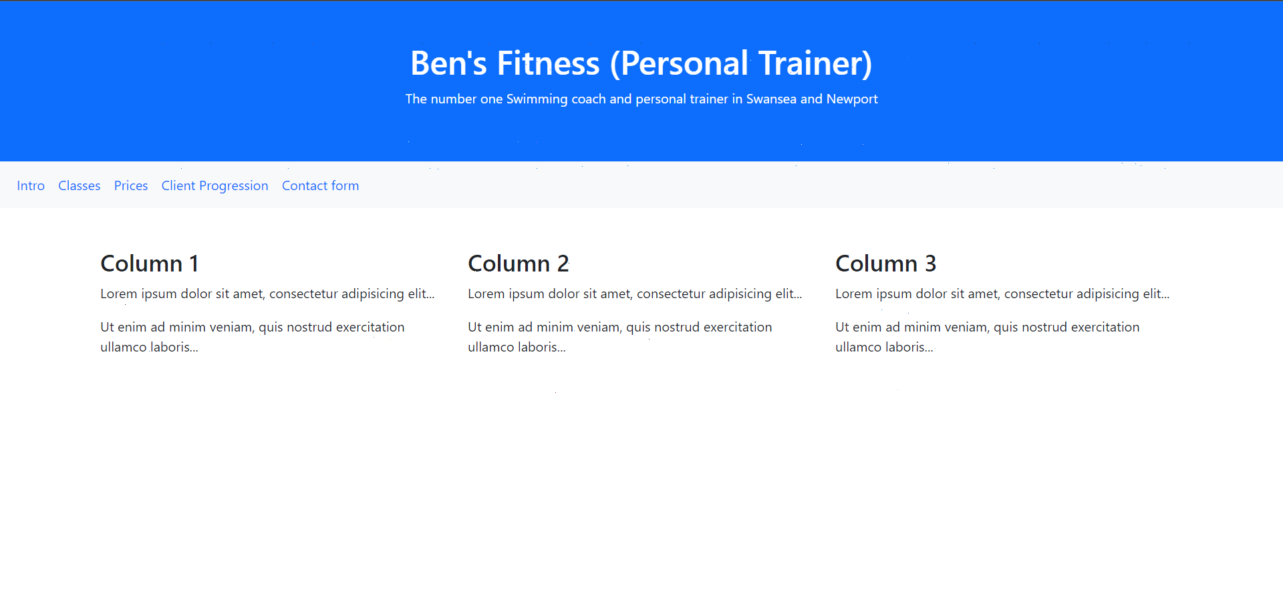
Figure 10 - Page 4
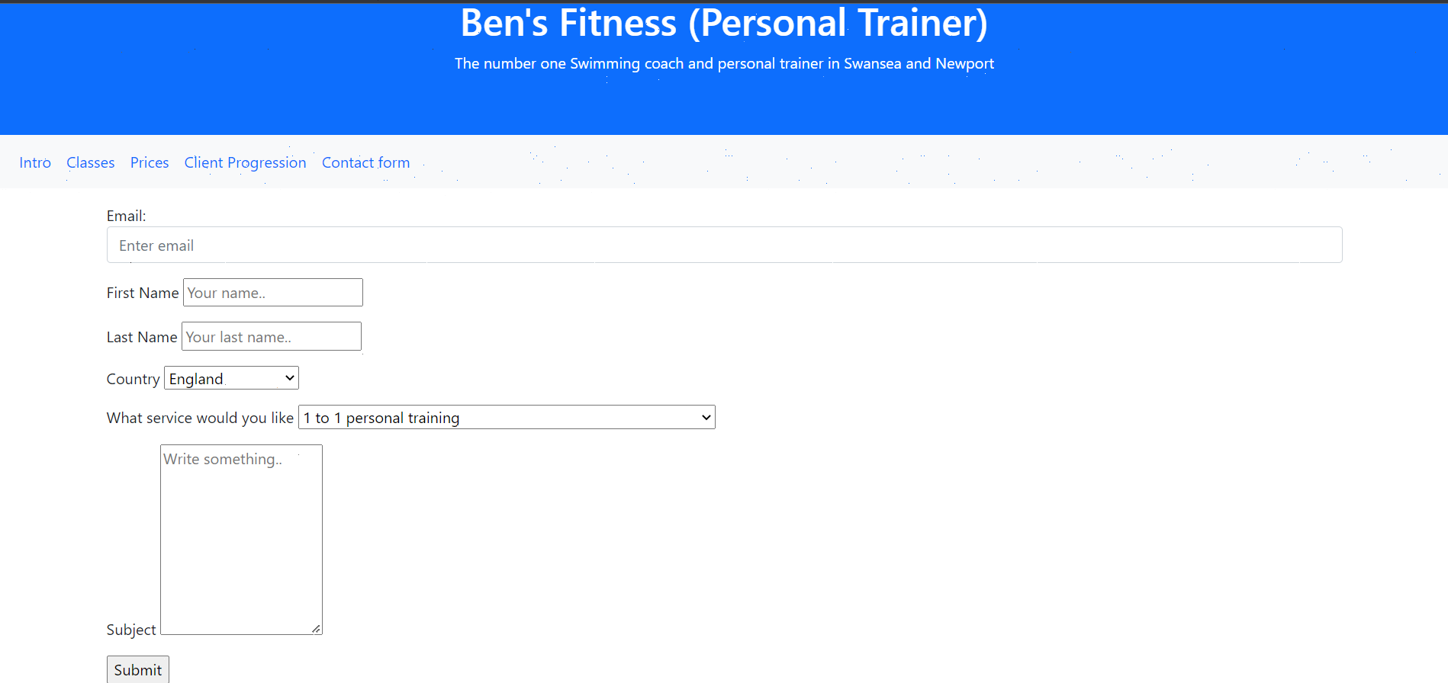
Figure 11 - Page 5

Validation

