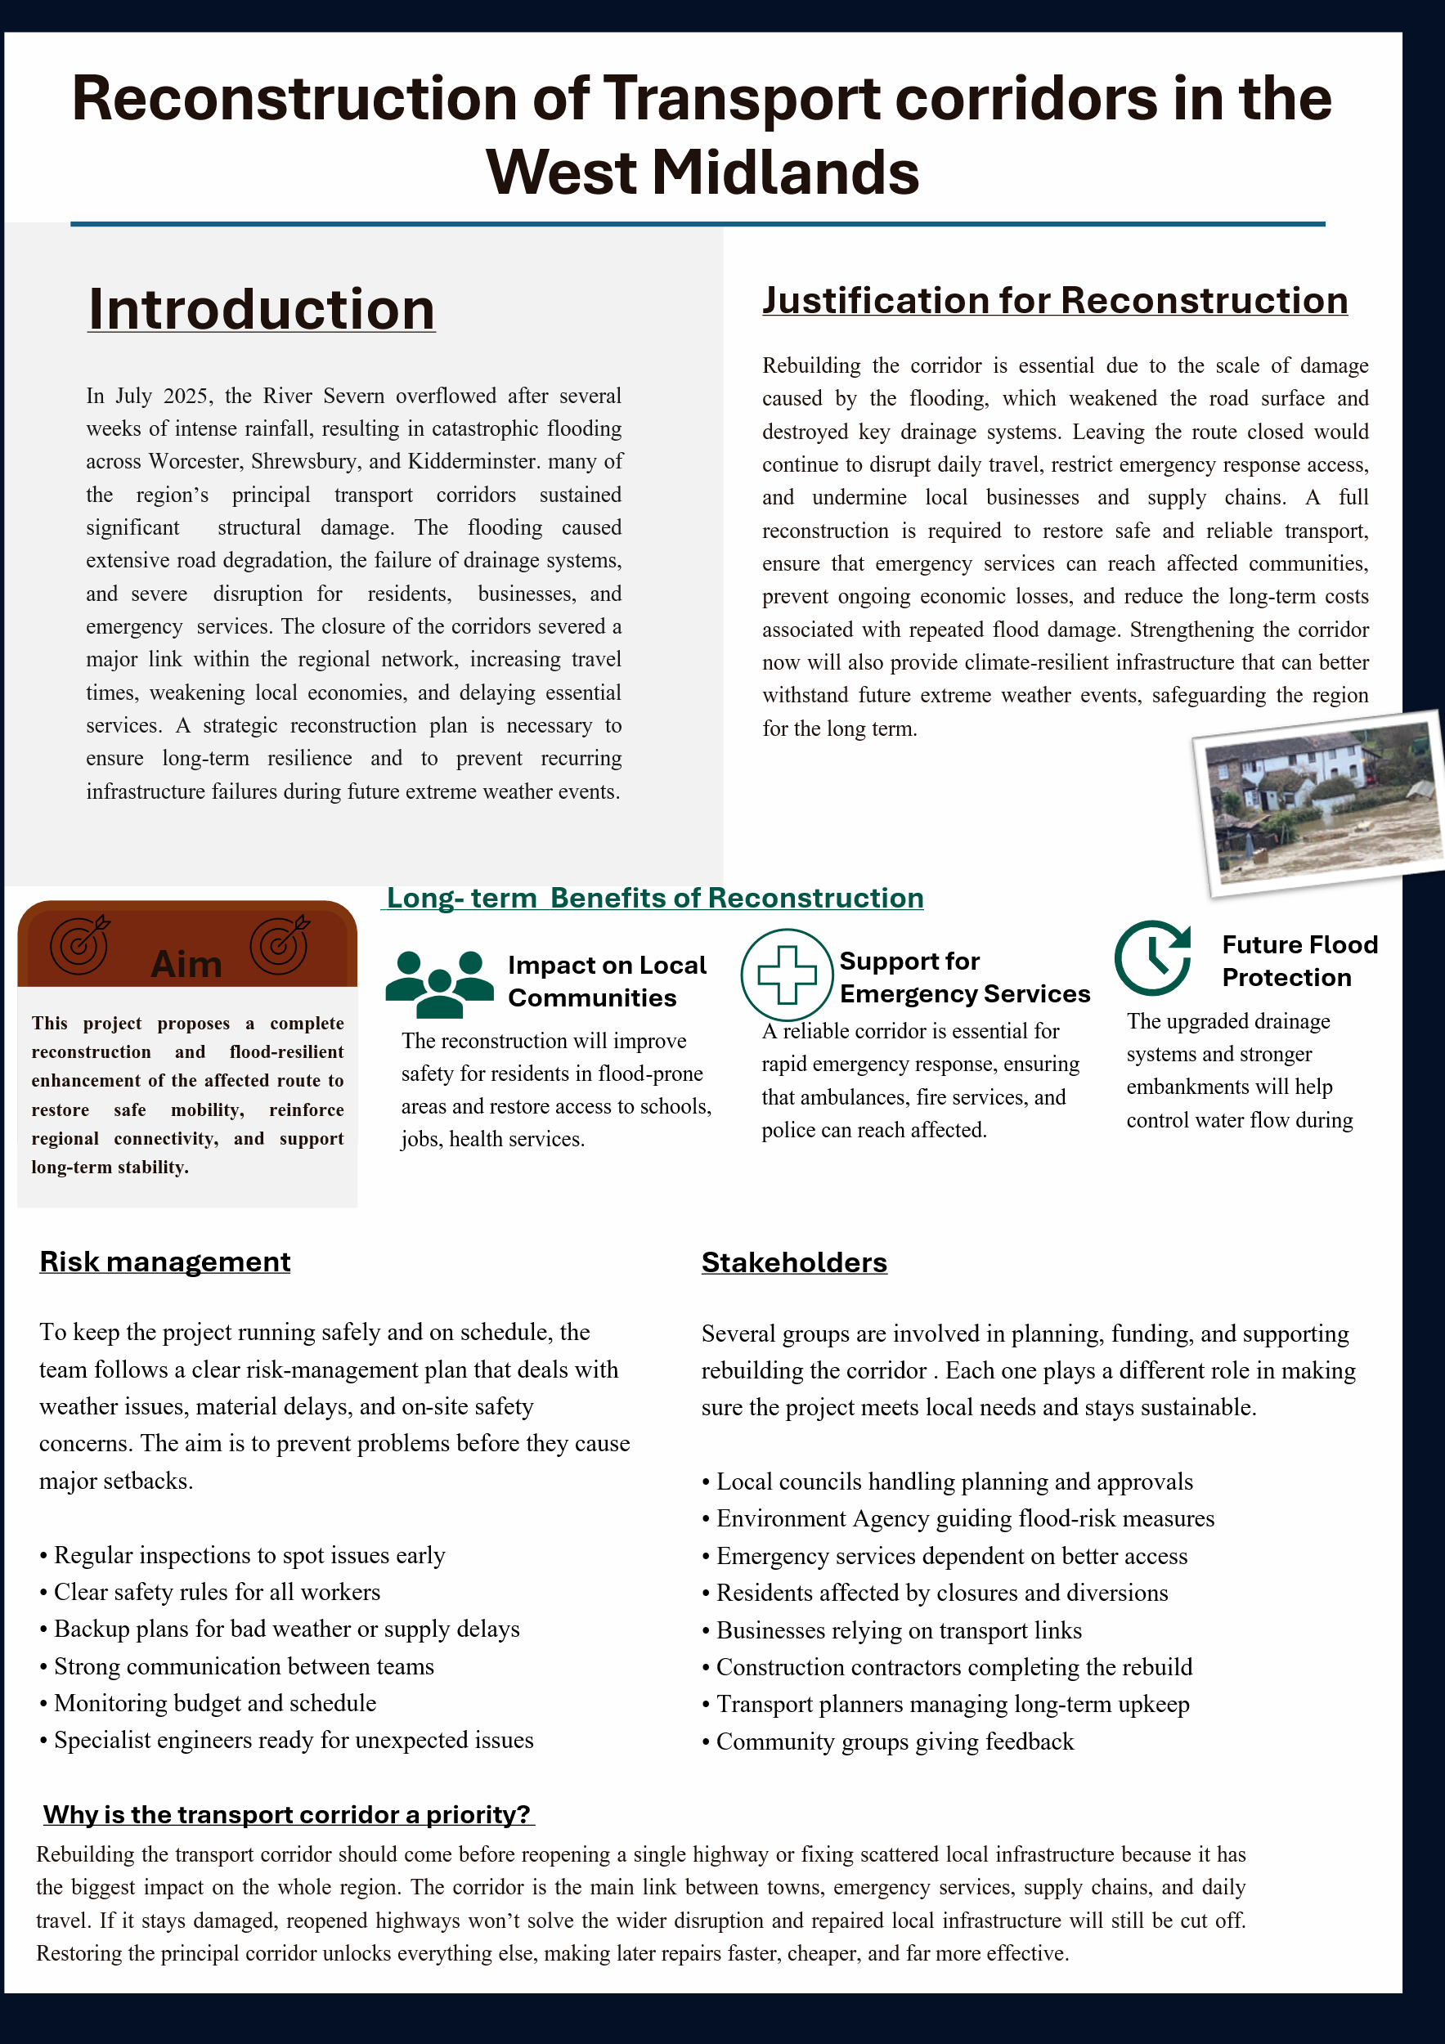Feedback Reflection Task

Serigne Gueye
Student ID: 2408648

Module: Project Management

Module code: LCLM5003

Lecturer : Samson Oladejo

The feedback on my poster highlighted several important points about both the strengths and weaknesses of my work. Reviewers recognised that one of the clearest strengths was the depth and quality of the research I presented. They felt that I demonstrated a solid understanding of the flooding impacts, the need for reconstruction and the wider consequences for the region. My explanations showed clear engagement with the topic and an ability to analyse the issue from multiple angles.
Another positive highlighted by peers and my tutor was the strong structure of the poster. They noted that the layout of the sections followed a logical order and helped guide the reader from the background of the issue through to the aims and justification of the project. This showed that the project had a strong foundation and that I had organised the material in a way that made sense academically, even if the visual layout needed refinement.
Despite these strengths, reviewers also identified three key areas that needed improvement. The most repeated and significant criticism was that the poster contained too much text. The paragraphs were long and dense, which made it difficult for viewers to quickly identify the most important points. This is a major issue in a poster format, where information should be easy to absorb at a glance.
Another negative point raised was the lack of visual elements. Reviewers explained that the poster would have been far more engaging if it had included diagrams, icons, maps or other graphics to break up the text. Without visuals, the poster felt overly heavy and made it harder for the audience to quickly interpret key ideas, especially in areas relating to risk management and community impact.
Finally, feedback pointed out several formatting issues. These included tight spacing, uneven alignment and repeated information across sections. These problems contributed to a cluttered appearance and reduced the clarity of the overall presentation. Reviewers suggested that improving spacing and removing duplication would make the work look more professional and easier to follow.
Overall, the feedback showed that while my poster had strong content and a solid structure, the presentation style needs refinement to make the information clearer, more engaging and easier for an audience to absorb. In my view, the feedback was fair and ultimately helpful because it pointed out issues I had overlooked while focusing too much on the written content. I can see now that I treated the poster like a report, which meant the strength of my research ended up buried under unnecessary detail.
The comments helped me recognise that effective academic communication depends not only on accurate research but also on presenting information in a clear, concise and visually accessible way.
The feedback has encouraged me to think more carefully about how my audience will interpret my work. I agree with the reviewers that reducing the text, improving the layout and adding visuals will significantly strengthen the final project plan. The feedback has pushed me to think more carefully about audience needs and the importance of clarity, and I believe that by applying these improvements, my work can become more impactful.
Project Management Plan: Flood Resilient Transport Corridor Reconstruction
Serigne Gueye
Student ID:2408648
Lecturer: Samson Oladejo

Introduction
Extreme weather events are becoming increasingly frequent and severe across the United Kingdom, placing growing pressure on national and regional infrastructure. Climate change is a key driver, contributing to heavier rainfall, rising river levels and more unpredictable weather patterns. The Met Office (2023) reports a notable increase in extreme rainfall events in recent decades, with projections suggesting that such events will continue to intensify. This trend creates significant challenges for infrastructure resilience, particularly in flood-prone regions.
The July 2025 flooding across the West Midlands demonstrated the vulnerability of transport networks to prolonged and intense rainfall. Rivers such as the Severn exceeded capacity, overwhelming flood defences and causing widespread disruption. Key routes became impassable, isolating communities, delaying emergency response, and inflicting substantial economic losses. The Environment Agency (2023) highlights that infrastructure failure during floods not only impairs mobility but also disrupts supply chains, public safety, and regional economic stability.
Project management is essential in guiding effective recovery and long-term resilience. It provides a structured approach to planning, coordinating, and delivering complex reconstruction efforts. The Project Management Institute (2021) emphasises that effective project management ensures projects are completed within scope, time, and cost constraints while maintaining quality standards. Importantly, it enables organisations to respond strategically to risk and uncertainty, a critical factor in disaster recovery.
Modern approaches go beyond simply restoring damaged infrastructure; there is a growing focus on “building back better.” This strategy integrates resilience measures into reconstruction to reduce vulnerability to future events. Kerzner (2017) notes that contemporary project management must incorporate both risk management and sustainability to remain effective in dynamic environments. For flood-affected transport corridors, this may include enhanced drainage, elevation of vulnerable routes, and monitoring technologies for early warning.
This report presents a detailed project management plan for reconstructing and upgrading a key transport corridor affected by the 2025 flooding. The plan takes a forward-looking approach, aiming not only to restore functionality but also to improve resilience against future events. By applying established project management principles, the project seeks to support economic recovery, enhance infrastructure reliability, and promote long-term sustainability of transport systems in the region.
Project Description
The proposed project centres on the restoration and strategic upgrading of a critical transport corridor linking key towns such as Worcester and Kidderminster within the West Midlands. This corridor plays a vital role in regional connectivity, supporting the movement of goods, enabling access for emergency services and facilitating daily commuting. Its disruption during the July 2025 flooding had far-reaching consequences, including delays in emergency response, interruptions to supply chains and reduced accessibility for local communities. As noted by the Department for Transport (2023), transport infrastructure is a key driver of economic stability, meaning its failure can have significant regional impacts.
The project goes beyond basic repair by adopting a resilience-focused approach to infrastructure redevelopment. Rather than restoring the corridor to its previous condition, the aim is to enhance its capacity to withstand future flooding events. This reflects the broader “build back better” principle, which emphasises long-term sustainability and risk reduction in post-disaster recovery (Project Management Institute, 2021).
Key improvements will include the reinforcement of road structures to withstand water damage and prolonged saturation, as well as the installation of advanced drainage systems designed to manage excess surface water more effectively. In addition, vulnerable sections of the corridor may be elevated to reduce the likelihood of future submersion. The integration of smart monitoring technologies, such as water level sensors and early warning systems, will further strengthen the corridor’s resilience by enabling faster response to changing environmental conditions. The Environment Agency (2023) highlights the importance of such adaptive measures in reducing flood risk and improving infrastructure reliability.
By combining reconstruction with resilience and technological innovation, the project adopts a forward-looking and sustainable approach to infrastructure recovery. This not only supports immediate restoration of transport functionality but also contributes to long-term regional resilience, ensuring that the corridor remains operational under increasingly unpredictable climate conditions.
.
Scope
Defining the project scope is critical to maintaining control over its delivery and ensuring objectives are achieved within agreed time, cost, and quality constraints. In large-scale infrastructure projects, poorly defined scope is one of the main causes of delays, cost overruns and stakeholder dissatisfaction. As highlighted by the Project Management Institute (2021), clear scope definition forms the foundation of effective project planning, as it establishes boundaries, clarifies deliverables and reduces ambiguity.
This project encompasses all activities directly required to restore and enhance the functionality and resilience of the identified transport corridor within the West Midlands. The scope is deliberately focused on infrastructure elements that contribute to both immediate recovery and long-term flood resistance, ensuring that the project delivers sustainable value rather than short-term fixes.
Core components of the project include:
- Repairing and resurfacing sections of the road network that were structurally compromised by flooding
- Installing enhanced drainage and flood mitigation systems to manage excess water more effectively
- Elevating low-lying and high-risk sections of the corridor to reduce future vulnerability
- Replacing and upgrading damaged infrastructure such as safety barriers, signage and protective features
While these activities form the operational scope, it is equally important to define what the project does not include. The exclusion of private property repairs and wider regional flood defence systems reflects a strategic decision to maintain focus and avoid overextension. According to Kerzner (2017), uncontrolled expansion of project scope, often referred to as scope creep, can significantly undermine project performance by stretching resources and introducing unmanageable complexity.
This selective scope ensures that the project remains achievable within its constraints while still addressing the most critical infrastructure needs. It also aligns with a prioritisation approach, where resources are directed towards assets that deliver the greatest public and economic benefit. For example, restoring a key transport corridor has a multiplier effect, supporting emergency services, supply chains and daily mobility, whereas broader flood defence initiatives would require separate, large-scale programmes beyond the capacity of a single project.
Furthermore, the clearly defined scope supports effective stakeholder management by setting realistic expectations from the outset. Stakeholders are less likely to demand additional, unplanned outputs when project boundaries are transparent and justified. The Association for Project Management (2020) emphasises that well-defined scope not only improves delivery efficiency but also strengthens governance and accountability.
Overall, the scope of this project reflects a balanced approach, combining targeted infrastructure recovery with resilience improvements while maintaining strict control over deliverables. This ensures that the project remains focused, feasible and aligned with its strategic objectives.
Work Breakdown Structure (WBS)
To ensure the effective delivery of the project, the overall work is systematically divided into smaller, manageable components through the use of a Work Breakdown Structure (WBS). This approach is widely recognised as a fundamental project management tool, as it enables greater clarity in planning, improves coordination across teams and strengthens accountability at each stage of the project. According to the Project Management Institute (2021), a well-developed WBS provides a hierarchical decomposition of the total scope of work, ensuring that all required deliverables are identified and organised.
The project lifecycle begins with the initiation phase, which includes critical activities such as site assessments and feasibility studies. These tasks are essential for determining the technical, environmental and economic viability of the project. Without a thorough initiation stage, there is a significant risk of pursuing solutions that are either impractical or unsustainable. As noted by Kerzner (2017), early-stage analysis is crucial in reducing uncertainty and preventing costly revisions later in the project.
Following initiation, the project moves into the planning and design phase. This stage involves developing detailed engineering designs, defining technical specifications and securing the necessary approvals from regulatory bodies. The quality of planning at this stage has a direct impact on the success of subsequent phases, as poorly defined plans often lead to delays and rework during construction. The Association for Project Management (2020) highlights that robust planning is key to aligning project objectives with available resources and stakeholder expectations.
Once plans are finalised, the procurement phase begins, focusing on sourcing materials, selecting contractors and establishing supply chains. This stage is particularly important in infrastructure projects, where delays in procurement can significantly disrupt timelines. Effective supplier management and contract negotiation are therefore essential to ensure reliability and cost control.
The construction phase represents the core of the project, where physical reconstruction of the transport corridor takes place. This includes implementing resilience measures such as improved drainage systems and structural reinforcements. Given the scale and complexity of this phase, clear task allocation and continuous monitoring are necessary to maintain quality and ensure adherence to timelines.
Finally, the project enters the testing and evaluation phase, where all completed work is assessed against required standards. This includes safety inspections, performance testing and compliance checks. Only after these criteria are met can the project move to formal closure, including documentation, stakeholder sign-off and handover.
Overall, the structured breakdown provided by the WBS supports effective project control by making it easier to allocate responsibilities, track progress and identify potential issues early. It also enhances transparency, as each component of the project can be monitored independently while still contributing to the overall objectives. This level of organisation is particularly important in complex infrastructure projects, where multiple interdependent activities must be carefully coordinated to achieve successful outcomes.
Quad Chart
A quad chart condenses the project’s most important information into four quick reference fields so decision makers can evaluate scope, risk and return at a glance; this format is particularly useful during early-stage stakeholder briefings and funding reviews (Project Management Institute, 2021). For this corridor reconstruction project the four quadrants are:
- Objective -Restore transport connectivity between Worcester and Kidderminster while increasing the corridor’s resilience to future flooding through structural reinforcement, improved drainage and smart monitoring.
- Schedule - Target delivery window 12 to 18 months, with staged milestones for assessment, design, procurement, construction and commissioning to enable early reopening of critical sections.
- Budget - Capital intensive due to civil works and specialised materials; the business case therefore balances near term recovery costs against long term reductions in disruption, emergency response costs and economic losses (Kerzner, 2017).
- Risks and mitigations - Principal risks include adverse weather, supply chain delays and unanticipated ground conditions; mitigations comprise contingency allowances, multiple supplier contracts and an adaptive schedule that prioritises critical route segments.
Summarising these elements in a single view helps sponsors and operational leads make rapid, informed choices about scope trade offs and funding commitments; it also provides a concise basis for regular executive updates and governance checkpoints.
Gantt Chart
The Gantt chart establishes the logical sequencing and relative timing of project tasks, clarifies dependencies and highlights the critical path that controls overall duration. The high-level schedule for the reconstruction project should include the following sequential phases with allowance for parallel activities where practical:
- Initiation and assessment (Month 0–2): site surveys, geotechnical investigations and feasibility reporting.
- Detailed design and approvals (Month 2–5): engineering designs, environmental consents and statutory approvals.
- Procurement and mobilisation (Month 4–6): contractor selection, material ordering and site set up; long lead items are ordered to overlap with late design work.
- Construction and resilience works (Month 6–14): phased rebuilding of carriageways, drainage upgrades, elevation of low sections and installation of monitoring systems; works are sequenced to reopen sections as soon as they are safe.
- Testing, commissioning and handover (Month 14–16): performance testing of drainage and monitoring systems, safety audits and formal handover to highway authorities.
- Closeout and lessons learned (Month 16–18): final account settlement, completion reporting and postimplementation review.
Key scheduling principles include identifying long lead items early, overlapping procurement with late-stage design where risk is acceptable, and maintaining float on noncritical tasks to buffer weather delays. Visualising these phases in a Gantt diagram makes dependencies explicit and provides an operational tool for monitoring progress, reallocating resources and triggering escalation when the critical path is at risk (PMI, 2021).

Stakeholder Involvement
Stakeholders are central to project success, as they both influence and are affected by its outcomes at different stages. Effective engagement ensures alignment between project objectives and stakeholder expectations, helping to reduce conflict and improve decision-making throughout the project lifecycle (Project Management Institute, 2021).
Key stakeholders in this project include local councils, emergency services, residents, businesses and environmental agencies within the West Midlands. Each group has different priorities, including safety, accessibility, economic continuity and environmental protection, which makes balanced and inclusive engagement essential.
Communication will be maintained through regular progress updates, consultation meetings and structured feedback channels. This approach promotes transparency, builds trust and allows concerns to be addressed early before they escalate. The Association for Project Management (2020) highlights that consistent communication is key to maintaining stakeholder support. Overall, active engagement contributes to smoother delivery and stronger long-term acceptance of the project outcomes.
Allocation of Resources
Effective resource allocation is essential to ensure the project is delivered efficiently and within defined constraints. This involves managing financial, human, material and technological resources in a coordinated and strategic manner.
The project will require a multidisciplinary team, including project managers, engineers and construction workers, each contributing specialised expertise. Funding is expected to come from government sources, supported by contingency reserves to manage unforeseen costs and financial risks. Reliable sourcing of materials, such as construction supplies and drainage systems, is also critical to avoid delays and ensure continuity during the construction phase.
In addition, technology, including project management software and monitoring tools, will support coordination, communication and progress tracking across teams. As noted by Kerzner (2017), effective resource planning reduces inefficiencies, improves productivity and helps prevent operational bottlenecks. Overall, careful allocation ensures that each phase of the project is properly supported and delivered to the required quality standards.

Risk Analysis
Infrastructure projects of this scale are inherently exposed to multiple risks, particularly when environmental and logistical factors intersect. Proactive identification, assessment and management of these risks are critical to ensuring the project stays on schedule, within budget, and meets quality standards (Project Management Institute, 2021).
The most significant risks for the transport corridor reconstruction include:
- Adverse weather conditions - Continued heavy rainfall or flooding could delay construction activities, compromise safety on site and extend the overall project timeline.
- Budgetary pressures - Increases in material costs, unforeseen ground conditions, or additional resilience measures could lead to budget overruns.
- Supply chain disruptions - Delays in sourcing construction materials, specialised equipment or skilled contractors could impede progress and create knock-on delays in critical path activities.
- Regulatory and environmental compliance -Failure to adhere to environmental or planning regulations could result in legal action, project stoppages or reputational damage.
Mitigation strategies will include contingency planning and financial reserves to absorb cost fluctuations, the adoption of flexible and adaptive scheduling to allow work to continue under variable conditions, and the engagement of multiple suppliers to reduce reliance on any single source. Regular environmental audits and strict adherence to planning and construction regulations will ensure compliance, minimise legal risk and safeguard project reputation.
A structured risk management framework, incorporating regular monitoring, reporting, and review of risk triggers, will be embedded throughout the project lifecycle. This approach not only reduces uncertainty but also enhances stakeholder confidence and increases the likelihood of successful, on-time and on-budget project delivery (Hillson, 2019).

Conclusion
The July 2025 flooding in the West Midlands revealed significant weaknesses in transport infrastructure, showing that simple repairs are insufficient for long-term resilience. This project management plan outlines a structured approach to reconstructing a key transport corridor while integrating measures such as improved drainage, elevated road sections, and monitoring systems to enhance future flood resistance. Through clear scope definition, effective resource allocation, stakeholder engagement, and risk management, the project aims to restore connectivity efficiently while strengthening the corridor against future disruptions. By combining immediate recovery with forward-looking improvements, the project supports economic stability, safer mobility, and the development of resilient infrastructure capable of withstanding future extreme weather events.

References
Association for Project Management (2020) APM Body of Knowledge.
Kerzner, H. (2017) Project Management: A Systems Approach to Planning, Scheduling and Controlling.
Office for National Statistics (2023) UK Infrastructure and Flood Impact Reports.
Met Office (2023) UK Climate Trends Report.
Environment Agency (2023) Flood Risk and Infrastructure Guidance.
Project Management Institute (2021) A Guide to the Project Management Body of Knowledge (PMBOK Guide).
Department for Transport (2023) Transport Resilience and Infrastructure Report.
.

