University of Wales Trinity Saint David, Module: LCBB4015 – Introduction to Leadership and Management

Assessment: Component 2 – Essay
Student: Ilie Tundrea
Student Id: 23214Student Id: 2321473
Tutor: Dr. Roopa A Nagaraju

University of Wales Trinity Saint David, Module: LCBB4015 – Introduction to Leadership and Management

Assessment: Component 2 – Essay
Student: Ilie Tundrea
Student Id: 23214Student Id: 2321473

2025

Daniel Goleman’s Leadership Styles: Application in Contemporary Business Contexts

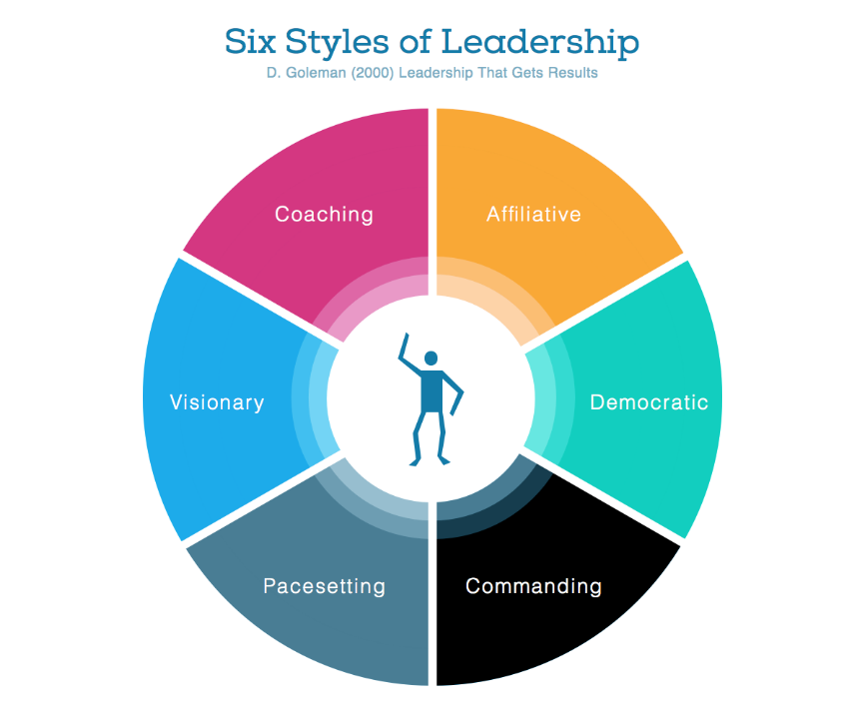
(Goleman, 2000)
1.Introduction
Leadership plays a fundamental role in shaping the culture, direction, and success of organisations. In modern business, effective leaders must balance vision, empathy, and adaptability to respond to rapid technological and social changes. According to Daniel Goleman (2000), leadership effectiveness is closely linked to emotional intelligence and the ability to use different leadership styles appropriately. Goleman identified six styles — authoritative, coaching, affiliative, democratic, pacesetting, and coercive — each suitable for specific contexts. This essay focuses on three of Goleman’s most constructive leadership styles — authoritative, coaching, and democratic. It analyses their key characteristics, advantages, and drawbacks, using real-world examples from contemporary leaders: Satya Nadella (Microsoft), Sheryl Sandberg (Meta/Facebook), and Tim Cook (Apple). The essay concludes by identifying essential leadership skills required today to sustain organisational growth and development.
2.Leadership Theories and Context
Goleman’s (2000) framework is grounded in emotional intelligence, encompassing self-awareness, self-regulation, motivation, empathy, and social skill. Unlike rigid hierarchical models, his approach recognises that leaders must flexibly apply different styles depending on the situation and people involved. The three styles selected — authoritative, coaching, and democratic — are particularly effective in organisations that value innovation, collaboration, and sustainable performance. These styles promote long-term engagement and align with the growing emphasis on ethical and emotionally intelligent leadership (Goleman, Boyatzis & McKee, 2013).
3.Authoritative (Visionary) Leadership – Satya Nadella, (Microsoft)
The authoritative style, also called visionary leadership, is characterised by a clear sense of direction and an ability to unite people behind a shared vision. Leaders who use this style communicate purpose and inspire commitment. Goleman (2000) notes that authoritative leaders say, “Come with me,” giving employees both freedom and clarity about goals.
Example:
When Satya Nadella became CEO of Microsoft in 2014, he inherited a company criticised for its rigid culture and internal competition. Nadella’s leadership transformed Microsoft through a vision of empathy, collaboration, and innovation. He replaced the old “know-it-all” mentality with a “learn-it-all” culture (Harvard Business Review, 2017). By promoting openness and emotional intelligence, Nadella revitalised employee morale and positioned Microsoft once again as a global innovation leader.
Advantages: Provides clarity of direction, motivates through vision, and unites teams during organisational change.
Disadvantages: May appear overcontrolling if the leader’s vision is too dominant or communication one-directional. In Microsoft’s case, Nadella mitigated this by encouraging inclusion and learning, blending vision with humility.
4.Coaching Leadership – Sheryl Sandberg, Meta (Facebook)
The coaching style focuses on personal development and long-term growth of employees. Coaching leaders help individuals identify strengths and weaknesses, linking personal goals with organisational objectives. Goleman (2000) describes this style as ideal when employees show initiative and potential but need guidance.
Example:
Sheryl Sandberg, former COO of Meta (Facebook), exemplified the coaching style by mentoring future leaders, especially women in technology. Through her “Lean In” movement and inclusive leadership philosophy, she created environments where employees felt supported to develop their careers. Sandberg prioritised open feedback and growth conversations, which contributed to team cohesion and high retention rates (Forbes, 2019).
Advantages: Builds commitment, enhances long-term talent development, fosters trust.
Disadvantages: Requires time and patience; may be less effective in crisis situations where rapid decisions are needed. In Meta’s dynamic environment, Sandberg’s coaching approach balanced the intense pace of innovation with human-centred growth, reinforcing Goleman’s principle that empathy and feedback are core to leadership success.
5.Democratic Leadership – Tim Cook, (Apple)
The democratic style is based on participation and shared decision-making. It values collaboration and diversity of thought, encouraging employees to contribute ideas. Goleman (2000) emphasises that this style strengthens team morale and innovation when the leader genuinely listens.
Example:
After the passing of Steve Jobs, Tim Cook adopted a markedly different leadership style at Apple — inclusive, empathetic, and democratic. Cook empowered senior teams to contribute to strategic decisions and cultivated a culture of transparency (The Guardian, 2020). Under his leadership, Apple has become not only highly profitable but also recognised for sustainability and workplace inclusion. Cook’s democratic leadership stabilised Apple after the intense, autocratic era of Jobs, showing that empathy can coexist with excellence.
Advantages: Promotes creativity, shared responsibility, and morale.
Disadvantages: Can slow decision-making and create indecision if consensus is difficult to reach. Cook’s balanced and respectful communication style has mitigated these risks by maintaining clear accountability alongside inclusivity.

6. Comparative Summary Table
Table 1.
Leadership Style | Key Traits | Example | Advantages | Challenges
Autthoritive/ Visionary | Inspiring  Goal-orientated | Satya Nadella (Microsoft) | Clarity  Motivation  Unity | Risk of overreliance on leader’s vision.
Coaching/ Supportive | Developmental  Feedback- focus | Sheryl Sandberg (Meta) | Talent growth  Trust  Long-term engagement | Time- consuming  Less effective in crisis
Democratic/ Collaborative | Pariticipative  Inclusive | Tim Cook (Apple) | Creativity  Morale  Shared responsibility | Slower decision-making  Potential indecision
Source: Authors own
7.Essential Skills for Contemporary Leaders
In today’s volatile and globalised business environment, successful leaders require a combination of emotional intelligence, adaptability, and strategic communication skills. Emotional Intelligence (EI): The ability to manage one’s own emotions and understand others’ feelings underpins all of Goleman’s styles. Nadella’s empathetic leadership illustrates how EI improves collaboration and innovation. Adaptability: Modern organisations face constant change; leaders must switch between styles according to context (Boyatzis, 2018). Cook’s flexibility in balancing inclusion with performance targets demonstrates this. Communication and Feedback: Coaching and democratic styles depend on clear two-way communication. Sandberg’s feedback-driven approach at Meta strengthened organisational learning. Ethical Awareness and Diversity: Leaders must integrate ethics and inclusion into decision-making. Goleman’s framework supports values-based leadership, crucial in global organisations with multicultural teams. Digital Literacy: In technology-driven contexts, understanding data, automation, and remote collaboration is essential for credibility and innovation.
8.Conclusion
Daniel Goleman’s leadership framework remains highly relevant to modern organisations. The authoritative, coaching, and democratic styles demonstrate how emotional intelligence transforms leadership from command to collaboration. Through real-world examples — Nadella’s visionary empathy at Microsoft, Sandberg’s developmental mentorship at Meta, and Cook’s participative inclusivity at Apple — it is evident that effective leaders adapt their approach to people and context. No single style guarantees success; instead, leadership excellence arises from emotional awareness, adaptability, and ethical responsibility. By mastering these principles, contemporary leaders can inspire innovation, sustain engagement, and guide their organisations toward purposeful growth in an increasingly uncertain world.

References:
1. Boyatzis, R.E., 1991. The competent manager: A model for effective performance. John Wiley & Sons.
2. Goleman, D., 2017. Leadership that gets results. In Leadership perspectives (pp. 85-96). Routledge.
3. Colgate, M., 2025. The Importance and Application of a Coaching Leadership Style in Businesses. Businesses, 5(3), p.32.
4. Gutterman, A.S., 2023. Leadership styles. Available at SSRN 4560197.
5. Wooldridge, A., Purdum, B. and Jones, S., 2025. Exploring Goleman’s Leadership Styles Through Role-Playing. Management Teaching Review, p.23792981251348399.
6. Harvard Business Review (2017) ‘How Satya Nadella redefined Microsoft’s culture’, HBR Online, 10 October. Available at: https://hbr.org (Accessed: [insert date]).
7. The Guardian (2020) ‘Tim Cook’s quiet revolution at Apple’, The Guardian, 8 February. Available at: https://www.theguardian.com (Accessed: [14 November 2025]).
8. Forbes (2019) ‘Sheryl Sandberg and the power of coaching leadership’, Forbes Business Leadership, 12 March. Available at: https://www.forbes.com (A 9. Goleman, D. (2000) ‘Leadership that gets results’, Harvard Business Review, March–April, pp. 78–90.ccessed: [14 November 2025]).

