Workplace Culture and its impact on Organizational Efficiency
Academic Report

Student Name: Katalin Fodor
Lecturer Name: Hossein Shokri

Table of Contents

Executive Summary 2
Starbucks brief introduction, history 2
Organisational Culture 3
Starbucks’ Organizational Culture 3
The impact of Covid-19 on the culture and business of Starbucks 5
Starbucks performance 7
Models and Theories 8
Pestle Analysis 11
References 13

Executive Summary

In this report, will be discussed the workplace culture, values, beliefs, and sustainability of an organization of Starbucks. Also, will be a brief introduction/ history of Starbucks, and the growth how become popular. Will be some management theory used to analyse and evaluate the workplace culture for Starbucks. PESTLE analysis will be used to analyse external environment in which Starbucks operates and its impact on Starbucks performance and culture. Also, will be critically evaluate organization of Starbucks corporate culture. The impact of Covid-19 on the culture and business of Starbucks.

Starbucks brief introduction, history

About Starbucks was established in 1971 in Seattle and the time went by, became one of the best-known companies all around the world (IBC Centre for Management Research, 2005). Starbucks is a global coffee roaster and retailer. The company has expanded in the late 1980s and 1990s, and by the 2000s, the company has almost 9000 Starbucks outlets across the world. An important milestone occurred in 1996, when Starbucks opened its first store in Japan and outside North America. The goal what the company dreamed for it was achieved in the 21st century with the increased shareholder value and improving margins by increasing the volume sales of premium coffee. It looks the Premium Coffee market worked well and because of this, the company wants to take advantage of the superior profit margins. According to Interbrand (Best Global Brand Rankings, 2016) Starbucks is positioned 64 globally amongst other premium brands. Starbucks is committed to delivering the innovation, execution, and elevated customer experience necessary to remain one of the world’s most trusted consumer brands. Is not a big word to say, but today, Starbucks is the largest coffeehouse company in the world, with 32,000 stores in 80 countries (Starbucks web side). Starbucks mission to inspire and nurture the human spirit- one person, one cup, one neighbourhood at a time. When talking about coffee, Starbucks is inseparable, as the largest and most famous coffee company, Starbucks has established about 30,000 stores in more than 80 markets around the world (Starbucks, 2020). According to Felton, coffeehouse culture created a sense of intimacy and offer social formations (Felton, 2012). That is why the people returning to the coffee shops, where they feel comfortable spending their time. However, Starbucks and its customers build based on loyalty. Starbucks’ legacy continues to expand, without doubts is the most recognized brands around the world.

Organisational Culture

The culture of an organization affects the way in which people behave and must considered as a contingency factor in any programme for developing organizations. Culture has been described in many ways from different researchers. For instance, Geert et al (2010) stated ‘’ it is the collective programming of the mind that distinguishes the members to one group or category of people from others’’. However, Kottler and Heskett (1992) culture is ‘’ a set of beliefs, values and behaviour’’. Or Deal and Kennedy (1982) addressed culture is short as ‘’the way we do things around here’’. Organizational or corporate culture is the model of values, norms, beliefs, attitudes, and assumptions. ‘Values’ refer to what is believed to be important about how people and organizations behave. ‘Norms’ are the unwritten rules of behaviour. Nevertheless, culture can have significant influence on people’s behaviour. There is another definition about organization culture from different researcher, saying that the culture of an organization refers to the unique configuration of norms, values, beliefs, and ways of behaving that characterize the way groups and individuals, combine to get things done (Eldridge and Crombie, 1974). Deal and Kennedy saying culture is a system of informal rules that spells out how people are to behave most of the time. However, Furnham and Gunter (1993) claim about culture is the commonly held beliefs, attitudes and values that exist in an organization. Putting simpler, culture is ‘the way we do things around here’. Culture is very important component to any organization, as it will define how the unique social and psychological environment of an organization formed. The other definition about organisations, like nations, have cultures’ (Francesco and Gold, 2005). Therefore, organisational culture is seen as the ‘natural’ way of understanding the business world and acting (Francesco and Gold, 2005). Definition for culture is changing significantly over the years from being a description of collective behaviours and norms within the organization. Organization culture requires focus and attentions from leadership and should be consciously embedded in the organizational structure.

Starbucks’ Organizational Culture

Starbucks produces, markets, and retails the coffee as its key product though as a policy they promote the culture the culture where they say that they are not in the business of selling coffee, but they are in the business of selling experience. By 2017 they had more than 10.000 physical facilities managed under it (Business insider.com), also, the company had more than 346.000 employees and sales of USD 26B, from operations spread in more 75 counters (Forbes)
For Starbucks, the size maintaining means a consistent culture throughout the organizer and every level of hierarchy within organization is a managerial challenge. The value asset for the company is to giving people importance and considering them. Starbucks company joined the list of the top companies, where showed it had a strong commitment by invest more its health care plane rather invest more in coffee. Starbucks culture based on inclusion of employees, diversity, and equality. These values are the key for Starbucks culture and respected throughout the organization. A strong culture can shape the firm and impact the company more than a weaker and less managed culture. Strong culture must be deliberately planned and created (Schein, 1985). The company has a strong corporate culture and well communicated, visible in working of its day-to-day functions. The company called their workers or employees ‘’ Partners’’ which is a strong emphasis on employees. The other thing what the Starbucks does, is their ‘partners’ engaged in working and their voice are heard with seriousness and followed through. Allowing them to give new ideas about operations and products. This fact is not only a strong employee motivation but based on personal diversity, the company able to generate new and diverse idea from their employee base. This culture of innovation has created by the company and employee engagement as well. Starbucks company made several points about the cares for its Partners (employees) and make sure all the aspect of diversity, inclusion and equal opportunities are practised in the company. According to (Panmore Institute, 2015) are servant leadership-driven approach: Collaboration and communication: openness, inclusion, and diversity. There is a servant leadership which means the employees and the servant the key figures in the company and they are leads the organization and its success. At Starbucks, its relationship driven approach, creates a friendly and open work environment where all employees at all levels are connected through a bond of friendship and they pass this feeling and care to customers as well. And because of the company has a strong communication networks that helps employees work together as a team and collaborate to fulfil tasks and operational competences. These competences are necessary for a coffee house to be a better service quality, enhanced customer experience and innovation. Openness is also important for the company, promote free flow of information and encourage employees to speak and ask questions without hesitating or without their concern also, share ideas with their supervisors or seniors.
Starbucks also weighs heavily on the Inclusion and Diversity in its corporate environment. This feature shapes Starbucks’ organizational culture is its anti-discrimination policy which prohibits any form of discrimination based on gender, race, ethnicity, sexual orientation, religion, age, cultural backgrounds, life experiences, thoughts, and ideas. The company has a culture to hire people with special needs or disabilities and provide them with technologies to help them in their job and accommodate their short comings. Starbucks partners that are how they call their employees, collectively work to enhance the model of employee inclusion, based on different backgrounds of its partners, the employees, who are employed with a clear view of diversification. The company wants to make sure every employee from manager to the person who serves coffee feel they are part of the organization. Starbucks functions more than 75 countries, which add value and diversity in its employee base, making the organization dynamic and diverse. The Starbucks with its culture able to create innovativeness and higher employment satisfaction. Also, with employee friendly policies resulted a very level of employee turnover, which is not usual in retail-based business. Glassdoor a website the measures employee satisfaction, mentioned that employees at Starbucks are highly satisfied at their work (Glassdoor.com). Starbucks culture that promotes inclusion of employees, enable to build trust, and connect with employees. With high moral at work can result better performance and better service to customers, resulting in customer loyalty and improved organizational performance, also, true for Starbucks as well. According to Kembell, (2002) success of Starbucks’ is because of its strong corporate communications and corporate culture. Employees of the Starbucks have been communicated by management all what they need to learn. Starbucks always investigated what employees want to learn Starbucks has always insured that they get what they wanted to learn or know. (Alvarado et al., 2007).

Starbucks also believe in training and creates learning opportunities for employees, which they can improve their own profile. With the training modules and Courses Company has managed to enhance the performance. Not just make the employees perform better but led to higher motivation too. For Starbucks called the partners rather than employees are like critical asset (IBC Centre for Management Research, 2005). Also, Starbucks is an example of retail company, who provide motivating financial benefits and perks to its partners, even to part time employees as well. Starbucks strategy is to improve business performance through strong culture where its employees understand the core values of the company.

Conclusio

The impact of Covid-19 on the culture and business of Starbucks

The Covid -19 pandemic has changed life patterns and economic conditions, and it affects eating-out behaviour. Because of the risk, Covid- 19 is likely to hinder the sales growth of coffee business, and coffee companies might try to minimize their loss by focusing on quarantine. The apps became very popular. According to Starbucks, the coffee chain’s software application became popular and consumers buying products through its online system more often (Starbucks Stories and News). The quarantine appeared as a critical element for few studies who researched the effect of quarantine and risk perception on consumer behaviour and decision making. Khan, Sarwar and Tan (2020) suggest that consumer buy intention is positively influenced by cosmetic safety. However, studies have examined the impact of Covid-19 quarantine on the consumer buying intention. Starbucks with its loyal customers, it makes the company qualify as the best object for lots of studies. In 2020, Starbucks has more than 30,000 locations worldwide in 80 countries. But Covid-19 forced the company to look for another or new strategy and alternatives to run its business efficiently. The companies try to fight the massive impact this sudden pandemic imposes on them and Starbucks include too. In some areas the negative impact felt where strict quarantine measure restricts production and consumption and convey warnings to managers and stakeholders (Shen et.al, 2020). Unfortunately, the negative impact what Covid -19 caused it was severe and the control of the pandemic was serious. Shen (2020) claimed, many industries have been hit by the pandemic. Starbucks revenue has been affected by Cocid-19 and caused sales drop, what the company not experienced since 2008- 2009 financial disaster (Levine, 2020). Levine (2020) stated the loyal customers of Starbucks the main advantage, also explained more than 44% business profit comes from its loyalty program members. Starbucks is a good example of how developed its brand image through simple way, without advertising was able to be sold of its product and make profit. The pandemic challenges organizations’ ability adapts. The company provide their online system service on the internet. However, the company did not anticipate this pandemic. Lots of companies had to turn their business through online services fully or partially. Such as fast-food chains, restaurants already had apps before, so they offered this option to their customers and take their products online. However, this process remains challenging, as Starbucks did not take further steps yet to ensure customers’ satisfaction while fighting the impact of pandemic. The World Health Organization (WHO, 2020) addressed that wear mask could minimize the spread of Covid-19; people less likely contract the virus if they wear masks in public places. Starbucks issues the policy and asks employees and customers must wear mask or face shield when they enter the coffee shops or just visiting the company. This policy not just try to prevent the virus, but also help the cooperation keep its image amongst its customers. Most restaurants, fast food chains and cafes closed their location because of the pandemic and only operated their product through ordering or delivery (Rizou, et. al, 2020). However, Starbucks using its app and makes the customer easy to buy products without visiting the coffee shop. The COVID-19 pandemic causes problems for employees and customers at Starbucks, interfering customer satisfaction. Due to its risks and the massive spread of infection, this disease has caused employees to work in the coffee shop, often when employees get sick and need to be quarantined, and they must pay medical fees. However, most Starbucks employees reported that they are happy with the salary what they earn. Also, Starbucks guaranteed to its employees will be covering the medical fees if they need to be in quarantine (Starbucks, 2020). This state was implemented several countries and that helped Starbucks grow its reputation among customers. Also washing hands, before eating the consumers strongly advised (WHO, 2020). The other thing what the World Health Organization (2020) suggest that the virus can be transmitted via metals, utensils, and surfaces, and because of that recommended for restaurants and catering industries extra care and proving their customers how clean their stores. Starbucks company provide hand sanitizers all its branches, furthermore, carefully understand the hygienic procedures when creating the products (Starbucks, 2020). If one of the employees of Starbucks suffer or have contracted Covid-19 or had a close relationship with someone in their store, the company offers some helpful payment, or for older people offers disaster pay.
According to Rosann Williams, the executive vice president and president, U.S. company-operated business and Canada, if employees could not return to work even after the previous payments, additional pay replacement may be made up to 26 weeks.

Starbucks performance

Millions of people all around the world walk into Starbucks and getting their cup of coffee, because what Starbucks give to people is a friendly environment and helpful staff who assist customers in any questions or issues they might have with the coffee or with the service. People like to buy from Starbucks because what represent and status symbol that comes along with. The culture of an organization is a major variable in corporate performance. Culture of an organization creates set of other organizational actions that together create high level of performance and corporate success (Ojo, 2014)
Starbucks success will be stated by Schultz (1994) ‘’When people ask me about the reasons for Starbucks success, I tell them not what they expect to hear. I tell them that it was the people at Starbucks and the way we managed them that was the true differentiating factor.’’ Starbucks has become a global brand, and the leader in its space, with more than $10 billion in revenues in 2011. This has been accomplished by managing its corporate culture, an intangible but real economic asset. Starbucks business requires significant changes around the world as quickly and dynamically as possible to be able to meet their customers, partners and communities needs during the Covid-19 pandemic. Using the ritual of connecting over coffee to uplift the everyday experience and drive deeper human connection. Starbucks want to continue and examine how the company can most responsively and constructively serve their communities and the planet going forward. Starbucks realized the world is small and need to take care of it and each other too. Understanding the interdependency of the health of humanity and the health of the planet. The company feel the threat of greater economic disparity in the future, as COVID-19 is often impacting socioeconomically disadvantaged communities more than others. Organization’s culture controls the way employees perceive and respond to the people and situation around them and how they use this information to make decisions (George and Jones, 2012). As a way of enhancing business performance, Starbucks instituted reforms in its organizational culture. Today, the company’s organizational culture is a distinct characteristic that builds competitive advantage and develops a consumer population of loyal Starbucks fans. Robbins and Judge (2013) define organizational culture as a system of shared meaning held by members that distinguishes the organization from other organizations.

Models and Theories

As the Global markets increasing international competition for managers necessary to understand the domestic culture but the host country culture too. Cross-cultural management is important and need to understand the cultural differences will become essential. Globalisation is around businesses and life too. Comes with strengths advantages also weaknesses and threats. Global weakness has just taken place in form of the global financial crisis, which has shaken markets worldwide and led Iceland into bankruptcy (Amadeo, 2008; Cline, 2010). ‘In the light of globalization and the rapid changes facing the world the need for understanding how people from different cultures interact and communicate has assumed a staggering importance’ (Bhawuk, 2008, p. 305). Various business model exists, the principles and structure of Starbucks is a good model to follow.
To evaluate the Corporate Culture of the Starbucks the Model of Developed will be used by Cameron and Quinn, called Competing Value Framework (CVF), which measure and monitor organizational culture (Cameron and Quinn, 1999). This model measures the culture in two-dimension matrix. The first one is flexibility and employee freedom and engagement and the second one is stability and rigid control. All organizations have cultures or sets of values which influence the way people behave in a variety of areas, such as treatment of customers, standards of performance, innovation, etc. For many people, Starbucks Coffee Company is an enigma. Corporate culture what Starbucks has is the sixth component of the Organisation Evolution Framework. Also, Starbucks has servant leadership which significantly characterizes the company’s organizational culture.

Culture with the organization Evolution framework.

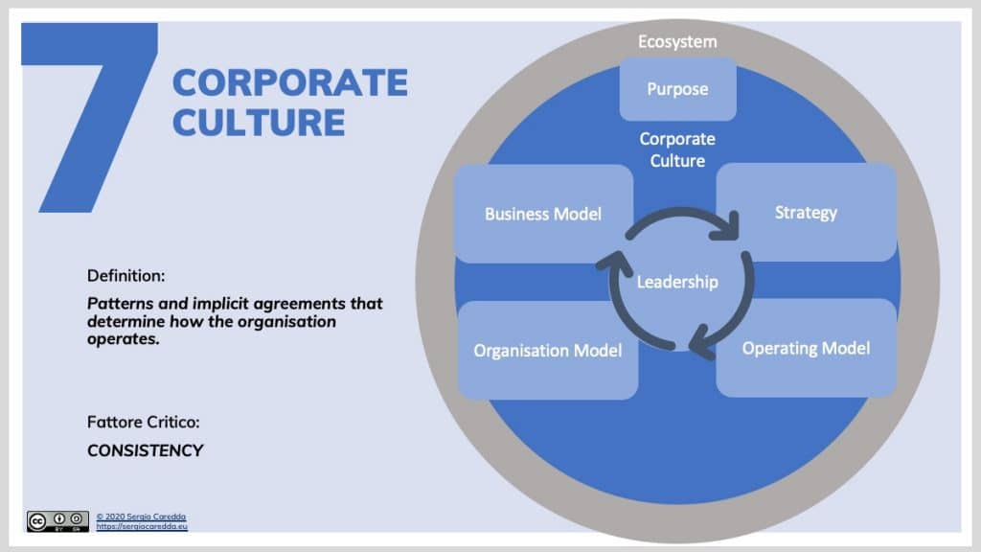
Corporate Culture | Organisation Evolution Framework

Hofstede Model of Organisational Culture is a world- known expert in culture, developing model that identified several components in the so called six-dimension model Hofstede, 1985).
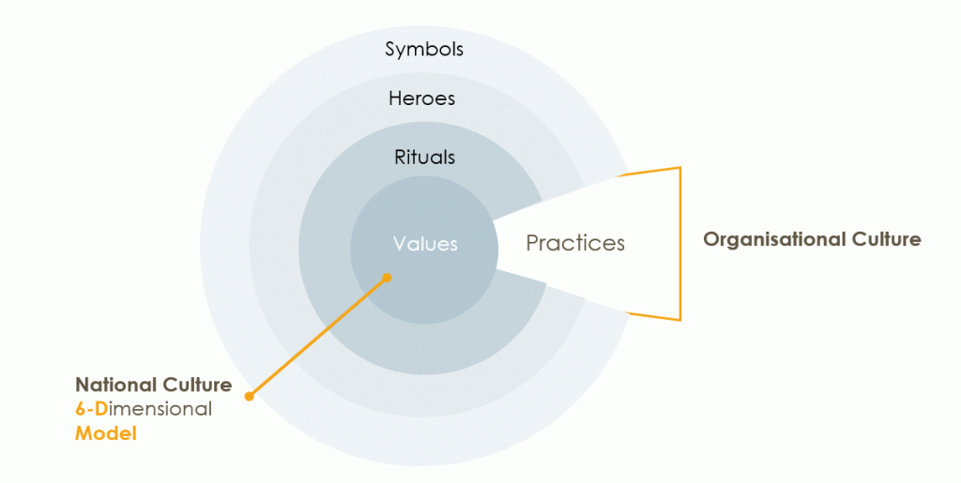 Hofstede’s Culture Onion. (Hofstede and Hofstede, 2005) Source: Hofstede Insights
Essentially the idea expanded by Hofstede is that organisational Culture touches upon the outer 3 three layers of the so-called, “culture onion” – working practices exemplified by symbols, heroes, and rituals.
Another Culture called Cultural web, is useful tool for analysing and altering assumptions surrounding the Culture of an organization. Also, can be used to highlight specific practices and beliefs to align them with the strategy subsequently.

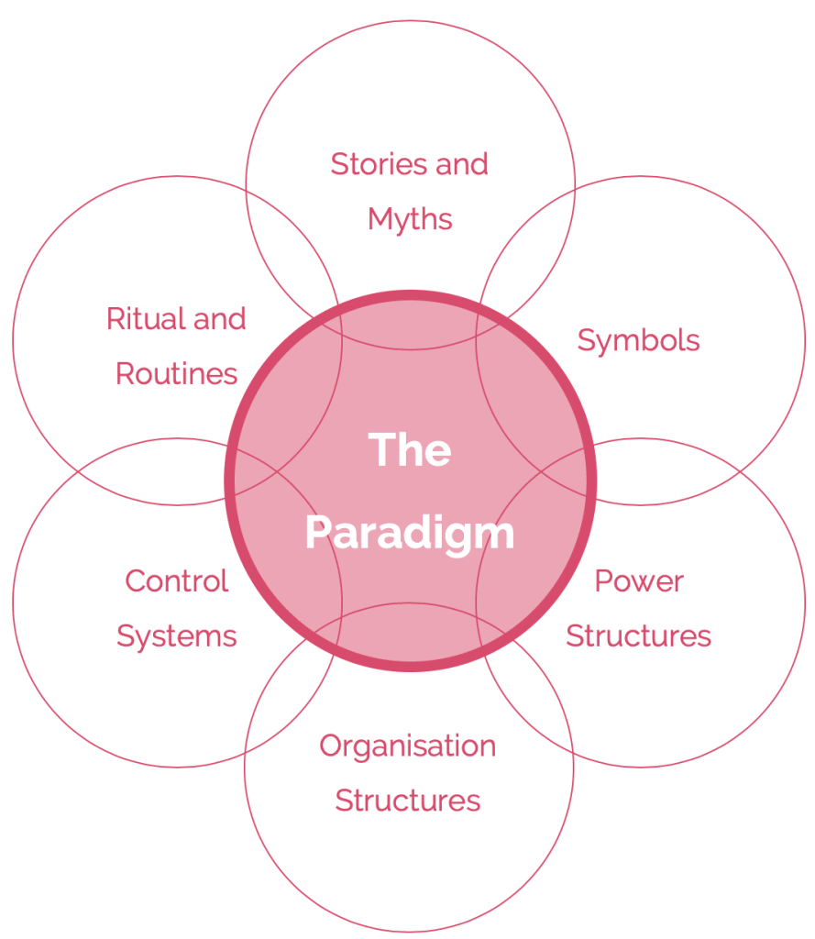
Cultural Web Model. Source: BusinessBall

Johnson and Scholes identified six distinct but interrelated elements which contribute to what they called the “paradigm” of an organisation, equivalent to what others define as the pattern of the work environment, or the values of the organisation. The other model is Organizational Culture framework developed by Spencer Stuart, and this culture focusing on eight dimensions (Singh and Mark, 2017). The dimensions are identified on two axes which is People interaction and Response to Change.

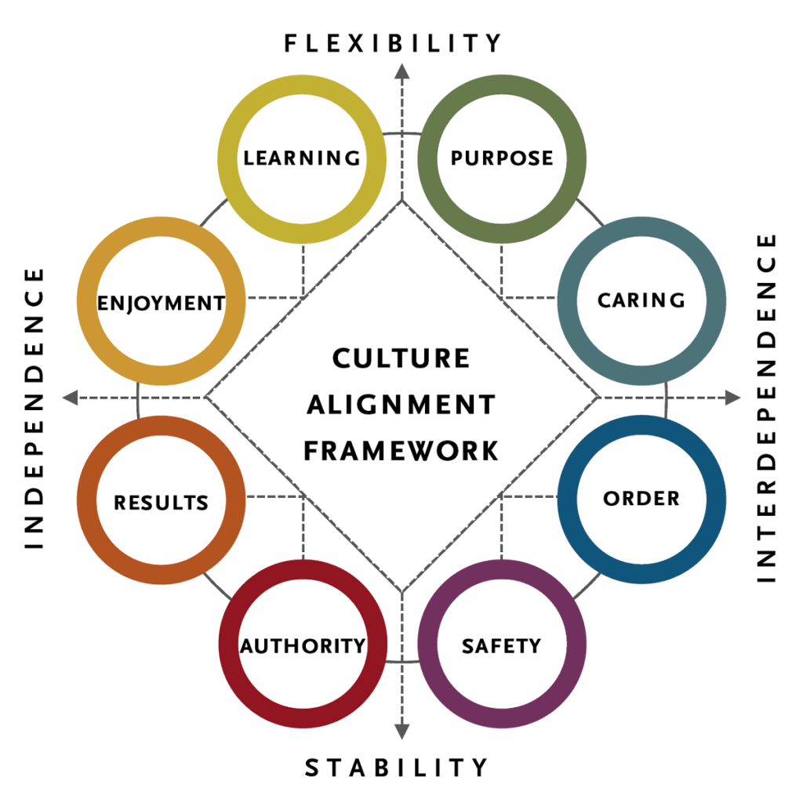
The Organisational Culture Framework. (Singh and Mark, 2017) Source: Spencer & Stuart

Pestle Analysis

PESTLE analysis framework identifies the impact of governments on business. Starbucks experiences some political external factors which are the regional integration of markets which is an opportunity for Starbucks to globally expand. The other things which that can be an opportunity for Starbucks is an improving governmental infrastructure, can access more markets and suppliers. The bureaucratic red tape persist can be a threat for Starbucks as makes business expand more difficult.
Economic factors can be a high growth of developing countries which is an opportunity for Starbucks to gain more revenues from various markets all around the world. However, the raising labour cost in developing countries is an external factor and threat for Starbucks because it increases the company’s spending for ingredients.
Social factors can be a growing coffee culture which is an opportunity for Starbucks to increase its revenue based on increasing demand for speciality coffee. The other factor which is another opportunity for Starbucks is to widen its array of more healthful products to attract health-conscious consumers.
Technological factor and related trends are identified such as rising mobile purchases especially during covid the mobile app and linked services increased and gained more revenues. Also, the other opportunity was shown to improve its supply chain based on new technologies coffee farmers use. Also, a threat affects Starbucks by using this home -use coffee machines.
Economical factors can be the business sustainability trends which is an opportunity. Starbucks has an opportunity to enhance its performance growing popular support for responsible sourcing, also for environmentally friendly products.
Legal Factors for Starbucks is to improve its performance by satisfying products safety regulations and regulations on ingredients from genetically modified organisms (GMOs). However, increasing staff regulation in developing country can be a threat for Starbucks Coffee’s access to the work market.

References

Alvarado, S. M. D. M. R. a. W. F., 2007. “Starbucks Corporation”. St. John’s University.. [Online]
Available at: Retrieved from http://www.stjohns.edu/media/3/1777fbd1bc794c54adc4265a33eea786.pdf
Anon., n.d. Glassdoor. [Online]
Available at: https://www.glassdoor.co.in/Reviews/Starbucks-New-York-City-Reviews-EI_IE2202.0,9_IL.10,23_IM615.htm?filter.defaultEmploymentStatuses=false&filter.defaultLocation=false
Brewer, R., n.d. Starbucks (SBUX). [Online]
Available at: https://www.forbes.com/companies/starbucks/#73b8f5f28acb
Cameron, K. a. Q. R., 2005. . Diagnosing and Changing Organizational Culture: Based on the Competing Values Framework. John Wiley & Sons., s.l.: John Wiley and Son.
CAREDDA, B. S., 2020. THE ORGANISATION EVOLUTION FRAMEWORK. [Online]
Available at: https://sergiocaredda.eu/organisation/organisation-design/corporate-culture-the-theory-and-the-practice/#Handy_Model_of_Organisational_
[Accessed 26 November 2020].
Company, S. C., 2015. Company information- Starbucks Coffee Company. [Online]
Available at:
Daisy Mui Hung Kee, M. F. S. A. L. A.-A. M. M. H. A. A. K., 2019. Navigating Through the COVID-19 Crisis: A Case Study of Starbucks. [Online]
Available at: file:///C:/Users/katal/Downloads/1030-2112-1-SM.pdf
Deal T.E. and Kennedy, A., 1982. Corporate Cultures: The Rites and Rituals of Organizational Life, . In: Reading, : Addison- Wesley.
FERGUSON, E., 2019. Starbucks Corporation’s Organizational Culture & Its Characteristics. [Online]
Available at: http://panmore.com/starbucks-coffee-company-organizational-culture
[Accessed 20 Februar 2019].
George, J. &. J., 2012. Understanding and managing organizational behavior.. 6 ed. New Jersey: Prentice Hall.
George, J. a. J. G., 2012. Understanding and managing organizational behavior. 6 ed. New Jersey: Prentice Hall.
Hofstede, G., 1985. Culture’s Consequences : Comparing values, behaviors, institutions, and Organizations across Nations. Thousand Oaks, Calif.: Sage.. 1 ed. Thousand Oak :California: Sage.
Johnson, S. :. K., 2019. GLOBAL SOCIAL IMPACT REPORT. [Online]
Available at: https://globalassets.starbucks.com/assets/38b8ab8576d24aa78170e46fd2a51acc.pdf
Kembell, B. M. H. S. K. L. P. a. L. O., 2002. “Catching the Starbucks Fever”. Missouri State University. [Online]
Available at: Retrieved from: http://www.academicmind.com/unpublishedpapers/business/marketing/2002-04-000aag-catching-t
[Accessed April 2002].
Khan, N., Sarwar, A. & Tan, B., 2020. Determinants of purchase intention of halal cosmetic products among Generation Y consumers.. In: M. J. Islam, ed. [CrossRef]. s.l.:Cross Ref, pp. 1-21.
Kotter, J. &. H. J., 1992. Corporate Culture and Performance.. s.l.:s.n.
Management, P. I. B., 2015. Starbucks Coffee Company’s organizational culture.. [Online]
Available at: [Accessed 22/9/2016] Retrieved from http://panmore.com/starbucks-coffee company- organizational-culture
[Accessed 2015].
Managment, P. I. B., 2015. Starbucks Coffee Company's organizational culture. [Online]
Available at: http://panmore.com/starbucks-coffee-company-organizational-culture
[Accessed 22 09 2016].
Minkov, G. H. &. G. J. H. &. M., 2010. Cultures and Organizations. In: Cultures and Organizations. s.l.:s.n.
Morcos, M., 2018. ORGANISATIONAL CULTURE: DEFINITIONS AND TRENDS. [Online]
Available at: https://www.researchgate.net/publication/329140215_ORGANISATIONAL_CULTURE_DEFINITIONS_AND_TRENDS
[Accessed 2018].
News, S. S. a., 2019. Starbucks Backs Restaurant Tech Company in Creation of End-to-End Digital Platform.. [Online]
Available at: Available online: https://stories.starbucks.com/press/2019/Starbucks-Backs-Restaurant-Tech-Company-in-Creation-of-End to-End-Digital-Plat
[Accessed 2020].
Research, I. C. M., 2005. Starbucks 'human resource managment policies and the frowth challenge. [Online]
Available at: http://www.icmrindia.org/casestudies/catalogue/Human Resource and Organization Behavior/HROB068.htm
[Accessed 12 09 2016].
Robbins, S. &. J. T., 2013. Organizational behavior.. 15 ed. USA: Prentice Hall.
RTTNews, 2018. Starbucks To Change Organizational Structure. [Online]
Available at: https://markets.businessinsider.com/news/stocks/starbucks-to-change-organizational-structure-1027560305
[Accessed 24 September 2018].
Schein, E. H., 1985. Organizational culture and leadership. San Francisco: Jossey-Bass .
SMITHSON, N., 2017. Starbucks Coffee PESTEL/PESTLE Analysis & Recommendations. [Online]
Available at: http://panmore.com/starbucks-coffee-pestel-pestle-analysis-recommendations
[Accessed 31 January 2017].
Starbucks, 2020. Starbucks: About us. [Online]
Available at: https://www.starbucks.co.uk/about-us

