Jake Weeks Methodology

Aim-To evaluate how the portrayal of UK policing on social media impacts public perception and confidence in the police.

Objective 1- Identify how the police are portrayed on social media within the UK.

Objective 2- Analyse the impact that negative social media coverage has on the perception of the police.

Objective 3- Explore the use of social media in promoting positive public perception of the police.

With the Literature Review showcasing the different types of opinions and incidents that have lead to public perception differing. Although there was some useful information discovered, there are heavy gaps in the research which do not provide decisive answers concerning the public's evaluation of the effectiveness of police communication. With the Literature Review being secondary research from other sources, the Methodology will focus on the methods in which all primary research for this study with be gathered.

The research onion, which was first proposed by Saunders et al., provides a thorough framework that helps researchers navigate the complexities involved in planning and carrying out a thorough investigation (Flick, 2011). It is divided into layers, each of which stands for an important phase of the research process. Starting from the deepest layer, investigators recognise and explain their research philosophy, which includes ontological and epistemological viewpoints. It is then decided which of the two methodologies to use, inductive or deductive, before deciding on an overall study plan (McNeill et al., 2005). The next step is to choose the time horizon, which can be either longitudinal or cross-sectional. Lastly, the identification, explanation, and defence of data collection techniques comprise the topmost layer.

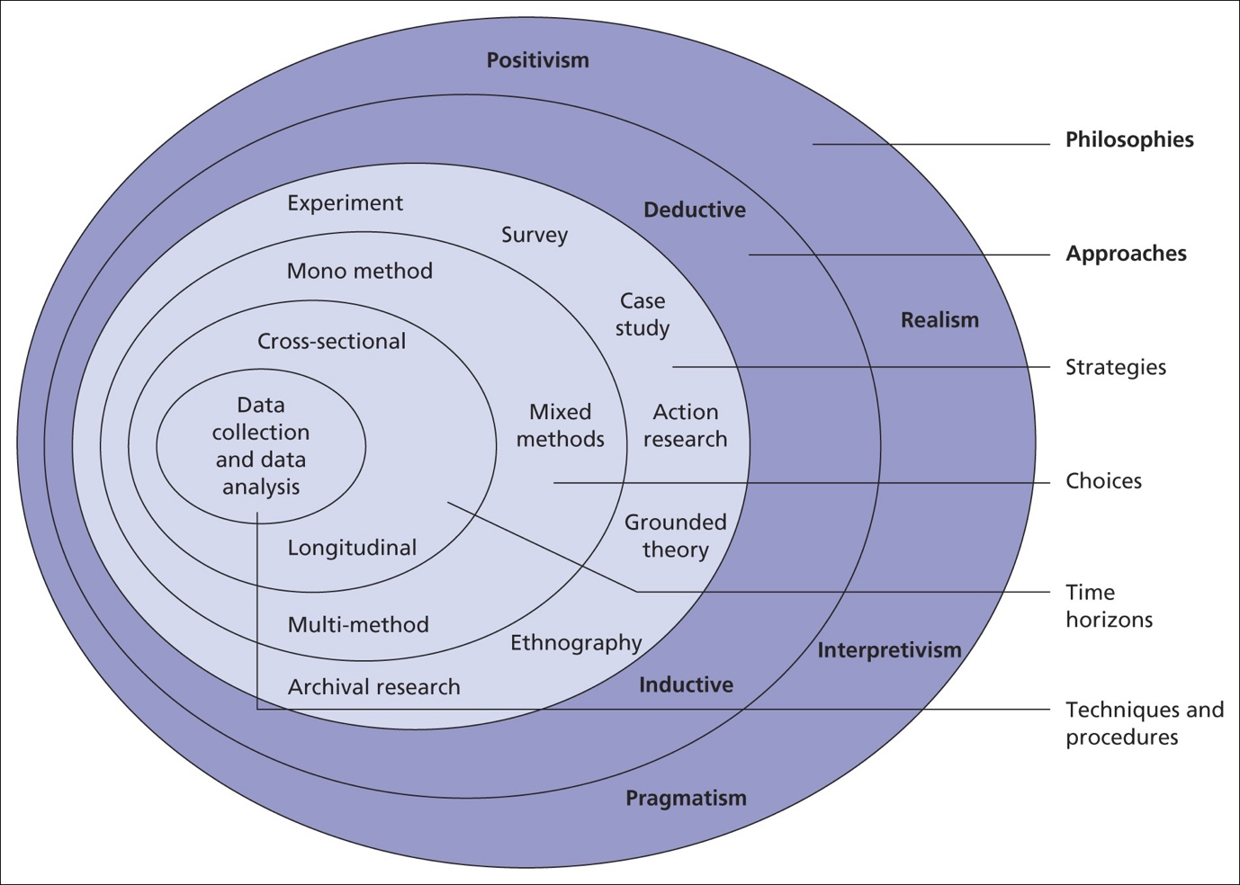

(Saunders et al., 2023)

Philosophy

The research philosophy is crucial due to it creating the framework that the rest of the study is built around (Saunders et al., 2023). It entails determining the ontological and epistemological stances of the researcher and matching them to the goals of the study (Meyer et al., 2016). This part effectively acts as the foundation for all other decisions, promoting a well thought out and coherent study design. For this particular study, a interpretivist perspective will be used, rather than a positivist or pragmatic one. An interpretivist proposal will be more beneficial to the survey that this study is carrying out, which will be taking in subjective opinions from numerous individuals. As well as this, an interpretivist perspective would be more suited to the wide range of opinions that people may have, with so many unique perspectives being able to be taken into account (Mcmillan et al., 2012). This is especially suited to this particular topic, with (Nikolovska et al., 2020) believing that policing being an opinionated topic.

Approach

Meyer et al (2016), states that the approach is an important part of the research study as sets the different strategies set out to investigate the research question and objectives. It acts as a guide for all research decisions, directing gathering, analysing, and interpreting data. This section determines the overall approach of the methodology, impacting the choice of research techniques and the general structure, regardless of whether a deductive or an inductive approach is taken (Proudfoot, 2023). For this particular section, an inductive approach will be most appropriate for taking on the research question, where the discovered research will be able to be used to create numerous different theories. With the topic of police perception on social media having numerous gaps, the inductive approach can allow for different theoretical perspectives to emerge. By allowing themes and patterns to organically arise from the data, the inductive approach promotes a more exploratory and open-ended exploration of the research topic. This is particularly relevant in the context of police perception on social media, where the complexities and evolving nature of online interactions require a significant understanding (Fielding, 2023).

Strategy

The methodology's strategy is crucial in determining the general course of the research project. It describes the overall strategy that will be used to answer the research question, gather information on the chosen topic, and accomplish the goals of the study (Baldwin et al., 2009). The technique used for this study calls for using a survey as the main means of gathering data. A survey will allow for a vast amount of opinions and statistics to be used for descriptive writing (Golde, 2019). The survey results in this study will be harnessed for descriptive writing to vividly portray and analyse the diverse perspectives on the police's presence on social media. The study will employ descriptive writing techniques to provide a complex representation of the many opinions towards the topic. It will also explore the specifics of how people view and engage with police forces on social media sites.

Choices

Saunders et al. (2023) provides a detailed description of the methodology's choices section, defining research choices in terms of the application of both quantitative and qualitative research methods, as well as the combination of both or the use of mono approaches. These choices, which range from picking research techniques to implementing certain strategies, guarantee compliance with the goals of the study (Feilzer, 2010). In this study, a mixed-method approach will be taken, which combines qualitative and quantitative data collection techniques. This decision is significant because it enables a deeper, more in-depth investigation of the study question. Qualitative data, which is obtained through techniques like interviews or open-ended survey questions, offers a deeper understanding of the underlying motivations and details within those perspectives, whereas quantitative data from the survey provides statistical insights into the prevalence of certain perspectives (Silverman, 2021). The study intends to leverage the advantages of both qualitative and quantitative data by utilising a mixed-method approach, promoting a more comprehensive and multidimensional examination of the complexities surrounding the perceptions of the police on social media.

Time horizon

The Time Horizon is crucial since it establishes the study's timeline, which affects how data is gathered and examined (Carter, 2018). The Time Horizon selection is essential for determining the timeframe within which the study captures the diverse perspectives and fluctuations in attitudes related to the research question, all depending on how long the data is going to be gathered for (Clark., et al 2021). In this chosen study a cross-sectional strategy will be implemented, gathering the needed data all at once. This decision is significant as it aids in answering the research question regarding how people view the police on social media in modern times. Using a cross-sectional approach allows for the most recent possible opinions and statistics to be gathered, which can then be compared and contrasted with previous data found to see how attitudes and ideologies have changed (Greetham, 2019). This strategy guarantees that a pertinent and current understanding of participants' perspectives, especially considering the dynamic nature of online interactions, is obtained.

Techniques for data collection, process and analysis

The methods for gathering, processing, and analysing data are essential parts of the research technique since they define the study's overall quality, validity, and depth (Flick, 2018). In the data collection process, a survey will be employed as the primary technique to gather insights related to the research question and objectives. Utilising platforms like Microsoft Forms or Google Sheets will facilitate efficient data collection, ensuring a broad and diverse sample that aligns with the study's scope and objectives. The sampling approach will involve selecting participants from various demographics and social media users to capture a comprehensive range of perspectives. This inclusivity is crucial for addressing the first objective, aiming to identify diverse portrayals of the police on social media. Upon collecting the data, the analysis will follow a thematic approach. Thematic analysis involves systematically organising and identifying patterns within the qualitative data, allowing for a nuanced exploration of the research question. Each objective will be addressed through the identification of themes related to the portrayal of the police on social media, the impact of negative coverage, and the role of social media in promoting positive perceptions.

Sampling

Sampling plays a crucial role in research methodology, shaping the validity and reliability of study findings (Brereton et al., 2022). Sampling, in this case, the way the UK police is portrayed on social media, directly affects the breadth and depth of insights gained by choosing a group of people or units from a wider population. A representative and varied sample guarantees the collection of a broad spectrum of viewpoints, which is consistent with the goals of the study and improves external validity. Furthermore, careful sampling reduces biases and guarantees that the results fairly represent the range of viewpoints within the target population, enhancing the validity and relevance of the research (Neuman et al., 2011).

Survey design

In research, survey design is crucial since it has a direct impact on the calibre and dependability of data that is gathered. An appropriately constructed survey guarantees that the goals of the research are met and that the information appropriately captures the viewpoints of the participants. It helps researchers by offering a methodical framework for data collection, leading participants through pertinent subjects, and reducing response bias. It is particularly beneficial for the survey design to include both closed-ended and open-ended questions because this enables a thorough examination of participants' perspectives and experiences (Gummer et al., 2022).

Ethical considerations

Surveys that gather data must take ethics seriously in order to respect the rights, welfare, and privacy of the participants. Prioritising ethical norms is crucial for researchers in order to uphold honesty and trust throughout the study process (Brittan et al., 2020). By safeguarding vulnerable groups, the study's requirement that participants be at least 18 years old contributes to the upholding of ethical norms. Ensuring confidentiality protects the privacy of participants and promotes candid and open communication. Respect for autonomy is demonstrated by voluntary participation, which gives people the freedom to choose whether or not to participate in the poll without being forced to. By giving participants the researcher's contact information, they can raise questions or voice concerns, encouraging openness and responsibility. These moral considerations support the rights of participants while also enhancing the validity and integrity of the study.

References

Baldwin, M.A. and Rose, P. (2009). Concept analysis as a dissertation methodology. Nurse Education Today, 29(7), pp.780-783. (Accessed February 7th, 2024)

Brereton, J.E., Tuke, J. and Fernandez, E.J. (2022). A simulated comparison of behavioural observation sampling methods. Scientific Reports, 12(1), p.3096. (Accessed February 1st, 2024)

Brittain, S., Ibbett, H., de Lange, E., Dorward, L., Hoyte, S., Marino, A., Milner‐Gulland, E.J., Newth, J., Rakotonarivo, S., Veríssimo, D. and Lewis, J. (2020). Ethical considerations when conservation research involves people. Conservation Biology, 34(4), pp.925-933. (Accessed February 5th, 2024)

Carter, C. ed., (2018). Successful dissertations: The complete guide for education, childhood and early childhood studies students. Bloomsbury Publishing. (Accessed February 3rd, 2024)

Clark, T. et al. (2021). Bryman’s social research methods. 6th edition. Oxford: Oxford University Press. (Accessed February 4th, 2024)

Fielding, N.G. (2023). Police communications and social media. European Journal of Criminology, 20(1), pp.316-334. (Accessed February 1st, 2024)

Feilzer, M. Y. (2010). Doing mixed methods research pragmatically: Implications for the rediscovery of pragmatism as a research paradigm. Journal of Mixed Methods Research, 4(1), pp.6-16. (Accessed February 5th, 2024)

Flick, U. (2011). Introducing research methodology: A beginner’s guide to doing a research project. (Accessed February 2nd, 2024)

Flick, U. (2018). The SAGE handbook of qualitative data collection. First edition. Thousand Oaks, California: SAGE Incorporated. (Accessed February 7th, 2024)

Golde, C.M. and Allen, J.E. (2019). The productive graduate student writer: How to manage your time, process, and energy to write your research proposal, thesis, and dissertation and get published. Routledge. (Accessed February 2nd, 2024)

Gummer, T., Christmann, P., Verhoeven, S. and Wolf, C. (2022). Using a responsive survey design to innovate self-administered mixed-mode surveys. Journal of the Royal Statistical Society Series A: Statistics in Society, 185(3), pp.916-932. (Accessed February 5th, 2024)

Greetham, B. (2019). How to write your undergraduate dissertation (Vol. 108). Bloomsbury Publishing. (Accessed February 2nd, 2024)

McMillan, K. and Weyers, J. (2012). How to write dissertations & project reports. Pearson Education. (Accessed February 9th, 2024)

McNeill, Patrick. and Chapman, S. (2005). Research methods. 3rd ed. London: Routledge. (Accessed February 1st, 2024)

Meyer, J.P. and Morin, A.J.S. (2016). “A person-centered approach to commitment research: Theory, research, and methodology,” Journal of organizational behavior, 37(4), pp. 584–612. Available at: https://doi.org/10.1002/job.2085. (Accessed February 7th, 2024)

Neuman, W.L., Nardi, P.M., Berg, B.L., Jackson, W., Varberg, N., Robson, K., Christensen, L.B., Johnson, R.B. and Turner, L.A. (2011). Research Methods in Communication. (Accessed February 5th, 2024)

Nikolovska, M., Johnson, S.D. and Ekblom, P. (2020). “Show this thread”: policing, disruption and mobilisation through Twitter. An analysis of UK law enforcement tweeting practices during the Covid-19 pandemic. Crime science, 9(1), pp.1-16. (Accessed February 4th, 2024)

Proudfoot, K. (2023). Inductive/Deductive hybrid thematic analysis in mixed methods research. Journal of Mixed Methods Research, 17(3), pp.308-326. (Accessed February 5th, 2024)

Saunders, M., Lewis, P., & Thornhill, A. (2023). Research Methods for Business Students. (9th ed.) Pearson. https://www.pearson.com/en-gb/subject-catalog/p/research-methods-for-business-students/P200000010080/9781292402727 (Accessed February 5th, 2024)

Silverman, D. (2021). Doing qualitative research. Doing qualitative research, pp.1-100. (Accessed February 6th, 2024)

