
University of Wales Trinity Saint David
Assessing the Impact of Staff shortage and staff turnover in the Ibis Bradford Hotel
Hotel Placement Research Project Module code: BMIH6008
Lecturer: Christopher Wilkin

June 8, 2025
LEVEL 6 Wordcount 7631

Student Name: Shahd Omer
Student ID: 2130010

Abstract

This report emphasises the significant consequences of staff shortages and turnover at the Ibis Bradford Hotel. These have had negative effects on day-to-day operations, the quality of service, guest satisfaction, and overall performance. The report used the case study of the Ibis Bradford Hotel to examine the interconnectivity of the problems, as a shortage of staff gives rise to inadequate service, dissatisfied guests, increased costs in recruitment and training, as well as reduced profits. To solve it, the Ibis Bradford Hotel must act decisively to lower staff turnover rates and enhance retention. This is achievable through the provision of improved compensation, offering opportunities for advancement, as well as enhancing the working environment. The hotel must also invest in efficient recruitment strategies and state-of-the-art recruitment tools to hire the right personnel and make the workplace more enticing. In all, these measures are required to minimise employee turnover rates and make the Ibis Bradford Hotel a comfortable environment for visitors as well as employees.

I confirm that I have not used any AI tools in the research and creation of this assignment. I confirm that I have not presented any AI-generated materials as my work. I confirm I have copies of my drafts, notes, and other resources I used, which I may be asked to provide as evidence

Table of Contents
1. Introduction 5
2. Literature review 6
3. Methodology 10
4. Case study 12
4.1 SWOT Analysis 14
4.4. Evaluation 22
5. Thematic analysis 24
6. Financial Impact on Ibis Bradford Hotel: 28
7. Customer Experience at Ibis Bradford Hotel: 29
8. Retention Strategies at Ibis Bradford Hotel: 30
9. Strategic Planning for the Ibis Bradford Hotel: 32
10. Workplace Culture and Employee Engagement at Ibis Bradford Hotel: 33
12. Conclusions and Recommendations 35
12.1. Conclusion 35
12.2. Recommendations 36
13. Reffrences………………………………………………………………………………………34

Acknowledgement

First, I want to thank myself for the hard work, resilience, and determination that have helped me throughout this journey. Taking on this placement project while managing various personal and academic responsibilities has required a great deal of self-discipline and perseverance, and I am proud of the dedication I have shown throughout.

I would also like to extend a huge thank you to my children and my best friend Basil Dawalbeat, whose endless love, patience, and support have been a constant source of motivation for me. Their understanding and encouragement have kept me going during tough times and inspired me to keep pushing toward my goals.

Finally, I want to sincerely thank my tutors at the University of Wales Trinity Saint David for their invaluable guidance and support. Their feedback and expertise have provided crucial direction throughout this project and have significantly contributed to my growth both professionally and personally.

This experience has been both tough and rewarding, and I am genuinely thankful for all the growth it has brought me.

1. Introduction

Staff shortages and turnover rates pose one of the greatest challenges to businesses nowadays. No organisation can operate efficiently without a committed and reliable staff. This paper explores the staff issues existing in the case of the Ibis Bradford Hotel to determine the causes and recommend possible means of resolving them. Ibis Bradford Hotel has a reputation for offering value for money comfort with excellent customer service in a popular, expanding city centre. It has the appeal to attract visitors, business travellers, as well as people living locally. Behind the scenes, however, lies the serious staff problem underpinning the pressure on service quality as well as the overall performance of the hotel. Not enough staff are the root issue. When the demand for hotel services grows, particularly in the high season, the staff is usually less than required to meet it. It causes additional stress to the current staff, resulting in burnout. Consequently, visitors end up experiencing delays, subpar services, or a disappointing experience. It repels repeat customers, generates complaints, and reduces revenue. The second significant concern is excessive staff turnover. Employees leave regularly, and new workers must be constantly recruited and trained. This "revolving door" hinders the establishment of solid, experienced staff. When experienced workers leave, the valuable knowledge and experience they bring with them harm the quality of the services even further. These staffing challenges not only reduce customer satisfaction but also harm the hotel’s reputation and long-term success. Addressing them is critical to creating a better workplace and delivering the service guests expect.

2. Literature review

Among the largest challenges confronting the hospitality sector is staff shortage as well as staff turnover. It impacts the efficiency with which a business is managed, the satisfaction of the customers, as well as the financials of the company. The goal of this paper is to discuss existing research and knowledge regarding staff shortage as well as employee turnover in the hospitality industry. To bring about emphasis to such a consideration in the hotel business (Singh, and Amandeep, 2017) investigated the effects of employee turnover in the hotel market in New Delhi. It revealed that the high turnover resulted in lower staff coordination, reduced guest satisfaction, as well as worse brand image. The authors cited low wages, lack of career advancement, as well as unsatisfactory working environment as root causes of turnover. Staff shortage as well as staff turnover in the hotel industry have been examined in another study. The staff turnover issue has been examined in the hotel industry by (Narkhede, 2014). The research revealed that the staff turnover issue is impacted by numerous causes, including employee dissatisfaction with the relationship with the superiors, work environment, work schedule, workload, salary as well and compensation. This research examined the causes of turnover in food-serving hotels in the city of Jalgaon, the data were obtained from serving staff using structured timetables. The research highlights the significance of effective staff retention as well as the maintenance of a healthy working environment to curb turnover. In related research, (Kysilka, et al., 2013) examined employee turnover, or the rate at which workers leave and get replaced in an organisation. It established that some turnover is natural and even beneficial, but excessive turnover can lead to severe complications. The research established that high turnover normally indicates workers do not remain long, resulting in higher costs and disruption in the workplace. It indicated organisations must have good strategies to retain workers and provide an improved working environment to lower turnover. In the same vein, (Santhanam et al.,2017) designed research where one can see the impact of groups of human resource management (HRM) practices, as well as broken promises between employers and workers, on workers who want to leave work, particularly in hotels and restaurants. The research indicates that many HRM practices combined have a larger influence. The research indicates that workers who are dissatisfied with their work and feel their work is unnoticed are likely to leave their workplace.

The research indicates that the organisations need to monitor their HRM practices from time to time and should fulfill promises to retain employees. The research in the future should consider external factors as well as differences in workers. In another paper, (O’Leary, 2021) examined the reasons for staff turnover in the hotel industry. The research discovered that the reason behind it is the shortage of staff, which causes existing staff to work long hours, which hinders employees from finding time to strike a work-life balance, so they tend to seek alternative employment. Most employees were also concerned about the security of their jobs and opted to work in more secure careers. The employees indicated that improved communication, additional training, and improved wages from the managers could assist in preventing them from leaving.

In addition, (Magnini et al.,2024) examined staff issues in the hotel industry using the 20-item career preference scale to examine the greatest concerns, as valued by hotel workers in Hampton Roads, Virginia. The research indicates work-family balance as the greatest concern requiring management attention, followed by wages being too low. The work-life balance was worse between hotels compared to restaurants, more so against front-of-house staff, full-time workers, and managers. The research indicates the necessity to have targeted interventions to enhance work-life balance in the hotel industry, as well as the need to intervene in wages in the hotel industry. The staff shortage as well as turnover has been investigated in another research, (Bello, and Bello, 2021) examined the reasons behind the high staff turnover in the hospitality industry. The research indicated one of the central causes behind staff turnover as stress, as well as the lack of career progression chances. The research recommended investing in developing the support from supervisors as well as the establishment of a work environment to decrease staff turnover. Similarly, (Deri et al., 2022) investigated the relationship between turnover intention and job satisfaction among hotel operational staff with particular emphasis on staff satisfaction as the reason for long working hours.

Four main drivers or factors impacting job satisfaction were revealed to be pay, supervision, promotion, and training/career development. The research established the inverse relationship between job satisfaction and staff intent to leave employment. The research indicates that enhancing staff satisfaction through offering competitive salaries and opportunities in the form of career development would contribute to the reduction in turnover.

Besides this, (Cabalcar, 2022) examined the increasing turnover rate of young workers in the hotel industry and revealed the determinants affecting their turnover decision. The research showed that the causes of staff turnover have close associations with career change, inadequate working environment, and poor management. The research indicated the necessity to enhance the working environment and motivation to keep young workers. In the same way, (May et al.,2022) examined the primary causes as well as the solutions to staff turnover in New Zealand’s hospitality industry. The research found the primary causes for staff turnover, the research showed the outcomes to be low wages, the work environment, and the absence of workers in decision-making to be the primary causes of staff turnover. The research provided some measures to solve these, such as improved recruitment, training, acknowledgement, work environment, as well as staff development. In addition, (Willie, 2021) examines staff turnover in the hotel industry, specifically examining work experience, supervision, and compensation.

The research revealed a high correlation between the three elements and employee turnover. The research indicated that enhancing how workers feel about their work experience, the supervision quality, as well as their compensation, can assist in minimising staff turnover. In the case of staff turnover, the relationship between HRM practice, work engagement, and turnover intention is very much established in the sense that it can enhance or undermine the effectiveness of HRM and engagement in affecting turnover intention (Ali et al.,2018). Staff turnover can negatively impact the tourism industry by contributing to higher recruitment and training expenditures, turnover in human capital, diminished quality in service, lower productivity, which impacts the reputation of the organisation as well as customer loyalty (Chikwe, 2009). In addition, staff turnover has a significant influence on customer satisfaction, particularly with service companies.
The research indicated that staff turnover has a moderate, negative correlation with customer satisfaction. That is, the higher the turnover in staff, the lower the customer satisfaction. Turnover harms the quality of the service, produces the erosion of customer confidence, and is costly to hire and train new employees (Woods, 2015).

3. Methodology
This research methodology would seek to solve the research question about the effects of staff shortages as well as staff turnover at the Bradford City Ibis hotel. It would be researched using several methods, including the case study research method. This section will discuss what the case study research method is. It would discuss the way it functions, its advantages, as well as some drawbacks it has. The case study research has been utilised in this research work since, as Schwandt and Gates (2018) state, it allows one to examine complex instances in their naturalistic settings, especially where it is difficult to disconnect the case from the environment in which it is occurring. The research work would have incorporated an ethnographic case study as part of the research methodology. This would suit the context in which the current work is situated. (Stake, 1995). The purpose of the use of the case study in the current work is to examine one singular case from many possible alternatives. The case may be an individual, a programme, an event, or even anything larger, such as a culture or society (Saunders et al., 2012). The technique is utilised to develop in-depth knowledge about one particular concern in its naturalistic environment. In the current work, the interest would be in the case of the Bradford city hotel, the Ibis hotel, where it would examine the influence of staff shortages as well as staff turnover in the hospitality industry. (Chikwe, 2009). This research employs the mechanism to go in-depth into the details of gathering authentic information from different sources to obtain an overall picture of the problem. It assists in gaining a better understanding of the issue as well as the environment surrounding it. Case studies form one technique principally employed in exploratory research to determine the relationship between the different elements in a scenario as well as to discuss problems in depth (Densin, and Lincoln, eds., 2011).

In the current research, the researchers seek to determine the way specifically hotel turnover and staff shortages influence hotel performance, guest satisfaction, as well as the stressfulness of the employees (Silva, and Martins, 2019). The findings, however, cannot be generalised to every other hotel or every industry, as the current case study only involves one hotel.
The ideas and views of the researchers may also determine how they select as well as read the data, which may provide one side of the picture. To ensure the findings are accurate, case study researchers would employ methods such as member checks to check or refute the findings. Ethnographic writing is one means through which researchers reflect on their feelings and experiences during the research (Jeffrey, 2018). Ethnographic writing. It assists them in recognising the personal biases or assumptions that could influence how the data is interpreted. By being self-aware, researchers can enhance the quality of their conclusions. Ethnography is also utilised in the same research to examine the online communities and behaviours (Hine, 2017). This involves studying such things as reviews, social media updates, and internet postings to determine what people feel about the Ibis hotel and why. Through merging case study methodologies with ethnographic research, the research can thoroughly investigate the influence of staff shortages and turnover in the hotel. Such methods can be the optimum selected methods for researching the influence of staff shortages in the hospitality industry.

4. Case study
Ibis Hotel Shipley Bradford
Ibis Bradford Shipley is a local leader among value hotels and is the flagship hotel with the Ibis chain belonging to the Accor Group, one of the world's largest hotel companies with a presence in over 110 countries. Located along the Leeds and Liverpool Canal in Shipley town centre just beyond Bradford, the Ibis Bradford Shipley continues to add to the area's hospitality through the provision of guaranteed dependability and affordable accommodations to leisure and business travellers alike. Its central location within walking distance of Shipley railway station and within close, easy driving distance to Bradford city centre positions it as particularly beneficial to visitors who need ready access to the wider West Yorkshire area. Ibis brand's commitment to comfort, efficiency, and simplicity is reflected in its aesthetic throughout its hotels. Its simply styled building exterior gives way to straightforward, clean interior spaces created with comfort in mind as well as convenience. Its en-suite bathrooms, flat-screen TVs, workspaces, and free Wi-Fi in all its 78 rooms ensure the guests have all the facilities required to have a comfortable stay. Although it is budget-conscious in its pricing, it is particular in its attention to consistency in delivering service as well as to cleanliness, the areas that have contributed to its established local reputation. Ibis Bradford Shipley is particularly notable for its friendly customer service and community-oriented ambiance. The hotel features an in-hotel restaurant and bar serving an informal dining experience with international favourites as well as locally sourced dishes featured on the menu. It has the option to provide continental as well as hot breakfast buffets daily to cater to early risers as well as weekend pit stops. True to the emphasis on the environment from the brand, the hotel demonstrates its dedication to the environment in the form of energy-efficient light usage as well as minimising wastage with strategies in conformity with Accor’s Planet 21 programme. Although it is not a large events conference hotel, Ibis Bradford Shipley is the right option for small business meetings and group bookings, especially from companies as well as hotel visitors to the Yorkshire location (Bing, 2025).

Its staff is also trained to offer personalised services from group arrangements to early arrival as well as local tips, which show the operational flexibility as well as customer satisfaction orientation of Ibis. In the end, Ibis Bradford Shipley reflects the very core values defining Ibis: service efficiency, affordability, and reliability. Its blend of brand consistency, local identity, as well as conscious positioning in Bradford’s hospitality market positions it as an affordable, consistent option with visitors to the area. By doing so, it reinforces Accor’s commitment to “hospitality for all” in terms of delivering high-quality accommodation with no unnecessary frills to make every guest feel well looked after during their stay (Bing, 2025).

4.1 SWOT Analysis
Being part of the Accor Group, ibis Bradford Shipley has the benefit of global recognition from the brand as well as the provision of quality, value-for-money accommodations. Its location close to the Leeds and Liverpool Canal, as well as to Shipley railway station, further appeals to leisure as well as business visitors who want easy access to the attractions of West Yorkshire, as well as business hubs. In addition, Ibis Bradford Shipley is characterised by reliable service delivery, hygiene, and value for money. The hotel features the required facilities in its 78 rooms, such as en-suite bathroom facilities, flat-screen televisions, work desks, and free Wi-Fi, making the stay comfortable. The restaurant and bar within the hotel provide comfortable dining with international dishes as well as locally influenced meals. The hotel is also committed to being green since it is part of Accor's Planet 21 programme, where it preserves energy and reduces waste (Ibis Bradford, 2025). Though the hotel has dependable services, it does have limited conference facilities, restricting its appeal to large corporate functions. Some customer feedback has identified areas where improvement is needed, like maintenance in the rooms and the amount of noise, which can detract from the overall experience. Nor is the hotel designed or the facilities it has likely to attract visitors looking to experience high-quality comfort. Still, it is possible to enhance the charm of the Ibis Bradford Shipley with room upgrades and additional meeting space to capture a wider variety of hotel visitors. Developing stronger alliances with neighbouring attractions, the UNESCO World Heritage Site at Saltaire, can enhance the experience of visitors with carefully designed activities to bring to the fore the cultural opportunities the area has to offer. Highlighting eco-friendliness can also appeal to green visitors (Saltire Village, 2024). Lastly, the hotel is in a competitive market where there are many accommodation options in the Bradford and Leeds area, ranging from budget hotels to higher-end hotels. Economic fluctuations in daily stays and travel patterns may influence occupancy levels. Negative reviews on the internet, if not acted on, can also have an influence on the perceptions and decisions of potential guests.

4.2. PESTLE analysis
Particularly through the application of developing immigration policies and regulatory measures, the UK political environment has an important influence on the conduct of the UK hospitality industry. More stringent visa restrictions, in recent times, have further hindered the recruitment of foreign staff in the hospitality sector as well as in hotels. The change has directly resulted in labour shortages within the industry. According to (Sumption, and Brindle, 2021), the post-Brexit immigration policy in the UK has dramatically lowered the number in the form of lower-paid migrants who can work as housekeeping staff, caterers, or front-line personnel in hotels. Consequently, the majority of employers encounter difficulty in filling positions previously covered by the EU as well as non-EU migrant workers. The impacts of recent immigration reforms in the UK go beyond the shortages in the tourism industry; international tourism trends are also being altered (Wadsworth, J., 2018). With tighter entry controls under the new immigration rules, it is now much harder for many foreign visitors to travel to the UK. This is leading to some visitors reconsidering their options to seek alternative travel options to less constrained locations. Consequently, hotels such as Ibis Bradford might experience a decline in international visitor numbers. The tighter border controls and the constraints posed by the new points-based immigration system have dramatically cut back incoming mobility, mainly from countries that used to make important contributions to UK tourism.

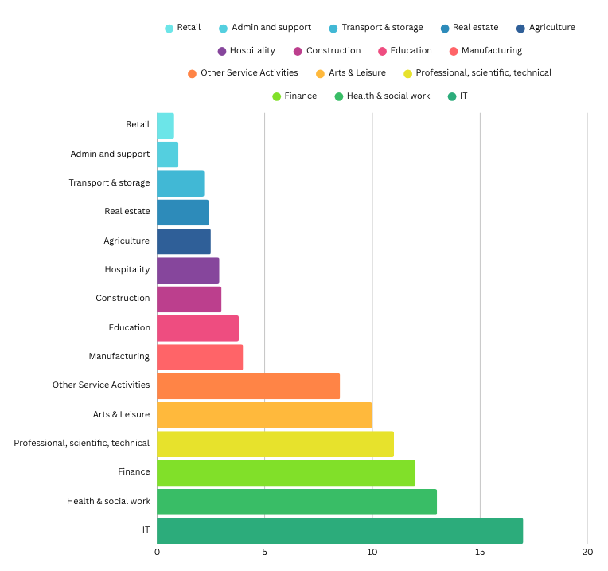

FIGURE 1 A SKILLED SPONSORED WORKS (EU AND NON-EU) Sumption, M., Forde, C., Alberti, G. and Walsh, P.W., 2022

Moreover, the Ibis Bradford Shipley is also sensitive to the local economic cycle. With economic slowdowns, demand for basic accommodation increases, providing some insulation, like how luxury hotels have benefited from reverse cyclical forces. The hotel, nevertheless, is under growing financial pressure from escalating energy costs, overall economic volatility, and particularly wage inflation, which puts it in an even tougher position to attract and retain competent staff in an already tight labour market.

According to (Baum, T. et al., 2023), wage inflation has become a growing concern in the UK hospitality sector, with businesses reporting that rising pay expectations, driven in part by inflation and a shrinking workforce straining operational budgets. While the hotel’s location near key business hubs in West Yorkshire provides access to a steady stream of guests, its limited conference facilities restrict opportunities to attract higher-paying corporate clients, which could otherwise help offset rising staffing costs. In addition to this, the Ibis Bradford Shipley hotel has an appealing value proposition in terms of pricing affordability, quality consistency, and reliable service attributes, which continue to attract hotel as well as leisure guests. Nonetheless, evolving social dynamics rethink guest expectations even in the budget hotel market. Guests today are in increasing need of a customised experience, environmentally friendly operations, as well as emotionally resonant services, regardless of the price.

Staff shortages, driven by wage pressures as well as high turnover, can have severe repercussions in the fulfillment of these increasing demands. Having fewer staff restricts the scope to offer precisely what they seek, which can easily influence the hotel through social media and feedback. (Tur-Porcar et al. 2018), There is also growing demand for the social sustainability of hotels, as well as the quality of employee-guest relationships, as well as employee well-being. Not fulfilling these changing demands can easily undermine the hotel's reputation as well as its competitive position. Ibis Bradford Shipley’s warm, community-proud environment allows guests and staff to feel comfortable and together. But when staff feel under stress and overworked all the time, as is the case with too few employees, this good feeling can gradually dwindle, making it difficult to continue to please the guests as well as develop long-term value in the hotel. Ibis Bradford Shipley, in providing sound and economical accommodations, has scope to upgrade its technological capabilities to cater to changing guest expectations as well as operational needs. The integration of digital technologies like contactless check-in, automated staff rostering, and effective guest feedback mechanisms can optimise operations as well as decrease the burden on sparse staff resources. Such enhancements not only enhance efficiency but also the overall guest experience through convenience as well as personalisation.
In today's digital age, online reviews and social media significantly influence customer decisions. A strong digital presence and responsiveness are crucial for reputation management. Investing in technology that monitors and responds to online feedback can help maintain and improve the hotel's image. Digital transformation in the hospitality industry is essential for improving efficiency and guest satisfaction, which are critical for competitiveness in the market. (D’Souza, and D’Souza, 2023) Embracing digital transformation, Ibis Bradford Shipley can meet the expectations of the guests, optimise operational efficiency, as well as reinforce its market position in the competitive hotel market. Moreover, Ibis Bradford Shipley is subject to UK employment law as well as health and safety law, specifically regarding staff stress and managing workloads in undermanned groups. Under the Health and Safety at Work etc. Under the 1974 Act, employers have the legal responsibility to provide the health, safety, and welfare of their staff, including the identification of work-related stress risks and the means to avoid them (Page, 2023). In particular, the hotel must abide by the General Data Protection Regulation (GDPR) as it deals with taking bookings online, feedback forms, and tracking customer details. This includes applying data mapping, gaining explicit consent, and securing the data storage to ensure the privacy of customers as well as preventing penalties (Kravetz, 2018). With the growing focus on employee rights in the hotel industry, the Ibis Bradford Shipley will likely receive closer inspection in the areas of reasonable hours of work, contractual terms, and methods to decrease staff turnover. The Employment Rights Bill 2024 is focused on employers offering guaranteed contractual hours and reasonable working conditions away from the zero-hours contracts which have dominated the industry (Sirur, S., et al., 2018) By taking proactive measures to meet these legal and regulatory needs, Ibis Bradford Shipley can create a healthier work environment, promote employee satisfaction, and ensure continued conformity with developing industry norms.

Ibis Bradford Shipley participates in Accor's Planet 21 environmental programme, aiming to reduce waste and promote sustainable practices. This environmental positioning aligns with growing public expectations for green accommodation options, even in the budget sector. Improving sustainability messaging can also help differentiate the hotel from local competitors, particularly if integrated with the customer experience (Nga, 2020).

4.3. Impact of Staff Shortage and Staff Turnover at Ibis Bradford Hotel
Ibis Hotel Bradford is also facing severe challenges in terms of staff shortages and turnover. Such challenges have had the overall consequence of affecting the quality of the services provided to the clients, resulting in lowered customer satisfaction. The diminished workforce has also put additional pressure on the current staff, who must perform additional duties, thereby causing them stress and exhaustion. These staffing issues have far-reaching effects beyond the hotel itself, representing an industry-wide crisis within the hospitality sector. The industry is currently unable to attract or retain experienced staff, with many applicants underqualified or inexperienced. As reported by (Big Hospitality, 2022), the shortage is exacerbated further by inflation combined with stagnant wage growth, which hinders employers from being able to provide competitive wages or invest in effective staff training. In the case of Ibis Hotel Bradford, these matters have interrupted daily operations, as simply enough staff to facilitate the operations of an open hotel do not exist. The Ibis Bradford Hotel is facing serious challenges now, especially staff shortages. This has resulted in the rest of the staff, particularly in areas such as housekeeping and food and beverages, carrying an excessive work burden. Consequently, the quality of service has reduced, and staff morale has decreased. In certain instances, workers have begun to pass the responsibility to their colleagues or report absent from work just to escape the heavy work burden.

The increasing pressure is taking a toll on the team, resulting in work-life imbalance, which, as Grigoryan (2024) explains, tremendously raises the possibility of workers leaving the workplace. Besides this problem, staff turnover is also high in Ibis Bradford as employees tend to leave the hotel constantly, necessitating continuous recruitment. The problem affects the quality of service as well as the satisfaction rate among customers, as efficient staff are lost. It also causes the hotel costs to grow, as well as the time spent in training the newly recruited staff. It is all a recurrent loss in terms of assets and funds to the hotel. Maintaining efficient staff as well as satisfaction is paramount to the prosperity, long-term continuity, as well as financial standing of any business, even in the hotel industry (Holston-Okae, 2018).

Staff shortages combined with high staff turnover pose various challenges to be rectified. High staff turnover means the workers lose concentration due to the busyness. Furthermore, continuous customer complaints, especially regarding the state of the rooms, undermine their confidence. This mix of work stress as well as criticism shakes their commitment towards the work, which in turn causes even further staff to leave. The physical as well as psychological stress from these situations adversely affects employee wellness (Blake, 2014). In addition, understaffing and turnover have impacted teamwork and productivity to the detriment of efficiency, resulting in decreased employee cooperation as well as in overall morale. In addition to the above, the hotel has also had to invest additional time and funds in the recruitment and training of new employees, to the detriment of the hotel's funds. Consequently, there is less capital to invest in improving services, like promotional efforts, as well as the embracing of new technologies. The financial constraint has stifled the growth and development of the hotel (Ahmad, et al., 2019). All such factors have adversely impacted the hotel's reputation as well as customer satisfaction. The guests have turned dissatisfied or unwilling to reserve the hotel due to the reduced quality of service resulting from employee shortages. It has resulted in market share as well as income loss, weakening the hotel's financial position.
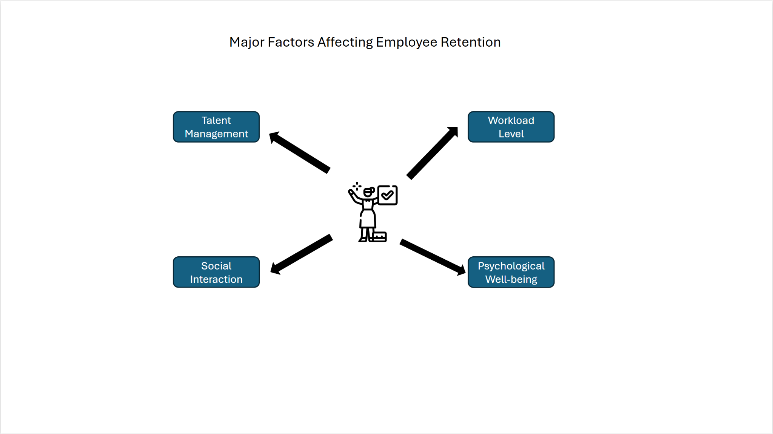

FIGURE 2 Major Factors Affecting Employee Retention (Mamahit, N.I.,et al, 2019).

4.4. Evaluation
The Ibis Bradford Shipley hotel is an established value-focused hospitality chain in a competitive local market. It is owned by the global Accor Group, which derives strength from standardised brand recognition as well as operating codes underpinned by affordability, dependability, as well as efficiency (Demirçiftçi et al.,2016). Its location in the central historic part of Bradford, with proximity to important transit locations connecting Shipley, Bingley, Bradford, as well as Keighley regions in West Yorkshire, ensures convenience to visitors as well as guests, motivating guests in need of reliable accommodation. Its strengths come from the consistent service quality, tidiness, as well as the inclusion of necessary amenities that fulfill the expectations of the targeted market. Also, the fact that Ibis Bradford Shipley is committed to Accor’s Planet 21 sustainability programme demonstrates an increasing dedication to green initiatives, which appeals to environmentally conscious visitors and distinguishes the hotel from similar hotels (Nga, 2020). Despite such strengths, serious operational issues loom large. The hotel suffers from critical staff shortages as well as high staff turnover, which has a direct impact on affecting service quality, staff morale, as well as final guest satisfaction. The underlying human resource challenges within have resulted from external dynamics, such as the UK’s post-Brexit immigration controls curtailing the supply of migrant workers hitherto occupying the essential areas in the hospitality industry. Coupled with the increasing wage inflation as well as economic uncertainties, the hotel has seen its capacity to have a consistent, competent workforce underpinned.
Ibis Bradford Shipley has deficiencies in its conference and events spaces as well, which limits opportunities to attract higher-yielding corporate clients to help balance financial stress from escalating operating costs. Guest feedback needs improvement in the areas of maintenance as well as in managing disturbances, pointing towards the need to invest in capital development to further the overall guest experience. In spite of the challenges, some opportunities also lie in improving the market position of the hotel. Increasing technological capabilities, including upgrading and investing in check-in technology, implementing automated scheduling, as well as enhancing online reputation management.
This would enhance efficiency in operations and guest satisfaction, alongside lessening the effects of staff shortages. There is also the possibility of closer ties with the local cultural venues, such as Bradford City Council who hosted scores of events surrounding the Bradford city of culture 2025 programme which hosted Bradford city council which could enhance the guest experience as well as the attraction of the wider visitor segment Council (B.C. 2025). Externally, the business is overseen in an environment influenced by developing immigration policies, economic volatility, as well as changing consumer preference towards customised and sustainable stay experiences. Compliance with new employment legislation and data protection is another operational burden, but one which can also lead to enhanced employee welfare and customer loyalty (Variz, 2020). In summary, Shipley is an established value brand with a definite market identity, with significant internal as well as external pressures that endanger long-term viability. To overcome the negative effects of personnel shortages as well as turnover, resolving its human resource challenges, investing in technology as well as infrastructure, as well as harnessing cultural strengths in the local vicinity will be crucial.

5. Thematic analysis
5.1. Staff Shortage and Turnover at Ibis Bradford Hotel:
Staff shortages as well as turnover contributed greatly to curtailing the operational efficiency of the Ibis Bradford Hotel, which directly resulted in the inability to satisfy the expectations of the guests. For example, the decreased housekeeping workforce means long cleaning times, which increases the time taken to have the rooms ready, resulting in guest dissatisfaction. Besides, it ensures additional work is put on the housekeeping personnel who feel fatigued and under pressure (Tews et al.,2013), which further reduces their productivity, as well as the overall quality of their services offered. Such employees may be unable to admit to deteriorating performance due to the pressure to fill in for absent staff. In addition to this, the reception suffers from critical challenges in staff shortages, with long lines and long waiting times during check-in and check-out because of understaffing. Such waits annoy the guests as well as worsen the overall guest experience. Furthermore, distressed reception staff expose themselves to error while handling guest requests, as many activities to which they have to cater lead to fluency hampering in the hotel. In addition, in the food and beverages department, the lack of adequate staff levels delays the delivery of the services as well as compromises meal quality. Restaurant staff in the hotel will take extra time to serve food as well as beverages.
5.2. Service Quality at Ibis Bradford Hotel:
Ibis Hotel Bradford has experienced deteriorating quality in service because of excessive staff turnover. The continuous recruitment of new staff means the staff are constantly required to learn the hotel procedures, rules, and service expectations all over again. The repeated cycle hinders daily operations, providing an unstable work environment as well as stress to the staff. In the case of a budget hotel such as Ibis, which is under the Accor group, consistency as well as efficiency is crucial for keeping the clients satisfied. With the staff constantly moving in such high volumes, however, the service becomes unreliable, resulting in guest dissatisfaction (Khairunisa et al., 2022). New staff might not have knowledge about the Ibis standards, which will enhance the probability of error and delayed service (Tapola, 2016). Meanwhile, long-serving staff will get frustrated or lose motivation as they have the burden of constantly training new staff. This reduces the overall motivation as well as the morale in the team. Consequently, staff might not go an extra step to provide an excellent experience to the guest. This can end up harming the hotel’s business in the long term. Dissatisfied guests will hardly come back, while the chances of them giving negative feedback about the hotel online is higher, which can negatively impact the hotel’s image. To enhance the quality of service, satisfy customers, and remain competitive in the hotel business, solving the issue of high staff turnover is inevitable (Massawe, 2013).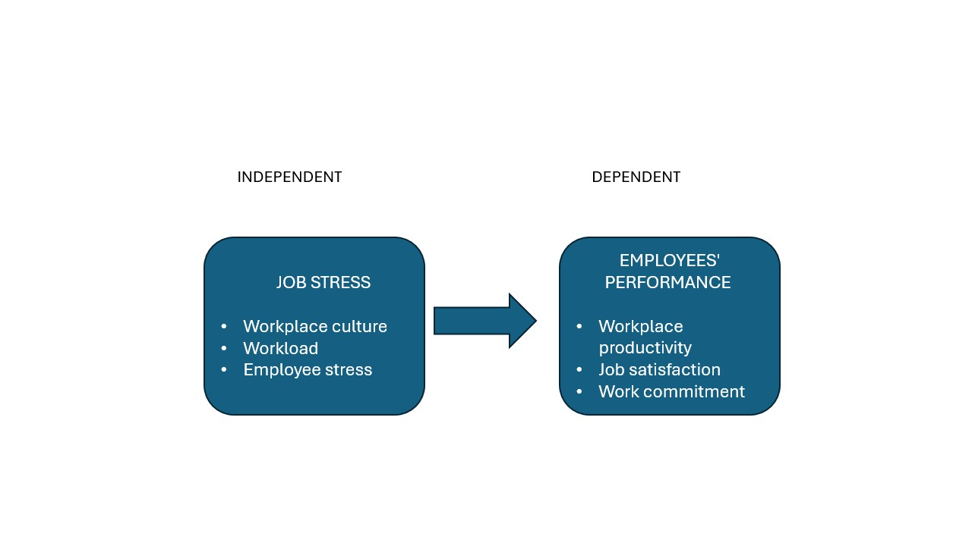

FIGURE 3 Relationship between work stress and employees' performance
(Imran, and Ayub, 2017).

5.6. Employee Engagement at Ibis Bradford Hotel:
One of the primary issues in the case of the Ibis Bradford Hotel is the low staff morale and lack of engagement. It is primarily the result of continuous staff shortages as well as turnover. When many staff members leave the workplace, it creates an unpleasant environment. The remaining staff lose their confidence in the management and believe the hotel is an unsupportive work environment (Windom, 2018). This can be emotionally draining. The rest of the staff must shoulder additional work, which causes stress, frustration, and a lack of teamwork. With tired, underappreciated staff, workers lose motivation to deliver quality services (Qureshi, et al., 2013). This decreased guest satisfaction hurts the hotel’s image, making it difficult for the Ibis Bradford to thrive as part of the Accor group. To rectify this, Ibis Bradford must work to enhance staff satisfaction with their work and the degree to which staff are engaged (Coffey, 2021). This can be accomplished through straightforward but effective measures such as using supportive leadership, celebrating good work, developing workplace culture, and providing workers with opportunities to develop in the workplace. When workers feel appreciated and cared about, they will be better motivated to stay as well as work to their highest capabilities. Providing training in aspects such as communication, customer service, and well-being will also make the staff feel competent and confident. Providing junior staff with opportunities to progress to more senior roles will enhance motivation. Investing in staff will lead to creating an improved workplace environment as well as enhancing the guest experience.

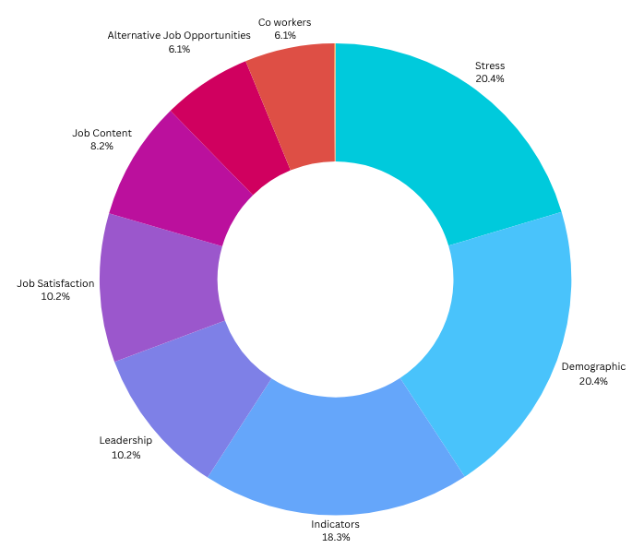

FIGURE 4 Factors leading to employee resignation (Meyer et al., 2021)

6. Financial Impact on Ibis Bradford Hotel:

One of the primary issues in the case of the Ibis Bradford Hotel is the low staff morale and lack of engagement. It is primarily the result of continuous staff shortages as well as turnover. When many staff members leave the workplace, it creates an unpleasant environment. The remaining staff lose their confidence in the management and believe the hotel is an unsupportive work environment (Windom, 2018). This can be emotionally draining. The rest of the staff must shoulder additional work, which causes stress, frustration, and a lack of teamwork. With tired, underappreciated staff, workers lose motivation to deliver quality services (Qureshi, et al.,2013). This decreased guest satisfaction hurts the hotel’s image, making it difficult for the Ibis Bradford to thrive as part of the Accor group. To rectify this, Ibis Bradford must work to enhance staff satisfaction with their work and the degree to which staff are engaged (Coffey, 2021). This can be accomplished through straightforward but effective measures such as using supportive leadership, celebrating good work, developing workplace culture, and providing workers with opportunities to develop in the workplace. When workers feel appreciated and cared about, they will be better motivated to stay as well as work to their highest capabilities. Providing training in aspects such as communication, customer service, and well-being will also make the staff feel competent and confident. Providing junior staff with opportunities to progress to more senior roles will enhance motivation. Investing in staff will lead to creating an improved workplace environment as well as enhancing the guest experience.

7. Customer Experience at Ibis Bradford Hotel:

The guest experience at the Ibis Bradford Hotel has been impacted by persistent staff shortages and a high turnover rate among employees. When there are insufficient staff members available, guests frequently experience longer wait times and slower service due to the overstretched team. Additionally, new employees, who may not yet be fully trained, can make errors or provide inconsistent service, which undermines the overall quality that guests anticipate (Holston-Okae, 2018).

In certain instances, the hotel has had to restrict or close specific services or facilities because there are not enough skilled staff to operate them. This results in guest dissatisfaction, leading to negative reviews and a decrease in return visits, both of which harm the hotel's reputation. If these issues persist, the hotel may encounter a reduction in bookings and revenue. Therefore, Ibis Bradford must implement measures to enhance customer service, even amidst limited staffing.

One effective approach is to introduce green training for both staff and guests (Han, 2023). For a budget hotel like Ibis Bradford, this entails promoting environmentally friendly practices such as utilising refillable water bottles, minimising plastic usage, and lowering CO₂ emissions. These "green experiences" can enable both employees and guests to feel as though they are contributing to a larger cause. For staff, this shared commitment to environmental values can enhance morale and lead to improved service, thereby increasing guest satisfaction.

Another beneficial strategy is to invest in technology that streamlines service and enhances efficiency, such as digital check-in, online room service requests, or automated booking systems. This enables staff to accommodate more guests with reduced pressure (Štilić, et al., 2023). Most importantly, empowering employees with greater responsibility and trusting them to make guest-centred decisions can significantly enhance the customer experience while also making staff feel more appreciated and motivated in their roles.

8. Retention Strategies at Ibis Bradford Hotel:
One of the most crucial actions the hotel can take is to enhance leadership and support staff development. This involves providing regular training and creating opportunities for career advancement. Management should motivate staff to express their thoughts, learn from one another, and feel a sense of involvement in the hotel’s achievements.
Another important aspect is ensuring fair compensation. Offering competitive salaries and benefits attracts skilled workers and reduces their reasons to seek better-paying positions elsewhere (Mngomezulu, et al., 2015).
Additionally, fostering a positive and supportive work atmosphere is vital. When employees feel respected, safe, and valued, they are more inclined to stay and perform at their best. Research by (Ghani, et al., 2022) indicates that employees who feel acknowledged and appreciated tend to be more loyal and productive.

Ibis Bradford can build this kind of workplace by:
- Recognising and rewarding good work
- Giving regular, helpful feedback
- Encouraging open, honest communication between staff and managers
- Promoting diversity and offering fair supervision
- Building trust within the team

To prevent burnout, a common problem in hospitality work-life balance, should also be a top priority (Esthi, and Panjaitan, 2023). The hotel can help by:
- Offering flexible working hours
- Giving access to wellness programmes or benefits like gym memberships and mental health support
- Making sure staff take breaks and have time off between shifts.

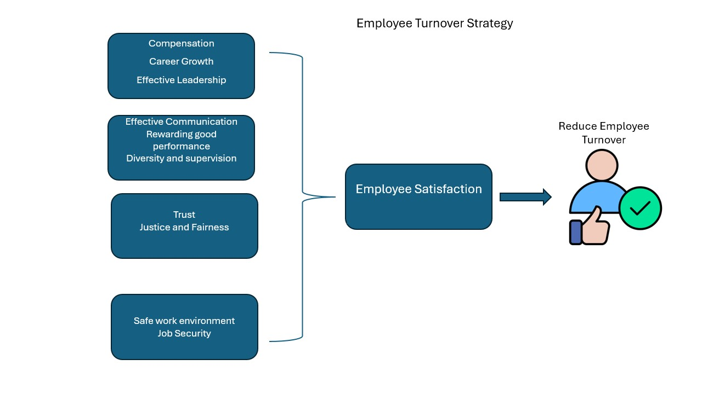
FIGURE 5 Retention Strategies (Cloutier, et al., 2015).

9. Strategic Planning for the Ibis Bradford Hotel:

The Ibis Bradford Hotel is presently encountering significant difficulties, such as a shortage of staff and a high rate of employee turnover. To remain competitive within the hospitality sector, the hotel needs to implement a robust strategic planning framework. This framework will assist in determining the necessary staffing levels, enhancing the recruitment process, and fostering employee growth and development.

One of the initial steps the hotel should undertake is to utilise knowledge management tools, including maintaining a record of past experiences, to monitor peak periods of activity such as holidays, weekends, or local events. This proactive approach will enable the hotel to plan effectively and ensure that sufficient staff are available to meet guest expectations and maintain high service quality (Karunanayake et al., 2022).

Adopting this strategy can also prepare the Ibis Bradford for unforeseen staff absences or temporary shortages. Establishing such a plan will facilitate smoother operations for the hotel, even amidst a competitive labour market.

To address employee turnover, the hotel must closely examine the reasons behind staff departures. When employees feel undervalued or dissatisfied, they are more inclined to seek employment elsewhere. The Ibis Bradford should foster an environment of open communication, utilising exit interviews and employee feedback to uncover the underlying causes of resignations. This data can be compiled into a turnover report that identifies necessary changes (Nwagbara et al., 2013).

Another crucial strategy involves formulating a comprehensive recruitment and retention plan. This plan could encompass offering competitive salaries, enhancing employee benefits, and establishing clear pathways for career advancement. By improving the work environment, the Ibis Bradford can attract skilled personnel and diminish the likelihood of losing existing employees.

10. Workplace Culture and Employee Engagement at Ibis Bradford Hotel:
To address staff shortages and high employee turnover, Ibis Bradford Hotel must foster a more positive work environment and enhance employee satisfaction regarding their roles. When employees feel supported, respected, and valued, they are more inclined to enjoy their work and remain with the organisation for a longer duration.
A beneficial strategy is to conduct regular employee satisfaction surveys to gauge staff sentiments and identify any issues that may be impacting their morale (Medina, 2012). Keeping employees informed about hotel updates, upcoming events, and team performance can also contribute to their sense of inclusion and connection to the workplace.
Furthermore, it is crucial to ensure that staff have opportunities to express their opinions. Establishing open and honest communication between staff and management fosters trust, enhances teamwork, and cultivates a sense of belonging. The hotel should also acknowledge and reward staff accomplishments. A simple expression of gratitude, a staff member of the month recognition, or a public acknowledgment can significantly contribute to making employees feel appreciated.

In addition to salary increases, the hotel can provide non-monetary benefits such as flexible working hours, extra time off, or team-building social events. These initiatives assist staff in achieving a healthier work-life balance, which is essential in a demanding and often stressful sector like hospitality. By prioritising the development of a robust workplace culture and actively listening to its employees, Ibis Bradford Hotel can enhance morale, decrease staff turnover, and cultivate a more motivated and loyal workforce.

11. Leadership and Management at Ibis Bradford Hotel:
To address the challenges of staff shortages and high employee turnover, Ibis Bradford Hotel must cultivate a more positive work environment and enhance employee job satisfaction. When employees feel supported, respected, and valued, they are more inclined to enjoy their work and remain with the organisation for a longer duration.
A beneficial strategy is to conduct regular employee satisfaction surveys to gauge staff sentiments and identify any issues that may be impacting their morale (Medina, 2012). Keeping employees informed about hotel updates, upcoming events, and team performance can also foster a sense of inclusion and connection to the workplace.
Furthermore, it is crucial to provide staff with opportunities to express their opinions. Establishing open and honest communication between employees and management is essential for building trust, enhancing teamwork, and fostering a sense of belonging. The hotel should also acknowledge and reward staff accomplishments. Simple gestures such as expressing gratitude, implementing a staff member of the month programme, or offering public recognition can significantly contribute to employees feeling appreciated.

In addition to salary increases, the hotel can provide non-monetary benefits such as flexible working hours, extra time off, or team-building social events. These initiatives assist staff in achieving a healthier work-life balance, which is particularly vital in the demanding and often stressful hospitality industry.

12. Conclusions and Recommendations

12.1. Conclusion

In summary, the case study of the Ibis Bradford Hotel illustrates that staff shortages and elevated employee turnover have adversely impacted the hotel's operations. These challenges significantly hinder the hotel's ability to deliver quality services, leading to guest dissatisfaction. When there is an insufficient number of staff or when numerous employees depart, the hotel’s efficiency diminishes. This situation results in extended waiting periods and subpar service in critical areas such as housekeeping, reception, and food and beverage services. Consequently, guests may leave unfavourable reviews, experience decreased satisfaction, and may choose not to return, which in turn affects the hotel's reputation and results in a loss of market share. Additionally, high turnover rates can diminish employee morale, rendering staff less motivated and productive.
The hotel also incurs increased costs as it must allocate more resources to recruit and train new personnel. Inadequate service stemming from staff shortages can damage the hotel's reputation and impact its revenue. The Ibis Bradford Hotel must address these challenges. This entails establishing training and development initiatives for employees, enhancing the work environment, providing improved and flexible compensation and benefits, formulating robust retention strategies, and refining workforce planning to prevent future shortages.

12.2. Recommendations
To tackle the issues at the Ibis Bradford hotel and achieve the best outcomes, the hotel should invest in staff development by implementing training programmes that emphasise employee growth and enhance their skills and knowledge. This will help ensure smooth hotel operations and elevate the quality of service offered to guests (Waqanimaravu et al., 2020).
Additionally, the Ibis Bradford hotel should strive to enhance the work environment by establishing effective communication channels (Lahap et al., 2016) that recognise staff achievements, involve them in decision-making, and address their concerns.
Moreover, the hotel should prioritise staff recognition and rewards, career advancement opportunities, flexible working hours, and a comprehensive medical plan (Udoh Augustine, 2020).
Furthermore, Ibis Bradford Hotel needs to implement strategic staffing plans, where managers anticipate staffing needs, identify areas with high turnover, and proactively manage hiring and retention (Silva, et al., 2019).
Another crucial area for investment is leadership and management. Strong leadership is essential for minimising staff shortages and turnover at the Ibis Bradford hotel. The hospitality sector requires managers with superior leadership abilities (Ajila, 2025) and the right motivation to excel and connect with their teams. Ultimately, these improvements would enhance the guest experience, decrease wait times, and make services and facilities more dependable (Book, et al., 2019).
Additionally, Ibis Bradford must focus on implementing green training for both staff and guests, which can help everyone feel like they are part of a larger mission and assist the hotel in lowering operational costs (Tanveer, et al., 2024).

13. REFERENCES:
Ahmad, R. and Scott, N., 2019. Technology innovations towards reducing hospitality human resource costs in Langkawi, Malaysia. Tourism Review, 74(3), pp.547-562.
Ajila, A., 2025. Understanding Retention: The Case of a Salt Lake City Agency (Doctoral dissertation, Trident University International).
doi:proquest.com/openview/45340b215ac6e92e31714a002b9f3be0/1?pq-origsite=gscholar&cbl=18750&diss=y
(Accessed, 29 April 2025).

Ali, J.A.M. and Mohamad, I.R., 2018. The factors affecting turnover intention, with the moderating role of intrinsic intention in Jordanian five-star hotels. International Journal of Engineering & Technology, 7(4), pp.6828-6832.
Available at: :https://www.researchgate.net/profile/Rashidah-Mohamad-Ibrahim-2/publication/336371436_The_Factors_Affecting_Turnover_Intention_with_the_Moderating_Role_of_Intrinsic_Intention_in_Jordanian_Five-Star_Hotels/links/5d9e7958a6fdcc04fac5e5b9/The-Factors-Affecting-Turnover-Intention-with-the-Moderating-Role-of-Intrinsic-Intention-in-Jordanian-Five-Star-Hotels.pdf
(Accessed, 26th May 2025).

Azeez, S.A., 2017. Human resource management practices and employee retention: A review of literature. Journal of Economics, Management and Trade, 18(2), pp.1-10.
Available at :https://d1wqtxts1xzle7.cloudfront.net/89830315/MTk2ODJAQHBm-libre.pdf?1660755981=&response-content-disposition=inline%3B+filename%3DHuman_ResourceManagement_Practices_and_E.pdf&Expires=1748557604&Signature=Yji62wXdRg70YmqCE9WkUx~BIAMZar2pQVUKdXQ3f4xIPlaA7fQOrw3yLECh-0EsI2boi6J7HjCHlLmvL8watrpLbvnuBgQLg1aCMg9PJqGuwCs52dIFnaQntc921W4RRqqZVB0z~qcuT3UhxlRCgEXYGtt64TKxqeVOFf36zp5KA3DsQQeHbU3GEN7xu6T41MPSsoofEAuC73LEpcCftvvojMWlW5g8RXz1CiAaI3BRaMgovrI3B3UBIha58pYFyYl~sF3aOjbJmQ9Ufe~2JzCphmUXpOLl8Ax1gC-8lqIvLRM8PGLDw-0ZGxrBIrfuYKzKYFMCExsso1pQ~DTh9w__&Key-Pair-Id=APKAJLOHF5GGSLRBV4ZA
(Accessed, 29th May 2025).
Baum, T., Rubio, J.C., Congreve, E., Alberti, G., Clifton, N., Guthrie, J., Hetherington, G., Ladkin, A., Nickson, D. and Simpson, B., 2023. ReWAGE Evidence Paper: Work, wages and employment in the UK’s hospitality sector.
avialable at:https://eprints.whiterose.ac.uk/id/eprint/204337/1/employment_in_uk_hospitality_-_evidence_paper_-_formatted_edited.pdf
(Accessed, 25th May 2025).

Beehner, C.G. and Blackwell, M.J., 2016. The impact of workplace spirituality on food service worker turnover intention. Journal of Management, Spirituality & Religion, 13(4), pp.304-323.
avialable at:https://www.ingentaconnect.com/content/jmsr/rmsr20/2016/00000013/00000004/art00005
(Accessed, 29th May 2025).

Bello, M.B. and Bello, Y.O., 2021. Job satisfaction and employees’ turnover in hotel industry: Evidence from Lagos state Nigeria. Journal of Tourism Theory and Research, 7(1), pp.32-43.
avialable at:https://dergipark.org.tr/en/pub/jttr/issue/58717/844747
(Accessed, 29th May 2025).
Bing. (2025). ibis bradford shipley - Bing. [online] Available at: https://www.bing.com/search?pglt=41&q=ibis+bradford+shipley&cvid=f7bc2c89571143ab8fcbe532d80ac18e&gs_lcrp=EgRlZGdlKgYIABBFGDkyBggAEEUYOTIGCAEQABhAMgYIAhAAGEAyBggDEAAYQDIICAQQ6QcY_FXSAQkxNDQ5NmowajGoAgCwAgA&FORM=ANNAB1&PC=U531

[Accessed 9 Jun. 2025].

‌Big Hospitality. (2022). Staff shortages in hospitality hit record high. https://www.bighospitality.co.uk/Article/2022/06/14/Staff-shortages-in-hospitality-hit-record-high.
avialable at: https://dergipark.org.tr/en/pub/jttr/issue/58717/844747
(Accessed, 23rd May 2025).
Blake, J., 2014. Work-family fit. Encyclopedia of Quality of Life and Well-Being Research, pp.7219-7221.
avialable at:https://books.google.co.uk/books?hl=en&lr=&id=kguzCQAAQBAJ&oi=fnd&pg=PP1&dq=Blake,+J.,+2014.+&ots=f8-7I7Naiu&sig=cD2Rad84zUfsBTx3VTVSMgx4LJU&redir_esc=y#v=onepage&q=Blake%2C%20J.%2C%202014.&f=false
(Accessed, 29 April 2025).

Book, L., Gatling, A. and Kim, J., 2019. The effects of leadership satisfaction on employee engagement, loyalty, and retention in the hospitality industry. Journal of Human Resources in Hospitality & Tourism, 18(3), pp.368-393.
avialable at:https://www.tandfonline.com/doi/abs/10.1080/15332845.2019.1599787
(Accessed, 29th May 2025).

Cabalcar, S.M., 2022. Factors Influencing Young Employees to Leave the Hospitality Industry.
avialable at: https://scholarworks.calstate.edu/concern/projects/rn301733j
(Accessed, 24th May 2025).

Chikwe, A.C., 2009. THE IMPACT OF EMPLOYEE TURNOVER: THE CASE OF LEISURE, TOURISM AND HOSPITALITY INDUSTRY. Consortium Journal of Hospitality & Tourism, 14(1).
avialable at:https://openurl.ebsco.com/EPDB%3Agcd%3A4%3A8919780/detailv2?sid=ebsco%3Aplink%3Ascholar&id=ebsco%3Agcd%3A43417951&crl=c&link_origin=scholar.google.com
(Accessed, 27th May 2025).

Cloutier, O., Felusiak, L., Hill, C. and Pemberton-Jones, E.J., 2015. The importance of developing strategies for employee retention. Journal of Leadership, Accountability & Ethics, 12(2).
avialable at;http://www.na-businesspress.com/JLAE/Pemberton-JonesEJ_Web12_2_.pdf
(Accessed, 29th May 2025).

Coffey, S.G., 2021. Strategies to Increase Employees’ Morale (Doctoral dissertation, Walden University).
avialable at: https://www.proquest.com/openview/319ce1801d393a770076e348efe69fbd/1?pq-origsite=gscholar&cbl=18750&diss=y
(Accessed, 26th May 2025).

Council, B.C. (2025). What’s on. [online] Bradford 2025. Available at: https://bradford2025.co.uk/whats-on/.
(Accessed, 29th May 2025).

Cronin, B., 2018. Strategies to Reduce Employee Turnover in the Hotel Industry. Walden University.
avialable at: https://www.proquest.com/openview/e044e25400e325fdb479602223160b95/1?pq-origsite=gscholar&cbl=18750
(Accessed, 29th May 2025).
Denzin, N.K. and Lincoln, Y.S. eds., 2011. The Sage handbook of qualitative research. Sage.
avialable at:https://books.google.co.uk/books?hl=en&lr=&id=qEiC-_ELYgIC&oi=fnd&pg=PR1&dq=Denzin,+N.K.+and+Lincoln,+Y.S.+eds.,+2011.+The+Sage+handbook+of+qualitative+research.+Sage.+Demir%C3%A7ift%C3%A7i,+T.+and+K%C4%B1z%C4%B1l%C4%B1rmak,+I.,+2016.+Strategic+branding+in+hospitality:+Case+of+Accor+Hotels.+Journal+of+Tourismology,+2(1),+pp.50-64.&ots=C5lYynIx4E&sig=cp-l8uKUyKkgMywEnUz9fDykPwo&redir_esc=y#v=onepage&q&f=false
(Accessed, 29 April 2025).
Demirçiftçi, T. and Kızılırmak, I., 2016. Strategic branding in hospitality: Case of Accor Hotels. Journal of Tourismology, 2(1), pp.50-64.
avialable at:https://dergipark.org.tr/en/pub/iuturizmoloji/issue/24615/260504
(Accessed, 29th May 2025).

Deri, M.N., Ragavan, N.A., Chireh, T.D., Zaazie, P. and Niber, A., 2022. Relationship between job satisfaction and turnover intention of hotel employees. Sciences, 3(2).
avialable at:https://royalliteglobal.com/index.php/rjass/article/view/810
(Accessed, 29th May 2025).

D’Souza, E. and D’Souza, K., 2023. A study on the impact of innovative technologies in the hospitality industry. Journal of Tourism, Hospitality and Culinary Arts, 15(1), pp.1-23.
avialable at: https://ir.uitm.edu.my/id/eprint/87652/
(Accessed, 29th May 2025).

Eide, D., Fuglsang, L. and Sundbo, J., 2017. Management challenges with the maintenance of tourism experience concept innovations: Toward a new research agenda. Tourism Management, 63, pp.452-463.
avialable at:https://www.sciencedirect.com/science/article/pii/S0261517717301516
(Accessed, 29th May 2025).

Esthi, R.B. and Panjaitan, S., 2023. The effect of work-life balance on turnover intention mediated by burnout. ProBisnis: Jurnal Manajemen, 14(1), pp.29-34.
avialable at:https://ejournal.joninstitute.org/index.php/ProBisnis/article/view/69
(Accessed, 1st June 2025).

Ghani, B., Zada, M., Memon, K.R., Ullah, R., Khattak, A., Han, H., Ariza-Montes, A. and Araya-Castillo, L., 2022. Challenges and strategies for employee retention in the hospitality industry: A review. Sustainability, 14(5), p.2885.
avialable at:https://www.mdpi.com/2071-1050/14/5/2885
(Accessed, 1st June 2025).

Grigoryan, K., 2024. Labor shortages in the hospitality industry: The effects of work-life balance, employee compensation, government-issued unemployment benefits and job insecurity on employees’ turnover intentions. Westcliff International Journal of Applied Research, 8(1), pp.59-73.
avialable at: https://pdfs.semanticscholar.org/daab/8a375d4c6756f1bbe49a367432e770c2157e.pdf
(Accessed, 1st June 2025).
Han, J.W., Kok, S.K. and McClelland, R., 2023. The impact of green training on employee turnover intention and customer satisfaction: An integrated perspective. Corporate social responsibility and environmental management, 30(6), pp.3006-3019.
avialable at: https://onlinelibrary.wiley.com/doi/full/10.1002/csr.2534
(Accessed, 1st June 2025).

Hine, C., 2017. Ethnographies of online communities and social media: Modes, varieties, affordances. The SAGE handbook of online research methods, 2, pp.401-415.
avialable at:https://www.torrossa.com/en/resources/an/5019467#page=430
(Accessed, 4th June 2025).

Holston-Okae, B.L., 2018. The effect of employee turnover in the hospitality industry: Quantitative correlational study. International Journal of Learning and Development, 8(1), pp.156-183.
avialable at:https://d1wqtxts1xzle7.cloudfront.net/72587846/10058-libre.pdf?1634270007=&response-content-disposition=inline%3B+filename%3DThe_Effect_of_Employee_Turnover_in_the_H.pdf&Expires=1748558237&Signature=NqHis8QrSx9sLUUcD-ubwY0jr8X2VnwpNzC6H6Ml55VVZ-ttwGQ14E4fYpHIbQNimFo7jsMReWP3kvam4NJk-XCPIgHU5mkCqFQmvSO3GXvLTrzEWVGD7lDstJA0Jg78CN3GAosVMLuS5tsbAL1HIPAeEzYMcJjDP8d5tomj8Fi7JyTgmpDli3NBwKCUvGODurZw6Pwi0GG1jgGp7CfbM9Nni4e3KMADO-ZCXdP-6cTs4MjNQ-XeptVx59PAQHuRr2o0PLjh4rNuo5zh8Rv7Nowq5hEO7v12-xLywMsza6R4argXE3enjyiSy~8sqKfQFl31DylJ7ySW2HtmblWt5Q__&Key-Pair-Id=APKAJLOHF5GGSLRBV4ZA
(Accessed, 5th June 2025).

Ibis Bradford (2025). Ibis Bradford Shipley | Comfortable Hotel in Bradford - ALL. [online] all.accor.com. Available at: https://all.accor.com/hotel/3158/index.en.shtml?utm_term=mar&gclid=CjwKCAjwi-DBBhA5EiwAXOHsGfczjdVLJBkRRCYshzK52pq4INm5Z3NN-6jWEb4yt-IIZVJolcg0QBoCA3sQAvD_BwE&utm_campaign=ppc-ibi-mar-goo-uk-en-uk_ai-mix-sear&utm_medium=cpc&utm_content=uk-en-GB-V0554&utm_source=google
[Accessed 29 May 2025].

Imran, S. and Ayub, R., 2017. Impact of staff turnover on employees’ performance. RADS Journal of Social Sciencess & Business Management, 4(1), pp.15-35.
avialable at: https://d1wqtxts1xzle7.cloudfront.net/78530674/25-libre.pdf?1641954405=&response-content-disposition=inline%3B+filename%3DImpact_of_Staff_Turnover_on_Employees_Pe.pdf&Expires=1748560219&Signature=g0FYxLVAGfleKF2oCt2Jbpe2UwN6MlraqNBuYA1FmWJiIUHpYLh1E4cj7gCSfnIEtCidxdzraqvT6YHWzH6L5D6VrmtU675l1RIMXQaPCLPN5x2FTGPgIEIv4uTaTOjUi7wisH211pP4ITS7F5-O2zbHm8sb~ceda2Npkfv5LFns~tjlPzeJ5KmcWEDPhiGaftk2ZZzjIRfbvEDF5EhPJArxqUAVIp7URoZrrnqto6y~JWG-qzv~BZb3Q2HL1lfN1ejO2RDJmz-PQlk33~4vB~ET4KkeH2gOgIUxGARYzhvTGHcxt4eH4-Za90Jq3HOD6LrRm7PdrdvXRgHOyJxpzQ__&Key-Pair-Id=APKAJLOHF5GGSLRBV4ZA
(Accessed, 29 April 2025).

Jeffrey, B., 2018. Ethnographic writing. The Wiley handbook of ethnography of education, pp.113-134.
avialable at:https://onlinelibrary.wiley.com/doi/abs/10.1002/9781118933732.ch6
(Accessed, 5th June 2025).

Karunanayake, K.P.A.N., Fernando, M.L.S.S. and Kulatunga, U., 2022. Knowledge management practices to minimize the impact of staff turnover. In Proceedings The 10th World Construction Symposium| June (p. 613).
avialable at:https://www.researchgate.net/profile/Lakshitha-Fernando-5/publication/368685032_Knowledge_management_practices_to_minimize_the_impact_of_staff_turnover/links/63f4feed0cf1030a563eb69e/Knowledge-management-practices-to-minimize-the-impact-of-staff-turnover.pdf
(Accessed, 29 April 2025).

Khairunisa, N.A. and Muafi, M., 2022. The effect of workplace well-being and workplace incivility on turnover intention with job embeddedness as a moderating variable. International Journal of Business Ecosystem & Strategy (2687-2293), 4(1), pp.11-23.
avialable at:https://www.bussecon.com/ojs/index.php/ijbes/article/view/303
(Accessed, 4th June 2025).

Khaleefa, Q. and Al-abdalaat, A., 2017. The impact of financial and moral dimensions of hotel on the staff turnover intention: A field study on five stars hotel in Aqaba special economic zone authority (ASEZA). Internafional Journal of Academic Research in Business and Social Sciences, 6(12), pp.658-677.
avialable at:https://www.researchgate.net/profile/Qusay-Khaleefah/publication/315933667_The_Impact_of_Financial_and_Moral_Dimensions_of_Hotel_on_the_Staff_Turnover_Intention_A_Field_Study_on_Five_Stars_Hotel_in_Aqaba_Special_Economic_Zone_Authority_ASEZA/links/5c7e4fc3458515831f841ee6/The-Impact-of-Financial-and-Moral-Dimensions-of-Hotel-on-the-Staff-Turnover-Intention-A-Field-Study-on-Five-Stars-Hotel-in-Aqaba-Special-Economic-Zone-Authority-ASEZA.pdf
(Accessed, 7th June 2025).

Kravetz, D. (2018). GDPR and the Hospitality Space: What You Need to Know. [online] CoStar. Available at: https://www.costar.com/article/2053820121/gdpr-and-the-hospitality-space-what-you-need-to-know?utm_source=chatgpt.com.
Kysilka, D. and Csaba, N., 2013. Employee turnover in the hospitality industry. Anale. Seria Stiinte Economice. Timisoara, 19, p.377.
avialable at:https://www.proquest.com/openview/0d76b87258fe8f31858fda865dc2f6f4/1?pq-origsite=gscholar&cbl=2029256
(Accessed, 5th June 2025).

Lahap, J., O’Mahony, B. and Dalrymple, J., 2016. The importance of communication in improving service delivery and service quality in the Malaysian hotel industry. Procedia-Social and Behavioral Sciences, 224, pp.213-220.
avialable at:https://www.sciencedirect.com/science/article/pii/S1877042816305304
(Accessed, 5th June 2025).

Magnini, V.P., Dorn, E.C., Adkins, C.L., Crotts, J.C. and Uysal, M., 2024. Understanding hospitality labor shortages: An importance-performance analysis of hospitality career preference drivers. Journal of Human Resources in Hospitality & Tourism, 23(3), pp.465-486.
avialable at:https://www.tandfonline.com/doi/abs/10.1080/15332845.2024.2335127
(Accessed, 3rd June 2025).

Malek, K., Kline, S.F. and DiPietro, R., 2018. The impact of manager training on employee turnover intentions. Journal of Hospitality and Tourism Insights, 1(3), pp.203-219
avialable at:https://www.emerald.com/insight/content/doi/10.1108/jhti-02-2018-0010/full/html
(Accessed, 3rd June 2025).

Mamahit, N.I., Worang, F.G. and Rumokoy, F.S., 2019. Factor analysis on employee retention at Ibis Hotel Manado. Jurnal EMBA: Jurnal Riset Ekonomi, Manajemen, Bisnis Dan Akuntansi, 7(1).
avialable at:https://ejournal.unsrat.ac.id/index.php/emba/article/view/22283
(Accessed, 3rd June 2025).

Massawe, D., 2013. Customer satisfaction and complaints as a means of gaining a competitive advantage in hospitality industry. The Eastern African journal of hospitality, leisure and tourism, 1(1), pp.1-10.
avialable at: https://d1wqtxts1xzle7.cloudfront.net/31209070/Customer_Satisfaction_and_Complaints-libre.pdf?1392331956=&response-content-disposition=inline%3B+filename%3DCustomer_Satisfaction_and_Complaints_as.pdf&Expires=1748558488&Signature=fbEu32K3X0stRUy6aci67sXhj7ngOVXZ5YtJhp87pXaKFVpSj7p6epY5i1FF1dQkgeqcgfQf2emkJ6mrlWQQw7RWK8mM8~q0Gk4dvypWr1~tgH00MNxpgQg~hqt2Cvaxqi00X7MiY~-SzdsQz58FfjYAiFGRxwFJVpYiuGaxgYTApbCjNvVyxyfSvk6FC9DjSHO2QfsxIwtPsXMHrqdOIVYj-XgjFriBDCR7vYovnBqqaDNPkixXL~6nChD0mRO92BsmA-PE~zWZx6X5GJdGvSC9ZcCy511iclKqzoe4-q0qxAu9HkEV4AyTlqn0LW646i7KHnkm0hFgzV-luzgf9g__&Key-Pair-Id=APKAJLOHF5GGSLRBV4ZA
(Accessed, 29 April 2025).

May, K., Baijal, S.J. and Potroz, M.G., 2022. Employee Turnover in the Hospitality Industry. September, 0–12. the https://doi. org/10.13140/RG, 2(20128.25600).
avialable at:https://www.proquest.com/openview/0d76b87258fe8f31858fda865dc2f6f4/1?pq-origsite=gscholar&cbl=2029256
(Accessed, 31 May 2025).

Medina, E., 2012. Job satisfaction and employee turnover intention: What does organizational culture have to do with it. Master's theses, Department of Quantitative Methods in the Social Sciences, Columbia University, New York.
avialable at: https://d1wqtxts1xzle7.cloudfront.net/41200095/Medina_Elizabeth-libre.pdf?1452864971=&response-content-disposition=inline%3B+filename%3DMedina_Elizabeth.pdf&Expires=1748558802&Signature=OXRIWxN5mDKTa6K~bZm-Tn08x4fJ~Ced8XT~qh2HzB02AbGajTqR0rs089TVgZ6oRaPbPwP22p1nio6s1Wg~3YvFD9CQDdms85~5r9trOr-TRa0fwczOdDzNVgr~IIkRhulnbb5f-UfCVw86yEumjfoe1o8p~JkdTjMWY-Hvoxo~-NuVCplm2ER0Kk1h-etA6q3GihczdpUfBUjE62F0UrACwpJzgqDneP~Bzm7xia-aXqyJtGWmscgzVb0RDLYZ0ipnJiZbrSHqlpOHfmKJahCyxOjrLONiXHSg1HlMjgPw3Izo~ir0UmPOdSK01Bw5Eocfg644CrHsCSiU0fxb2A__&Key-Pair-Id=APKAJLOHF5GGSLRBV4ZA
(Accessed, 30 May 2025).

Meyer, J. P., Becker, T. E., and Vandenberghe, C. (2021). Employee commitment and motivation: A conceptual analysis and integrative model. Journal of Applied Psychology, 89(6), 991-1007.
avialable at: https://psycnet.apa.org/buy/2004-21169-007
(Accessed, 31 May 2025).

Mngomezulu, N., Challenor, M., Munapo, E., Mashau, P. and Chikandiwa, C.T., 2015. The impact of recognition on retention of good talent in the workforce. Journal of Governance and Regulation, 4(4), pp.372-379.
avialable at:https://virtusinterpress.org/IMG/pdf/10-22495_jgr_v4_i4_c3_p2.pdf
(Accessed, 30 May 2025).

Narkhede, P.A., 2014. Employee turnover in hospitality industries A study of service staff. JIMS8M: The Journal of Indian Management & Strategy, 19(3), pp.4-8.
avialable at: https://www.indianjournals.com/ijor.aspx?target=ijor:jims8m&volume=19&issue=3&article=001
(Accessed, 31 May 2025).

Nga, M.N.T.T., 2020. Corporate social responsibility: a case study of accor hotels group. Sustainable tourism: Shaping a Better Future, 203.
avialable at:https://www.researchgate.net/profile/Rangana-Wadippuli-Arachchi/publication/343334678_Perceptions_and_Attitudes_of_Female_Tourism_Graduates_Towards_Retention_in_the_Tourism_Industry_With_Special_Reference_to_Sri_Lanka/links/5f23ac7e458515b729f5e4e4/Perceptions-and-Attitudes-of-Female-Tourism-Graduates-Towards-Retention-in-the-Tourism-Industry-With-Special-Reference-to-Sri-Lanka.pdf#page=216
(Accessed, 31 May 2025).
Nwagbara, U., Smart Oruh, E., Ugorji, C. and Ennsra, M., 2013. The Impact of Effective Communication on Employee Turnover Intension at First Bank of Nigeria. Economic Insights-Trends & Challenges, 65(4).
avialable at:https://upg-bulletin-se.ro/old_site/archive/2013-4/2.Nwagbara_Oruh_Ugorji_Ennsra.pdf
(Accessed, 30 May 2025).

O’Leary, N., 2021. A Qualitative Investigation into the Causes of Employee Turnover within the Hospitality Industry (Doctoral dissertation, Dublin City University).
avialable at:https://www.researchgate.net/profile/Niamh-Oleary-11/publication/358349152_A_Qualitative_Investigation_into_the_Causes_of_Employee_Turnover_within_the_Hospitality_Industry/links/61fcffa84393577abe0de83b/A-Qualitative-Investigation-into-the-Causes-of-Employee-Turnover-within-the-Hospitality-Industry.pdf
(Accessed, 29 April 2025).

Page, L. (2023). Does an Employer’s Duty of Care Extend to Stress? | Peoplesafe. [online] Peoplesafe. Available at: https://peoplesafe.co.uk/blogs/does-an-employers-duty-of-care-extend-to-stress/?utm_source=chatgpt.com [Accessed 28 May 2025].
Qureshi, M.I., Iftikhar, M., Abbas, S.G., Hassan, U., Khan, K. and Zaman, K., 2013. Relationship between job stress, workload, environment and employees turnover intentions: What we know, what should we know. World Applied Sciences Journal, 23(6), pp.764-770.
avialable at:
saltire village (2024). Saltaire, World Heritage Site. [online] saltairevillage.info. Available at: https://saltairevillage.info/.
(Accessed, 28 May 2025).

Santhanam, N., TJ, K., Dyaram, L. and Ziegler, H., 2017. Impact of human resource management practices on employee turnover intentions: Moderating role of psychological contract breach. Journal of Indian Business Research, 9(3), pp.212-228.
avialable at:https://www.emerald.com/insight/content/doi/10.1108/jibr-10-2016-0116/full/html
(Accessed, 30 May 2025).

Saunders, M.N., 2012. Choosing research participants. Qualitative organisational research: Core methods and current challenges, pp.35-52.
avialable at:https://www.torrossa.com/en/resources/an/4913040#page=54
(Accessed, 30 May 2025).

Schwandt, T. A., & Gates, E. F. (2018). Case study methodology. The SAGE handbook of qualitative research, 5, 600-630.
avialable at:https://books.google.co.uk/books?hl=en&lr=&id=k2LgDQAAQBAJ&oi=fnd&pg=PA341&dq=+Schwandt,+T.+A.,+%26+Gates,+E.+F.+(2018).+Case+study+methodology.+The+SAGE+handbook+of+qualitative+research,+5,+600-630.&ots=yOdhIXRKMQ&sig=4EI7faGmfbDcwepqVCmYjToS1sk&redir_esc=y#v=onepage&q&f=false
(Accessed, 28 May 2025).

Silva, S., Silva, C. and Martins, D., 2019, September. Knowledge management and staff turnover in the hospitality industry. In European Conference on Knowledge Management (pp. 941-XXVI). Academic Conferences International Limited.
avialable at:https://www.proquest.com/openview/41ce0fb00b3be61ee5103e51d6944c14/1?pq-origsite=gscholar&cbl=1796412
(Accessed, 28 May 2025).

Singh, D. and Amandeep, M., 2017. Impact of employee turnover on hotel industry-a study of selected hotels of New Delhi. International Journal of Research–Granthaalayah, 5(4), pp.153-158.
avialable at: https://d1wqtxts1xzle7.cloudfront.net/59227846/impactofetoonhotel20190512-49666-pfqc2b.pdf?1738383880=&response-content-disposition=inline%3B+filename%3DImpactofetoonhotel.pdf&Expires=1748559162&Signature=IenT0BRZ7DN2bxVd9cIPecc6qTSkKDHfGYR~hIeCBdtz0O9t76Z~5pYwKEfVmIFkQziTlfSaW~PVttcJtzXZfeD7uTIjcKV6SG0VcmrySFuv4LjYWifY6PZGh81GsU6IDpVM824IJziGRIr38AHGXbNOOvse5GL-HuIujPoK7XE0y6lY3~xPFEXYfBUKhPbUXOxEf0LE7TPigf9zeOhTASeoPTjk~MqQIQnNVXRGk73gZeVH~NHkJdLkZcW15h0doRaqvg-WG~YvWrSmG0WzT0lU3qIePmQR2CwVtQsBwfgP1cTwdkB6xHIcT47YkZhYtNuYRuqzVoyieotkqLhUcQ__&Key-Pair-Id=APKAJLOHF5GGSLRBV4ZA
(Accessed, 28 May 2025).

Sirur, S., Nurse, J.R. and Webb, H., 2018, January. Are we there yet? Understanding the challenges faced in complying with the General Data Protection Regulation (GDPR). In Proceedings of the 2nd international workshop on multimedia privacy and security (pp. 88-95).
avialable at:https://dl.acm.org/doi/abs/10.1145/3267357.3267368
(Accessed, 28 May 2025).

Stake, R., 1995. Case study research. Cham: Springer.
avialable at:https://link.springer.com/chapter/10.1007/978-3-030-85124-8_7
(Accessed, 28 April 2025).

Štilić, A., Nicić, M. and Puška, A., 2023. Check-in to the future: Exploring the impact of contemporary information technologies and artificial intelligence on the hotel industry. Turističko poslovanje, (31).
avialable at:https://www.aseestant.ceon.rs/index.php/turpos/article/view/43739

Sumption, M. and Brindle, B., 2021. Work visas and migrant workers in the UK. Migration Observatory briefing, COMPAS, University of Oxford.
avialable at:https://migrationobservatory.ox.ac.uk/wp-content/uploads/2022/08/MigObs-Briefing-Work-visas-and-migrant-workers-in-the-UK-2024.pdf
(Accessed, 29 April 2025).

Sumption, M., Forde, C., Alberti, G. and Walsh, P.W., 2022. How is the end of free movement affecting the low-wage labour force in the UK. The Economics of Brexit: What Have We Learned.
avialable at: https://kclpure.kcl.ac.uk/ws/portalfiles/portal/175707837/Economics_of_Brexit.pdf#page=91
(Accessed, 28 April 2025).

Tanveer, M.I., Yusliza, M.Y. and Fawehinmi, O., 2024. Green HRM and hospitality industry: challenges and barriers in adopting environmentally friendly practices. Journal of Hospitality and Tourism Insights, 7(1), pp.121-141.
avialable at:https://www.emerald.com/insight/content/doi/10.1108/jhti-08-2022-0389/full/html
(Accessed, 28 April 2025).

Tapola, M., 2016. Effects of employee turnover on service quality and customer satisfaction in contact centers.
avialable at:https://aaltodoc.aalto.fi/items/3e22f565-c6a0-4c1f-ab08-b835c156d6b0

Tews, M.J., Michel, J.W. and Ellingson, J.E., 2013. The impact of coworker support on employee turnover in the hospitality industry. Group & organization management, 38(5), pp.630-653.
avialable at:https://www.mdpi.com/2071-1050/10/2/452
(Accessed, 28 April 2025).

Tur-Porcar, A., Roig-Tierno, N. and Llorca Mestre, A., 2018. Factors affecting entrepreneurship and business sustainability. Sustainability, 10(2), p.452.
avialable at:
Udoh Augustine, N., 2020. The impact of creating loyalty in employees to create a competitive advantage for organisation within the hospitality industry (Doctoral dissertation, Dublin, National College of Ireland).
avialable at: https://norma.ncirl.ie/4688/
(Accessed, 29th May 2025).

Variz, A.I.C., 2020. The Effects of Data Access Vulnerability on the Perception of Trust: In the Hotel Industry (Master's thesis, Universidade NOVA de Lisboa (Portugal)).
avialable at:https://www.proquest.com/openview/cbe184226826c73bf3051d2bc4372f12/1?pq-origsite=gscholar&cbl=2026366&diss=y
(Accessed, 29th May 2025).

Wadsworth, J., 2018. Off EU go? Brexit, the UK labour market and immigration. Fiscal Studies, 39(4), pp.625-649.
avialable at:https://www.cambridge.org/core/journals/national-institute-economic-review/article/abs/uk-labour-market-and-immigration/EF2783748B96EEE4427E9111112F3C03
(Accessed, 3rd June 2025).

Waqanimaravu, M. and Arasanmi, C.N., 2020. Employee training and service quality in the hospitality industry. Journal of Foodservice Business Research, 23(3), pp.216-227.
avialable at:https://www.tandfonline.com/doi/abs/10.1080/15378020.2020.1724850
(Accessed, 29th May 2025).

Willie, E.D., 2021. Hospitality Industry Employee Turnover (Doctoral dissertation, Walden University).
avialable at:https://www.proquest.com/openview/3908e974c47fe403caab6d43dcfff28f/1?pq-origsite=gscholar&cbl=18750&diss=y
(Accessed, 5th May 2025).

Windom, G.E., 2018. Employee Turnover and Its Effect on Remaining Colleague Motivation (Doctoral dissertation, Walden University).
avialable at:https://www.proquest.com/openview/94ad0901d547cb530ec91be07540daa3/1?pq-origsite=gscholar&cbl=18750
(Accessed, 26th May 2025).

Woods, K., 2015. Exploring the relationship between employee turnover rate and customer satisfaction levels. The Exchange, 4(1).
avialable at:https://papers.ssrn.com/sol3/papers.cfm?abstract_id=2676840
(Accessed, 28 April 2025).

