
Learning In The Digital Era
Component 1: E-Portfolio
Submitted by: Prince Derick Yeboah
Student Number: 2523170

Masud Siddiqui | 3/8/26 | Computing Skills for the Workplace

Table of contents
Contents
E-portfolio link 2
Screenshot of e-portfolio cover page/ welcome page 3
Task 1 3
Screenshot of ‘Essential Skills’ 4
Screenshot of ‘Reflection’ 4
Task 2 4
Screenshot of mind map 5
Link to mind map 5
Screenshot of the academic poster 5
Link to the academic poster 6
Task 3 6
Screenshot of automatic referencing tool 7
Task 4 7
Screenshot of each page of e-portfolio 8

E-portfolio link

PRINCE'S E-PORTFOLIO

Screenshot of e-portfolio cover page/ welcome page
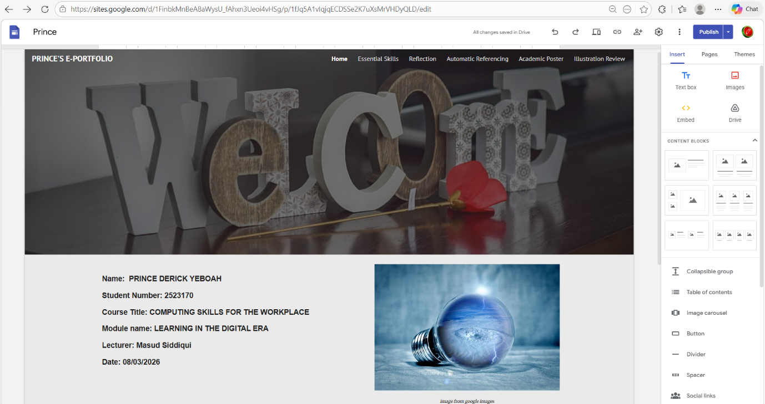

Task 1

Screenshot of ‘Essential Skills’

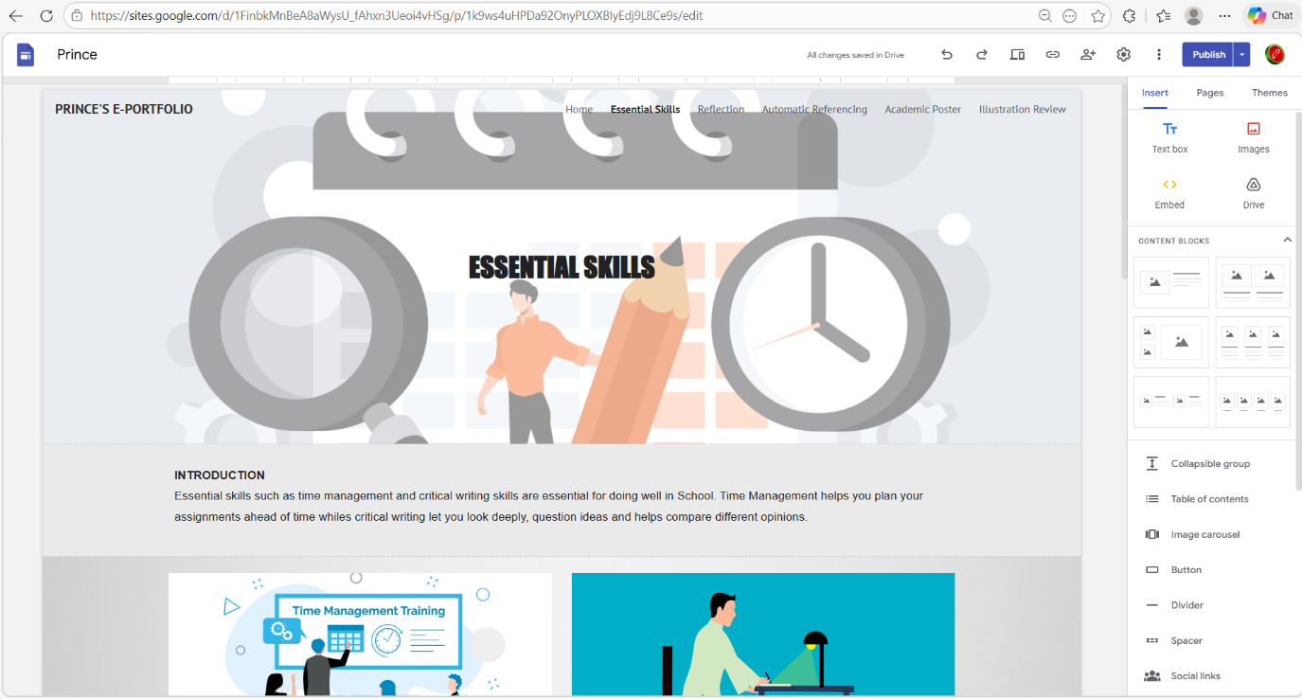
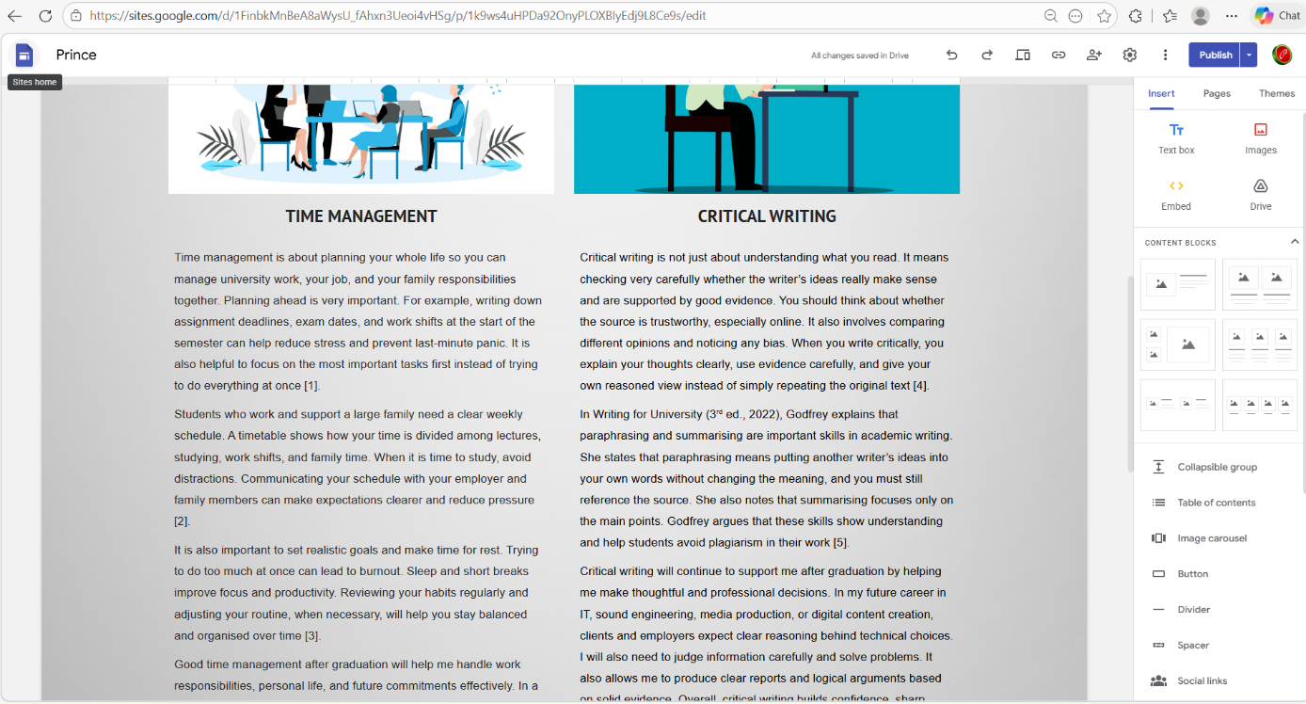

Screenshot of ‘Reflection’
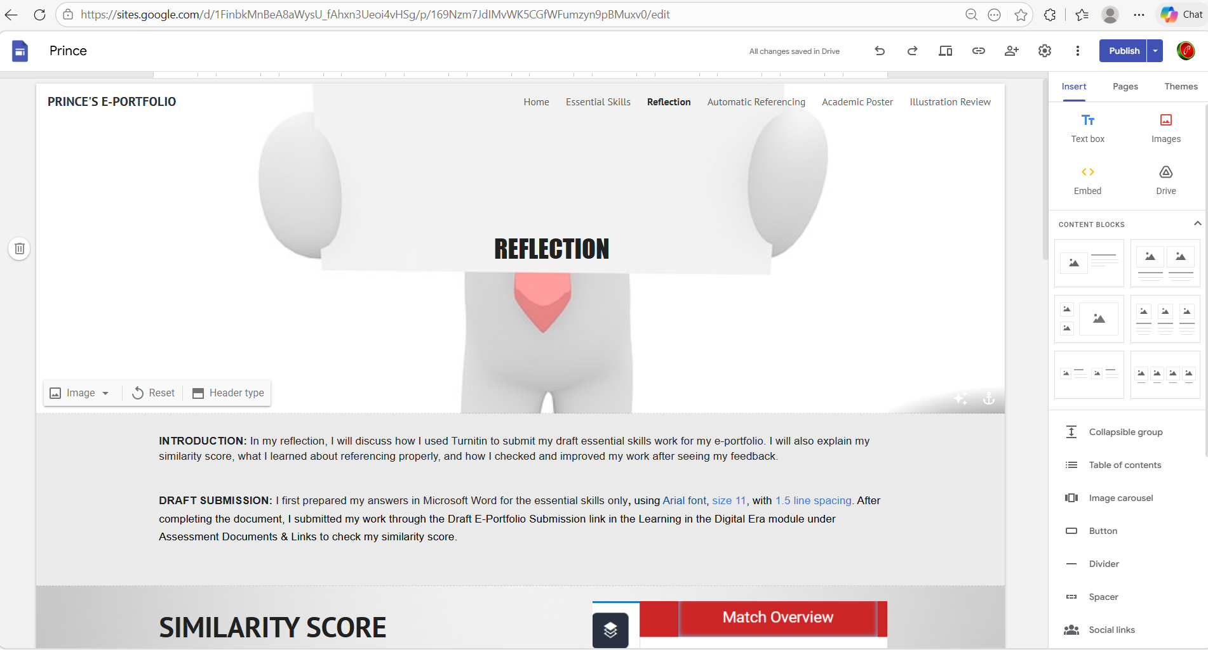
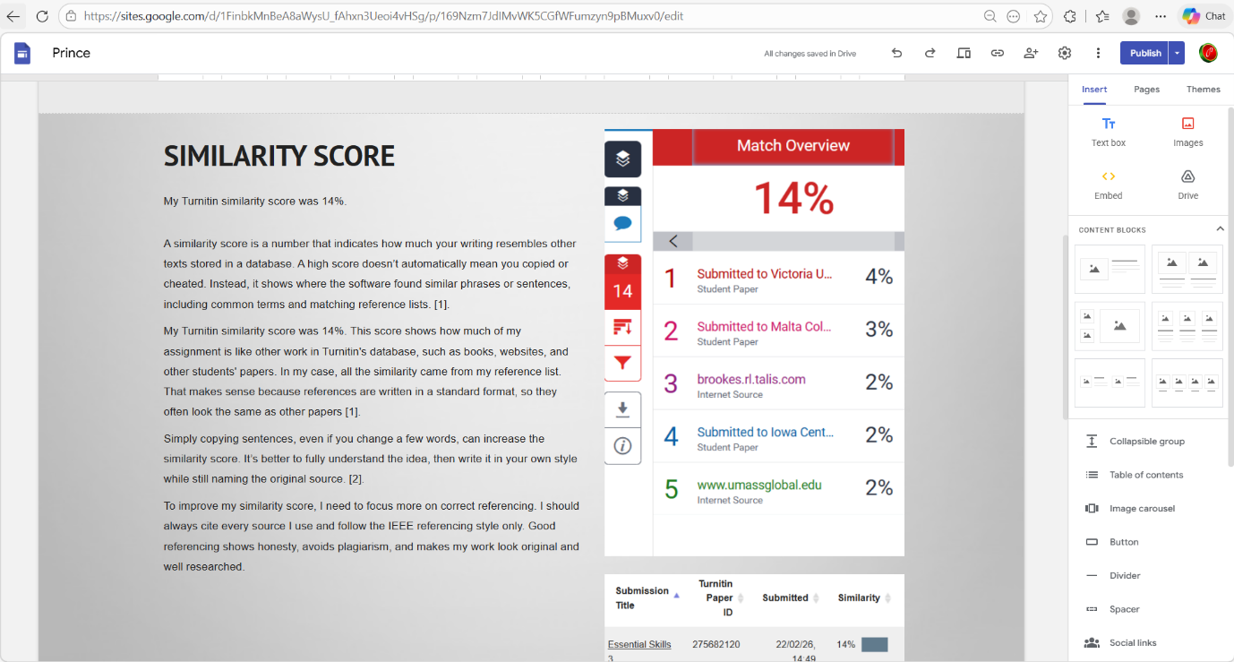

Task 2

Screenshot of mind map
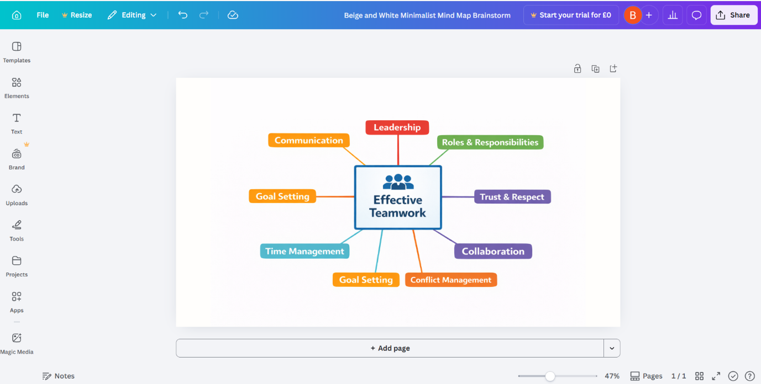

Link to mind map

https://drive.google.com/file/d/1az3Ae2Juk7nTZGYed5DDhdg80XKcngxN/view?usp=drive_link

Screenshot of the academic poster

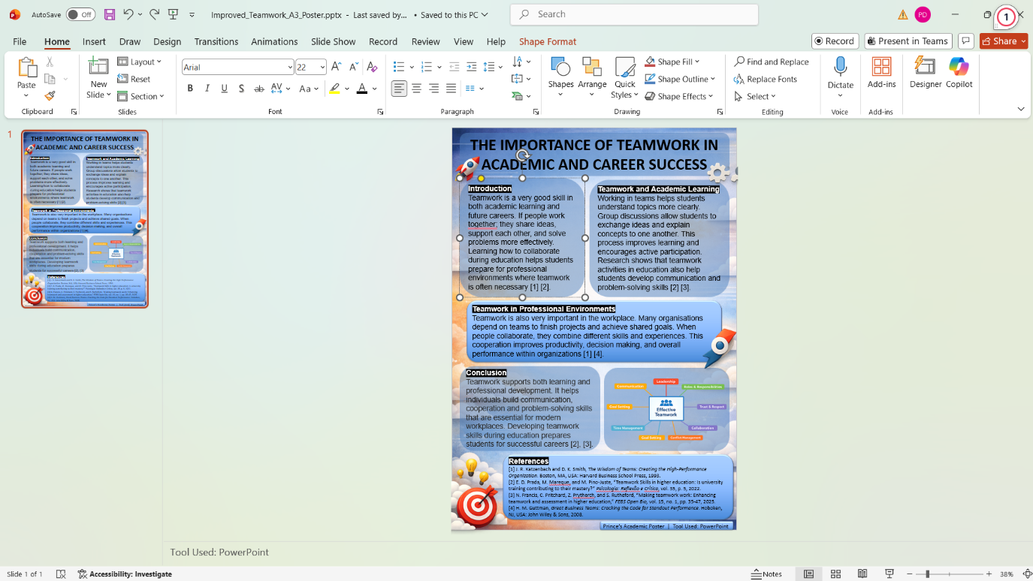

Link to the academic poster
https://sites.google.com/d/1KfLTL0a8FEZGtY2lVgQRAINQWAxcheJl/p/1SvuoteEb4-fdu1L6d1sI4075QMD_b9iT/edit

Task 3

Screenshot of automatic referencing tool 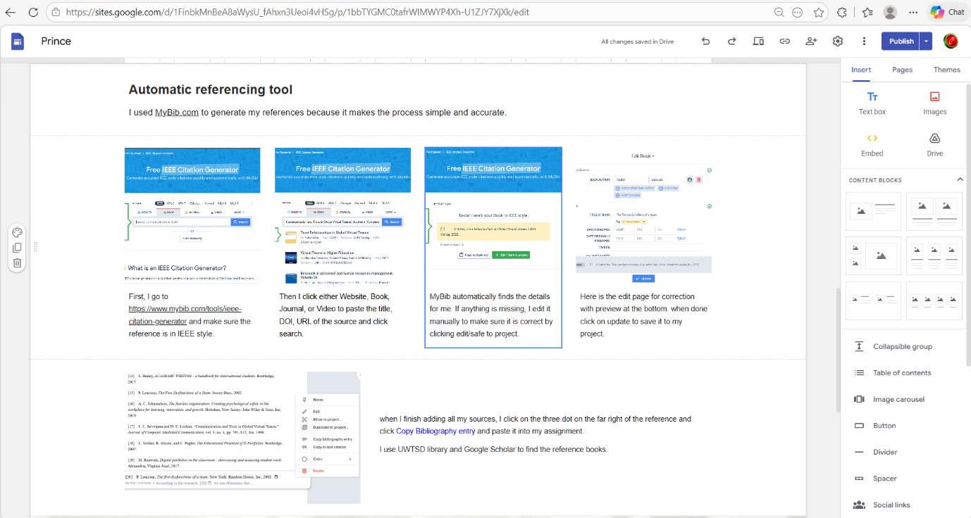

Task 4


