
TRANSFER LEARNING WITH EFFICIENTNET-B0
FOR MULTI-DISEASE CLASSIFICATION ON THE
PLANT PATHOLOGY DATASET
ACCA7025 — Component 2
Student Name: | Gaurav Anil Bansod
Student ID: | 2519815
Assignment Title: | Deep Learning Image Classification Report
Module: | ACCA7025 — Application of Machine Learning
Lecturer: | Dr Aliyu Sambo
Programme: | MSc Data and Artificial Intelligence

Abstract
This report presents the design, implementation and critical evaluation of a deep learning image-classification pipeline based on EfficientNet-B0 for identifying apple leaf diseases in the Plant Pathology dataset. Following an updated dataset issued by the module lecturer, the working dataset comprises twelve target categories, including healthy leaves, individual diseases and compound disease combinations, superseding the five-class configuration originally listed in the assessment specification. This formulation creates a challenging single-label classification task because several compound classes are severely under-represented and visually overlap with their constituent diseases.
A two-stage transfer-learning strategy was implemented and critically compared against alternative convolutional and transformer-based architectures. First, an EfficientNet-B0 backbone pre-trained on ImageNet was frozen while a task-specific classification head was trained; second, the final thirty backbone layers were unfrozen for low-learning-rate fine-tuning. Every architectural and hyperparameter decision — backbone selection, optimiser choice, learning rate, batch size, dropout and the number of unfrozen layers — is justified with reference to the literature. On the held-out test set of 1,863 images, the model achieved approximately 66.7% accuracy, a weighted F1-score of 0.64 and a macro F1-score of 0.34. The gap between weighted and macro performance demonstrates severe class imbalance: majority classes were recognised comparatively well, while five rare compound classes recorded zero precision, recall and F1-score.
A diagnostic analysis of the training logs further shows the fine-tuning stage did not improve on the frozen-backbone stage, and the likely implementation causes — reused callback state and Batch Normalization behaviour under unfreezing — are identified and discussed. Transfer learning provided effective feature extraction for common disease categories but did not independently resolve an imbalanced compound-label problem; class weighting, focal loss, targeted oversampling and genuine multi-label reformulation are recommended.
Keywords: Neural Networks; Plant Pathology; EfficientNet-B0; Convolutional Neural Networks; Transfer Learning; Fine-Tuning; Class Imbalance; Architecture Comparison

Section | Contents | Page
— | Abstract | 2
1 | Introduction | 5
1.1 | Background of Neural Networks | 5
1.2 | Image Classification in Agriculture | 5
1.3 | Plant Pathology Dataset | 5
1.4 | Aim and Objectives | 6
2 | Literature Review | 6
2.1 | Neural Network Architectures: RNNs versus CNNs | 6
2.2 | Deep Learning for Plant Disease Classification | 7
2.3 | Transfer Learning and Convolutional Architecture Selection | 7
2.4 | Research Gap | 8
3 | Dataset Description and Data Preparation | 8
3.1 | Dataset Overview and Partitioning | 8
3.2 | Target Classes and Class Imbalance | 9
3.3 | Image Pre-processing and Augmentation | 9
4 | Methodology and Implementation | 9
4.1 | Analytical Design | 9
4.2 | Architecture Selection and Comparative Justification | 10
4.3 | EfficientNet-B0 Backbone | 11
4.4 | Classification Head and Compilation | 11
4.5 | Two-Stage Training Procedure and Hyperparameter Justification | 12
4.6 | Evaluation Metrics | 13
5 | Results and Evaluation | 13
5.1 | Training and Fine-Tuning Behaviour | 13
5.2 | Held-Out Test Performance | 14
5.3 | Classification Report Analysis | 14
5.4 | Confusion Matrix Analysis | 15
6 | Discussion | 15
6.1 | Impact of Class Imbalance | 15
6.2 | Rare Compound Classes | 16
6.3 | Architecture and Hyperparameter Effectiveness | 16
6.4 | Limitations | 17
7 | Recommendations and Future Work | 17
8 | Conclusion | 18
— | References | 19

1. Introduction

1.1 Background of Neural Networks
Artificial neural networks are computational models composed of interconnected processing units organised into layers. During training, network parameters are adjusted to minimise a loss function, enabling the model to learn non-linear relationships directly from data. Deep neural networks extend this concept through multiple hidden layers that progressively learn hierarchical representations. In computer vision, convolutional neural networks (CNNs) are especially effective because convolutional filters learn spatial patterns such as edges, colours and textures before deeper layers combine them into higher-level visual concepts [1].

1.2 Image Classification in Agriculture
Plant disease diagnosis traditionally depends on manual visual inspection, which is valuable but time-consuming, subjective and hard to scale. Image classification can support earlier, more consistent identification of foliar symptoms such as lesions, discolouration and powdery deposits [2]. Hand-crafted colour, texture and shape descriptors have also been explored, but depend strongly on manual feature selection and generalise poorly under variable imaging conditions [3]. Automated classification therefore has clear potential to support crop monitoring and timely disease-management decisions.

1.3 Plant Pathology Dataset
Note on dataset version. The assessment specification originally referenced a five-class subset (healthy, scab, frog_eye_leaf_spot, rust, powdery_mildew) of the Plant Pathology 2021-resized dataset [4]. The module lecturer subsequently issued an updated, pre-split dataset that expands this to twelve classes, adding compound categories such as complex, rust complex and scab frog_eye_leaf_spot complex. This report uses the twelve-class dataset in line with that updated instruction; all figures and results below reflect this configuration.
The dataset contains expert-annotated RGB photographs of apple leaves drawn from the wider Plant Pathology 2021 collection [4]. The executed notebook identified 8,691 training images, 1,862 validation images and 1,863 test images across the twelve classes. A conceptually multi-label biological problem is thus represented as a twelve-way single-label task, creating several small compound categories and increasing the difficulty of learning reliable class boundaries.

Figure 1: Dataset loading, split sizes and automatic discovery of twelve classes from the executed notebook

1.4 Aim and Objectives
The aim is to design and critically evaluate an EfficientNet-B0 transfer-learning model for multi-disease apple leaf classification. The objectives are to: examine the dataset structure; implement pre-processing and augmentation; critically compare candidate CNN and transformer-based architectures and justify the final selection; develop a transfer-learning architecture with fully justified hyperparameters; apply frozen-backbone training and partial fine-tuning; evaluate performance using accuracy, precision, recall, F1-score and a confusion matrix; and explain the effect of class imbalance and implementation choices on rare compound categories.

2. Literature Review

2.1 Neural Network Architectures: RNNs versus CNNs
Neural networks can be broadly organised by the structure of connections between units and the data they are designed to process [1]. Recurrent Neural Networks (RNNs) introduce feedback connections that let information from previous time steps influence current processing, making them well suited to sequential and temporal data such as text, speech and time-series signals. The Long Short-Term Memory (LSTM) architecture was proposed to address the vanishing-gradient problem that limits vanilla RNNs' ability to learn long-range dependencies, and remains a landmark solution for sequence-modelling tasks [5]. Convolutional Neural Networks (CNNs), by contrast, exploit spatial locality and weight sharing, giving them translation-invariant sensitivity to local visual patterns that combine hierarchically into higher-level concepts [1].
Because this task involves classifying static, single-frame RGB leaf images with no temporal dependency between samples, a CNN-based architecture is the appropriate choice; an RNN would only become relevant for classifying disease progression across a time-ordered sequence of images of the same leaf, which is outside scope but noted as a future extension in Section 7.

2.2 Deep Learning for Plant Disease Classification
Earlier plant disease recognition systems relied on manually engineered colour, texture and shape descriptors followed by classifiers such as support vector machines. Dubey and Jalal [3] demonstrated the value of such features for apple disease classification, but hand-crafted pipelines depend strongly on feature selection and generalise poorly under variable imaging conditions. CNNs reduce this dependence by learning representations directly from images: Mohanty, Hughes and Salathe [2] demonstrated strong deep-learning performance for image-based plant disease detection, although controlled datasets may not fully represent field conditions. Too et al. [6] extended this by comparing several fine-tuned pre-trained CNN architectures for plant disease identification and found that deeper, more parameter-efficient networks consistently outperformed shallower networks trained from random initialisation — directly reinforcing the case for transfer learning used here rather than training a bespoke CNN from scratch on a comparatively small dataset.

2.3 Transfer Learning and Convolutional Architecture Selection
Training a deep CNN from random initialisation normally requires a very large labelled dataset, such as the roughly 1.2-million-image ImageNet corpus [15]. Transfer learning instead reuses visual representations learned from a large source dataset; Pan and Yang [7] showed this is particularly effective when the target dataset is comparatively small, as here (8,691 training images across twelve classes). A pre-trained backbone is combined with a new head: the head is first trained while the backbone is frozen, and selected backbone layers are then fine-tuned.
Several backbones were considered, with meaningfully different trade-offs. He et al. [10] introduced residual connections in ResNet to mitigate vanishing gradients in very deep networks; Huang et al. [11] extended this with DenseNet's dense feature-reuse pathways — both improve capacity at the cost of far more parameters. Howard et al. [12] proposed MobileNets, using depthwise-separable convolutions to minimise parameters for mobile deployment, trading some accuracy for efficiency. Tan and Le [8] proposed EfficientNet, using compound scaling to balance depth, width and resolution jointly, later extended as EfficientNetV2 [14]. Dosovitskiy et al. [13] proposed the Vision Transformer (ViT), replacing convolutional inductive bias with global self-attention, but typically needing very large-scale pretraining to match CNN accuracy at moderate dataset scale [13]. EfficientNet-B0 was reported to match or exceed ResNet-50's ImageNet accuracy with far fewer parameters [8], and Atila et al. [9] specifically reported effective plant leaf disease classification using EfficientNet — directly supporting its selection here; a full comparison is given in Section 4.2.

2.4 Research Gap
High aggregate accuracy in plant disease studies can conceal weak minority-class performance. Thapa et al. [4] showed that ambiguous complex symptoms remained difficult even when overall Plant Pathology performance was strong. More broadly, He and Garcia [16] and Buda et al. [17] showed that standard CNN training under cross-entropy loss is systematically biased toward majority classes when the training distribution is imbalanced — directly relevant to the twelve-class compound-label formulation used here. This study therefore evaluates per-class behaviour rather than relying on accuracy alone.

3. Dataset Description and Data Preparation

3.1 Dataset Overview and Partitioning
TensorFlow's image_dataset_from_directory utility loaded images directly from the training, validation and test folders. Images were resized to 224 × 224 pixels, matching the standard EfficientNet-B0 input resolution [8], and processed in batches of 32, with labels inferred automatically from directory names and encoded as integers.

Partition | Image Count
Training | 8,691
Validation | 1,862
Test | 1,863
Total | 12,416

3.2 Target Classes and Class Imbalance
The twelve classes are: complex, frog_eye_leaf_spot, frog_eye_leaf_spot complex, healthy, powdery_mildew, powdery_mildew complex, rust, rust complex, rust frog_eye_leaf_spot, scab, scab frog_eye_leaf_spot and scab frog_eye_leaf_spot complex. The compound-class formulation is methodologically important because each disease combination must be learned as an independent softmax category. Several of these classes contain very few observations, whereas healthy, scab and frog-eye leaf spot contribute much larger numbers of examples. This pattern of a small number of majority classes alongside many low-support minority classes is a canonical instance of the class-imbalance problem described by He and Garcia [16] and specifically characterised for CNN training by Buda et al. [17].

3.3 Image Pre-processing and Augmentation
The training pipeline applied random horizontal flips, rotation, zoom and contrast adjustment (each ±20%) and translation (±10%). This increases visual diversity and reduces memorisation risk; Shorten and Khoshgoftaar [18] identify geometric/photometric augmentation of this kind as an effective, low-cost regulariser for limited training data. Validation and test data were not augmented, since they must provide consistent generalisation estimates. Caching, shuffling and prefetching were used to improve throughput.

4. Methodology and Implementation

4.1 Analytical Design
A supervised multi-class image-classification design was adopted, comprising candidate architecture comparison, dataset loading, augmentation, pre-trained feature extraction, task-specific head training, partial backbone fine-tuning and held-out evaluation. TensorFlow/Keras was used for model development, scikit-learn for the classification report and confusion matrix, and the experiment was run in Google Colab.

4.2 Architecture Selection and Comparative Justification
Five candidate backbones were compared prior to implementation: EfficientNet-B0, ResNet-50, DenseNet-121, MobileNetV2 and ViT-B/16. Table 2 summarises published parameter counts and ImageNet top-1 accuracy for each, from their respective original publications.
Architecture | Approx. Parameters | ImageNet Top-1 Acc. | Key Mechanism | Ref.
EfficientNet-B0 (selected) | ~5.3M | ~77.1% | Compound depth/width/resolution scaling | [8]
ResNet-50 | ~25.6M | ~76.0% | Residual skip connections | [10]
DenseNet-121 | ~8.0M | ~75.0% | Dense feature-reuse connections | [11]
MobileNetV2 | ~3.4M | ~72.0% | Depthwise-separable convolutions | [12]
ViT-B/16 | ~86M | 77–85%* | Global self-attention (no convolutional inductive bias) | [13]
Table 2: Comparison of candidate backbone architectures considered for this task
With only 8,691 training images spread unevenly across twelve classes, minimising overfitting risk while maximising transferable feature quality was the primary selection criterion, not raw published accuracy alone. ResNet-50 and DenseNet-121 offer strong accuracy but carry roughly five and one-and-a-half times more parameters than EfficientNet-B0, raising overfitting risk when only a lightweight head and limited backbone layers are trainable. MobileNetV2 was excluded for its comparatively low accuracy ceiling, undesirable where recall on rare classes is already a known challenge (Section 6.2). ViT-B/16 was excluded because transformers lack the convolutional inductive bias CNNs get by construction, and need very large pretraining or heavy augmentation to match CNN accuracy at this scale [13] — impractical within the Colab budget. EfficientNet-B0 therefore offered the best accuracy-to-parameter ratio, consistent with its prior success in plant leaf disease classification [9].

4.3 EfficientNet-B0 Backbone
EfficientNet-B0 was instantiated without its original ImageNet [15] classification head and with ImageNet pre-trained weights. The convolutional base was initially frozen. Freezing preserves previously learned generic visual filters and prevents large updates from a randomly initialised classification head from immediately altering useful backbone representations.

Figure 2: Successful loading of the ImageNet pre-trained EfficientNet-B0 backbone

4.4 Classification Head and Compilation
The custom head used global average pooling — preferred over flattening as it reduces parameter growth and adds translation invariance — followed by batch normalisation to stabilise training [19]. Two dense blocks followed: a 512-unit ReLU layer with 50% dropout, then a 256-unit ReLU layer with 30% dropout, before a twelve-unit softmax output. The model was compiled with Adam [21] at 1×10⁻⁴ and sparse categorical cross-entropy, appropriate for integer-encoded single-label targets.
Adam was chosen over SGD and RMSProp because it combines momentum with per-parameter adaptive rates from bias-corrected moment estimates [21], converging faster and more stably for a fresh head on frozen features. SGD needs careful manual LR scheduling to match this, impractical given limited Colab time; RMSProp is similar but lacks bias correction and is a less common default for transfer-learning heads in the literature reviewed above [8], [9].

4.5 Two-Stage Training Procedure and Hyperparameter Justification
In Stage 1, the backbone remained frozen while the new head trained for up to fifteen epochs with early stopping and LR-reduction callbacks. Training accuracy rose from 34.94% to 65.48%, while validation accuracy reached 71.05% by epoch 15, evidencing progressive head adaptation.
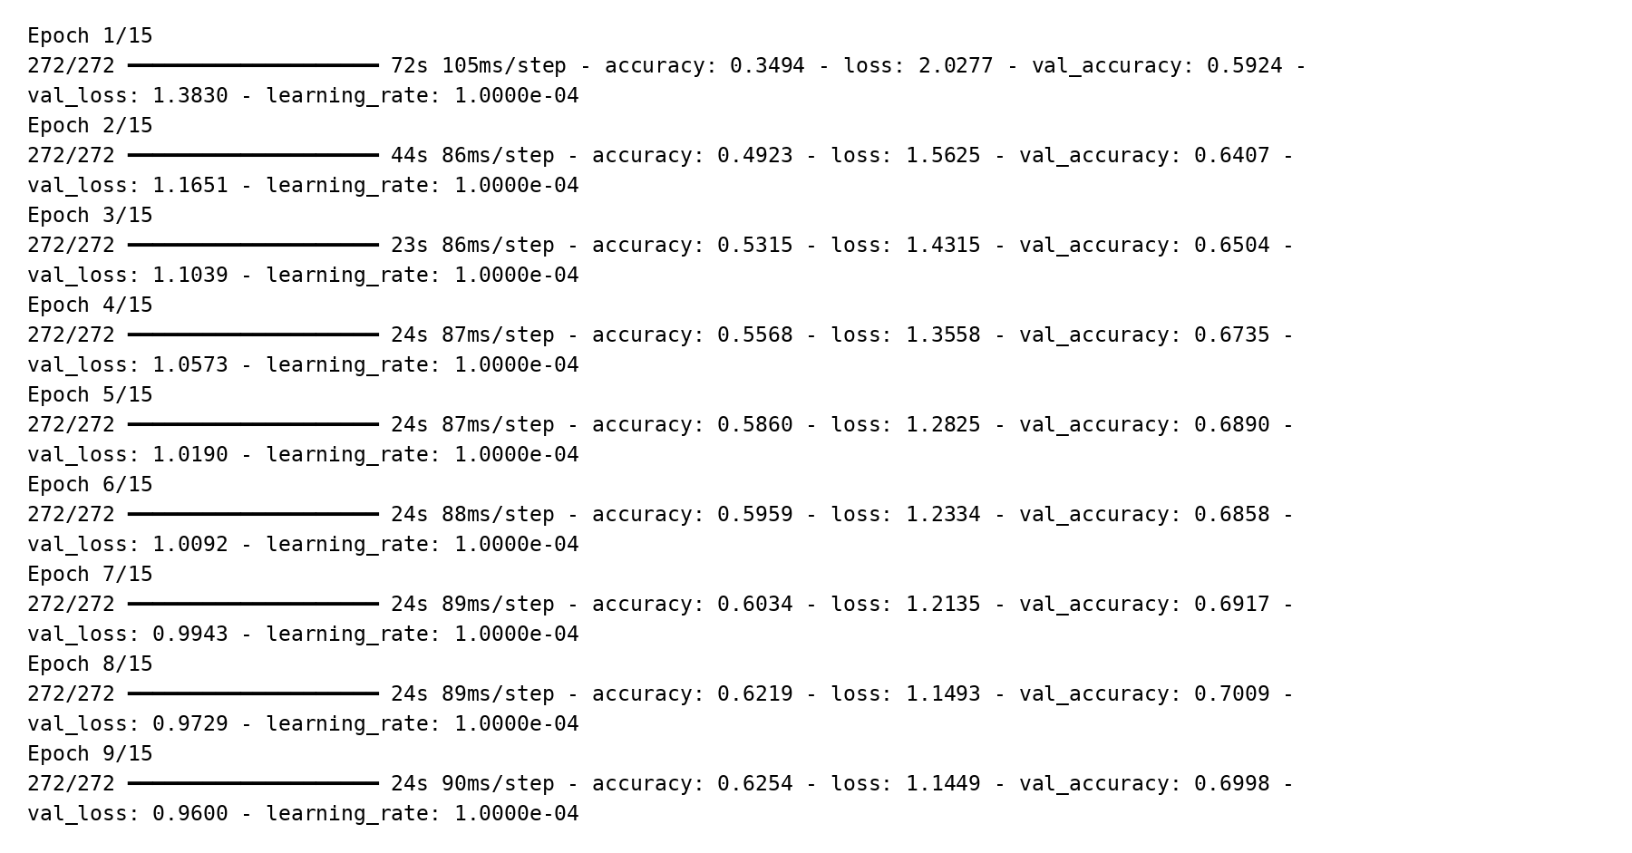
Figure 3: Stage 1 training log with the EfficientNet-B0 backbone frozen

In Stage 2, the base model was made trainable but all layers except the final thirty were re-frozen, and recompiled at a lower rate (1×10⁻⁵), intended to let high-level representations adapt while protecting earlier feature detectors. In practice, training accuracy fell to 53.6–56.2% and validation accuracy settled around 65.9–67.2%, marginally below Stage 1's best of 71.05%.
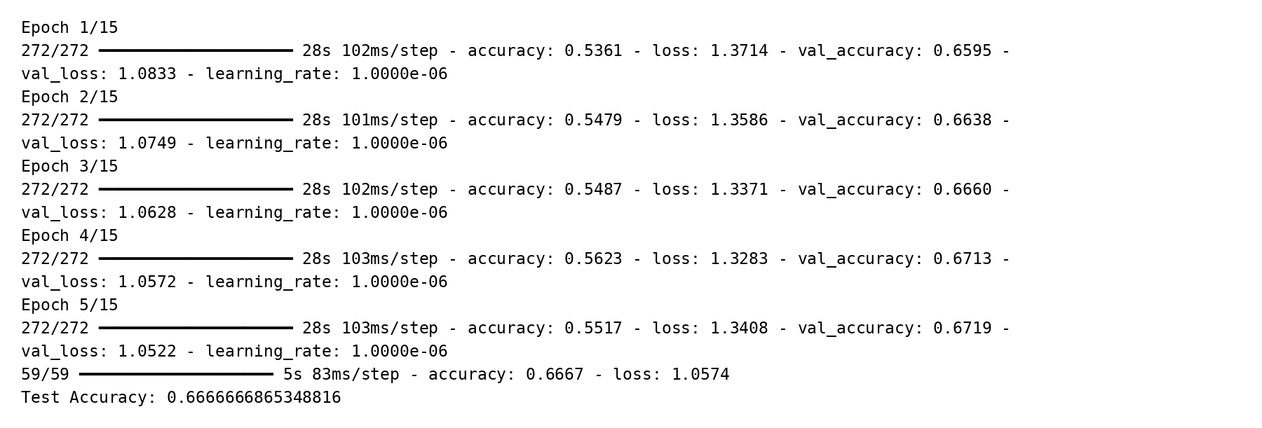
Figure 4: Stage 2 fine-tuning log for the final thirty EfficientNet-B0 layers
Two implementation-level factors help explain this, reported here for critical transparency rather than being concealed. First, setting the backbone's trainable flag to True switches every Batch Normalization layer from moving-average to batch-level statistics, known to temporarily destabilise activations before any weight update takes effect. Second, the same ReduceLROnPlateau callback instance was reused across both fit() calls; its state carried over from Stage 1, and the Stage 2 log confirms the effective learning rate had already collapsed to the callback's 1×10⁻⁶ floor rather than the recompiled 1×10⁻⁵. This left the unfrozen layers with a near-negligible step size, plausibly explaining the lack of improvement — an implementation limitation rather than a modelling one, and a priority fix noted in Section 7.
Hyperparameter | Value Used | Justification
Image size | 224×224 | EfficientNet-B0's native resolution [8]; limits resizing distortion and compute.
Batch size | 32 | Balances gradient stability vs Colab memory; smaller = noisier/slower, larger risks memory errors.
Optimiser | Adam | Momentum + adaptive rates [21] converge faster than SGD for a fresh head on frozen features.
Stage 1 LR | 1×10⁻⁴ | Moderate rate for a randomly initialised head on informative frozen features [21].
Stage 2 LR | 1×10⁻⁵ | Standard ten-fold fine-tuning reduction, protecting pre-trained representations [7].
Unfrozen layers | Final 30 | Final layers are task-specific and benefit from adaptation; early layers stay generic [7]; full unfreezing risks overfitting.
Epochs (max) | 15/stage | Caps session time; early stopping reaches a plateau without excess training.
Early stopping | patience 5, val_loss | Tolerates augmentation noise while stopping at genuine overfitting; restores best weights.
ReduceLROnPlateau | factor 0.2, patience 2, min_lr 1×10⁻⁶ | Lowers LR automatically once val_loss stalls.
Dropout | 0.5 then 0.3 | Reduces co-adaptation in the new, unregularised dense layers [20].
Loss function | Sparse categorical cross-entropy | Appropriate for integer-encoded single-label targets.
Table 3: Decision-reason justification for all hyperparameters used in the training pipeline

4.6 Evaluation Metrics
Accuracy was supplemented with per-class precision, recall and F1-score. Precision measures the reliability of predictions assigned to a class, while recall measures the proportion of true class samples correctly recovered. F1-score balances both measures. Macro averaging weights every class equally, while weighted averaging accounts for class support; their difference is particularly diagnostic in an imbalanced dataset such as this one [16], [17]. A confusion matrix was also used to identify systematic class-to-class errors.

5. Results and Evaluation

5.1 Training and Fine-Tuning Behaviour
Validation accuracy frequently exceeded training accuracy during Stage 1, plausibly because augmentation and dropout make the training pass harder while validation inference uses unaugmented images with dropout disabled — this does not by itself indicate data leakage. As discussed in Section 4.5, Stage 2 fine-tuning produced no net improvement over Stage 1, attributable to Batch Normalization behaviour under unfreezing and a reused learning-rate-scheduler state rather than to an unsound fine-tuning strategy.
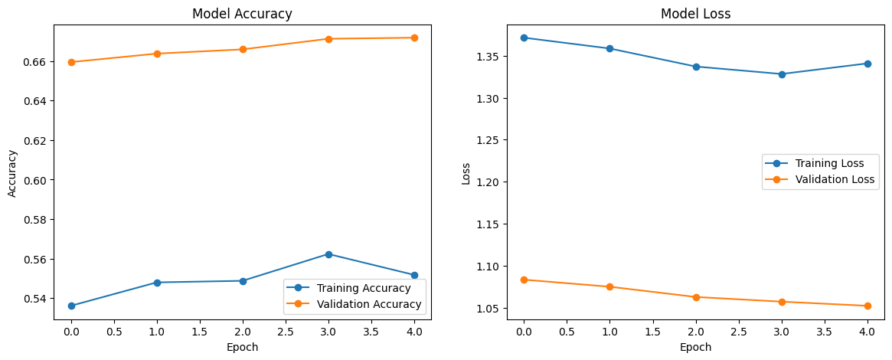
Figure 5: Training and validation accuracy/loss curves generated in the executed notebook

5.2 Held-Out Test Performance
On 1,863 held-out test images, the model achieved 66.7% overall accuracy. The weighted F1-score was 0.64, whereas the macro F1-score was only 0.34. This large gap demonstrates unequal class performance: weighted metrics are dominated by large classes, while macro averaging exposes failure on rare labels [16].
Metric | Result
Test Accuracy | 66.7%
Weighted F1-score | 0.64
Macro F1-score | 0.34
Macro Precision / Recall | 0.34 / 0.35
Test Images | 1,863
Table 4: Overall held-out test performance

5.3 Classification Report Analysis
The classification report confirms strong variation across categories. Healthy and powdery mildew achieved F1-scores of 0.80 and 0.81, while frog-eye leaf spot and rust reached 0.65 and 0.67. The complex class (160 images) and scab frog_eye_leaf_spot (73 images) performed poorly but non-trivially (F1 = 0.25 and 0.17). Five compound classes — frog_eye_leaf_spot complex, powdery_mildew complex, rust complex, rust frog_eye_leaf_spot and scab frog_eye_leaf_spot complex — received no correctly predicted samples and recorded zero precision, recall and F1-score, reinforcing the need to inspect class-level metrics rather than relying on overall accuracy alone [16].
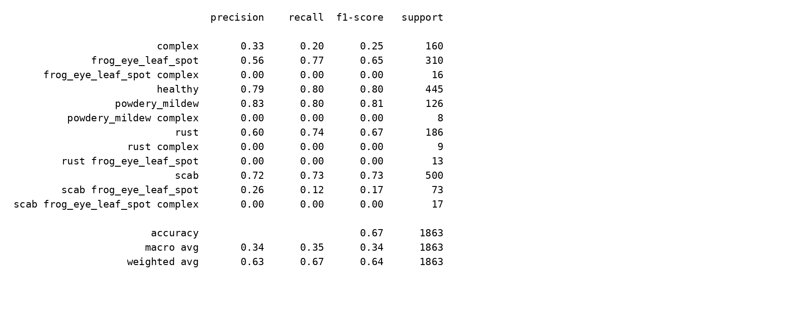
Figure 6: Classification report generated for the held-out test set

5.4 Confusion Matrix Analysis
The confusion matrix provides a visual explanation of the metric imbalance. Majority classes form clearer diagonal concentrations, whereas rare compound categories are routed into larger, visually related classes. This is intuitive for compound symptoms: an image containing both scab and frog-eye leaf spot can retain strong scab features and be classified as scab rather than the dedicated combination label. The matrix therefore suggests both a data-distribution problem and a label-formulation problem [17].
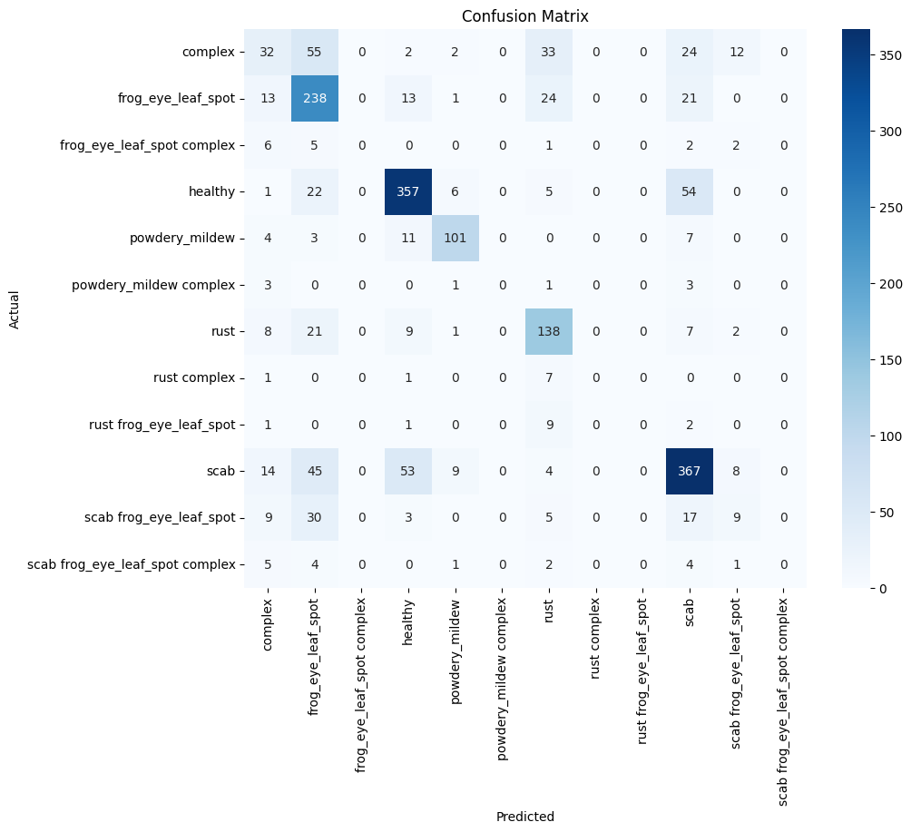
Figure 7: Confusion matrix for predictions on the held-out test set

6. Discussion

6.1 Impact of Class Imbalance
Class imbalance is the dominant limitation of this study. Under ordinary sparse categorical cross-entropy, each sample contributes equally to the objective, so majority classes generate far more optimisation signal than rare classes [16]. A model can substantially reduce global loss by improving common categories while effectively ignoring classes with few examples — explaining why overall accuracy remains moderate despite the low macro F1-score, matching the general behaviour documented for imbalanced CNN training by Buda et al. [17].

6.2 Rare Compound Classes
The same five rare categories recorded zero precision, recall and F1-score, with test supports of only 16, 8, 9, 13 and 17 images respectively. This is intensified by visual overlap, as each compound label shares disease features with larger constituent classes. Because no class weighting, minority oversampling or focal loss was used, the optimisation process had insufficient incentive to establish distinct decision regions for these labels [22].

6.3 Architecture and Hyperparameter Effectiveness
EfficientNet-B0 transfer learning was effective for well-represented categories, consistent with its comparative advantage over heavier backbones such as ResNet-50 and DenseNet-121 established in Section 4.2 [8], [10], [11]. The individually justified hyperparameters (Table 3) were reasoned from literature rather than chosen arbitrarily, and Stage 1's 71.05% validation accuracy supports their suitability. However, Stage 2's underperformance relative to Stage 1 — diagnosed in Section 4.5 as arising from Batch Normalization statistics switching and reused ReduceLROnPlateau state — shows that hyperparameter values alone do not guarantee correct behaviour; implementation details are equally consequential.

6.4 Limitations
The study is limited by the fine-tuning implementation issue identified above, the absence of an empirically re-trained comparison across the five candidate architectures (reasoned from literature given the available compute budget), and the single-label compound-class formulation. The result should therefore be read as a strong, well-justified baseline rather than a fully optimised disease-recognition system.

7. Recommendations and Future Work
Future work should first fix the fine-tuning implementation identified in Section 4.5 by instantiating a fresh ReduceLROnPlateau callback for Stage 2, so the intended 1×10⁻⁵ rate is actually used rather than collapsing to the callback floor.
Second, class-weighted cross-entropy and focal loss [22] should be evaluated so errors on rare classes contribute more strongly to the objective, alongside minority oversampling, balanced batching and targeted augmentation [18]. The architecture comparison in Section 4.2 could also be validated empirically by fine-tuning ResNet-50 or DenseNet-121 under an identical protocol.
Most importantly, the task should be reformulated as genuine multi-label classification — predicting scab, frog-eye leaf spot, rust and powdery mildew independently via a sigmoid output and binary cross-entropy — to better represent co-occurring diseases. If temporal image sequences became available, an RNN or convolutional-recurrent hybrid could also model disease progression over time [5].

8. Conclusion
This study designed and critically evaluated an EfficientNet-B0 transfer-learning pipeline for twelve-class apple leaf disease classification, selected from among five candidate architectures on the basis of a literature-grounded accuracy-to-parameter comparison. The model used ImageNet pre-training, a custom regularised classification head, frozen-backbone training and partial fine-tuning, with every hyperparameter individually justified. Evaluation on 1,863 held-out images produced 66.7% accuracy, a weighted F1-score of 0.64 and a macro F1-score of 0.34.
The model learned useful visual representations for majority disease classes but failed to recognise five rare compound categories, explained primarily by severe class imbalance, visual overlap between compound and constituent diseases, and the absence of imbalance-aware training. A diagnostic review of the training logs also identified a specific, correctable implementation issue limiting the fine-tuning stage. The study therefore meets its objective of implementing and critically evaluating a transfer-learning solution while identifying the principal factors restricting performance; future development should prioritise correcting the fine-tuning learning-rate schedule, adopting imbalance-aware loss functions and minority sampling, and reformulating the disease targets as multi-label.

References
[1] LeCun, Y., Bengio, Y. and Hinton, G. (2015) 'Deep learning', Nature, 521(7553), pp. 436–444.
[2] Mohanty, S.P., Hughes, D.P. and Salathe, M. (2016) 'Using deep learning for image-based plant disease detection', Frontiers in Plant Science, 7, 1419.
[3] Dubey, S.R. and Jalal, A.S. (2016) 'Apple disease classification using color, texture and shape features from images', Signal, Image and Video Processing, 10(5), pp. 819–826.
[4] Thapa, R., Zhang, K., Snavely, N., Belongie, S. and Khan, A. (2020) 'The Plant Pathology Challenge 2020 data set to classify foliar disease of apples', Applications in Plant Sciences, 8(9), e11390.
[5] Hochreiter, S. and Schmidhuber, J. (1997) 'Long short-term memory', Neural Computation, 9(8), pp. 1735–1780.
[6] Too, E.C., Yujian, L., Njuki, S. and Yingchun, L. (2019) 'A comparative study of fine-tuning deep learning models for plant disease identification', Computers and Electronics in Agriculture, 161, pp. 272–279.
[7] Pan, S.J. and Yang, Q. (2010) 'A survey on transfer learning', IEEE Transactions on Knowledge and Data Engineering, 22(10), pp. 1345–1359.
[8] Tan, M. and Le, Q. (2019) 'EfficientNet: Rethinking model scaling for convolutional neural networks', Proceedings of the 36th International Conference on Machine Learning (ICML), pp. 6105–6114.
[9] Atila, U., Ucar, M., Akyol, K. and Ucar, E. (2021) 'Plant leaf disease classification using EfficientNet deep learning model', Ecological Informatics, 61, 101182.
[10] He, K., Zhang, X., Ren, S. and Sun, J. (2016) 'Deep residual learning for image recognition', Proceedings of the IEEE Conference on Computer Vision and Pattern Recognition (CVPR), pp. 770–778.
[11] Huang, G., Liu, Z., van der Maaten, L. and Weinberger, K.Q. (2017) 'Densely connected convolutional networks', Proceedings of the IEEE Conference on Computer Vision and Pattern Recognition (CVPR), pp. 4700–4708.
[12] Howard, A.G., Zhu, M., Chen, B., Kalenichenko, D., Wang, W., Weyand, T., Andreetto, M. and Adam, H. (2017) 'MobileNets: Efficient convolutional neural networks for mobile vision applications', arXiv:1704.04861.
[13] Dosovitskiy, A., Beyer, L., Kolesnikov, A., Weissenborn, D., Zhai, X., Unterthiner, T., Dehghani, M., Minderer, M., Heigold, G., Gelly, S., Uszkoreit, J. and Houlsby, N. (2021) 'An image is worth 16x16 words: Transformers for image recognition at scale', Proceedings of the International Conference on Learning Representations (ICLR).
[14] Tan, M. and Le, Q. (2021) 'EfficientNetV2: Smaller models and faster training', Proceedings of the 38th International Conference on Machine Learning (ICML), pp. 10096–10106.
[15] Russakovsky, O., Deng, J., Su, H., Krause, J., Satheesh, S., Ma, S., Huang, Z., Karpathy, A., Khosla, A., Bernstein, M., Berg, A.C. and Fei-Fei, L. (2015) 'ImageNet large scale visual recognition challenge', International Journal of Computer Vision, 115(3), pp. 211–252.
[16] He, H. and Garcia, E.A. (2009) 'Learning from imbalanced data', IEEE Transactions on Knowledge and Data Engineering, 21(9), pp. 1263–1284.
[17] Buda, M., Maki, A. and Mazurowski, M.A. (2018) 'A systematic study of the class imbalance problem in convolutional neural networks', Neural Networks, 106, pp. 249–259.
[18] Shorten, C. and Khoshgoftaar, T.M. (2019) 'A survey on image data augmentation for deep learning', Journal of Big Data, 6, 60.
[19] Ioffe, S. and Szegedy, C. (2015) 'Batch normalization: Accelerating deep network training by reducing internal covariate shift', Proceedings of the 32nd International Conference on Machine Learning (ICML), pp. 448–456.
[20] Srivastava, N., Hinton, G., Krizhevsky, A., Sutskever, I. and Salakhutdinov, R. (2014) 'Dropout: A simple way to prevent neural networks from overfitting', Journal of Machine Learning Research, 15(1), pp. 1929–1958.
[21] Kingma, D.P. and Ba, J. (2015) 'Adam: A method for stochastic optimization', Proceedings of the International Conference on Learning Representations (ICLR).
[22] Lin, T-Y., Goyal, P., Girshick, R., He, K. and Dollár, P. (2017) 'Focal loss for dense object detection', Proceedings of the IEEE International Conference on Computer Vision (ICCV), pp. 2980–2988.

