Assignment 2
Andrew Gibson
Jack Edwards
1. Abstract
1.1 This report outlines the procedure adopted in testing three engines from different European emission legislation era’s, and the emission control systems that were used to satisfy the Euro regulations at the time. There will be research carried out into the exhaust emission gases that engines produce, and how modern ECU’s control the devices fitted to the engines to control the exhaust emission levels.
Paragraph number. | Page number. | Title.
1 | 2 | Abstract
2 | 2 | Contents
3 | 3 | List of figures
4 | 3 | Introduction
5 | 4 - 9 | Research
6 | 9 - 10 | Methodology
7 | 11 - 12 | Results/analysis
8 | 13 | Conclusion
9 | 13 | Evaluation
10 | 14 - 15 | References
2. Contents
3. List of figures.
Figure number | Page number | Title
Image 1 | 5 | Petrol cap pressure valve
Image 2 | 11 | Ford EEC4 idle valve waveform
Image 3 | 11 | Ford EEC4 Camshaft position sensor waveform
Image 4 | 11 | Ford EEC4 Fuel injector waveform
Image 5 | 12 | Vauxhall ecotec EGR waveform
Image 6 | 12 | Vauxhall ecotec Idle control valve waveform

4. Introduction
4.1 This report has been written to outline the operation and application of the modern emission control systems fitted to spark ignition petrol engines, and how they help in satisfying modern emission legislation. There will be discussion of each control system implementation and how they may work in cooperation with each other to combat exhaust gas emission levels.
4.2 There will be discussion as to the chemistry behind some emission control systems, as well as the applications of the systems to spark ignition petrol engines. The chemistry behind some systems operation will be discussed as well as the procedures adopted to observe their operation. There will be reference to books and technical papers whereby information has been taken from or observed, and analysis of several emission control systems operations.
5. Research.
5.1 The emission control systems used on the engines that were tested during this investigation are: PCV (Positive Crankcase Ventilation) system, SAI (Secondary Air Injection) systems, EGR (Exhaust Gas Recirculation) systems, Charcoal canisters (EVAP), catalytic converters, and Pulsed air systems. The six systems listed above were used alone and in conjunction with each other on the engines tested in this investigation.
5.2 Before beginning the test background research must be undertaken to understand the operation and function of the emission control systems. The first emission control system to be researched is the catalytic converter, according to Robert Bosch 2011 a catalytic converter is a section of the exhaust system whereby a monolith sits between an inlet and outlet of the catalytic converter, the monolith contains a lot of fine parallel channels with an active catalytic coating. Robert Bosch, 2011 also describes the number of channels ranges from 400-1200 cells per square inch, and the monoliths can be made from metal for higher flow capabilities mainly used on performance vehicles or made from ceramic to allow for greater stability to temperature, most catalytic converters have several different monolith coatings to allow for a mixture between flow and filtering properties.
5.3 According to Robert Bosch, 2011 the catalytic converters monolith is coated in platinum, palladium and rhodium. Platinum and palladium are the material that are responsible for accelerating the oxidisation of HC (Hydrocarbons) and CO (Carbon Monoxide), while Rhodium is responsible for reducing NOx (Nitrogen oxide). Robert Bosch, 2011 shows the following equation to annotate the process of how the Catalytic converter reduces exhaust gas emissions:$2CO+O2=2Co2$ for carbon monoxide oxidisation, and $2C2H6+7O2=4Co2+6H2O$ for hydrocarbon oxidisation, Then $2NO+2CO=N2+2Co2$ for the reduction of NOx. The oxygen required for the oxidation process is taken from present oxygen left from incomplete combustion or from the NOx when reduced at the same time. Due to chemical materials being used to oxidise the exhaust gas emissions, they have a certain “Lag” time while the materials are heated before they become a catalyst and likewise they have an operating window of temperature whereby they can be very efficient.
5.4 According to Lee S, Bae C, Lee Y, and Han T 2002, the catalytic converter starts to work effectively at 500 degrees Celsius, then operates at its highest efficiency between 700 degrees Celsius and 800 degrees Celsius whereby its oxidisation efficiency is between 80% and 98%. Therefore it is vital to get the catalytic converter temperature must be raised as quickly as possible to reduce the exhaust gas emissions during “Cold start”, according to Bernhardt, W. and Hoffmann, E 1972 this is done by reducing heat capacity of exhaust system pre catalytic converter, reduced heat capacity of catalytic converter, mounting the catalytic converter closer towards the exhaust ports as possible, or introduce a SAI system to raise the exhaust temperature as will be discussed later on during this report. However the catalytic converter cannot operate as efficiently past 800 degrees Celsius in terms of oxidising or converting both CO and NOx, however the catalytic converter can still oxidise HC up to 1050 degrees Celsius as outlined by Lee S, Bae C, Lee Y, and Han T 2002, however the chemical material (alumina) breaks down, then past 1100 degrees Celsius the catalytic converter material begins to melt and cannot function.
5.5 The vehicle can check to see if the catalytic converter is functioning by monitoring exhaust gas emissions by a pre and post-CAT lambda sensor. Rovai, F 2008, describes the secondary lambda sensor’s function (Post Catalytic converter) as monitoring the catalytic converters function, it monitors the catalytic converters function by measuring the oxygen storage in the catalytic converter. Rovai, F 2008 dictates that the post ECU should receive a signal from the post catalytic converter lambda sensor of 0mV for the maximum converter oxygen storage capacity is achieved, and up to 800mV means that the catalytic converter has little to no oxygen stored. The modern catalytic converters utilise Cerium which is a substance which can store oxygen from the exhaust gas, to later be used for oxidisation of the exhaust gas emissions. Modern catalytic converters are fitted with updated Lambda sensors, whereby on the Vauxhall Motronic unit tested the lambda sensor was a zirconium type lambda sensor, according to Robert Bosch, 2011 the zirconium sensor would compare the atmospheric oxygen content and the oxygen content of the exhaust gas and use that to establish whether fuelling is too rich or too lean. Whereas the ford and Vauxhall ecotec use the titanium type sensor whereby it would only measure exhaust gas alone and use that value to adjust fuelling, Modern systems utilise a heated wideband lambda sensor, Robert Bosch 2011 describes the heated wideband O2 sensor as a porous ceramic sensor that is heated to decrease the warmup phase of the sensor during cold start, the sensor works by the heater causing the heater to “come online” sooner and allows the sensor to read exhaust gas emissions during cold start phase.
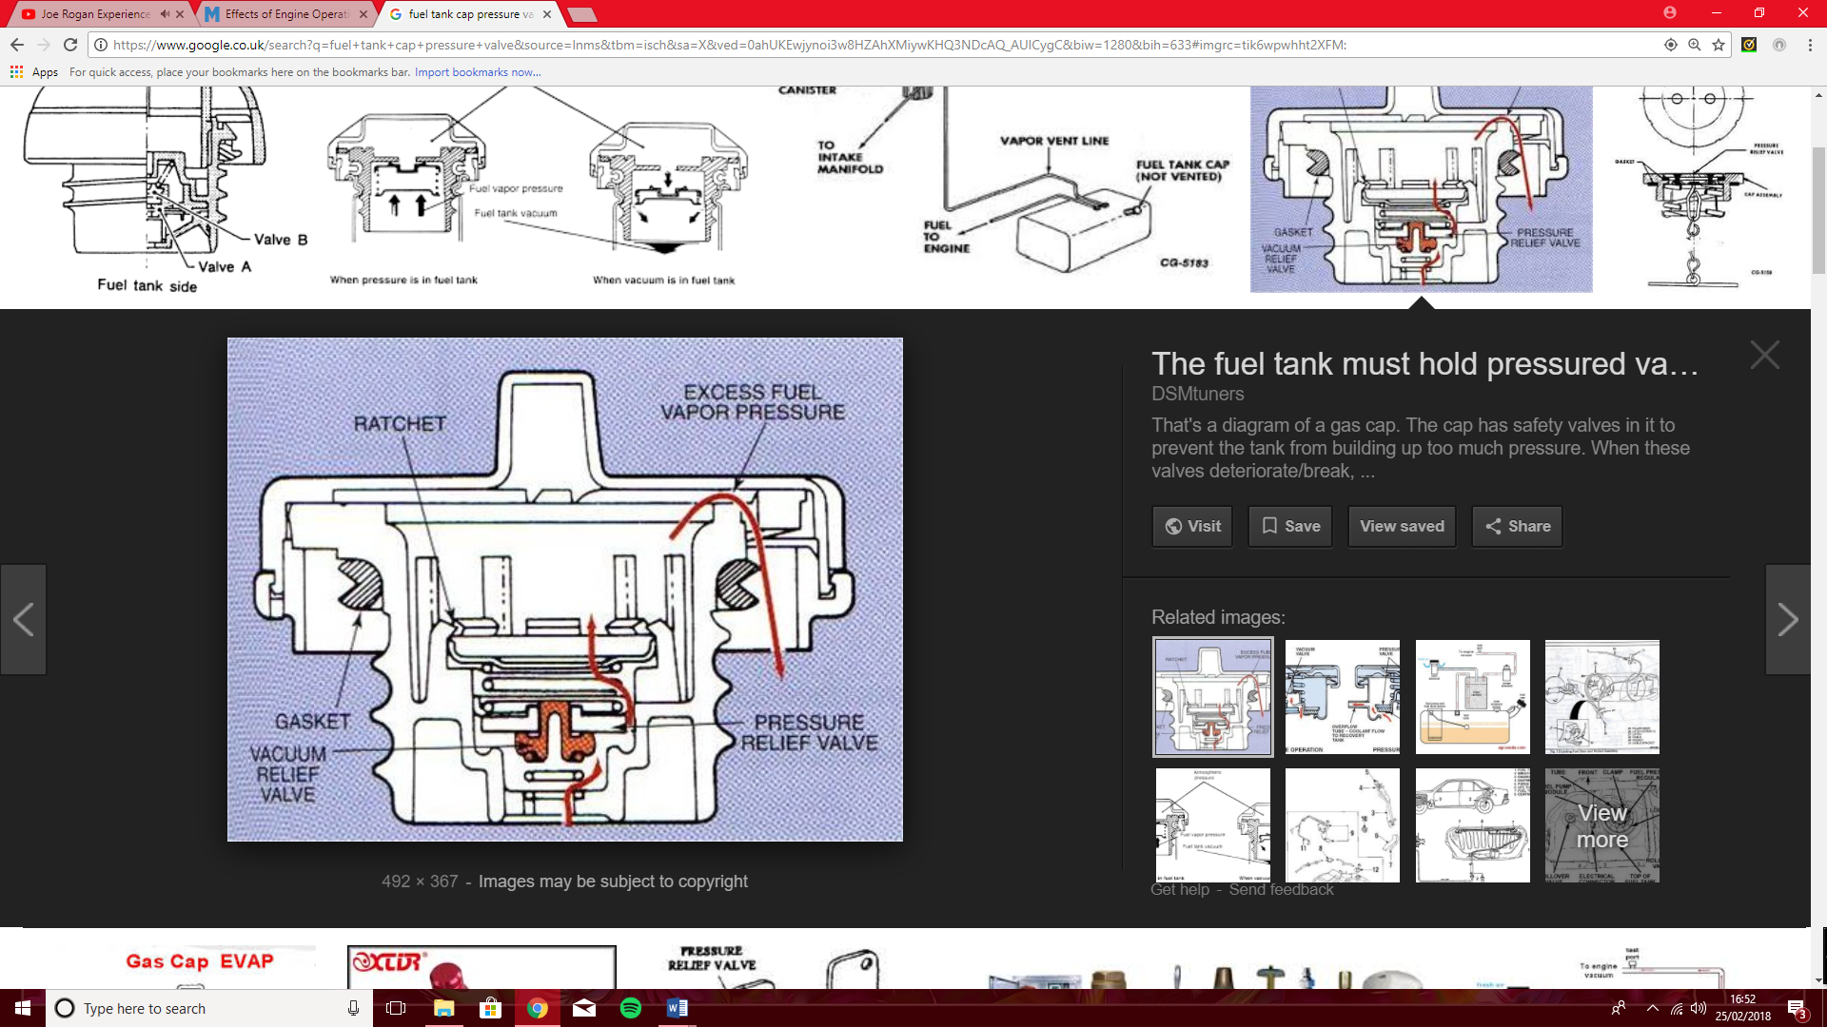
5.6 Another emission control system used on the engines that were tested during this investigation was the Charcoal cannister system (EVAP), this is because it was part of the earliest emission control system used, as it was introduced as part of the directive 70/2201/EEC 1970 according to Robert Bosch, 2011. According to Robert Bosch, 2011 the “Charcoal Canister” system was introduced to recover fuel vapours from the fuel tank, whereby under increased temperature or heated fuel from return fuelling systems, before the Charcoal cannister system was introduced, fuel tanks would simply have a pressure relief valve fitted to the fuel filler cap which would open under a given pressure and vent the fumes to atmosphere as shown in image 1.
5.7 When the directive 70/2201/EEC 1970 was introduced it dictated that the fuel system was no longer allowed to vent hydrocarbons to atmosphere, from reading Heinemann, J. and Gesenhues, B. 1993 it was found that EVAP systems were introduced to comply with Euro 2 regulations, whereby Euro 2 dictated a restriction of hydrocarbon emissions and therefore a need for a control system to prevent the hydrocarbons from venting to atmosphere was required.
5.8 According to Robert Bosch, 2011 the “Charcoal cannister” system works by the vent line from the fuel tank is fed to the charcoal cannister whereby fresh air is drawn through the carbon cannister and that mixture is then drawn into the manifold due to the vacuum created in the manifold through a purge valve which is electronically controlled, into the manifold to then be burnt instead of vented and wasted as previous. The system has parameters in which it can operate, with regards to the Vauxhall Motronic 2.0 engine that was tested as part of this investigation the vehicle has protocols that prevent the hydrocarbons being purged into the manifold, the purge valve will not open until the oil temperature reaches 50 degrees Celsius, this is because after 50 degrees Celsius the engine will run on a normal idle map, whereas before 50 degrees Celsius the engine still runs on its cold start map. It was also observed that the engine has an 80-degree Celsius running temperature due to the vehicle being fitted with a catalytic converter. From the tests carried out on the Vauxhall Motronic 2.0, it was found that the ECU can detect whether the charcoal canister has purged because the pre-CAT lambda will detect a rich mixture as the additional fuel vapours have been introduced to the mixture, making it richer than the ECU would detect. The ECU can also check for back EMF (Electro Magnetic Field) from the purge solenoid, these two methods are the only ways the Vauxhall Motronic ECU can monitor the charcoal cannisters operation.
Image 1.
5.9 The changes on the charcoal cannister EVAP system between the Vauxhall Motronic system which satisfy Euro 2/3 regulations and the Ford 1.6 EEC4 engine which had to satisfy Euro 3/4 and Vauxhall 2.0 ecotec engine which satisfied Euro 4/5, is that the Ford ECU has to detect movement from the wheel speed sensors in order for the purge solenoid to be energised while the ECU will still check for a back EMF signal from the purge solenoid, the difference in the purge sensor is that this sensor is grounded to operate and will produce a square waveform similar to that of a hall sensor. Whereas the Vauxhall 2.0 ecotec ECU is more like the previous Vauxhall Motronic unit whereby it can only check that the charcoal cannister has purged by monitoring back EMF from the purging solenoid.
5.10 On of the main concerns regarding exhaust emission gases that has been outlined in the Euro regulations is that of oxides of nitrogen or NOx. The European Automobile Manufacturers Association 2018, outlines the NOx emission tolerance between Euro 2 and Euro 4 dropping from 0.5 g/km to 0.08 g/km, and between euro 4 and Euro 6 it has dropped from 0.08 g/km to 0.06 g/km, Therefore the European government has made clear its need to tighten down on NOx being produced by motor vehicle. The NOx has been an issue more recently due to “Downsizing” of engines and higher compression ratios being utilised, causing engine temperatures to rise. This coincides with NOx as NOx is only formed at very high temperatures, according to EPA, 1999 NOx forms proportionately greater at temperatures exceeding 1300 degrees Celsius and oxygen content exceeding 200,000ppm. Therefore, NOx must be controlled by controlling the combustion and engine running temperatures, one of the methods vehicle manufacturers used to control the NOx emission levels and satisfy modern Euro emission legislation is the EGR system (Exhaust Gas Recirculation).
5.11 From the tests carried out on the engines as part of this investigation the EGR system was introduced as part of Euro 4/5 regulations in the form of the Vauxhall ecotec 2.0 engine. The Vauxhall 2.0 ecotec engine utilises a solenoid controlled EGR valve to try and reduce combustion temperatures. Newhall H, 1967 describes the EGR system as reducing combustion temperatures by introducing inert (Chemically inactive) exhaust gas back into the combustion chamber to assist in reducing temperature. Newhall. H 1967 also says the inert gas that is introduced into the combustion chamber absorbs a portion of the chemical energy released during combustion, and then in effect will reduce the cylinder temperatures and in turn, reduce NOx production. One of the issues with the Vauxhall 2.0 ecotec EGR system is that it’s a basic EGR system and the ECU cannot observe and monitor many parameters about the inert gas, including mass, volume and what inert gas it should allow to flow. From the tests undertaken the Vauxhall 2.0 ecotec ECU can only observe EGR operation by referencing back EMF from the solenoid, however because it is ECU controlled it has parameters it has to meet before it can operate. One of the parameters that must be satisfied before the ECU can initiate EGR function is the engine temperature must be at operating temperature, whereas older style systems that use a vacuum diaphragm to operate the EGR valve would not be able to control when the EGR would operate and would then operate at times where it would not be beneficial for it too.
5.12 The use of EGR systems has developed since the Vauxhall 2.0 ecotec was introduced, the developments include monitoring systems for EGR units, the ECU has greater control over the EGR valves operation and changes in EGR design itself. An example of a modern EGR design is the change from an open/close EGR valve as the Vauxhall ecotec uses, to the modern EGR valve which is a rotary style unit with varying size apertures, so the ECU can control EGR flow entirely. Pachner, D. and Beran, 2016 dictates that Modern EGR systems also utilise flow sensors within the EGR circuit to monitor flow and to more accurately reduce NOx emissions, the flow sensors are used in conjunction with exhaust gas temperature sensors to allow the ECU to monitor whether the EGR system is influencing exhaust temperature and in turn NOx levels. During the engines operation the EGR will be active and non-active, this is because EGR is only effective under certain operating conditions determined by the ECU’s monitoring system. If EGR was not used at all during the engines operation then the temperatures within the cylinders would continue to increase, as disclosed by Robert Bosch, 2011 the EGR works at its most efficient when temperatures do not exceed 150 degrees Celsius. Therefore, modern EGR systems make use of EGR coolers whereby the EGR gas is fed through a cooler to maintain a low temperature when re-entering the cylinder, however the Vauxhall 2.0 ecotec unit tested as part of this investigation did not utilise an EGR cooler, showing the development of the EGR system to satisfy modern Euro emission legislation.
5.13 The issue with Catalytic converters as discussed in paragraph 5.4 is they have a high operating temperature, and before they reach their optimum temperature they are not efficient, therefore getting the catalytic converter to temperature as quickly as possible is critical for reducing exhaust gas emissions. One method of satisfying this requirement is SAI (Secondary Air Injection), Robert Bosch 2011, describes SAI as a circuit whereby an external pump is used to pump oxygen into the exhaust manifold, which produces a leaner exhaust gas mixture. According to Kavekar, P. and Ghodeswar, D 2013 the un-burnt fuel (HC) can be oxidized above a certain temperature before it reaches the catalytic converter, therefore the use of SAI increases exhaust temperature “pre-CAT” and will increase the oxidisation of the un-burnt fuel (HC) and decrease the warm-up time of the catalytic converter, therefore will decreasing the levels of HC exhaust gas emissions as well as the reduction of CO.
5.14 The SAI circuit consists of an external air pump which is controlled by the vehicles ECU, the external air pump draws air into the exhaust system via a secondary-air valve which prevents backflow from the exhaust manifold. The Ford 1.6 EEC4 engine that was tested was fitted with a pulsed air injection system, which operates on the same principle as a SAI unit, the ford 1.6 EEC4 system uses the motor to pulse air into the exhaust system rather than a continuous flow. The Ford 1.6 EEC4 was able to satisfy the Euro 3/4 regulations when it was released, however the issue with the pulsed air system that the ford utilises is that the ECU cannot monitor its operation due to it having no sensors designated to monitoring SAI operation. The Vauxhall 2.0 ecotec unit tested as part of this investigation shares the same fault, although it satisfies euro 4/5 emission regulations it also cannot monitor the SAI systems operation. Methods to improve the accuracy of SAI operation would be to include flow sensors where the SAI feed pipe meets the exhaust manifold, this would allow the ECU to observe if the pump is delivering air to the exhaust manifold whereas the previous systems used on the ford and Vauxhall ecotec systems only mode of monitoring SAI operation was referencing a back EMF from the secondary air solenoid, however if there was a break in the pipe between the solenoid and the exhaust manifold then the ECU would not be able to detect any faults. Another method to improve the reliability of the SAI system would be to use existing exhaust temperature sensors on modern systems or to use exhaust temperature sensors in the exhaust manifold of an older vehicle such as the ford or Vauxhall ecotec system tested.
5.15 Similar to the previous emission control systems discussed in this report the SAI system as operating conditions whereby it is more effective than others. According to Pachner, D. and Beran, 2016 the SAI system has 3 main operating conditions, During idle (Steady State) and acceleration the SAI system will continue to provide air flow to the exhaust manifold, however during deceleration the reed valve is closed to prevent the excess HC left over from incomplete combustion after the throttle is closed to cause an “after burn Effect” in the exhaust manifold and create sudden high pressure.
5.16 Positive Crankcase Ventilation was introduced the same time as the EVAP systems were introduced as discussed in paragraph 5.7, under directive 70/2201/EEC 1970 hydrocarbons could not be vented to atmosphere. In conjunction with the charcoal cannister systems, according to Tracy, C. and Frank, W 1964, PCV systems were introduced to prevent the fuel/air charge venting to atmosphere after escaping the piston seals due to “blow-by”, from venting through a crankcase or rocker cover ventilator and in-turn to atmosphere. The blow-by charge is then taken though a flow control valve and re-entered into the intake manifold to be burnt. The PCV system that was used on the Vauxhall Motronic system tested as part of this investigation had a direct link PCV system whereby the blow-by charge which is unmetered and unmeasured is then taken back into the intake manifold and is burnt, however the system can only check whether the PCV has operated by lambda, The Vauxhall Motronic system could only see a rich lambda signal to signify that the PCV has operated. Development was made to the Ford 1.6 EEC4 PCV system whereby it had to satisfy the Euro 3/4 regulations compared to the Vauxhall Motronic system which only had to satisfy the Euro 2/3 regulations, The main development would be the use of a solenoid controlled flow valve to control the flow of the blow-by charge, the use of a solenoid also gives the ECU the ability to control the PCV valve’s operation, however if there is a break in the pipe between the flow control valve and the manifold then the ECU still cannot monitor whether it has completed its function.
5.17 The Vauxhall 2.0 ecotec system also uses a solenoid valve to control the flow control valve to control when the PCV valve was allowed to operate, however the Vauxhall 2.0 ecotec ECU cannot monitor whether the PCV system has operated, similar to the Ford 1.6 EEC4 system if there is a separation in the pipe between the flow control valve and the intake manifold the ECU would not be able to detect the fault. Modern PCV systems however have developed in their ability to self-check and monitor its operation and they also have separators whereby the charge mixture was sent through a separator which would remove the oil from the charge mix which could have been picked up through the engine surfaces during its travel. CDX Automotive, 2013 describes modern PCV systems that utilise variable orifice valves whereby their position can be varied depending on the pressure in the intake manifold. Due to modern systems feeding blow-by charge mix directly into the manifold, the vehicles OBD (On Board Diagnostic) system can monitor the MAP (Manifold Absolute Pressure) sensor to detect whether or not the PCV system is connected, due to decreased manifold pressure if the PCV system is disconnected it allows the vehicles ECU to detect any leakages or breaks in the PCV pipes. The PCV valve can also become stuck or damaged during the vehicles lifetime, J.Halderman and J. Linder 2005 describes the operation of the PCV valve as being open during idle and high load conditions, however when the inlet manifold experiences high pressure the PCV valve will shut and prevent backfire and manifold damage.
5.18 J.Halderman and J. Linder 2005, describe a faulty PCV valve as having the following effects: rough idle/cutting out. This is due to the PCV valve accounting for 20% of the air needed by the engine at idle, therefore if the PCV valve is clogged or damaged then the engine will not have enough air to maintain idle, or lambda could display a “Rich” value due to the lack of air the PCV is able to provide. As listed by J. Halderman and J. Linder 2005 the following diagnostic procedures can be applied to diagnose a faulty PCV system: Vacuum check can be performed on crankcase, smoke test could be performed on PCV circuit to check for leaks, back probe PCV solenoid to check for correct operation.
5.19 Finally, a major influence on exhaust gas emissions is the air/fuel mixture that the vehicle runs on. Robert Bosch, 2011 describes Air/fuel ratio as the term used to describe the ratio at which the fuel and air charge is during combustion. There is an “ideal” mixture called stoichiometric, stoichiometric is the ratio of air to fuel of 14.7:1. This mixture provides a lambda reading of 1, this lambda reading is what the ECU will base its fuelling on to try and maintain a lambda reading of 1. However, the fuelling can be changed in relation to the air supply being a constant to alter exhaust gas emission levels. Examples of this could be lean operating conditions, as supported by Robert Bosch, 2011 the lean operating conditions i.e. lambda readings of >1 will provide decreased levels of NOx than stoichiometric operating conditions while also having very little to no CO content in the exhaust gas mixture, likewise having reduced HC content. Whereas a rich operating condition i.e. a lambda reading of <1 also produces reduced NOx levels compared to stoichiometric conditions, however will have increased CO and HC emission levels due to the excess fuel being burnt.

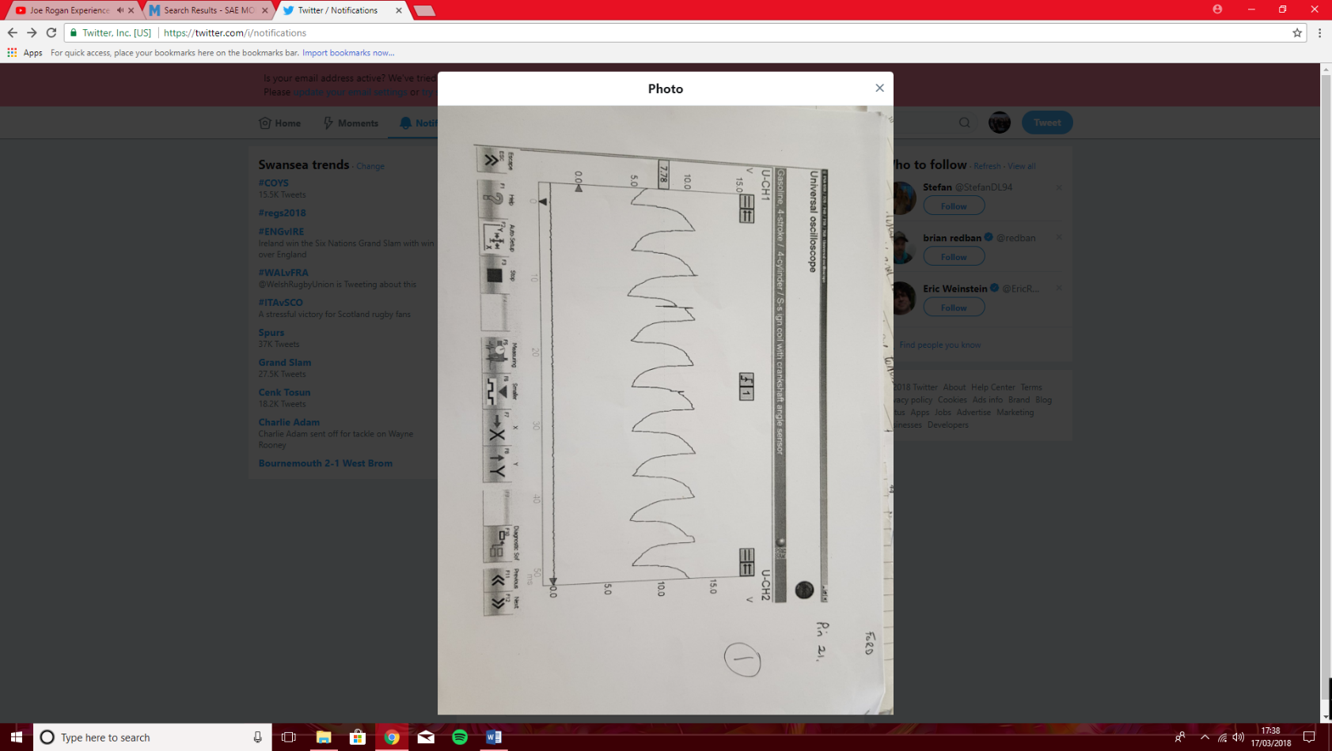
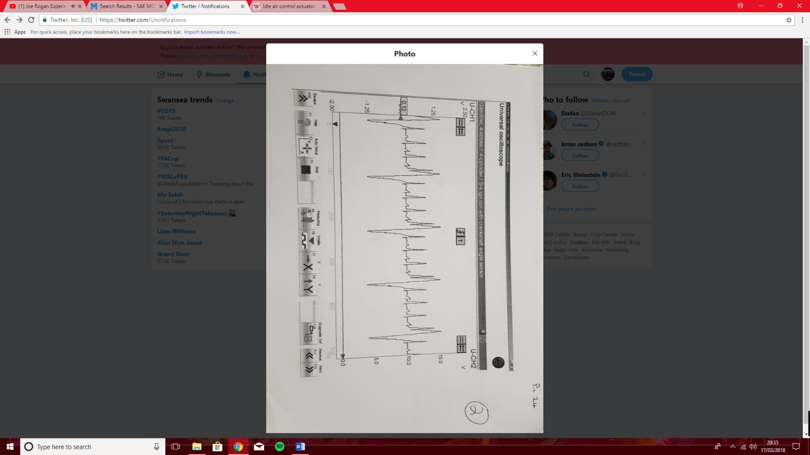
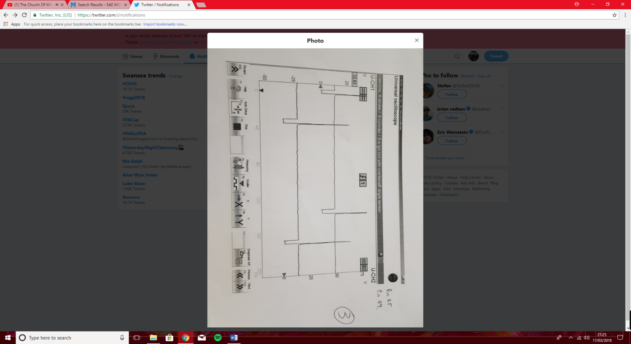


5.20 Modern vehicles will utilise lean operation conditions to minimise exhaust gas emission levels, to satisfy Euro 6 emission legislation. This is to satisfy Euro 5 and 6 legislations compared to that of Euro 4 legislation, whereby the NOx tolerance dropped by 0.02 g/km, CO and HC levels remained the same as Euro 4, therefore the use of methods to reduce only NOx was required. Robert Bosch, 2011 stated that direct injection engines were able to maintain operation at a much higher lambda reading (ʎ = 4), in contrast manifold injection engines were not able to sustain load at as high of lambda values (ʎ = 1.2-1.5) however they are able to maintain the lowest specific fuel consumption. The modern engines utilise direct injection fuelling alongside stratification mixture, to achieve a more complete combustion, however the benefit of direct injection according to Robert Bosch, 2011 they are capable of running under higher lambda readings than manifold injection engines under partial load conditions. In contrast to lean operating conditions, richer running conditions would provide high CO and HC emissions due to engine not being able to burn all the fuel within the cylinder, meaning the HC readings will be out of tolerance.
5.21 The systems discussed during this section are still utilised on current vehicles, however they have been updated and more closely monitored to satisfy modern Euro 6 emission regulations. According to Robert Bosch, 2011 the CO, HC, NOx and particulate matter has been cut by at least 50%, therefore from the date when the emission legislation was released to Euro 6 the emission control systems have been updated to comply. The greatest development with the emission control systems discussed in this section, is the use of more accurate monitoring systems and the use of already existing sensors in conjunction with new sensors specific to emission control systems to closely monitor exhaust gas emission levels. Examples of this will be discussed during the results and methodology sections.
6. Methodology
6.1 The engines tested during this investigation were scoped using a designated automotive oscilloscope, the negative side of the battery was used as an earth and the positive lead was used with a back-probe tool to scope the relevant sensors to establish the function of the emission control systems fitted to the engines. The systems tested were: charcoal canister system (EVAP), Catalytic converter, SAI (Secondary Air Injection), EGR (Exhaust Gas Recirculation) and PCV (Positive Crankcase Ventilation).
6.2 Robert Bosch, 2011 describes modern petrol engines as “Zero-emission” machines. The change in petrol engine emissions since the introduction of European emission regulations in July 1992, comes from the increase of modern monitoring systems. This includes variable aperture EGR valves as discussed in paragraph 5.12, combined with flow sensors in PCV systems and the ability for the ECU to utilise data from separate sensors to influence emission control systems operation. Therefore the engines tested as part of this investigation require updates If they were to be eligible to pass modern Euro 6 legislation, the Vauxhall Motronic 2.0 engine would require the following updates and additions to its existing emission control systems to pass Euro 6: changes from air volume sensor to an air mass sensor as it will allow the ECU to more accurately measure air flow as the mass sensor will be able to account for changes in air density and temperature compared to the volume sensors which would not be able to account for these variables. The PCV system would require a variable aperture solenoid valve, along with flow sensors to detect the solenoid operation and to measure the flow of recirculated charge back into the induction system, the use of a solenoid valve would allow the ECU to control when the PCV would operate and the mass of recirculated charge mix more closely regulated. Along with the modifications the lambda sensor would require updating to more accurately measure exhaust gas emissions, the sensor would need to be updated from a zirconium type sensor as discussed in paragraph in 5.5 to the modern type wideband O2 sensor as discussed in paragraph 5.5 to allow for more accurate monitoring, The idle control valve will also require updating from the rotary style valve which is solenoid controlled, to the modern plunger style system whereby the solenoid undergoes phasing to control position rather than simply open or closed, the plunger idle control valve fitted to the Ford engine and Vauxhall ecotec engine tested during this investigation can be scoped using a back-probe and the waveform analysed to calculate load, which can be found In the analysis section, under figures 1 and 5.
6.3 The Ford 1.6 EEC4 engine had more updated emission control systems than the Vauxhall Motronic engine, however the SAI system would need to be fitted with flow sensors to allow the ECU to measure how much air is being pumped into the catalytic converter, the PCV system will also require updating as stated in paragraph 6.2. The Vauxhall 2.0 ecotec is the most updated engine out of those tested as it satisfies euro 4/5, however there are still methods that can be used to allow it to satisfy Euro 6 legislation. One method is to update the EGR system used on the ecotec, the ecotec utilises a solenoid controlled open/close style EGR valve whereby the ECU must observe protocols before the EGR can be utilised such as operating temperature and lambda data.
6.4 A modern variable aperture EGR valve as discussed in paragraph 5.12 would be more efficient at reducing NOx emissions. According to Robert Bosch, 2011 the difference between Euro 4 and Euro 6 is the decrease in NOx from 0.08 g/km to 0.06 g/km, whereas the CO and HC have remained unaltered, however the Euro 6 legislation now measures PM (Particulate Matter), according to Bogarra-Macias, M., Herreros-Arellano, J., Tsolakis, A., York, A. 2016 direct injection engines produce more PM than port injection engines, however they have both reduced HC and CO emission levels, so the direct injection used in this engine could be altered so it would be port injection to reduce PM levels, meanwhile utilising modern heated lambda sensors to more accurately monitor fuel delivery to maintain low HC and CO emissions. Vehicle manufacturers have changed the operation of fuel injectors rom the early simultaneous style as used on the Vauxhall Motronic system, Robert Bosch, 2011 describes simultaneous injection as the ECU firing injectors in pairs, i.e. cylinders 1 and 3 then 2 and 4 will fire together irrespective of which cylinders inlet valves are open.
6.5 However, this method of injector firing is only used in port injection engines as if simultaneous injection was used on direct injection engines fuel would be sent out of the exhaust and increase HC emissions. Modern vehicles such as the Ford EEC4 and the Vauxhall ecotec engine utilise sequential injection whereby the injectors are fired in firing order sequence, this method can be used in both port and more prominently in direct injection. The varying methods of fuel injection and the methods of fuel injector firing will influence emissions, Bogarra-Macias, M., Herreros-Arellano, J., Tsolakis, A., York, A. 2016 found that direct injection engines have higher PM emissions with reduced HC and CO emissions in comparison to port injection whereby port injection has reduced PM emissions but higher HC and CO emission outputs. The efficiency difference between sequential and simultaneous injection comes from how efficient each method is at being able burn the fuel delivered, simultaneous injection has lower efficiency than sequential as simultaneous injection by design is spraying fuel onto the back of a closed valve and therefore is wasting a percentage of fuel by the fuel vapour condensing onto the valve rather than staying as a vapour and being burnt effectively as with sequential injection where it delivers atomised fuel into the cylinder rather than onto the back of a valve.
7. Results/analysis
7.1 Image 2 to the right shows the waveform produced by the back-probing pin 21 of the Ford EEC4 ECU tested as part of this investigation. Pin 21 is the pulsed side of the idle control valve fitted to the vehicle, the pulses show voltage ranging from approximately 5v – 10v signals, which in turn is the ECU activating the idle control valve to control air flow into the engine on idle. From image 2 the spikes and parts of the curve that are not linear is the ECU phasing the idle control valve to control engine idle speed, higher voltages could mean the ECU is compensating for additional load i.e. AC systems or power steering being utilised. Systems such as the plunger style unit used on the Vauxhall Ecotec system would produce a square waveform whereby the ECU is just opening and closing the plunger to regulate air flow to the engine.
7.2 The image to the right labelled Image 3 shows channel 2’s data as being the ground (0v), and channel 1 as being the signal waveform generated by the ford EEC4’s variable reluctance camshaft sensor. Image 3 shows four turns of the camshaft, as shown by the largest peak and four smaller peaks which is how the ECU determines camshaft position, the ECU will then process this analog signal into a digital signal which is used to control fuelling (image 4) and ignition. Modern systems utilise “Hall effect” sensors whereby the waveform would be a square waveform rather than the Sin waveform shown in image 3. The reason for this update in sensors is that the hall effect sensors do not require a conversion in signal output from analog to digital, because the hall effect sensor produces a digital signal as an output.
7.3 The third test carried out was on the fuel injectors of the ford EEC4, image 4 shows the waveform created by the ECU. As discussed above in paragraph 6.5 the Ford EEC4 utilises sequential injection, image 4 shows the waveform pattern generated by the sequential injector firing. Image 4 shows the waveform generated by pins 35 (injector number 4 ground) and 39 (injector number 3 ground), from analysing the waveform the injector circuit is ground switched and is a “pull down” circuit as the voltage signal drops while the injector is fired. The duration of the earth signal will determine the duty cycle (Pulse width) of the injector, and the spike of voltage in the graph is the collapse of a magnetic field caused by the ground being switched to open, this is called back EMF.
7.4 Image 5 shows the waveform generated by the negative side of the EGR solenoid valve. As per image 4 the peaks are caused by back EMF from the ground being switched open, and the circuit is a “pull down” type as while the EGR is activated the circuit is grounded. The duration of the earth can be used to determine the duty cycle of the EGR valve. According to Tom Denton, 2000 modern EGR systems are phased as discussed in paragraph 5.12 would show a square waveform as it delivers a voltage to control the position of the solenoid and will have a permanent ground.
7.5 An example of a modern idle control valve as discussed in paragraph 7.1 is the idle control valve as used on the Vauxhall ecotec engine. Channel 2 in mage 6 shows the square waveform generated by the switched live circuit used, and channel 1 shows the constant ground. The circuit is a pull up design whereby when high voltage is witnessed (approx. 15v), the pulse width of the idle control valve can be used to calculate engine load. The more accurate rotary style used in the Vauxhall ecotec engine can be witnessed as being phased in one position, as the voltage signal is constant. However, if the solenoid was being phased into different positions then the voltage would be witnessed as changing as the ECU controls the position of the plunger within the idle solenoid.
Image 2.
Image 3.
Image 4.
Image 5.
Image 6.

8. Conclusion
8.1 From the test carried out on the engines discussed in this report, and the background research carried out in paragraph 5 it can be concluded that the modern engine that satisfies Euro 6 emission legislation is more complicated in its operation. The monitoring systems have become more capability in its ability to monitor the vehicles emission outputs and change parameters to satisfy the requirements. The ability for the modern vehicle to access data from various sensors that carry out more than one purpose has increased since the initial European emission legislation was introduced, from the tests carried out on the engines during this investigation the change in ECU capability is clear and is reflected by the emission outputs of the engines.
9. Evaluation
9.1 The tests carried out on the vehicles allowed accurate and reliable data to be gained, and therefore allowed reliable interpretations to be made. However, if the test was to be repeated then it would be advisable to test the same emission control systems throughout vehicles from Euro 1 through to Euro 6, to allow the changes to be illustrated and supporting evidence could be provided to define the difference in operation between different requirements of the same component. Using a 4-gas analyser to directly measure exhaust gas emission levels, then de-activating certain emission control systems and measure the impact they have on HC, NOx, CO and other exhaust gas emission levels. This would allow measurements to be taken directly on the influence of the emission control system fitted to the vehicle, without other emission control systems influencing the results.

10. References.
10.1 Robert Bosch, 2011 - Bosch automotive handbook, 8th edition for information on introduction of emission control systems and regulations surrounding their introduction, catalytic converter and EGR operating conditions, SAI operating principles and function, fuel injection systems.
10.2 Rovai, F, 2008. "Downstream Lambda Sensor Control Optimized to Fuel Blend," SAE Technical Paper 2008-36-0082, 2008, https://doi-org.ezproxy.uwtsd.ac.uk/10.4271/2008-36-0082. For information regarding lambda sensor function and catalytic converter observation.
10.3 Lee, S., Bae, C., Lee, Y., and Han, T. 2002. "Effects of Engine Operating Conditions on Catalytic Converter Temperature in an SI Engine," SAE Technical Paper 2002-01-1677, 2002, https://doi-org.ezproxy.uwtsd.ac.uk/10.4271/2002-01-1677. For information regarding catalytic converter operating temperatures.
10.4 http://www.dsmtuners.com/threads/the-fuel-tank-must-hold-pressured-vapors.259430/ for image of pressure relief valve integrated into fuel cap.
10.5 Bernhardt, W. and Hoffmann, E. 1972, "Methods for Fast Catalytic System Warm-Up During Vehicle Cold Starts," SAE Technical Paper 720481, 1972, https://doi-org.ezproxy.uwtsd.ac.uk/10.4271/720481. For information regarding catalytic converter warm up techniques during cold start.
10.6 Heinemann, J. and Gesenhues, B. 1993 , "Evap-System - New Actuators Facing the Future Requirements for Purge Flow Management," SAE Technical Paper 930858, 1993, https://doi-org.ezproxy.uwtsd.ac.uk/10.4271/930858. For information regarding introduction of EVAP systems and the Euro emission regulations that created it.
10.7 European Automobile Manufacturers Association, 2018 linked - http://www.acea.be/industry-topics/tag/category/euro-standards, for information regarding euro emission test limits.
10.8 EPA, 1999 linked - https://www3.epa.gov/ttncatc1/dir1/fnoxdoc.pdf, for information regarding NOx formation temperatures.
10.9 Newhall, H., "Control of Nitrogen Oxides by Exhaust Recirculation - A Preliminary Theoretical Study," SAE Technical Paper 670495, 1967, https://doi-org.ezproxy.uwtsd.ac.uk/10.4271/670495. For information regarding EGR effects on NOx emissions.
10.10 Pachner, D. and Beran, J., "Comparison of Sensor Sets for Real-Time EGR Flow Estimation," SAE Technical Paper 2016-01-1064, 2016, https://doi-org.ezproxy.uwtsd.ac.uk/10.4271/2016-01-1064. For information regarding modern EGR systems.
10.11 Kavekar, P. and Ghodeswar, D., "1-D Modeling and Experimental Evaluation of Secondary Air Injection System for a Small SI Engine," SAE Technical Paper 2013-32-9091, 2013, https://doi-org.ezproxy.uwtsd.ac.uk/10.4271/2013-32-9091. for information regarding SAI function and how it reduces exhaust gas emissions.
10.11 Tracy, C. and Frank, W., "Fuels, Lubricants, and Positive Crankcase Ventilation Systems," SAE Technical Paper 640261, 1964, https://doi-org.ezproxy.uwtsd.ac.uk/10.4271/640261. For information regarding PCV systems.
10.12 CDX Automotive, 2013 – Fundamentals of automotive technology. For information regarding modern PCV systems and their monitoring systems.
10.13 J. Halderman, j. linder, 2005 - Automotive fuel and emission control systems. For information regarding modern PCV monitoring systems and operating conditions.
10.14 Bogarra-Macias, M., Herreros-Arellano, J., Tsolakis, A., York, A. et al., "Reformate Exhaust Gas Recirculation (REGR) Effect on Particulate Matter (PM), Soot Oxidation and Three Way Catalyst (TWC) Performance in Gasoline Direct Injection (GDI) Engines," SAE Int. J. Engines 9(1):305-314, 2016, https://doi-org.ezproxy.uwtsd.ac.uk/10.4271/2015-01-2019. For information regarding PM emission levels in DI spark ignition engines.
10.15 Tom Denton, 2000 – Advanced Automotive Diagnosis. For information regarding signal waveforms and control systems.

