Strategic Management for SMEs

BMSW6104

Student Name: Titu Miah 1708800

Lecturer Name: Paul Bocij

Table of Contents
Student Name: Titu Miah 1708800 1
Lecturer Name: Paul Bocij 1
1. Introduction 4
2. Vision 4
2.1 Mission 4
2.2. Balanced Scorecard 5
2.3 Balance Scorecard with Objectives and Measures in the Four Perspectives: 5
3.0 Environmental Scanning: 9
3.1 PESTLE Analysis 10
3.2 Porters Five Forces 13
3.3 Internal Environment 15
3.4 SWOT: 16
3.5 Advance SWOT for Warwick Spice Restaurant 17
4.0 Stakeholders Analysis: 18
4.1 High Power and High Interest: 18
4.2 Vrio Analysis 19
5.0 Mckinsey 7s Model : 20
5.1 Strategic Direction: 22
5.2 Ansoff Matrix 22
5.3 SAFe Analysis: 23
5.4 Findings: 24
Recommendations: 24
Bibliography: 25

1. Introduction
The purpose of this report is to understand the strategic management of Warwick Spice Indian restaurant as a small sized enterprise (SME’s). The report will examine the current strategic direction of the business and will also be examining their objectives, content, and assessment of the strategic management. Critical analysis will be done of internal scanning, which is the strength and weaknesses, the environmental scanning which is the external factors of Warwick Spice. A stakeholder’s analysis will be performed, the expectations will be evaluated and also formulating new strategies for the growth of the restaurant will be included in the report.
The scanning tools of PESTLE and SWOT will be used to analyse the businesses internal and external in order to give a systematic approach. This will give a better understanding as to how the environment within an organization functions affects or is affected by the organization.

2. Vision
We are a part of a small independent chain of restaurants and have been established in Warwick for 20 years. During this time, we have built a reputation for quality dinning service, our value, our exceptional service, and the artistry of our award-winning chef.
In our Restaurant, we welcome all customers from the moment they enter, they are greeted by courteous and friendly staff, we have live sitar music, a warm atmosphere and live Elvis entertainment nights. It is a place where people come to relax and enjoy their dining experience.
We cater for birthday parties, large groups, visitors of Warwick Castle and also romantic dinners. We offer take away service for collection and deliveries within a 5-mile radius. Order can be given by landline phone, mobile text and online using our website.

2.1 Mission
To provide delicious authentic Indian and Bangladeshi food that meet the highest standards of quality, freshness, seasonality and combine both modern and traditional styles of cooking in a creative way. Using fresh spices and herbs to achieve rich authentic flavours, whether you like your curry mild, hot, or home cooked style.
To provide our customers with excellent customer service by demonstrating efficiency, knowledge, professionalism, and integrity in our job.
To make sure all customers who come into our establishment depart feeling impressed and excited to visit again.
To maintain and create a restaurant that is exceptional, unique, and comprehensive in its observations to every detail of operations.
To provide all employees with an environment that is friendly, cooperative, rewarding which encourages long term, satisfying, growth employment.
To use our restaurant to enhance the quality of life in our region and also to be an active member of the local community.

2.2. Balanced Scorecard
The balance scorecard is a strategic planning and performance management tool used by business, government, and charity organizations to follow daily activities with business vision, mission, and values. The balance scorecard tracks both financial and operational measures (Kaplan and Norton, 2010). In a restaurant food service management, there are four distinctive areas to monitor business health. These are financial, customer service, internal process, innovation, and growth (organization capacity).

2.3 Balance Scorecard with Objectives and Measures in the Four Perspectives:

The Financial Perspective:

Financial management is needed to implement strategies that will boost profitability of a restaurant.
- Controlled fixed expenses such as telephone and internet can be checked for cheaper prices.
- Purchasing of goods prices need to be checked.
- Sale prices to be checked for food and beverages to determine if price increase is needed or if it is in line with competitors.
- Reduce food waste by monitoring peak & off-peak times and also reducing cooking accordingly.
- . Strategic decision to analyse and forecast the impact of any changes that will affect the restaurant internally or externally.

The Customer Perspective:

Customer’s choice of when to dine out are changing and becoming more unpredictable which is due to the ever-changing environment.
- Customer satisfaction is of prime importance to every business but in Hospitality industry it has a far greater influence and particularly in full-service restaurants because of other competitors.
- Past research has revealed that when rivalry is fierce, customer satisfaction scores is essential to be high in order for a restaurant to expect repeated customers in the future.
- It is important to build relationship with customers to gain repeated customers. Friendly employees to engage with customers.

Internal Process Perspective

Improving operations of internal process by reducing the time of customers that visit the restaurant.
- Accurately taking of order without any mistakes.
- Serving customers meal from one course to another giving a little gap and within a certain time frame.
- Teamworking and flexibility is important in order to operate smoothly during busy times and also improves time cycles.
- A time metric can be incorporated into management information system, which would have records of delivery times, service time, customer waiting time and this information can be used in team meetings for improvements.

The Growth and Development Perspective

- Adding new items in the menu such as Chef special or todays special.
- Live entertainment evenings such as Elvis night.
- Charity event for local community programme.
- Cooking classes for customers.
- Invest in technology i.e., POS system.
- Invest in new kitchen equipment to improve reducing cooking time cycle.
- Apply training on salesmanship, food service and customer relations.
- Weekly meetings about safety at work.
- Staff meals out or sports activity to improve team bonding.

3.0 Environmental Scanning:
Analysis of External Environment
The external environment analysis could be done using PESTLE and Porters Five Forces Model. This analysis helps organizations to have a clear understanding of how the environmental factors are affecting them.
PESTLE analysis is used to understand the external factors and influences that may affect the strategic planning process of an organization either negatively or positively. It is a useful tool for examining the political, economic, socio- culture, technological environment that an organization operates in. This tool can be utilised for evaluating the business position, the potential, the direction and also the market growth or the decline of it. As an example, internal factors that are manageable such as employees, wages but external factors that are not manageable by the organization such as customers, legislation, tax, health, and safety guidelines. In order to move forward with the organization, it is necessary to analyse what is around you in order to compete and to survive for the future.

3.1 PESTLE Analysis:

Political Factors:
Political factors are determined and regulated by local councillors and governments. It is dependable on political stability because if governments change then there may be changes in regulations. The factors that can impact a restaurant locally and nationally are business taxes, the rates, laws for selling alcohol (license), trading under covid lockdowns rules, guidelines for health and safety (covid 19), labour laws, employment laws and pricing regulations. Also, with Brexit there is knock on effect in getting goods such as packaging, spices, vegetable produce such as lettuce or tomatoes, poultry, meat are short of supply and the prices are being increased by suppliers selling to the UK. The changes in government legislations have a direct effect on the strategic planning process of a business at present time because it is constantly changing which means the business process have to change accordingly as well.
Economic Factors:
The coroner pandemic has affected the hospitality industry very hard. The present economic climate has impacted all organizations in the UK and all over the world. It has affected businesses in loss of revenues and income, closures of some businesses, staffs are on furlong, no dining inn customers but only take away service is allowed to operate under the lockdown rules set by the government. And to minimise operational expenses some are focusing in reducing employees, changing operational process by downsizing, and the shortage of supplies of goods to the restaurant due to not enough stock being imported. There are other factors which effect the economy such as exchange rates, labour costs, unemployment rates, inflation rate, banks interest rates, business cycle (e.g., recession, recovery), import and export of goods from Europe (free market).
Social Factors:
The corona pandemic has spread all over the U.K. Non-essential shops like Primark, Jhon Lewis, Next etc are all closed and also some schools have been closed as well. This is causing families to stay home. There are restrictions on keeping 2-meter distance, no socialising between families or people, only going out for exercise and shopping, staying in a bubble and this is like as if you are taking part at Big Brother programme. Customers are now using online and contact less services for food ordering. Businesses now have to adopt to the trend of delivery service and online payment system in order to compete with McDonalds, KFC, Uber Eats, Deliveroo, Just Eat and this is has become a very competitive market. Population demography is another factor to take into consideration. The population is decreasing because of the pandemic and this will affect Hospitality trade operating in inner city or small towns.
Technology Factors:
Technology has advanced over the years that a lot of customers are using most services online. Customers are using online services for ordering, reviews (feedback), check location and time for delivery and also the choice to shop anywhere in the world online. At the Warwick Spice they have taken advantage of technology by adapting the online opportunity. They have created an online ordering and payment system which has given them an edge over other competitors because they do not have to pay any commission to another provider/company. To engage with customers, they are using Facebook and Instagram accounts for their online platform presence, which is being used to advertise, keeping customers informed about government guidelines, any offers, customer feedbacks, uploading videos and photos of new dishes and also updates such as need to wear a mask when entering the restaurant to collect food. They also use an analytic company to handle customer data. This data helps the company to understand demographic location of customers, most popular dish/less popular dish, average spending of customers, complaints issues, age groups of customers and the busy time periods.
Environment Factors:
It is important for all organizations to consider external and internal environmental factors that can affect them. The environmental policies are a business’s responsibilities to regulations, waste management, climate change, environment pollution, recycling, and attitudes to green or ecological products. A restaurant produces a lot of waste and this can be resolved by implementing policies to a sustainable approach of food waste management (Food Waste (Reduction) Bill - Parliamentary Bills - UK Parliament, 2021). The restaurant can manage this by having 5 different bins which are Food bin, Cardboard bin, Glass bin, Aluminium can bin and general waste bin.
Legal Factors:
Businesses are influenced by legal and local governing bodies. Regularity authorities such as food hygiene (FSA) and food standards will inspect the premises. They also give a rating after completion of inspection. The welfare of employees is another legal requirement for a business. Employees rights is protected legally by The Employee Acts 1966 (Employment Rights Act 1996, 2021). Discrimination of any person is protected by the law under The Equality Act 2010. The public authority burdens that are being imposed on businesses and it encourages monetary turn of events and shields purchasers from defilement and unlawful variables. when during the time spent maintaining a business as needs be, it is significant to consider the job of provincial assessment measures, market related legitimate elements and controller measures in choosing how your organization is influenced.
Ethical Environment Factors:
Ethical consumers are concerned about where their food has come from, the environmental impact, the workers’ rights and was the animal mistreated. These consumers make decisions in the hope that their purchases have a meaningful impact, and these ethical issues play an important part in their lives and also it is part of their self-identity. As an example, fair trade products prove to consumers that the product/food has come from a country which is adhering to workers welfare rights. It would be advantageous for restaurants to assist by doing ethical purchasing, buying organic produce, sustainable seafood and eco label products.

3.2 Porters Five Forces
Porters five forces framework is also another method that can be used to analyse the external environment. The Hospitality industry is in dire straits at present but when lockdown for covid is lifted then all business will open and there will be a lot of competition in attempting to bring customers back again. It will be important for restaurants to acquire and maintain knowledge about the activities of their competitors. In doing so they also need to understand about factors that make them unique and distinctively different from everyone else.
it is crucial for the restaurant industry to exploit and comprehend the use of Porters five forces. Considerations is required to understand about interconnections among services in the restaurant, competitions will produce differences in revenues amongst the organizations and the profitability amongst restaurants will either be influenced or dictated by the market conditions. By understanding Porters five forces restaurants will be able to shape the forces in their favour.

Bargaining Power of Suppliers:
The suppliers bargaining power has an effect on the operation of the restaurant industry in relation to workers, supply of merchandise and services. The number of suppliers in an industry determine the influence a supplier can have on the buying power decisions of their customers (Pete Chong, Chen, and Chou‐Hong Chen, 2001). If there are minimum suppliers, then the power of bargaining lies with the supplier but if there is plenty of suppliers then the power advantage swings to the restaurants(buyer). The bargaining power of a restaurant depends also on the amount of the order, if it is a large quantity then the suppliers will lower their price in order to keep that customer because they are in a weaker negotiations position. For suppliers in order to keep ties with bigger restaurants, the suppliers have to adjust their positioning in their services and also the prices according to the demands of these businesses. So, it would be a good idea to have 3rd party suppliers who are dependable to this restaurant. There are restaurants that will not be able to hold bargaining power due to being in a region where it is difficult finding more than one supplier. With the Covid 19 it has been difficult for suppliers to get imported products.
Threat of Substitutes:
Low switching costs gives advantage to customer to carry their loyalty to another restaurant. This restaurant industry is high threat of substitute because the ease of customer can switch from on establishment to another if their expectations or experience is not adequate. Finding a substitute product is difficult but for supermarkets are a genuine substitute for restaurants. To tackle the threat of substitute restaurant can be service oriented preferably to just being product oriented, understanding costumers need rather than what the customer is purchasing and the cost of switching for customers be increased. It is difficult at present time because of Brexit new rules and mostly because of Covid 19 as customers are not able to dine inside the restaurant.
Competitive Rivalry:
The more numbers of competitors, the more intense would be the competitive rivalry in the industry (Pete Chong, Chen, and Chou‐Hong Chen, 2001). The restaurants have high intensity in competition, which is coming from fast food companies, take- away establishments, online services such as Just Eat, Uber Eats, Deliveroo etc. These fast food and online delivery companies have big budgets in Marketing, special offers, cheaper prices, and product innovation gives the benefit of maintaining a competitive edge with other counterparts. The competitive rivalry increases because of different products, customer behaviour changes, the increasing of competitors in the region, rising cost of products and the rising costs of risk management.
Technology is being used by a lot of businesses. With Covid 19 a lot of restaurants are relying on technology because of restriction on lockdown for customers and businesses. They are exploiting the use of online services such as Facebook, Twitter, Trip advisors and other search engines. These are being used to reduce marketing costs and also to give them an online presence. Customers can check online for prices, bookings, ordering foods, make comments (feedback), star ratings and also be able to make their own comparisons with other restaurants.
Bargaining Power of Buyers:
Buyers such as Warwick Spice are sometimes demanding but all they want is to get the best prices available by paying the minimum. In order to decrease the buying power of buyer, the restaurant would need to increase the customers base, so that would give them an advantage and also it would help them to streamline sales and productions. New products innovation will divert and reduce customers going to rival competitors. Customers always like to make savings on purchases weather it is getting discounts, offers, promotions and if a restaurant can create new dishes of food, then this could limit the bargaining power of buyers. At the present time due to Corona virus the advantage is with the power of buyers and this is because there is a variety choice for buyers as a lot of restaurants have closed.
Threat of New Entrants:
The threat of new entrants brings new ideas of doing things and it also will try to lower prices, offer discounts, and do a marketing strategy. Restaurants would need to safeguard its competitive advantage by contributing money to research and development, innovating new products to bring new and old customers to compete. At the present time due to the Covid 19 it will be difficult for new entrants to compete with the restaurants that have survived this pandemic because nothing is certain with lockdowns and a lot of unemployment, business debt and the banks are not lending with so much uncertainty around the U.K.

3.3 Internal Environment
It is important for a business to analyse the internal environment for marketing or strategic planning. There are different tools that can be adapted to analyse the internal environment. A SWOT analysis is a scanning tool that can be used for this. This tool can be used to critically examine the internal influences in a business. The SWOT will examine factors of strength, weaknesses, opportunities, and threats that the business is facing. The SWOT would give the opportunity for the business to evaluate their own position in the area, seek any opportunity in their industry they serve and then indicate or recognise a strategy to implement in going forward.

3.4 SWOT:
The SWOT analysis for Warwick Spice Restaurant in the diagram below:
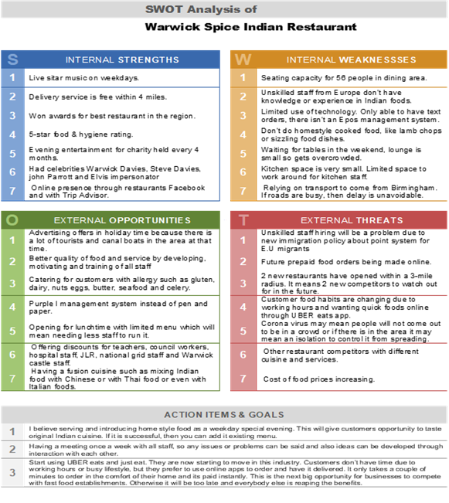

3.5 Advance SWOT for Warwick Spice Restaurant:
Importance Rating Score
Strengths:
Winning Awards for best restaurant |  | 0.15 |  | 2 | 0.3
Delivery service of food |  | 0.25 |  | 3 | 0.75
5-star rating by FSA (food standard agency) |  | 0.3 |  | 3 | 0.9
Celebrity visitors |  | 0.35 |  | 2 | 1.7
Weaknesses:
Lockdown Restrictions |  | 0.32 |  | 3 | 0.96
Not enough seating capacity |  | 0.2 |  | 2 | 0.4
Limited use of Technology |  | 0.25 |  | 3 | 0.75
Reliance on Transportation for doing delivery |  | 0.32 |  | 3 | 0.96
business dependant on take away meals |  | 0.3 |  | 3 | 0.9
External Opportunities:
Advertising during holidays for tourists |  | 0.3 |  | 2 | 0.6
Lunch time opening of business |  | 0.25 |  | 1 | 0.25
Purple I management technology |  | 0.3 |  | 2 | 0.6
Catering for Allergy customers |  | 0.25 |  | 3 | 0.75
Innovating new fusion dishes |  | 0.25 |  | 2 | 0.5
Offering discounts for NHS, JLR & Teachers |  | 0.3 |  | 2 | 0.6
External Threats:
Online competitors |  | 0.30 |  | 3 | 0.90
2 New restaurants have opened nearby |  | 0.28 |  | 3 | 0.84
Customer habits changed to ordering take away |  | 0.3 |  | 3 | 0.9
Food prices increasing because of COVID 19 |  | 0.32 |  | 3 | 0.96
Competition from different cuisines |  | 0.32 |  | 3 | 0.96
Future orders made by using pre-paid method |  | 0.31 |  | 3 | 0.93

4.0 Stakeholders Analysis:
In any organizations business stakeholders play an important part. Stakeholders are the people or a group who have an interest in the success or failure in an organization. Stakeholders are who can affect or is affected by the business (Phillips and Freeman, n.d.). All the stakeholders have different power and interest, and they are not all equal. Some are more important than others. The business will need focus to find ways to keep stakeholders satisfied.

4.1 High Power and High Interest:

Stakeholders can be affixed into 1 of 4 categories in the table below using the Mendelow Matrix:

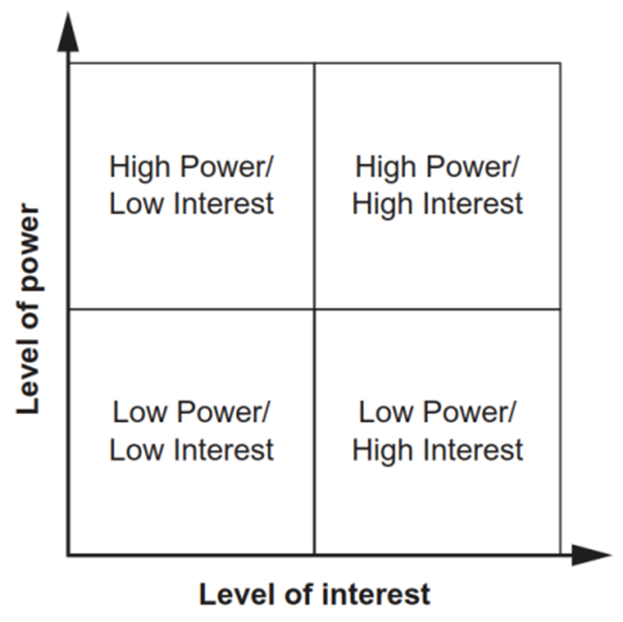
(Mendelow, 1982)
Internal stakeholders are the ones who operate at the Warwick Spice Restaurant on a daily basis. They are employees, managers and Directors. There is also external stakeholders who are not working in the restaurant but have an interest. These are customers, suppliers, government, banks and competitors.
The high power group are directors, main cheffs, management team and customers. The restaurants planning startegy should include a tactical management of this group. They are all have a high interest and power as stakeholders. They need to be kept informed and consulted.
The high power low interest group are government and regulators. It is in the best interest of the company to have a good relationship and also adhere to regulations. They need to be kept informed and may need action.
The low power high interest are local competitors, assistant managers, 2nd cheff, suppliers and local community groups. Although they don’t have power but it is neccesary to keep an eye and only give minimum information as needed.They have less power to influence the organization.
The low power low interest are front of house staff, kitchen porters, cooks and barman. They need to be kept happy and provide them with satisfactory knowledge about the management decisions. The are less aware of changes and have little influece.
4.2 Vrio Analysis:

Resource/capability | Valuable | Rare | Inimitable | Exploited | Implication
Brand | yes | yes | yes | yes | Competitive Advantage
Global Presence | No | no | yes | no | Competitive Disadvantage
Customer Loyalty | yes | no | yes | yes | Temporary Advantage
Human Resources | yes | no | yes | yes | Temporary Advantage
Quality of Food | yes | no | yes | yes | Temporary Advantage
Food products | yes | no | yes | yes | Competitive Advantage

5.0 Mckinsey 7s Model :
The Warwick Spice to succeed as an organization needs to look at the seven internal factors that will need to be arranged and aligned. This can be done by using the Mckinsey 7s model. This can be used to find what needs to be adjusted or to speed up performances, be used to maintain arrangements during a crisis and determine how to support a strategy direction a company. The diagram below displays the model.
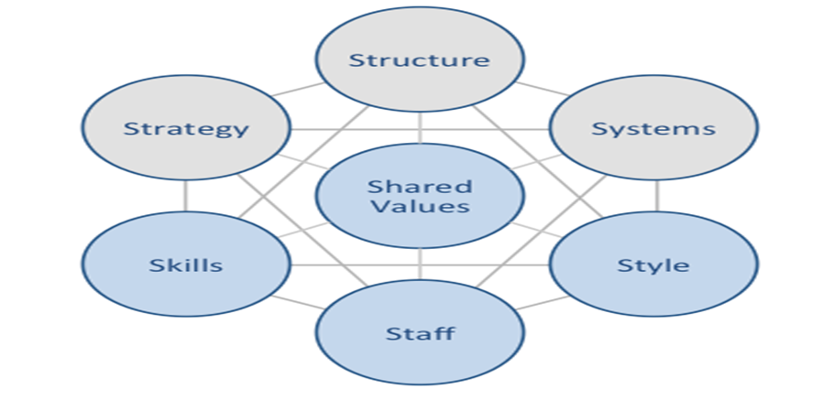
Hard Elements:
- Strategy. The strategy of the restaurant is to be the finest in Warwickshire region.
- Have created excellent service to local customers.
- The profit margin in this pandemic (COVID) has been reasonable.
- Structure. The restaurant is partnership-based structure but there is manager who has the responsibility of running the establishment on a daily basis.
- The decision making is done by the partners and the manager.
- Systems. The finance is carried out by the company accountant.
- Staffs are allocated in the positions most suitable in order to achieve company goals.
Soft Elements:
- Staff. The staff required for the company are manager, waiters service and front of house, chefs, cooks, and delivery drivers.
- All staffs go through a recruitment using advertisements and are interviewed.
- Staff have holiday and bonuses which keeps their Morales high.
- Skills. The skilled staffs are responsible for training new staff.
- Style. Indian, Bangladeshi, and English foods is catered for. The style is old and classy.
- Shared Values. There is different background and cultures working alongside each other. Everybody learns about each other’s cultures and respect the diversity and also the background of all in order to work in harmony.

5.1 Strategic Direction:
A strategic direction within Warwick Spice will create direction and also the extent of the business.
Warwick Spice has been operating in Warwickshire and their competitor Balti Hut restaurant has a more competitive advantage over them. In order to compete, Warwick Spice will need to exploit this opportunity by using market strategy, using resources such as updating themselves with modern technology and focus on their goals.
Market analysis is a component that can help the restaurant to examine the region/ area they supply, from the demand of customers to the existing competitors. With the market being limited to no dining inn due to the pandemic (COVID19), the competition has widened up for Warwick Spice because there are now other competitors such as Just Eat, Uber Eats and Deliveroo. In order to compete with these rivals, the market analysis can be used to improve menu prices to be inline with others, determine what food choices are in need and this would give the restaurant the opportunity of integrating into the market and also edging out the competition. A social networking presence and radio advertisement can be used for demographic target.
5.2 Ansoff Matrix:
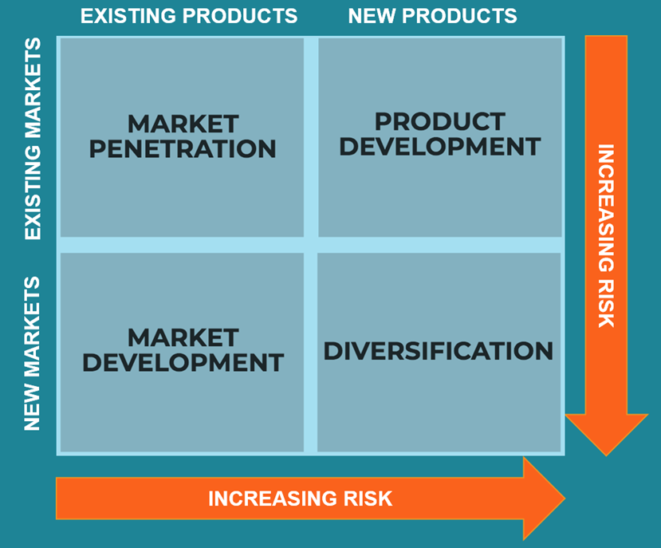
Market penetration is initially the first choice for growth in majority of organizations. According to Ansoff, market penetration is to seek the increasing of business sales without leaving product market strategy at the cost of competitors in the market. Advertising to existing customers and new ones who are suitable for your aimed market.
Warwick Spice offers home delivery service to attract more customers and to serve current customers. Discounts of 10% are offered for all customers that collect their food from the restaurant. Products is promoted in existing market through various means such as newspaper ads, local magazines, social media and door to door leaflet distribution.
Market development is a strategy for increasing company revenues by marketing existing products in a new market. The product stays the same, but it is marketed to a new targeted audience (consumers). For example, product could be exported, or it could be marketed in new territories.
For Warwick Spice this market development strategy can be helpful because the reliance on delivery of food service. If they market existing products to a new market, promoting the product by advertising and target new customers.
Product development is replacing or making new products to raise market share in comparison to competitors. To be able to do this Warwick Spice will need to solve customer issues, be aware of their needs, their wants and demands of which would give the opportunity to develop to find an answer.
Diversification is used if there is no success in market penetration, market development and product development. This strategy involves entering unknown markets. It would involve going into a diverse line of business market selling new products.
This is a risky strategy for Warwick Spice because at present pandemic environment there is need to concentrate on surviving as a business. A lot of customers have been lost during this pandemic and it is a very competitive market to work in due to competitions from online food businesses and also the government guidelines on business operations.

5.3 SAFe Analysis:
Suitability is a critical feature of SAFe. The risk component which are associated with the organization can be discovered with the use of this analysis. Finding a suitable replacement is the response to if the plan can or cannot perform what the business wants it to. Suitability is counted in a variety of unique factors that are very important to the market or business. These are suitability for the environment, accuracy for standards and suitability for capability.
Acceptability
The acceptability component of SAFe procedure which addresses the risk, the profit, and the reaction of shareholders from a given project/ plan. The profit will be assessed in relation to the results stakeholders anticipate from the strategy and significantly on what stakeholders’ decisions are.
Feasibility
The feasibility of the SAFe procedure is achievability of the organization. It is weather the organization has the funds, the desire, and the capacity to effectively executing the plan is important to its performance. Self-supporting needs to be tested by forecasting and evaluating cash flows and also executing break even analysis.

5.4 Findings:
Scanning tools were used for Warwick Spices external and enternal environments in order to have a better understanding.These are the tools used for examinations PESTLE, Porters Five Forces and SWOT.
PESTLE analysis gives Warwick Spice to find the oppertunities and threats in their external environment, As an example these are customers, competitors, government laws and regulations, consumers choices and COVID 19 pandamic. These factors are not contrable by the restaurant but can affect the destiny of the business. So it is vital for the future and survival of the business to analyze your surroundings to be competitive.
Porters five forces helps Warwick Spice to understand that to keep brand image there is the need to aquire knowledge/ information about their competitors. To have competitive advantage over rivals it is neccesary to use different resources and understand the factors that makes them different from others, provide quality food and have excellent customer services.
SWOT analysis will help Warwick Spice to evaluate their postion, find any oppertunities in their market and then they can work on stratefy in moving forward. The analysis enables to understand what you do efectively, amend what you neglected, coutering the effect of risks and utilize the advantage to be successful.

Recommendations:
The restaurant market at present with the situation of COVID 19 is turbulent and continuing changing due to unpredictability with the new guidelines. At present restaurants are not able to have dinning inn customers, so they are having to rely effectively on take away food service in order to survive as a business. In order to prosper in this competitive environment, monitoring present trends in the market is vital, anticipate threats and opportunities by performing SWOT (internal), doing PESTLE (external) analysis of business capabilities and resources (strength and weaknesses) and then map out effective strategies to implement to gain competitive advantages over other rivals (businesses).
Warwick Spice to attain competitive advantage they need to focus on establishing a strengthened performance measuring system. This system needs to be aligned with their strategy, that supports the overall vision. One of the relevant tools that can be used for this is the Balance Scorecard (BSC) perspectives. BSC can be custom built for any business because it is a method and a plan that can be used to bring about achieving a goal or target. Secondly, organizing and marshalling of resources for the most efficient and effective use based on the highest priority of a target.

Bibliography:
Barney, J. and Hesterly, W., 2018. Strategic management and competitive advantage. 6th ed. United States: Pearson Education.
Creelman, J. and Makhijani, N., 2005. Succeeding with the balanced scorecard. Singapore: J. Wiley & Sons (Asia).
Du, J., 2019. Rethinking Competitive Advantage in Today’s Strategic Management. Academy of Management Proceedings, 2019(1), p.15762
Johnson, G., Whittington, R. and Scholes, K., 2011. Exploring strategy. Harlow: Prentice Hall
Kaplan, R. and Norton, D., 2009. The balanced scorecard. [Boston, MA]: Harvard Business School.
King, W. and Cleland, D., 1987. Strategic planning and management handbook. New York: Van Nostrand Reinhold Co.
Legislation.gov.uk. 2021. Employment Rights Act 1996. [online] Available at: <https://www.legislation.gov.uk/ukpga/1996/18/contents> [Accessed 28 March 2021].
LYNCH, R., 2021. STRATEGIC MANAGEMENT. [S.l.]: SAGE PUBLICATIONS
Mendelow, A., 1982. Some relationships between a chief executive officer's background and his perception of stakeholder effectiveness criteria, corporate financial performance, and strategy. Pretoria: Unisa.
Muckenhuber, P., 2011. Translating strategy into action - using the balanced scorecard. Saarbrücken: VDM Verlag Dr. Müller.
McClell, S., 1994. Gaining Competitive Advantage through Strategic Management Development (SMD). Journal of Management Development, 13(5), pp.4-13
Morris, B., 1998. The Service Profit Chain:983James L. Heskett, W. Earl Sasser Jr, Leonard A. Schlesinger. The Service Profit Chain: How Leading Companies Link Profit and Growth to Loyalty, Satisfaction, and Value. Simon & Schuster, 1997. 300 pp, ISSN: 0-684-83256-9 UK £20.00 hardback. International Journal of Service Industry Management, 9(3), pp.312-313.
Phillips, R. and Freeman, R., n.d. Stakeholders.
Pete Chong, P., Chen, Y. and Chou‐Hong Chen, J., 2001. IT induction in the food service industry. Industrial Management & Data Systems, 101(1), pp.13-20.
Porter, M., Magretta, J. and Kramer, M., 2014. Strategy and Competition. Boston: Harvard Business Review Press
Porter, M., 2004. Competitive strategy. New York: Free.
Reichheld, F. and Teal, T., 2008. The loyalty effect. Boston, Mass: Harvard Business School Press.
Thompson, J., Scott, J. and Martin, F., 2017. Strategic Management. Andover: Cengage.
Services.parliament.uk. 2021. Food Waste (Reduction) Bill - Parliamentary Bills - UK Parliament. [online] Available at: <https://services.parliament.uk/bills/2015-16/foodwastereduction.html> [Accessed 28 March 2021].
Jones, O. and Tilley, F., 2003. Competitive advantage in SMEs. Hoboken, NJ: J. Wiley.
Olsen, M. and Zhao, J., 2001. The Restaurant Revolution-Growth, Change and Strategy in the International Foodservice Industry. Journal of Restaurant & Foodservice Marketing, 4(3), pp.1-34.
Warner, A., 2010. Strategic analysis and choice. New York [N.Y.]: Business Expert Press.

