ASSESSMENT 1: DEBATE AND SUPPORTING PAPER
Name-Badmus Adeshola Omotosho
Student Number-1914925
Lecturer’s Name-Bianca Sanfilippo
ModuleCode-BMH6006
Executive Summary
The study is about somatoform disorder, one of the mental disorders of ICD (2010). In this regard, the overview of the mentioned disorder has been elucidated that is further analyzed for implementing therapies. Historical and contemporary support for the disorder is analyzed for maintaining provision for the policy associated with the disorder. In this context, analyzing treatment procedures for the mentioned disorder is mandatory in order to provide people with a healthy and happy life. Past and present services regarding mental disorders are further determined in order to eradicate these issues. The disorder is based on mental illness that causes bodily symptoms such as physical pain.
Table of Contents
1. Introduction 4
2. Overview and Evaluation 4
2.1 Historical and Contemporary Support 4
2.2 Treatment and Provisions 5
3. Knowledge of Past and Present Services 6
4. Analyzing Positives and Negatives of Treatments 7
5. Issues in Provision, Professional Support or Policy 8
6. Conclusion 9
Reference List 10

1. Introduction
The study introduces stress-related and somatoform disorders from the ICD-10 classification that affect the mental health of people. Stress is one of the mental factors that cause physical symptoms and the phenomenon is regarded as somatisation. The mentioned disorder affects a person with several types of complications such as poor health, physical disability, relationship problems, and unemployment problems. In addition to this, disorders such as depression, personality disorders, and anxiety cause people to be affected by somatoform disorders. Physical symptoms consist of low energy, headaches frequent infections, rapid heartbeat, aches, pains, stomach upset and tense muscles that are detrimental in affecting the healthy lifestyle of an individual. In this regard, having depression, experiencing trauma, and family history with the disease are a few of the risk factors associated with somatoform disorder.

2. Overview and Evaluation

2.1 Historical and Contemporary Support
Stress and somatoform disorders are caused in a person due to pressure and anxiety at the workplace or home. Family issues and workplace issues play a significant role in disturbing the mental condition of people and they are usually trapped into somatoform disorders. Several physical symptoms are unexplained that is caused due to psychiatric disorders (Liu et al. 2019, p. 6). The mentioned disorder occurs due to the exemption of somatoform disorder because this disorder affects the physical strength of an individual. The disorder is based on mental illness that causes bodily symptoms such as physical pain. The scenario can be devastating because people feel depressed and distressed because they are not able to pay attention to the work going on in the present situation. They feel extreme physical pain that is unbearable and they cannot demonstrate effective outcomes for the work done to them (Thambyet al. 2019, p. 371). In this regard, it becomes normal for a person with the mentioned disorder to have abnormal thoughts, behaviors, and feelings due to distressing situations or physical pains.
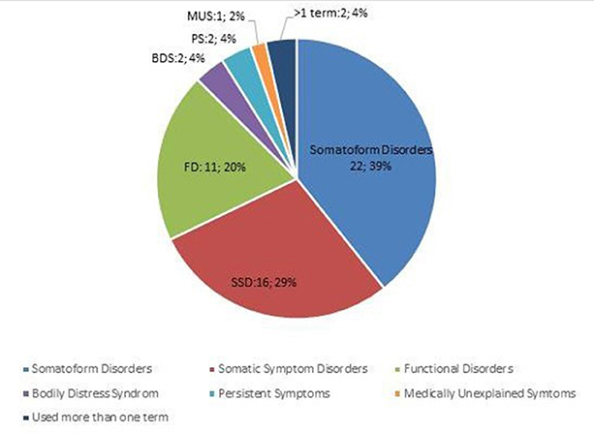
Figure 1: Classification of Somatoform Disorder
(Source: frontiersin.org, 2022)
As per the above figure, 22.39% of people have been evaluated to suffer from somatoform disorders (frontiersin.org, 2022). Generally, people suffering from this disorder are unaware of their mental health conditions and they feel that physical ailments are affecting their life. In this regard, it has been stated that there are times; symptoms are reported due to this concerned disorder. The mental distress causes them to take recommendations from several healthcare providers, and perform medical tests and other irrelevant procedures. The anxiety level of people suffering from somatoform disorder is prevalent to think excessive about their health conditions and illness (Carlieret al. 2018, p. 552). Pain, fatigue, and shortness of breath are three prominent physical symptoms of somatoform disorder.

2.2 Treatment and Provisions
Treatment for this specific disorder is detrimental because it eliminates negative thoughts from patients’ minds. Together with this, it is important to eradicate this disorder from people to make their lives happy and healthy. In general, evaluating beliefs and feelings for physical symptoms is one of the “Cognitive Behavioral Therapy” (CBT). Reducing anxiety and stress that is caused due to the symptoms of somatoform disorder is devastating. Mental illness can disrupt the entire working performance of patients because they feel anxious and stressed about their health condition. Diverting the mind of patients from being focused on physical symptoms is another CBT that helps people to move out of distressing situations. Charis (2018, p. 24) opined that recognizing the issue that is depleting the mental health condition can be beneficial. The scenario can help in maintaining positive vibes for patients that can further help them to lead healthy lives.
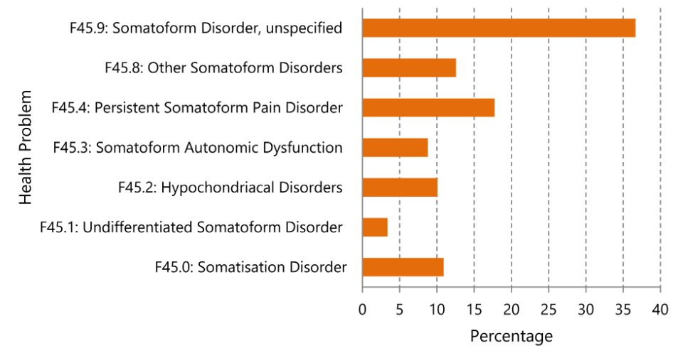
Figure 2: Patients with Somatoform Disorder
(Source: journals.plos.org, 2022)
As per the above figure, approximately 37% of somatoform disorder has been evaluated that are unspecified (journals.plos.org, 2022). In this regard, the health problems of patients can increase drastically because of the existence of unspecified disorders. Therefore, finding ways for staying social and active can help determine positive attitude all around. Moreover, this scenario can further help in blowing the pain and other symptoms away (Bass and Yates, 2018, p. 148). In order to make life function effectively and efficiently, it is important to demonstrate these CBT.

3. Knowledge of Past and Present Services
In past, the concerned disorder has been considered a psychosomatic disorder or Somatic Symptom Disorder (SSD). As per my perception, relaxation therapy used to be one of the effective ways of dealing with this concerned disorder in an individual. In this regard, it is important to be relaxed and clear out all negative thoughts from the mind. Filling minds with positive vibes can help patients to come out of their distress level and enjoy life to the fullest. Accepting the truth and forming commitment therapy is necessary in order to eradicate the problems related to the management of physical health (Belokrylovet al. 2021, p. 192). I think that patients need to be provided with a friendly environment that helps them to be happy and get a reason for leading happy and healthy life. In this context, my previous knowledge stated that relaxation and commitment therapy are prominent for dealing with an introduced disorder effectively.
Before the pandemic situation, 13% of people suffered from anxiety while during the starting stage of a pandemic, the value doubled with 24% of people suffering from anxiety (bristol.ac.uk, 2022). The data suggest that there is a holistic increase in people suffering from stress due to work pressure, family issues, and other reasons. Furthermore, these issues are a result of the occurrence of somatoform disorder. As per my present perception, CBT and mindfulness-based interventions are remedies for the concerned disorder. By applying this therapy, patients can effectively be cured of the disorder they are facing. Implementation of therapy can be beneficial because they are effective in eradicating negative vibes from the minds of patients.
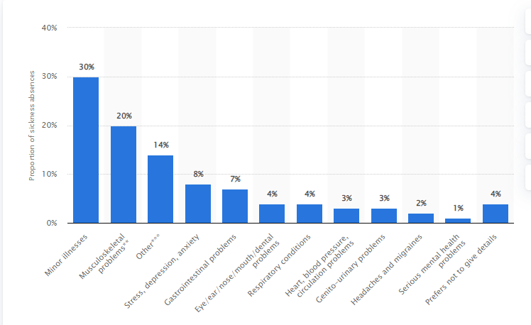
Figure 3: Reason for Sickness Absence in the UK
(Source: statista.com, 2022)
As per the above figure, 8% of sickness absence is due to depression, anxiety, and stress in the UK. The data states that somatoform disorder occurrence is fatigue due to the mentioned reason. Hair plucking, lalling, nail-biting, behavioral factors, physiological factors, lisping, thumb sucking, and Tourette syndrome are a few of the effects of the mentioned disorder (icd.who.int, 2022). From the “World Health Organization” (WHO), it has been specified that ICD (2010) is deliberate in classifying and diagnosing mental disorders. Filling positive vibes in people can be effective in analyzing the scenario of their effective and healthy lives.

4. Analyzing Positives and Negatives of Treatments
Treatment of mental health implications is advantageous because it makes people feel strengthened in fighting challenges. The positive aspect of treatment is that it changes the negative perception of patients toward life. In this regard, it is a prominent way of dealing with patients having a negative mindset about the issue. In this regard, making people aware of their relationship skills and helping them to build adequately is great support for enhancing the status of people. Moreover, strengthening self-confidence is one of the treatment procedures that double the assessment procedure for analyzing the effectiveness of patients (Buryaet al. 2021, p. 1401). Making them feel positive vibes by providing them with friendly surroundings that further tends them to eradicate negative perception is necessary. Furthermore, these are positive aspects of treating mental health problems and making people aware of the detrimental factors affecting their health.
Sociocultural society, lack of financial support, and fear of stigmatization are a few of the obstacles in treating mental illness. However, it is important to treat patients suffering from somatoform disorder because they apply to motivate patients for inculcating positive vibes (Firleet al. 2019, p. 484). Furthermore, there are times analyzed that providing therapies to patients can result negatively. In this regard, it is important to maintain the decorum of the therapy; however, these therapies are prominent in supporting the mental status of people.
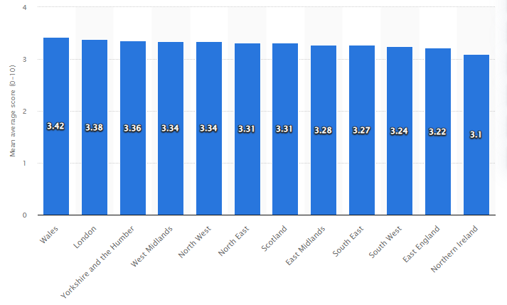
Figure 4: Anxiety Levels in the UK
(Source: statista.com, 2022)
According to the statistics, the mean average score of anxiety levels in various parts of the UK has been demonstrated. As per the analysis, the mean average score in Wales is found to be 3.42 (statista.com, 2022). In this regard, it is important to examine the condition of people effectively and efficiently. In this context, therapists need to pay their full attention to patients and inspect them timely because therapies can have negative results as well. In this context, it can be elucidated that patients need to focus on grabbing positive vibes that can enlighten their minds and fill them enthusiastically (Howard and Khalifeh, 2020, p. 313). The shortage of qualified mental health professionals is a disadvantageous factor because they are responsible for treating patients effectively. In this regard, it is mandatory to ignore the use of alcohol and other substances that can affect their mental health seriously.
Classifying and diagnosing mental disorders are beneficial because they are prominent methods for treating the disorder opulently and exhibiting positive results. In this regard, it is important to centralize the focus on positive aspects of the treatment process by eradicating all atrocious elements.

5. Issues in Provision, Professional Support or Policy
Professional support and policies are made for treating patients suffering from a somatoform disorder. Economic and social disadvantages are depriving the scenario for people suffering from the mentioned disorder. Physical pain and increased stress level are reasons behind the occurrence of an introduced disorder. Several issues are related to the management of somatoform disorder that makes the treatment process viable. Professional support and policies can help maintain the decorum of patients and provide them positive environment. However, it is important to be aware of the atrocious factors associated with the policies, provisions, and professional support.
Professionals recommend several types of therapies; however, these therapies can have negative results. Patients tend to harm themselves physically and this is detrimental in making them aware of the diagnosing details. In this respect, it is important to manage and define effective criteria for people. In this context, it is important to centralize the focus on the management strategies of substance use disorder. The feelings and emotions of mentally ill people are not prominent;therefore, they need extra care in this context (Das et al. 2018, p. 69). Adequate policies are detrimental to maximizing the status of mentally ill patients. In order to make people aware of the issues of therapy, it is important to have quality knowledge of somatoform disorders. Physical pain and stress are symptoms of the mentioned disorder that needs to be eradicated prominently. As per the analysis of WHO, analysis for mentally ill patients is necessary to make them aware of mental disorders. Critically analyzing the aspects of mental disorders is important in order to motivate people to for classifying treatment and provisions methods for treating people.

6. Conclusion
The study concludes that somatoform disorder is affecting the normal and healthy life of individuals that occurs due to stress and anxiety. The mentioned disorder affects the physical strength of patients and makes them feel depressed and distressed. They need to be aware of the advantages associated with a healthy lifestyle that tends them to lead happy life. Contemporary and historical support for the somatoform disorder has been discussed that states the positive outcome for people suffering mentally.
Mental trauma and implications are detrimental elements that affect the health condition of an individual. Patients need to be aware of the detrimental issues that occur due to the increased level of stress. Treatment and provisions for those living with mental disorders are necessary in order to provide them effective and friendly environment. Mental disorders affect the entire working stamina of an individual because it is associated with physical pain and illness. Loss of stable mental health can be disruptive for any patient suffering from an introduced disorder. In this context, diagnosis and classification of mental disorders are important because this can help in the identification of illness and symptoms causing a person to suffer from mental trauma and implications.

Reference List
Bass, C. and Yates, G., 2018. Complex regional pain syndrome type 1 in the medico-legal setting: high rates of somatoform disorders, opiate use and diagnostic uncertainty. Medicine, Science and the Law, 58(3), pp.147-155.
Belokrylov, I., Semikov, S., Tkhostov, A., Rasskazova, E. and Yavorovskaya, A., 2021. Cognitive and behavioral factors of quality of life in patients with somatoform disorders. European Psychiatry, 64(S1), pp.S192-S193.
bristol.ac.uk, 2022, COVID-19 impact on mental health and wellbeing, Viewed on: 14/07/2022, Viewed from: https://www.bristol.ac.uk/alspac/participants/discoveries/covid-mental-health/#:~:text=The%20analysis%20showed%20that%20the,figure%20had%20risen%20to%2027%25.
Burya, L.V., Kapustianska, A.A., Moiseieva, N.V., Vakhnenko, A.V., Rumiantseva, M.O. and Zviagolska, I.M., 2021. Chronic obstructive pulmonary disease and comorbidities: management of somatoform disorders, pp.1401-1403.
Carlier, I.V., AndreeWiltens, D.H., Van Rood, Y.R., Van Veen, T., Dekker, J. and Van Hemert, A.M., 2018. Treatment course and its predictors in patients with somatoform disorders: a routine outcome monitoring study in secondary psychiatric care. Clinical Psychology & Psychotherapy, 25(4), pp.550-564.
Charis, C., 2018. Somatoform Disorders from Psychodynamic Point of View. In Somatoform and Other Psychosomatic Disorders (pp. 23-38). New York: Springer, Cham.
Das, A., Matin, M.A., Ahmed, S., Ahmed, M.S. and Dey, P., 2018. Somatoform disorders among children and adolescents in a tertiary hospital. KYAMC Journal, 9(2), pp.69-72.
Firle, C., Teufel, M., Blumenstock, G., Smolka, R., Erschens, R., Windthorst, P., Zipfel, S. and Junne, F., 2019. Perception of music-induced emotions in patients with somatoform disorders compared to healthy controls. Psychology of Music, 47(4), pp.483-503.
frontiersin.org, 2022, A European Research Agenda for Somatic Symptom Disorders, Bodily Distress Disorders, and Functional Disorders, Viewed on: 14/07/2022, Viewed from: <https://www.frontiersin.org/articles/10.3389/fpsyt.2018.00151/full>
Howard, L.M. and Khalifeh, H., 2020. Perinatal mental health: a review of progress and challenges. World Psychiatry, 19(3), pp.313-327.
icd.who.int, 2022, Somatoform disorders, Viewed on: 14/07/2022, Viewed from: <https://icd.who.int/browse10/2010/en#/F45>
journals.plos.org, 2022, Patients with somatoform disorders, Viewed on: 14/07/2022, Viewed from: <https://journals.plos.org/plosone/article/figure?id=10.1371/journal.pone.0202546.g001>
Liu, J., Gill, N.S., Teodorczuk, A., Li, Z.J. and Sun, J., 2019. The efficacy of cognitive behavioural therapy in somatoform disorders and medically unexplained physical symptoms: A meta-analysis of randomized controlled trials. Journal of affective disorders, 245, pp.98-112.
statista.com, 2022, Anxiety levels of regions of the United Kingdom in 2020/21,Viewed on: 14/07/2022, Viewed from: <https://www.statista.com/statistics/1166090/anxiety-levels-of-uk-regions/>
statista.com, 2022, Distribution of sickness absence in the United Kingdom (UK) in 2013, by reason*, Viewed on: 14/07/2022, Viewed from: <https://www.statista.com/statistics/290223/reasons-for-sickness-absence-in-the-united-kingdom-uk/>
Thamby, A., Desai, G., Mehta, U.M. and Chaturvedi, S.K., 2019. Deficits in theory of mind and emotional awareness in somatoform disorders. Indian Journal of Psychological Medicine, 41(4), pp.368-374.

- The study introduces the disease in which a person is significantly affected by physical symptoms such as pain, weakness, shortness of breath, and significant distress. In this section, we are going to contradict and debated the mental illness or mental health problems existing in people. Together with this, increasing stress is one of the factors in spreading mental diseases in people. The concerning disease affected the person from different kinds of mental disorders such as poor health, physical disability, relationship problems, moreover, the employment problem. The fundamental reason for increasing this disease is mental illness, disability, headache, and physical inconsistency.
- The concerning contradiction is for increasing the case of mental disorders, especially the somatoform disease in people due to physical symptoms. It is a kind of psychiatric disorder that affects the human mind ineffectively and they become impatient with excessive thoughts and overlap of feelings. In my consideration, More or less, it affects the physical as well as mental strength of a people. It affects the interpersonal dynamics and personality disorders of people, however, includes big factors such as neuroticism, extraversion, openness, agreeableness, and conscientiousness. It is concerning as prominent physical health factors that consistently damage the overall health of a person.
- The overall treatment of concerning disease is important because it helps to reduce the negative thoughts from the patient and provides a healthy environment to feel relaxed. The efficiency of cognitive behavior therapy is useful, when, it considerably the consistent treatment to promote health accessibility in common people. Owing to this, it needs to be aligned with the proper care and nourishment to foster a reliable condition with the help of therapeutic approaches. The main contradiction is for enabling the government framework for eradicating this disease easily and it refers to continuous change within the affected people.
- The Figure is critically a point of discussion about the symptoms that rapidly increase the mental disorder in people, collecting records from the survey on this specific disease.
The discussion is over the identification of its significant services whether in the past or present and how far, people get to know the symptoms concerning the disease. I observed that in the earlier time it was known as a psychosomatic disorder, whereas, at present, it is a kind of mental disorder. A lot of contradiction is happing due to the emergence of this disease and its relation to the physical activities within the human mind. The major part is that helps in discussing through an empirical mind and providing a well-structured framework for the patient.
The figure helps to discuss the overall cognitive-behavioral therapy is useful for reducing the mental disorder and presenting a framework to overcome this disease.

- The current perspective about this disease is just providing the suitable or feasible framework to accomplish the situations rapidly. As per the global data, in 2019, 500 thousand people were treated with neurotic and somatoform disorders, while approximately 132.5 thousand people are the highest prevalence of such diseases. The main discussion is also that this disease consistently affects the age group 35 to 54 age group. It is important to discuss with the most assertive framework that helps in identifying the existing consequence relating to the disease.
- An effective treatment is always been a hot cake for discussion and much positive, as well as negative perception comes from different sides. I thought providing therapy can be assigned as positive vibes to the patient whereas, it helps in changing the mindset of a patient to feel comfortable and relaxed. The main contradiction is for the negative aspect of treatment while analyzing the co-relative activity with the patient during the therapy. Delivering positive treatments with the help of innovative implementation ideas to reduce the mental disorder. The negative aspect is self-compassion in a multidimensional role. Due to this, they felt tolerance, loneliness, and uncomfortable with the different symptoms they usually face in the diagnosis process.
- The most effective discussion is needed for providing well-structured therapy that helps in releasing mental disorders. They usually face unavoidable concerns regarding the treatment; however, it needs to be submerged with qualified mental health considerations. You need to care for a patient more carefully, which is the part of positive concerns of treatment. The main discussion is for classifying and diagnosing the mental disorder patient with consolidated efforts. Furthermore, it is mandatory to reduce the use of alcohol and other substances that eventually affects mental illness.
The main contradiction is for enabling the professional's support and policies that help in treating the somatoform disorder effectively. Hingray et al. (2018, p. 2) argued that effective access to this disease is always helpful for the patient as well as for policymakers in providing accessibility regarding health. They considered several issues related to the management and it needs to be professional support in favor of providing clarifications regarding process health considerations. The discussion is over atrocious factors associated with the relevance factors continuously to demonstrate the overall consequence regarding the processing health issue.
In the present debate most parts of the discussion are based on the relative aspect of policy and framework that help in identifying the feelings and emotions of mentally ill people are not prominent. In these concerns, it is better to forecast the extra care in this context and present the idea to promote the vulnerable toolkit for policymakers and supporting segments by the government. In order to make awareness about the disease is to push the disease back and its prevalence effects.
- The overall conclusion is for making a clear discussion relates to the somatoform disease increasing rapidly in the present era. Moreover, it is evaluating the disorder effects that occur due to anxiety and mental disorders within the people. They need to be aware of the better treatment considering mental disorders.

