Module Code- BMIH6007
Module Name-International Meetings Management for the Hotel
Industry
Assignment Title- Feasibility Plan for an International Meeting
Presentation
Student ID:2210661
Student Name: Yanka Stancheva
Module Lead: Kathryn Flynn
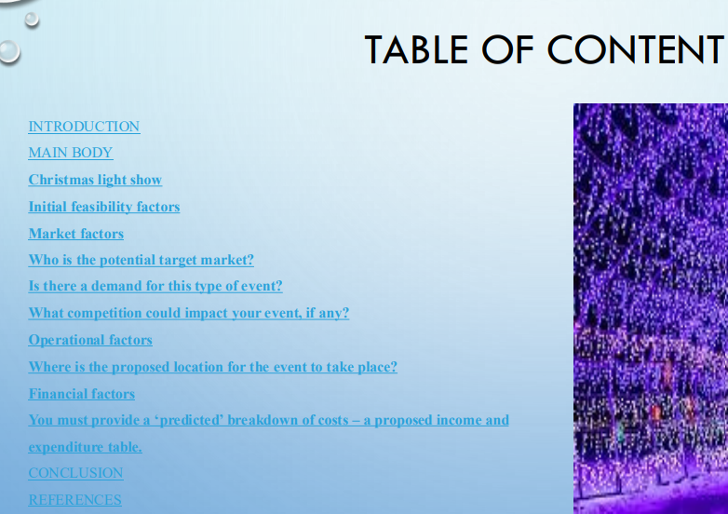
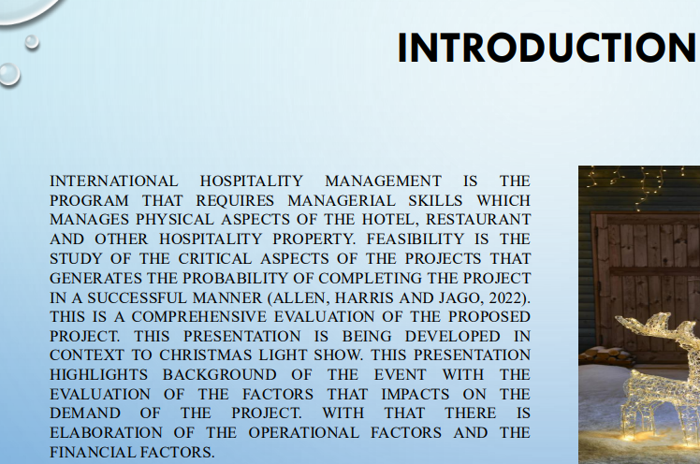
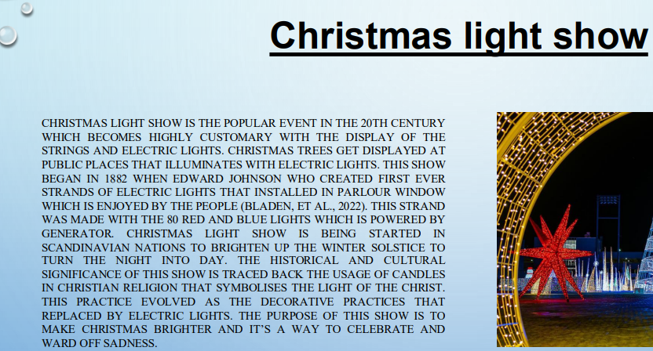
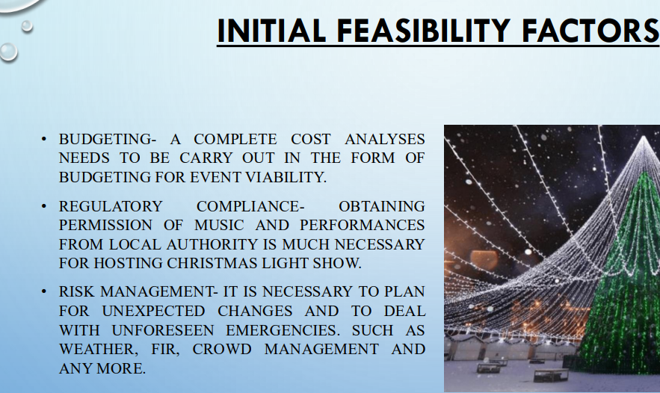
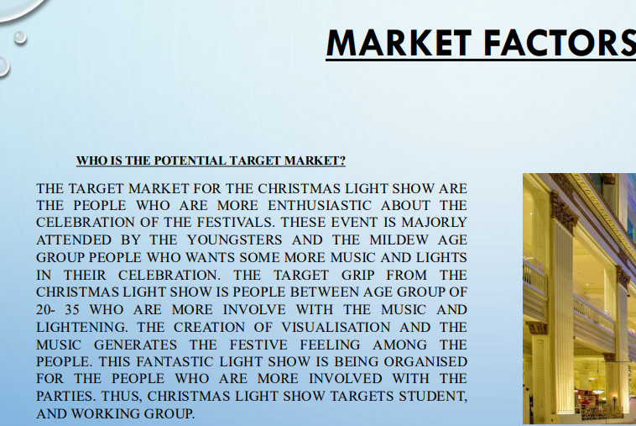
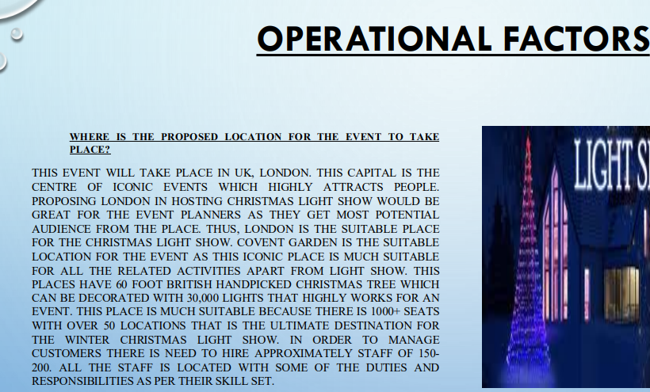
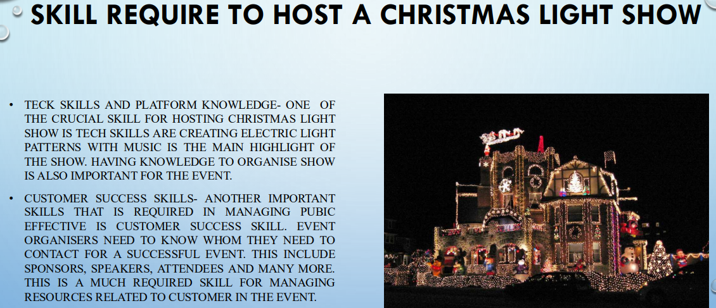
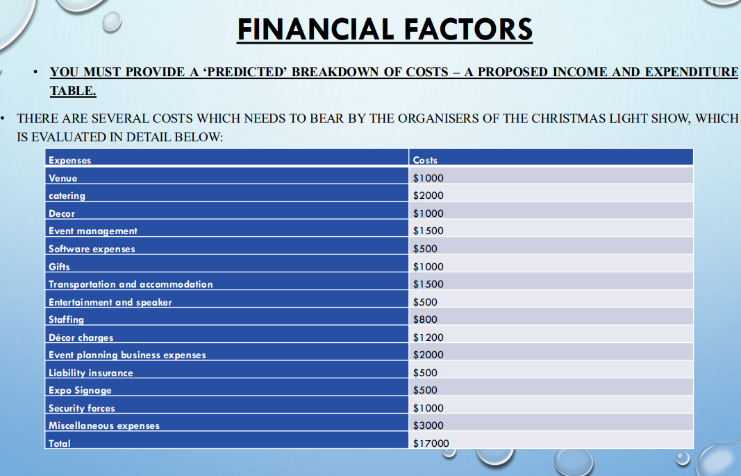
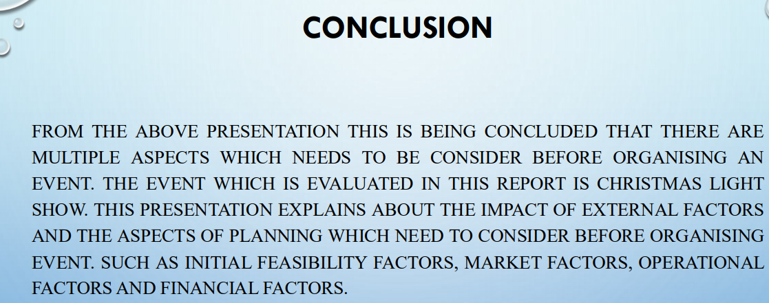

• ALLEN, J., HARRIS, R. AND JAGO, L., 2022. FESTIVAL & SPECIAL EVENT MANAGEMENT. JOHN WILEY & SONS
• BLADEN, C., KENNELL, J., ABSON, E. AND WILDE, N., 2022. EVENTS MANAGEMENT: AN INTRODUCTION. ROUTLEDGE
• CUSKELLY, G., FREDLINE, L., KIM, E., BARRY, S. AND KAPPELIDES, P., 2021. VOLUNTEER SELECTION AT A MAJOR SPORT EVENT: A STRATEGIC HUMAN RESOURCE MANAGEMENT APPROACH. SPORT MANAGEMENT REVIEW, 24(1), PP.116-133.
• ROGERS, T. AND WYNN-MOYLAN, P., 2022. CONFERENCES AND CONVENTIONS: A GLOBAL INDUSTRY. ROUTLEDGE.
• LAI, I.K.W. AND WONG, J.W.C., 2020. COMPARING CRISIS MANAGEMENT PRACTICES IN THE HOTEL INDUSTRY BETWEEN INITIAL AND PANDEMIC STAGES OF COVID-19. INTERNATIONAL JOURNAL OF CONTEMPORARY HOSPITALITY MANAGEMENT, 32(10), PP.3135-3156
• RAHIMIAN, S., SHAMIZANJANI, M., MANIAN, A. AND ESFIDANI, M.R., 2021. A FRAMEWORK OF CUSTOMER EXPERIENCE MANAGEMENT FOR HOTEL INDUSTRY. INTERNATIONAL JOURNAL OF CONTEMPORARY HOSPITALITY MANAGEMENT, 33(5), PP.1413-1436.
• SANN, R. AND LAI, P.C., 2020. UNDERSTANDING HOMOPHILY OF SERVICE FAILURE WITHIN THE HOTEL GUEST CYCLE: APPLYING NLP-ASPECT-BASED SENTIMENT ANALYSIS TO THE HOSPITALITY INDUSTRY. INTERNATIONAL JOURNAL OF HOSPITALITY MANAGEMENT, 91, P.102678.
• ROMERO, I. AND TEJADA, P., 2020. TOURISM INTERMEDIARIES AND INNOVATION IN THE HOTEL INDUSTRY. CURRENT ISSUES IN TOURISM, 23(5), PP.641-653.
• AWAN, M.I., SHAMIM, A. AND AHN, J., 2021. IMPLEMENTING ‘CLEANLINESS IS HALF OF FAITH’IN RE-DESIGNING TOURISTS, EXPERIENCES AND SALVAGING THE HOTEL INDUSTRY IN MALAYSIA DURING COVID-19 PANDEMIC. JOURNAL OF ISLAMIC MARKETING, 12(3), PP.543-557.

