Assessment Form

Module: Preparing for Professional Policing
Student Name: Christina Davies
Module Tutor (s): Kelly Andrews
Question | 1  Situation | 2  Task | 3.  Action | 4.  Result |  | Total Mark
1 | 3/5 | 4/5 | 9/15 | 3/5 |  | 19/30
2 | 3/5 | 1/5 | 10/15 | 3/5 |  | 17/30
3 | 3/5 | 2/5 | 12/15 | 3/5 |  | 20/30
 |  |  |  |  |  | Total Mark 56/90
Key
No Reference | Minimum | Satisfactory | Exceptional
0 | 0-4 | 5-10 | 11-15

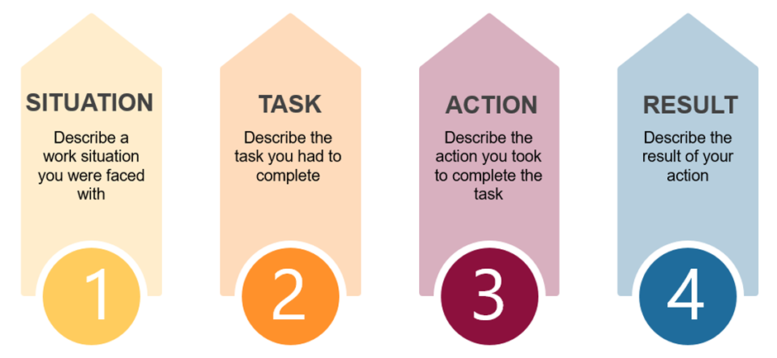

Question | Comments
1 | Q1  Student example – taking part in group presentations one presentation was about CT.  Task – was to organise who was going to discuss what.  Actions: Went off to research what we were going to discuss – I researched CT in general and policing.  We had a month to do this, we decided to do this in 3 weeks so we could go over the work first.  Result: collaborated well – had good grades. I had good communication skills.  Be more confident.
2 | Q8:  Situation – Special constable training attended Bridgend HQ to complete a role play about a domestic incident. Use I not we.  Took lead with dealing with the victim – asked him some questions including DASH questions.  He was being harassed and didn’t want contact with ex-partner.  Needed to focus upon communication skills in more detail  I listened to everything he needed to say – used empathy.  Needed to explain why this was important.  Result: Open minded – I was respectful and collaborated well with partner.  STAR used – needed more detail around decisions made and more detail on TASK which was missed.
3 | Q9  Support worker role:  Working in challenging situations – there is one resident who can be very aggressive. I need to assess the situation when he is being aggressive, you cannot deal with challenging situation by yourself – I need to remain calm and empathic – asked open ended questions. – needed to explain why you did this –  This can normally de-escalate. the situation – explained different ways that this can be dealt with.  Needed more information around decision making here and her ability to adapt way of working.  Result – covered – needed to be more specific to the incident dealt with.  .

.

.

