Questions and Guidelines for Assessment Component 1


Changemakers: Creativity and Value Creation
Professions (BMHP5014)
Component 1: Online portfolio of set exercises
Student name: Hajar Muzemil
Student number: 2414545
Lecturer’s name: Dr Laila Surani
Contents
Introduction- 3
Task 1- Defining Key Concepts in Practice 3
Task 2 - Mind Map – Childhood Obesity in Barking and Dagenham 5
Task 3 - Self-Reflection of Group Activity 7
Task 4 – Case Study Analysis– Virtual Wards in the NHS 8
Task 5 - Research Task – Staff Stress and Burnout 9
Task 6 - Exploring Digital Innovation in Health and Social Care 11
Reflection 13
Task 7 - Understanding the NHS Leadership Framework 13
Part 3: Reflection on Creativity and Value Creation 14
Task 8 – Self-Reflection Journal Entry 15
Reference List 16

Introduction-
This assignment examines four key ideas in health and social care: innovation, creativity, value creation, and change. These concepts are essential for healthcare professionals to improve patient outcomes, address complex challenges, and adapt to the evolving demands of services (NHS England, 2021). Innovation involves introducing new methods, technologies, or approaches, while creativity focuses on developing practical solutions using existing knowledge and skills (Amabile and Pratt, 2020). Value creation ensures that care achieves the best results while using resources efficiently, and effective change management supports organisations in implementing improvements successfully. By applying these concepts, healthcare teams can enhance service quality, strengthen patient safety, and foster a culture of continuous development. This assignment links theory to practical examples from the NHS, showing how these concepts are applied in real-world settings.

Task 1- Defining Key Concepts in Practice
1.Innovation
Definition: Innovation in healthcare means introducing new ideas, technologies, or ways of working that improve patient care and service delivery (NHS England, 2021).
Real-life example: During the COVID-19 pandemic, many NHS hospitals introduced virtual appointments. Patients could see their doctors by video call instead of travelling to clinics, keeping people safe, saving time, and reducing waiting lists (NHS England, 2021).
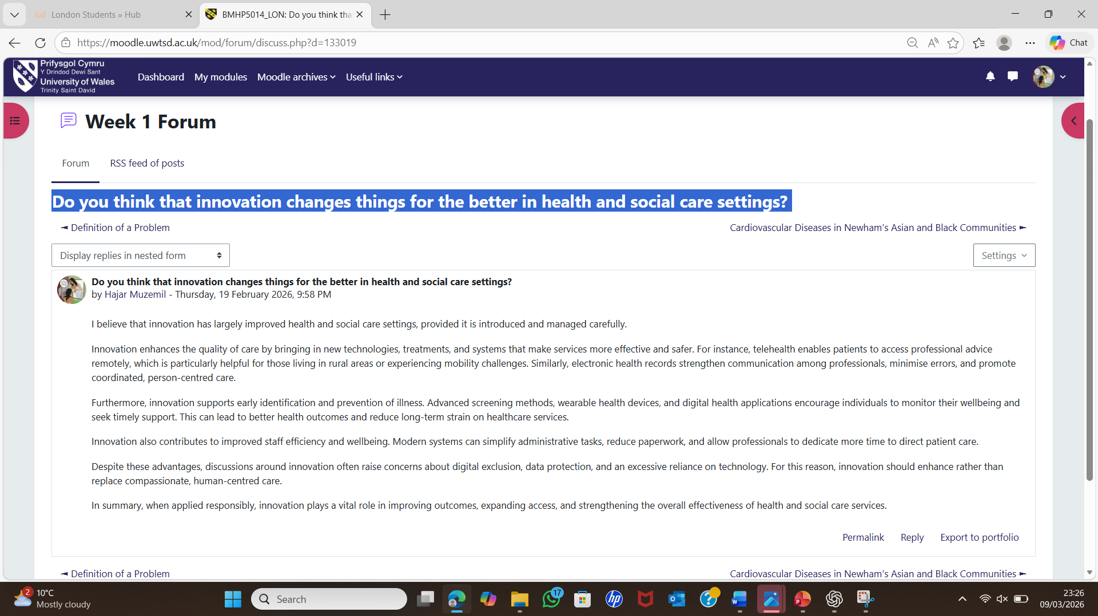
Figure 1: Week 1 forum – Innovations in health and social care.
Why it matters: Innovation makes healthcare more accessible, though not everyone has internet access, so solutions must be inclusive.
2.Creativity
Definition: Creativity is the ability to generate new and useful ideas by combining knowledge, skills, and motivation (Amabile and Pratt, 2020).
Real-life example: A mental health team in Manchester worked with patients to design peer support groups. Former patients helped run sessions, improving attendance and engagement (The Health Foundation, 2022).
Why it matters: Creativity involves patients in their care and helps generate practical solutions, not just artistic ideas.
3. Value Creation
Definition: Value creation in healthcare means improving patient outcomes while using resources effectively (Teisberg, Wallace and O’Hara, 2020).
Real-life example: Joined-up diabetes care, combining specialist nurses, dietitians, and health apps, reduces hospital visits and improves blood sugar control (Teisberg, Wallace and O’Hara, 2020).
Why it matters: Working smarter benefits both patients and the NHS by delivering better outcomes without wasting resources.
4. Change
Definition: Organisational change means shifting how things are done to improve outcomes and effectiveness (Burnes, 2017).
Real-life example: A care home replaced paper care records with electronic tablets, enabling staff to update information instantly and improving family confidence (West, 2021).
Why it matters: Change can be uncomfortable, but with leadership and training, it leads to safer, more reliable care.
Linking sentence
Together, innovation, creativity, value creation, and change form an interconnected framework that enables healthcare teams to solve problems, improve patient outcomes, and make services more efficient, demonstrating how theory translates into practical improvements in everyday health and social care.

Task 2 - Mind Map – Childhood Obesity in Barking and Dagenham
Childhood obesity in Barking and Dagenham is a serious health problem. Nearly one in three Year 6 children are obese, double the rate in affluent areas like Richmond (Keane, 2023). If not addressed, children face higher risks of diabetes and long-term health complications (NHS Digital, 2026).
Key causes include low household income, reliance on cheap fast food, limited access to fresh food, and unsafe or limited green spaces that reduce physical activity (Keane, 2023; London Borough of Barking and Dagenham, 2024). Impacts include poorer health, lower school performance, and increased healthcare costs.
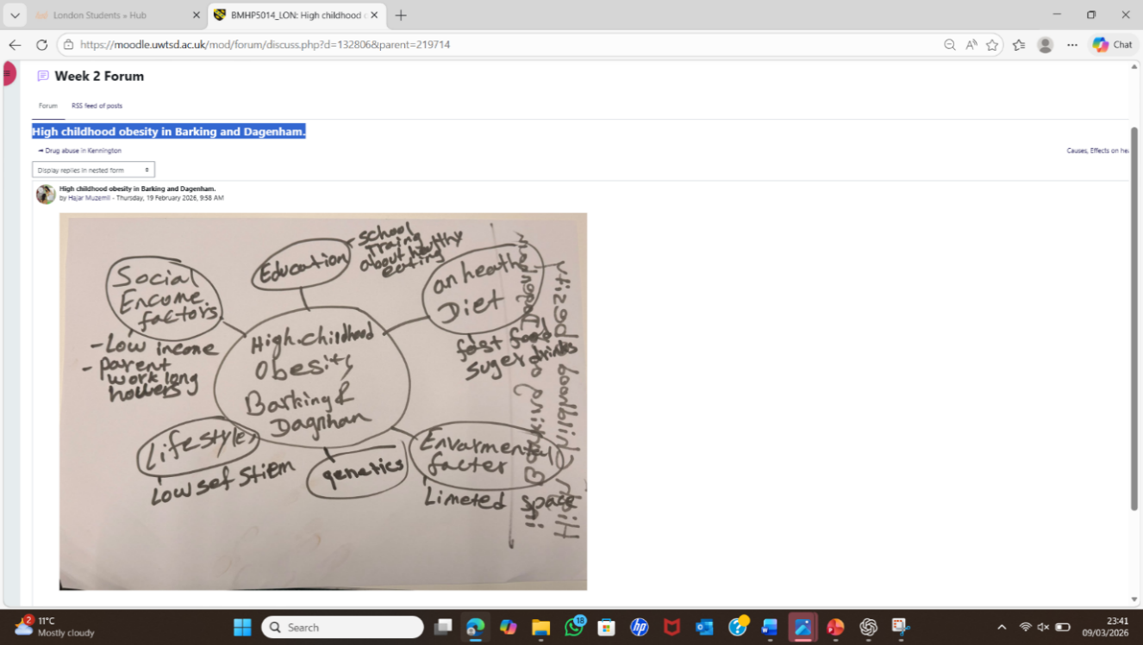
Figure 2: Week 2 forum – Childhood obesity in Barking and Dagenham.
A systems thinking approach recognises that these factors are interconnected, so solutions must be multi-layered (Meadows, 2008; Headen, Eaton and Kumanyika, 2025). Solutions include free school meals, community sports programmes, safer parks, and stricter regulation of junk food advertising. The council’s Healthy Weight Strategy includes cooking classes and school programmes, but further investment is needed to reach high-risk families. Lasting improvement requires a whole-system partnership between the council, NHS, schools, and communities (London Borough of Barking and Dagenham, 2024).

Task 3 - Self-Reflection of Group Activity
In our group activity, I applied both divergent and convergent thinking. Divergent thinking involves generating multiple creative ideas, while convergent thinking focuses on narrowing options to find the best solution (Runco, 2014). Using Gibbs’ Reflective Cycle (1988) helps me analyse this experience systematically.
Description & Feelings: During the online forum, I explored confirmation bias using an example of an elderly patient whose symptoms were initially dismissed. I felt confident using divergent thinking to consider multiple perspectives. Later, in the case study discussion about Stanley's vaccine programme, the group applied convergent thinking to focus on practical solutions such as extra staff and mobile clinics. I initially felt frustrated because we had many conflicting ideas.
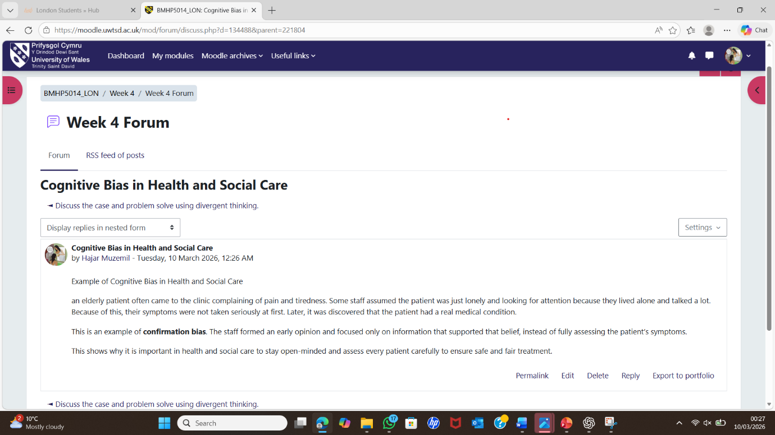
Figure 3: Week 4 forum – Divergent and convergent thinking activity.
Evaluation & Analysis: What went well was my ability to switch between thinking styles. Suggesting a pros-and-cons list helped the group prioritise ideas and reach consensus efficiently. I realised divergent thinking feels natural to me, but convergent thinking is essential for implementing realistic solutions in healthcare.
Conclusion & Action Plan: I learned both thinking styles are crucial. In future group work or clinical problem-solving, I will apply convergent thinking earlier and guide discussions toward practical outcomes, ensuring creative ideas lead to actionable solutions.

Task 4 – Case Study Analysis– Virtual Wards in the NHS
Virtual wards, or hospital-at-home services, allow patients to receive acute care at home through remote monitoring (NHS England, 2025). This innovation addressed hospital bed shortages and long A&E waiting times, particularly during winter pressures (NELFT NHS Foundation Trust, 2026).
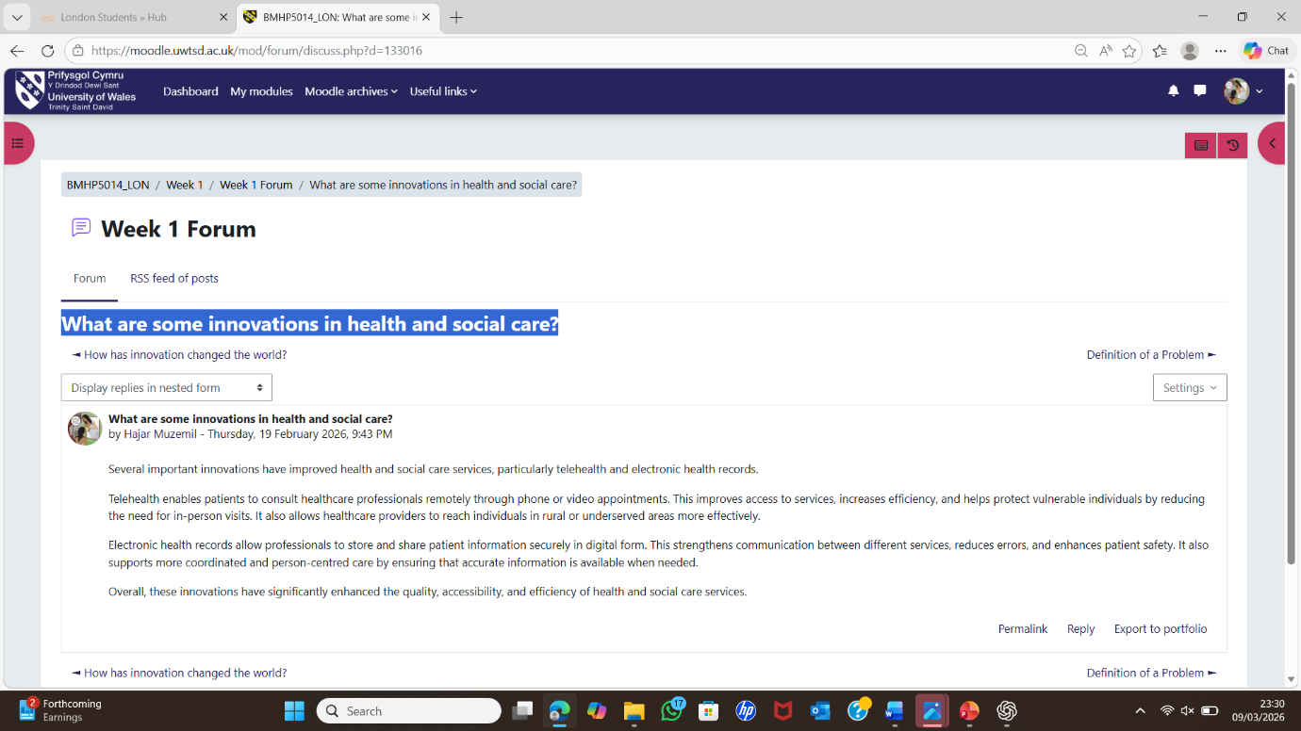
Figure 4: Week 1 forum – Virtual wards innovation discussion.

Creativity was central. Rather than building more beds, clinicians combined wearable devices with daily virtual check-ins to provide hospital-level care remotely (Nottingham University Hospitals, 2026). A Clinical Lead stated: "Our virtual ward allows us to deliver hospital-level care in the comfort of people's homes" (NELFT NHS Foundation Trust, 2026).
The value created is significant. Patients recover at home with reduced infection risk, staff can focus on critical cases, and the system saves costs (BHR Hospitals, 2024; NHS England, 2025). At BHR Hospitals, over 200 patients benefited, with 91% rating the service good or very good (BHR Hospitals, 2024). The Frailty Virtual Ward also helped achieve the trust's best A&E performance in five years.
Rogers' Diffusion of Innovation Theory explains adoption: the service demonstrates clear benefits, aligns with NHS priorities, and shows observable outcomes, encouraging uptake (Rogers, 2003). The Value Proposition Canvas highlights that virtual wards meet patient needs for safe, comfortable recovery while addressing NHS capacity challenges (Osterwalder et al., 2014).
Reflection:
This task challenged my assumption that innovation requires new technology. Instead, I learned that innovation often involves developing new relationships between clinicians, patients, and technology. Virtual wards succeeded because staff reimagined how to connect with patients remotely, rather than relying on advanced devices alone. This will shape my future practice, as I will focus on relational solutions rather than relying only on technical approaches.

Task 5 - Research Task – Staff Stress and Burnout
Staff stress and burnout are growing challenges in the NHS, manifesting as high sickness absence, staff turnover, and reduced care quality (The King’s Fund, 2022). Two academic studies help explain the causes and impacts.
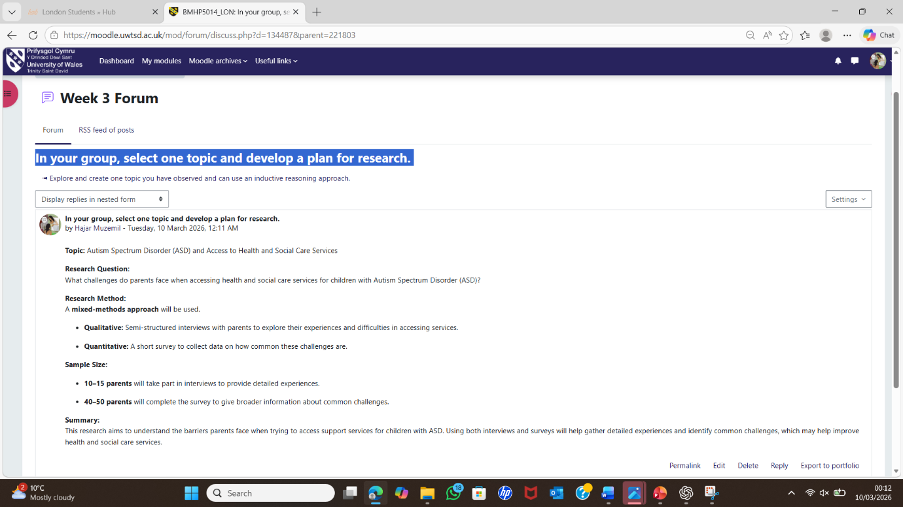
Figure 5: Week 3 forum – Research planning: staff stress and burnout.
Amiri et al. (2024) identify workplace bullying, high job demands, and poor communication as major contributors to burnout. They highlight that supportive environments, sufficient staffing, and resilience-building act as protective factors. This demonstrates that burnout is strongly influenced by organisational culture rather than individual weakness.
Zhang et al. (2024) explore psychological aspects, showing that exhaustion and reduced engagement are closely linked to depression among healthcare workers. Their findings suggest that different staff groups, such as nurses and doctors, experience burnout differently, requiring tailored interventions.
Both studies agree that workplace factors play a key role, but Amiri et al. emphasise organisational causes while Zhang et al. focus on mental health interactions. Addressing staff stress therefore requires a combined approach: improving working conditions and providing mental health support.
These findings relate to Maslach Burnout Theory, which identifies emotional exhaustion, depersonalisation, and reduced personal accomplishment as core dimensions of burnout (Maslach, Jackson and Leiter, 1996). Amiri et al. highlight environmental causes of exhaustion, while Zhang et al. show its psychological consequences.
Reflection:
This task showed me that staff wellbeing is a systemic issue, not just about personal coping. In my future practice, I will advocate for supportive environments and recognise the signs of stress early, ensuring both staff and patient safety. Understanding these dynamics will help me contribute to healthier workplaces that improve care quality.

Task 6 - Exploring Digital Innovation in Health and Social Care
Question 1: Benefit of Wearable Technologies
Wearable devices, such as smartwatches, can detect early warning signs up to 34 days before a heart failure event (NHS England, 2025). This enables clinicians to intervene early, adjust treatment, and prevent hospital admission. Wearables shift care from reactive to preventive approaches, empowering patients to monitor their health. However, accessibility remains a challenge as some patients cannot afford these devices. The Technology Acceptance Model explains that technology is more likely to be used when it is perceived as useful and easy to use (Davis, 1989).
Question 2: How EHRs Improve Communication
Electronic health records (EHRs) store medical information in one secure system, providing access for hospitals, GPs, and social care providers (NHS Digital, 2024). In Greater Manchester, shared records help avoid duplicate tests and improve coordination. Patients can also access their data through the NHS App. The NHS Long Term Plan highlights EHRs as essential for integrated care and informed decision-making (NHS England, 2019). EHRs improve collaboration, reduce errors, and enhance patient safety.
Figure 6: Week 1 forum – Digital innovation in healthcare.
The Digital Health Passport supports young people with asthma through smartphone-based coaching (NHS Innovation Accelerator, 2025). Teenagers from deprived areas benefit from improved self-management and reduced NHS costs. This shows how digital tools support prevention rather than treatment. However, digital exclusion remains a challenge, so alternative support is needed. This aligns with the NHS aim of shifting from treatment to prevention (NHS England, 2019).

Reflection
This task demonstrated that digital innovation is not only about new devices but also about improving patient empowerment and system efficiency. Wearables, EHRs, and health apps show how technology can create value for patients, staff, and the NHS. The Technology Acceptance Model highlights that adoption depends on usability and perceived benefit. In future practice, I will consider how digital tools can support prevention, improve communication, and enhance patient engagement while ensuring equitable access for all patients.

Task 7 - Understanding the NHS Leadership Framework
Part 1: Summary of the NHS Leadership Framework
The NHS Leadership Framework provides a structured approach to effective leadership across health and social care, applying to all staff, not only senior managers (NHS Leadership Academy, 2013). It focuses on five domains: demonstrating personal qualities, working with others, managing services, improving services, and setting direction. Each domain highlights behaviours such as developing capability, inspiring shared purpose, and evaluating information.
The framework is important because healthcare is complex and requires collaboration, innovation, and adaptability. Effective leadership improves patient safety, staff wellbeing, and service quality, while creating an environment where staff feel supported to contribute ideas and improve practice (NHS Leadership Academy, 2013). By providing clear standards, it promotes consistent, compassionate care and encourages staff to adopt creative solutions that add value for patients.
Part 2: Applying ‘Inspiring Shared Purpose’
‘Inspiring shared purpose’ involves creating a clear vision that motivates others to work towards shared goals (NHS Leadership Academy, 2013). A leader can use this behaviour to encourage creativity by inviting staff to suggest improvements in patient care, such as reducing anxiety during hospital stays. By linking ideas to the team’s purpose, staff feel valued and engaged. This reflects Transformational Leadership, where leaders inspire teams to innovate and adopt new approaches (Bass and Avolio, 1994). For example, a ward manager could support nurses to test small interventions, evaluate outcomes, and implement effective changes, improving patient experience and team confidence.

Part 3: Reflection on Creativity and Value Creation
This module deepened my understanding of creativity and value creation in healthcare. Task 4 on virtual wards demonstrated that innovation involves reimagining resources to deliver care differently (NELFT NHS Foundation Trust, 2026). Task 2 on childhood obesity highlighted the importance of systems thinking, showing how interconnected solutions improve outcomes (Meadows, 2008). I now understand that effective leadership combines vision, motivation, and practical support to implement creative solutions that enhance patient care (Teisberg, Wallace and O’Hara, 2020). In my future role, I will apply these principles by encouraging staff to share ideas and supporting improvements that create real value for patients.
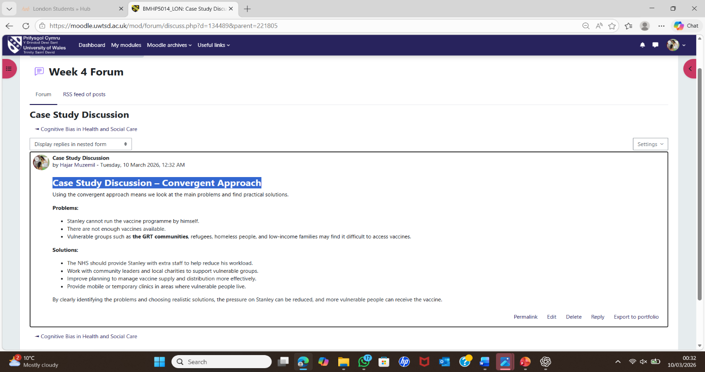
Figure 7: Week 4 forum – Leadership and creativity in teams.

Task 8 – Self-Reflection Journal Entry
Before this module, I thought innovation in healthcare meant only new technology. However, my view has changed. I now understand that creativity involves improving how existing resources are used to deliver care.
I chose to reflect on Task 4 about virtual wards because it demonstrated how innovation works in real healthcare practice. Clinicians reimagined the hospital ward by delivering care in patients’ homes, showing that innovation often involves thinking differently rather than increasing costs (NELFT NHS Foundation Trust, 2026). The creativity was in combining existing tools with new ways of working.
I also chose Task 2 on childhood obesity because it helped me better understand complex health problems. Systems thinking highlighted that health issues have interconnected causes, so single solutions are often ineffective (Meadows, 2008).
Using Gibbs’ Reflective Cycle improved my ability to analyse experiences and identify improvements (Gibbs, 1988). The key concept I will carry into my career is value creation, focusing on actions that improve outcomes that matter most to patients (Teisberg, Wallace and O’Hara, 2020). In my next placement, I will consider how existing resources can be used more effectively before suggesting new solutions.

Reference List
Amabile, T.M. and Pratt, M.G. (2020) 'The dynamic componential model of creativity and innovation in organizations: Making progress, making meaning', Research in Organizational Behavior, 40(1), pp. 1–17.
Amiri, S., Mahmood, N., Mustafa, H., Javaid, S.F. and Khan, M.A.B. (2024) 'Occupational risk factors for burnout syndrome among healthcare professionals: A global systematic review and meta-analysis', International Journal of Environmental Research and Public Health, 21(12), p. 1001. Available at: https://www.mdpi.com/ (Accessed: 4 March 2026).
Bass, B.M. and Avolio, B.J. (1994) Improving organizational effectiveness through transformational leadership. Thousand Oaks: Sage Publications.
BHR Hospitals (2024) Our virtual ward keeps patients out of A&E. Available at: https://www.bhrhospitals.nhs.uk/news/our-virtual-ward-keeps-patients-out-of-ae-4465 (Accessed: 4 March 2026).
Burnes, B. (2017) Managing Change. 7th edn. Harlow: Pearson.
Davis, F.D. (1989) 'Perceived usefulness, perceived ease of use, and user acceptance of information technology', MIS Quarterly, 13(3), pp. 319–340.
Gibbs, G. (1988) Learning by Doing: A Guide to Teaching and Learning Methods. Oxford: Further Education Unit, Oxford Polytechnic.
Headen, I.E., Eaton, T.M. and Kumanyika, S.K. (2025) 'Using system dynamics mapping to explore synergy in an equity-focused obesity prevention framework', Frontiers in Public Health, 13, p. 1525224.
The Health Foundation (2022) Innovation in health and social care: Learning from the pandemic. Available at: https://www.health.org.uk/ (Accessed: 26 February 2026).
Keane, D. (2023) '“Tackle junk food” call as one in four London primary pupils are obese', Evening Standard, 11 April. Available at: https://www.standard.co.uk/news/health/tackle-junk-food-london-primary-pupils-obese-b1068725.html (Accessed: 26 February 2026).
The King's Fund (2022) NHS workforce: Our position. Available at: https://www.kingsfund.org.uk/ (Accessed: 4 March 2026).
London Borough of Barking and Dagenham (2024) A New Strategic Approach to Healthy Weight in Barking & Dagenham. Available at: https://lbbd.moderngov.co.uk/ (Accessed: 26 February 2026).
Maslach, C., Jackson, S.E. and Leiter, M.P. (1996) Maslach Burnout Inventory Manual. 3rd edn. Palo Alto: Consulting Psychologists Press.
Meadows, D.H. (2008) Thinking in Systems: A Primer. White River Junction: Chelsea Green Publishing.
NELFT NHS Foundation Trust (2026) Innovative virtual wards project wins top recognition at NELFT. Available at: https://www.nelft.nhs.uk/news-events/innovative-virtual-wards-project-wins-top-recognition-at-nelft-11687 (Accessed: 8 March 2026).
NHS Digital (2024) Shared Care Records. Available at: https://digital.nhs.uk/services/shared-care-records (Accessed: 6 March 2026).
NHS Digital (2026) Health Survey for England, 2024: Children's overweight and obesity. Available at: https://digital.nhs.uk/data-and-information/publications/statistical/health-survey-for-england (Accessed: 26 February 2026).
NHS England (2019) The NHS Long Term Plan. Available at: https://www.longtermplan.nhs.uk/ (Accessed: 7 March 2026).
NHS England (2021) Innovation and Life Sciences Strategy. Available at: https://www.england.nhs.uk/publication/innovation-and-life-sciences-strategy/ (Accessed: 26 February 2026).
NHS England (2025) 'Multi-sensor wearables re-shaping care of chronic heart-failure: A narrative review', Indian Journal of Medical Research, 162(4), pp. 471–478. Available at: https://www.ncbi.nlm.nih.gov/pmc/articles/PMC12744564/ (Accessed: 8 March 2026).
NHS Innovation Accelerator (2025) The Digital Health Passport - Empowering Youth in Managing Asthma and Epilepsy. Available at: https://nhsaccelerator.com/innovations/the-digital-health-passport/ (Accessed: 4 March 2026).
NHS Leadership Academy (2013) The NHS Leadership Framework. Available at: https://www.leadershipacademy.nhs.uk/ (Accessed: 4 March 2026).
Nottingham University Hospitals (2026) How Virtual Wards are helping to boost bed space in Nottingham and Nottinghamshire's hospitals this winter. Available at: https://www.nuh.nhs.uk/news/how-virtual-wards-are-helping-to-boost-bed-space-in-nottingham-and-nottinghamshires-hospitals-this-winter-6849 (Accessed: 7 March 2026).
Osterwalder, A., Pigneur, Y., Bernarda, G. and Smith, A. (2014) Value Proposition Design: How to Create Products and Services Customers Want. Hoboken: John Wiley & Sons.
Rogers, E.M. (2003) Diffusion of Innovations. 5th edn. New York: Free Press.
Runco, M.A. (2014) Creativity: Theories and Themes: Research, Development, and Practice. 2nd edn. London: Academic Press.
Teisberg, E., Wallace, S. and O'Hara, S. (2020) 'Defining and implementing value-based health care', Academic Medicine, 95(5), pp. 682–685.
West, M.A. (2021) Compassionate leadership: Sustaining wisdom, humanity and presence in health and social care. London: The King's Fund.
Zhang, Y., Yu, P., Liu, S., Li, X. and Chen, C. (2024) 'Differences in the depression and burnout networks between doctors and nurses: evidence from a network analysis', BMC Public Health, 24, p. 1668. Available at: https://bmcpublichealth.biomedcentral.com/articles/10.1186/s12889-024-11668-0 (Accessed: 4 March 2026).

