MODULE CODE/ COD Y MODIWL: ACCC4000 ACADEMIC AND EMPLOYABILITY SKILLS

Cloud computing

Aleksandar Andonov
Student number: 1813107



Table of Contents
I.INTRODUCTION.................................................................................. 1. PERSONAL OVERVIEW ............................................................................................................. II. SKILLS EVALUATION ……………………………………………………………………. 1. Technical skills ……….......................................................................
2. Personal skills ……………………………………………………………………………
3.Mind tools method of evaluating of own skills ................................
III. ACTION PLANS ………………………………… ........................................
1.Long - and short-term goals………………………………………………………….
2.Personal mastery ………………………………………………………………………..
2.1Problem solving and presentation skills …………………………………..
2.2 Communication skills ………………………………………………………………
IV. DATA PROTECTION ....................................................................... V. TIME MANAGEMENT AND ORGANISATION................................... VI. CONCLUSION ................................................................................
References ......................................................................................... VII. APPENDICES ................................................................................. 1. PDP Presentation ..........................................................................

I.INTRODUCTION

1.Personal overview

In this era of time the social and business environment can be very dynamic and difficult for individual, organisations and achieving personal objectives.

My name is Aleksandar Andonov and I was born and raised in small country named Bulgaria. I have spent most of my life in Bulgaria with my family until we decided to move to England. I have been in London for almost five years now and plan on staying here. Since a young age I have always been interested in computing and programming.
When I was in high school, I was studying and working with a program language called Pascal. It was then that I found my passion for computing and programming. Pascal is an imperative and procedural programming language, intended to encourage good programming practices but in this era of time it is less and less used as other programming languages are developing. However, I was unable to pursue my passion because I graduated and went into the business of a mortgage advisor and in the department of financial management which made my desire for computing harder to follow and therefore left in the past, until now!
I believe that my past experience has brought a better understanding of what a good presentation and working environment should be and has led me to my technological curiosity and interest in Cloud Computing.
In order for me to develop my knowledge of computing and connect my passion to my lifestyle I have set some crucial goals for myself which I intend on fulfilling.
This paper is focused on my personal vision on what my future should look like and a personal development plan to help me fulfil my goals.

II.SKILLS EVALUATION

There are different skills needed to pursue my goals and career in computing. There are two main groups; long term technical skills and long-term personal skills and management.

1.Technical skills needed:
- Software development
- Cloud computing technologies
- Data base management system
- Security systems
- Network operating systems
- Computing principles and information
- System analysis
All of the skills listed above and many more are practical and theoretical skills and knowledge that can be obtained from Cloud Computing Course. These skills are fundamental to the course and my goals which I aspire to achieve. This course will bring many opportunities for me and my desired career path. Another positive aspect is that this would give me excellent employment prospects in the industry of web development. A web developer is a programmer who specialises in the development of world wide web applications or applications running over HTTP or is specifically involved in it.
Furthermore, recent statistics show that the vast majority of graduates from the Computing portfolio are following their chosen career paths within six months of graduating. (Doyle, 2019)
As previously mentioned, there are other aspects of skills that are required, for example personal skills such as;
2.Personal skills
- Communication and good positive attitude
Communication is very important to companies and individuals as it allows them to be productive and operate effectively. Individuals can experience an increase in productivity and commitment if they are able to communicate up or down the communication chain. This links to the positive attitude as when you have a positive thinking it will reflect on how you perform as well as making your work more productive and effective. Positive attitude can result in more constructive and organised self-image and work environment. (Lombardo, Chapter 14)
- Teamwork
Good teamwork makes individuals more productive and ultimately improves work ethic and management. For organisations that have excellent teamwork, problem solving is easier due to different people with different skills and knowledge work together to produce a solution. Networking and using technical resources enables us as individuals to connect to people or devices despite their location, distance and all the limitations of country boundaries. Being able to communicate to people from all around the world gives us an opportunity to understand the skills of other people and their knowledge, which we can then apply to our work and develop our comprehension of their skills. (Wehbe, 2017)
- Self-management
Self-management skills are important because they help you contribute to a better work environment. Self-management skills include self-confidence, persistence, resilience and perceptiveness. These skills allow you to strive for your goals, perform at work, and contribute to a healthy work environment for yourself and your co-workers. This is a very beneficial factor for me and my work ethic as it allows me to organise my priorities and mange my data as well as resources. (Sean Kennedy)

- Desire and willingness to learn
This a crucial skill for improving and achieving my goals and any type of success in the career and business. Being willing also allows you to stay focused and concise on the work you are trying to produce or master. This skill is particularly necessary for me to pursue in the web developing career as it involves many different categorises which require you to be focused and have the desire to learn. (businessphrases.net)

3.Mind tools method for evaluating of own skills
Evaluating personal skills using the Mind Tools - Test Your Skills Questionnaire. Answering 15 statements by giving a subjective and honest opinion about your own capabilities, this simple test helps with identifying one's potential and weaknesses by giving basic directions on how to improve our employability skills. Own results of the test are as shown:

My total score is 54

Leadership and Management
(Questions 5, 7, 12)
Your score is 9 out of 15
Whether you're in a formal leadership position or not, you need good leadership and management skills if you're going to make best use of the opportunities open to you. (After all, you can get much, much more done when you have the help of other people.)

Problem Solving and Decision Making
(Questions 2, 10, 14)
Your score is 7 out of 15
Problem solving and decision making are two areas where you'll need to excel to be a success in your career. (Together with people skills, they're what make up "good judgment" and "wisdom.") Like leadership and management, these two areas are closely related.

Communication Skills
(Questions 9, 11, 13)
Your score is 10 out of 15
The ability to communicate clearly is key to your success, whatever role you're in.

Time Management
(Questions 1, 4, 6, 15)
Your score is 20 out of 20
Time management is one of the most important career skills areas. Not only does it help you to be more productive; you'll also be much less stressed!

Personal Mastery
(Questions 3, 8)
Your score is 8 out of 10
When you know how to "lead yourself" and make good choices for your future, you'll be that much further ahead when it comes to the other skills areas that we've already looked at.
(source of self-evaluation test: https://www.mindtools.com/pages/article/get-started.htm)
In my previous introduction I introduced myself as a hardworking and determined individual. This test showed me that I have good time management and should focus on Problem solving and decision making as my score was lower on that category, which I also believe is the area I need to focus on to succeed in my work ethic and environment.
Time management is a key skill that is needed as it allows you to manage your tasks and be productive as well as work efficiently and effectively.
Communication skills also play a big part in understanding and acknowledging other people and their knowledge and applying it to our work.
Leadership and management can also be important as it allows you to make the best of the opportunities that are open to us and we can get more done when we have the help of other people. This leads onto personal mastery which enables you to lead yourself and make the best possible decisions for the career path you have a passion for which for me a web developer and computing. I am confident that I can achieve my goals if I follow the steps above.

III.ACTION PLANS

1.Long- and short-term goals

I have set myself different types of goals which I want to fulfil in order for me to succeed in the career path I would like to follow. There are some aims I still need to work on, such as my technical and personal skills which were based on the self-evaluation test above. These are some of the long- and short-term goals.

 | Long term goals |  | Short term goals
My goals | - Going into the web developer industry  - Developing my skills for the programming application |  | - Graduate form the cloud computing course  - Improve my communication skills  - Have more knowledge of the course
Skills and knowledge required | Technical  -Understanding of the software  -Programming and computing principles  -Understanding the Web developer regulations | Personal  -Communication skills  -Willingness and being determined  -Team work | Technical  -Data base maintaining  -Understanding the computing regulations | Personal  -Time management  -Improve language vocabulary  -Presentation skills

The goals and aims I have set for myself are clear and achievable with determination and perseverance over time. The short- and long-term goals both require major steps for them to be fulfilled. I have made a life changing decision to start the course of cloud computing and I am dedicated to finish it with the highest mark possible and follow my passion for computing. In order for me to do this I have made a learning plan with the results I got from the self-evaluation test and also the skills I learned in academic and employability skills module and in class. These are some of the things I have included in the self-reflective plan to success;
My action plan for the technical skills consists of incorporating much more extra reading from the module and the course subjects. I aim to do up to 4 hours of reading and going over any material that I am unsure about at least 3-4 days a week. I intend on doing additional practical exercises and watching videos about what we have learned in lectures to secure my knowledge and have a better understanding of the material. In addition, I would do research on web designing as well as in programming and its practices and uses. This would help me have a better idea of the industry and what it is about. Furthermore, I also intend on practicing my knowledge and understanding of the course which I have gained in the lecture and from the additional studying I have done.
However personal skills are quite different as you have to take a different approach to it as it involves you and your personality. On the self-evaluation test I score quite high on the time management section but not as high on the problem solving and decision-making section.

2.Personal mastery

I believe that having control of your personal growth is a major step to your personal success as it helps you understand yourself and your weaknesses as well as strengths. As I person wanting to go the industry of web developing, interpersonal skills are very important as it allows me to have better communication skills with customers and my work team. It also allows me to develop a strong relationship with work partners and customers, it allows me to gain their trust towards my knowledge and my team.

2.1Problem solving and presentation skills

I think problem solving and presentation skills are skills that can be improved with practice and determination over time with useful feedback from a mentor or a professor. I think that my problem-solving skills have improved over time as well as my decision making due to various life choices, I have made for example taking the cloud computing course and continuing my computing journey. Additionally, confidence is also something I need to work on as I believe building confidence is a major step which is going to help on my success journey in programming and web developing.

2.2 Communication skills

Another skill I need to improve on according to the self-evaluation test is my communication skills with others. I think this skill is the most significant one I need to work on as communicating with others is a fundamental part in any type of business especially a business where you need to work with a ream to find solutions and create new ideas. Varying my vocabulary and extending it so it is to a high standard will be very beneficial to me and my chosen career path.

IV.DATA PROTECTION

In the era we live in now, technologies and digital data is everywhere. Not only is digital data and technology used by most people in the world, it is the most wide spread way of communication between people. A survey report about global digital communication had been done to show the usage of data by age and education.

The survey by the Pew Research Centre’s Global Attitudes Project, conducted March 21 to May 15, also finds that social networking is popular in many nations around the globe. This is especially true in Israel (53%) and the U.S. (50%), where half or more say they use social networking websites. More than four-in-ten use these sites in Britain (43%), Russia (43%) and Spain (42%). (Pew Research Centre, 2012)
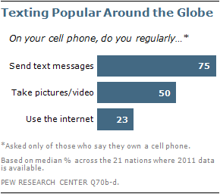

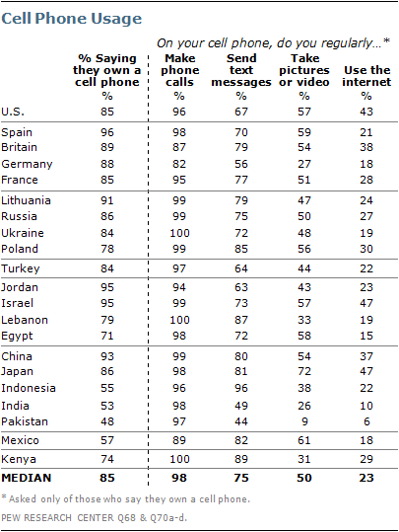
https://www.pewglobal.org/2011/12/20/global-digital-communication-texting-social-networking-popular-worldwide/

Therefore, this makes our data and personal factors about us vulnerable to outside threats and making our data secure is fundamental for individuals and organisations.
In an interview with TechRepublic, Limor Kessem, Executive Security Advisor at IBM Security, said, "A lot of personal data is no longer private, and consumers are finding it a lot harder to protect themselves when their data is out in the open." (Mukheirjee, 2018)
On one side we have the physical damage that can occur to the hardware that carries our data. The hardware can be also lost or stolen or even damaged by natural disasters and vandalism. The security ways in which we can protect that hardware are slightly different as it concerns with the outside sources of danger. Even though there are protection sources put on most of our digital devices against natural disasters there are still precautions we as users of the hardware need to take, such as restricting the use of the equipment and physically being more considerate with its use and the way it is stored. (Information Systems and Technology)
However, on the other side we have to protect out interior software just as well as there are a lot of assets from the outside digital web that are not secure which can lead to unnecessary harm to your digital system. Many of these assets include things like hacking, computer viruses or malware. In order for us to keep our software safe we would need to restrict the access to our equipment and systems to trusted members of our community and organisation. Furthermore, we clearly explain and determine instructions on how the data on our software should be used. The best way of protecting our data against hackers or viruses is installing a trustworthy virus detection program which lets us know when a virus is trying to be installed. Another way of keeping our data secure is by adding thoughtful password for sensitive information that we want to keep safe such as firewalls and personal banking information.
Knowing the risks and threats that can occur to data I have encountered another way to keep my data safe, which is to make copies and store in different places. The different places possible for me to store my data is on my personal computer, a memory stick or another laptop on and internet cloud that is easily accessible for me. My personal computer is a safe place for me to store any of my important data or software’s as there are many different virus detecting programs installed as well as secure passwords for sensitive information or encrypting. It is also stored in a safe establishment with the best security possible for the data itself. Nevertheless, having taken these precautions there is still a minor chance of the equipment itself or the software being stolen or being under intrusive software attack.

V.TIME MANAGEMENT
In our day to day lives we are filled with different tasks and activities we need to do, and in order for us to fulfil these tasks we need to manage our time accurately and efficiently. In an era where technology is used as previously mentioned we are expected to manage our time effectively as we have so many tools such as calendars, check lists, alarms and all other sorts of apps that can helps us win more time and yet some of us are still falling behind in our work.
In a book written by David Allen called ‘Getting things done’, published in 2001, revised edition of the book was released in 2015 which reflected on the changes of information and technology throughout the preceding decade. The book talks about the idea of moving planned tasks and projects out of the mind and recording them externally step by step, so you are able to break them down easily into actionable work items. This is therefore allowing the individual to focus on achieving the set tasks and projects instead of recalling them and wasting time on wondering when and how they should start. (David, 2015), (Allen, 2015)
In the book, not only does it talk about how you can manage your time effectively but also how you can reduce your stress levels and have a clear outcome of the goal you have set for yourself, which in the long run will be a benefit to you and the career path you have chosen. (Allen, 2015)
As an individual with a very busy schedule, trying to manage my work hours the course itself and my family life could be a challenge, however I intend on following the advice from the book by David Allen and focusing my time and energy on specific task I have set myself. Furthermore, I also aim to follow a few of these steps: (Polevoi)
- Prioritising important and urgent projects and tasks
- Knowing my goals
- Planning ahead
- Eliminating distractions
- Avoid procrastination
- Perseverance
- Taking regular breaks
https://quickbooks.intuit.com/r/employees/8-tips-for-effective-time-management/
All of the ways listed above are ways in which I can manage my time productively in order for me to intensify my work in the course and the extra studying I intend on doing.
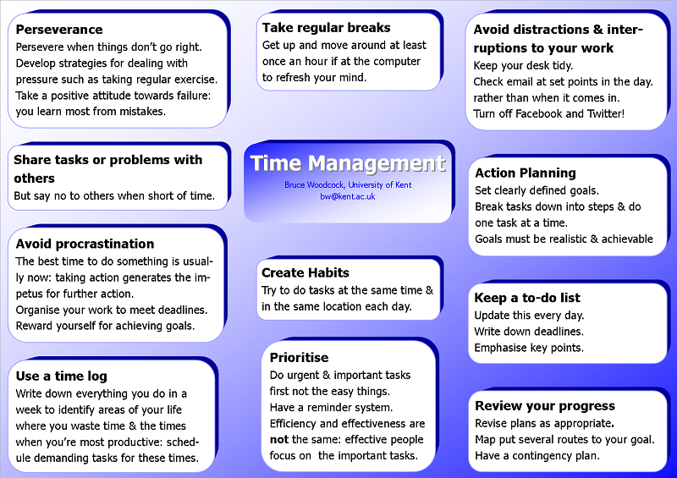
I also used another self-evaluation test from the website of the University of Kent to understand my time management and organisation skills better so I can be more productive. (University of Kent)

https://www.kent.ac.uk/ces/sk/time.html
Here are my results;

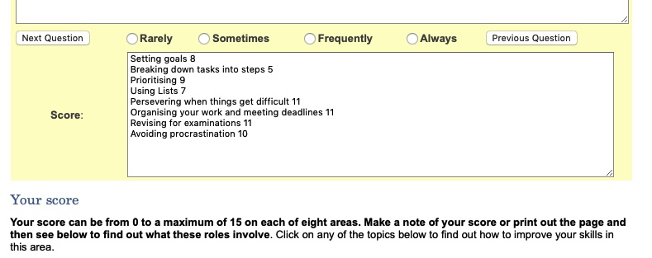
From this test I have found out that I need to work on breaking down tasks into steps in order for me to do them effectively as well as making lists and setting frequent goals for myself. This also links to the book ‘Getting Things Done’ as it reflects on how individuals should break down tasks.

VI.CONCLUSION

In a constantly changing social environment we as individuals face challenges in our lives which we need to overcome in order for us to achieve our goal and succeed in the career path we have chosen.
In this paper I have discussed the strengths and weaknesses as well as a way in which I can overcome them. Various skills were determined which also allowed me to understand what I need to work on and how I can improve my skills.
I have learned that with perseverance and productiveness you can achieve every goal you have set for yourself. I have also taken into consideration all the results from the two tests I did and all the steps in order for me to enhance my knowledge and learning.
A copy of my PDP/ personal development plan has also been created so that I can shape a career path full of success. (Assignment)

References
Allen, D. (2015). https://en.wikipedia.org ,Getting Things Done. Retrieved from https://en.wikipedia.org/wiki/Getting_Things_Done: https://en.wikipedia.org/wiki/Getting_Things_Done
Assignment, S. (n.d.). Personal Development Plan. p. 11.
businessphrases.net. (n.d.). https://www.businessphrases.net/willingness-to-learn/. Retrieved from Willingness To Learn : Definition & Guide To Improve It: https://www.businessphrases.net/willingness-to-learn/
David, A. (2015). Getting Things Done. In D. Allen, Getting Things Done (p. 267). Penguin. Retrieved from https://en.wikipedia.org/wiki/Getting_Things_Done: https://en.wikipedia.org/wiki/Getting_Things_Done
Doyle, A. (2019, May 1). https://www.thebalancecareers.com/technical-skills-list-2063775. Retrieved from https://www.thebalancecareers.com: https://www.thebalancecareers.com/technical-skills-list-2063775
Information Systems and Technology. (n.d.). https://ist.mit.edu/security/protecting_data. Retrieved from https://ist.mit.edu/security/protecting_data: https://ist.mit.edu/security/protecting_data
Lombardo, J. (Chapter 14). Workplace Communication: Importance, Strategies & Examples. Retrieved from https://study.com: https://study.com/academy/lesson/workplace-communication-importance-strategies-examples.html
MindTools. (n.d.). https://www.mindtools.com/pages/article/get-started.htm. Retrieved from https://www.mindtools.com: https://www.mindtools.com
Mukheirjee, B. (2018, May 1). 6 Useful Ways To Protect Your Data From Leakage . Retrieved from https://www.entrepreneur.com/article/312771: https://www.entrepreneur.com/article/312771
Pew Research Centre. (2012, February 29). Global Digital Communication: Texting, Social Networking Popular Worldwide. Retrieved from https://www.pewglobal.org/2011/12/20/global-digital-communication-texting-social-networking-popular-worldwide/
Polevoi, L. (n.d.). 8 Tips for Effective Time Management. Retrieved from https://quickbooks.intuit.com/r/employees/8-tips-for-effective-time-management/: https://quickbooks.intuit.com/r/employees/8-tips-for-effective-time-management/
Sean Kennedy, C. 2. (n.d.). Self-Management Skills for the Workplace. Retrieved from https://study.com: https://study.com
University of Kent. (n.d.). How to manage your time effectively. Retrieved from https://www.kent.ac.uk/ces/sk/time.html: https://www.kent.ac.uk/ces/sk/time.html
Wehbe, S. (2017, march 31). 5 Important Reasons Why Teamwork Matters. Retrieved from https://www.potential.com: https://www.potential.com

VII.APPENDICES

1.PDP Presentation







