

Case Study: Creating an Automated Testing Tool for SIEM Rules within the DVLA

by
Thomas Pritchard

Supervisor: Michael Dacey

Project submitted as part of the requirements for the award of
BSc (Hons) Computing (Software Engineering)

July 2022

DECLARATION

I, Thomas Pritchard declare that I am the sole author of this Project; that all references cited have been consulted; that I have conducted all work of which this is a record, and that the finished work lies within the prescribed word limits.

This work has not previously been accepted as part of any other degree submission.

Date : 27/07/2022

FORM OF CONSENT

I, Thomas Pritchard hereby consent that my Project, submitted in candidature for the B.Sc.(Hons) Computing (Software Engineering) degree, if successful, may be made available for inter-library loan or photocopying (subject to the law of copyright), and that the title and abstract may be made available to outside organisations.

Date : 27/07/2022

1 Abstract
This report sets out a case study created on behalf of the DVLA, to investigate the potential for creation of a tool meeting specific agency requirements to eventually be implemented into a ‘playground’ environment for testing of security information and event management (SIEM) rules. The tool intends to simulate activity as defined by a user by generating logs matching specific criteria and outputting these into a SIEM ingestible format.
To develop a proof-of-concept, research was undertaken surrounding SIEM tool ingestion and log generation tools already available, a selection made and further developed to create a bespoke tool featuring a frontend to be utilised for the testing purposes described above.
Results indicated a tool of this type is feasible for the purposes described above, logs were produced matching the format as required by the SIEM tool, and data can be successfully ingested into log fields for rule testing purposes. Multiple recommendations have been made for future development of a wider and more complex tool, adding additional functionality and improving on the functionality already in place.

2 Contents

1 Abstract 3
2 Contents 4
3 Introduction 1
3.1 Background 1
3.2 Aim 1
3.3 Objectives 1
4 Literature Review 2
4.1 Requirements 2
4.2 SIEM Tools 2
4.3 Log Ingestion 3
4.4 Sample Log Generator 4
5 Approach and Methodology 12
5.1 Research Methodology 12
5.2 Design Methodology 13
6 Design 15
6.1 Requirements 15
6.2 User Stories 15
6.3 Wireframe 17
6.4 Flow Diagram 17
6.5 Design Decisions 18
7 Implementation 20
7.1 Log Generator 20
7.2 User Interface and Underlying Functionality 22
8 Results 27
8.1 SIEM RegEx Matching 27
8.2 Injection and Repetition Counts 29
8.3 User Experience and Feedback 32
9 Conclusion and Future Work 34
10 Reflection 36
11 Bibliography 38

3 Introduction

3.1 Background
The DVLA currently utilises a SIEM tool in its SOC (Security Operations Centre) - the agency’s current tool is LogRhythm, however there is potential for this to change in the future. Within the SIEM tool, alerts are configured to fire based on predefined rules, which can then be investigated by analysts.
Creation of these rules can begin in a variety of ways; recommended by the vendor, recommended by other sources (other vendors, organisations, users) as best practice, or bespoke as required by the agency based on internal requirements or threat intelligence. In all cases, before implementation into live, the rules are generated and set to monitor without alerting to identify false positives, which can then be ironed out. However, except for rules which are testing for known frequent activity, or otherwise activity which can be manually triggered, testing these rules for genuine positives is often difficult to impossible.
One option is to look at Purple Teaming exercises with the in-house Ethical Hacking team, however, this requires careful planning and timetabling, and could only realistically come into effect where a rule is ready for live. In scenarios where a looser approach is required during the initial stages of rule generation and design, a requirement has arisen for a ‘playground’ environment within which a rule could be implemented, with sample logs then generated for the SIEM tool to sift, to determine whether a rule triggers on expected activity, and remains dormant on activity that doesn’t match.
Rules may be created by a variety of team members with varying levels of technical expertise, and so consideration should be given to how this testing can run in a user-friendly manner.

3.2 Aim
To investigate the requirements for implementing a tool to assist with fake log generation, which will allow for automated testing of SIEM tool rules by users with different levels of technical expertise in the DVLA. This tool will form a proof-of-concept for evidencing the possibility of a more featured tool which will be eventually implemented in a ‘playground’ testing environment, within the remit as outlined within the business case.

3.3 Objectives
- To identify and evaluate potential tools and techniques to assist with sample log generation, and how these tools could be integrated with a frontend.
- To evaluate the feasibility and potential benefits of a standalone testing tool for SIEM rules by demonstrating a proof-of-concept for an automated log generation tool.
- To determine whether an automated testing tool could generate fake logs similar enough to genuine logs that they can be ingested by a SIEM tool, with field changes input by users with varying levels of expertise at the DVLA.

4 Literature Review

4.1 Requirements
Discussed further in the following design section, these key requirements as identified and agreed by the DVLA, have been included here to provide context for the following sections, where these are often referenced.
- The tool must generate sample logs for at least one log source, with the potential to add more going forwards
- The tool must allow for selection of a variety of criteria eg. log source, host source and destination, time gap, specific indicators etc. to allow for testing of a variety of rules
- The tool must allow users with varying levels of technical expertise to run a test
- The tool should allow tests to be re-run during a session to allow repeated testing of rules as changes are made
- The tool should be vendor-neutral, allowing it to generate logs which can be ingested by a variety of SIEM tools
- The tool should allow for future building of additional functionality as described above

4.2 SIEM Tools

4.2.1 Background
The DVLA utilises LogRhythm as its SIEM tool, therefore the proof-of-concept as requested for this case study will look at LogRhythm as the method for log ingestion. However, a key formal requirement has also been identified:
- The tool should be vendor-neutral, allowing it to generate logs which can be ingested by a variety of SIEM tools
The reasoning is two-fold and relates to potential future procurement plans. Should a change of SIEM tool be considered, either as a replacement or a secondary to the existing, the tool created from this case study could act as a test-bed for multiple SIEM tools, allowing the agency to verify requirements. Secondly, should implementation of another SIEM tool then go ahead, it would be essential that the tool created from this case study would still provide a viable testing environment.
For this reason, the following research firstly considers implementation requirements for a variety of SIEM tools, however, the main focus for the proof-of-concept will remain with LogRhythm.

4.2.2 SIEM Tool Landscape
Previous research by the author identified the SIEM tooling landscape is frequently changing [1], with leaders as identified by Gartner Magic Quadrant reports [2], [3] changing completely within the past ten years - no tools remained static in the Leader Quadrant over that time, this disparity can be seen in fig. 1 and fig. 2.
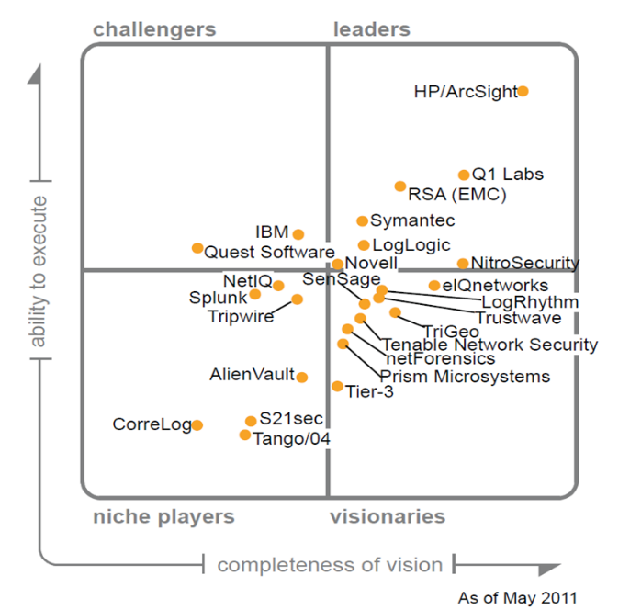

However, recent years appear to show a more steady pattern, with LogRhythm having remained a leader for nine consecutive years [4].
Fig 2. Gartner Report 2011 for SIEM - Magic Quadrant
Fig 1. Gartner Report 2011 for SIEM - Magic Quadrant

4.2.3 Conclusions
With the suite of top SIEM tools being relatively volatile, the need is shown to ensure development of a testing tool considers future requirements, remaining open and versatile to allow for future tooling changes.

4.3 Log Ingestion
As discussed in the previous overview, a key component of this case study is:
- A SIEM tool to allow log ingestion and rule configuration
Which can be further broken down; the second half (rule configuration) is applicable and bespoke to all SIEM tools as it enables their primary functionality, however the first component (log ingestion) relies on the SIEM tool ingesting from a variety of third party devices and sources. As such, it is the log ingestion component which provides the challenge of ensuring cross-compatibility - the format of logs ingested into one SIEM tool may differ from the format required by another.
The United States National Institute of Standards and Technology (NIST) has established a comprehensive guide to Computer Security Log Management [5] which provides best practice guidance, and whilst not a requirement, it is expected the majority of SIEM providers aim to meet these standards.
Of interest to this case study are two identified methods SIEM tools use for log ingestion: agentless and agent-based. Agentless requires hosts talk directly to the SIEM tool, which will then normalise and process ingested logs, this provides quick setup with minimal CPU overhead on the hosts themselves [6]. Agent-based requires an agent install on each host, which processes and normalises the logs before handing to the SIEM tool, this provides higher reliability through caching and is network bandwidth efficient as not all logs are sent [6].
Additionally, the NIST guidance [5] identifies multiple log formats of interest, specifically two widely recognised variants: syslog and windows event logs. The syslog protocol as described in RFC 5424 [7] has become the most widely used protocol for logging in unix based systems [8].
A 2022 paper by Solutions Review [9] compares and contrasts a variety of aspects of SIEM tools on the market, looking at their usage and organisational benefits. Usefully, it provides a resource for identifying trends for ingestible log formats, from which two once more become apparent: syslog and windows event management. Other buyer’s guides [10], [11] identify the same - however as these are vendor produced they contain bias towards own tooling and so multiple vendors have been compared to compensate.

4.3.1 Conclusions
As advised in the formal requirements, vendor neutrality is needed to allow for future changes to tooling. As such, the above considers various documentation looking at logging requirements and functionality across different SIEM tool providers.
It is not possible to know what future decisions the Agency might make around tooling, resultanty the following conclusions can be drawn:
- The first focus of the proof-of-concept should be creating a tool allowing for log ingestion by LogRhythm, the current SIEM tool.
- A log format widely ingested by a variety of SIEM tools offers the best chance of future compatibility.
From the above review, it is evident there are two front-runner formats best meeting these criteria; Syslog and Windows event management logs. These are both ingestible by LogRhythm, and are the most widely accepted by alternative SIEM tool providers - making both a good choice for this project.

4.4 Sample Log Generator

4.4.1 Background
The next major component for consideration is sample log generation; to provide logs to test SIEM rules, logs must be generated which closely simulate real logs, including real attack activity.
Two key requirements have been identified for this aspect:
- The tool must generate sample logs for at least one log source, with the potential to add more going forwards
- The tool must allow for selection of a variety of criteria eg. log source, host source and destination, generation time, time gap, specific indicators etc. to allow for testing of a variety of rules
SIEM tools ingest a variety of log sources to act as a central repository for host and network logs, this enables rules to be run against all logs seen, and therefore potential malicious activity identified even across disparate sources. For this reason, the tool will be required to generate sample logs matching a variety of log sources to closely simulate the agency’s environment. For the proof-of-concept stage it has been agreed that demonstrating generation of logs for at least one source will sufficiently showcase potential, with further log sources to be added at a later stage.
Once a log source is selected, specifications will need to be given to the tool as to what type of logs are required, and any specific elements to be included - e.g. number of logs, timings, or specific indicators or fields. The log generation element needs to take these requirements as inputs, and use them for log generation.
The following research considers the above requirements, whilst looking at availability of open source tools, comparing benefits and drawbacks of each potential solution.

4.4.2 Academic Review
In relation to sample log generation for SIEM tool testing specifically, academic studies are as yet unavailable, and so later research in this section focuses on drawing information from various sources as applicable, such as whitepapers, data sheets, vendor documentation, and community discussions. However, some interesting studies are available in parallel areas providing insight into challenges faced with sample log generation more generally, and some solutions identified.
A 2021 article by Christian Tommel [12] considers an alternative use for sample logs in Cyber Security; red teams utilising AI to produce sample logs with the intent of deceiving system administrators. The author tests the hypothesis that generative adversarial networks (GANs), as used in other areas of Cyber Security such as malware detection [13] and steganography [14], may provide a solution to creating complex and varied sample logs offering the ability to deceive administrators. This could potentially be useful to in-house red teams for complex testing exercises, but could also be utilised by attackers to either mask malicious activity, or overwhelm administrators with excessive noise.
Whilst an interesting concept, and one which identifies further research potential into alternative AI, the three main GAN methods studied were not found to perform well for this purpose - none succeeded in creating convincing logs, mainly due to issues around chronology. The conclusion can be drawn that GANs are unlikely a good fit for sample log generation for SIEM rule testing, as SIEM rules often utilise event order to identify malicious activity.
Additionally, the study notes that static log generators are available which, due to their rigidity, often also produce results identifiable as samples to a trained analyst owing to key characteristics. However, for the application planned within this project where logs are only ingested by SIEM tools rather than manually investigated, this is unlikely to act as a blocker.
Another study [15] dated 2019 also looked at utilising GANs for the slightly different purpose of simulating user behaviour in a test environment. This study found more success in its use case, attributable to the fact the simulation carried out actual user behaviour on the test system - therefore logs were generated by the genuine tool as an indirect result, so weren’t directly generated by the GAN. For the SIEM testing project, the test environment will not contain actual live hosts or networking, therefore this form of implementation wouldn’t be possible.
This study does note that training AI to either produce logs, or imitate user activity, requires vast amounts of training data. For this SIEM testing project, extensive training data wouldn’t be available as it would require logs of example attacks from within the agency’s environment. Other more broad attack samples non-specific to the agency could provide useful training scenarios, but it is unlikely these would openly be available in a number large enough for training. As advised by the National Crime Agency [16], large numbers of cyber attacks are believed to be under-reported, and those announced receive little open publication owing to data sensitivity.
Another study providing useful insight to give direction to the SIEM testing project, was presented at the 2009 International Conference on Information Assurance and Security [17]. The authors of the resulting paper discuss a need for sample log files for creation of detection schemes for web application firewalls, protecting online services. Whilst the content is dated in areas, the issues faced by the researchers aligns with those of the SIEM testing project - and as such some useful insight is provided.
This paper looks at DoS attacks only, whilst making recommendations for further attacks to be studied. Findings were that as logs were being injected directly into the original application logs, unlike the study above which simulated real activity, the activity could be completed on the live system with minimal service disruption, allowing real-time testing of the detection utility. However, due to the nature of DoS attacks generating large numbers of logs, these started to impact the logging facility, and from a detection perspective caused confusion where the computed normal activity for the service became artificially inflated by the sample logs, resulting in otherwise identifiable suspect logs going unrecognised.
The results show the need for this type of testing to be completed in a separate environment, as is the aim of the SIEM testing project. Additionally, this brings up concern with thresholds - within SIEM rules thresholds for alerting can either be set on defined requirements, or otherwise automatically deduced by the SIEM tool measuring normal activity to then monitor for deviations. It should be considered by users of the log generation tool that for testing rules containing thresholds, results may not carry over directly into the live environment, and further tweaking could be required. A potential solution would be to use a user-defined threshold in the test environment to keep a controlled variable, and enable auto-generation once in live to allow the SIEM tool to build a baseline on real-world data.

4.4.3 Static Log Generators
Multiple open-source static log generator tools have been identified, offering varying levels of functionality. The following review considers the benefits and drawbacks of each, allowing comparisons against the project requirements for a best recommendation. It has been split into two sections, those meeting all requirements for consideration, and others of interest but holding deeper caveats.

4.4.4 Log Generators for Consideration

4.4.4.1 Anlyz Logs.to
Logs.to [18] offers a web application for log generation specifically for the purpose of SIEM testing, amongst others including red teaming. This service is provided by Anlyz [19], a company offering its own SIEM tool, so whilst it appears efforts have been made to ensure the two services remains separate, consideration should be given that its possible generated logs are biased towards ensuring the Anlyz product performs optimally.
There is an API available free-to-use allowing requests to the service to get log files returned. With the project requirement to allow logs to be generated in a user-friendly manner, this is key, as it would allow all log generation to take place in the background without user intervention. Being an online service however results in two caveats, firstly there is no guarantee the service will remain live and free indefinitely, the service could be disabled resulting in an alternative needing to be introduced. Additionally, the SIEM playground environment would require internet access, and whilst not containing live or confidential data, it would hold test SIEM rules which could be considered useful to an attacker - as such, internet access would need to be as locked as possible.
This service offers functionality beyond the requirements of this project - however it also comes with compromises. In terms of the requirement for providing the ability to select a variety of log criteria, there are options [20] for date/time ranges and number of logs (up to 100,000 via the API). It additionally offers ‘threat contexts’ broadly defined as types of malicious activity (e.g. credential access, excessive firewall denies and lateral movement).
This functionality may be a double-edged sword; on one hand this provides rich example logs for testing behaviour-based rules looking for a particular type of activity by comparing logs over a time period, but wouldn’t allow for injection of specific indicators-of-compromise into the logs defined by the user - e.g. testing indicators within a threat list.
Considering the organisation's requirements, behaviour-based rules are more complex to implement, therefore the functionality to test these over more tried-and-tested indicator-based rules is considered more beneficial to the use case. An additional element to consider is that testing is limited to threat contexts already defined and available within Logs.to. These may increase over time but there is no guarantee, so testing scenarios are limited - however, functionality offered is good for threat contexts available, a separate tool or bespoke generation could expand on the functionality offered by Logs.to in future SIEM testing tool revisions.
Similar to the above, multiple logging devices are available for simulation, including Windows and multiple Cisco devices - however the list is not comprehensive of all devices within the Agency’s environment, therefore future revisions may require supplementation in the same manner.
Logs.to exports logs in multiple formats, some (such as CSV and CEF) are directly importable into LogRhythm - but for generic future-proofing a tool such as NXLog [21] could be utilised to process the logs via Syslog.

4.4.4.2 Peter Scopes’ Log Generator
An alternative identified for consideration was recently created by Peter Scopes for NCC Group [22], released on an open-source licence as ‘Log Generator’ [23]. Created in Python as a standalone application, no internet connection is required, ensuring the install environment remains as ‘standalone’ as possible.
Compared to Logs.to, this generator is broader; instead of pre-defined log formats and attack scenarios, everything is built from the ground up by the user - this offers both benefits and drawbacks.
The generator allows users to select from a vast array of options, including the amount of logs required and timestamp ranges, as well as self-defined fields. A log format is defined within a YAML file by the user, an example format definition is below:
format: "{log_ip} - - [{log_time} +0000] \"{log_method} {log_path} HTTP/1.1\" {log_status} {log_bytes}" [23]
Values such as {log_ip} are user-defined and can be multiple types, including lists with weighted chances of inclusion, or integers within a defined range, allowing for a variety of randomly generated logs meeting user-defined patterns. This offers versatility meeting the requirement to allow for a variety of values to be included, as well as for specific indicators where required.
The downside to this flexibility is that all settings need to be defined individually - there are no predefined attack types creating traffic reminiscent of a particular attack scenario, each would need to be crafted using evidence from historic attacks - and as discussed previously, this data is not readily available in most cases. With increased flexibility offered by this tool, comes potential decrease in user friendliness.
Similar applies looking at log source formats, with no formats pre-defined, all would require creating from scratch utilising vendor documentation. The benefit being that any log source can be created within the tool, it is not reliant on those already available - the downside is none are available natively, all having to be created from scratch. This potentially introduces the chance for errors, and increases development time and future maintenance.

4.4.4.3 Comparison
Essentially, both tools offer the ability to automate logs generation, but achieve results using different methods; table 1 summarises these differences - highlighted in blue are perceived benefits:
Logs.to | Log Generator
Low resource | High resource
Online | Offline
Prebuilt log sources | No prebuilt log sources
No bespoke log sources | Bespoke log sources
Prebuilt threat contexts | No prebuilt threat contexts
Best for behaviour-based testing | Best for indicator-based testing
No bespoke indicators | Bespoke Indicators
Table 1: Comparison between static log generators
These can be further summarised as a comparison between:
- Quick, effective implementation with pre-configured data sets (‘Logs.to’)
- More costly manual configuration with greater flexibility (‘Log Generator’)

4.4.5 Other Tools of Interest

4.4.5.1 Apache Malicious Log Generator
A Python-based generator of sample Apache logs, created for a 2020 thesis by Sean Guthrie [24], which looks at traffic generators for network testing; including a discussion around differences between traffic generators requiring directed network activity to create logs, against synthetic dataset generators to purely create logs for analysis. This second component relates closely to the SIEM testing project, however research indicated multiple options for traffic generators, compared to little for log generation.
The author created and published the tool open-source [25]. The benefits for the SIEM testing project are that the tool is standalone, and provides a variety of attack simulation options including DoS, DDoS and application side attacks, based on real-life attack data. The data used is publicly available and can be verified for authenticity, making this generator likely to have the most accurate attack representation for testing out of the tools compared.
However, the tool is unlikely to fit this project, as it targets one type of log source (Apache), and therefore its use cases would be limited for the SIEM testing tool.

4.4.5.2 Windows Event Logs
Powershell offers the ability to directly write to Windows event logs via the Cmdlet ‘Write-EventLog’ [26] specifying fields as required [27], writing directly to the logs of the host in use. This is an efficient and simple method of generating Windows event logs, but cannot generate other log types, and additionally writes amongst genuine logs on the running host, which would vary over time, preventing logs from being replayed in the manner required for the SIEM testing tool.

4.4.5.3 Bulk Logs
There are multiple other Apache log generators available, such as Mihkel’s Fake Apache/Nginx Log Generator [28] and LunaticLog [29]. More generic options such as WuerthPhoenix’s Random Log Generator [30] allow specification of any log format using YAML templates, and Mingrammer’s Flog [31], [32] also offers similar functionality.
However, these don’t target Cyber Security purposes and are aimed at network testing, resultantly they don’t provide granularity required to test specific log fields, instead providing randomly generated bulk sample logs. These could potentially have a purpose in the SIEM testing tool for testing alarms relying on thresholds, e.g. an unusually large amount of activity seen between two hosts, but this can likely be replicated in a more specific fashion in other tools.

4.4.5.4 Vendor Specific
Multiple vendor specific log generators are available, including Kiwi SyslogGen [33]–[35], and logrun.pl for QRadar [36]–[38]. Due to the limited output being created specifically for the tooling for which they are designed, these wouldn’t meet requirements to work with the Agency’s current SIEM tool. Whilst they could potentially be useful for future testing if the Agency were to move to one of these SIEM tools as an alternative, this would limit functionality unnecessarily.

4.4.6 Conclusions
The need for a standalone testing environment separate from live services has been evidenced, aligning with the case study objectives. Consideration has been given to studies attempting to utilise AI for log generation, with findings indicating that at this stage AI doesn’t provide reliable results, mainly due to limited training data availability, and difficulty creating realistic logs chronologically.
There are many options for static log generation tools, filling a variety of niches, from specific log formats and vendor-specific tools to bulk log generation for network testing. Additionally, random log generators are available providing more broad datasets - but these don’t allow for the targeted results required for rule testing.
To refresh, the following two requirements are key for log generation:
- The tool must generate sample logs for at least one log source, with the potential to add more going forwards
- The tool must allow for selection of a variety of criteria eg. log source, host source and destination, generation time, time gap, specific indicators etc. to allow for testing of a variety of rules
Two tools have been identified meeting these requirements, ‘Logs.to’ and ‘Log Generator’, however they offer different, often opposing, functionality. ‘Logs.to’ provides an API, offering multiple predefined log sources, and pre-generated complex attack types. ‘Log Generator’ offers a standalone Python package, offering no predefined log sources or attack types, but with flexibility to create bespoke logs sources and fields. Both meet requirements, with ‘Logs.to’ providing pre-built functionality, and ‘Log Generator’ providing development opportunities.
Therefore, the initial recommendation was that ‘Logs.to’ should be utilised for the proof-of-concept within this case study, and for early use of the SIEM testing tool in the Agency. However, in line with the below requirement:
- The tool should allow for future building of additional functionality as described above
It would be beneficial to plan a hybrid approach, supplementing with ‘Log Generator’ once there is appetite to test additional log sources not available in ‘Logs.to’; the tool should be built with this future expansion in mind.
However, as explored further in the implementation section, access ‘Logs.to’ API has been unattainable, resulting in the necessity to take ‘Log Generator’ forwards as the only viable tool, requiring a more complex but easier to build on proof-of-concept.

5 Approach and Methodology

5.1 Research Methodology
Overall, this project intends to evidence the possibility of a tool for log generation which could be utilised within a playground environment for testing SIEM rules. Looking at individual project components makes clear the key areas of interest for research for achieving the aforementioned aims and objectives:
- The log ingestion requirements of a SIEM tool
- A feature to generate sample logs
- A front-end to request the required logs
These three components brought into a singular environment form the basis for meeting the requirements as identified by the DVLA, and thus the basis of the literature review. The review focused mainly on the first two components which are the key decision points determining the specifics of the front-end implementation; the front-end will be built to requirements set utilising these findings.
Elements of deductive research were used to compare existing studies surrounding SIEM tools and log generation, allowing for related information in the broader field to feed into the conclusions made throughout the review. This provides important context, enabling the design decisions made as a result to be tested at implementation.
When looking at tools available for log generation, a more inductive approach was taken. The research takes specific observations about the tools to feed into recommendations for the proof-of-concept development, from which generalisations will be made about future development possibilities for a full-featured tool providing maximum value to the agency.
To compare tools under consideration a qualitative approach was taken, utilising sources including software documentation, blogs, whitepapers, vendor documentation and discussion forums, to compare and analyse qualities of each tool. Where a tool was determined to meet requirements, hands-on testing took place for first-hand experience in its usage, benefits and drawbacks. Due to this being an comparison of functionality, a quantitative approach was not chosen as comparison is intended to be against whether tools have particular elements, as opposed to how effective these elements are which could have been assessed quantitatively using data - this information is not readily available and testing to generate first-hand data would fall outside of the scope of this project.

5.1.1 Research Process
This research has fed into the requirements analysis; whilst overall project requirements were agreed between the developer and DVLA, methods to enable meeting these (e.g. selecting a log generation tool) have been deduced in the above research and below design stages.
Unit testing will take place throughout development, with further testing on completion to ensure requirements are met. A qualitative behavioural UX testing approach was selected to test the proof-of-concept with potential users, results will be evaluated to determine success. This approach has been selected at the proof-of-concept stage due to the broad feedback it can provide, which will prove useful shaping future development plans, as opposed to more specific and targeted quantitative approaches to be used at later development stages. The planned users are a small pool of DVLA Cyber Security staff, therefore only a small pool of testers is available.
Statistical analysis will be completed on the tool’s output utilising RegEx used by the SIEM tool for log ingestion; if the tool produces logs matching these RegEx requirements it can be shown that the tool produces logs similar in nature to the original genuine log sources, therefore can be successfully ingested by the SIEM tool for testing rules.
Further statistical analysis will be completed on key functionality to test the injection and repetition requirements, in the field these would be utilised to test indicators-of-compromise and threshold alerts. Logs will be generated by the tool and analysed to injected value frequency, with and without repetition enabled. To evidence success, injection values should be in logs a minimum of either once, or the repeat value if set.

5.2 Design Methodology
The development stage follows on from the literature review, utilising conclusions and findings of this research, alongside the requirements as identified by DVLA to move towards a proof-of-concept tool. To do so, a number of approaches and methods have been used.
Initial requirements gathering was undertaken alongside DVLA to identify measurable and specific needs using the MoSCoW model. These requirements are not exhaustive to the entire future project, but gives those essential for the proof-of-concept, if success is proven with all requirements met, further requirements may be supplied for future development.
The Agile methodology was considered, however with this being a non-teamworking project, some concepts were unsuitable. Elements have however been adopted for design and development stages, e.g. using the user stories to offer a user-first design approach, and allowing development to take place with individual elements of functionality to achieve an MVP as fast as possible. This is especially important with a requirement being to allow for future development, by utilising this ‘chunking’ approach to split into individual stories, future change and sprints should be easy to onboard; extra features and further development can be implemented should the proof-of-concept prove successful, and a more full-featured solution worked towards.
The selected requirements analysis method is user story mapping, due to it enabling the breaking down of requirements into measurable, manageable elements, which can be used to form development tasks. Breaking down user wants and needs enables description of a minimum viable product (MVP) forming the proof-of-concept, whilst retaining a backlog of proposed functionality for future development; design thinking in this manner has enabled concepts to be identified outside the scope of this development round, which will be valuable later. With this project being carried out by an individual developer, the ability to break down the project into manageable tasks whilst retaining top-down view of the project’s intentions has been vital to maintaining pace. Use

To ensure both the developer and DVLA understand the project plans, wireframe diagrams have been utilised for idea sharing, ensuring standards are agreed and met. Additionally, check-in points are placed to communicate with both the DVLA and potential users to ensure the project is on track and meeting user requirements. Use cases were considered as an alternative, however it was decided that the additional complexity and technical data provided by use cases to support decisions across a team would not prove beneficial over user stories for this project, due to design decisions being made by a standalone developer.
A flow diagram has been created in the design stage for a holistic understanding of how elements interact and flow into the next, using user stories as the basis to ensure all aspects are covered. This provides a vital understanding of functionality interactions, especially considering the connecting of the GUI, backend and log generator seamlessly.

6 Design

6.1 Requirements
At this stage, a proof-of-concept has been requested offering key functionality, however further requirements for future revisions may arise such as creation of alternative log sources, complex rule generation such as baselines, and use of the log generation tool with other SIEM tools.
The following key requirements have been identified and agreed by the DVLA:
- The tool must generate sample logs for at least one log source, with the potential to add more going forwards
- The tool must allow for selection of a variety of criteria eg. log source, host source and destination, time gap, specific indicators etc. to allow for testing of a variety of rules
- The tool must allow users with varying levels of technical expertise to run a test
- The tool should allow tests to be re-run during a session to allow repeated testing of rules as changes are made
- The tool should be vendor neutral, allowing it to generate logs which can be ingested by a variety of SIEM tools
- The tool should allow for future building of additional functionality as described above

6.2 User Stories
To analyse the requirements, as well as provide insight into the mind-set of a potential user, and additionally utilise the Agile methodology of chunking up work, a user story map (fig. 3) was created covering main tool features. Some stories form the MVP which effectively acts as the proof-of-concept, these are either aspects of the requirements or otherwise essential to functionality. Others have been added to the backlog to be included in future development past the proof-of-concept.
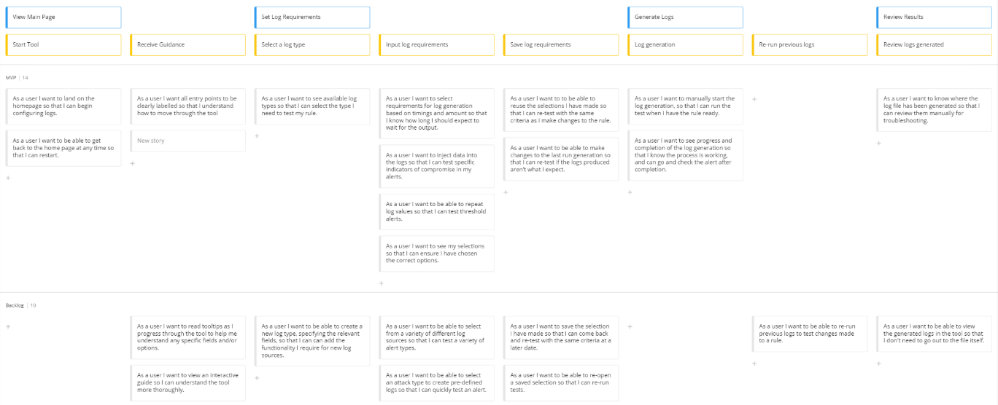
Fig 3. User Story Map
To demonstrate this part of the design process, a sample of these user stories are detailed, including rule-oriented acceptance criteria, below.

6.2.1 Data Injection
Goal: Set Log Requirements
User Step: Input Log Requirements
User Story: As a user I want to inject data into the logs so that I can test specific indicators of compromise in my alerts.
This refers to the following requirement, specifically in relation to ‘specific indicators’:
- The tool must allow for selection of a variety of criteria eg. log source, host source and destination, time gap, specific indicators etc. to allow for testing of a variety of rules
These indicators-of-compromise are often used in building SIEM rules to identify a particular value in a particular log field, e.g. an IP or URL of security concern, or event codes from a security device. The following acceptance criteria are defined:
- User can choose field
- User can enter value to be injected
- Inject value saved in relevant field of config file
- Log generation runs until value injected
- Message shown confirming injection

6.2.2 Log Generation Progress
Goal: Generate Logs
User Step: Log generation
User Story: As a user I want to see progress and completion of the log generation so that I know the process is working, and can go and check the alert after completion.
This refers to the following requirement:
- The tool must allow users with varying levels of technical expertise to run a test
For the tool to be user-friendly, it is essential the user understands interactions as they occur, receiving feedback to confirm requested actions are underway or completed. The following acceptance criteria Are defined:
- When log generation begins, output box displayed
- Message shown at each generation stage
- Message shown when generation completes
- Output box clears each time new generation run

6.3 Wireframe
To visualise layout of the finished project a wireframe diagram was created (fig. 4)
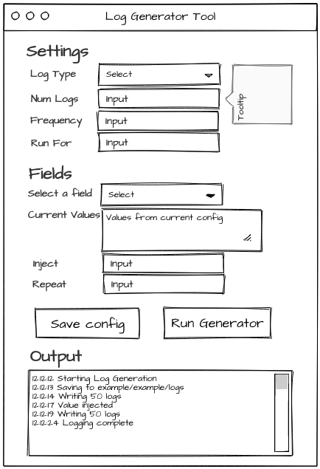
Fig 4. User Story Map
This was developed aiming to meet all user stories with a visual element, it was shown to potential users, and feedback received was positive. During development this was utilised as a starting point for layout of the forms, and to ensure all required fields were available and generated. However, changes were made during development such as addition of top-level windows and extra buttons for increased functionality. As a result this wireframe, whilst useful to development, is not a completely accurate representation of the finished product.

6.4 Flow Diagram
To gain an understanding of a user journey an initial flow diagram (fig. 5) was created. At the design stage, it takes into account the requirements, and uses the user stories as its base; the intention being to, at a high level, visualise how different components of the tool might interact.
At development and testing, to resolve issues and add additional features, changes were made to the flow, however the below was used as the original development basis.
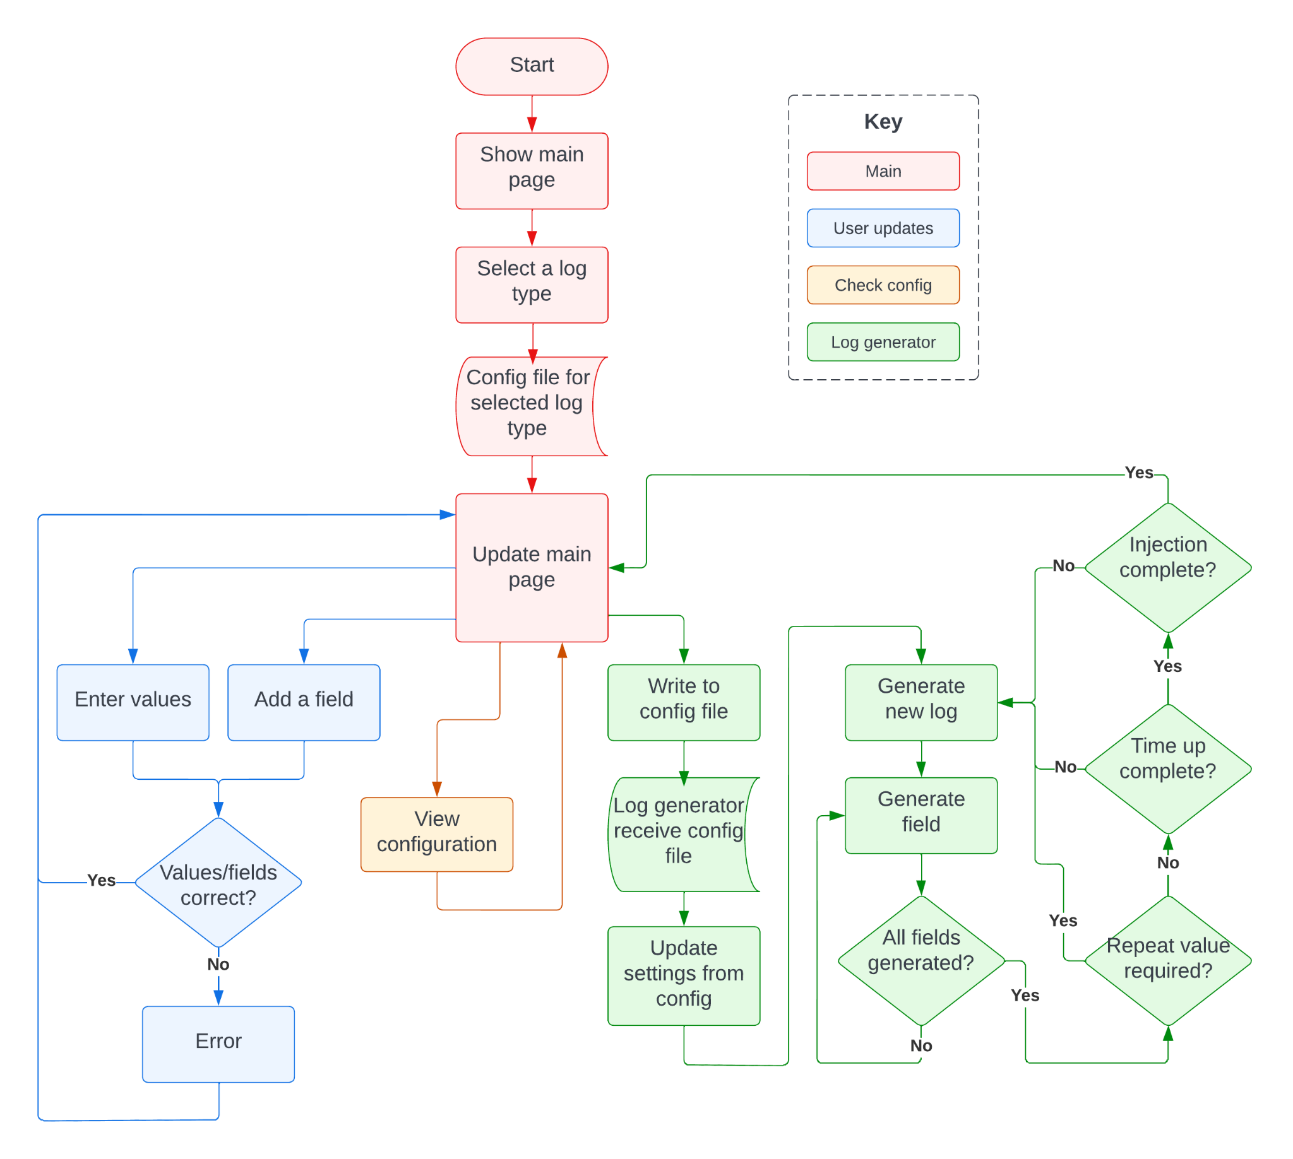
Fig 5. Flow Diagram

6.5 Design Decisions
Based on the literature review, research and design process, some design decisions were made in advance of development, the most essential being language. As concluded above, Peter Scopes’ ‘Log Generator’ was chosen for the log generation aspect, this is built in Python. Whilst other programming languages could achieve similar results, some development work is needed in Python to amend and add functionality to ‘Log Generator’, and to aid ease of communication within the tool and development, Python has been selected for the remainder of the tool.
To build a GUI, a Python module was required. Current organisational setup utilises a Windows environment for the SIEM tool, and it’s expected that this will continue, however consideration has been given to ensuring maximum future compatibility per requirements:
- The tool should be vendor neutral, allowing it to generate logs which can be ingested by a variety of SIEM tools
- The tool should allow for future building of additional functionality as described above
Due to the developer’s prior experience, consideration was firstly given to a browser-based front-end, this was decided against due to the eventual standalone environment potentially having its browser disabled to ensure maximum security. Therefore, it is beneficial for the tool to be completely standalone with an inbuilt GUI. To meet these requirements, Tkinter [39] has been selected with its wealth of documentation, tight integration with Python, and ability to be platform agnostic.

7 Implementation
The development phase required work on two separate components: the log generator itself, and the user interface and its underlying functionality.

7.1 Log Generator
As discussed above, the initial recommendation was for a hybrid approach beginning with building a tool that integrated and made requests to ‘Logs.to’ API, whilst leaving development opportunity to later onboard ‘Log Generator’ as a secondary once usage of ‘Logs.to’ functionality was exhausted. However, as was an identified drawback of relying on external tools, gaining access to ‘Logs.to’ API has been unsuccessful; whilst the project is still live, it appears no longer supported. Therefore, the proof-of-concept has gone ahead utilising ‘Log Generator’, which offers increased flexibility for future development, but requires more costly manual configuration.
Original testing of ‘Log Generator’ indicated strong functionality, and minimal work was planned to setup this tool for effective use, mainly creation of template files ingested by the tool as a basis for its log output. However, once development began it became evident that some key functionality was unavailable to meet project requirements, meaning more extensive work was required. With the tool being open-source, these changes could be implemented into the tool, the following covers some of these additions, and why they were required.
The tool was originally built to run on Linux, and some signal functionality (specifically SIGHUP) for command line communication didn’t work on Windows, which is where the tool will be required. Removal of some unix specific code, whilst retaining functionality via more generic code was completed to address this.
Additionally, extra fields were added to the YAML template files, utilised to provide options for log generation output. Field types were added for public and private IP generation, and a field for the generation running time. Public and private IP types expand on the generic IP type already offered by the tool; with the proof-of-concepts use case to simulate log sources in the agency environment for SIEM rule testing, multiple SIEM rules classify traffic as inbound, outbound or internal depending on origin and destination IP addresses. Making this distinction was essential to implement logs sources where SIEM rules rely on determining traffic direction, such as web gateways where the expectation is requests will be outbound. Two code blocks were added (code 1), along with type definitions, to randomly generate valid IP addresses either within or outside private ranges.
if field['type'] == 'priv_ip':
if 'inject' in field.keys() and random.uniform(0,1) < inject_chance:
return field['inject']
else:
privips = [10, 172, 192]
first_quad = random.choice(privips)
if first_quad == 10:
return str(first_quad) + '.' + '.'.join(str(random.randint(0, 255)) for _ in range(3))
elif first_quad == 172:
return str(first_quad) + '.' + str(random.randint(16, 31)) + '.' + '.'.join(str(random.randint(0, 255)) for _ in range(2))
else:
return str(first_quad) + '.168.' + '.'.join(str(random.randint(0, 255)) for _ in range(2))

elif field['type'] == 'pub_ip':
if 'inject' in field.keys() and random.uniform(0,1) < inject_chance:
return field['inject']
else:
first_quad = 10
while first_quad == 10 or first_quad == 172 or first_quad == 192:
pub_ip = '.'.join(str(random.randint(0, 255)) for _ in range(4))
first_quad = pub_ip.split('.')[0:1]
return pub_ip
Code 1: Private and Public IP generation
In a similar manner, extra parsing was required and the module ‘time’ imported to allow the timestamp field be formatted with epoch time, as is the case for multiple log sources, which was not offered natively (although other formats are available).
The above offer functionality to expand on ingestion options offered by the tool, however key changes were also required to the running logic.
Firstly, the aforementioned new field for running time was used to set a limit on the amount of time the generator should run for. The original tool was designed to be run continuously, however for the purposes of this implementation logs need generating in batches at the size the user requires, and the tool then stop. Logic was added to test this (code 2), ending generation once time is up, unless the below scenario takes place.
For SIEM rules, especially indicator-based, often a rule looks for a particular piece of information in a log, to flag for manual analysis. This might be connection to an IP of concern, a user account lockout, or a particular server event for example. The tool natively generates logs randomly or using data within template files, but offers no function guaranteeing particular values will appear in a batch of logs. For fields with few sample values (e.g. usernames) it is likely a value would appear in generated logs by chance, but for a wider field (e.g. randomly generated IP addresses), it’s unlikely the required value would appear even if generation runs for a long time period.
To meet the requirement to provide host sources, destinations, and specific indicators, injection functionality was added. This took the form of implementing a new ‘inject’ key, to be added to any field in a template file, and some logic provided to the main generation function testing whether injection is complete before log generation is due to finish, running the generation for longer if not. This way, a user-injected value is guaranteed to be output at least once. To prevent this causing the tool to run an exceptionally long time, a calculation was added to determine the amount of logs expected to be generated over the planned running period (defined by the user’s options), and a random chance comparison logic added to each field generated to make it likely the value will be injected extending running time. This method still ensures value insertion at a random point each time logs are generated, which is important for SIEM rule testing as static insertion points could result in errors were rules to be built and tested as false successes, without knowing it is down to the fixed location of a value in a set of logs.
Later development expanded on this further, allowing a user to inject values into multiple fields within the same batch, adding functionality for a use case where a rule is being tested requiring multiple distinct indicators to be seen within a short time of each other, e.g failed user logon, and then a large outbound data transfer. This is implemented using a template file to generate a list of fields containing inject values, and removing the field from the list once its injection has completed. A condition was added to the running loop to check list state (code 2), allowing the generation to end if the list is empty (and other conditions have been met). Whilst not required at this proof-of-concept stage, a future development suggestion would be to implement a method for multiple fields to be injected but guaranteed within the same log, which could be used to test tied activity rules, e.g. a particular user visiting a particular URL.
#TP counter for injections
inject_complete = 0
inject_req = 0
inject_fields = []
for field in config['fields']:
if 'inject' in config['fields'][field]:
inject_fields.append(field)

#TP set runfor time
time_end = time.time() + config['runfor'].total_seconds()

self.logger.info('Writing "%s" logs to (%s)' % (config['name'], config['file']))

#TP finish loop when time reached, and stop after loop, unless inject value not added
while (not event.wait(config['frequency'].total_seconds())) and (time.time() < time_end or (inject_req == 1 and inject_fields)):
self.logger.info('Writing %4d logs for "%s"' % (config['amount'], config['name']))
for ts in self.get_timestamps(config, datetime.datetime.utcnow()):
config['timestamp'] = ts
values = {field: self.next_value(config, field) for field in config['fields']}
#TP check whether inject value has been injected
for field in config['fields']:
if 'inject' in config['fields'][field]:
inject_req = 1
if config['fields'][field]['inject'] == values[field]:
if field in inject_fields: inject_fields.remove(field)
self.logger.info('Injected \'%s\' into \'%s\'' % (values[field], field))
log_entry = config['format'].format(**values)
with open(config['file'], 'a') as log_file:
log_file.write(log_entry + '\n')
Code 2: Log generation loop showing checking for time out and injection

7.2 User Interface and Underlying Functionality
Development of the user interface and underlying code to edit template files and connect to the log generator took place utilising Python and Tkinter. As discussed in the methodology, user stories were utilised to break down the project workload, as a result an iterative development process took place starting with creating a basic gui, and building features onto it until the MVP was reached, additionally, as time allowed, a couple of further stories were completed.
The following sections briefly cover the main functionality, before covering some of the more interesting considerations during the development process.

7.2.1 Functionality Overview
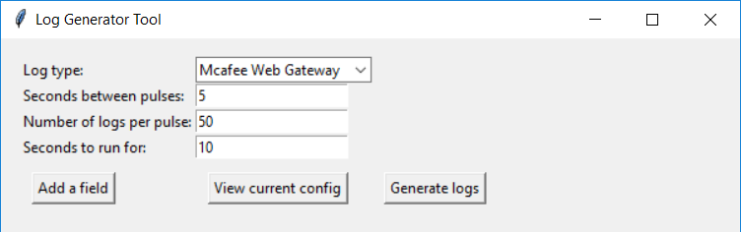
Fig 6. GUI: Main Window
On first load, a window is created containing a form and action buttons, a log type is auto-selected, and a drop-down provides a list of available log types. Based on the selected log type, the remaining fields are populated with default configuration, but can be amended by the user.
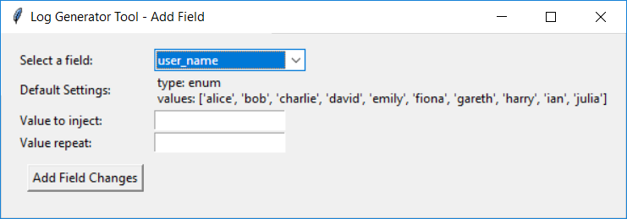
Fig 7. GUI: Add Field Window
If the user chooses ‘Add a field’ a second window is created, within which the user can select a field from a list populated by the configuration file for their selected log type. Once selected, default configuration and values are displayed, and the user can opt to add a value to inject, and repeat this value if required. A user can repeat this action to inject values into multiple fields.
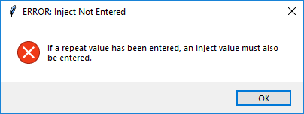
Fig 8. GUI: Example Error Message
At various points, if a user tries to make changes or enter a value that isn’t allowed, an error message is displayed and they are taken back to the previous window to amend, such as in the above example which occurs when a user enters a value in the ‘repeat’ field, but has not specified an ‘inject’ value, therefore there is no value to repeat.
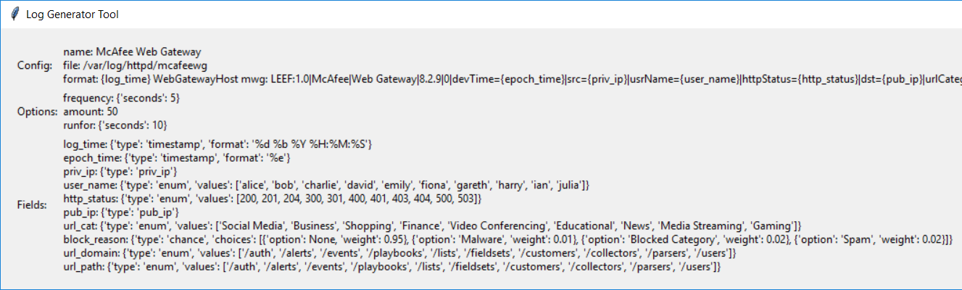
Fig 9. GUI: View Current Config
The user can choose to ‘View current config’ which will display the current settings and field values, this is a way to check what values are default or will run when the log generator is called.
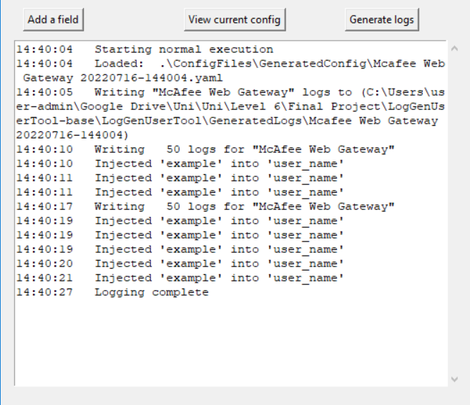
Fig 10. GUI: Log Generation Output
Selecting ‘Generate Logs’ will write the amended config containing all options and field changes to a new .yaml template file, named by the current date and time, and will pass this file to the log generator tool calling the process to begin. A scrollable text box appears to retrieve the output from the log generator tool, allowing the user to monitor progress, and a message displayed once generation is complete. At this point a file containing the sample logs has been created in a directory defined by the tool, which can either be directly ingested as a flat file to the SIEM tool (if the tool allows, LogRhythm does) or otherwise set up to be monitored with a syslog exporter such as NXlog [40], which can pass the logs on to the relevant SIEM tool for ingestion, however this may come at a cost for enterprises.

7.2.2 Development Process
When the tool begins, a loop iterates through the configuration files directory searching for all .yaml files, and splits the results into a list passed to the log type dropdown. By using this method over a predefined list, the requirement to allow future development is satisfied. Hardcoding would result in changes being required to the code when onboarding new log sources, however the chosen method allows a configuration file to just be created and dropped into the relevant directory - making changes possible by users with limited technical experience.
The underlying functionality of the tool relies on the python modules PyYAML and JSON to read, write and amend configuration at user request. Once a log type is selected, the relevant .yaml file is loaded and assigned to a dictionary variable used throughout the program. Default options are pulled from this dictionary to populate relevant fields, if a change is made by the user this is updated before log generation.
Similar functionality is utilised when a user chooses to ‘Add a field’, values for ‘Select a field’ are generated by going through keys within the ‘fields’ key of the main dictionary. However, after some unit testing of the value injection functionality, it became evident filtering of fields may be required at this point, as fields with a type ‘timestamp’ should not be injected into, as this has the potential to create logs widely outside the time range of other, and as such produce results not reflective of genuine log sources. It was considered this could be controlled with user instructions advising against injecting into timestamps, or error handling preventing injection before the configuration file is created - however, the most user-friendly solution was to filter these values from the selection box. Checking was integrated on the field list to generate a second list containing fields with type ‘timestamp’ (for some log sources there can be multiple, often in differing formats) and a final list generated only containing non-timestamp values. To compare these lists, the decision was made to convert to sets, then take the timestamp set from the main fields set, this was chosen as evidence [41] shows this to be a time-efficient way of handling this problem in Python.
For the ‘View current config’ section, original development took the currently selected .yaml file template - which is written in a specific order described by the log generator schema, and parsed the file into a string, before reformatting the key-value pairs to be more human readable, and combination of RegEx matches and string splits cut the string into the three required sections (code 3). This was an effective method for parsing the original file, however an issue was identified on later testing as a result of the way dictionaries operate in Python, their order (from v3.7+) is determined by the elements order of insertion [42], in older versions ordering cannot be guaranteed. Therefore, when a user changes a value within the tool and the new value is inserted in the python dictionary, the new value will no longer be in the original order, and therefore no longer match the RegEx and split criteria, resulting in unexpected behaviour. This issue arises on insertions, but equally when a new .yaml template is created by the user, and with the requirement to allow for simple additional future development of the project, this would prevent implementation of the user story allowing opening and reloading a .yaml file previously created within the tool. To correct this, the code was altered (code 3) to instead split the dictionary by keys into three individual dictionaries; this way the ordering is irrelevant, as they are then individually run through the string formatting function.
#Split config into sections, and reformat for easier reading

#ORIGINAL
#config_c_o = '\n'.join(['%s: %s' % (key, value) for (key, value) in config.items()])
#config_c_o = re.match('((.|\n)*?)fields:',config_c_o).group()
#config_c_o = re.split('(frequency:)', config_c_o)

#UPDATED
config_c = {x: config[x] for x in ('name','file','format')}
config_c = '\n'.join(['%s: %s' % (key, value) for (key, value) in config_c.items()])
config_o = {x: config[x] for x in ('frequency','amount','runfor')}
config_o = '\n'.join(['%s: %s' % (key, value) for (key, value) in config_o.items()])
config_f = '\n'.join(['%s: %s' % (key, value) for (key, value) in config['fields'].items()])
Code 3: Importing and reformatting configuration file
When a user runs the log generator, the tool updates any currently entered values, performs error checking, calculates a filename based on current datetime and utilises yaml.safe_dump (recommended in PyYAML documentation [43]) to create a new config file with the user’s changes. This filepath is then passed as an argument to a function which runs the ‘Log Generator’ tool itself. Unfortunately this resulted in the GUI freezing until log generation had completed, resulting in poor user experience with not knowing current processing status or whether the application has frozen completely, and additionally means a user would not see an error message if the generator fails. Due to the requirement that users of various technical expertise should be able to use the tool, this poor user experience wasn’t acceptable. To resolve, threading was implemented to run the generator in a new thread, allowing it to run simultaneously alongside the GUI and pass output back to display in real time.
On running the log generator, multiple methods were attempted to pull the output into the GUI for user display, however these continuously failed. Investigation identified ‘Log Generator’ does not output to stdout, instead logging using the Python Logging function as ‘info’ or ‘error’. A second handler was tested duplicating log entries into stdout, however this sometimes resulted in misbehaviour of the generator, new output didn’t include timings added by the logging feature, and additionally changing the log generator behaviour in this manner did not align with the function of the messages, which are intended to be for logging purposes and not user information. As such, it was decided a more appropriate route would be to set logging level to ‘info’ in ‘Log Generator’, ensuring all relevant data is captured and passed to stderr, which could be utilised then on the GUI side to display. This then required tweaking with substrings to provide the data in the most human-readable format.
#GENERATE LOGS
def runloggenerator(window, file):
#create command to run log generator
cmd = '\"' + loggenerator_fp + '\\log-generator.exe\" \"' + file + '\"'

#create output box
tb_output=scrolledtext.ScrolledText(window, width=60)
tb_output.grid(sticky="W",row = 7,column=0, columnspan = 3)

#run process and print output to textbox
process = subprocess.Popen(cmd, stderr=subprocess.PIPE,universal_newlines=True)
while True:
op = process.stderr.readline()
if process.poll() is not None:
break
if op:
tb_output.insert(tk.END, op[11:19] + ' ' + op[33:])
Code 4: Generate logs function
Additionally throughout, error handling was added and changes made following testing, firstly to the comboboxes which were adjusted to read-only, preventing users from entering their own values causing errors. Error handling was added to all user fields preventing incorrect data from being input (e.g. non-integer values in fields which take a number of seconds), and to prevent values being entered when another required field is empty (e.g. the ‘repeat’ field which can only be utilised should an ‘inject’ value be entered).

8 Results
As discussed in the methodology, results have been analysed from three separate tests to determine project success; SIEM RegEx matching, injection and repetition counts, and user experience and feedback. Looking at requirements, these tests act to confirm or deny success against the following, the other three were developmental and confirmed by input at the development stage:
- The tool must generate sample logs for at least one log source, with the potential to add more going forwards
- The tool must allow for selection of a variety of criteria eg. log source, host source and destination, time gap, specific indicators etc. to allow for testing of a variety of rules
- The tool must allow users with varying levels of technical expertise to run a test

8.1 SIEM RegEx Matching
To test the tool successfully generates logs for at least one log source, generated logs have been run through a RegEx string, if all produced logs match, they are an accurate representation of genuine logs from the original source. The RegEx string was taken from the SIEM tool which uses this to pattern match genuine inbound logs, pulling out the required information into various fields. By using this string, we can be certain that if the generated logs match, they would be successfully accepted and processed by the SIEM tool in a testing environment.
To confirm that changing values within the tool, with the intention of affecting its output, still produces logs matching the RegEx, multiple tests have been completed utilising a variety of options within the tool, these are detailed below along with the percentage of logs matching the string. The first round of tests changes one value at a time, later rounds test with multiple simultaneous changed values - whilst this does not exhaust all possible actions an effort has been made to select a representation of possible variations (i.e. changing ‘Amount’ and ‘Injection’, or ‘RunFor’ and ‘Frequency’).
Table 2 showing tests taken and results for SIEM RegEx Matching
Test # | Test Description | Result
1 | None - kept as default:  Frequency: 5  Amount: 50  RunFor: 5  Injection: none  Repeat: none | 50 logs  100% match
2 | Frequency: 2 | 150 logs  100% match
3 | Frequency: 10 | 50 logs  100% match
4 | Amount: 10 | 10 logs  100% match
5 | Amount: 1000 | 1000 logs  100% match
6 | RunFor: 8 | 50 logs  100% match
7 | RunFor: 30 | 200 logs  100% match
8 | Inject: user_name: tom | 50 logs  100% match
9 | Inject: pub_ip: 100.20.987.64 | 50 logs  100% match
10 | Inject: url_domain: google.com  Repeat: 10 | 50 logs  100% match
11 | Inject: user_name: tom  Inject: url_domain: google.com  Repeat: 10 | 50 logs  100% match
12 | Inject: pub_ip: 100.20.987.64  Amount: 500 | 500 logs  100% match
13 | Inject: user_name: tom  RunFor: 30 | 200 logs  100% match
14 | Inject: user_name: tom  Frequency: 8 | 50 logs  100% match
15 | Frequency: 30  RunFor: 70 | 100 logs  100% match
16 | RunFor: 20  Amount: 1000 | 1000 logs  100% match
17 | Frequency: 15  RunFor: 10 | 0 logs  N/A
18 | Frequency: 2  Amount: 100 | 100 logs  100% match

From these results, two things become evident - first is that all tested generated logs match the SIEM tool RegEx, and so can be said to be an accurate representation of logs produced by the original source, therefore meeting this requirement.
However, a further interesting trend can be identified looking at the number of logs produced for each pass. On many occasions the logs actually produced don't match the expected number of logs to be produced, examples included test numbers 3, 16, and 17 (where no logs were produced at all) - this appears to be due to two separate factors.
Firstly, the ‘Log Generator’ tool performs a wait function between each loop based on the frequency set, on reading through the source code it has been discovered this also applies to the first loop, meaning the tool waits the set frequency before producing the first batch. In scenarios where the ‘Frequency’ value is set higher than the ‘RunFor’ value, the behaviour the user would expect is this would produce one batch of logs, and time out for the next; however, the tool will in fact time out before it produces any logs (e.g. test #17). This effect can also be seen in tests where the expected number of logs is not produced, for example in test #3 where ‘Frequency’ is 5 and ‘RunFor’ is 10. Expected behaviour would be two batches of 50 logs (one at second 0 and one at second 5) before time out, resulting in 100 logs total. However due to the first wait, only a single batch is produced at second 5 before time out, resulting in 50 logs total.
Additionally, where a higher amount of logs is requested per batch, the production of the logs may take longer than the frequency value, resulting in the wait running out but the loop still being in progress, therefore until the loop finishes the frequency value is ineffectual. In test #16 this is seen where ‘Frequency’ is 5, ‘Amount’ is 1000 and ‘RunFor’ is 20. Taking into account the aforementioned issue, we would expect this to produce 3000 logs total, however only 1000 are produced due to the generator taking >15 seconds to produce the logs, therefore the loop only completes once.
Both these issues affect requirement #3 as the results differ to user expectations, resulting in a subpar user experience. It is recommended that in the first case, revisions be made to run the generator without a wait for the first loop. For the second, a few solutions could be jointly employed; performance improvements should be sought in the first instance so more logs can be processed in a shorter time, multithreading could be considered to run more than one generation loop simultaneously (with higher numbers this could require careful management and error handling), and user instructions should note that excessively high log counts may result in generation delays and as such equivalently high ‘RunFor’ values should be utilised.

8.2 Injection and Repetition Counts
To test the requirement for value injection and repetition for testing indicator-of-compromise and threshold alerts, a test has been deduced to generate logs with a variety of injection values, repeat values, and scenarios with multiple of each. The aim is to determine the minimum number of injected values that should be seen, to be compared against the value actually found within the generated logs. Because injections should be completed on a weighted random basis, three runs have been completed for each test, and the lowest result used for analysis.
All runs were completed with default settings of ‘Frequency’ = 5, ‘Amount’ = 50 and ‘RunFor’ = 10. Where a run resulted in extra logs being generated after run time (in scenarios where an injected value has not yet been injected, the generator will run until this completes), these results have been excluded and the test re-run to allow comparison between runs with equal amounts of logs.

Table 2 showing tests taken and results for Injection and Repetition Counts
Test # | Values | Minimum Acceptable | Results
1 | Inject: user_name: tom | tom: 1 | tom: 4, 3, 2
2 | Inject: user_name: tom  Repeat: 5 | tom: 5 | tom: 43, 41, 42
3 | Inject: pub_ip: 111.22.333.44 | 111.22.333.44: 1 | 111.22.333.44: 1, 2, 1
4 | Inject: pub_ip: 111.22.333.44  Repeat: 50 | 111.22.333.44: 50 | 111.22.333.44: 50, 50, 50
5 | Inject: user_name: tom  Inject: url_domain: google.com | tom: 1  google.com: 1 | tom: 7, 2, 4  google.com: 4, 7, 5
6 | Inject: http_status: 500  Repeat: 10  Inject: url_domain:google.com | 500: 10  google.com: 1 | 500: 46, 46, 47  google.com: 7, 11, 7
7 | Inject: user_name: tom  Inject: url_domain: google.com  Inject: pub_ip: 111.22.333.44 | tom: 1  google.com: 1  111.22.333.44: 1 | tom: 8, 5, 4  google.com: 7, 12, 9  111.22.333.44: 1, 2, 3
8 | Inject: user_name: tom  Repeat: 25  Inject: url_domain: google.com  Repeat: 5  Inject: pub_ip: 111.22.333.44  Repeat: 10 | tom: 25  google.com: 5  111.22.333.44: 10 | tom: 49, 49, 49  google.com: 42, 43, 43  111.22.333.44: 46, 46, 45
9 | Inject: pub_ip: 111.22.333.44  Repeat: 60 | 111.22.333.44: 60 | 111.22.333.44: 50, 50, 50
10 | Inject: http_status: 500  Repeat: 10  Inject: user_name: tom  Repeat: 25 | 500: 10  tom: 10 | 500: 49, 46, 47  tom: 47, 48, 46

Taking the smallest value from runs completed on each field for each test, a chart (fig. 11) can be plotted of result values, which should always be equal to or above the expected minimum. Effectively, in the chart, orange bars representing the actual tested values should always be equal to or larger than the minimum expected values displayed in blue.
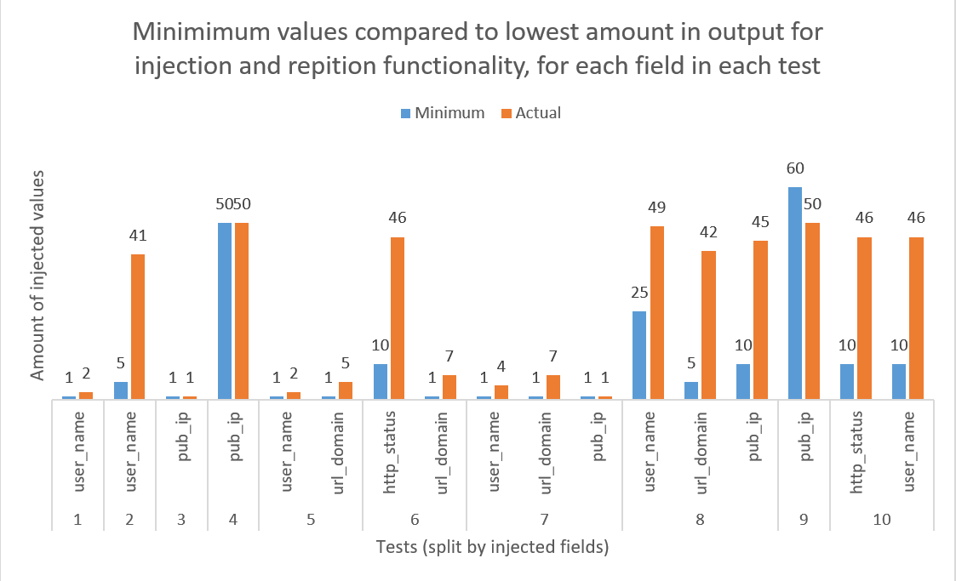
Fig. 11. Chart showing expected minimum values vs. results for testing of Injection and Repetition
There are three interesting findings resulting from these statistics. Firstly, in nearly all cases generated values are higher than or equal to those defined by the user, meeting the requirement for injections and repetitions as described above, in this the tool is successful.
There is however one test for which the expected minimum is above the generated values, test #9. The reason being that only 50 logs were generated due to the default settings used for all the tests, resulting in the maximum possible value being 50. Therefore, the test is not necessarily a failure as the tool is performing as it should, however once again this has the potential to result in a confusing user experience if users don’t have a full understanding of the tools settings. It is recommended future revisions include a warning to users if a repetition value is entered above the value in the ‘Amount’ field, either by default or user input.
Additionally of note is that some results produce values considerably higher than the minimum, and there are a few reasons for this. Firstly, for fields of type ‘enum’ as defined by the ‘Log Generator’ schema (e.g. user_name and url_domain), values are randomly selected from a predefined list, if this list is small compared to the ‘amount’ setting, there is a high chance values will be selected multiple times, the smaller the list the more frequent the selections. In comparison to fields such as pub_ip where each value is completely randomly generated, which as shown above results on most occasions to values closer to the minimum. This behaviour is expected and in line with real log traffic, fields such as user_name are expected to have much more repetition than an outbound IP for example, however the effect could be reduced by ensuring default configuration files contain large lists of potential values for ‘enum’ type fields.
Where repetitions are requested, it is also evident from these statistics that result values tend to be considerably higher than the expected minimum, on analysis of the ‘Log Generator’ tool the initial reason has been identified. To ensure all repetitions are completed within the allocated amount of logs and running time, if a field if allocated a repeat value, that batch of logs is started with the value in question, thus ensuring the repeat takes place at the beginning of the batch where it will certainly have enough logs left to complete the repetition the required number of times. This is a sensible approach, but results in behaviour that is less randomised than a real log source. As a recommendation, future revisions might look to introduce a function to check the ‘repeat’ value before a batch begins, and either assign a start log number to ensure the value is first injected at this point, or otherwise identify the last possible log to allow for the full repetition and inject the value at this point if it has not already been injected by chance earlier in the batch.
These two issues, whilst not related, do have a compounding effect, and in scenarios where both are in play (e.g. test #10), the effect can be dramatic. These high values still meet the requirements as they would be effective tests to be utilised for threshold alerts, however there is value in having the results more closely aligned to the user’s expectations.

8.3 User Experience and Feedback
To test the tool against the requirements for users of varying technical expertise to be able to use the tool effectively, three volunteers from the Cyber Security team have completed hand-on testing of the tool to gather thoughts and provide feedback. Each of these volunteers falls within a different level of expertise within the team; a Cyber Security Analyst (tier 1), SOC Specialist (tier 2), and Senior SOC specialist (tier 3).
General feedback on the user experience from all three has been mostly positive, comments have made clear that when compared against the previous process of manually testing alerts in live, this proof-of-concept offers a marked improvement. However, some constructive feedback has been received which has identified some potential improvements that could be made to future revisions. It is proposed that as future development work takes place, regular testing is completed with these users to determine whether they perceive an improvement in their previous issues, and also to identify areas where further work should be undertaken.
Feedback from all testers discussed that whilst the tool is easy to use once shown, without being taught there are certain elements (such as field and button labelling) which would benefit from further explanation. This was particularly expressed by our Cyber Security Analyst who has less experience with the building and testing of SIEM rules, with a lower understanding of rule generation it is apparent that certain features of the tool such as why an injection or repeat might be useful require further explanation. With the requirement being that the tool is usable by those with varying levels of expertise, it is therefore important that an assumption isn’t made as to the knowledge a user might have of the wider area before going into the tool. As such, it is recommended that future revisions beyond the proof-of-concept should look to begin building user documentation targeting a variety of levels, or in more advanced revisions building in guidance to the tool such as tooltips and perhaps a guided tutorial. For future consideration also would come further down the development line once the tool is considerably more mature, but it may be sensible to ensure users are not overwhelmed by a multitude of unknown options by splitting certain features into an ‘advanced’ area, those that might be used sparingly and for specific use cases only applicable to more experienced users.
Additionally, it was noted that one user performed a log generation function with a relatively high frequency value, this resulted in the issue as discussed in the above ‘SIEM RegEx Matching’ section where log generation did not appear to start for a long period of time, as a result of the loop performing a wait of the frequency amount on the first loop. This caused confusion and questioning from the user about whether the tool was working until the log production eventually began, further evidencing the need to consider the improvement recommendations in the above section.

9 Conclusion and Future Work
To revisit the project objectives, this case study intended:
- To identify and evaluate potential tools and techniques to assist with sample log generation, and how these tools could be integrated with a frontend.
- To evaluate the feasibility and potential benefits of a standalone testing tool for SIEM rules by demonstrating a proof-of-concept for an automated log generation tool.
- To determine whether an automated testing tool could generate fake logs similar enough to genuine logs that they can be ingested by a SIEM tool, with field changes input by users with varying levels of expertise at the DVLA.
Considering these alongside the results, an overarching conclusion is that the outcome of the case study and developed proof-of-concept tool does indicate the feasibility of a more full-featured tool.
The literature review focuses on elements of objectives one and two, concluding firstly that the SIEM tool landscape is frequently changing and evolving, and therefore the need for vendor-neutral tools and techniques to assist with administration and testing of these tools is evidenced. Additionally, it is clear sample log generation is both a complex, wide and under-represented field of study; use-cases are wide reaching and many tools have evolved to fill specific niches, however these are often poorly supported, vendor-specific or limited in functionality. Investigations have been made into potential uses of AI to generate sample data, which at this time doesn’t appear feasible due to a lack of training data and difficulty creating convincing logs. A comprehensive analysis of tools identified as potentially useful to the case study is documented, the outcome points to one specific open source tool meeting the Agency’s requirements - albeit with some edits required. Benefits of a standalone testing environment are discussed throughout, and it is evident this would reduce operational issues and allow for more comprehensive testing to take place at a higher pace.
Following a developmental design process, ensuring all Agency aims were considered and included, a proof-of-concept tool was developed adding required functionally to the previously identified log generation tool, including a frontend for users with varying levels of technical expertise. Eventual testing proved successful, therefore, as per the third objective, it has been evidenced the tool can produce sample logs similar enough to genuine logs that they could be ingested by the Agency’s SIEM tool in 100% of tested cases, and so could be used for rule testing. Further tests proved the remainder of this objective, testing showed user configuration options including indicator-of-compromise injection and value repetition can be successfully implemented, with all requested values appearing in generated logs at least the minimum requested times, allowing for testing of a variety of SIEM rules such as IOC and threshold. User feedback indicated positive experiences using the tool and provided some suggestions for future development. These results evidence the benefits a more full-featured tool could bring, whilst also identifying key areas for future development, the report makes recommendations for achieving a better user experience in future revisions.
From this testing, recommendations for future improvements have been made which should be utilised to form requirements and user stories for development sprints going forwards. Whilst explained in more detail in the results section, these include further development on the open-source Log Generator tool to improve on its functionality in relation to first-loop log processing, how repeat values are handled and performance improvements, including considering multithreading. Additionally, some user experience improvements have been recommended for the front-end, such as improved error handling and user warnings for settings that will result in long operations, as well as documentation and other options for improving user knowledge.

10 Reflection
This project has been a learning experience for myself in a variety of ways, academic, professional and personal. Academically to date this has been the largest project I have worked on, combining multiple of the elements of learning I have achieved over the last four years in my studies, from programming and development skills, to softer skills such as project management and personal resilience.
I have had a number of personal setbacks throughout which have challenged my original plans, pushing back timelines and making it difficult to focus on working towards the project goal. But from completing the project I have learned to trust in my skills that I have developed, to be resilient and know that as long as I pace myself effectively, I am able to achieve my aims.
I utilised various methods throughout the development stage to break down the project development into manageable, and importantly individual, chunks; however, this is in fact a methodology I employed more broadly to the project as a whole. I have found this has personally been an effective method of managing my time and expectations, ensuring I can reward myself at key milestones which has been vital to my motivation, and also meaning that when I’ve reached a point where I need to pause working on the project for any reason, I’ve been able to pick back up starting on the next section of work fresh.
As a part time student, juggling work alongside the project has been challenging at times, especially during periods where work pressures have been more demanding than usual. Personally, working through this project has taught me more about my boundaries, to have an overall goal in sight but not to lose sight of other important aspects of your life along the way. I have found it has been essential to make time outside of work and studies for down time, for friends and family, and for personal development in other areas of my life, such as my physical health. Vitally, this has given me mental breaks that have allowed me to think differently about aspects of the work, by taking a step back I’ve been able to re-approach concepts with fresh eyes, this has proven especially beneficially in the development piece where I have often left a problem and come back to it with a solution already in mind. This prioritisation of other personal needs is not something I believe I had managed effectively in the past, and also into the early days of this work, but by building in this time I feel that the eventual project work has proved more enjoyable, and hopefully this is expressed in the finished product.
I’ve picked up, worked on and honed a multitude of academic skills throughout, which I really believe will prove beneficial to me within my professional career, both at my current stage, but also by giving me a basis on which to future develop and strengthen my skill set. In my professional life, I’m often required to perform quick research to make comparisons between various solutions, and produce recommendations as a result, this however is often a looser and quicker affair due to the necessity for quick decisions, than I have found in my studies. By dedicating time to research, really being able to analyse the research of others, as well as professional documentation and reports, I’ve found a new found appreciation for deeply understanding a subject area, and feeling well-informed and confident in making decisions as a result. This knowledge itself will prove directly useful to my professional life, however of more importance is the skillset I’ve been able to grow and strengthen by performing that research and review. Whilst I may not be able to dedicate the same amount of time to this for decision making in my career, the skills I’ve learned have better equipped me to analyse information, to make comparisons and to consider options - which will enabled me to ingest information and make better-informed decisions than I might previously have been able to.
Whilst many of the technical skills translate into my workplace, and have allowed me to build a niche with my skills into my team, I think a real positive for me both personally and professionally has been the ability to have full oversight and control of a project from start to finish. The opportunity to make decisions, make plans, complete the work and review results myself has given me an appreciation for the work that goes into management of a bigger project, which I believe will make me a more effective manager within my team, being able to deal with all aspects of project management and not only the elements I am usually involved in. This will also carry over into my personal life as I feel more assertive and confident in taking on bigger tasks, knowing that by building, and importantly adapting, an appropriate plan I can work towards a bigger goal.
Overall, I believe by planning, working through and finishing this project, I’ve developed and improved a considerable number of skills which will prove both useful to me in my professional and personal life. From resilience and confidence, to time management and written communication; this project has taught me the importance of taking manageable steps towards a larger goal, of putting provisions in place to make reaching this goal achievable and measurable, including adjusting my expectations along the way, and of valuing and making time for the important things in life.

11 Bibliography
[1] T. Pritchard, ‘Exploring the potential for automation within SIEM tooling’, University of Wales Trinity St. David, Jan. 2022.
[2] ‘Gartner Magic Quadrant for SIEM Products (2020,2018,2017,2016,2015,2014,2013,...)’, Cybersecurity Memo. http://blog.51sec.org/2012/02/gartner-siem-magic-quadrant-2010-and.html (accessed Dec. 28, 2021).
[3] K. Kavanagh, T. Bussa, and J. Collins, ‘Magic Quadrant for Security Information and Event Management’, Gartner, G00467384, Jun. 2021. Accessed: Dec. 28, 2021. [Online]. Available: https://www.gartner.com/doc/reprints?id=1-289HRX4A&ct=211129&st=sb
[4] K. G. on July 16 and 2021, ‘LogRhythm is a Nine-Time Gartner SIEM Magic Quadrant Leader’, Security Boulevard, Jul. 16, 2021. https://securityboulevard.com/2021/07/logrhythm-is-a-nine-time-gartner-siem-magic-quadrant-leader/ (accessed Dec. 29, 2021).
[5] K. Kent and M. P. Souppaya, ‘Guide to computer security log management’, National Institute of Standards and Technology, Gaithersburg, MD, NIST SP 800-92, 2006. doi: 10.6028/NIST.SP.800-92.
[6] ‘Difference between agent based monitoring and agentless monitoring?’, ResearchGate. https://www.researchgate.net/post/Difference_between_agent_based_monitoring_and_agentless_monitoring (accessed Apr. 05, 2022).
[7] R. Gerhards, ‘The Syslog Protocol’, Internet Engineering Task Force, Request for Comments RFC 5424, Mar. 2009. doi: 10.17487/RFC5424.
[8] ‘Computer operating system logging and security issues: a survey’, doi: 10.1002/sec.1677.
[9] D. Hein, ‘Security Information and Event Management Buyer’s Guide’, Solutions Review, 2022. Accessed: Apr. 05, 2022. [Online]. Available: https://solutionsreview.com/dl/bg/2022_6724567373_SIEM_BuyersGuide.pdf
[10] ‘The SIEM Buyer’s Guide for 2021’, Splunk, 2021.
[11] ‘SIEM Buyer’s Guide’, Logpoint. Accessed: Apr. 05, 2022. [Online]. Available: https://chessict.co.uk/media/3432/logpoint-buyers-guide.pdf
[12] C. Toemmel, ‘Catch Me If You GAN: Using Artificial Intelligence for Fake Log Generation’, ArXiv211212006 Cs, Dec. 2021, Accessed: Apr. 12, 2022. [Online]. Available: http://arxiv.org/abs/2112.12006
[13] Z. Tan and D. Agha, Ransomware Detection with Deep Learning Analysis of GAN. 2020.
[14] Z. Fu, F. Wang, and X. Cheng, ‘The secure steganography for hiding images via GAN’, EURASIP J. Image Video Process., vol. 2020, no. 1, p. 46, Oct. 2020, doi: 10.1186/s13640-020-00534-2.
[15] X. Zhao, L. Xia, L. Zou, D. Yin, and J. Tang, ‘Toward Simulating Environments in Reinforcement Learning Based Recommendations’, ArXiv190611462 Cs, Sep. 2019, Accessed: Apr. 12, 2022. [Online]. Available: http://arxiv.org/abs/1906.11462
[16] ‘Cyber crime’, National Crime Agency. https://www.nationalcrimeagency.gov.uk/what-we-do/crime-threats/cyber-crime (accessed Apr. 12, 2022).
[17] C.-H. Lin, J.-C. Liu, and C.-R. Chen, ‘Access Log Generator for Analyzing Malicious Website Browsing Behaviors’, in 2009 Fifth International Conference on Information Assurance and Security, Aug. 2009, vol. 2, pp. 126–129. doi: 10.1109/IAS.2009.310.
[18] ‘Log Generator’. https://www.logs.to/ (accessed Apr. 13, 2022).
[19] ‘Anlyz | Cyber Security | Business Security. Reimagined’. https://anlyz.co/ (accessed Apr. 13, 2022).
[20] Anlyz, Logs.to SIEM Logs generator, (Jun. 15, 2020). Accessed: Apr. 13, 2022. [Online Video]. Available: https://www.youtube.com/watch?v=wmhKyT2-9Vs
[21] ‘Importing csv file and converting to syslog and sending to log server’, nxlog.co. https://nxlog.co/question/5419/importing-csv-file-and-converting-syslog-and-sending-log-server (accessed Apr. 13, 2022).
[22] P. Scopes, ‘Peter Scopes’, NCC Group Research. https://research.nccgroup.com/author/pdscopes/ (accessed Apr. 15, 2022).
[23] P. Scopes, log-generator: Generates dummy logs based on configuration files.
[24] S. Guthrie, ‘Apache Malicious Log Generator’, 2020. doi: 10.13140/RG.2.2.22944.00005.
[25] S. G, Apache-Malicious-Log-Generator. 2022. Accessed: Apr. 14, 2022. [Online]. Available: https://github.com/McLabraid/Apache-Malicious-Log-Generator
[26] ‘How to Use PowerShell to Write to Event Logs’, Scripting Blog, Jun. 20, 2013. https://devblogs.microsoft.com/scripting/how-to-use-powershell-to-write-to-event-logs/ (accessed Apr. 14, 2022).
[27] ‘Writing Windows events using PowerShell’. http://winpowershell.blogspot.com/2006/07/writing-windows-events-using.html (accessed Apr. 14, 2022).
[28] M. Selgal, Fake Apache/Nginx Log Generator. 2021. Accessed: Apr. 14, 2022. [Online]. Available: https://github.com/mihkels/fake-log-generator
[29] ‘lunaticlog: Fake log generator — lunaticlog 0.1.0 documentation’. https://xuwenyihust.github.io/lunaticlog/lunaticlog/html/ (accessed Apr. 14, 2022).
[30] Random Log Generator. Würth Phoenix, 2022. Accessed: Apr. 14, 2022. [Online]. Available: https://github.com/WuerthPhoenix/log-generator
[31] M. Kwon, Flog. 2022. Accessed: Apr. 15, 2022. [Online]. Available: https://github.com/mingrammer/flog
[32] M. On, ‘Flog: A fake log generator for common log formats | HackerNoon’. https://hackernoon.com/flog-a-fake-log-generator-for-common-log-formats-f7bd41617bf6 (accessed Apr. 15, 2022).
[33] ‘Kiwi Free Trials & SolarWinds Software | Kiwi’. https://www.kiwisyslog.com/downloads (accessed Apr. 14, 2022).
[34] ‘Use SyslogGen to test Kiwi Syslog Daemon’. https://support.solarwinds.com/SuccessCenter/s/article/Use-SyslogGen-to-test-Kiwi-Syslog-Daemon?language=en_US (accessed Apr. 14, 2022).
[35] ‘Troubleshooting Tools - Kiwi Syslog Generator Tool’. https://support.solarwinds.com/SuccessCenter/s/article/Troubleshooting-Tools-Kiwi-Syslog-Generator-Tool?language=en_US (accessed Apr. 14, 2022).
[36] ‘Generating and receiving events with QRadar - Robert Rojek’, Dec. 30, 2018. https://www.robertrojek.pl/2018/12/30/generating-and-receiving-events-with-qradar/ (accessed Apr. 14, 2022).
[37] N. Alleyne and Ms. | C. | GCIA|H|REM, ‘Spoofing/Replaying A QRadar Log Source’. https://www.securitynik.com/2016/02/spoofingreplaying-qradar-log-source.html (accessed Apr. 14, 2022).
[38] ‘Load logs to Qradar’, <date>. https://community.ibm.com/community/user/security/communities/community-home/digestviewer/community.ibm.com/community/user/security/communities/community-home/digestviewer/viewthread?communitykey=f9ea5420-0984-4345-ba7a-d93b4e2d4864&messagekey=7b21bc4a-bad3-4d80-828c-f1f8c937fbf9&tab=digestviewer (accessed Apr. 14, 2022).
[39] ‘Graphical User Interfaces with Tk — Python 3.10.5 documentation’. https://docs.python.org/3/library/tk.html (accessed Jul. 16, 2022).
[40] lindsay, ‘nxlog - Convert any text file to Syslog’, Lindsay Hill, Jan. 25, 2014. https://lkhill.com//nxlog-convert-to-syslog/ (accessed Jul. 16, 2022).
[41] T. Godfather, ‘Answer to “Remove all values within one list from another list?”’, Stack Overflow, May 20, 2015. https://stackoverflow.com/a/30353802 (accessed Jul. 16, 2022).
[42] ‘Built-in Types — Python 3.10.5 documentation’. https://docs.python.org/3/library/stdtypes.html#dictionary-view-objects (accessed Jul. 16, 2022).
[43] ‘PyYAML Documentation’. Accessed: Jul. 16, 2022. [Online]. Available: https://pyyaml.org/wiki/PyYAMLDocumentation

