 | Module. Introduction to Health and Social Care  (LCHS4003)  Lecturer. Daniel Hanura  Assignment Title. Portfolio – Task 1 & 2  Submitted By  Zaib Un Nissa  (Student ID. 2511761)  Submission Date  21 Feb 2026  Word Count.  Task 1 - 641  Task 2 - 699  (Excluding table of contents and references)

Table of Contents

- Task 1 – Community Health Services Poster…………………………………3
- Task 2 – Pharmacy Services in England ………………………………………4
- References …………………………………..………………………………………. 6


Community Mental Health Services
HISTORICAL BACKGROUND
The way we look at community mental health issues has changed from the mid-20th century onward. Previously, mental health patients were admitted to the large psychiatric hospitals for a long time, even for life, restricting their movements in the free world. The change in attitude toward this led countries to shift from such institutions to helping such individuals within their own communities. As a result, community mental health teams and early intervention support became a new norm in the 90s, helping mental health patients receive treatment closer to them, effectively reducing hospital admissions. Evolving from this, more support is provided to the people to make better choices, get person-centric care, and stay connected to reestablish a meaningful life. National and international policies also encourage an integrated, community-based mental health system grounded in human needs.

CURRENT FUNCTIONING
Community Mental Health Teams (CMHTs) are responsible for providing support through various professionals working together. These include social workers, occupational therapists, community psychiatric nurses, psychiatrists, psychologists, and peer support workers. Mental health patients are often referred to CMHTs by their GP, local crisis teams, or, in some areas, by self-referral. CMHTs provide support including psychological therapies, medication reviews, home visits, and help with housing, employment or daily living. These teams also work closely with GPs and voluntary organisations to provide a combined, holistic care, and reduce the need for hospital admission. (NHS England 2019; Royal College of Psychiatrists 2020)



CHALLENGES FACED BY THE SECTOR
1). Fragmentation and Funding Constraints
Another challenge which is a major problem with the community mental health service is that different organizations are responsible for different parts of the support being provided to an individual. This creates gaps in care provision, resulting in a service not linked up well. Short-term funding issues also create problems for the teams in planning a continuous level of support to be provided.
To mitigate, various departments need to work together to establish a streamlined support provision. Similarly, community mental health funding can be ring-fenced to ensure that the money is there when needed. Involving volunteers and community organisations also helps create stable support networks for the mental health patients relying on these services. (King’s Fund 2020; Mental Health Europe 2021).
2. Workforce Capacity and Retention
One of the challenges of community mental health services often struggle with workforce shortages that put pressure on the existing staff. This extra workload with limited resources and emotional strain leads to burnout, reduced continuity of care and increasing waiting times. This makes it extremely difficult to build and retain strong teams.
To mitigate this, recruitment pipelines must be strengthened, training opportunities increased so that clearer pathways are created. Furthermore, flexible working, protected well-being time and dedicated supervision to support staff can also increase staff loyalty. Introduction of peer support workers and using digital platforms to streamline tasks can enhance service delivery (Royal College of Psychiatrists, 2021).

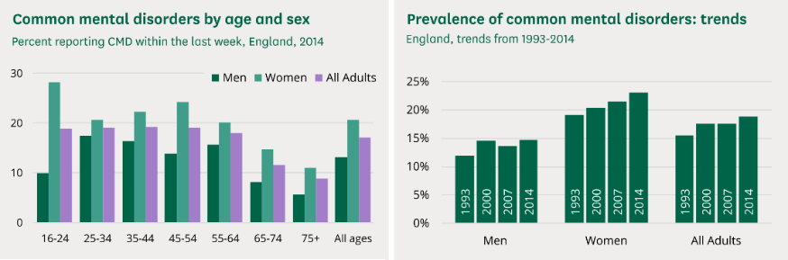
PRACTICAL IMPLICATIONS
Long-term commitment and investment are required to provide better mental health services. Recruiting and retaining staff, offering on-going training, and providing the required resources they need to deliver better care. Equally important is improved coordination among organisations such as the health department, social services, and voluntary organisations. Providing stable funding for housing, better employment support, and meeting other social needs helps people stay well rather than reaching a crisis level where an intervention is required, reducing pressure on hospitals.
Involving people with experience in designing, implementing and evaluating services ensures that service provision is under proper checks. Use of outcome-based contracts also encourages services to focus on meaningful improvements in the lives of the people rather than short-term targets. Early intervention, accessible community treatment and strong crisis alternatives can prevent problems from escalating, reduce pressure on hospitals and support long‑term recovery. These approaches align with national priorities set out in the NHS Long Term Plan (2019) and WHO guidance (2021).

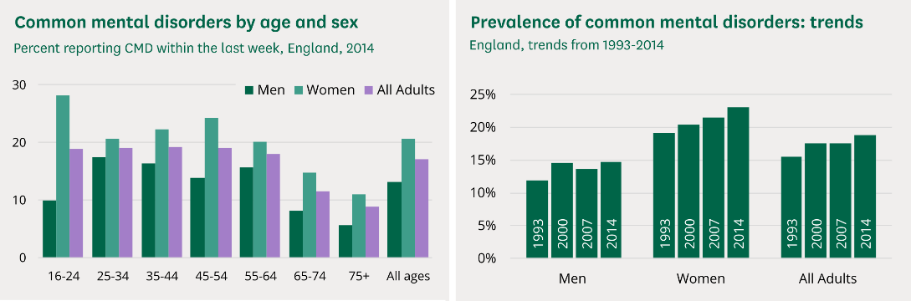
Figure 1: Common mental disorders by age and sex. (Baker and Kirk-Wade, 2024)
Figure 2: Trends of common mental disorders (Baker and Kirk-Wade, 2024)

TASK 2
Pharmacy Services in England
PRACTICAL IMPLICATIONS
Long-term commitment and investment are required to provide better mental health services. Recruiting and retaining staff, offering on-going training, and providing the required resources they need to deliver better care. Equally important is improved coordination between various organizations such as the health department, social services and voluntary organizations. Provision of stable funding for housing, better employment support and meeting other social needs helps people stay well rather than reaching a crisis level where an intervention is required and reducing pressure on the hospitals.
Involving people with experience in designing, implementing and evaluating services ensures that service provision is under proper checks. Use of outcome-based contracts also encourages services to focus on meaningful improvements in the lives of the people rather than short-term targets. Early intervention, accessible community treatment and strong crisis alternatives can prevent problems from escalating, reduce pressure on hospitals and support long‑term recovery. These approaches align with national priorities set out in the NHS Long Term Plan (2019) and WHO guidance (2021).

Introduction
Pharmacy services, one of the four pillars of the primary care system in England, along with general practice, optical services, and dentistry, play a crucial role in supporting public health, preventing illness, and helping people manage long‑term conditions. About 90% of the population in England lives within a 20-minute walk of a pharmacy, rising to almost 100% in areas of the highest deprivation, although in rural areas it is only about 20% (Baird, 2025). As a first point of contact, people approach community pharmacies for advice. Pharmacies have evolved to meet the changing needs of the people.
The Origin of Pharmacy Services
The pharmacies originated in the early 2000s when the government found out that many people were struggling to take medication correctly. It was estimated that almost half of patients with long-term medical conditions were not taking their medication as prescribed by their doctors, resulting in deteriorated health and increased hospital admissions (Horne & Weinman, 1999). At the same time, the National Health Service (NHS) was under pressure to reduce costs associated with medication waste and poorly managed medical conditions. Under these circumstances, the government introduced the NHS Community Pharmacy Contractual Framework 2005.
This framework formally recognised pharmacists as clinical professionals rather than simply being a dispenser of medication (Chauvelot E, et al, (2010). Medicine Use Reviews (MRUs) and New Medicine Service (NMS) were also founded to improve safe and effective use of medicine through structured consultation.
A major national reorganisation of health and care commissioning responsibilities occurred with the Health and Social Care Act 2012. Under which NHS England expanded its collaborations with community pharmacies (Robertson & Ewbank, 2020).

In January 2025, there were around 10,000 community pharmacies in England and around 430 distance-selling pharmacies delivering services under contract for the NHS (Baird, 2025).
Current Practices
The New Medicine Service (NMS) is one of the main clinical services provided by community pharmacies in England. It assists people who have been newly prescribed medicines for conditions such as asthma, hypertension, type 2 diabetes and heart disease. The three stages of NMS include an initial consultation, a follow‑up, and a final check‑in. These stages are structured for the pharmacist to know if the patient is getting on well, or otherwise, with the new medication, ask questions about any side effects, and offer advice. Evidence shows that the NMS improves observance and reduces the risk of complications, making it a valuable part of modern pharmacy practice (Elliott et al., 2016).
Modern pharmacy services act as an extension of primary care with a wide range of services offered by them, e.g. flu vaccinations, blood pressure checks, emergency contraception, and support to end the habit of smoking. More recently, the Pharmacy First service, which allows pharmacists to treat minor conditions without the need for a GP appointment and prescribe medication to the patients to provide relief.
Most pharmacists are open till late; some are even open 24 hours a day. They do not require appointments, enabling them to provide advice to people with busy schedules or mobility issues. All these help reduce pressure on the GP surgeries which can give more time to the patients with complications.
These days, the pharmacy service plays a vital role in improving the quality of life of people with medical conditions. People can access regular support from a pharmacist, thus being able to manage their health conditions better. This results in better disease control and a greater sense of independence. Services such as the NMS provide early intervention, reducing hospital admissions and reducing anxiety around new medical treatments. For the wider community, such services are vital to promote public health by providing various types of vaccinations (such as the flu vaccine), advice on maintaining a health life style, and taking care of minor illnesses.
Conclusion
Pharmacies in England were developed to address changing health care needs and the acceptance of pharmacists in a clinical role. Services like the New Medicine Service play a crucial role in supporting long-term medical conditions. Pharmacists act as easily accessible, local medical experts who can provide personalised care to the people in local communities, thus improving quality of life and strengthening the overall health system.

References

Baird, B. (2025) Community Pharmacy explained | The King’s Fund. Available at: https://www.kingsfund.org.uk/insight-and-analysis/long-reads/community-pharmacy-explained (Accessed: 20 February 2026).
Chauvelot E, et al, (2010) Choosing health through pharmacy—A programme for pharmaceutical public health 2005-2015., Department of Health (2005), London. Available at: https://www.scirp.org/reference/ReferencesPapers?ReferenceID=55120 (Accessed: 20 February 2026).
Elliott, R.A. et al. (2016) ‘Supporting adherence for people starting a new medicine: a randomised controlled trial of the New Medicine Service’, BMJ Quality & Safety, 25(10), pp. 747–758.
Horne, R. & Weinman, J. (1999) ‘Patients’ beliefs about prescribed medicines and their role in adherence to treatment in chronic physical illness’, Journal of Psychosomatic Research, 47(6), pp. 555–567.
Mental Health Europe. Commentary on community mental health reform and WHO guidance (2021).
NHS England. Community mental health services overview; NHS Long Term Plan (2019).
Robertson, R. and Ewbank, L. (2020) Thinking differently about commissioning Learning from new approaches to local planning, Department of Health (2005 - scientific research publishing. Available at: https://www.scirp.org/reference/ReferencesPapers?ReferenceID=55120 (Accessed: 20 February 2026).
Royal College of Psychiatrists. Workforce and community mental health priorities (2020–2021).
World Health Organization (2021) Guidance on community mental health services - Promoting person-centred and rights-based approaches. . Available at: https://iris.who.int/server/api/core/bitstreams/184ff4ef-9c4c-4aad-b1c5-437b08bc0184/content (Accessed: 20 February 2020).

