

Module Name: Strategic Management
Module Code: LCMB7003
Student Name: Kush Jani
Student Id :2504341
Lecturer Name: Andry Rakotovololona
Reference Style: Harvard
Submission Date: 1 May 2026

Table of Contents
Section 1 4
Organisational Context and Overview 4
Summary of the chosen organisation (GSK) 4
Discussion of the industry in which GSK operates 4
External and Internal Environment Analysis 6
PESTLE Analysis 6
Identification of critical success factors and strategic challenges faced by GSK in the external environment 9
Assessment of the organisation’s internal environment focusing on key resources, capabilities, and core competencies 11
VRIO Analysis for evaluating the strategic capabilities of GSK 12
Critical discussion of GSK’s internal strengths’ contribution to competitive advantage 12
CSR and Sustainability objectives 14
Critical discussion of GSK’s CSR strategy and its alignment with business objectives 14
Comprehensive and holistic view of the organisation 15
Analyss of financial, customer, internal business processes, and learning and growth using Balanced Scorecard 15
Strategic Choices and Implementation 17
Strategic choices available for GSK at the business level and corporate level 17
Critical assessment of the change management in GSK and its impact on strategic implementation 18
Strategic Evaluation and Recommendations 19
Critical evaluation of GSK’s current strategy using SWOT, Ansoff Matrix 19
Recommendations for improving its strategy to maintain or enhance competitive advantage 22
Justification of the recommendations with references to theories and real world examples 22
Section 2 24
Reflection 24
Description 24
Feelings 25
Evaluation 25
Analysis 26
Conclusion 26
Action plan 26
References 28
Appendix: Action Plan 34

Section 1
Organisational Context and Overview
Summary of the chosen organisation (GSK)
GlaxoSmithKline (GSK) is a major international biopharmaceutical firm headquartered in the UK, established in 2000 as a result of the merger of Glaxo Wellcome and SmithKline Beecham. GSK has a long history of operation as a science-based organisation since it was founded in the 18th century with the main aim of enhancing global health outcomes by innovating in medicines and vaccines (GSK, 2024c). The company has the mission of getting ahead of disease together as it focuses on preventing, treating and providing long-term healthcare solutions. Its strategic plan focuses more on scientific innovation in things like infectious diseases, immunology, respiratory diseases and cancers. Over the last few years, GSK has experienced a radical change in its business model. The company has reported revenues of £32.7 billion in 2025 and has approximately 66,800 employees working in 70 countries (GSK, 2026a). Its innovative culture, enabled by its substantial investment of £6.6bn in R&D, makes it globally competitive in both vaccines and speciality medicines. In 2022, the company demerged its consumer healthcare to establish the Haleon company, so GSK could concentrate on the biopharmaceutical business (GSK, 2022). Such reorganisation has led to a lean structure with two focus areas that include speciality medicines and vaccines.
Discussion of the industry in which GSK operates
The pharmaceutical business unit makes huge profits off patented, high-value-added medicine, and the vaccines market segment is high in demand and barriers to entry in the world (Sharma, 2026). GSK functions in a competitive global pharmaceutical market that is characterised by high technology development, stringent regulatory measures and heavy research and development (R&D) expenditure. Several of the major competitors, such as Pfizer, AstraZeneca, and Novartis, compete in terms of their therapeutic focus and in their line of innovation (KoalaGains, 2025).
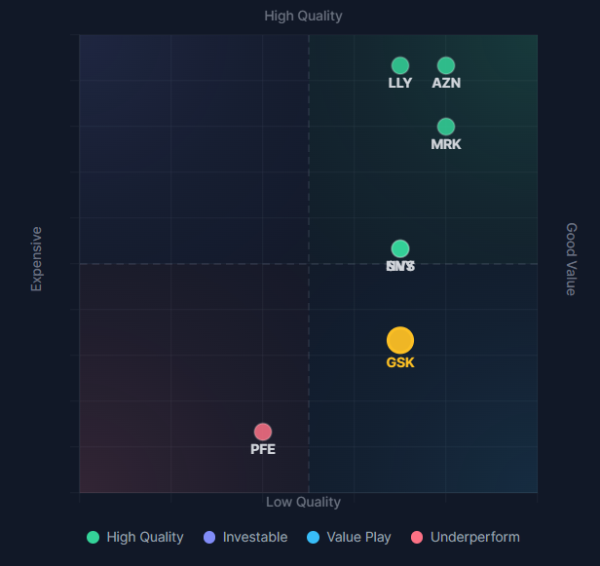
Figure 1:GSK along with its competitors. (Source: KoalaGains, 2025)
GSK has a strong market position and is ranked among the world's leading pharmaceutical companies, with particular strength in vaccines and HIV drugs. It is a pioneer in adult immunisation and has a competitive presence in the key markets such as the United States and Europe. Working in a highly-ranked place among world pharmaceutical companies, GSK experiences mounting pressure among its rivals with a more well-developed oncology portfolio and larger diversification. The strategic repositioning of GSK as a targeted biopharma model and its competencies in vaccines and in speciality medicine support its attempts to maintain competitive advantage in the long run in the vibrant healthcare ecosystem.
Table 1: Competitor Analysis (Source: Author)
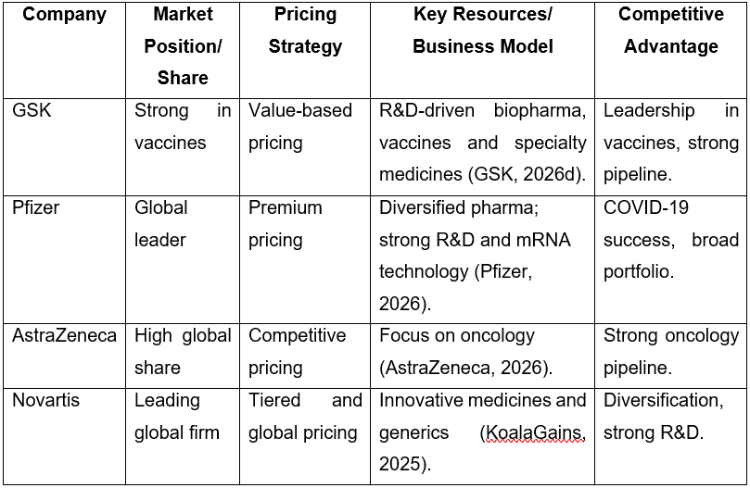
External and Internal Environment Analysis
PESTLE Analysis

Table 2: PESTLE Analysis (Source: Author)
Factor | Key Issues in the UK Pharmaceutical Sector | Strategic Implications
Political | The UK pharmaceutical industry is heavily influenced by government policies, particularly through the National Health Service (NHS), pricing regulations, and post-Brexit trade agreements (Lorgelly, 2018). Regulatory bodies such as the Medicines and Healthcare products Regulatory Agency (MHRA) govern drug approval. | Political decisions directly affect pricing, reimbursement, and market access. Post-Brexit regulatory divergence creates uncertainty but also opportunities for faster approvals.
Economic | The sector is characterised by high R&D expenditure, rising operational costs, inflation, and currency fluctuations. The UK remains a major hub for pharmaceutical investment, although economic pressures may constrain public healthcare spending (ABPI, 2025). | Firms must balance cost efficiency with sustained investment in innovation. Economic instability can influence funding availability and profitability.
Social | An ageing UK population, increasing prevalence of chronic diseases, and growing demand for preventive healthcare drive pharmaceutical consumption. The ageing group chronically prescribed three or more medicines rose from 44.6 to 66.2% (Melzer et al., 2016). Public expectations regarding ethical pricing and access to medicines are also rising. | These trends create opportunities for growth in vaccines and speciality medicines, but companies must address affordability and health inequality concerns.
Technological | The UK is a global leader in life sciences innovation, with advancements in R&D, biotechnology, artificial intelligence, and precision medicine (Government of the UK, 2025). Collaboration with universities and research institutions is strong (ABPI, 2025). | Technological progress enhances drug discovery and development but requires continuous investment and adaptation to remain competitive.
Legal | The industry is subject to strict legal frameworks, including patent laws and clinical trial regulations like the Human Medicines Regulations 2012 and The Medicines for Human Use Regulations 2004 (Ankit et al., 2021; UK Research and Innovation, 2026; Government of the UK, 2026). Intellectual property rights are essential for protecting innovation. | Strong legal protection supports profitability through exclusivity, while regulatory compliance increases operational complexity and costs.
Environmental | Increasing focus on sustainability, carbon reduction targets, and environmentally responsible manufacturing practices is shaping the industry. Moreover, the disposal of pharmaceutical waste, such as the safe processing of chemical and biological by-products has become a primary regulatory issue (Ankit et al., 2021). Regulatory pressure for greener operations is intensifying. | Companies must integrate sustainable practices into operations, which may increase short-term costs but improve long-term reputation and compliance.

Identification of critical success factors and strategic challenges faced by GSK in the external environment
Competing in this environment, GSK needs to align its strategy with various critical success factors to remain competitive. Its R&D capability is a key success factor (ABPI, 2025). The pharmaceutical business is very reliant on unceasing inventions, and the allocation of funds to the research carried out by GSK allows new medicines and vaccines to be produced. This is especially significant in responding to changes in healthcare issues like infectious diseases, as well as chronic health conditions. The protection of intellectual property (IP) is one of the main success factors, as it enables GSK to have exclusive rights to its products (GSK, 2025c). IP is a foundation of competitive advantage because patents help the company to obtain high margins, and extensive R&D investment is recovered.
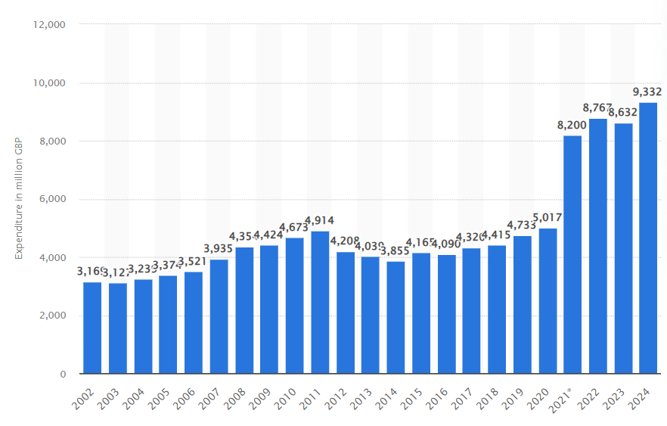
Figure 2: R&D expenditure of pharmaceutical businesses in the UK. (Source: Statista, 2026)
The success is also predetermined by the availability of the worldwide market and reaching a variety of healthcare systems. The UK government has made advancements in R&D, biotechnology, artificial intelligence, and precision medicine (Government of the UK, 2025). The graph demonstrates that pharmaceutical R&D spending in the UK was gradually growing around £3.1 billion in 2002 to reach an all-time high of over £9.3 billion in 2024, with an active decrease after 2020 (Statista, 2026). According to Rizhamadze (2020), GSK has been operating in several locales, meaning that it will not depend on the performance of a particular market, but it will be able to enter high-growth emerging markets. Moreover, expertise in regulation and trust of those who are regulated are crucial, as adherence to high standards in healthcare rules guarantees a possibility to enter the market and be trusted. Yet, GSK has a big problem with its strategy. Among them is fierce competition by large pharmaceutical companies, like Pfizer, AstraZeneca and Novartis (KoalaGains, 2025). There is a heavy investment in these competitors in R&D, thus compelling us to create new products all the time and sustain a market share.
As demonstrated by Lorgelly (2018), a possibility is pressure associated with pricing and regulatory measures especially in the UK where NHS has a dominant role in going through the contract of negotiating the prices of drugs. This restricts profit-making, and companies are left to strike a balance between being affordable and being innovative. Moreover, the end of patent terms poses a significant threat, as it contributes to heightened competition with generic producers and the possibility of the loss of revenues. The aesthetic expiry of patent is a source of serious risk, as it makes using a generic highly competitive and decreases revenues. The pharmaceutical sector is another area affected by a high confidence of failure in R&D, as approximately 90% of drug development projects do not pass clinical trials (Zhavoronkov, 2023). The company thus needs to have a robust flow of new products in order to counter these losses. Another important challenge is the technological disruption. Although improvements in artificial intelligence and biotechnology are offering a promise of quicker growth in drugs, it has brought about a lot of competition and demand huge investments (GSK, 2024a). Furthermore, supply chain risks and uncertainties in the geopolitical arena have the potential to disrupt the operations in a globalised pharmaceutical market.
Assessment of the organisation’s internal environment focusing on key resources, capabilities, and core competencies
Key Resources
GSK has both tangible and intangible assets. On a financial aspect, the company is running into large revenues, which allows it to invest more into R&D and innovations (ABPI, 2025). By 2025, revenues have been reported to have been at £32.7 billion in the company (GSK, 2026a). This financial capacity facilitates the strategic plans in the long term and makes them stronger in an unstable market.
Another much-needed asset is human resources. GSK has a highly qualified group of scientists and researchers, as well as healthcare professionals; their professional faculties fuel innovation and product development. Physically, according to Aars, Clark and Schwalbe (2021), the company has the highest technology production and distribution networks around the world, hence efficient production and distribution of medicines and vaccines. The intangible resources are important. The brand reputation constitutes the element of trust among the stakeholders, such as patients, governments, and healthcare providers, established by GSK over the decades. It has a competitive advantage in terms of the scope of its patent and proprietary technologies as well.
Capabilities
The capabilities of GSK focus on its capacities to develop, produce and commercialise innovative pharmaceutical products. It has good R&D potential, which is backed by specialised scientific knowledge and partnerships with research institutes and biotechnology companies (GSK, 2023b). For example, R&D investment of £6.6 billion in 2025 with 14 new partnerships indicates innovation capability of GSK (GSK, 2026a). The company also exhibits good operational and supply chain, which has seen it continually deliver high-quality products to world markets. Its capability to cope with complicated regulatory settings also makes it more effective in terms of its operations. Strategic focus and portfolio management are another key competence. The recent demerger of its consumer healthcare unit has helped GSK to narrow down to a few areas, such as vaccines and speciality medicines, increasing its capability to efficiently deploy resources and to create a much better strategic picture.
Core Competencies
The fundamental strengths of GSK lie in its outstanding capabilities of drug discovery and development, backed by a high level of scientific research and innovation (GSK, 2023). The essence of GSK competencies revolves around the capability to innovate, global scope, and science. It received 5 FDA approvals, which proves the high innovative ability (GSK, 2026a; GSK, 2026d). Moreover, its profound knowledge of the regulatory systems makes it efficient in the approval procedures in markets. Strategic collaborations and partnerships also help GSK to share its knowledge and speed up the innovation process to improve its capabilities in providing pertinent healthcare solutions worldwide.
VRIO Analysis for evaluating the strategic capabilities of GSK
Table 3: VRIO Analysis (Source: Author)
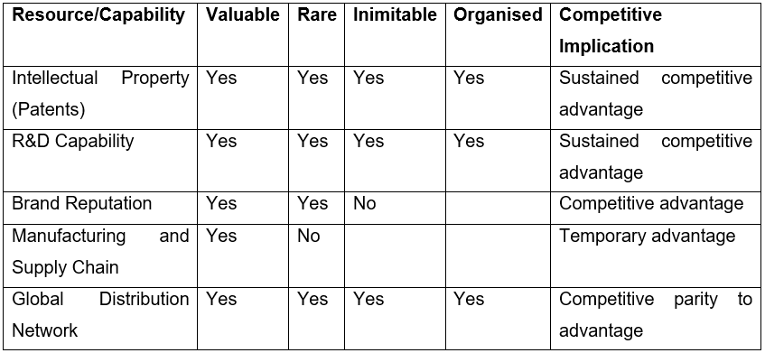

Critical discussion of GSK’s internal strengths’ contribution to competitive advantage
The internal strengths of GSK like 92% Responsible Business Performance Rating are essential in maintaining its competitive advantage, that is especially when evaluated using the resource-based view (RBV) framework (GSK, 2026a). Its intellectual property portfolio is one of the greatest assets, as it grants its products legal protection and exclusive rights in the market (GSK, 2025c). This helps GSK to make big revenues and keep its position in the market. The pharmaceutical nature is always developed by innovations, and the fact that GSK has developed new treatments changes its fortunes as far as being able to remain relevant in a market that is changing at an incredible pace (GSK, 2021). Having strong innovation and R&D capabilities, GSK has become the 1st company to pioneer HIV treatments in 1980 (GSK, 2026a). According to Nunes, McKee and Howard (2024), involvement in global health efforts and vaccine programmes improves the credibility of GSK and the level of relationships with governments and healthcare organisations. The contribution of this intangible asset is to customer loyalty and access to the market.
However, not all advantages are long-term. As per the opinion of Rizhamadze (2020), things such as manufacturing and supply chain capabilities are crucial but can be duplicated by other competitors who are willing to invest accordingly. Moreover, GSK is strategic in its vaccines and speciality medicines, which further improves its competitiveness, as the resources are directed to high-growth and high-margin markets (GSK, 2024b). This is a strategic fit which helps in the long-term creation of value and competitive differentiation. These strengths notwithstanding, there are challenges. Ankit et al. (2021) further added that the unpredictability and the expensive nature of R&D restrict profitability in the case of unsuccessful clinical trials. Moreover, exposure to risk by relying on a few successful products is enhanced. In this way, innovation, intellectual property, and scientific credentials, engaged by strong organisational strengths, are crucial factors expected to provide GSK with a competitive edge. The drawback of these advantages is that they are hard to match and are long-term; however, this advantage can only be maintained through constant investment, tactics, and the ability to respond to changes in the external environment.
CSR and Sustainability objectives
Critical discussion of GSK’s CSR strategy and its alignment with business objectives
GSK has integrated the principles of Environmental, Social, and Governance (ESG) into the company strategy and branded sustainability as part of the long-term value creation. The ESG initiatives of the company are regarding global health impact, environmental responsibility and ethical governance (GSK, 2023a). The major strength in this is its eagerness to attain access to medicines in low and middle-income economies, where GSK implements tier-based pricing and licenses voluntarily to help in enhancing affordability (GSK, 2023a). As much as this will improve its social legitimacy, opponents say that the accessibility is still uneven and, in many cases, it is not based on systemic affordability but partnership-based access.
On the environmental front, GSK has also converted to carbon neutrality and net-zero objectives to minimize emission of its operations and the supply chain. Through these programs, it shows a proactive compliance with internationally expected sustainability (GSK, 2023a). The intricate nature of the manufacturing procedures of the pharmaceutical industry and the domination by relying on international supply chains pose a challenge to fulfilling these targets fully, however, so that the speed and scalability of such commitments remain doubtful. Regarding ethical prices of drugs, GSK believes in transparency and responsible pricing policies, especially those concerning vaccines and vital medicines.
However, there are still tensions between profitability and affordability, particularly in the developed markets where the pricing pressure of the healthcare systems such as the NHS, is still high. According to Lorgelly (2018), his points to a structural issue in the industry with innovation costs to be offset against the responsibility to the health of the population. Overall, the CSR and sustainability strategy of GSK displays a strategic move in achieving business goals and internationalisation concerns, which are aligned with the demands of society.
Comprehensive and holistic view of the organisation
Analyss of financial, customer, internal business processes, and learning and growth using Balanced Scorecard
Table 4: Balanced Scorecard. (Source: Author)
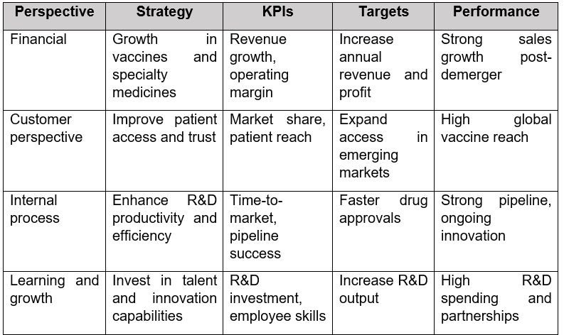
The Balanced Scorecard framework is an effective way of evaluating a comprehensive assessment of GSK because it combines financial and non-financial performance measures in a four-perspective framework that is based on financial, customer, internal business processes, and learning and growth. As demonstrated by Madsen (2025), this methodology offers a comprehensive insight into how the organisation is co-existing its strategic goals with the performance of the organisation. On the financial side, GSK is concerned with increasing revenue, profitability, and the value of shareholders. This strategic change towards biopharmaceuticals and especially vaccines and speciality medicines is seen as a focus on high-end products and sustainable revenue streams. The major performance indicators are the growth rate of revenue, operating margins and the turnaround level of any investment (GSK, 2025b). As much as GSK has excelled in financial performance due to its innovative product line, the organisation has been experiencing the pressure brought about by high R&D expenses and high prices applied by healthcare institutions like the NHS. This emphasises the problem of profitability and low cost.
The customer perspective focuses on patient outcome, access and trust. According to Berlanda Scorza et al. (2022), GSK seeks to enhance health in the world by providing effective and accessible medicines and vaccinations. Patient reach, customer satisfaction and market share are the important indicators of success. The efforts of the company to increase access to drugs in developing countries contribute to its image and credibility among stakeholders. For example, the company has donated more than 12 billion tablets used to treat Lymphatic filariasis, a debilitating disease and the disease has been eradicated in 21 countries (GSK, 2026a). Nevertheless, the differences in access and cost issues in developed markets suggest that equitable provision of healthcare is a challenging issue. GSK focuses on internal business processes in terms of efficiency of research and development, regulatory compliance and supply chain management (GSK, 2025a). The potential to speed up drug discovery, successful clinical trials, and timely delivery of the product are among the core aspects of operational effectiveness. The most important metrics are R&D productivity, time-to-market and manufacturing efficiency. Although innovation is facilitated by the robust R&D system in GSK, the rate of failure is very high in drug development processes, and the demanding regulatory processes weaken the processes.
The learning and growth approach is about organisational capabilities, employee development and culture of innovation. GSK has been spending a lot of money on scientific research, digital transformation, and talent development to sustain its competitive advantage (GSK, 2025a). This focus is manifested in indicators like employee engagement, technological development, and output in terms of innovation. Its partnership with research organisations and embraces of new technologies, such as artificial intelligence, make the firm robust in terms of long-term strategic capabilities (ABPI, 2025). However, the need to stay innovative is expensive and demands constant creativity and changes in response to the fast-changing technological environments. In such a way, the Balanced Scorecard indicates the interrelation of the GSK strategic objectives. Customer trust, internal processes efficiency, and constant learning and innovation are closely interconnected with financial success. In 2024, GSK recorded a turnover of £32.7 billion and operating profit amounting to £7.9 billion and still an amount of high R&D investment (GSK, 2025). However, despite GSK showing alignment within the Balanced Scorecard perspectives, cost and pressures of competing determine performance.
Strategic Choices and Implementation
Strategic choices available for GSK at the business level and corporate level
Table 5: Organizational strategies (Source: Author)
Organizational strategies | Strategic approach
Business level strategies | Differentiation strategy, focus or niche differentiation, and cost leadership
Corporate level strategies | De-diversification and strategic alliances
The business level strategic choices available to GSK are differentiation strategy, focus or niche differentiation, and cost leadership. These strategies at the business level are crucial for the company to achieve a better competitive positioning. The R&D activities and innovation at GSK are key factors in supporting differentiation. The organisation invests a significant amount in R&D activities to become a leader in vaccination programmes and develop advanced platforms for oncology, immunology and infectious diseases (GSK, 2026b). This is considerable for the organisation to have strong global leadership in vaccination by competing with companies like Pfizer. Another strategic choice available at the business level strategy is focus or niche differentiation. This strategy is considerable for GSK to focus on areas like vaccination, oncology, respiratory issues, and HIV treatments. Through focus or niche differentiation in specific therapeutic areas, GSK can improve its clinical success rates, capital efficiency, and speed to market. Cost leadership is another business-level strategic choice available to the company. GSK does not consider adopting a cost leadership strategy; instead, it focuses on the selective application of cost efficiency. The organisation considers manufacturing optimisation and scaling of the vaccination programme to ensure cost efficiency.
At the corporate level, de-diversification and strategic alliances are the options for GSK. The approach of de-diversification has been seen with the demerger of consumer healthcare in GSK. The organisation demerged its consumer healthcare branch to establish Haleon in 2022 (GSK, 2026a). This strategy is considered for the organisation to avoid strategic conflict. GSK has faced strategic conflict due to its high-margin biopharma product and low-margin consumer goods. Thus, the demerger helped in developing the identity of GSK as a biopharma company. Strategic alliances with other companies from the same sector are also a strategic choice for GSK at the corporate level. The organisation actively consider collaboration options to have better access to capabilities and reduce risk. For example, collaboration with ViiV Healthcare for the development of HIV vaccination as a joint venture is a strategic alliance for GSK that helped in accelerating the programme.
Recommendation of the choices and their justification
At the business level and corporate level, two different strategies have been recommended to the company. A focused differentiation strategy has been recommended to GSK at the business level. The organisation should focus on intensifying its differentiation strategy in the high-value therapeutic areas. Instead of broadening the business scope or competing on cost, GSK should focus on a focused differentiation strategy. In recent years, GSK has established its leadership capability in vaccinations and strong scientific approaches in the development of infectious diseases (Berlanda Scorza et al., 2022). This proves that science driven approaches have been significant for the company to establish its strong position in the market. In regards to corporate level strategy, GSK needs to focus on developing strategic alliances with companies from the same sector. GSK should focus on strategic alliances for a collaborative innovation approach at the organisation. The use of new technologies like mRNA AI-driven discovery is needed for drug discovery and innovation. For such a purpose, diverse expertise is needed in the sector, which justifies the need for a strategic alliance.
Critical assessment of the change management in GSK and its impact on strategic implementation
Change management is the approach of transitioning teams, individuals or organisations from a current state or situation to a new state. GSK has gone through several changes in its structure, leadership and governance, and shifting the R&D strategy. In 2022, GSK made changes to its structure by demerging the consumer healthcare division. It has led to the establishment of Haleon as the consumer goods division of GSK (GSK, 2026a). This change management approach has helped GSK to make the transition from a conglomerate model business to a complete biopharma company. It has also been significant for GSK to focus on its major areas like vaccination programme. This change in the organisational structure is also influenced by the change in leadership and governance. In 2017, CEO Emma Walmsley brought changes to the strategic approach of GSK (GSK, 2018). With the strategic approach, GSK focused on increasing productivity and invest in R&D.
Strategic Evaluation and Recommendations
Critical evaluation of GSK’s current strategy using SWOT, Ansoff Matrix
SWOT Analysis

Figure 3: SWOT Analysis (Source: Author)

The SWOT analysis added above highlights potential for GSK to explore new product segment utilising the existing strengths to conquer the biopharma sector.
Ansoff matrix
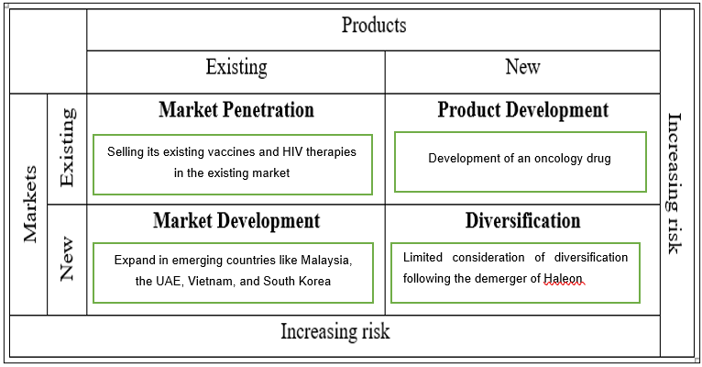
Figure 4: Ansoff Matrix (Source: Author)
The Ansoff matrix incorporates four key strategies, which are market penetration, product development, market development, and diversification. Market entry and product introduction are the aspects that decide strategies within Ansoff. Regarding market penetration, GSK is selling its existing vaccines and HIV therapies in the existing market. This strategy is supportive of low risk in business and higher returns. However, the growth potential of GSK under the strategy is limited. The product development strategy of the Ansoff matrix is about new product introduction to the existing market. The development of an oncology drug is an example of a product development strategy in GSK. In the case of market development, it is about introducing existing products in the new market. GSK has considered the strategy to expand in emerging countries like Malaysia, the UAE, Vietnam, India, and South Korea. Diversification is another strategy under the Ansoff matrix that focuses on the introduction of new products in a new market (Kaar and Stary, 2019). Currently, GSK has very limited consideration of diversification in the business. Following the demerger of Haleon as consumer foods, GSK has made less focus on diversification to reduce risks.
Recommendations for improving its strategy to maintain or enhance competitive advantage
As a biopharma company, GSK needs to focus on developing advanced technologies. Thus, GSK should focus on accelerating its next-generation technologies by aggressive investment and partnership with mRNA platforms or AI technology providers. In the competitive market, rivals of GSK like Moderna and Pfizer have already transformed the business with mRNA technology. The use of advanced technology like AI can help GSK to reduce clinical trial costs.
The development of oncology medicine is another area where the organisation should focus for a competitive advantage. GSK should consider targeted acquisitions and partnerships for developing its capability in oncology medicine. Within the approach, GSK should consider a focused inorganic growth strategy to prioritise immuno-oncology and cell and gene therapies. The focus on developing oncology medicine can be a significant opportunity for GSK to have an enhanced competitive advantage. This is because oncology is the fastest-growing pharma segment in the world. Under the strategy, GSK can also focus on the acquisition of late stage biopharma company to reduce the developmental risks.
Justification of the recommendations with references to theories and real world examples
In order to justify the first recommendation, the dynamic capability theory can be considered. According to the theory, firms need to sense, seize and reconfigure capabilities to respond to the technological changes (Wang and Liu, 2023). As a biopharma company, GSK needs to focus on the adaptation of new technology like mRNA and reconfigure its R&D activities. For example, mRNA technology is important in vaccine production as it helps with rapid, and cell free synthesis of antigens (Li et al., 2025). However, considering the dynamic capability theory, it can be said that the current response of GSK exhibits a slow approach to incorporating mRNA technology and a capability gap in the company to sense and seize the disruptive innovation. Regarding mRNA leadership, the real-world example of Moderna can be considered. The organisation has built its business model around mRNA technology that helped in rapid vaccine development for COVID-19 and transformed the business into a global leader (Moderna, 2026). The strengthening of oncology through acquisition and partnership can be explored using the Ansoff matrix. Based on the Ansoff matrix, it can be said that entering a new segment of oncology falls in the product development strategy. Under this strategy, GSK needs to develop an oncology medicine as a new product in the existing market.
Section 2
Reflection
In this section, a reflective account has been incorporated for reflecting on my experience and process of researching, analysing and preparing the assessment. For a structured reflective account, I have used Gibbs reflective cycle here. The Gibbs reflective cycle includes six key elements, which are description, feelings, evaluation, analysis, conclusion, and action plan.
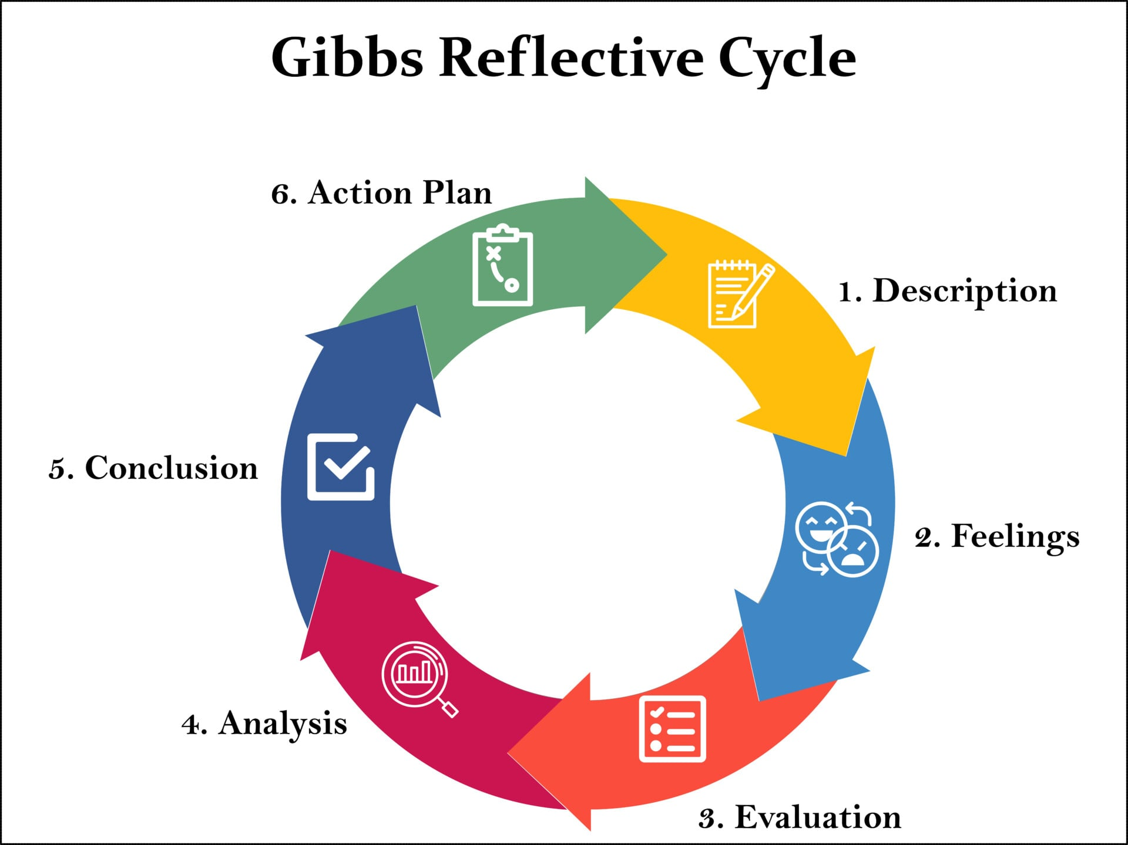
Figure 5: Gibbs Reflective Cycle (Source: Ahmadpour, Shariati and Moghadam, 2025)
Description
In order to complete the previous sections of the assignment, I have followed a structured approach to research, analyse and evaluate the business context of GSK. I have followed the approach of analysis of internal and external business environment, CSR approaches, and the strategic position of the company. In the analysis and discussion, I have used certain tools and models too. I have used tools and models like PESTLE analysis, VRIO analysis, SWOT analysis, and Ansoff matrix. To provide recommendations to GSK, I have also used theories and real world examples. The use of models, frameworks and theories is significant for strategic analysis and evaluation (Ziam et al., 2024). It helps to strengthen and justify the claims with theoretical support. Before starting with the analysis, I have developed a concrete plan that I followed thoroughly in the study. At first, I focused on the collection of information regarding GSK, its business environment, strategic approaches, and CSR strategy. After the collection of information, I have analysed those with theories, models and evidences. Based on the analysis, I have given justified recommendations in this study too.
Feelings
Before the beginning of work, I thought it was a complex task due to the depth of analysis required. Especially, the integration of theories to write real-world information was quite concerning for me. I was also tense to write some parts as I was confused about selecting the appropriate frameworks. The selection of an appropriate framework is essential for effective analysis and evaluation of information (Moullin et al., 2020). Thus, I was concerned that the analysis would remain critical or not. However, progression with the work has helped me to become confident in writing by effectively linking theoretical concepts and real-world information. I would also say the process of writing became easier in the study as I progressed with the sections. It became engaging for me as I improved my understanding of strategic decision-making in pharma companies.
Evaluation
Evaluation in the Gibbs reflective cycle means reflecting on the strengths and weaknesses of a situation or event. In this regard, I would say the use of recognised frameworks was a significant strength for me. It has helped me to effectively analyse the information and structure the analysis. Also, the use of real-world information was a major strength. The use of real world information has helped to strengthen the credibility of arguments made in the study. Overall, the effective use of frameworks and real world information has helped in providing justified recommendations by identifying the gaps. However, certain limitations also exist in the work which restricted me to improve the quality of the assignment. For example, I have not used quantitative or financial data extensively. I think the use of these data would have been effective in the assignment to provide stronger support and in-depth analysis. Other than this, I would also say limitation of words have restricted me to write extensively and incorporate multiple perspectives.
Analysis
The use of Gibbs reflective cycle has helped me to effectively examine my work in the study. The consideration of Gibbs' reflective cycle has also been effective for a systematic approach of reflection. In regard to the main assignment, I would say the use of strategic tools and frameworks has helped in simplifying the analysis from complex information. It is critical for the better representation of information in the study. Along with this, the use of theories like the Dynamic capability theory has helped in understanding GSK’s current situation. Critical thinking skill is considered to be important for applying theory as it helps in better translation of abstract concepts into practice and real world contexts (Rivas, Saiz and Almeida, 2023). I would say that the understanding of GSK’s situation with segregation of different business aspects were also easier with the use of models and theories. Based on the understanding and activities, I would say that effective strategic analysis requires both theoretical consideration and real world examples. It can help in incorporating factual information and theoretical support. The use of theories has been significant to ensure criticality and avoid descriptive writing.
Conclusion
My overall approach of researching and analysing GSK’s strategy was effective to develop comprehensive and critical understanding of the company’s strategic position. I believe I was successful and effective in applying the theoretical frameworks. The effective and relevant use of frameworks and theories was critical in supporting the argument and providing recommendations. I would also say that the use of real world information was critical for effective use of specific information and evidences. However, I would also say that the reflection has highlighted the need for further critical analysis. Specifically, a critical analysis was needed by incorporating more financial and quantitative data. I think more use of quantitative data would have improved the robustness of the analysis.
Action plan
In future assignments or studies, I would like to incorporate more financial data and quantitative information. I would like to search more on the internet for collecting financial data and quantitative information that can strengthen the analysis (Refer to appendix 1). In future, I would also like to focus on more critical engagement by doing an evaluation of alternative strategic options. I think it can be helpful to incorporate more perspectives in the study. Another area that I would like to focus on is the use of more journals and academic references (Appendix). The increased use of academic references can be significant in the study to support the evidences and quality of writing. Furthermore, I would like to spend more time on the review and scrutiny of information (Appendix). I think this can be helpful to identify issues in writing and rectify the identified issues.

References
Aars, O.K., Clark, M. and Schwalbe, N. (2021) ‘Increasing efficiency in vaccine Production: A primer for change’, Vaccine: X, 8, pp. 1–7. Available at: https://doi.org/10.1016/j.jvacx.2021.100104. (Accessed: 11 April 2026).
ABPI (2025) UK tumbles down global rankings for pharma investment and research, Abpi.org.uk. Available at: https://www.abpi.org.uk/media/news/2025/september/uk-tumbles-down-global-rankings-for-pharma-investment-and-research/ (Accessed: 11 April 2026).
Ahmadpour, N., Shariati, A. and Moghadam, M.P. (2025) ‘Effect of narrative writing based on Gibbs’ reflective model on the empathy and communication skills of nursing students’, BMC Medical Education, 25(1), p.10. Available at https://doi.org/10.1186/s12909-024-06593-7 (Accessed: 12 April 2026)
Ankit, T., Shrikalp, D., Maitreyi, Z., Kumar, J.P. and Kiran, K. (2021) ‘Transition of pharmaceutical regulations: The new regulatory era after Brexit’, Journal of Pharmaceutical Research International, 33(47A), pp.804-817. Available at: https://doi.org/10.9734/jpri/2021/v33i47A33076. (Accessed: 11 April 2026).
AstraZeneca (2026) Oncology - Our Therapy Areas - AstraZeneca, www.astrazeneca.com. Available at: https://www.astrazeneca.com/our-therapy-areas/oncology.html (Accessed: 17 April 2026).
Berlanda Scorza, F. et al. (2022) ‘A strategic model for developing vaccines against neglected diseases: An example of industry collaboration for sustainable development’, Human Vaccines & Immunotherapeutics, 18(6). Available at: https://doi.org/10.1080/21645515.2022.2136451. (Accessed: 11 April 2026).
Berlanda Scorza, F., Martin, L.B., Podda, A. and Rappuoli, R. (2022) ‘A strategic model for developing vaccines against neglected diseases: An example of industry collaboration for sustainable development’, Human vaccines & immunotherapeutics, 18(6), p.2136451. Available at: https://doi.org/10.1080/21645515.2022.2136451 (Accessed: 12 April 2026).
Government of the UK (2025) £55 billion R&D funding boost to unlock UK breakthroughs from health to clean energy, GOV.UK. Available at: https://www.gov.uk/government/news/55-billion-rd-funding-boost-to-unlock-uk-breakthroughs-from-health-to-clean-energy (Accessed: 17 April 2026).
Government of the UK (2026) Clinical trials for medicines: apply for authorisation in the UK, GOV.UK. Available at: https://www.gov.uk/guidance/clinical-trials-for-medicines-apply-for-authorisation-in-the-uk#when-a-clinical-trial-authorisation-cta-is-needed (Accessed: 17 April 2026).
GSK (2018) GSK delivers improvements in sales, margins and cash flow in 2017. Available at: https://www.gsk.com/en-gb/media/press-releases/gsk-delivers-improvements-in-sales-margins-and-cash-flow-in-2017/ (Accessed: 12 April 2026)
GSK (2021) New GSK to deliver step-change in growth and performance over next ten years driven by high-quality Vaccines and Specialty Medicines portfolio and late-stage pipeline | GSK, GSK. www.gsk.com. Available at: https://www.gsk.com/en-gb/media/press-releases/new-gsk-to-deliver-step-change-in-growth-and-performance-over-next-ten-years/ (Accessed: 11 April 2026).
GSK (2022) Consumer Healthcare Demerger | GSK, www.gsk.com. Available at: https://www.gsk.com/en-gb/investors/corporate-actions/consumer-healthcare-demerger/ (Accessed: 11 April 2026).
GSK (2023a) ESG Performance Report 2023, GSK, pp. 1–62. Available at: https://www.gsk.com/media/w2kpioqk/esg-performance-report-2023.pdf (Accessed: 11 April 2026).
GSK (2023b) Research and development approach | GSK, www.gsk.com. Available at: https://www.gsk.com/en-gb/innovation/research-and-development-approach/ (Accessed: 11 April 2026).
GSK (2024a) ‘We’ve seen an explosion in computing power’: Using AI, machine learning and data to unlock the mysteries of disease | GSK, www.gsk.com. Available at: https://www.gsk.com/en-gb/behind-the-science-magazine/ai-ml-data-computing-power/ (Accessed: 11 April 2026).
GSK (2024b) Annual Report 2024, GSK. Available at: https://www.gsk.com/media/vounsu2k/strategic-report-2024.pdf (Accessed: 11 April 2026).
GSK (2024c) History and Heritage | GSK, www.gsk.com. Available at: https://www.gsk.com/en-gb/company/history-and-heritage/ (Accessed: 11 April 2026).
GSK (2025) Annual Report 2025 | GSK, Gsk.com. Available at: https://www.gsk.com/en-gb/investors/financial-reports/annual-report-2025/ (Accessed: 18 April 2026).
GSK (2025a) 2025 Annual Report, GSK. Available at: https://www.gsk.com/media/kn0bknmd/annual-report-2025.pdf (Accessed: 11 April 2026).
GSK (2025b) GSK makes strong start to 2025 with growth in sales, profits and earnings | GSK, Gsk.com. Available at: https://www.gsk.com/en-gb/media/press-releases/gsk-makes-strong-start-to-2025-with-growth-in-sales-profits-and-earnings/ (Accessed: 11 April 2026).
GSK (2025c) Our position on Intellectual Property. Available at: https://www.gsk.com/media/tabhxvsi/gsk-position-on-intellectual-property.pdf.
GSK (2026a) GSK at a glance | GSK, www.gsk.com. Available at: https://www.gsk.com/en-gb/company/gsk-at-a-glance/ (Accessed: 17 April 2026).
GSK (2026b) Research and development approach. Available at: https://www.gsk.com/en-gb/innovation/research-and-development-approach/ (Accessed: 12 April 2026).
GSK (2026c) Consumer Healthcare Demerger. Available at: https://www.gsk.com/en-gb/investors/corporate-actions/consumer-healthcare-demerger/ (Accessed: 12 April 2026).
GSK (2026d) Improving access to healthcare | GSK, www.gsk.com. Available at: https://www.gsk.com/en-gb/responsibility/global-health-and-health-security/improving-access-to-healthcare/ (Accessed: 18 April 2026).
Kaar, C. and Stary, C. (2019) ‘Intelligent business transformation through market‐specific value network analysis: Structured interventions and process bootstrapping in geomarketing’, Knowledge and Process Management, 26(2), pp.163-181. Available at: https://doi.org/10.1002/kpm.1587 (Accessed: 17 April 2026).
Kakkar, A.K. (2021) ‘Pharmaceutical price regulation and its impact on drug innovation: mitigating the trade-offs’, Expert Opinion on Therapeutic Patents, 31(3), pp.189-192. Available at: https://doi.org/10.1080/13543776.2021.1876029 (Accessed: 12 April 2026)
KoalaGains (2025) GSK plc (GSK) Competitive Analysis & Comparison, KoalaGains. Available at: https://koalagains.com/stocks/NYSE/GSK/competition (Accessed: 11 April 2026).
Li, J., Liu, Y., Dai, J., Yang, L., Xiong, F., Xia, J., Jin, J., Wu, Y. and Peng, X. (2025) ‘mRNA vaccines: current applications and future directions’, MedComm, 6(11), p.e70434. Available at: https://doi.org/10.1002/mco2.7043 (Accessed: 17 April 2026).
Lorgelly, P.K. (2018) ‘The Impact of Brexit on Pharmaceuticals and HTA’, PharmacoEconomics - Open, 2(2), pp. 87–91. Available at: https://doi.org/10.1007/s41669-018-0072-5. (Accessed: 11 April 2026).
Madsen, D.O. (2025) ‘Balanced Scorecard: History, Implementation, and Impact’, Encyclopedia, 5(1), pp. 1–39. Available at: https://doi.org/10.3390/encyclopedia5010039. (Accessed: 11 April 2026).
Melzer D, Tavakoly B, Winder RE, Masoli JA, Henley WE, Ble A, Richards SH. (2016) Much more medicine for the oldest old: trends in UK electronic clinical records. Age Ageing. 44(1):46-53. Available at: https://pmc.ncbi.nlm.nih.gov/articles/PMC4255615/ (Accessed: 17 April 2026).
Moderna (2026) The power of mRNA. Available at: https://www.modernatx.com/power-of-mrna/modernas-mrna-platform (Accessed: 12 April 2026).
Moullin, J.C., Dickson, K.S., Stadnick, N.A., Albers, B., Nilsen, P., Broder-Fingert, S., Mukasa, B. and Aarons, G.A. (2020) ‘Ten recommendations for using implementation frameworks in research and practice’, Implementation science communications, 1(1), p.42. Available at: https://link.springer.com/article/10.1186/s43058-020-00023-7 (Accessed: 12 April 2026).
Nature (2026) Accelerating vaccines R&D in collaboration with GSK: partnerships that open new frontiers. Available at: https://www.nature.com/articles/d43747-022-00155-w (Accessed: 12 April 2026).
Nunes, C., McKee, M. and Howard, N. (2024) ‘The role of global health partnerships in vaccine equity: A scoping review’, PLOS global public health, 4(2), pp. 1–16. Available at: https://doi.org/10.1371/journal.pgph.0002834. (Accessed: 11 April 2026).
Pfizer (2026) How a Novel ‘Incubation Sandbox’ Helped Speed Up Data Analysis in Pfizer’s COVID-19 Vaccine Trial | Pfizer, Pfizer.com. Available at: https://www.pfizer.com/news/articles/how_a_novel_incubation_sandbox_helped_speed_up_data_analysis_in_pfizer_s_covid_19_vaccine_trial (Accessed: 17 April 2026).
Rivas, S.F., Saiz, C. and Almeida, L.S. (2023) ‘The role of critical thinking in predicting and improving academic performance’, Sustainability, 15(2), p.1527. Available at: https://doi.org/10.3390/su15021527 (Accessed: 17 April 2026).
Rizhamadze, K. (2020) ‘ANALYZING BUSINESS MODEL, NARRATIVE AND NUMBERS OF GSK (GLAXOSMITHKLINE)’, Eurasian Journal of Social Sciences, 8(1), pp. 35–41. Available at: https://doi.org/10.15604/ejss.2020.08.01.004. (Accessed: 11 April 2026).
Sharma, A. (2026) How Is GSK Competing in the Vaccine Market?, Kalkine. Available at: https://kalkine.co.uk/news/healthcare/how-is-gsk-competing-in-the-vaccine-market (Accessed: 11 April 2026).
Statista (2026) Pharmaceutical businesses: R&D expenditure 2002-2018, Statista. Available at: https://www.statista.com/statistics/411881/pharmaceuticals-united-kingdom-uk-research-and-development-spend/ (Accessed: 18 April 2026).
UK Research and Innovation (2026) Clinical trials regulations, www.ukri.org. Available at: https://www.ukri.org/who-we-are/mrc/our-policies-and-standards/research/clinical-research-governance/clinical-trials-regulations/ (Accessed: 17 April 2026).
Wang, W. and Liu, C. (2023) ‘Dynamic capability theory based study on performance of intelligent manufacturing enterprise under RFID influence’, Electronics, 12(6), p.1374. Available at: https://doi.org/10.3390/electronics12061374 (Accessed: 12 April 2026).
Zhavoronkov, A. (2023) AI can clean up the wasteful pharmaceutical industry. This is how, World Economic Forum. Available at: https://www.weforum.org/stories/2023/12/ai-pharmaceutical-industry-wef24/ (Accessed: 17 April 2026).
Ziam, S., Lanoue, S., McSween-Cadieux, E., Gervais, M.J., Lane, J., Gaid, D., Chouinard, L.J., Dagenais, C., Ridde, V., Jean, E. and Fleury, F.C. (2024) ‘A scoping review of theories, models and frameworks used or proposed to evaluate knowledge mobilization strategies’, Health Research Policy and Systems, 22(1), p.8. Available at: https://link.springer.com/article/10.1186/s12961-023-01090-7 (Accessed: 12 April 2026).

Appendix: Action Plan
Goals | Actions | Required resources | Measurable outcomes | Timeline
Incorporating more financial data and quantitative information | Extensive of search of information and data | Access to paid website | Preparing next 2 business reports using sufficient quantitative data from credible sources | 2 months
Use of more journals and academic references | Extensive search for journals in different databases | Access to paid databases | Incorporating at least 15 relevant and peer-reviewed journals in my next research work | 3 months
Increased time on review and scrutiny of information | Proper planning of work with assigned time for review | Use of advanced software and technologies to quick review | Self-marking for at least 3 projects to find areas of improvement and correct accordingly | 4 months
(Source: Self-developed)

