

Student name | Japhet Nwaeke
Module name | Managing Enterprise in 21st Century
Student ID | 1810253
lecturer | Husam Helmi

Introduction
This is a reflection of what happened in my group presentation of last term on managing enterprise in 21 st century. It is not enough modest to have an encounter in other to learn ,without reflecting upon this experience it may rapidly be forgotten or its learning prospective lost.[ Gibbs 1988].

Gibbs relecting cycle is a well know model for reflection, the model is made up of 6 phases of reflection and it is presented below.
Gibbs Reflective Cycle 1988.
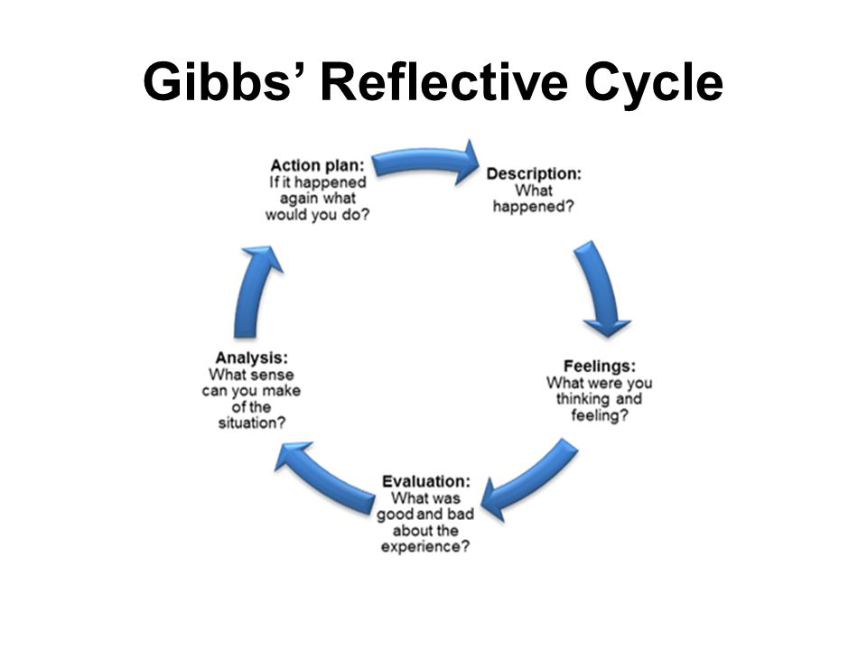

REFLECTIVE REPORT
It help you to consider what happened well and what you need to improve on,thinking of your personal story and history may help you to change your view of what occur, that may have cause unwanted physical and heart breaking situation or response. [Brookfield,1995]
FLOWERS
Since the origin of time, flowers have tantalize us with special beauty and attractive scents, but some this extraordinary gift of nature influence unbelievable characteristic that are uncommon to many of us. There are some abnormal facts about flowers, both rare breeds and the common ones. Flowers are so unique and accepted by almost every living creature and it is use for so many purposes, like birthday, burial, for appreciation, thanks given and for valentine, flowers are also been admired and used by humans to beautify their homes.
DESCRIPTION
In our written group work presentation assignment, my group was made up of [4 persons 1 male and 3 female] so in our first meeting we agreed on what to present and how to communicate in the group. It was one of the female in my group [Petal] who brought the idea of what we will present, and the her idea was really nice and we all agreed to work on that topic [Flower] so l suggested that every one should do research on that topic and post it in our WhatsApp group chat so that we can look at it and deliberate on it before our face to face meeting. It was in second meeting that we agreed that every one should send his or her bullet point and send to [ Natasha] who is very good in IT Skills so that she can put on Slide [power point] but unfortunately 2 of members in our group frustrated us because their work was not good enough and that made us to rewrite their own part of the assignment together in the morning the day before the deadline,[ but before the presentation we have been taught some skills like communicational skills, Entrepreneurship Initiative, The Dragons Den videos, all these teaches help us to build on our presentation] The team was in constant touch with one anther on our WhatsApp group that was created for the purpose of the presentation. We were sharing ideas on WhatsApp and some times we put a call across one another.
Feelings.
Before the group was formed we were already friends in the class, so communication was not a problem so when the group was form we were very happy in the group so we divided the work between us, but when it was time to gather the work we realised that two persons work was not good enough that we have to cancel the two members work, I got quite frustrated we started some section afresh. I was convince that the presentation will come out well because my group was made up of people with good communication skills, so two persons have to cancel their plans in other for us to finish the work that made me to feel guilty because they scarify there time to stay back for us to rewrite the work and this help me to work harder and make sure we had the work done faster. Looking back after the presentation and seeing our score am feeling satisfied that we decided to rewrite our work before we presented it.
EVALUATION
The things that were good that work very well was the fact that each group member was very good in communication and well committed to the assignment that we were able to produce a very good presentation on time before the deadline, moreover, the fact that two people work was cancelled in the group which motivated us to work harder in the group before the deadline that added positively to the groups work moral. The things that did not work well was that we were well relax till almost the deadline that we did not give enough time if some thing were to go wrong, we assumed we will produce a perfect work that there will be no need to rewrite any section of our presentation, therefore the overall time plan of the group failed. Professionals get the job done. They take responsibility of the promises. If for any reason or circumstances problem occur and prevent them from delivering on the promises, they contain projection up front, and do what it is needful to make the situation right.
ANALYSIS
In our group presentation every body in the group was able to have is own contribution towards the group assignment, and we divided according to peoples identified strength, I in person have experienced working this way before and l find out that am good working by myself, l enjoy working in the area that match my strengths, . We have one or two people who were very good in IT enough. I never though any thing could go wrong we just assume because we had a good communication skills, but at the at the end two members of group have to cancelled their program which could have been avoided if we were meeting regularly . The stress and rush to rewrite the work lead me to read some literature review on group work and discovered two things that help me understand the situation. According to Belbin [1981]. Believes that we possesses a pattern of behaviour in relationship to another in facilitating the progress of a team. Group think is where people in the group will make decisions as a group, resulting typically in unchallenged or poor decision making, l me being the only man in the group and have had experience in group presentation before l was silent in our meetings because I did not want the female to feel intimidated so l could not ask question or suggest to the group presentation. I believe , if we were meeting regularly we would not have had problem but because we so much believe in ourselves because of our communication skills we nothing will go wrong. l think being aware of group think in future will be helpful in group work when trying to make decision.

CONCLUSION.
I learned from my last group work assignment that to share responsibility in a group presentation, we must not wait till the deadline before meeting and one should not always assume there is enough time before making preparation. I will continue to have people self identify their area of strengths, especially in group work, I also learned not to always assumed that every body will get it right and to always create time for discussion before deadline to avoid complications. Lastly that in group work one should always feel free to ask questions, challenge decisions and never to be silent when necessary.

ACTION PLAN
When nest am working in group presentation, l will make sure that every one work according to their own strengths they have. I will suggest we write out the introduction in the first meeting with every one present so as to have reference for when we are writing our own parts. I will also make sure I create room for amendment should there be any wrong in write up to avoid rush work before presentation. When nest am work in group presentation l will be bold to ask questions, l will suggest we have more meetings not just phone calls or WhatsApp group but face to face meeting which is very important, if l have any challenge concerning my group work l will speak out in the meeting by remembering that the best result is possible if the work is excellent . When nest am doing group presentation l will make sure l read business pages of news papers, read magazines that that carry economic stories, watch videos that deals with presentation. I believe watching news channels that broadcast programmes that deals with business news will be help me to understand more about the business entity. In future work l will make sure l build up a relationship with my group or colleagues, l am working along with including my lecturers during my placement and I intent to speak to each of them when am challenging situation. Finally I have registered into a presentation skills workshop at university, and I aim to follow it up by undertaking the practise meetings, this experience has expose my weak point and I have realise that I need to build on my confidence when am doing presentation especially in public places. [Maughan & Webb,2001]

communicational skills, Entrepreneurship Initiative, IT, academic skills
I need to develop a good communicational skills that will help me to build my future both in business and work place.
There are three main types of communication which I must focus on the , Verbal Communication Skills, Nonverbal Communication Skills and Visual Communication Skills.
Verbal Communication is the ability to communicate with people at any given time . It is very useful in sharing information through spoken word either face to face or remotely.
Nonverbal Communication is when you communicate with people through facial expressions, hand gesture , posture and even your dressing can speak for you with out saying a word.
Visual Communication is when you communicate with people through signs, maps, or graphic design. This can be helpful when you forgot topics or direction it will help you to remember it is a way to convey messages.
Entrepreneurship Initiative Skills is what l need to develop to help me build my business in nearest future when l will open my business.
TIME MANAGEMENT SKILL – This is a very important skill on how to make good of your time in business especially when planning your day to day businesses
STRATEGIC THINKING. -- This skill will help you to be creative to grow your business and also it will help in providing solution.
Networking Skill--- Growing a network smooth the way for business opportunities. It help to deliver message to your customers and to the public.
Finance --- Finance management skill is very import because if your money is not manage well there is tendency that your business will collapse.
BRANDING. --- Building the same way, the same attitudes towards things or people will help you to tailored to the audience.
SALES --- The ability to market your product to people, discover the best right channels to carry out your sales.
OPTIMISM.--- You have to be optimistic to be a successful entrepreneur, this will help you get through the tough times.
DIGITAL SKILLS [IT] --- Because of the world we are now, every one need to develop [IT SKILLS] to be able to function effectively in this model technology world , so they are basic [IT Skills] that one need to have .
Network.---networking is mostly required of IT Professionals
CYBER SECURITY
INFORMATION MANAGEMENT
WIRE LESS
CLOUD SYSTEM
At list one need to have the knowledge of all this skills.
CODING SKILL.---- This skill is very important to know or have because most employers prefer people who can code in different languages.
Application development.—Able to create a computer program that can be use for different business purposes .
Cloud Computing.---To be able to use internet for business, it is a computing technology accessible by SAAS,PAAS, IAAS business models.
Architecture.
COMMUNICATION SKILLS
Communication skills are very essential for any one that wants to be successful in business.
Team work
Team building
Leadership
Written communication
Oral communication
Active listening.

REFERENCE

Dye, V. [2011].Reflection, Reflection, Reflection. Gibbs, G.[1988].Reflective Cycle. Dr Meredith Belbin [1981]].Team Roles .
Janis, I. [1991]. Groupthink. Skillsyouneed.com. Brookfield, S. [1995].Becoming a Critically Reflective Teacher. Hillkirk , K, [1989]. Hammond, Wiley[2009]. Johnson & Johnson.[1993]Maughan, C, & Webb, J. ]2001]. Mindtools.com.[2018]. Williams K, Woolliams, M & Spiro, J [2012] Reflective writing Basing Stoke: Palgrave Macmillan. Schon, D [1983] The reflective practitioner How professionals think. Honey, P & Mumford, A [1986] Effective learning. Maughan, C.,& Webb, J.[2001]. Kristensen, N.[2010] Nice to have or Need to have. Dawes, J.[2014]

