

Name: Andronic Iuliana
Student Number: 1913619
Module code: B4x01917

Module Title: Business skills for international Hotel Industry
Assignment Title and Your Module Lecturer’s Name: Dale Clarke Referencing about our experience Interview skills



Introduction
Hello, my nickname is Julia I’m one of the lucky student’s at the University of Wales Trinity Saint David in the first year, we were challenged to make an assessment in class about teamwork and delivering the best presentation and we responded to our challenges with five hundreds words assessment.
I will start my report, the report is based on my experience with my team and our goals as a team.

Description
(Gibbs cycle )
For the beginning I will make a short structure with all the subject than need to attempt:
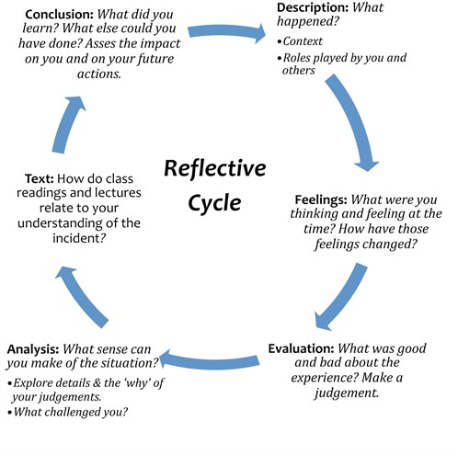
- Interview
- What is an interview?
- Clothes
- Body language
- Manners and behaviour
Was need for a first meeting to be able to fix these things, only with this encounter I could see about what we need to look for information and the topics we are interested in. We focused our attention on all the details even on all the smallest we tried not to admit anything important or less important not to create signs of question.
We are five people in the group who participated in this presentation the work was completed in the team, we communicated all the time and helped with what we could do more. I used knowledge than Reflection Cycle Kolb. Within the Reflective Cycle: Description, Feeling, Evaluation, Analyses, Text and Conclusion.

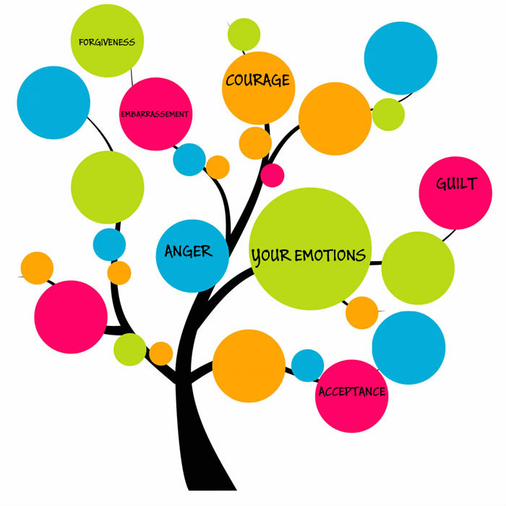

Feeling
My emotions this time has been seen in both my voice and small gestures. The shyness of presenting a project to my colleagues and talking made me lose some ideas that we had prepared for them but that did not make me quit or feel disappointed. I appreciate these opportunities to have these little presentations because it makes you more much trust and power in you. I realized that I can talk to some people and eventually make a speech even when you are afraid or emotions do not let you often get you up or down as you were proposing or expecting to come. Here I can even define the success that often comes with the chances of trying even if you often did not trust your powers.

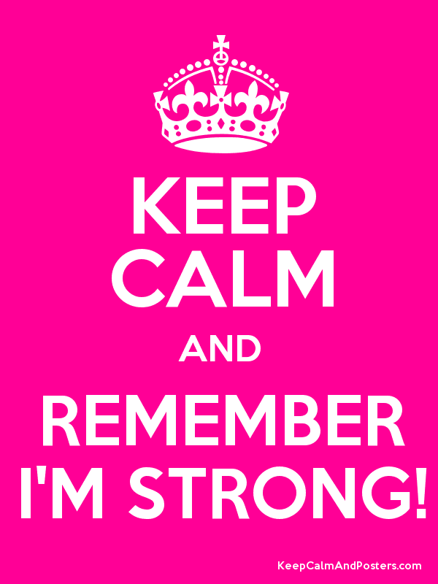

Evolution

One more step forward in team work and communication is due to my colleagues who were very open, they have patiently helped me and mean explained everything. It is very important to have people right to you when you want to evolve and grow, the encouragements received have even been helpful. I am confident that future projects will be easier to make the organization plan and to communicate even more. In conclusion I have learnt to be more confident in myself and be more creative and improve my skills. I realise that i am clever and encourage people with the supportive team members behind me.



Analysis

Communication is one of the point than have the principal attribute for a successful assessment. Growing during to communicate with my colleges and will be aware of all their idea and opinion.

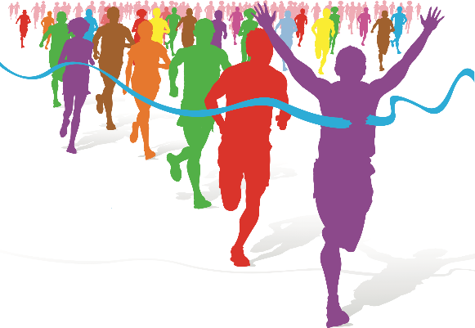

Conclusion
In conclusion the most important experience because we delivered our opinion about the interview and we make them understand the complexity and flexibility of interview.
I felted very involved in the work with my team, I have learnt from them to be stronger, to trust more in myself.
I find strong team members behind me and that is help me a lot to improve myself and not to be so emotional, because I’m a very emotional person, I can start to cry for the smallest thinks . I have learned one really important thing, for example when we work in a team it is easier, because when we work alone we can feel unsupported.

References
Corfield, R. (2009). Successful interview skills. London: Kogan Page.
Corfield, R. (2009). Successful interview skills. London: Kogan Page.
Rubin, S. and Farley, R. (1980). Intake interview skills for rehabilitation counselors. [Hot Springs, Ark.]: Arkansas Rehabilitation Research and Training Center, University of Arkansas, Arkansas Rehabilitation Services.

