Module: Learning in the Digital Era
Module code: ACCA4025
Assignment Title: Assignment 1
Student Name: Pele Windross
Course title: CertHE Computing Skills for the Workplace

Table of Contents
Task 1 4
a) Essential skills for study and employment 4
b) Similarity Score and Development 6
Task 2 6
a) Mind Map 6
b) Poster 8
Task 3 11
a) Unit 3 Topic summary: 11
b) Use of Cite This For Me 12
Task 4 13
a) E-Portfolio Creation 13
b) Illustrative Review 13
References 18

Homepage


Task 1

a) Essential skills for study and employment
A Data Administrative Operator needs to have basic knowledge of technology, interpersonal skills, cognitive competencies and team management abilities to handle organisational data efficiently (Franke and Hiebl, 2023). It has been observed that some core skills, including data management with detailing abilities, are essential for this role. Additionally, the professional needs to have abilities to protect data accurately in different platforms. It is important to ensure that data recordings are reliable and error-free to maintain data administration dignity. Thus, proper data gathering abilities are essential in both graduate and employment skills. Moreover, a professional needs to have sufficient digital literacy on handling worksheets, spreadsheets, enterprise systems and databases along with time management skills (Almgerbi et al. 2022).
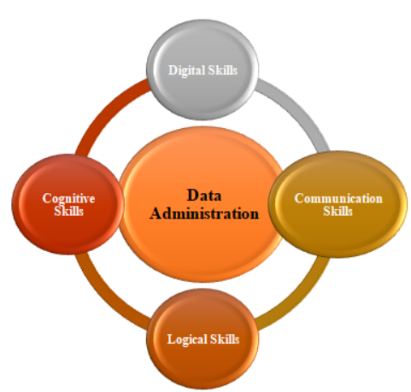
Figure: Required Skills for Data Administration
(Source: Learner)
It is also observed that knowing machine learning, Big Data management, and automation is important. During the time of project development, Data Privacy maintenance, cloud computing and data modelling skills are essential along with communication abilities (Almgerbi et al. 2022). These skills are essential for both employment and study. Moreover, based on the opinion of Schmidt et al. (2023), it has been observed that a professional, especially one who is seeking a career in the business data analyst field, having professional skills with sound knowledge of data coordination is essential.
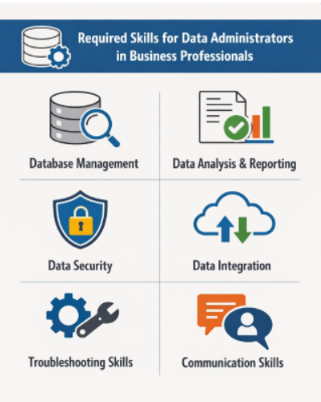
Figure: Required Skills for Data Administrators
(Source: Chatgpt, 2026)
Additionally, maintaining data security by involving different logical as well as digitalised strategies, including firewall management, encrypted data storing and the ability to adopt AI-empowered data protection tool, Data Integration abilities and Troubleshooting skills are essential for employment purposes (Kabashkin et al. 2023). Both graduate skills and employment skills help an aspirant candidate to get a job in the field of Data Analytics Associate in a real-time professional domain.

b) Similarity Score and Development
After completing the similarity check in the Turnitin Similarity checking platform, I have gained knowledge on multiple genres and am able to understand how to make a study unique and free from plagiarism. Additionally, I can mention that my submission to the Turnitin platform, with the help of Moodle, resulted in some similarity in writing. This indicates that during the time of using resources as references, some specific phases are close to the main content. To enhance my ability, I will try to make a smart and advanced paraphrasing style without violating the meaning of the content and involving ideas from multiple resources. By utilising the Generic Assessment Criteria or GAC, I would like to give myself a mark of 76 out of 100 for clear structure of the writing, using relevant content, involving multiple resources and conducting a critical discussion to evaluate the topic as per the higher-study level.

Task 2

a) Mind Map
Link: https://gitmind.com/app/docs/m0ergmwi
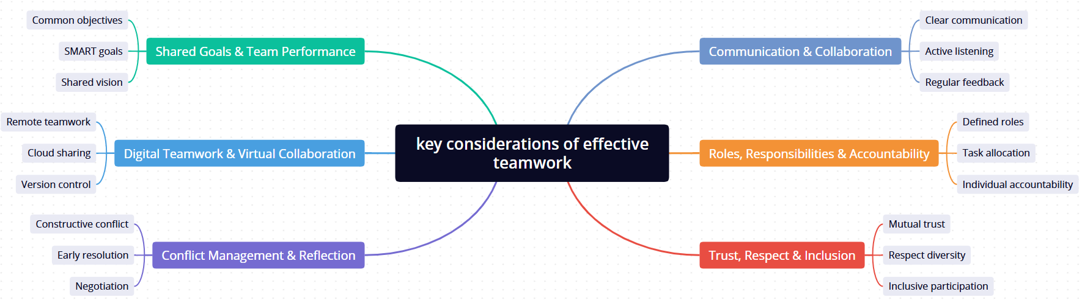
(Source: Learner)
The mind map indicates the main considerations needed to achieve the best in team work in both academic and professional settings. The central message is the necessity of teamwork in a well-coordinated group effort with the help of well-defined structures and good interpersonal behaviours.
Team success is based on communication and collaboration. Effective communication, listening, and frequent feedback help to make sure that information exchange occurs between members (Fatih et al., 2025). Such practices minimise misunderstandings and also enable teams to remain focused towards their goals. Effective communication also facilitates joint problem-solving and enhances the overall efficiency of the team.
Another important area is roles, responsibilities and accountability. Role definition and assigned tasks establish the work of teams to utilise personal strengths. Member accountability will prevent the situation of one member being overburdened, and dedicated tasks will enable teams to meet deadlines and remain productive. Lack of a clear role results in the risk of duplication and poor performance by the team.
Teamwork has a social basis which comprises trust, respect and inclusion. Openness is promoted by mutual trust whereas diversity is respected leading to better decision-making based on different views (Abu Raya et al., 2023). Being an inclusive person will make every member feel appreciated and involved which enhances a sense of team unity and encouragement.
It is also in the shared goals and team performance that are highlighted in the map. Setting common goals, SMART goals, and a common vision will allow aligning individual input with team results. Tracking the progress of the achievement of these goals helps teams to stay on track and keep on enhancing performance.
Online cooperation and virtual teamwork are signs of the contemporary work pattern. Remote collaboration, cloud sharing and version control tools help in effective cross-location collaboration. The technologies are becoming more critical in academic work in groups and in the workplace.
Lastly, there is conflict management and reflection that are found to be required in order to do constant improvement. Constructive conflict, early resolution, negotiation, and reflective learning assist teams to solve the issues professionally and use the improvement to improve their performance in the future.

b) Poster
Link: https://www.canva.com/design/DAHCJFjktas/XIWmbBNAAcW3aEEBqCivhQ/edit?utm_content=DAHCJFjktas&utm_campaign=designshare&utm_medium=link2&utm_source=sharebutton

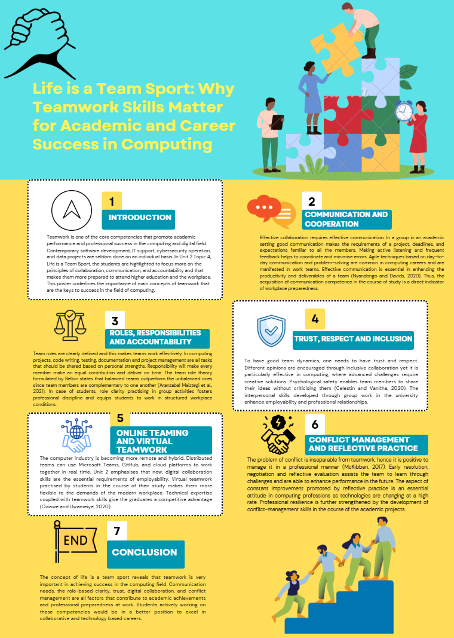
Introduction
Teamwork is one of the core competencies that promote academic performance and professional success in the computing and digital field. Contemporary software development, IT support, cybersecurity operation, and data projects are seldom done on an individual basis. In Unit 2 Topic 4, Life is a Team Sport, the students are highlighted to focus more on the principles of collaboration, communication, and accountability and that makes them more prepared to attend higher education and the workplace. This poster underlines the importance of main concepts of teamwork that are the keys to success in the field of computing.
Communication and Cooperation
Effective collaboration requires effective communication. In a group in an academic setting good communication makes the requirements of a project, deadlines, and expectations familiar to all the members. Making active listening and frequent feedback helps to coordinate and minimise errors. Agile techniques based on day-to-day communication and problem-solving are common in computing careers and are manifested in work teams. Effective communication is essential in enhancing the productivity and deliverables of a team (Nyandongo and Davids, 2020). Thus, the acquisition of communication competence in the course of study is a direct indicator of workplace preparedness.
Roles, Responsibilities and Accountability
Team roles are clearly defined and this makes teams work effectively. In computing projects, code writing, testing, documentation and project management are all tasks that should be shared based on personal strengths. Responsibility will make every member make an equal contribution and deliver on time. The team role theory formulated by Belbin states that balanced teams outperform the unbalanced ones since team members are complementary to one another (Aranzabal Maiztegi et al., 2021). In case of students, role clarity practising in group activities fosters professional discipline and equips students to work in structured workplace conditions.
Trust, Respect and Inclusion
To have good team dynamics, one needs to have trust and respect. Different opinions are encouraged through inclusive collaboration yet it is particularly effective in computing, where advanced challenges require creative solutions. Psychological safety enables team members to share their ideas without criticising them (Celestin and Vanitha, 2020). The interpersonal skills developed through group work in the university enhance employability and professional relationships.
Online Teaming and Virtual Teamwork
The computer industry is becoming more remote and hybrid. Distributed teams can use Microsoft Teams, GitHub, and cloud platforms to work together in real time. Unit 2 emphasises that now, digital collaboration skills are the essential requirements of employability. Virtual teamwork practised by students in the course of their study makes them more flexible to the demands of the modern workplace. Technical expertise coupled with teamwork skills give the graduates a competitive advantage (Oviawe and Uwameiye, 2020).
Conflict Management and Reflective Practice
The problem of conflict is inseparable from teamwork, hence it is positive to manage it in a professional manner (McKibben, 2017). Early resolution, negotiation and reflective evaluation assists the team to learn through challenges and are able to enhance performance in the future. The aspect of constant improvement promoted by reflective practice is an essential attitude in computing professions as technologies are changing at a high rate. Professional resilience is further strengthened by the development of conflict-management skills in the course of the academic projects.
Conclusion
The concept of life is a team sport reveals that teamwork is very important in achieving success in the computing field. Communication needs, the role-based clarity, trust, digital collaboration, and conflict management are all factors that contribute to academic achievements and professional preparedness at work. Students actively working on these competencies would be in a better position to excel in collaborative and technology based careers.

Task 3

a) Unit 3 Topic summary:
The virtual collaboration has been turned into a critical element of contemporary academic education and professional activity. It is the utilisation of digital technologies that allows one to coordinate the work of people and a team without losing mutual understanding even in cases of geographic dispersion. Unit 3 emphasises that remote work, globalisation, and cloud computing have grown more and more and as a result, virtual teamwork skills have gained higher significance.
Enhanced flexibility is also one of the main benefits of virtual collaboration. Synchronous and asynchronous communication is enabled in digital platforms such as Microsoft Teams, Zoom and shared cloud environments wherein team members can communicate and collaborate (Kubacz-Szumska and Szumski, 2021). This creates the possibility of organisations and students to harmonise the work across time and place. It has been shown that team productivity and sharing of knowledge are possible through the effective application of collaborative technologies.
Nonetheless, Unit 3 also highlights a number of issues that are related to virtual collaboration. Without the use of non-verbal communication, communication barriers may emerge and thus miscommunication occurs. This can also be caused by technical problems, issues with connection, and different degrees of digital competence which can impact the functioning of the team. In order to overcome these problems, the teams should develop effective communication guidelines, apply the rightful collaboration tools, and conduct periodic virtual meetings.
Digital professionalism is another significant theme. Virtual teams should be guided by the principles of netiquette, such as respectful communication, prompt response, and proper online behaviour (Assad et al., 2018). Trust and accountability in virtual environments are very important in effective teamwork. Research shows that teams that have defined work roles and work organisation are more effective when they work remotely.

b) Use of Cite This For Me
The Cite This For Me online referencing tool was utilised to come up with proper IEEE references. To start with, pertinent academic materials were located and identified. The source information was copied into the Cite This For Me and the referencing style was IEEE. This tool was used to create formatted in-text citations and the reference list automatically. The process was depicted using screenshots, the input page where the source was entered, as well as the citation generated and the resulting reference list. Citation This For Me enhanced the accuracy of referencing, saved time and ensured that the reference policies and conventions of academic research pertinent to this assignment were adhered to.
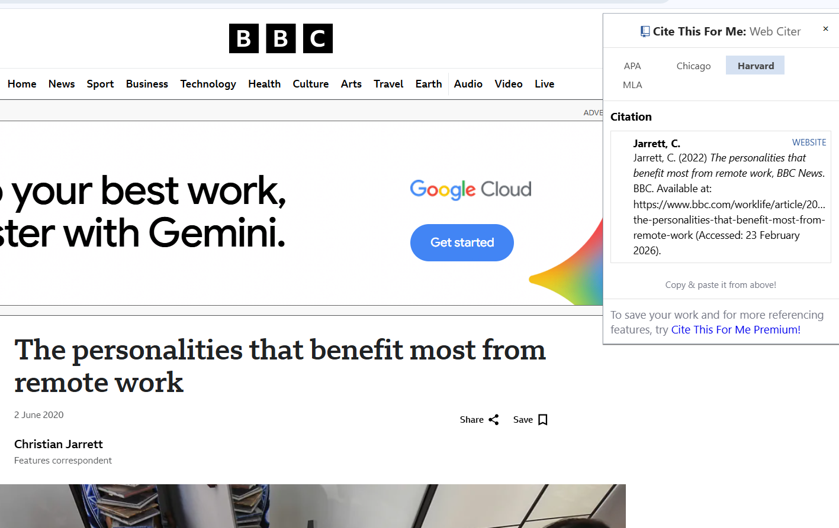

Task 4

a) E-Portfolio Creation
Wix was used to make an online e-portfolio to display the assessment tasks in a well-formatted and accessible format. In the portfolio, there is a welcome/home page that presents the purpose of the site and also gives navigation to each of the tasks sections. Task 1, Task 2, Task 3, and Task 4 were created on separate pages in order to be logically organised and easier to mark. Wix was enabled to be viewed publicly so that the tutors would find it easy to be able to access the content without restrictions to log-ins. The customisable nature of the platform allowed the establishment of a professional layout that can be used in academic and career development purposes.

b) Illustrative Review
Wix has been chosen as a tool of developing the e-portfolio because of its convenient interface, the ability of different design templates, and the possibility to publish the information online. The platform will enable multimedia integration, responsive layouts, and simple sharing, hence appropriate to academic portfolios. Moreover, Wix provides the possibility to control access and create sharing links, which guarantee the accessibility to the tutor. The professional presentation also can be facilitated with the tool, which is significant to the digital employability skills. The screenshots of every portfolio page are taken and attached to the Turnitin submission document as the evidence of effective implementation and to show how the e-portfolio completed looks and is structured.
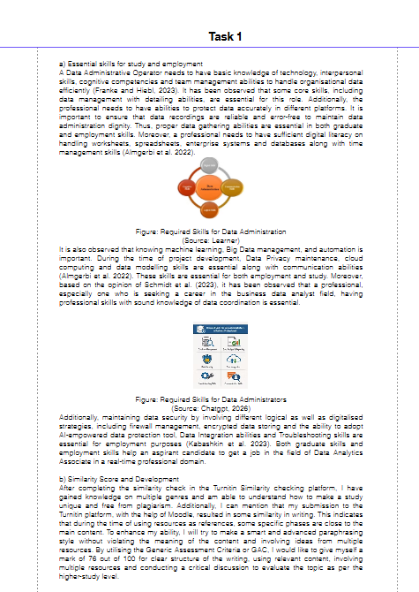
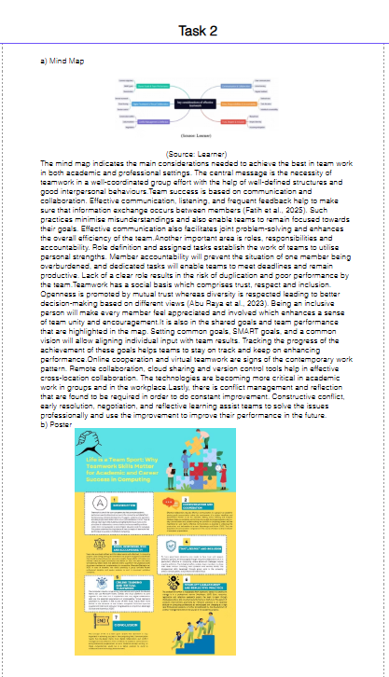
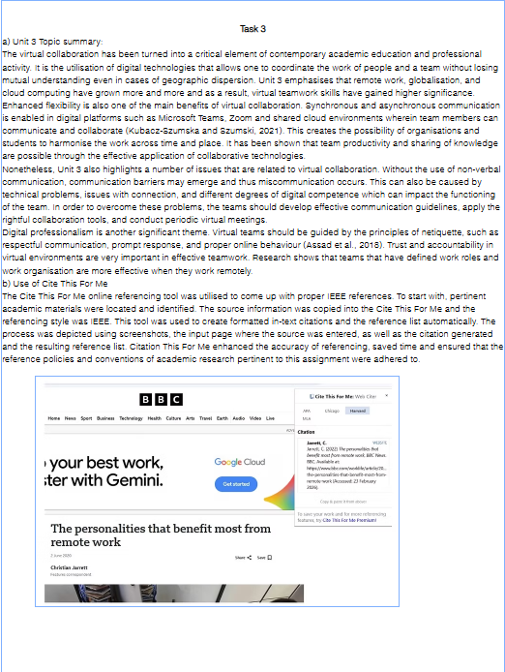
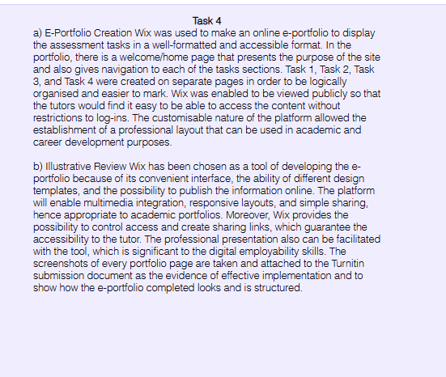

References
A. Aranzabal Maiztegi, E. Epelde Bejerano, and M. Artetxe Uria, 2021, “Team formation on the basis of Belbin’s roles to enhance students’ performance in project-based learning,” Education for Chemical Engineers, vol. 38.
A. Assad, A. Kaleel, I. Zainal, and R. Wadood, 2024, “Practicing netiquette in online communication between students and professors in higher education: A systematic review,” Studies in Media and Communication, vol. 12, no. 4, pp. 65–78.
Chatgpt, 2026, ‘Required Skills for Data Administrators’, available at: https://chatgpt.com/c/699c4803-c44c-8321-8e35-50027f94a42f Accessed-on: 23-02-2026
D.H. Schmidt, D. Van Dierendonck, and U. Weber, 2023. The data-driven leader: developing a big data analytics leadership competency framework. Journal of Management Development, 42(4), pp.297-326.
F. Franke and M.R. Hiebl, 2023. Big data and decision quality: the role of management accountants’ data analytics skills. International journal of accounting & information management, 31(1), pp.93-127.
G.W. Griffin and D. Holcomb, 2023. Data literacy and skills development. In Building a Data Culture: The Usage and Flow Data Culture Model (pp. 109-122). Berkeley, CA: Apress.
I. J. Oviawe and R. Uwameiye, 2020, “Approaches for developing generic skills in building technology graduates for global competitiveness,” Journal of Vocational Education Studies, vol. 3, no. 1, pp. 25–38.
I. Kabashkin, B.Misnevs, and O. Zervina, 2023. Artificial intelligence in aviation: New professionals for new technologies. Applied Sciences, 13(21), p.11660.
J. Kubacz-Szumska and O. Szumski, 2021, “Cloud communications during the pandemic from the perspective of collaboration platforms,” European Management Studies, vol. 19, no. 93, pp. 138–149.
K. M. Nyandongo and M. A. R. A. Davids, 2020, “The impact of communication on project performance: An empirical study.”
L. McKibben, 2017, “Conflict management: Importance and implications,” British Journal of Nursing, vol. 26, no. 2, pp. 100–103.
M. Abu Raya, A. O. Ogunyemi, V. Rojas Carstensen, J. Broder, M. Illanes-Manrique, and K. P. Rankin, 2023, “The reciprocal relationship between openness and creativity: From neurobiology to multicultural environments,” Frontiers in Neurology, vol. 14, p. 1235348.
M. Almgerbi, A. De Mauro, A. Kahlawi, and V. Poggioni, 2022. A systematic review of data analytics job requirements and online-courses. Journal of Computer Information Systems, 62(2), pp.422-434.
M. Celestin and N. Vanitha, 2020, “The diversity dividend: Why inclusive leadership drives innovation,” International Journal of Applied and Advanced Scientific Research (IJAASR), vol. 5, no. 2, pp. 47–54.
M. Fatih, N. Fauzi, and E. Norman, 2025, “Effective communication in building healthy and productive relationships,” MES Management Journal, vol. 4, no. 1, pp. 662–671.

