University of Wales Trinity Saint David
School of Engineering
Title of Report
Victoria Greene
P142884
Automotive Engineering BSc
21.3.18
Electric and Hybrid Propulsion Control

Word count:
Excluding References, Titles, Appendices + Tables: Approx. 1695

Contents

1.0 Introduction 3
1.1 Spread Sheet Changes 3
2.0 Technology Review 4
2.1 Motor/controller 4
2.2 Brushless Vs Brushed 5
2.3 ICE 6
2.5 Energy Storage 7
3.0 System Specification and Discussion 8
3.1 Motor Choice - Validation 8
3.2 Motor Rpm - Validation 9
3.4 Calculating the Final Drive Ratio Required: 10
3.5 Ice engine/generator 11
3.6 Storage 12
4.0 Costing 13
5.0 Maintenance requirements 14
6.0 Safety 14
7.0 Conclusion 14
Bibliography 15
Appendices 16
Motor Specifications: 17

Introduction

This report will detail the specification of a simple series hybrid system for a corporate event leisure buggy. The author specifies chosen components whilst providing adequate validation that each component is suitable by comparison to the buggy’s duty cycle requirements.

1.1 Spread Sheet Changes
The original error values of average power have been rectified. The significant figures have been changed to make the spreadsheet more user friendly.

The power requirements and corrected average power produced by the internal combustion engine are plotted on the graph below:

2.0 Technology Review

2.1 Motor/controller
A motor is required for converting electrical energy into mechanical energy (and vis-versa). When specifying an electric motor, it is important to understand the load that the motor is experiencing.
Motors run at varying efficiencies that change with speed/load that are plotted on a curve. (U.S Department of Energy, 2000)
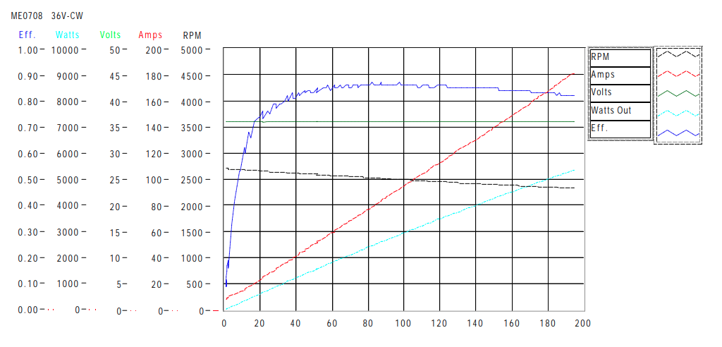

(Electric Motorsport , 2018)

Motors also have the ability to operate above their specified operational capacity (in very short periods of time). E.g. A motor rated at a maximum 5HP may be able to operate at 6Hp for a very small time. This is referred to as a ‘service factor’. If a motor is taken to its service factor too often or to a value greater than the service factor, this can cause prolonged damage. (Douglass, 1997)

The motor must be able to withstand a maximum load of 7.38 Kw but only really for 10 seconds or so, therefore this could be achieved the service factor of an appropriately chosen motor. To summarise, the selected motor should be able to transmit the maximum power needed whilst also maintaining efficiency. The motor selected has a controller included which is preferable since compatibility is guaranteed.

Different types of motors are discussed on the following page.

2.2 Brushless Vs Brushed
The table below shows factors to consider when choosing a motor:

Motor – Factors to Consider | Cost | Wear + Maintenance | Complexity | Interference | Availability
Brushed | Cheaper | Wear on brushes, more maintenance | Less Complex, | Possible Magnetic Interference | Easily available
Brushless | Considerable More Expensive | Less Wear | More Complex | Less possible magnetic interference  (closed unit) | Difficult to find

(Wernick, 1978) (NMB Technologies Corporation, 2014)

The table below demonstrates the difference between AC and DC motors:

AC/DC | Cost | Wear and Maintenance | Noise | Speed Control
AC | Expensive | Less wear | Less Noise (but irritating) | Adequate for task
DC | Cheaper in general (for this application) | More wear | More noise – due to brushes | Adequate for task

(Khamis, 2012) (Wernick, 1978)

*AC motors cannot be powered by a battery without the use of an inverter to change from DC to AC.

2.3 ICE
The Engine/generator has been chosen based on the average power requirements needed from the duty cycle plus slight additional power to account for loses in the system. The average power should be achieved in an efficient manor, therefore choosing an engine that can only achieve maximum power when operating flat out (high rpm) will most likely be inefficient.

2.4 Likely fuel consumption Benefits
Choosing to operate with this hybrid system instead of ICE alone would be beneficial in terms of fuel consumption. The engine is constantly operating within its sweet spot and does not have to exceed this because energy from the battery is used when more energy is required.

A brake specific fuel consumption graph can also be used to assist with setting the maximum operating rpm of the engine. The graph above suggests that the most efficient operating rpm is approximately 2000 rpm.

The Difference in engine efficiency can be explained by comparing two BFSC graphs below:

Operating in sweet spot = High efficiency Operating elsewhere = Always less efficient

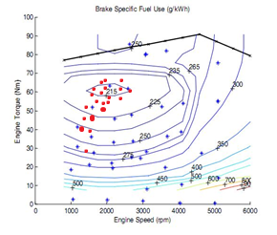
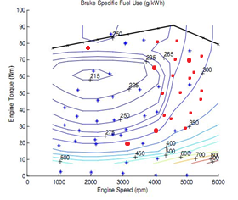

(Modder, 2017)

2.5 Energy Storage

Though-out the Drive cycle, hybrid technology is constantly using and storing energy. Energy is stored when the power demand from the vehicle is less than the average power produced by the internal combustion engine. Though-out the cycle energy is being ‘given’ and ‘taken away’ from the battery (storage), the maximum energy that is taken from the battery according to the duty cycle is 95.69kJ. (this is assuming that the engine is working within its ‘sweet spot’ of 2.1 Kw.

Although the duty cycle estimates that the maximum storage capacity on the battery would be 95.69kJ, this does not mean that this value would be appropriate to use to spec the battery.

When a battery has all of its available energy drawn, the health of the battery starts to deteriorate rapidly, this is the reason that batteries have a ‘depth of discharge’ value, this is the amount of energy that can be drawn from the battery before damage occurs. (MIT Electric Vehicle Team, 2008)

$$∴battery needs to be chosen with more energy than required from duty cycle$$

*The Ah rating of a battery also has to be considered, please see pg.12

3.0 System Specification and Discussion

3.1 Motor Choice - Validation
The chosen motor is the Motenergy ME0708 DC Brushless motor equipped with a sigma control system included in the cost. This motor has been picked because of its availability, cost and efficiency information. It has an approximate efficiency rating of 90%, despite this rating, it is important to investigate the efficiency curve to see what efficiencies are possible with the loads being applied from the duty cycle.

Efficiency Curve:

(Electric Motorsport , 2018)

The average power is considered then compared to the graph above, whilst running at an average power of just over 2Kw gives an efficiency of approximately 90%, this is acceptable noting that the losses at this point would be 10%.

The graph above also suggests that when operating at full capacity (7.36 Kw) the efficiency would decrease, although the amount this decreases by is difficult to interpret. However, when estimating the fall in efficiency it does not seem to be drastic.

If the range of capacity from 2.1Kw to 7.36Kw is considered, the efficiency can be predicted to range from approximately 88% to 70%. Suggesting a worst-case inefficiency value of approx 30%.

A wiring diagram of the controller can be found in the appendices (pg.14)

3.2 Motor Rpm - Validation
The maximum rpm that the motor can provide is 5000 rpm, although it would be unsuitable to operate the motor at this speed as it is functioning at full capacity at would be at risk of inefficiency, wear and overheating, therefore a maximum rpm of 3500 is chosen.

It is important to check that the motor at the chosen max rpm is capable of achieving the maximum rpm required by the wheels, this can be investigated by calculating the rpm of the wheel at maximum speed:

3.3 Maximum linear velocity 9.5 m/s

$$Revolutions per minute=\frac{speed in metres per min}{circumference (in metres)}$$

$$circumference=2πr=2π×0.17=1.068.141 m$$

$$Speed in metres per minute=9.5 × 60=570 metres per minute$$

$$RPM= \frac{570}{1.068}=533.707$$

$∴$This motor can provide sufficient rpm to the wheels to achieve the maximum wheel speed required from the duty cycle.

*a value of 0.17 was used from general research carried out on small buggy wheels.
(Off road Buggy Wheels, 2018)

To see any additional specifications on the chosen motor, please see appendices.

3.4 Calculating the Final Drive Ratio Required:
Comparing the chosen maximum rpm of the motor to the maximum required rpm of the wheel gives a suggested final drive ratio:

$$\frac{3500}{533.707}=6.5579=6.56$$

Although this method is good for suggesting a value of final drive ratio, this needs to be compared to the torque required from the motor due that are directly related to tractive effort:
$$Maximum Tractive effort from drive cycle= 934.64 N$$

$Tractive Effort × Radius=Torque$ = $934.64 × 0.17=158.9 Nm$

$$\frac{158.9}{6.56}=24.22 Nm$$

$$∴Maximum torque required from the motor=24.22 Nm$$

The maximum torque that the motor can provide is stated by the motor efficiency graph which is approximately $200 pound/feet = 271.149 Nm$.

$$∴Motor is sufficient in terms of Torque$$

3.5 Ice engine/generator

The Honda EM 2300 engine/generator (maximum output 2.3Kw) combined configuration has been chosen for simplicity and packaging purposes. The engine will be operating at a maximum of 2000 rpm to maintain efficiency (taken from the BSFC graph, please see technology review section pg.6.

Another aspect to consider is the energy lost through the system before reaching the wheels. Although the duty cycle requires a maximum power of 7.36Kw, (2.01 from engine, the rest from storage) some of this power from both of these sources will be lost before reaching the wheels due to inefficiencies. An engine/generator has been chosen that has slightly more power than predicted from the buggy cycle to account for these loses. (Douglass, 1997)

3.6 Storage

The Storage chosen is an Elektromotus 36V (60Ah) lithium-ion battery with a charge and discharge rate of 3C and maximum depth of discharge of 80%. This Purchase of this battery would also include charger and battery management system.

The following calculations validate the use of this battery:

Calculating Amps required by duty cycle:

$$Current= \frac{Power (\max{power needed from storage)}}{Voltage}$$

$$Current=\frac{5350}{36}=148.6 Amps (Maximum required from storage)$$

Calculating Amps Provided from Battery:

$$Amps provided by chosen Battery=60Ah ×3C=180Amps$$

$$∴Battery is sufficient in terms of Amps$$

Calculating the capacity of the battery in terms of joules:

$$60A ×36V ×60 ×60=7776000=7776 Kj$$

Capacity needed according to spreadsheet = 95.96 kJ

$$∴Battery is sufficient in terms of Capacity$$

$$\frac{95.96}{7776} ×100 = 1.23\%$$

Duty cycle is only using approximately 1.23% of battery capacity per run. If the Depth of discharge is 80%, the battery could theoretically achieve:

$$\frac{80\%}{1.23\%}=64.83 runs (64 full runs ofduty cycle without additional charge time)$$

4.0 Costing
Ice/Generator Combined:  Honda EM 2300 |  | £499 Inc. VAT
Motor/controller:  Motenergy ME0708 DC Brushless motor with controller included | 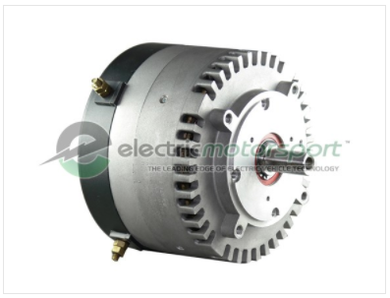 | £449 – controller included Inc. VAT
Battery:  Elektromotus 36V (60Ah) lithium-ion battery | 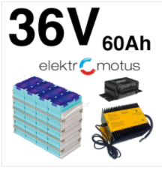 | £1320.51 - for battery, charger and battery management system Inc. VAT
 | Total Cost: | 2268.51 Inc. VAT

5.0 Maintenance requirements
The maintenance of this buggy would include

- Servicing of the small ice engine/generator
- Battery maintenance (avoidance of exceeding depth of discharge level – battery comes with Battery management system)
- Possible servicing of the brushed motor (brushes may wear)

6.0 Safety can be considered by:

- Following appropriate safety procedures when servicing all vehicle components.

- Handling lithium ion batteries in accordance with the ‘NERC Guidance on the Safe Use of Lithium Batteries’ (NERC, 2016)

7.0 Conclusion

Components have been chosen by using technical research and validation against the buggies duty cycle, therefore all components specified are suitable for this application. Recommendations of specific components can be found throughout the System Specification and Discussion section.

Bibliography
Douglass, J. G. (1997). Efficacy of Methods for Estimating In-service Motor Efficiency. Washington: Wahsington State University.
Electric Motorsport . (2018). Motenergy ME0708. Retrieved March 16, 2018, from http://www.electricmotorsport.com/ev-parts/motors/brushed-motors/emc-r-me0708-pmdc-motor-24-48v-8-hp-cont-15-hp-pk.html
Khamis, F. (2012). Advantages and Disadvatages of AC/DC Motor. Retrieved March 15, 2018, from https://www.slideshare.net/fikakhamis/advantages-and-disadvatages-of-acdc-motor
MIT Electric Vehicle Team. (2008). Battery Basics. USA: MIT.
Modder, E. (2017). Brake Specific Fuel Consumption (BSFC) Maps. Retrieved from http://ecomodder.com/wiki/index.php/Brake_Specific_Fuel_Consumption_(BSFC)_Maps
NERC. (2016). NERC Guidance on the Safe Use of Lithium Batteries. Retrieved from http://www.nerc.ac.uk/about/policy/safety/procedures/guidance-lithium-batteries/
NMB Technologies Corporation. (2014). Brushless DC Motors . Retrieved March 18, 2018, from http://www.nmbtc.com/brushless-dc-motors/why-brushless-motors/
Off road Buggy Wheels. (2018). Off road Tyres . Retrieved from Off road Buggy Wheels: https://www.funbikes.co.uk/sc711_wheel
U.S Department of Energy. (2000). Determining Electric Motor Load and Efficiency. USA: Motor Challenge.
Wernick, E. (1978). Electric Motor Handbook. London: McGraw.

Appendices
The motor/controller combination has a Sigma controller of which the wiring diagram is shown below:

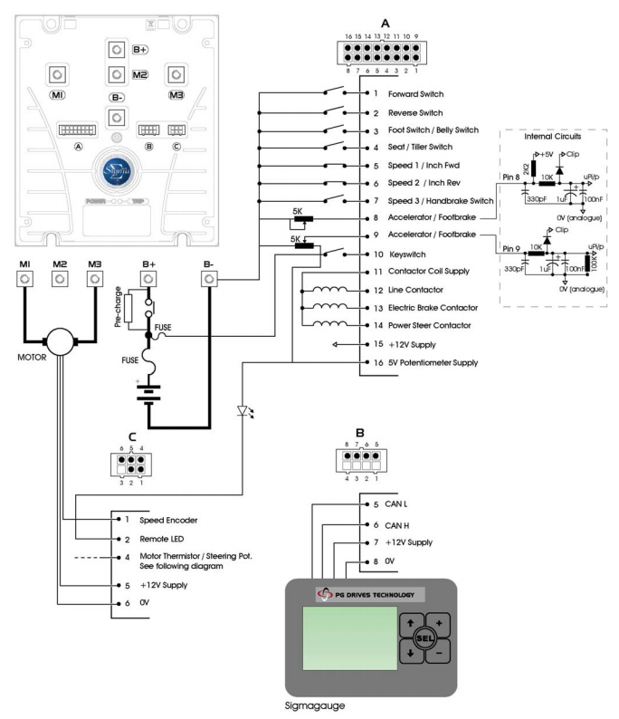

(Electric Motorsport , 2018)

Motor Specifications:

ME0708 Drive Kit with Motor + Controller
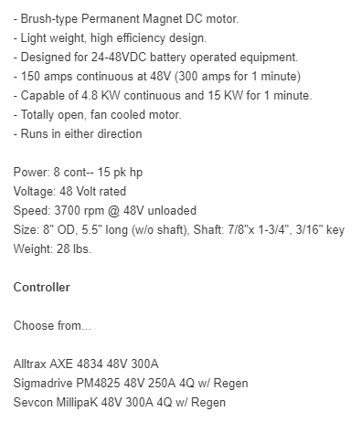

(Electric Motorsport , 2018)

